Essay one: How effectively has the police service adapted to accommodate diversity within the UK? Consider the police force itself and/or the way police engage with diverse communities. Your answer must be based on academic research. Word limit: 1000 words.

How effectively the Police service have adapted to accommodate diversity within the UK has been subject to much debate in parliament, media and in the Police Organisation itself.

The diversity of the population in the UK is ever changing evidenced by (ONS, 2021) Census. Census data from 2021 of states that 81.7% UK residents identify as white compared to 86% in 2011 Census. This only states the change in ethnic diversity, but the Census also states that the number of residents that class themselves as “White British” is also decreasing to a total of 74.4% in 2021 from 87.5% in 2001. It is therefore clear that the makeup of the population in the UK is changing and with that brings different culture, beliefs and requirements.

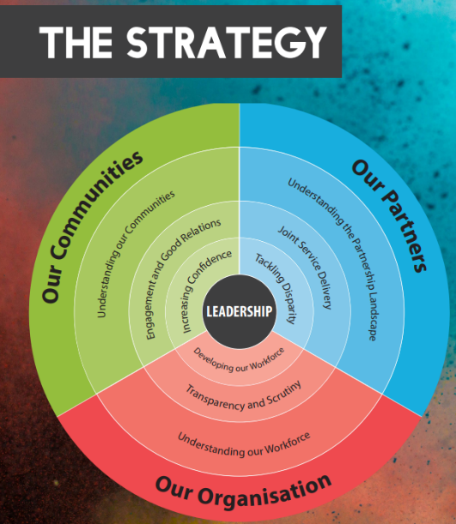
(NPCC Police UK, 2018) Chief Constable Gareth Wilson Chair of the NPCC Diversity, Equality and Inclusion Coordination Committee states in the 2018-2025 NPCC DEI Strategy Publication 9 pledges based around 3 key areas of “our communities” “our organisation” and “our partners”

The Police when learning about “Our Communities” look at statistics of confidence in the Police by community (GOV.UK, 2021) “74% of people had confidence in their local police in the year ending March 2020 of that, people from the Asian (77%), White (74%) and Other ethnic groups (75%) were more likely to have confidence in their local police than Black people (64%)”. This is an indicator of how effectively the Police service have adapted to accommodate diversity within the UK. As you can see only 74% of the population have confidence in the Police and 64% for black members of the population. This shows that there is still a lot of work required by the Police to build confidence.

Officers and PCSO’s are encouraged to get to know their communities and listen to community concerns and thoughts. You can see on South Wales Police’s social media pages, that officers have celebrated special occasions from multiple faiths and beliefs, working with community leaders (Facebook, 2024). When recruiting, “Join Us” is in multiple languages to show inclusion and let people who speak that language know that the Police is for them. Social media is a way Police can communicate with a huge number of people.

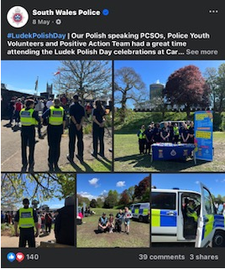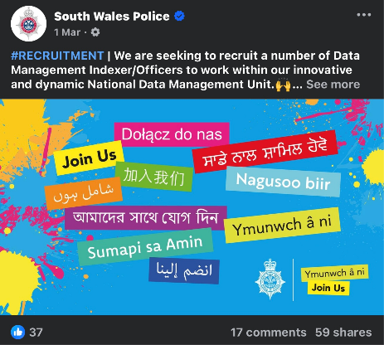

Chief Constable Jeremy Vaughan of South Wales Police while addressing The National Black Police Association Conference in October 2023 discusses institutional racism (South Wales Police, 2023). Based on Baroness Casey’s definition of institutional racism, it’s his view that the “term institutional racism applies to South Wales Police”. This is a public acknowledgment of an issue within the police and allows the Chief Constable to put forward a plan to deal with the issue and hopefully let all people know that he is planning to improve the situation.

“Our Organisation” aims to get a workforce that reflects the community it Polices. (South Wales Police, 2024) states that it wants to “Eliminate discrimination, harassment, victimisation and any other conduct that is prohibited by or under Equality Act. Advance equality of opportunity between persons who share a relevant protected characteristic and persons who do not share it. Foster good relations between persons who share a relevant protected characteristic and persons who do not share it.” This means that the Police is looking to level the playing field with all applicants to the police.
Police Officers also undergo Equality, Diversity, and Inclusion training. (Exudehc, 2022) states some of the benefits “Critically examine stereotypes and cultural assumptions. Evaluate how they perceive others and how others perceive them. Discuss the negative effects of discrimination and prejudice. Increase awareness of attitudes and behaviours. Create situations to reinforce team building. Turn knowledge into usable skills for serving the community.” This is then educating new and existing Police Staff how important it is to treat everyone fairly. Personally I have learnt a lot from this training and believe I’m a better Officer because of it.

(South Wales Police, 2024) is “proud to have a range of different staff associations and networks operating within South Wales Police”. These are groups set up to support officers such as South Wales Association of Muslim Police and South Wales Black Police Association. This is to help officers and to retain officers “who may feel under-represented in the workplace”

(Gov.uk 2023) looks at the percentage ethnicity of Police Officers in 2021 as shone by graph below.
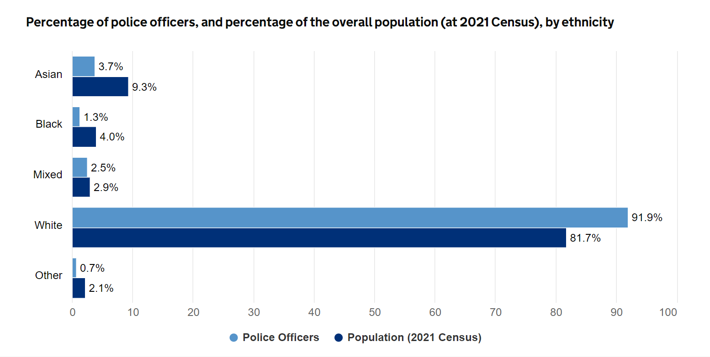
As you can see there is still a large disparity between ethnic minorities in the UK and the percentage of Police workforce that represent them. This shows there is still a lot of work to do. However, (Gov.uk, 2023) does show the improvements made in several ethnic minority areas. It shows a continued improvement in percentage numbers since 2007 to 2020. It is great that the Police force is getting closer to parity in representation of the community they serve. However, my concern is that as discussed earlier the demographic of the country is changing faster than the change in police representation.
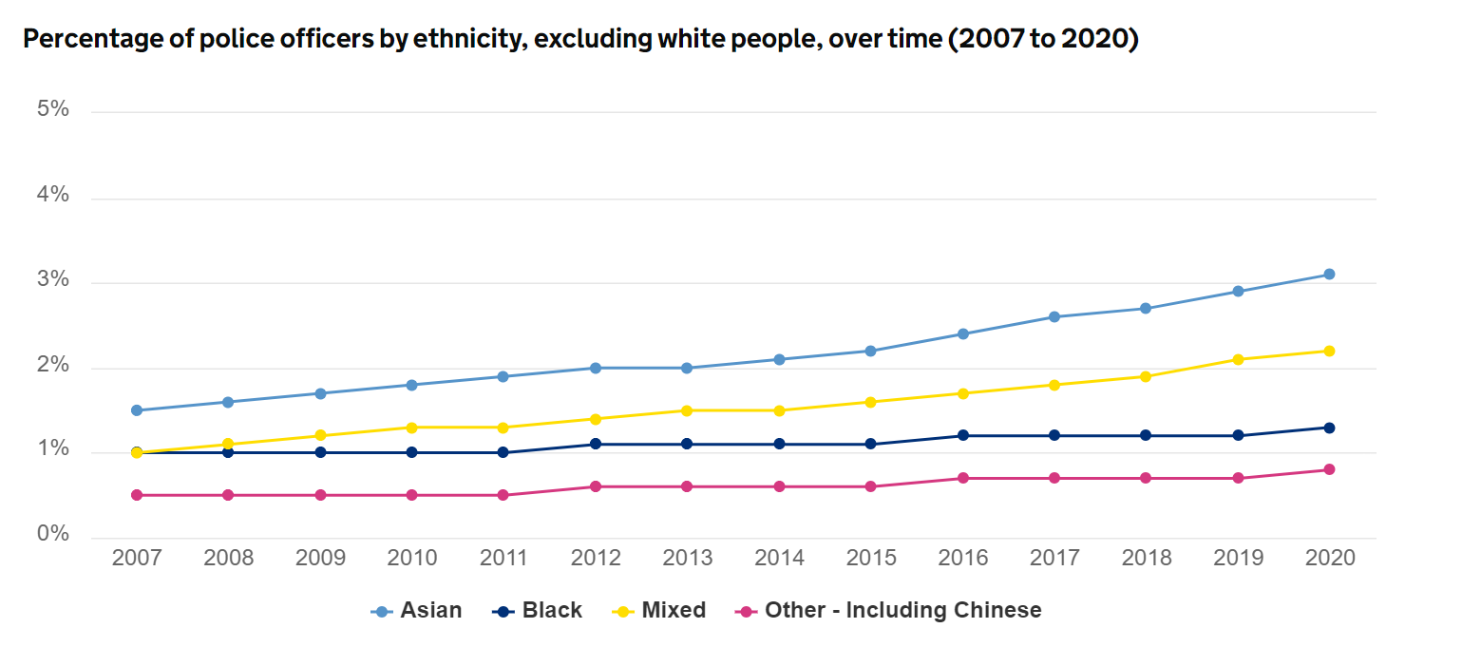
(The University of Law, 2023) look at Police ethnicity, gender and sexuality representation and state “Nationwide, around 65% of people agreed that they feel seen and represented within their local police force.” Meaning 35% do not feel represented within their police force. It goes on to brake down into individual minority groups who have negative views on this.

(UK Parliament, 2023) states “there has been a series of high-profile cases of gross misconduct and illegal behaviour by police officers”. Domestic high-profile cases such as the Sarah Everard Case, where Everard was kidnapped and murdered by serving officer Couzens. Also international high-profile cases such as the George Floyd case in the USA where Floyd died while being arrested by American Police. This has a huge impact on police perception. (UK Parliament 2023) reiterates that the Police in the UK must follow the principle of ‘policing by consent’. This comes from Sir Robert Peel’s General instructions. It “refers to the power of the police coming from the common consent of the public, as opposed to the power of the state” This means that for the Police to function, the Police need support from the public. It is important to acknowledge horrible cases like I mentioned and to do everything to punish and prevent anything like this happening again.

Overall, with the figurers provided, it is clear in my opinion that the Police still have a lot to do to accommodate diversity within the UK. However, it also shows from my research that the Police have identified concerns and they have come up with several plans and strategies to build confidence and trust with the community going forward.

Word count 1098

Essay two:
• Response policing – Why is it important to manage mental wellbeing in policing? What can be the consequences if mental wellbeing is not managed appropriately?
Word limit: 1000 words.

Over the last few decades understanding of mental health and wellbeing has increased. The consequences on mental wellbeing not being managed can have a huge impact on the individual and the organisation.

(Mental Health Foundation, 2024) states “When our mental health is good, we feel good inside. We might feel calm or content, peaceful, hopeful and accepting of ourselves and valued by the people who matter to us. Having good mental health makes life easier. It helps us to calm and comfort ourselves when we’re upset, to cope with the losses, changes, fears and uncertainties in life, to make and keep good relationships with other people and to learn.” Mental Wellbeing is not just about preventing poor mental health. Good mental wellbeing can also have a positive impact on the individual.

(Police Federation, 2024) describes that with additional cuts to services it has meant that Officers are under more strain now, than ever before. Officers are doing more, with less resources and it is inevitable that with additional pressures, it will have an impact on officers mentally. Therefore, there is a significant enhanced risk of mental wellbeing issues and more vital Police staff are mindful of this and looking out for signs and symptoms of themselves and others around them. A (Police Federation 2024) “survey of 17,000 officers in 2016 showed an alarming set of statistics around mental health of officers, with 39% seeking help with mental health issues.” This shows the size of the issue Officers are facing with mental wellbeing.

(Mind, 2019) have done a survey asking Police employees what aspects of the role caused Police to feel low, depressed, stressed or mentally unwell. This graph shows the outcomes of that survey compared to the 2015 results.
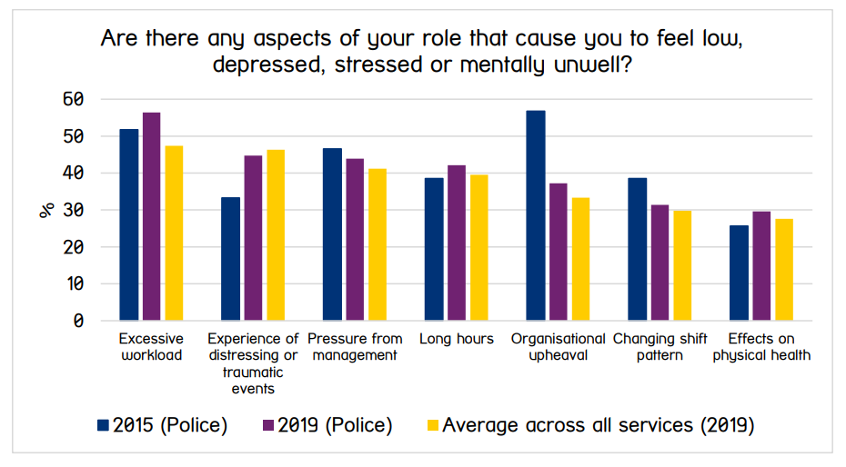
This shows that there are multiple causes to Police felling low, depressed, stressed or mentally unwell. There are many stresses in the Officer role therefore mental wellbeing is challenging to maintain and requires extra consideration.

(National Library of Medicine, 2024) suggests that there are several negative consequences to poor mental health in policing to the individual, including “job loss, marital problem and difficulty sleeping”. It also states that that the long-term effects can have a physical and psychological impact on the individual. Possible physical problems could be, but not limited to, increased occupational injuries, high blood pressure or gastrointestinal ulcers. Psychological problems could be, but not limited to, a “significant change in personality or habits, such as an officer being more likely to engage in a violent confrontation with a citizen, an increment in domestic altercations, or an increase in drug or alcohol abuse, suicidal ideation, and self-harm.” “Police stressors and their mental and physical implications harm the police organization in the long term by reducing performance, raising absenteeism, and rising officers’ aggressiveness”. I will now investigate some of these areas.

(IOSH magazine, 2023) report in an article talking about national statistics for general occupational injuries that “Workers with poor mental health take more risks and are more likely to be injured at work, stats reveal”. This would be a risk to the individual for injury and then a cycle of further wellbeing concerns following injury. It would also be an issue to the organisation as more time off required for sick leave. Finaly this could have an impact on the people Police serve as Officers may not be making the best decisions while in stress.

(NHS, 2024) states that high blood pressure can put “extra strain on your blood vessels, heart and other organs, such as your brain, kidneys and eyes. If untreated can cause heart disease, heart attacks, strokes, heart failure, kidney disease and vascular dementia.” These are all very serious problems and could end in at worst death.

(Crisis House, 2024) states “The psychological impacts of stress can lead to angry outbursts and have been shown to increase the risk of violent behaviour.” This has been linked to an increment in domestic altercations and therefore could put the Officer at risk from legal proceedings, threatening the Officers career, impacting the Police organisation and the public.

(National Library of Medicine, 2024) states “Many studies that have demonstrated an association between Alcohol and Drug use and stress have been unable to establish a causal relationship between the two.” An increase in both drug or alcohol abuse could make an Officer unfit for work, could have an impact on physical health and could put an Officers job at risk.

One of the worst outcomes of poor mental wellbeing and one of the saddest consequences, is suicide. Having experienced this to a colleague, I have personally seen the devastation on friends, family and colleagues. (ONS, 2022) have all deaths by suicide, cross referenced by occupation. I have taken this data and produced these spreadsheets. It shows 221 deaths by suicide between 2011 and 2021 of Officers. This is a terrible loss and a devastating consequence of poor mental wellbeing in policing.
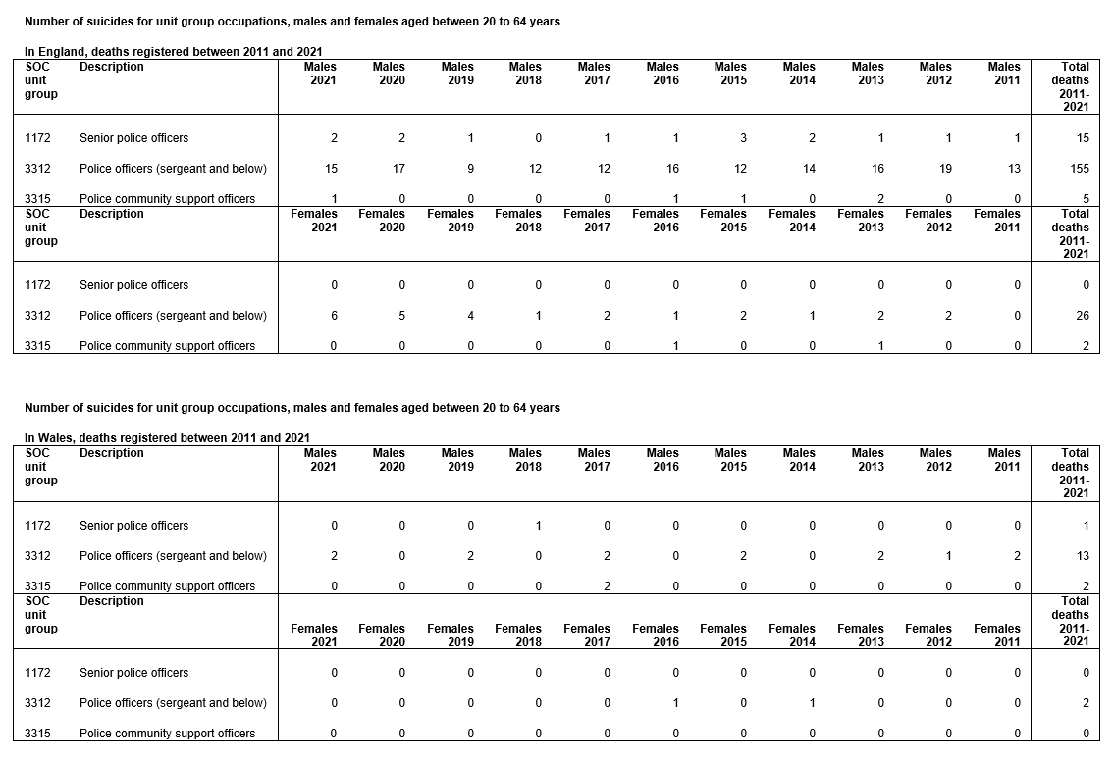

Poor mental wellbeing can harm the police organisation in the long term by reducing raising absenteeism. (Cartwright and Roach, 2020) state “between 2008 and 2018 the number of police employees that were absent due to psychological or mental ill- health almost doubled from 4.72% to 8.82%.” The graph below shows the data. This shows that mental wellbeing is getting worst in the police and due to increased absences will be having a significant impact on resourcing, ability to deal with demand and impact on the public we serve. In addition, a loss of 8.82% of workforce could have a cycle impact on the 91.18% who have not taken a leave of absence and could affect their mental wellbeing due to increased workload.

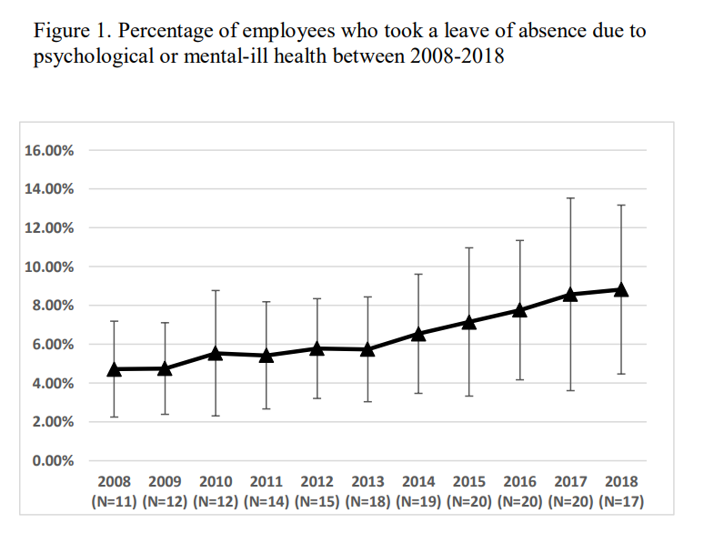
Finally, (Police Federation, 2024) said that following a survey they did with Officers, 22% said “that they had an intention to resign from the police service either ‘within the next two years’ or ‘as soon as [they] can.’ The most frequently cited reasons being how the Police are treated by the government and the impact of the job on their mental health and wellbeing.” Therefore, poor mental wellbeing is likely to mean that we lose Officers. There is a long training period for Officers and a lot of time and money is invested in them. Losing officers can have a huge impact on the organisation.

Overall, it is vitally important that mental wellbeing of Officers is prioritised and looked after. It can have a huge impact with physical and phycological effects on individuals. It can have a significant impact on the organisation as a whole and finally an impact on the wide public we serve.
Word Count 1096

Essay four: Outline potential links between serious and organised crime and public protection issues. What characteristics make some people more vulnerable to exploitation by serious and organised crime gangs? Your answer must be based on academic research. Word limit: 1000 words.

Serious and organised crime and the insurgence of County Lines is having a significant effect on communities across the UK. There is a notable link between these serious and organised crime groups and the most vulnerable individuals in society. I will now investigate these links and discuss what characteristics make some people more vulnerable to exploitation by serious and organised crime gangs.

Officers complete a Public Protection Notification (PPN) when there are concerns about a Vulnerable Adult, Child at Risk or Domestic Violence, following an incident involving anyone that would apply to any of these areas. (HMICFRS, 2023) describes “A PPN is an information-sharing document that records safeguarding concerns about an adult or child. PPNs are shared with partner agencies to inform a multi-agency response.” There are several questions on these forms Officers complete to identify risk and potential links to these serious and organised crime groups. The results of these notifications are shared with multiple other organisations including health, education, social services, domestic abuse services and child services to come up with a multi-agency approach to protect the vulnerable subject person.

(GOV.UK, 2023) describes “‘County lines’ is a term used to describe gangs and organised criminal networks involved in exporting illegal drugs into one or more importing areas within the UK, using dedicated mobile phone lines or other form of “deal line”. They are likely to exploit children and vulnerable adults to move and store the drugs and money and they will often use coercion, intimidation, violence (including sexual violence) and weapons.” As this describes these serious and organised crime groups look to exploit children and vulnerable adults for their own gains. I will now look at how they do this and how they select their victims.

The term and act of Cuckooing is one way that serious and organised crime groups take advantage of vulnerable people. (Salvation Army, 2024) describes this as “Cuckooing involves a criminal taking over the home of a vulnerable person in order to establish a base for illegal activity such as sex work or drug dealing, often as part of a county lines operation.” The article goes on to say that that criminals will attempt to isolate victims through threats, lies and manipulation. Often using financial, mental, physical and emotional abuse to take over a vulnerable victim’s house and use that home as a hub for illicit activity. Criminals will target people battling addiction, people with mental health issues, people with learning difficulties, physical disability, isolated people and people with social difficulties. Serious and organised crime groups see this practice of Cuckooing as a quick and cheap way to set up a criminal hub in an area to partake in their illicit activities. As they are targeting vulnerable people, they often get little, to no opposition and they can control them using the abuse mentioned above.

Serious and organised crime groups target juveniles to aide in their crimes. (NSPCC, 2023) says in their article on this that criminals may use alcohol and drugs to encourage youths into a gang lifestyle. Criminals may trick youths into a drug debt, known as “debt bondage” that they have to pay off through county lines activity. There is a serious link between this activity and serious violence such as gun and knife crime. Regarding the above cuckooing, children may be forced to live in cuckooed address to deal drugs, this could be a long way from home. Gangs may force children to move quantities of drugs around the country and criminals may lauder money through children’s bank accounts.

(Children’s Society, 2024) states that “4 in 5 parents are worried about county lines in their area” and “90% of English Police Forces have seen county lines activity in their area and the violence is getting worse.” This shows how big a problem this type of crim is.

(HM Inspectorate of Probation, 2024) state “there are many factors that can make children more vulnerable to Child criminal exploitation including:
- living in poverty and/or in a deprived community
- trauma, abuse and neglect
- behavioural challenges
- school absence and exclusions
- special educational needs
- care experience
- substance misuse
- mental health issues”

Any child can be at risk from exploitation by serious and organised crime groups but the above vulnerabilities increase the risk and are seen as easy targets for the gangs. (HM Inspectorate of Probation 2024) states that this image shows the signs of child criminal exploitation.
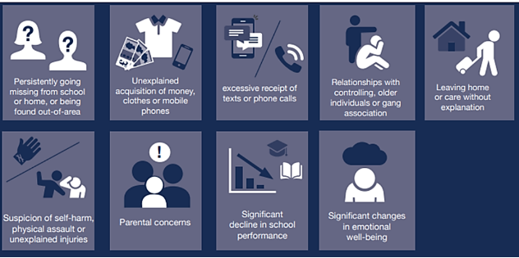

As part of the PPN mentioned before, there are questions to identify these types of changes in behaviour. As you can see these signs are a result of some of the controlling behaviour these serious and organised crime groups are using to control these vulnerable children.

(Crime stoppers UK, 2024) states “as of July 2023, the Children’s Commissioner for England believes that at least 27,000 children are County Lines gang members, with 4,000 in London alone.” This shows how much of a problem this is to the UK and a how many vulnerable children are exploited by this criminal behaviour.

Young female children are also targeted for child sexual exploitation. The (Metropolitan Police, 2024) describe this as “a person under 18 is given something, such as food, accommodation, drugs, alcohol, cigarettes, affection, gifts or money in return for performing sexual activities or having sexual activities performed on them. It can also involve violence, coercion and intimidation, with threats of physical harm or humiliation.” Youths are targeted online and by local gangs, initially with gifts and “love bombing” which then turns into control and then forcible sexual acts for profit going to the Criminals.

One of the most serious cases of child sexual exploitation was in Rotherham 1997 to 2013, known as “Operation Stovewood”. The (national crime agency, 2024) has written a report of this terrible exploitation of young vulnerable females. There were a “recorded 1367 crimes, arrested 209 individuals and nominated 1080 survivors.” Children were inducted and lured into the gang and used for prostitution under a controlling environment.

Overall, serious and organised crime groups look to take advantage of vulnerable adults and vulnerable children for the financial gain through illegal ventures of sex, drugs and crime. This this a significant risk to the victims and to society as a whole. Serious violence comes hand in hand with these operations and puts many people’s lives at risk.

Word Count 1050

Essay five: How effective is early intervention an effective means of preventing young people from offending or re-offending? Your answer must be based on academic research, but you may make reference to relevant case studies. Word limit: 1000 words

Youth offending and re-offending can not only have a huge impact on the community in which the offending takes place, but it can also have a serious impact on the future of the child. It is generally agreed that getting youth offenders early intervention is preferable to criminalising the child. I will now investigate the effectiveness of the early intervention as means of preventing young people from offending or re-offending.

(GOV.UK, 2023) has produced this flow chart showing how children have been dealt with within the criminal justice system. As you can see there is a lot of children being put through the criminal justice system but there will be a huge amount more engaged with early intervention to prevent children getting to this point or re-entering the system.
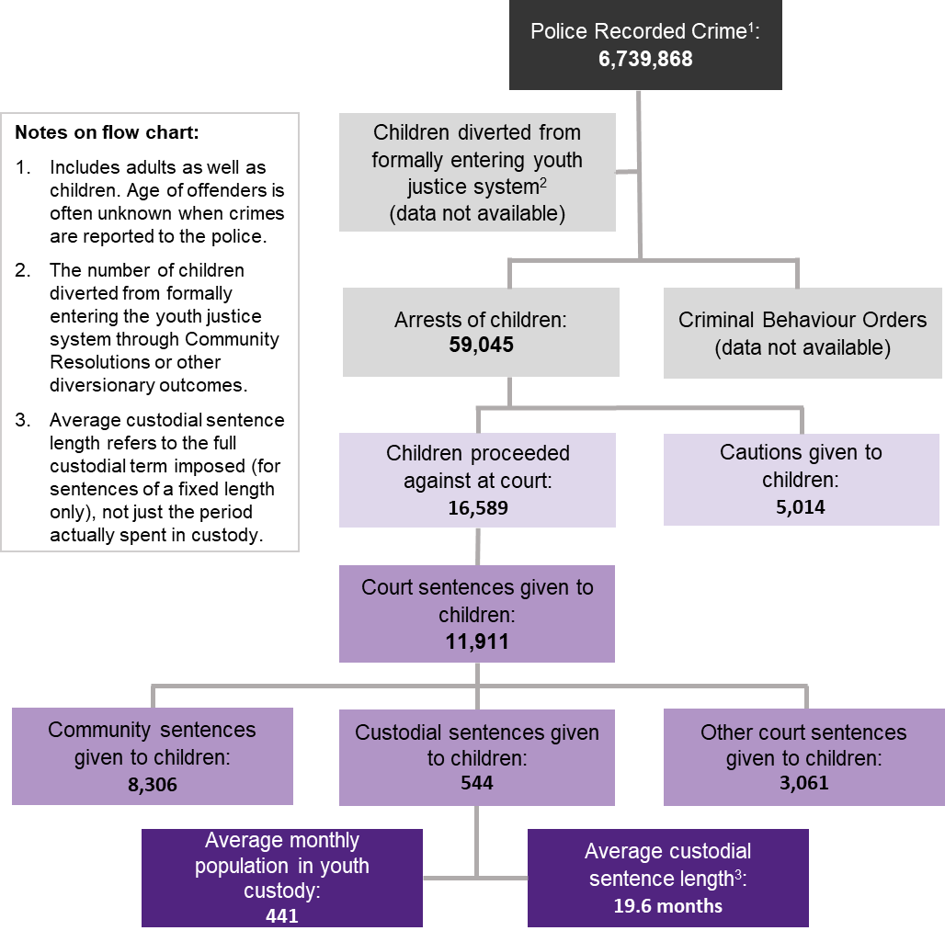

Understanding the reasons for youth offending is vitally important in the early intervention of youth offending. There may be causes for children acting out or getting involved in criminality. A multi-agency generally used assessment on a child’s risk of offending and acting out is Adverse Childhood Experiences (ACE’s). (Young Minds, 2024) states “ACEs are highly stressful and potentially traumatic events or situations that occur during childhood and/or adolescence.” It goes on to state that significant childhood trauma can have a massive impact on a child’s mental health and can contribute to a child acting out and offending in the future. (Young Minds, 2024) give this graphic as some of the childhood trauma that could contribute to negative future affects. The understanding that many children do not have the best start in life allows Police, Schools and other agencies an incite into why a child acts like they do and will then lay out a plan to prevent these areas and deal with childhood trauma before it manifests into offending.

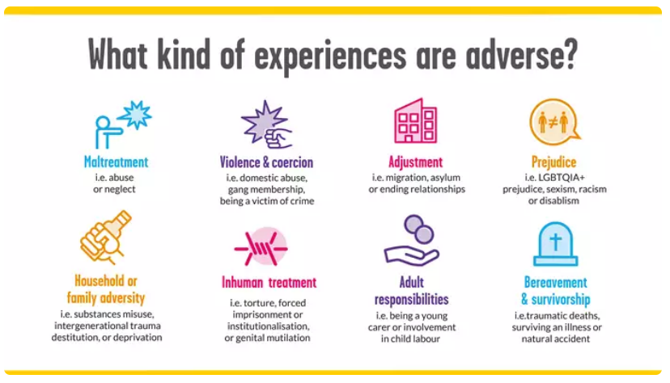

One of the daily tools Officers use for early intervention is the Public Protection Notification (PPN). (HMICFRS, 2023) describes “A PPN is an information-sharing document that records safeguarding concerns about an adult or child. PPNs are shared with partner agencies to inform a multi-agency response.” Officers will utilise this for a “Child at Risk” whenever officers are called to a crime involving a child. This with trigger a multi-agency approach to protecting this child and prevent future issue. Education, social services, child services, health and police will work together to see if further support is necessary and can bring in the parents or carers for the child to set up additional support going forward. The limitations of this are due to demand and amounts of the referrals sent through. Often they will only get involved when the child is already involved with services or deeply embedded in crime. Potentially earlier intervention is better as a preventative before it gets this far.

Officers have the option to refer at risk children to “early help” services. (NHS WALES, 2024) “Early Help Services in Cardiff and the Vale of Glamorgan provide children, young people, families and professionals with information and support on a range of topics that could affect families. This includes family relationships, childcare, parenting, employment, money and housing.” This is often a good option to Officers to refer children to get advice with issues they maybe having, this third-party organisation may be able to help with.

Police School Liaison Officer (SLO) are officers that are based in a specific school or have a few schools. They have a very important role in schools. (Safer Schools Partnership, 2023) state that SLO’s are a “visible and familiar point of contact” that can “advise head teacher(s) and their staff on policing issues”. SLO’s can work as part of a multi-agency approach for case conferences and can work with schools for crime prevention and child welfare concerns. They can gather information and intelligence for crime prevention and most importantly can work with children and provide education, in regards to staying away from crime, ASB, county lines and online safety. This early education could have a significant impact on children before they get in trouble. In addition, if they do take the wrong path and get in trouble SLO’s can work with schools, the family and the child to prevent this from happening again.

Most areas will have a Youth Justice department that will have and Early Support Service. The (Vale of Glamorgan.gov, 2024) discuss their own service and state “Our vision is to support young people to build on their strengths and fulfil their potential by setting out our ambitions to work together to improve the lives of young people, their families, victims, and the community through a restorative approach. Work with young people to build on their strengths, enhance their opportunities, and encourage better decisions through a person-centred approach. Value the importance of young people and remain driven by fairness, inclusion, and equality” They will work with child offenders and victims in a restorative approach to justice. They will work with child offenders to prevent from reoffending. I have referred a youth offender to this service, and it had a very positive impact on the offender and gave the victim closure to the crime they were exposed to. This required the child offender to engage with services and look to rehabilitate them.

Overall, there is a significant problem with youth offending and ASB in today’s world. Using the early intervention strategies I have discussed can have an impact on some youth offending. However, as you can see from the 1st graphic I have shown, the numbers of youth offenders going through the criminal justice system. There is still a lot of children that society are letting get to a level of criminality that could shape their entire life. I would suggest that there is an impact been made on some children but there is still a significant opportunity to affect more youth offenders. Dealing with the causes of offending, education of children and prevention would benefit the child, the family and the community further.

Word Count 988

Bibliography

Cartwright and Roach (2020) WELLBEING OF UK POLICE Available at: https://pure.hud.ac.uk/ws/portalfiles/portal/20475565/Revised_Final_Anon_main_text_29.4.pdf (Accessed: 1st of September 2024).
Children’s Society (2024) What is county lines? Available at: https://www.childrenssociety.org.uk/what-we-do/our-work/child-criminal-exploitation-and-county-lines/what-is-county-lines (Accessed: 1st of September 2024).
Crime stoppers UK (2024) What are County Lines? Available at: https://crimestoppers-uk.org/keeping-safe/community-family/county-lines#:~:text=Once%20someone%20is%20involved%20with,(Source.) (Accessed: 1st of September 2024).
Crisis House (2024) The Effects of Stress and Its Ties to Domestic Violence Available at: https://crisishouse.org/blog/the-effects-of-stress-and-its-ties-to-domestic-violence/ (Accessed: 1st of September 2024).
Exudehc (2022) Police Diversity Training Available at: https://exudehc.com/blog/police-diversity-training/amp/ (Accessed: 1st of September 2024).
FACEBOOK (2024) South Wales Police. Available at: https://www.facebook.com/swpolicebook (Accessed: 1st of September 2024).
GOV.UK (2021) Confidence in the local police. Available at: https://www.ethnicity-facts-figures.service.gov.uk/crime-justice-and-the-law/policing/confidence-in-the-local-police/latest/#:~:text=people%20from%20the%20Asian%20(77,than%20Black%20people%20(64%25) (Accessed: 1st of September 2024).
GOV.UK (2023) County Lines Programme overview Available at: https://www.gov.uk/government/publications/county-lines-programme/county-lines-programme-overview (Accessed: 1st of September 2024).
GOV.UK (2023) Police workforce Available at: https://www.ethnicity-facts-figures.service.gov.uk/workforce-and-business/workforce-diversity/police-workforce/latest/ (Accessed: 1st of September 2024).
GOV.UK (2023) Youth Justice Statistics: 2022 to 2023 Available at: https://www.gov.uk/government/statistics/youth-justice-statistics-2022-to-2023/youth-justice-statistics-2022-to-2023-accessible-version (Accessed: 1st of September 2024).
HM Inspectorate of Probation (2024) Safeguarding – child criminal exploitation Available at: https://www.justiceinspectorates.gov.uk/hmiprobation/research/the-evidence-base-youth-offending-services/specific-types-of-delivery/safeguarding-child-criminal-exploitation/ (Accessed: 1st of September 2024).
HMICFRS (2023) Public protection notice (PPN) Available at: Public protection notice (PPN) - His Majesty’s Inspectorate of Constabulary and Fire & Rescue Services (justiceinspectorates.gov.uk) (Accessed: 1st of September 2024).
IOSH magazine (2023) Workers with poor mental health take more risks and are more likely to be injured at work, stats reveal Available at: https://www.ioshmagazine.com/2023/11/30/workers-poor-mental-health-take-more-risks-and-are-more-likely-be-injured-work-stats (Accessed: 1st of September 2024).
Mental Health Foundation (2024) Better mental health Available at: https://www.mentalhealth.org.uk/explore-mental-health/about-mental-health#:~:text=Having%20good%20mental%20health%20makes,feeling%20good%20all%20the%20time. (Accessed: 1st of September 2024).
Metropolitan Police (2024) Child sexual exploitation Available at: https://www.met.police.uk/advice/advice-and-information/caa/child-abuse/child-sexual-exploitation/ (Accessed: 1st of September 2024).
Mind (2019) Mental Health in the Emergency Services Available at: https://www.mind.org.uk/media-a/4849/2019-survey-police-service-summary.pdf (Accessed: 1st of September 2024).
National crime agency (2024) Operation Stovewood – the NCA’s investigation into child sexual abuse in Rotherham Available at: https://www.nationalcrimeagency.gov.uk/what-we-do/crime-threats/operation-stovewood-rotherham-child-sexual-abuse-investigation (Accessed: 1st of September 2024).
National Library of Medicine (2024) Mental Disorders and Mental Health Promotion in Police Officers Available at: https://www.ncbi.nlm.nih.gov/pmc/articles/PMC10875161/ (Accessed: 1st of September 2024).
National Library of Medicine (2024) The Role of Stress in Alcohol Use, Alcoholism Treatment, and Relapse Available at: https://www.ncbi.nlm.nih.gov/pmc/articles/PMC6760383/ (Accessed: 1st of September 2024).
NHS (2024) High blood pressure Available at: https://www.nhs.uk/conditions/high-blood-pressure/ (Accessed: 1st of September 2024).
NHS WALES (2024) Early Help Services Available at: https://cavuhb.nhs.wales/our-services/children-young-people-family-health-services/cyp-early-intervention-prevention-services/early-help-services/ (Accessed: 1st of September 2024).
NPCC Police UK (2018) NPCC Diversity, Equality & Inclusion Strategy. Available at: https://www.npcc.police.uk/SysSiteAssets/media/downloads/publications/publications-log/2018/npcc-diversity-equality--inclusion-strategy-2018-2025.pdf (Accessed: 1st of September 2024).
NSPCC (2023) Protecting children from county lines Available at: https://learning.nspcc.org.uk/child-abuse-and-neglect/county-lines (Accessed: 1st of September 2024).
ONS (2021) Ethnicity, national identity and religion in the UK and non-UK born population. Available at: https://www.ons.gov.uk/peoplepopulationandcommunity/culturalidentity/ethnicitytistics (Accessed: 1st of September 2024).
ONS (2022) Suicide by occupation, England and Wales, 2011 to 2021 registrations Available at: https://www.ons.gov.uk/peoplepopulationandcommunity/birthsdeathsandmarriages/deaths/adhocs/15043suicidebyoccupationenglandandwales2011to2021registrations (Accessed: 1st of September 2024).
Police Federation (2024) Mental health Available at: https://www.polfed.org/our-work/wellbeing/mental-health/ (Accessed: 1st of September 2024).
Police Federation (2024) Poor pay and treatment pushing officers towards resignation Available at: https://www.polfed.org/news/latest-news/2024/poor-pay-and-treatment-pushing-officers-towards-resignation/#:~:text=%27%20The%20most%20frequently%20cited%20reasons,their%20mental%20health%20and%20wellbeing. (Accessed: 1st of September 2024).
Safer Schools Partnership (2023) The roles within a UK Safer School Partnership Available at: https://www.saferschoolpartnerships.com/article/20/The-roles-within-a-UK-Safer-School-Partnership (Accessed: 1st of September 2024).
Salvation Army (2024) What is Cuckooing Available at: https://www.salvationarmy.org.uk/modern-slavery/cuckooing (Accessed: 1st of September 2024).
South Wales Police (2023) Chief Constable Jeremy Vaughan addresses the National Black Police Association Conference Available at: https://www.south-wales.police.uk/news/south-wales/news/2023/hyd-oct/chief-constable-jeremy-vaughan-addresses-the-national-black-police-association-conference/ (Accessed: 1st of September 2024).
South Wales Police (2024) Our Equality Objectives Available at: https://www.south-wales.police.uk/police-forces/south-wales-police/areas/careers/careers/equality-diversity-and-inclusion-recruitment/our-equality-objectives/ (Accessed: 1st of September 2024).
South Wales Police (2024) Staff Associations Available at: https://www.south-wales.police.uk/police-forces/south-wales-police/areas/careers/careers/equality-diversity-and-inclusion-recruitment/staff-associations/ (Accessed: 1st of September 2024).
The University of Law (2023) Diversity in policing 2023: Do constabularies truly represent the communities they serve? Available at: https://www.law.ac.uk/resources/blog/diversity-in-policing/ (Accessed: 1st of September 2024).
UK Parliament (2023) Police standards and culture: Restoring public trust Available at: https://lordslibrary.parliament.uk/police-standards-and-culture-restoring-public-trust/ (Accessed: 1st of September 2024).
Vale of Glamorgan.gov (2024) Youth Justice and Early Support Service Available at: https://www.valeofglamorgan.gov.uk/en/living/social_care/children_and_young_people/Youth-Justice-and-early-support-service.aspx (Accessed: 1st of September 2024).
Young Minds (2024) Understanding trauma and adversity Available at: https://www.youngminds.org.uk/professional/resources/understanding-trauma-and-adversity/ (Accessed: 1st of September 2024).

