

Elliot Shaw - 1705678
Energy in a flywheel
Introduction
The aim of our group experiment was to as accurately as possible prove the theory for energy in a flywheel using an ES9 kit. A flywheel is a mechanical device which stores energy in the form of rotational momentum. The flywheel consists of a heavy circular disc/massive wheel fitted with a strong axle projecting on either side. By Attaching a length of cord and an assortment of weights, it is possible to conduct the following experiment demonstrating both the potential and the kinetic energy in a flywheel and to discover the difference between potential and kinetic energy and the transfer of energy from one form to another.
Experimental procedure

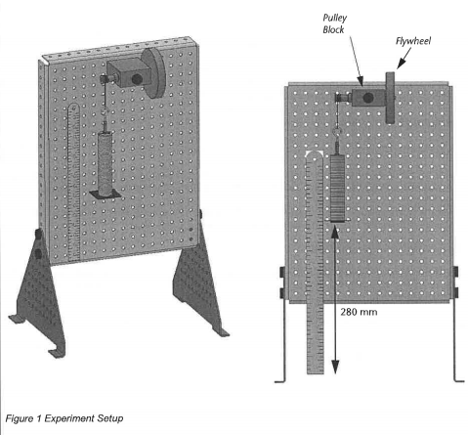
- Assemble the ES9 kit, starting with the work panel.

- Fix the flywheel and the bearing block to the work panel using the holes in the panel.

- Attach the plastic guide to the bottom of the weight hanger.

- Measure the cord from the bottom of the weight hanger to 290mm.

- Line magnetic ruler against the magnetic work panel measuring 280mm.

- Add 9 of the 10g metal weights to the weight hanger to achieve a total of 100g in mass.

- Wind the flywheel slowly, lifting the weights, lining up with the 280mm line on the ruler.

- Use the stopwatch provided to accurately measure how many seconds it takes the stack of weights to go from 280mm down to 0 and then back up to its maximum height.

- Repeat the process multiple times to achieve the most accurate average possible.

Results
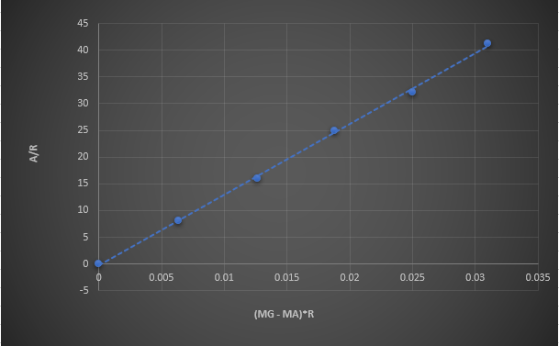

Graph of the angular acceleration (a/r) in relation to the Torque generated (mg – ma)*r
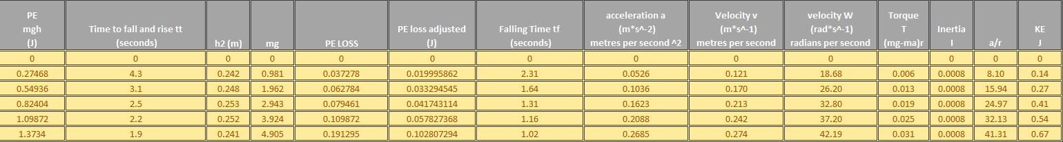
Using the data we
Results
Table of data:

- The height values for each individual weight.

- Potential energy

- Falling time of the weights

- Inertia

- The loss in Potential energy

- Torque ( mg – ma) r

- Linear and angular velocity

- Linear and angular acceleration

- Kinetic Energy

Using the data collected from our experiment we had to then calculate the potential energy, the potential energy lost during the experiment and mg value (mass x gravity). Other values calculated are the falling time of the weights, the acceleration and velocity, the Force achieved and the (a/r) values.
Once the values for inertia (I) had been worked out its then possible to calculate the kinetic energy for the flywheel for each of the different weights from the experiment.

Analysis
When delegating roles in a group its important we make sure everyone had a role to guarantee everybody would focus and the task at hand seriously.
I chose to take note of each height the weights hit when then rebounded back up the 280mm ruler. Each time the weights were dropped the height varied so we took the most accurate average we could for both the time it took to complete the cycle and for the height.
Every 4th attempt we increased the weight by 100g, adding ten 10g weights each time till we had sufficient data for the table to be able to work out accurate values.
With the height values its possible to work out the potential energy values for each weight. We do this using the following formula:
(Mass x Gravity x Height).
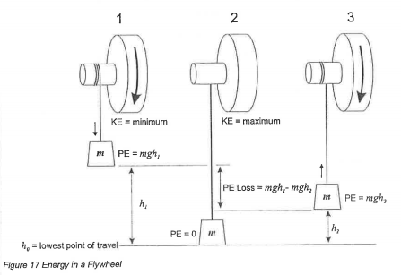
The unit for Potential energy (PE) is expressed in Joules (J) as does Kinetic Energy. After having worked out the potential energy values for both sets of heights its then possible to work out the potential energy lost by deducting them as follows:
(mgh1 – mgh2)
After converting the height into metres from millimetres it can be divide by itself plus the added sum of the rebounded height. If the answer is then multiplied by the total time it took to complete the cycle this will give you the total falling time it took for the weights to hit 0mm.
If the falling times are square rooted and then divided by the total height the value we get is the linear acceleration of the weights measured in metres per second squared.
(H1/tf^2)

Since this value is in metres its important to check the total height value is in metres beforehand. With this value you simply multiply it by Falling time value and u get the velocity which the weights fall at.
To eventually work out the kinetic energy for each weight we must work out the angular velocity. The angular velocity of the flywheel is calculated by multiplying 2 PI by the answer of dividing the linear velocity value by the circumference of the flywheel. What we have now is the angular velocity, measured in radians per second, meaning the speed in which the flywheel is turning as its acted upon by the falling weights.
With a turning force being applied to turn the flywheel its creating a large amount of Torque to start the motion. Torque is an angular turning effect of force, often spoken about in the motorsport industry the biggest example of the effect of torque would be in the Mercedes SLS.
The SLS has almost identical horsepower to a Ferrari 458, however due to the extra torque its engine creates, the force spinning the tires is greater therefore destroying its tires at a much faster rate.
To calculate Torque (T) you use the potential energy, linear acceleration values worked out previously and multiply your answer by the radius value provided for the flywheel using the following formula:
(mg-ma) x r
When the Torque (T) has been calculated its then possible to calculate Inertia. Inertia is a property of matter which will stay stationary or at rest, until acted upon by an external force. In the case of this experiment Inertia happens as soon as the weights are released causing the flywheel to turn even with other forces adding friction to counter this act of motion. It is also an indicator of the amount of torque that will be needed accelerate the body of the flywheel in its rotation. Just as the mass is a measure of resistance of linear acceleration, a moment of inertia is a measure of resistance to angular acceleration.
To calculate Inertia (I) one simply divides the values for torque by the angular acceleration. To find the values for angular acceleration, you take the linear acceleration values worked out previously and divide them by the radius value provided. There are obviously friction forces between the various moving parts in the setup, however these forces were not taken into consideration when calculating the values of Inertia.

Finally, with all the values worked out in the table we have to calculate the kinetic energy value for each of the set of weights. Commonly known as Rotational KE, any object has kinetic energy when its moving, this movement can be the displacement of the objects centre of mass, It can also be the object spinning on its self. An object that rolls without slipping will have some fraction of their energy as rotational kinetic energy and the ratio depends on the moment of Inertia of the object. The formula used for calculating the Kinetic energy in the flywheel experiment was the following:
½ x (I x ω^2)
Kinetic energy is equal to work that must be done on the object to bring it up to velocity, thus being a measure of the flywheels capacity to do work.
Evaluation
During the experiment, our group were very professional with accurate readings and data the only time we struggled was during one of the attempts the weights started to sway and make contact with the work panel, meaning our height readings were off.
To make sure we got accurate readings we had to wait till weights and stop moving completely to stop any sway and after several extra attempts we did get consistent accurate readings. It was interesting to see the how conflicting factors augmented with the increase in weight. The final 500g of weight required a few extra attempts to get right due to this.
Due to the extra attempts where the sway conflicted with the results you can see in the graph below where both times it affected the results, showing the later calculations were affected in a way even though an average was taken.
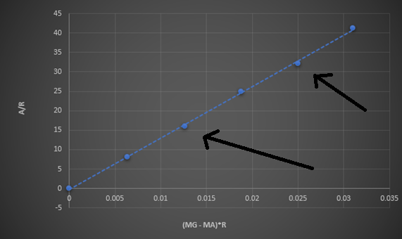
I noticed also that after a few attempts the timing was a millisecond or so off so we re-attempted the first few again and wrote them off as practice attempts.
It was to my surprise that during all the tests the cord maintained its integrity even at the higher weights as it had indeed snapped for other groups. This shows the force of the weights hitting bottom dead centre (BDC) is substantial.
If the process could be simulated on a computer, then the whole process could be done by a single individual then it would eliminate human error since getting 4 to 5 individuals to act in sync for a reasonable amount of time will always lead to inaccuracies therefore a simulated experiment will always provide the most accurate answers.
The motion of the mass that was attached to the spring could have been affected by factors such as the air resistance in the room and the friction which would lead to easy energy loss during experiment, which in turn, would lead to further inaccuracies in final values.
A way around this problem could have been avoided by doing the experiment in a closed system, which not only would have minimised errors, but also increased the accuracy and reliability of the results.

Conclusion
With reference to the results mentioned prior, it is proved that the moving parts of a flywheel have consistent energy both kinetic and potential. A direct link between the mass, velocity and the kinetic energy is also found in the experiment: Whilst the mass of speed of the moving object increases, the kinetic energy increases as well – likewise, when the velocity does decrease, the kinetic energy it could obtain decreases.

Furthermore, it is also found that the kinetic energy in the flywheel is equal to half the product of its moment of inertia and its regular velocity squared.
I would say the group experiment was a success, our results from the experiment allowed us to go away and complete the work. The work made sense, the calculations were accurate and methodical and overall I feel like I can take something away from the assignment.
Working out each table correctly with accurate collected data it was well represented in my graph, with a clean straight gradient with the only 2 slight imperfections coming from the extra attempts due to the sway mentioned earlier.
References & bibliography
1 - Graph – Taken from my excel document
2 - Data table – Taken from my excel document

3 - Image of Energy in a flywheel – Engineering science M4X00385 - Assignment brief

4 - https://www.tecquipment.com/potential-kinetic-energy-kit

5 - https://vlab.amrita.edu/?sub=1&brch=74&sim=1517&cnt=1 – Virtual Amrita laboratories Universalizing Education – Torque And angular acceleration of a flywheel

