THE IMPACT OF EMPLOYEE ENGAGEMENT AND MOTIVATION ON ORGANIZATION PERFORMANCE IN THE UK

STUDENT NAME: Krisztina Pocsik
STUDENT ID: 2115263

Table of Contents
Introduction 2
1.1 Significant of the research 3
Research Purpose 3
1.2Aim, Objective, and Research Questions 3
Chapter 2: Literature Review 4
2.1 Models and theories of motivation 4
2.2 Factors affecting employee engagement and motivation in hospitality industry 5
2.3 The relationship between employee engagement, motivation, and organizational performance 5
Chapter 3: Research Methodology 6
3.1 Research Philosophy 7
3.2 Research Paradigm 7
3.3 Research Approach 8
3.4 Research Methodology 8
3.5 Research Strategy 8
3.6 Research Sampling Method 8
3.7 Data collection method 9
3.8 Ways of Interpreting Data 9
Chapter 4: Conclusion 10
Chapter 5: Reference 11

Introduction

1.1 Significant of the research
This proposal explores the critical relationship between employee engagement and motivation in organizational performance in UK based companies. As the UK economy evolves global competition and technological advances, understanding the dynamics of employee engagement has become critical for an organization. The hospitality industry relies heavily on human capital, making it imperative to optimize employee performance for sustained success (CIPD, 2024). Globalization has resulted in a progressively diverse workforce and expanding complexity of the social dynamics within organizations (CIPD, 2019). Hospitality stands as one of the largest revenues for the UK, however that industry faces some ongoing challenges like high turnover, low employee engagement and motivation, variable consumer demands, and the impact of external factors like economic or global crises (Workbuzz, 2024). Turnover is considered critical challenge of human resources management and is vital to meeting an organization’s needs. It can be considered that the phenomenon of accidental managers, by promoted into managerial roles without proper training, is prevalent in the hospitality industry (Herbert, 2023).

Research Purpose
The purpose of this research is to examine the relationship between employee engagement, motivation, and organizational performance within the UK. To exploring how these factors involve and the study aims to identify key elements of productivity and success which employee engagement and motivation contribute to organizational success. Organizations how can enhance their performance through effective engagement and motivation strategies. Employing surveys, interviews, and possibly case studies within UK organizations will provide insights into strategies for engagement and motivation.

1.2Aim, Objective, and Research Questions
Aim:
The aim of this research proposal is to investigate the impact of employee engagement and motivation on organizational performance in the hospitality of UK based industry. By understanding the impact of the relationship between employee engagement, motivation and organizational performance the goal is to provide insights on effective strategies for enhancing productivity, innovation and success in the workplace.
Objectives:
- Explore the concept of employee engagement and motivation for organizational performance.
- To analyse the relationship between employee engagement, motivation and key performance as productivity and employee satisfaction.
- To identify strategies that influence employee engagement and motivation within UK organisations.
- Provide recommendations for organizations in the UK to improve employee engagement and motivation.
Research Questions:

- RQ1: What is the current level of employee engagement and motivation within the UK hospitality?
- RQ2: What factors contribute to employee engagement and motivation?
- RQ3: How does employee engagement connect with customer satisfaction and productivity?
- RQ4: What are the most effective strategies for enhancing employee engagement?

Chapter 2: Literature Review

2.1 Models and theories of motivation
Employee engagement is a critical measure of organizational health and productivity. Employee engagement refers to the emotional commitment and involvement employees have towards their work, organization and goals. Motivation is the internal impulse, behaviour to achieving goals, influenced by needs and desires (CIPD,2024). Together, they are a positive work environment. Hospitality performance culture has been playing a significant role in employee engagement. Cross-cultural effectiveness can be developed based on the context of cultural competencies (CQ) by applying self-efficacy theory and Hofstede's cultural dimensions. Cultural competencies are valuable for navigating diversity, their effectiveness depends on ongoing learning, self-awareness, and adaptation to evolving cultural dynamics. Organizations must critically evaluate and integrate cultural competencies into their practices to ensure meaningful and fair interactions across cultures (Meira Jessica Vieira de Souza, 2023). Therefore, it can be observed that Cultural values and behaviors by understanding through the Hofstede's dimensions, like individualism-collectivism and power distance (Garamvölgyi, and Rudnák, 2023). Individuals can develop their interactions with diverse cultural groups by recognizing these dimensions by changing their communication leadership styles. Maslow's Hierarchy of Needs can guide employee motivation and satisfaction. Addressing basic physiological needs like fair pay and a safe environment ensures stability. Providing opportunities for social connections and recognition fulfills the need for belonging. Encouraging personal growth and career advancement satisfies needs. Fostering a sense of purpose and meaningful work aligns with self-actualization, driving overall employee well-being and productivity (CIPD, 2021). The 5 levels of Maslow’s needs: Physiological needs, Safety, Love and belonging, Esteem, and Self-actualization. Herzberg’s two-factor theory is hygiene factors and motivators. Hygiene factors, such as salary, working conditions, and company policies, prevent dissatisfaction when adequate but don't necessarily lead to satisfaction when improved. Motivational factors, including recognition, responsibility, and opportunities for growth, directly contribute to job satisfaction and motivation (CIPD,2021).

2.2 Factors affecting employee engagement and motivation in hospitality industry
Understanding the factors that motivate employees is essential for a positive work environment and maximizing organizational performance. Motivated employees are more likely to be productive, engaged, and committed to achieving company goals. However, can have both advantages and disadvantages within an organization. By analysing these factors an organization’s can lead a sustainable success.
Advantages:
- Recognition and rewards: It can be offering rewards, bonuses, and recognizing outstanding performance can motivate employees to excel in their roles and contributing positively to organizational goals.
- Innovation and Creativity: Motivated employees are more likely to contribute new ideas and innovative solutions, driving continuous improvement and adaptation within the organization (Subramaniam, 2019).
Disadvantages:
- Inequity Treatment: It can be recognition as rewards that are perceived as unfair or certain employees receive preferential treatment, which can lead to demotivation by reducing morale among employees.
- Lack of career advancement opportunities: Limited opportunities based on growth as well as advancement among organizations may result in reduced motivation as well as improved turnover (De Winnnie Sophie, 2019).
- Potential for Burnout: Overemphasis on employee motivation can lead to excessive workloads and stress, increasing the risk of burnout among employees. Unrealistic expectations setting overly ambitious goals or expectations to motivate employees can lead to frustration if they are unattainable or unrealistic.
Through integrating self-efficacy theory with Hofstede's cultural dimensions, based on the people by culturally competent by addressing cultural differences, changing the way they behave, believing that they can successfully by negotiate cross-cultural situations (Jadil et al. 2023). It can be develop overall cross-cultural communication and collaboration within diverse, as teams and organizations while fostering inclusivity as well as collaboration.

2.3 The relationship between employee engagement, motivation, and organizational performance
The relationship between employee engagement, motivation an organizational performance metrics has been playing an understanding of the overall effectiveness and success of the organization. Therefore, it can engage based on motivating employees by demonstrating higher levels of productivity, quality of service, and innovation, by providing a direct impact on key performance metrics like revenue, customer satisfaction, and employee rates (Modak, and Chaudhuri, 2023).
- High turnover rates: In the hospitality industry, turnover rates can be particularly high, based on the operations and developing costs associated with recruitment.
- Workforce diversity: It can be maintained a diverse workforce based on backgrounds, experiences, as well as motivations can pose challenges in effectively engaging as well as motivating employees.

One gap in the literature concerning employee engagement and motivation, particularly regarding organizational performance. Additionally, there might be a gap in understanding the role of factors such as generational differences, diversity and inclusion practices, and regional disparities could significantly influence the effectiveness of engagement initiatives and their impact on organizational outcomes. Lastly, there could be a gap in exploring the potential downside of overly simple approaches to fostering employee engagement and motivation, such as relying solely on financial incentives or generic one-size-fits-all programs (CIPD, 2024).
While existing research acknowledges the link between engagement, motivation, and organizational performance, there's a need for more in-depth exploration. Furthermore, qualitative research methods such as interviews or focus groups could be employed to gain insights into employees' experiences, perceptions, and decision-making processes related to organizational performance, providing a deeper understanding of the role played by engagement and motivation in shaping organizational performance intentions and behaviors.

Chapter 3: Research Methodology
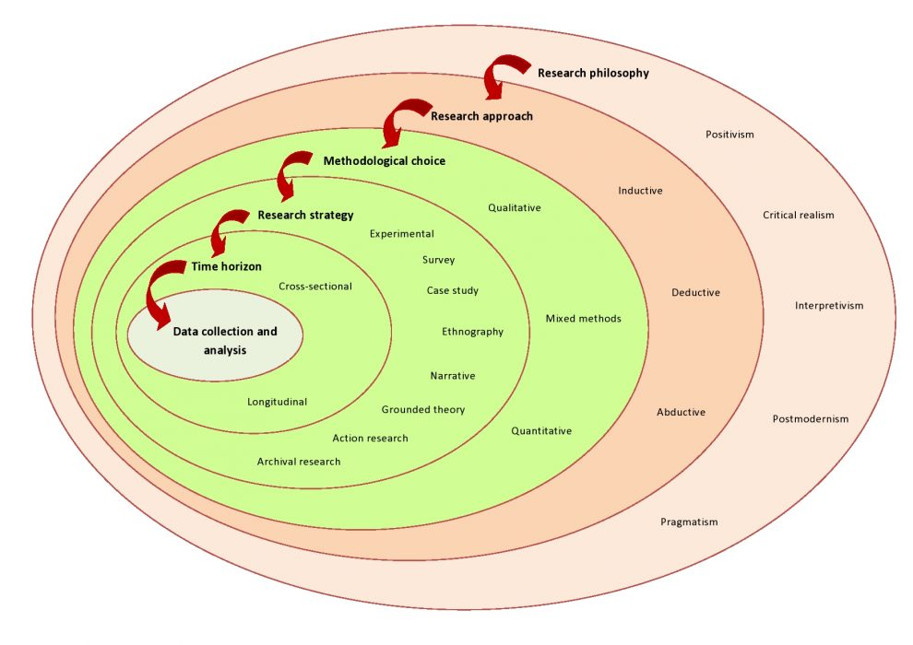
(Source: Aesanetwork.org, 2024)

The research process as an onion with multiple layers, the research onion model helps researchers understand the complexity of research and make informed decisions at each stage of the process (Aesanetwork.org, 2024).

3.1 Research Philosophy
Ontology in philosophy provides a framework for understanding the essence of being, which can deepen insights into the motivations and existential aspects underlying employee engagement and motivation. It can be considered that methodical examination of the data available by supporting as recommendations and evidence-based insights (Saunders, 2019). Adopting an ontology reflection on my own beliefs, biases, and perspectives. This is essential for conducting strict and ethical research, as it helps acknowledge and mitigate potential sources of bias that could influence findings. By addressing ontological questions, I can ensure alignment between of understanding of reality and the methods to generate knowledge.

3.2 Research Paradigm
The positivism has been the research paradigm for this study, by understanding subjectivity of employee perceptions with recognising the objective reality by organisational performance metrics (Sanders, 2019). By collecting data from a diverse sample of organizations across the UK, I can generate insights that apply broadly to the wider population of organizations in similar contexts. This approach allows to draw meaningful conclusions based on evidence.

3.3 Research Approach
The research approach for this secondary research will be deductive, depends on existing theories as well as hypotheses derived from literature by evaluating applicability to organization. This approach has been focused on systematic analysis by drawing meaningful with practical recommendations. Deductive research involves testing a specific hypothesis or theory by collecting and analysing data to confirm or rejection (Sanders, 2019). By starting with well-defined hypotheses from existing theory and evidence, I establish a clear framework for this study and ensure research questions are tightly aligned with research objectives.

3.4 Research Methodology
It can be stated that extensive literature review, organisational documents, industry reports, and previously published academic papers will be research methodology for this study. It aims to critically evaluate the existing knowledge, identify gaps, with survey questionnaire, sampling, data collection and analysis and provide a comprehensive understanding of the subject matter (Sanders, 2019). Quantitative methods offer systematic and objective approaches to collecting, analysing, and interpreting numerical data, enabling rigorous testing of hypotheses, identification of patterns, and generalization of findings.

3.5 Research Strategy
The research strategy for this research has been depends on descriptive research which aims to describe characteristics, behaviours, providing of the current state without manipulating variables. structured approach by collecting based on the way of synthesizing existing literature on employee engagement by motivating the organization. Therefore, it can be focused on the retrieval of relevant information with evidence-based insights by recommending to organization's improvement (Sanders, 2019).

3.6 Research Sampling Method
The sampling method has been purposive sampling, based on the employee engagement and motivation based on the hospitality industry, particularly based on the organization. This method has been collaborating with Convenience sampling, which is a nonprobability sampling method where participants are selected based on their availability and accessibility to the researcher. Examples include surveying individuals who happen to be nearby or easily accessible through existing networks or online platforms. This method ensures that the sample represents the diversity within the population (Sanders, 2019).

3.7 Data collection method
The data collection method has been focused on surveys allow to gather quantitative data from a large number of participants efficiently. Design survey questions to measure various aspects of employee engagement and motivation, such as their perceptions of job satisfaction, organizational commitment, and motivation (Sanders, 2019).

3.8 Ways of Interpreting Data
By examining the extent to which variations in employee engagement and motivation changes in organizational outcomes, regression analysis allows to identify key drivers of success within hospitality industry. Through this statistical technique, we can uncover actionable insights into how enhancing employee engagement and motivation levels can positively impact the overall performance and success of hospitality industry. It can be building that the research topic by understanding for providing evidence-based insights as recommendations (Sanders,2019).

3.9 Timetable

 | week1 | week2 | week3 | week4 | week5 | week6 | week7 | week8 | week9 | week10
Identify Research Area
Formulate Research Questions
Research Strategy and Methods
Write Research Proposal
Negotiate Access
Literature Review
Date collection
Date Analysis
Recommendations
Dissertation Date

3.10 Ethical Consideration
The ethical aspects of this research include protecting intellectual property rights, making sure that sources are properly cited and attributed, and keeping any sensitive data that was obtained from organisational documents private. This guarantees honesty and openness in the study process (Sanders,2019).

Chapter 4: Conclusion
This research proposal has been focused on approach to addressing the impact of employee engagement by providing motivation on organizational performance based on the organization in the UK. Therefore, it can be stated that research methods, by including a literature review and analysis, aim to achieve insights into the factors by providing influence regarding employee engagement and motivation. It can address the challenges faced by the organization and propose strategies for improvement. Moreover, it can be implementing a positivism paradigm as a deductive research approach, systematically analysing existing literature to draw meaningful practical recommendations. After that, it can be observed that through thematic content analysis, has been covering recurring employee engagement and motivation informing evidence-based insights with the organizational.
On the other hand, UK has been growing performance, retaining a competitive edge in the hospitality sector, by developing employee satisfaction by collaborating with the employee engagement model and identifying issues such as workforce diversity and turnover. This study has the potential to advance the field's understanding and assist to building an environment at work by supportive organizational to success.

Chapter 5: Reference
Aesanetwork.org. (2024, 4 11). Retrieved from Blog 132-Research Onion: A Systematic Approach to Designing Research Methodology: https://www.aesanetwork.org/research-onion-a-systematic-approach-to-designing-research-methodology/
CIPD. (2019). Building Inclusive Workplace.
CIPD. (2024, 4 12). Retrieved from Employee engagement and motivation: https://www.cipd.org/uk/knowledge/factsheets/engagement-factsheet/#how-engaged-are-uk-employees
CIPD. (2021). Work motivation: an evidence review
De Winnnie Sophie, M. E. (2019). The impact of employee turnover and turnover volatility on labor productivity: a flexible non-linear approach. p.,3-18.
Garamvölgyi, J. and Rudnák, I., 2023. Exploring the Relationship between Cultural Intelligence (CQ) and Management Competencies (MC). Sustainability, 15(7), p.5735.
Gordon, D., Blundell, C., Mills, R. and Bourke, T., 2023. Teacher self-efficacy and reform: A systematic literature review. The Australian Educational Researcher, 50(3), pp.801-821.
Herbert, J. C. (2023). An Examination of the Roles of Cultural Intelligence and Work Engagement in Predicting Faculty Turnover Intention. p.9-12, p.22-66.
Jadil, Y., Jeyaraj, A., Dwivedi, Y.K., Rana, N.P. and Sarker, P., 2023. A meta-analysis of the factors associated with s-commerce intention: Hofstede's cultural dimensions as moderators. Internet Research, 33(6), pp.2013-2057.
Mark Saunders, P. L. (2019). Research Methods for Business Students eight edition. Pearson Education, Limited.
Meira Jessica Vieira de Souza, H. M. (2023). Human resources #practices and employee motivation in the hopitality industry: A cross- cultural research.
Modak, A. and Chaudhuri, T.D., 2023. Organisational culture, revealed innovation advantage and growth-a framework of analysis. International Journal of Management and Enterprise Development, 22(2), pp.110-138.
Subramaniam, S. S. (2019). Cultural intellingence and work engagement of expatriate academics: The role of psychological needs satisfaction. p.7-26.

