Appendix 1 - Focus Interview write up for School A
- What did you think of the starter activity?
Child 1 – Oh I loved the game, it was so fun that you loop it around. I think we should do that in our classroom.
Child 3 – Yeah I really enjoyed it, it was fun.
Child 2 – I got a bit confused at the beginning because I thought the answer was written on it but it wasn’t it was for someone else.
- Did you find it easy or difficult?
Child 1 – I found it difficult and easy at the same time.
Child 2 – yeah some of the questions were really hard and I got confused at the beginning about the big number but then I got it.
Child 3 – It was like kind of easy and kind of hard because like we had to do it like in our heads, find the answer in our heads
Child 1 – and it was really hard to not shout out the answer to all the questions.
- Do you like doing independent activities or do you prefer working with others?
Child 1 – I like working in groups
Child 3 – I like working on my own sometimes (others agree) sometimes it’s a little bit easier
Child 2 – yeah, working with friends makes it easier.
Child 1 – yeah it depends how I’m feeling.
- Did you lose concentration at all during either the starter or the lesson afterwards? If so, why?
Child 1 – yes definitely yes. Not in the game, that was really fun and you had to work the answers out in your brain but when we were doing the worksheets my friends were trying to chat to me so I wasn’t concentrating as much as I normally would I think.
Child 2 – yeah [another child] kept talking
Child 1 - yeah he was pretty distracting.
- Did the starter make you feel excited about the lesson?
Child 1 - Yes it gets your body ready to do some maths doing it. Maybe I would ask [Class teacher] if we can do that before every maths lesson. We could do it before every lesson and call it the ‘before maths game’.
Child 2 – Yeah it was really fun
Child 3 – Yeah you had to think in your head so it was easier when you had paper so it was good.
- Could you tell me one positive thing and one negative thing about the starter?
Positive: Child 1 - A good thing is the looping, i really liked that. And I like that it’s not just the answers written on the bottom which is what I thought it was at first.
Child 3 – When we was playing the first maths game, it was a little bit easy and a little bit hard because when I was looking at the cards and I thought the answer was at the bottom because you told us what we was doing with them and I thought it was going to be really easy but it made my mind get a little bit trickier because they’re not the same answer, you have to find the answer.
Child 1 – I’ll call it the ‘Get ready maths game’
Child 2 –I liked the loop
Child 1 – yeah we just can’t stop talking about that loop, it is just really really interesting.
Negative: Child 2 – because you can’t shout it out if you don’t have the card.
Child 3 – yeah same as [Child 2]
Child 1 – Yeah the temptation to scream out the answer when you’re not supposed to.
- If we were going to do this lesson again, what do you think we could do differently?
Child 1 – We could do a team
Child 2 – Girls versus boys.
Child 3 – or maybe in partners
Child 1 – yeah partners that would be good. We could have like 10 partners and we all do it.

Appendix 2 – Focus interview write up for School B
- What did you think of the starter activity?
Child 3 – “good because it can help people learn lots of maths, people can call out maths things in pairs”.
Child 1 – it was good because everyone got a chance to ask and answer a question.
Child 2 – “I thought when you were saying the questions it was good because we all got a chance to say the answers and we all got a chance to say the questions and it also included teamwork and it helps you with your maths and now you know new sums”.
- Did you find it easy or difficult?
Child 3 – “kind of easy!” – agreed with child 2.
Child 2 – “50/50 because some of the sums are easy and some of the sums are hard”.
Child 1 – Easy “I just need harder sums because I’m good maths, they were really easy”.
- Do you like doing independent activities or do you prefer working with others?
Child 3 – “I liked doing it in teams because it’s entertaining and it can help everyone learn instead of just you” Thinks it would have been harder on your own “because you wouldn’t have anyone to help you
Child 1 – “no I liked doing it on my own because I like being independent”.
Child 2 – “I liked to be in a partner because if you have a partner and you’re stuck on a question they can help you”
- Did you lose concentration when we were doing the starter? If so, why?
Child 1 – “I didn’t lose concentration”
Child 3 – “no”
Child 2 agreed with child 1 and 2.
- Did the starter make you feel excited about the lesson?
Child 3 – “yeah I was excited because the maths game made me really happy”.
Child 1 - “yes because I like maths!”
Child 2 – “yeah, first because we were doing maths and second we were playing a game so it’s the same”.
- Could you tell me one positive thing, and one negative thing, about the starter?
Good things
Child 3 – “it helps people with education”
Child 1 – “it helps people with maths” – it helps people to practice their mental maths skills.
Child 2 – “It helps with teamwork in maths. We got to help each other”
Child 3 – “we got to spend time with our friends”.
Child 1 – “we could be independent”.
Bad things
Child 3 – “nope!”.
Child 1 – “no”.
Child 2 – “The bit when I couldn’t do the sums, they were hard”.
- If we were going to do the starter again, what do you think we could do differently?
Child 1 – “could do harder sums because that’s what I want”.
Child 2 – “if we did it in groups we could have different sums. This group could have hard sums, that group could have easier sums”.
Child 3 – “we could play like a bingo thing where we shout out the number and we look on our cards and shout out the number”.
Child 2 – “id like it if we could have a few cards instead of one”.

Appendix 3: Lesson plan for Lessons study 1 in School A.
 |  |  |  |  |  |  |  |  |  |  | 1B

Session Plan – Key Stage 2
Name of trainee: |  | Caitlin McGiveron |  |  |  | Session ref: |  |  | 200219
Personal target(s) in relation to QTS: AFL Strategies.
Year group: | 4 |  | No. of learners: |  | 6 |  | ALN:
Additional Adults: |  |  | 1
Learning objective(s): To continue work on understanding division, moving away from practical division. |  |  |  |  |  |  | Success criteria: Use the method that best suits their learning to gain a correct answer.
Links to previous learning: Continuation from concrete division lesson previously.
Curriculum coverage (range, skills): Mathematics/Numeracy - Division

Literacy(LNF): |  |  |  |  |  | Numeracy (LNF): transfer mathematical skills to a variety of contexts and everyday situations
DCF: |  |  | Thinking |  |  | ESDGC |  |  |  | YCC
Key vocabulary(English/Welsh):
Welsh numbers.
Da iawn.

Time | Session activities, organisation and management | Key questions & Assessment for Learning opportunities
10 minutes | Introduction:  TF - Loop card game – using mental maths to solve different addition and subtraction sums. | How many are we sharing it between?  What is a different way of asking this?  Their level of understanding will be assessed by correct answers.
30 minutes | Main activities:  TF – Practical division using blocks  Completing division/ multiplication worksheets in any method that they find easiest (sharing, column, bus stop etc.).
30 minutes | Plenary: Continuous plenary throughout lesson and going through the answers to the worksheet once they are finished.

Appendix 4: Lesson plan for second Lesson Study in School B.
 |  |  |  |  |  |  |  |  |  |  |  | 1B

Session Plan – Key Stage 2
Name of trainee: |  | Rachel O’Sullivan |  |  |  |  |  | Session ref: |  | 21/02/19
Personal target(s) in relation to QTS: |  |  |  |  | Ensure Steps for Success are clearly noted in lesson plans.  During mini plenaries, allow pupils an opportunity to assess their own achievement in meeting the steps for success
Year group: | 3/4 |  | No. of learners: 8 |  |  | ALN: Differentiated worksheets
Additional Adults: 1
Learning objective(s): To understand regular and irregular shapes. |  |  |  |  |  |  | Success criteria:  - I can explain the difference between a regular and an irregular shape.  - I can draw an irregular polygon.
Links to previous learning: Links to previous lesson on 2D shapes and their properties.
Curriculum coverage (range, skills)
Mathematics – geometry skills and number skills.
Literacy (LNF) |  |  |  |  |  |  |  | Numeracy (LNF)  N/A as it is a mathematics lesson.
DCF  The children will be introduced to the topic through the use of an interactive PowerPoint. |  |  | Thinking  Children will have to make decisions based on the shape they are shown, or on the information they are given. They will have to think back to the previous lesson and use this knowledge to support them throughout the task. |  |  |  |  | ESDGC |  |  | YCC  Children will be encouraged to count in Welsh – I’ll be giving dojos if I hear them using Welsh during the lesson.
Key vocabulary(English/Welsh): regular, irregular, polygons, quadrilaterals.

Time | Session activities, organisation and management | Key questions & Assessment for Learning opportunities
20 mins | Introduction  This lesson will be done with a group of 8 children.
20 mins | Starter – addition loop cards for mental warm up. Children will complete this activity in pairs. Each pair will be given a card, they must call out the answer if it is on their card and then read the question that they have. If a child is absent, then one child will work alone.  Introduce the lesson – recap previous lesson on 2D shapes. Get them to call out the names of shapes.  Explain that polygons can be regular or irregular. Draw an example of each on the board – ask what’s different about the shapes? Can they work out what an irregular shape might be?  Draw some examples of irregular shapes on the board. |  | Questioning – how many sides does an octagon have? How do we remember this? What is a 5-sided shape called?
25 mins | Main activities  Children are to complete the worksheets on regular and irregular polygons.  Differentiated  Group 1 – sort irregular polygons and quadrilaterals into a Carroll diagram.  Group 2 – answer questions on polygons and draw an irregular polygon.  Groups 3 and 4 – same as group 2 but they will be given an image of a regular polygon before they draw their irregular one. |  | Stop the children during the lesson and link back to steps for success. Show examples of children meeting these steps.
10 mins | Plenary |  | Questioning  Thumbs up, thumbs down.
10 mins | What have we learnt today?  How did it link to Monday’s lesson?  Have a look at the steps for success, what do you think you got better at this lesson?

Appendix 5: Observation Schedule for School A.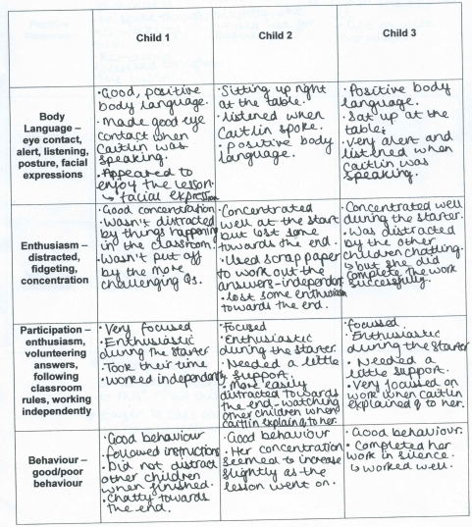
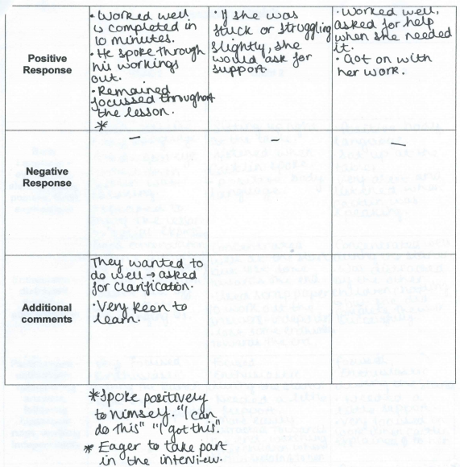
Appendix 5 continued.

Appendix 6: Observation Schedule for School B.
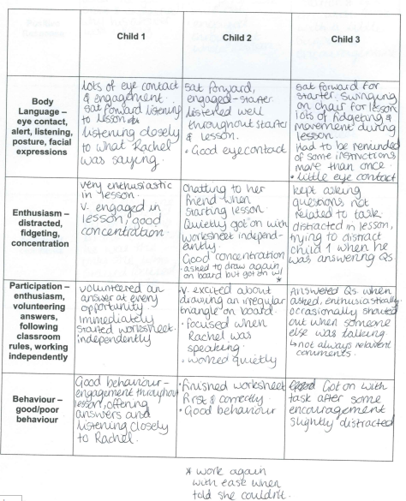
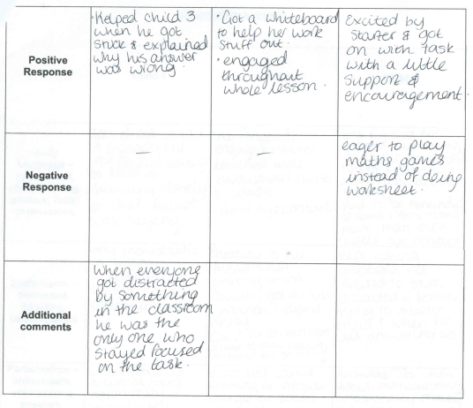
Appendix 6 continued.

Appendix 7: Loop card game.
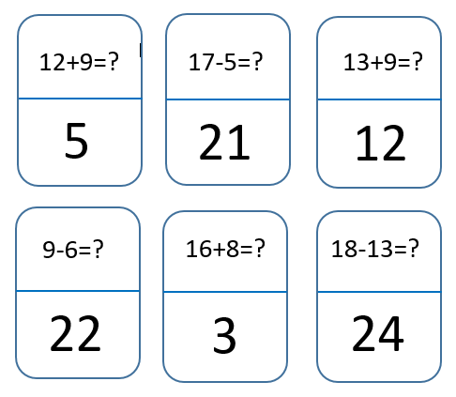

Appendix 8: Table of Reflection using Brookfield’s Four Lenses Reflection Model.
Self-review
How do you think it went? What were your emotions?
Student review
Feedback from students. Too challenging/ not challenging enough? Etc.
Peer review
Constructive criticism about your teaching. Advice.
Benchmarking/ Literature
Any links to literature/theories that help you understand your practice.

