Contemporary Challenges

Who’s doing what slides
- Rebecca- First slides covering the history and how it cam about.
- Georgia- The impact and what it caused.
- Erin- Design ideas and solutions
- Me- The solution and why we came up with our idea.

Ideas as to what we can do:
- Global warming
- plastic waste
- recycling
- Cost of living
- Child poverty
- Wages
The final decision was the cost of Living crisis/ child poverty. We came to this decision as a team.

Script
Slide One
We have chosen to create a family workshop where we will cover all sorts of family friendly things on a budget. This will include cooking, budgeting, saving and so much more.
Slide Two
In order for our family workshops to be promoted we would design a poster along the lines of this basic example and put them up around schools, youth centres and local shops. It will display all of the relevant information about the group.
In order to get our workshop to run we would have volunteers trained in school training programmes or other programmes run by council in order for them to help us carry the workshop.
Slide Three
Get support from government funding and local businesses. Provide us with food that’s close to its use by or best before date so that we can create budget friendly meals and freeze them or eat them as a group. Smaller business can support with children eat free with a paying adult. Supports families mentally and financially. Getting to know other families in your situation so you know your not alone. Through that they can make friends and do things together.

Slide Four
Why, Why is this going to work? Why is this going to help the cost of living crisis and child poverty. This idea may not completely solve the wicked problem and prevent it happening anymore but it will make a big impact in many other ways. Families connecting with others in similar situations, how to live happily and budget friendly, how to manage your money and still be able to enjoy other things.
Conclusion-Wrap it Up
So lets wrap it up, our workshop will help low income families who are struggling with the cost of living and child poverty by helping with their mental and physical health, their financial worries and so much more. And as a group we hope to make that change. Thank you for watching

Extra Research
“Money is more than a practical matter. It can actually impact your mental health. Financial stress is a real thing, and it could be causing you significant worry that spills over into the rest of your life, keeping you awake at night and affecting your physical health. Take money management seriously for less anxiety and better mental health” (BetterSleep, 2022).
Poster
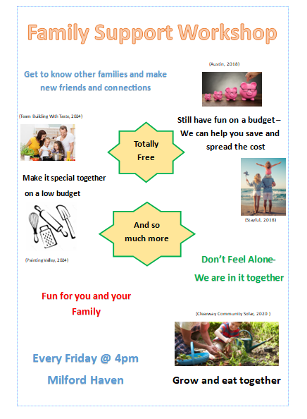
Cover how this is only a basic example, if this were to be taken into further account once we know about funding and so for then we would add this to the poster and develop the poster and its information accordingly.

References
Team Building with taste, Why family cooking together matters, (2024). Available at: https://www.teambuildingwithtaste.com/why-family-cooking-together-matters/. Accessed 15/04/24.
Painting Valley, (2024), Available at: https://paintingvalley.com/cooking-utensils-drawing#cooking-utensils-drawing-22.jpg. Accessed 15/03/24.
Michael Austin, JustWebWorld, (2018), Available at: https://www.justwebworld.com/ways-marketing-has-changed-to-suit-higher-online-sales/. Accessed 15/03/24.
Stayful, (2018), Available at: https://www.stayful.com/travel/10-budget-friendly-family-vacation-ideas-for-this-summer/. Accessed 15/04/24.
Clearway Community Solar, (2020), Available at: https://www.clearwaycommunitysolar.com/blog/sustainable-living/growing-your-own-fruits-and-vegetables/. Accessed 15/04/24.
Community Care Inform et al Aisling Philip, (2021) Available at:
https://adults.ccinform.co.uk/cygnor-sir-penfro-pembrokeshire-county-council/pembrokeshire-county-council-community-mental-health-team/. Accessed 26/03/24.
Expert commentator, (2017), Available at: https://www.smartinsights.com/online-pr/reputation-management-online-pr/tesco-turned-marketing-strategy-around/. Accessed 26/03/24.
The Galloper News, (2021), Available at: https://thegallopinghorse.co.uk/kids-eat-free/. Accessed 26/03/24.https://www.logo.wine/logo/Home_Bargains. Accessed 26/03/24.
BetterSleep, (2022), How Budgeting Improves Your Mental Health, Available at: https://www.bettersleep.com/blog/how-budgeting-improves-your-mental-health/. Accessed 26/03/24
Family Lives . “Family Budgeting | Family Lives.” Www.familylives.org.uk, 2021, www.familylives.org.uk/advice/your-family/family-finance/family-budgeting. Accessed 26/03/24

