

Student Name: Janina Marinela Fira

Student Number :2435168

Module Title: Enterprise and Entrepreneurship

Assignment Title: Task 1: Individual Written Business Plan

Table of Contents
Introduction 3
1. Overview of the business idea 3
2. Legal format and management structure of the startup enterprise 4
3. PESTEL analysis and some information about the competition 5
4. Explanation of the marketing strategies the enterprise will adopt to reach its customers 7
5. Financial Position 8
Conclusion 9
Reference List 11

Individual Written Business Plan

Introduction
This report will provide the business plan of Sweet Cravings, which is a home-based cake studio aimed at catering to the increased demand for personalised celebration products. It will provide the business idea, product and positioning in the competitive market of the bakery. The report will also assess the external environment, marketing strategy, operational structure, and financial needs. It will provide the commercial feasibility of the venture, its competitive strength, as well as prospective expansion in the high-end but affordable homemade cake market through in-depth consideration.

1. Overview of the business idea
An overview of the business idea
Sweet Cravings will be a small-scale home bakery that focuses on freshly made, ordered celebration cakes to have during birthdays, weddings, and other corporate parties. The business will initially use a home-based production model with an online ordering and delivery model to offer quality and freshness to its products, and thus small batches. The UK cake sector has been making billions of pounds each year, and the demand for individualised celebration products is growing (Todd and Klingbeil, 2024). The positioning of Sweet Cravings will be in the luxury but affordable market that involves customised designs at a high quality of ingredients and hygienic preparation levels.
Business Concept and Value Proposition
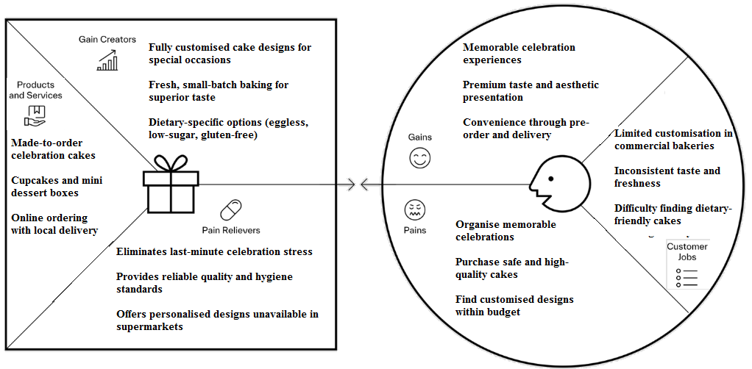
Figure 1: Value Proposition
(Source: Author)
Sweet Cravings shall have a differentiated value proposition with the focus on freshness, personalisation and emotional relationship. The production of each product will be done in small batches, and high-quality ingredients will be used, unlike mass-produced supermarket cakes, to maintain uniform taste and texture (Jalandoni, 2023). Customers will also be able to tailor flavours, designs, and diets of their preferences, such as eggless and low-sugar, considering the increased health awareness. The company will minimise the stress associated with celebrations by having trusted pre-ordering, as well as delivery, on time. Although the premium ingredients will mean that the production cost will rise, the bespoke customer experience will be met with the increased perceived customer value.
Entrepreneurial Rationale and Unique Selling Proposition (USP)
The entrepreneur opportunity can be seen through increasing consumer demand for personalised celebration experiences and dietary-specific services. Contrary to the mass production that is targeted by the supermarket chains like Tesco, Sweet Cravings will target the aspect of customisation, freshness and emotional value (Koerniawan, 2022). Its selling point is its entirely custom-designed design, eggless, and low-sugar options, and personal contact with the customer in the process of ordering. Although the increase in ingredient cost will decrease margin flexibility, the customised strategy will increase customer loyalty and purchase behaviour, intensifying the sustainability of the business in the long run.

2. Legal format and management structure of the startup enterprise
Choice of Legal Structure and Theoretical Justification
To have protection of limited liability and increased credibility by suppliers and financial institutions, Sweet Cravings will be incorporated as a Private Limited Company. This type of structure, known as the personal and business division of assets, is essential in a food business, possibly subject to the risks of product liability (Gilmore et al., 2023). Established bakery brands like those of Lola cupcakes are owned and operated with limited company structures to access structured growth and access to investment. The conceptual justification is found in minimisation of risk and capital formation, but incorporations add to administration and regulatory reporting requirements.
Strengths and Limitations of the Selected Legal Format
The Private Limited allows the investor to have more confidence in the venture, allows the venture to utilise structured funding methods and will not put the personal assets of the founder at risk by having to cover the operational liabilities, e.g. food safety claims. It improves brand credibility during supplier contract or commercial lease negotiations. But under this format, formal registration in Companies House, submission of annual financial statements and portfolio corporate tax are mandatory (Bondarkov et al., 2025). Operation workloads are higher in administrative duties than in sole traders.
Ownership Structure and Capital Contribution
The firm will be entitled to be founder-led, where total ownership will be held in the start-up to ensure strategic control. The initial capital will be an estimated £25,000, used to finance kitchen equipment, licensing, branding, and initial marketing (Coldrey et al., 2023). Angel investors can be provided with future equity in exchange for expansion capital. Voting and profit distribution will be termed in shareholder agreements. Although the founder control ensures that the vision for the implementation of the plans is stable, the problem of equity dilution in the future may reduce the capacity to make free decisions.
Management Structure and Operational Governance
Sweet Cravings will assume a lean management framework that comprises the Founder-Director, who will be in charge of production planning, sourcing suppliers, financial management, and customer relations. Baking preparation and hygiene compliance will be handled by one of the trained kitchen assistants under well-organised food safety procedures (Rane, 2023). The advantage is that the overheads can be low and the decisions made quickly, but the disadvantage is that the staffing can be very low and can become a strain to operations in the seasonal periods of the year, like weddings or Christmas.

3. PESTEL analysis and some information about the competition
Political | The business environment is favourable to the micro food businesses, with the small enterprise funded by the UK government under start-up loan programmes and local council grants (Cowling and Dvouletý, 2022). Nevertheless, the local authority controls related to street trading, food premises approval and business rates have a direct impact on the operational costs and location viability of Sweet Cravings.
Economic | The tax rate for UK corporations is 25 on profits exceeding £250,000 and 19 on lower profits. Value Added Tax is levied at 20 per cent on goods and services liable (Omotor, 2024). The cost of production in the bakeries is altered by increasing costs of energy and rising costs of ingredients. The market in the UK bakery market, however, offers billions in a single year, which indicates that people are willing to spend on celebration products.
Social | Market expansion is facilitated by the growing demand for customised party experiences and healthy consumption habits, such as eggless and low-sugar cakes. The purchasing behaviour is significantly influenced by social media platforms.
Technological | The customers are accessed through online ordering platforms and online payment platforms, as well as social media advertising (Botelho et al., 2022). Instagram and TikTok allow visual branding and one-to-one communication with a customer.
Environmental | Increased concern about packaging sustainability promotes biodegradable boxes and minimised use of plastics. More and more consumers tend to choose food businesses that are environmentally friendly.
Legal | Sweet Cravings will be required to adhere to the Food Safety Act 1990, Food Hygiene Regulations 2006, and allergen labelling to meet the requirements of the UK Food Information Regulations (Hart et al., 2025). Registration as required by the local authority and frequent inspections of the Environmental Health are mandatory.

4. Explanation of the marketing strategies the enterprise will adopt to reach its customers
Digital Marketing and Online Customer Acquisition Strategy
Sweet cravings will create a mobile optimised site incorporating an online order system, online payment gateways and delivery selection. The process of optimising search engines will be focused on finding high-intent keywords like custom birthday cakes in Birmingham that will help narrow down to location-based keywords (Patterson and Sinex, 2024). Google Business Profile sign-up will increase the local exposure and customer reviews. There is the advantage of having quantifiable information about customers and the ability to directly control sales, but the costs of the site development, maintenance costs, and online advertisement competition can raise costs in the operations.
Social Media Branding and Engagement Strategy
Sweet Cravings will create a mobile-friendly webpage that incorporates online placing of orders, a safe payment gateway and scheduled delivery options. The location-based keywords will be used to optimise search engines with keywords like custom birthday cakes in Birmingham to get high-intent customers. The registration of Google Business Profile is going to increase the visibility in the neighbourhood and customer reviews (Arief, 2023). Seasonal collections and repeat purchases will be promoted via email marketing campaigns. The advantage is in the fact that client information and physical sales control can be measured.
Location Strategy and Physical Market Positioning
Instagram and TikTok will be used to promote the business with correct images of cake designs. Videos of the process of customisation will be used to make the short videos more credible. The brand will be extended to parenting bloggers and influencers through collaboration with local event organisers (Agrikolianskaia, 2023). Targeted advertising will be done to people who search for celebration services. The advantage is the ability to tell the visual story and build the brand personality, but the changes in the algorithm and saturation of the content can decrease the organic reach in the future.

5. Financial Position
Start-up Cost:
Start-up costs are mainly the initial costs or one-time expenses. The start-up costs are the initial investment that a new business must make before it can start business operations (Ahamat and Sin, 2022). According to the financial estimation, the total initial cost will be 10000 pounds for starting "Sweet Cravings”. In this initial cost, there are also included purchasing costs, website development costs, legal costs, and rent expenses.
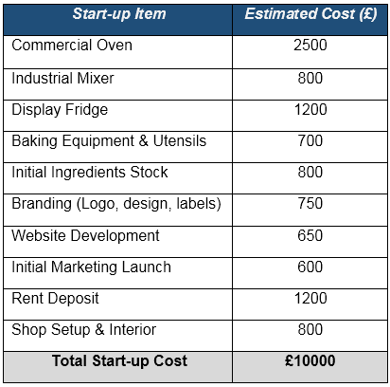
Table: Start-Up Costs
Source of Funding and its importance
The source of funding is also essential for a new start-up business. Sweet Cravings' new business might focus on the two types of sources of funding, debt financing (bank loan) and owner’s capital. In the present situation, a business can easily get a bank loan with a limited interest rate (Wang, 2025). The main advantages of a bank loan are that it is easy to access. However, bank loans also increase financial burden, and high interest rates create more pressure on businesses. Owner’s capital is another source of capital. In this condition, the business owner invests his own capital in the business. As the start-up cost of this new venture will be 10000 pounds, in that case, a proper source of funding is essential. On the other hand, equipment purchase and rent are essential costs of business. To fulfil the initial costs, a proper source of capital is also important.
Outline the Expected Expenses (Cash Flow Statement)
As per the cash flow projection for the new venture, total cash inflows will be £15600. In cash inflow, there are also included loan amount, estimated sales revenue and deposit received amount. Furthermore, total cash outflows are £11600 also. In cash out flows, there are also operational expenses, such as rent, utilities costs, marketing and advertisement costs, equipment purchase expenses and other essential costs (Dalwadi, 2023). According to the analysis section, the net cash flows amount to £4000. Net cash amount also shows a positive business condition.
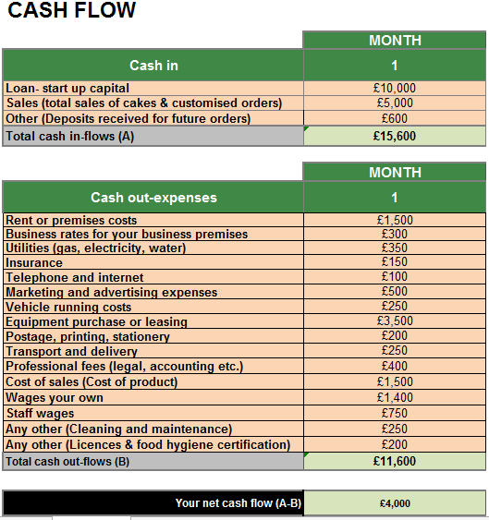
Table: Cash Flow Statement

Conclusion
Sweet Cravings will offer a commercially viable and well-positioned home-based cake business opportunity in a rapidly growing celebration-based market. By offering personalised products, a good legal framework, internet marketing, and superior customer interaction, the business will be able to create a competitive advantage. Although there are challenges in the business, the value proposition and scalability of the business will ensure sustainable growth and entrepreneurial success.

Reference List
Agrikolianskaia, K. (2023) ‘Investigating effective ways to engage the younger generation through events’, Theseus.fi [Preprint]. Available at: https://www.theseus.fi/handle/10024/817056.
Ahamat, A. and Sin, G.K.W. (2022) ‘Developing a business start-up model for technopreneurs.’ International Journal of Technoentrepreneurship, 4(3), pp.198-218. Available at: https://doi.org/10.1504/IJTE.2022.127155
Arief, I. (2023) ‘Deciphering the Visibility of Higher Education Institutions: A Statistical Analysis of Google Search Console Data’, International Journal of Advanced Science Computing and Engineering, 5(1), pp. 75–85. Available at: https://doi.org/10.30630/ijasce.5.1.131.
Bondarkov, S., Ledenev, V. and Skougarevskiy, D. (2025) ‘Russian Financial Statements Database: A firm-level collection of the universe of financial statements’, Scientific Data, 12(1). Available at: https://doi.org/10.1038/s41597-025-05150-1.
Botelho, L.V., Freitas, J.V., Camara, A.O. da, de Almeida, I.F., Gonçalves, T. de S., Horta, P.M., Canella, D.S. and Cardoso, L. de O. (2022) ‘Digital marketing of online food delivery services in a social media platform before and during COVID-19 pandemic in Brazil’, Public Health Nutrition, 26(1), pp. 1–25. Available at: https://doi.org/10.1017/s1368980022002191.
Coldrey, O., Lant, P. and Ashworth, P. (2023) ‘Elucidating Finance Gaps through the Clean Cooking Value Chain’, Sustainability, 15(4), p. 3577. Available at: https://doi.org/10.3390/su15043577.
Cowling, M. and Dvouletý, O. (2022) ‘UK government-backed start-up loans: Tackling disadvantage and credit rationing of new entrepreneurs’, International Small Business Journal: Researching Entrepreneurship, 41(7), p. 026624262211247. Available at: https://doi.org/10.1177/02662426221124733.
Dalwadi, P. (2023). Cash flow statement analysis: Identifying red flags and warning signs for financial distress.' Vidya-A Journal Of Gujarat University, 2(2), pp.36-42. Available at: https://doi.org/10.47413/vidya.v2i2.205
Gilmore, A.B., Fabbri, A., Baum, F., Bertscher, A., Bondy, K., Chang, H.-J., Demaio, S., Erzse, A., Freudenberg, N., Friel, S., Hofman, K.J., Johns, P., Karim, S.A., Lacy-Nichols, J., Carvalho, C.M.P. de, Marten, R., McKee, M., Petticrew, M., Robertson, L. and Tangcharoensathien, V. (2023) ‘Defining and Conceptualising the Commercial Determinants of Health’, The Lancet, 401(10383), pp. 1194–1213. Available at: https://doi.org/10.1016/S0140-6736(23)00013-2.
Hart, K.H., Hill, A.J., Gonzalez, J.T., de la Hunty, A., Gallagher, A.M. and Stanner, S.A. (2025) ‘Diet in Pregnancy: A Review of Current Challenges and Recommendations. A British Nutrition Foundation Briefing Paper’, Nutrition bulletin, p. 10.1111/nbu.70016. Available at: https://doi.org/10.1111/nbu.70016.
Jalandoni, M.E. (2023) An Exploration on Experience Design: Developing an Experience Concept for Pastry Shops with Mass Customisation, www.theseus.fi. Available at: https://www.theseus.fi/handle/10024/811741.
Koerniawan, N. (2022) ‘The Use of Customised Market Intelligence by Small Food and Drink Producers: The Role of Strategic Orientations and Commitment - UEA Digital Repository’, Uea.ac.uk [Preprint]. Available at: https://ueaeprints.uea.ac.uk/id/eprint/97288/1/Nadia%20Koerniawan%20Final%20Thesis%20Document.pdf.
Omotor, S.O. (2024) ‘Sustaining the corporate income tax rates of small businesses in developing economies : lessons for Nigeria from Canada, South Africa, and the UK’, Library.ubc.ca [Preprint]. Available at: https://doi.org/10.14288/1.0412966.
Patterson, L. and Sinex, J. (2024) ‘How to retain website traffic in a generative AI world’, Applied Marketing Analytics: The Peer-Reviewed Journal, 10(3), p. 289. Available at: https://doi.org/10.69554/dyqz2768.
Rane, S. (2023) ‘Street Vended Food in Developing World: Hazard Analyses’, Indian Journal of Microbiology, 51(1), pp. 100–106. Available at: https://doi.org/10.1007/s12088-011-0154-x.
Todd, E.C.D. and Klingbeil, D.F. (2024) ‘Impact of Food Waste on Society, Specifically at Retail and Foodservice Levels in Developed and Developing Countries’, Foods, 13(13), p. 2098. Available at: https://doi.org/10.3390/foods13132098.
Wang, O. (2025) ‘Banks, low interest rates, and monetary policy transmission.’ The Journal of Finance, 80(3), pp.1379-1416. Available at: https://doi.org/10.1111/jofi.13436

