Using a typed Chat Room has particular challenges and these guidelines have been drawn up to try to make the process as productive as possible.
Start of the Chat and General Points
- First posts are to welcome everyone to the Chat.
- Remember to be polite and courteous, usual lecture rules apply.
- Please, NO SHOUTING!
- Keep your posts focused on the question in hand.
Moving the Chat forward
- The Chat Room Moderator (usually the Lecturer) will then post a question.
- Participants will then post their replies.
- At this point do not respond to any replies.
- The Moderator will then respond to replies in turn (they may ask additional questions).
- Please respond only to the Moderators questions (if we all start responding to different posts then it becomes chaotic).
- The Moderator will let participants know when a discussion is moving on and then post the next question. (in this way we are attempting to reproduce the discussions in lectures).
- N.B. The moderator will ‘Beep’ participants if they want to pause the discussion (e.g. to summarise).
Closing the Chat
- The Moderator will give notice when the Chat is coming to an end.
- Once the Chat is finished participants should sign out.
After the Chat
If you want to access the record of the Chat afterwards then please see overleaf;

- Click on the Link to the Chat Room e.g.
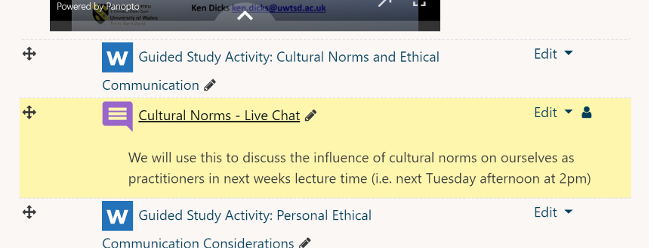

- Select ‘View Past Sessions’ e.g.
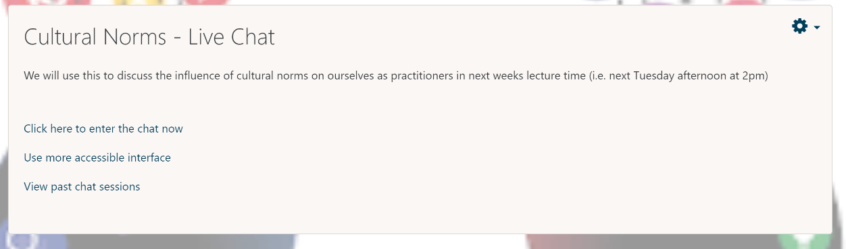

- Select ‘See This Session’


