Noriesiah Shallow

Climate Change, risks or opportunities for Organizations

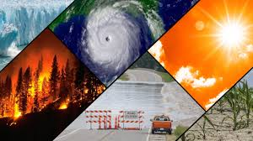
Figure 1 NOAA 2019

Introduction
“End of life on earth unless we change now”, “Global climate crisis inevitable, unprecedented and irreversible”, “what countries produce the most Green House Gas emission”, “Climate Change: IPCC report is code red for humanity”.These are just a few of the headlines making worldwide news. Why? According to Scheraga the climate has changed, is changing, and will continue to change despite attempts made to prevent it from happening (IPCC 1996a as cited in Scheraga, 1998, p.86) and while some of those changes are as a result of natural climatic variation, others are as a result of human activities. Nonetheless the conditions of the atmosphere have been altered and the potential for severe, frequent and unexpected disasters, droughts and floods have increased (Scheraga, 1998, p.86), which means that many of the systems (ecosystem, socio-economic) human beings have come to rely will be affected. More specifically,
Climate change will present many risk but for one such as Organizations it may also present opportunities (IPCC 1996b, 1997 as cited in Scheraga 1998, p.87). The aim of this paper is to discuss how climate Change can produce both risks and opportunities for organizations.

The paper will gather information from secondary sources including publication and scholarly articles on the World Wide Web.

Discussion
According the United Nations “Climate Change” refers to long term shifts in temperatures and weather patterns. These shifts can be natural, but since the 1800s, human activities have been the main driver of climate change, primarily due to the burning of fossil fuels (like coal, oil and gas), which produces heat-trapping gases” (United Nations. Org, n. d.).

“Climate change” refers to a change in the state of the climate that can be identified by changes in the mean and/or the variability of its properties and that persists for an extended period, typically decades or longer. It refers to any change in climate over time, whether due to natural variability or as a result of human activity” (IPCC, n.d.).

The Climate is changing
According to scientist the average global temperatures is likely to rise to 2°C by the year 2100 (IPCC 1996a as cited in Scheraga 1998, p. 86).
- “Global surface temperature was 1.09C higher in the decade between 2011-2020 than between 1850-1900” (McGrath, 2021)
- According to Scheraga over the past one hundred years (100) the average atmospheric temperature has risen from 0.3 to 0.6°C while average sea level has increased from 10 to 25 cm (IPCC 1996a as cited in scheraga, 1998, p. 86)
- “The past five years have been the hottest on record since 1850
- The current rate of sea level rise has nearly tripled compared with 1901-1971
- Human influence is responsible for about 90% of the global retreat of glaciers since the 1990s and the decrease in Arctic sea-iceberg.
- It is certain that hot extremes including heatwaves have become more frequent and intense since the 1950s, while cold events have become less frequent and less severe”
- (McGrath, 2021).

Scientist believe that the occurrence of natural disasters worldwide have more than doubled between 1990 and 2016. They also believe that the climate will continue to change as a result of both natural variations in the climate and human activities, predominately from burning of fossil, deforestation, agricultural and industrial activities. They now warns of increasing and extreme disasters, floods, droughts and heat waves with potential damaging effects to air and water quality ,agriculture and the ecosystems (Scheraga & Grambsch, 1998, p. 91).

Organizations have a huge role to play in driving Climate Change, many of whom have to now choose between short term profitability and the crucial need to reduce their emissions. One study found that since 1988 more than half of global industrial emissions can be linked to twenty five (25) corporate and state-owned entities, thereby, producing sufficient fossil fuels to have contributed significantly to climate change (Riley, 2017).

Therefore, given the fact that these fossil fuel producers are responsible for a significant proportion of emissions that is driving climate change, halting that produce may not be so easy since it plays huge part in their productions processes.
But the earth’s temperature is changing at such a rapid rate that between 31st October 2021 - 12th November 2021, leaders of all countries came together at COP26 Summit in Glasgow with the common goal of working together in order to keep the planet’s temperature under control (United Nations Climate Change Conference UK, 2021) This will require the world including companies to deviate from fossil fuels towards green energy, which will take time and large amounts of investment (Soobiah &, 2011). But how will Climate Change affect organizations?

Climate Change, risk for Organizations
Economic times define risk as “future uncertainty about deviation from expected earnings or expected outcome. Risk measures the uncertainty that an investor is willing to take to realize a gain from an investment” (The Economic Times, n. d.).

“Organization” refers to both government and private businesses incorporating sectors such as Tourism, Agriculture, Transportation, Insurance and oil and gas.

Damages to buildings and infrastructure
- Organizations may suffer physical damages to buildings and equipment as a result extreme of weather conditions which can be expensive. Roads, transportation systems and ports may also sustain damages, which can make it difficult to transport and receive goods and services. It can also make it difficult for employees to travel to work’ thereby reducing production (Sussman & Freed, 2008, p. 8) “In 2011, flooding in Thailand resulted in disruptions of supply chains in manufacturing (comprised of 39% of Thai GDP) and other sectors. This event damaged Thailand’s national economy at the time (BBC, 2011).

Increase insurance cost
- Due to their locations some properties may become expensive to insure because of the risk associated with their locations while others may be unable to obtain insurance policies. Organizations may also suffer loss from depreciation of property value (Trager, 2021).

Loss of labor and customers
- Organizations may lose employees as these employees may decide to resign because of the risk associated with their jobs while customers may cease from the organization due to fear of damages from storms. These damages can include disruption in food supplies and drinking water and loss of assets (Trager, 2021).

Damages to agriculture
- Companies that are heavily dependent upon agricultural supplies may suffer from damages and loss of crops as a result of extreme weather pattern such as droughts. For example, heat waves in 2010 created losses in key production areas in places such as Russia, Ukraine which contributed to a dramatic increase in the price of staple foods (Future Learn, n. d.).

Opportunity Cost
- Organizations that continue to use products that are harmful to the environment may miss out on opportunities for development, growth and investments (Trager, 2021).
Reputation
- Organizations may also suffer from negative publicity due to their involvement with environmentally harmful products (Trager, 2021).

Reduce capacity of workforce
- Employees may be unable to get to work as a result of sickness. Over time employees absence can slow down production. One study states that by 2050 cities like Chicago and Illinois will experience more frequent heat days, heat related disorders, respiratory disorders, asthma, Depression and post traumatic stress disorder (Patz, Frumkin and Haines, 2018).

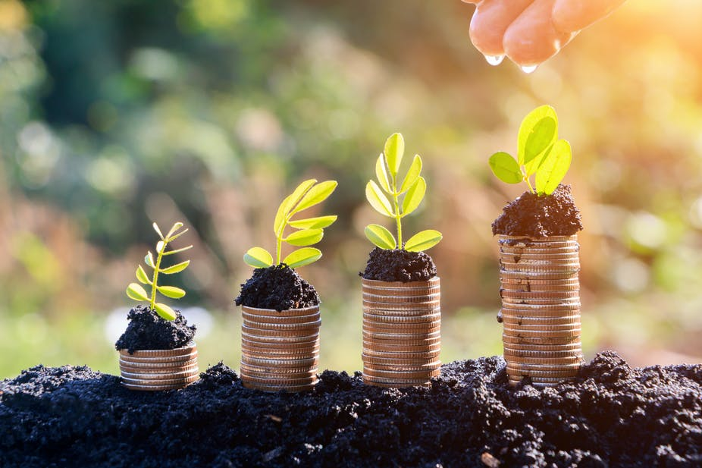
Climate Change, Opportunities for Organizations
Figure 2 Giamporcaro and Gond 2020

Nonetheless, “Climate Change” can present many opportunities for organizations, however these opportunities may lay in investing in “Sustainable Investments” which refers to “a combination of traditional investment approaches with environmental, social and governance (ESG) insights to reduce risk and enhance long-term returns” (Kyte, 2014).

Over the past decade the term “Sustainable” referring to “the use of components of biological diversity in a way and at a rate that does not lead to the long term decline of biological diversity, thereby maintaining its potential to meet the needs and aspirations of present and future generations” (United Nations, 1992, p.4) has achieved popularity as investors are now concerned about the social and environmental impact of their investments given the urgency of climate change. Many of them now seek to make sustainable investments (Chan, 2021). This type of investment means that organizations will not invest in facilities, equipment and projects that do not harm the environment as and a result contribute to climate change instead they will invest in those that are safe for the environment.

- Investment opportunities for organizations may arise in some developing countries such as Caribbean, for construction and infrastructure projects, as these countries would decide construct buildings that are able to withstand extreme weather events (Trager, 2021).

- Opportunities may also arise in the United States for companies that can refit existing buildings and infrastructure so that they can become resilient to weather conditions. According to Trager (2021) a recent study of the construction industry found that nearly half of companies expect that green building projects will account for more than 60% of their work by 2021”.

- Investment can also be made in companies that are in the lead for creating products that are environmentally friendly. They can also benefit from opportunities when they reduce exposure to traditional energy sectors and invest in companies that are focused on renewable forms of energy such as solar energy, biofuels and electric vehicles can bring about benefits to organizations (Trager, 2021).

- Organizations can invest in sustainable agriculture and water facilities which may prove to be profitable. On the other hand, they can evaluate other organizations in different part of the world in order to know the ones that are susceptible to food and water scarcity in order to avoid making any high risk investments. For example agricultural production in the United States is affected by heat waves and droughts, these include corn and soy. It is projected that profits from these products could fall 30% by 2070 with no adaption (Trager, 2021) (Schneider , 2005, p.15).

Conclusions and Recommendations
The climate has changed, is changing, and will continue to change despite attempts made to prevent it from happening (IPCC 1996a as cited in Scheraga (1998, p.86,). While some changes result from the natural variation of the climate, others are as a result of human activities, by large organizations.
Nonetheless, scientists believe that the atmospheric conditions have been altered and the potential for unexpected and severe disasters have increased, therefore, the world is now watching and waiting, because everyone will be affected including organizations as they may experience both risk and opportunities in the face climate change. These risks include damages to building and infrastructure; increase insurance cost, disruption of supplies and opportunity cost while opportunities lie in turning to sustainability. By doing this organization can adapt to the changing time, help to preserve the environment, increase their profits and most importantly contribute to the fight against climate change. However, education is important; companies need to be educated on the urgency of climate change and its potential effects on their organizations.

References
BBC News. (2011). Thailand flood disrupts distribution and supply chain. Google. https://www.google.com/amp/s/www.bbc.com/news/business-15285149.amp.
Chan, K. (2021). Sustainable investing on the rise amid environmental concerns. South China Morning Post. https://www.google.com/amp/s/amp.scmp.com/special-reports/article/3152958/climate-change-sustainable-investments-rise-investors-tie.
Soobiah, D. (2021). Why solar energy is a reliable investment for our carbon future, come rain or shine. inews.co.uk. https://inews.co.uk/inews-lifestyle/money/ethical-money/solar-energy-reliably-investent-carbon-future-rain-shine-1292244
FutureLearn. (2013). Impact of climate change on agriculture. https://www.futurelearn.com/info/courses/climate-smart-agriculture/0/steps/26565
Gambarelli, G. (2020). Climate change, new risks and opportunities for businesses. LifeGate. https://www.lifegate.com/climate-change-risks-opportunities-businesses
Giamporcaro, S. (2020). Your pension has a huge role to play in combating climate change – here's how to make it sustainable. The Conversation. https://www.google.com/amp/s/theconversation.com/amp/your-pension-has-a-huge-role-to-play-in-combating-climate-change-heres-how-to-make-it-sustainable-132062
Kyte. (2014). Climate change is a challenge for Sustainable Development. World Bank. https://www.worldbank.org/en/news/speech/2014/01/15/climate-change-is-challenge-for-sustainable-development
McGrath, M. (2021). Climate change: IPCC report is 'code red for humanity. Google. https://www.google.com/amp/s/www.bbc.com/news/science-environment-58130705.amp
NOAA. (2019, February 1). Climate change impacts. National Oceanic and Atmospheric Administration. https://www.noaa.gov/education/resource-collections/climate/climate-change-impacts
Scheraga, & Grambsch. (1998). Risks, Adoption and opportunities to climate change. Inter Research » . https://www.int-res.com/articles/cr/11/c011p085.pdf
Schneider, & Lane. (2005). An Overview of “Dangerous” Climate Change. Standford.edu. https://stephenschneider.stanford.edu/Publications/PDF_Papers/Schneider-lane.pdf
Sussman, & Freed, F. R. (2008). Adapting to climate change: A Business approach. Center for Climate and Energy Solutions. https://www.c2es.org/wp-content/uploads/2008/04/adapting-climate-change-business-approach.pdf
Trager, L. (2021). Risks and opportunities of climate change. Morgan Stanley. https://www.morganstanley.com/articles/risks-and-opportunities-of-climate-change
The Economic Times. (n.d.). What is risk? Definition of risk, risk meaning. https://www.google.com/amp/s/m.economictimes.com/definition/risk/amp.
The Forum for responsible and Sustainable Development. (n.d.). Sustainable investing Basics. The Forum for Sustainable and Responsible Investment. https://www.ussif.org/sribasics
The institutional investors group on climate change. (n.d.). Understanding physical climate risks and opportunities. Acclimatise – Building climate resilience Acclimatise. https://www.acclimatise.uk.com/wp-content/uploads/2020/05/IIGCC-Understanding-Physical-Climate-Risks.pdf
Patz, Frumkin, & Haines. (2014). Climate change: Challenges and opportunities for global health. PubMed Central (PMC). https://www.ncbi.nlm.nih.gov/pmc/articles/PMC6108836/
Riley, T. (2017). Just 100 companies responsible for 71% of global emissions. Google. https://www.google.com/amp/s/amp.theguardian.com/sustainable-business/2017/jul/10/100-fossil-fuel-companies-investors-responsible-71-global-emissions-cdp-study-climate-change
UN Climate Change Conference UK 2021. (2021). COP26 in partnership with Italy. UN Climate Change Conference (COP26) at the SEC – Glasgow 2021
United Nations. (1992). Convention on Biological Diversity. https://www.cbd.int/doc/legal/cbd-en.pdf
United Nations. (n.d.). What is climate change?https://www.un.org/en/climatechange/what-is-climate change.
United Nations Framework Convention on Climate Change. (2011). https://unfccc.int/files/press/backgrounders/applic

