Discuss the impact of changing ground conditions on the preservation of wood and human/animal remains and how these factors influence the nature of the questions that can be addressed in an archaeological project. Selecting from at least three or more sites, illustrate your answer with reference to a range of sites and conditions.

The conditions of the ground, where archaeological matter resides, are essential to the preservation or decomposition of such artefacts. Organic matter, namely wood and the remains of humans and animals, are susceptible to decay, unless anaerobic conditions, including peat, waterlogging, and freezing deter this. While these cannot completely halt decay, changes in ground conditions can alter the rate of decay. Ground conditions can change due to natural environmental changes (water, weather, climate, soil type), or could be a result of human disturbance. Examples of these human disturbance types include agricultural or pastoral, development, infrastructure or transport, industrial or productive, military, archaeological excavation, and looting (Rayne et al., 2017: Table 3). Conditions including urban development, land drainage, agriculture and climate change can lead to the acceleration of decay (Holden et al., 2006: 2). Similarly, environmental impacts, such as a decrease in water levels upon previously waterlogged sites, can accelerate decay if the ground becomes unsaturated (English Heritage, 2012; quoted in Malim et al., 2015: 20).
In an archaeological project, there are a number of typical questions that can be asked; for example, what was the purpose of the site, how was it lived in and engaged with, and what can we learn about the culture of the people related to this site? However, with good preservation, evidence to answer questions can cause ideas to be extended or altered, offering the possibility of more detailed theories to be formed, such as whether it was a permanent, or temporary, settlement, or a religious or ritualistic site. Human remains and personal items can indicate cultural behaviours and some concept of their views on death; burial rites, sacrifice, longevity, and level of mortality due to conflict.
This essay will address the changing ground conditions of the sites Ötzi the iceman, Star Carr, and Flag Fen, and how they have influenced the nature of the questions that can be asked regarding such sites.

Ötzi (the name for the 5300-year-old male body found in the Ötzal Alps on the Italian-Austrian border) is a permafrost mummy; his body became dehydrated and then the snow that had fallen around him became a gully in a glacier, preserving him as he was (Spindler, 1995: 165). There is evidence that the glacier moved, which altered the position in which his body lay, as well as a suggestion that the gully melted at least once between 3300 and 800BC, and then refroze (ibid: 165-166; Acs et al., 2005). These frozen conditions meant that decay did not occur on his body, clothing, or equipment, and analysis could be undertaken on these items, some of which would not have preserved in other conditions, providing answers to questions which could not be answered, or even considered, before; his cause of death and other injuries, diseases, intolerances and allergies, diet, last meal, geographic origin, where he had last been, and his final route to death.
The preservation of his skin meant that his tattoos were still visible, and they could be analysed to answer questions, for example: what was the method used for tattooing? What materials were used, both as a needle and for the ink? What were the designs, and could there be a meaning behind them? The complete preservation of his body also allowed for analysis of his stomach contents, which showed what he consumed for his “final meal”, but does not show his regular diet, for which an indication of this could be attained by analysis of his bones and teeth. His stomach contents could also give an idea regarding food processing prior to consumption; were items cooked? Did they use items which would alter the taste of the food? Did they consume anything that had medicinal effects, and could they have understood these effects?
Because of these preservation conditions, other organic matter had been preserved alongside the human remains, and from this, the interaction between the human and this other organic matter could be established. His clothing (fur cap, leather and fur upper garment, fur leggings, leather loincloth, grass cloak, and grass and leather shoes) made from organic material were a unique find, and show that clothing was a concept in Neolithic times, as well as the knowledge and ability of construction of such items (Spindler, 1995: 134-145). His clothing allowed for an insight into how the Neolithic people in the Ötzal mountains lived; the resources they had access to, their hunting habits, how they clothed themselves, and possible trade for luxury items (if certain resources were not local, then trade or distance hunting must have occurred).
The movement of the glacier meant that the position of his body changed (as Figure 1 shows). Instead of laying on his left side with his arms outstretched, the glacier moved him ninety degrees onto his front with his left arm directly beneath his chin and across his neck. The thawing of the gully moved some of the artefacts out of their original position, and spread his floral remains across the site. This change in position during movement of the glacier may have made him more discoverable, by bringing him to the surface, despite being off the hiking path. There is evidence for glacial movement moving his body and changing the position of the left arm, as well as the movement of his other artefacts, which could have distributed these in such a way that they were visible, and could be discovered.
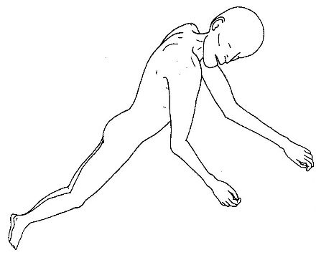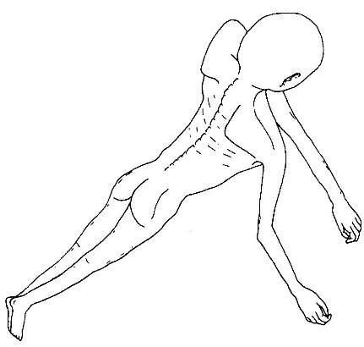
Fig.1: Two drawings showing Ötzi’s position at death (left) and the position in which he was found (right) (Spindler, 1995: 164, 166).

Had these remains not preserved as well as they did, the questions that would have been answerable would be severely limited in comparison; his bones may have survived, enabling a few questions regarding origin, diet, and cause of death, to be answered, but not to the more detailed extent now available. Also, the tattoos and other organic matter would have been unlikely to survive, so questions regarding culture, clothes, and equipment would have been reduced, and our knowledge of the Neolithic may not have advanced as rapidly as it has due to Ötzi being discovered.

Star Carr, a Mesolithic site in Yorkshire, had lay upon the western shore of a broad and shallow lake, which proceeded to infill with peat, therefore preserving the organic material, including animal remains and wood (Legge and Rowley-Conwy, 1988: 1; Conneller et al., 2012: 1006). Originally it had been excavated in the late 1940s, the organic artefacts (namely antlers, as seen in Figure 2, and a wooden platform) were well preserved, however, in the 1980s it was revisited and, in particular, an antler that was found had been less well preserved compared to the original excavations. The site was ploughed in the early 2000s and then used for fieldwalking, which resulted in the observation of the reduction in the depth of the peat by two metres, possibly due to intensified agricultural drainage, over the past few decades (Milner et al., 2011). Reasons for the changing conditions of the peat (its dehydration and increased acidity) included the 1820s Hertford drainage cut, tile drains from the first excavations and in 2000, and ploughing (Milner, 2007). Further excavations were started in 2004 because of these threats, which would likely lead to losing the remaining organic artefacts which could potentially be uncovered. These excavations produced extremely limited organic artefacts; in 2006 a set of worked antler was found, though they were ‘severely compressed and degraded’ and worse condition to the 1980s find (Milner et al., 2011). Milner (2007) makes a claim that ‘any antler, bone and wood that still survives will probably disappear within the five to 10 years’, showing the rate at which the organic artefacts can be destroyed due to the human influence on the ground in which it is buried.
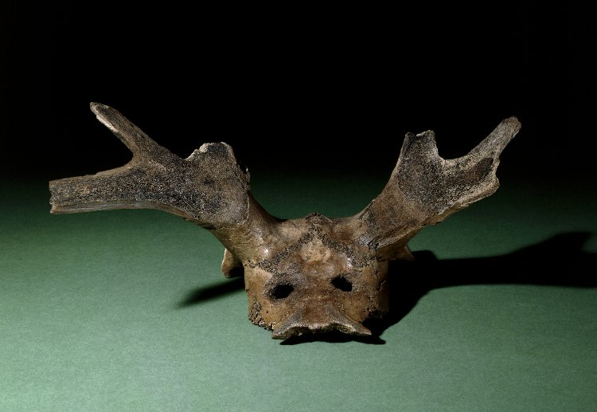
Figure 2: A photograph of a worked red deer “headdress” found at Star Carr (British Museum, museum number 1953,0208.1).
The preservation of the organic artefacts, the antlers and wooden platform, pose questions regarding their creation and use: how were the antlers altered by man, and what were they used for? and how was the wooden platform constructed, what was it made using, and what was it used for? With the changing conditions of the peat, any further excavations of the site are likely to produce a very limited amount, if any, organic artefacts, leading to a loss of potentially unique finds which could provide answers, or could be the cause of a whole new set of questions if it were something unexpected at the site.

Flag Fen, located near Peterborough, had marked a border between the flooded Fenlands and the drylands to the north and west during prehistoric times, and had provided the inhabitants with an array of resources, namely animals in the form of fish, waterfowl, and birds (Bahn, 1996: 78). During the middle Bronze Age, the climate became wetter, leading to an increase in water levels and the subsequent flooding of the dry land (ibid). After this change in climate, there became the need for some sort of path along the flooded land between the Fengate side of the Flag Fen basin and the eastern side to the island of Whittlesey (positions within the basin shown in Figure 3), so the timber causeway was constructed c. 1300 BC, and was repaired over the next 400 years (Malim et al., 2015: 20). Simultaneously to the construction of this causeway, peat was beginning to form and continued over the 2nd and 1st millenniums BC, which would preserve the timbers in situ. Prior to the Roman settlement in the area, salt extraction industries developed in sites which access to marine waters, and further exploitation of the marine waters followed in the Roman period, with the development of canals (Hall and Coles, 1994: viii). Siltlands were particularly exploited during Medieval times, as saltmaking was becoming a major industry. Salt is a key aspect to the preservation of organic materials, and the reduction of the salt in the ground would inhibit said preservation and could lead to the destruction of the remains (Cronyn, 2004: 28). In more modern times, the change in land-use would change the ground conditions and jeopardise this preservation. Such changes in land-use include the intensification of farming, and industrialisation from the seventeenth century, which resulted in the draining of the land to provide more farmland and consequently the depletion of five metres depth of peat (Hall and Coles, 1994: 19). A survey funded by English Heritage was conducted in the area after similar work on the Somerset Levels by John and Bryony Coles, which showed the reduction of both the peat and water levels (ibid).
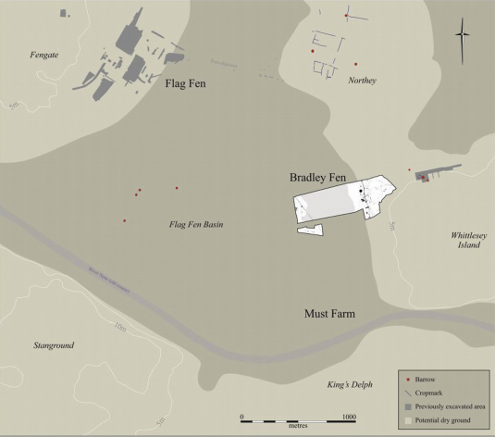
Fig. 3: A map of the Flag Fen basin showing the positions of Fengate in the west and Whittlesey island in the east, along with markers of major archaeological finds (Cambridge Archaeological Unit; in Malim et al., 2015: 22).

Despite these changing ground conditions (the reduction in the conditions for preservation: water levels, salt levels, and peat levels), both wooden and human remains were preserved; particularly the middle Bronze Age finds of the wooden causeway between Fengate and Whittlesey. The wooden causeway can enable archaeologists to look at the use of wood in middle Bronze Age. It can also suggest construction methods (of the tracks as well as how it could be used in a similar way) and possible reasons for the necessity of the track: were there trade opportunities? Resources that the other desired or required? Had one been a previous settlement that, due to a potential increase in population or conflict of some sort, had split it in two (or more) and led to the creation of a new settlement, or the redevelopment of a previous settlement? Although these questions may not be definitively answerable, they can give suggestions into the middle Bronze Age people's lives, and potentially, if used in comparison to other contemporary sites, look at the development of the people and the variations in life in different parts of Britain.

In conclusion, changing ground conditions that allow for organic remains, specifically wood, animal and human remains, to be preserved, allow archaeologists the opportunity to explore questions that may not have otherwise been able to answer; questions can be given a more evidenced answer instead of an entirely theorised answer. These questions can explore ancient settlements (their construction, trade, use of objects, structure of society), as well as look at the possible loss of some evidence through these changes (either previously, presently, or in the future) which could alter the answers.
The changing conditions in which Ötzi was preserved allowed for an exploration into the Neolithic people of the Ötzal mountains which may not have been possible as quickly without his discovery, particularly in the uses of animal derived products (leather, fur), the concept of clothing, diet and food consumption, and culture (tattoos).
The development of the peat at Star Carr, and the later draining of the ground water, lead to both the preservation and the threat of destruction of the wood and animal remains. These finds allowed for exploration into the construction and purpose of the platform, and manipulation and purpose of the antlers.
Flag Fen’s change in climate conditions resulting in the flooding and waterlogging of the site, the formation of peat, the extraction of salt, and the further draining of the site’s water level allowed for the creation and preservation of the timber causeway. This, in turn, could allow for an exploration into the reasons for the causeway, for example, the possibility of communication and trade between Fengate and Whittlesey.

Reference List

Acs, P., Wilhalm, T., and Oeggl, K. 2005. “Remains of Grasses Found with the Neolithic Iceman ‘Ötzi’”. Vegetation History and Archaeobotany, vol. 1, pp. 198–206. [Available at: https://www.researchgate.net/profile/Klaus_Oeggl/publication/271763742_72_ACS_P_WILHALM_T_OEGGL_K_2005_The_Plant_Remains_of_the_Neolithic_Iceman_Otzi_The_Grasses_Poaceae/links/54d9bc380cf2970e4e7c9c5d/72-ACS-P-WILHALM-T-OEGGL-K-2005-The-Plant-Remains-of-the-Neolithic-Iceman-Oetzi-The-Grasses-Poaceae.pdf]

Bahn, P. 1996. The Story of Archaeology. London: Orion Publishing Group.

British Museum. 1953. Red Deer Headdress Found at Star Carr. [Available at: :http://www.britishmuseum.org/research/collection_online/collection_object_details/collection_image_gallery.aspx?partid=1&assetid=788317001&objectid=1362906]

Conneller, C., Milner, N., Taylor, B., and Taylor, M. 2012. “Substantial Settlement in the European Early Mesolithic: New Research at Star Carr”. Antiquity, Vol. 86, Iss. 34, pp. 1004-1020. [Available at: https://search-proquest-com.ezproxy.uwtsd.ac.uk/docview/1266509623/fulltextPDF/A57C302E8977412APQ/1?accountid=130472]

Cronyn, J.M. 2004. The Elements of Archaeological Conservation. London: Routledge.

Hall, D. and Coles. J. 1994. Fenland Survey: An Essay in Landscape and Persistence. English Heritage.

Holden, J., West, L.J., Howard, A.J., Maxfield, E., Panter, I., and Oxley, J. 2006. “Hydrological Controls of In Situ Preservation of Waterlogged Archaeological Deposits”. Earth-Science Reviews, vol. 78 (1-2), pp. 59-83. [Available at: http://eprints.whiterose.ac.uk/1606/1/holdenj13_Revised_ESR_Mar_2006_not_tracked.pdf]

Legge, A.J. and Rowley-Conwy, P.A. 1988. Star Carr Revisited. Oxford: Alden Press.

Malim, T., Morgan, D., and Panter, I. 2015. “Suspended Preservation: Particular Preservation Conditions within the Must Farm – Flag Fen Bronze Age Landscape”. Quaternary International, Vol. 368, pp. 19-30. [Available at: https://www-sciencedirect-com.ezproxy.uwtsd.ac.uk/science/article/pii/S104061821400799X]

Milner, N. 2007. “Fading Star”. British Archaeology: The Voice of Archaeology in Britain and Beyond, issue 96. [Available at: https://www.researchgate.net/publication/240321377_Fading_Star]

Milner, N., Conneller, C., Elliott, B., Koon, H., Panter, I., Penkman, K., Taylor, B., and Taylor, M. 2011. “From Riches to Rags: Organic Deterioration at Star Carr”. Journal of Archaeological Science, vol. 28, issue 10, pp. 2818-1832. [Available at: http://www.sciencedirect.com/science/article/pii/S0305440311000549#bib23]

Rayne, L., Bradbury, J., Mattingly, D., Philip, G., Bewley, R., and Wilson, A. 2017. “From Above and on the Ground: Geospatial Methods for Recording Endangered Archaeology in the Middle East and North Africa”. Geosciences, 7(4), 100. [Available at: http://www.mdpi.com/2076-3263/7/4/100/htm]

Spindler, K. 1995. The Man in the Ice: the Preserved Body of a Neolithic Man Reveals the Secrets of the Stone Age. London: Weidenfeld and Nicolson.

