Develop Database Desktop Application

Name: Sean Samuel
Student Number: SAM18841586
Course: HND Applied Computing
Module: Application Development
Date: 20/04/2020

Contents
Develop Database Desktop Application 1
Introduction 1
Requirements 3
Brief Overview 3
Design & Implementation 5
Screenshots of pages 5
Main design features 9
Evaluation 11
Testing 11
Login system 11
Find and select tab 12
Add tab 13
Edit Tab 15
Delete Tab 16
Add Purchases Tab 17
Customer Search Bar 18

Introduction

Within this report, I will be talking about my C# database application. I will talk about what it consists of, what is the main aspect of the app, the coding techniques I have used, and testing. I will be documenting my application, displaying the interface of the application and the functionalities within it. I will talk about some tools I used to help me create my database, such as an Entity Relationship Diagram. I will also talk about the links between my tables and how doing this helps me further on with my application to appropriately reference my tables to create a more in depth look for the customers information being displayed, such as purchases. I will also document my testing and what I done to check that the core parts of my application were working correctly.

Requirements

Brief Overview

I created a database driven desktop with c# programming. For this, I decided to base it around a hardstyle album system where customers would be stored in a database and were able to buy albums. The company name is called “The Harder Styles”. The purpose of this app is to sell albums to hardstyle lovers and people who enjoy music. With the help of a database, it is a lot easier to be able to keep track of customers and albums they buy. I had multiple tables for this, including customers, albums, purchases, price, labels, and a login table. I had primary and foreign keys, and the tables could link throughout.

My backend database was created in SQL Server and was attached to my C# Application via visual studio. I created an ERD to show my tables that I planned to create and how to link them. I also created the fields here, so it was easy to do when it came to create the tables for real.
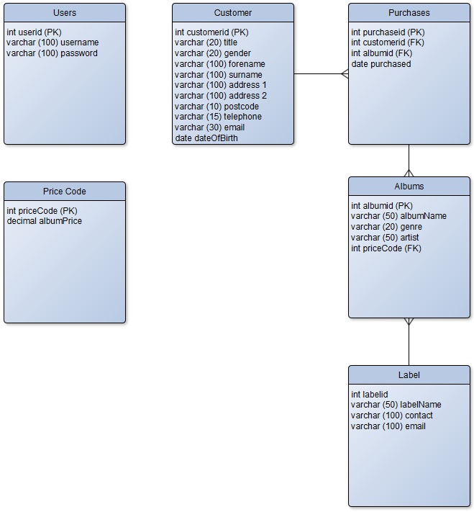

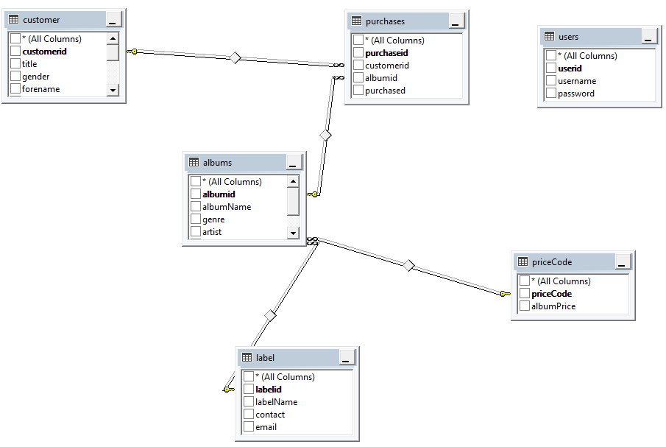
Here are my tables created in SQL server.

When my app first starts up, you are greeted by a login system. The login is connected through the database with the details there. You have 3 attempts to log in, if you fail 3 times, the application will shut itself down and prevent you from trying again. If, however you succeed, then you will be directed to the dashboard where you are able to either exit the application or go into the customers tab.
Once you click on the customers button, you will be directed to a large tab showing the first customer in my database. The purchases that customer has made will also be displayed here. From here, you can search through the list of customers within my database through the “find” button. This will open another tab that you can then see the customers and select which one you would like to view. You can also exit if you choose not to select anyone. Back to the main customer tab, you can also click the “add” button which will bring up a new tab with blank textboxes and fields that you can enter yourself to input a new customer within the database through the application.
Once you click the “create” button from this tab the customer will be created and input into the database. There is also the “edit” button that will allow you to change an existing customers detail. There is also the “delete” button where you can delete the current customer from the database, including their purchases.
Finally, there is the “add purchases” button which will bring up a new tab showing the album records in the database, so a customer is able to make purchases and add them to their account in the database. You can purchase many albums at once by holding CTRL while selecting the albums. You will also need to click on the whole row of the DataGrid to select the album you wish.

Design & Implementation

Screenshots of pages

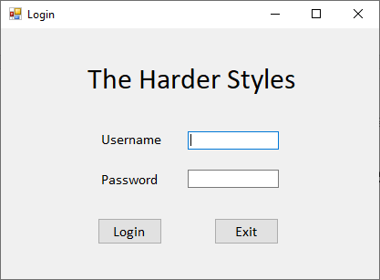
The login page.

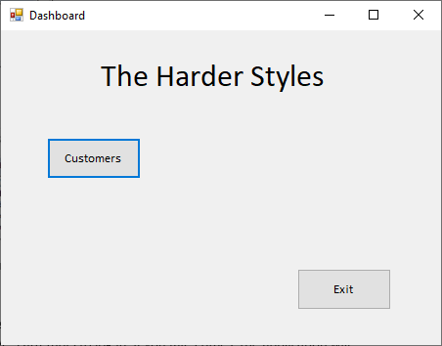
The dashboard.

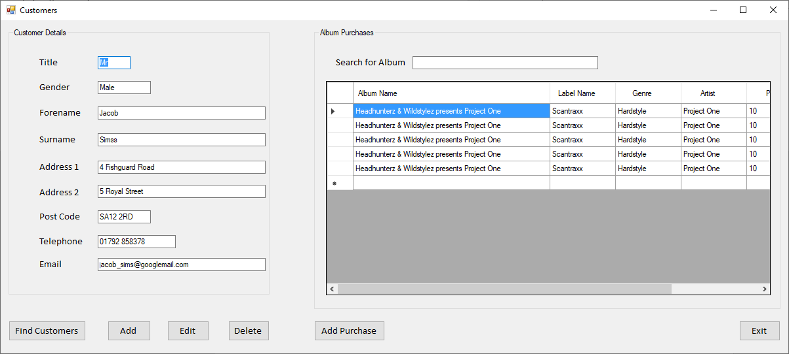
The customer tab.

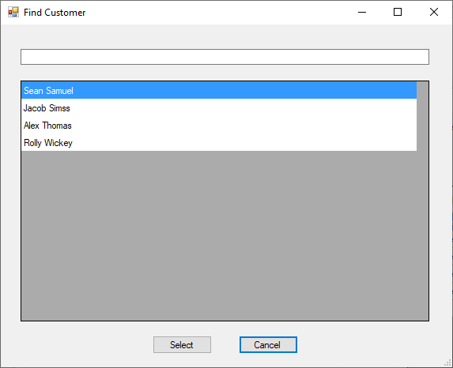
The find customer tab.

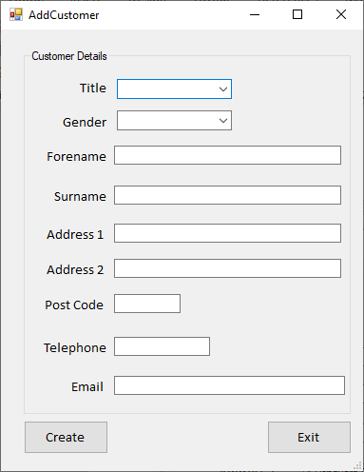
The add customer tab.

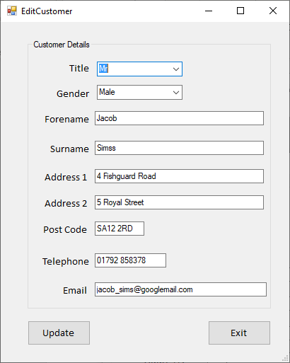
The edit customer tab.
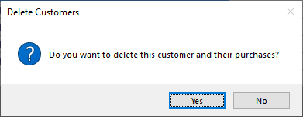
Warning to delete customer.

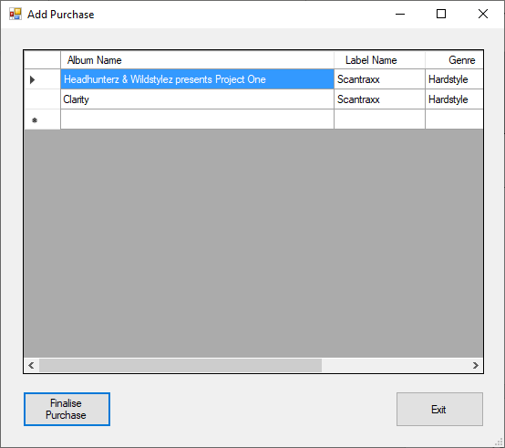
Add purchase tab.

Main design features

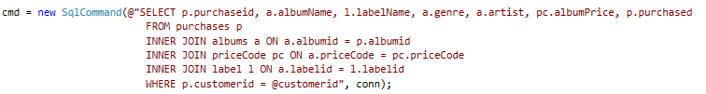
Inner joins.

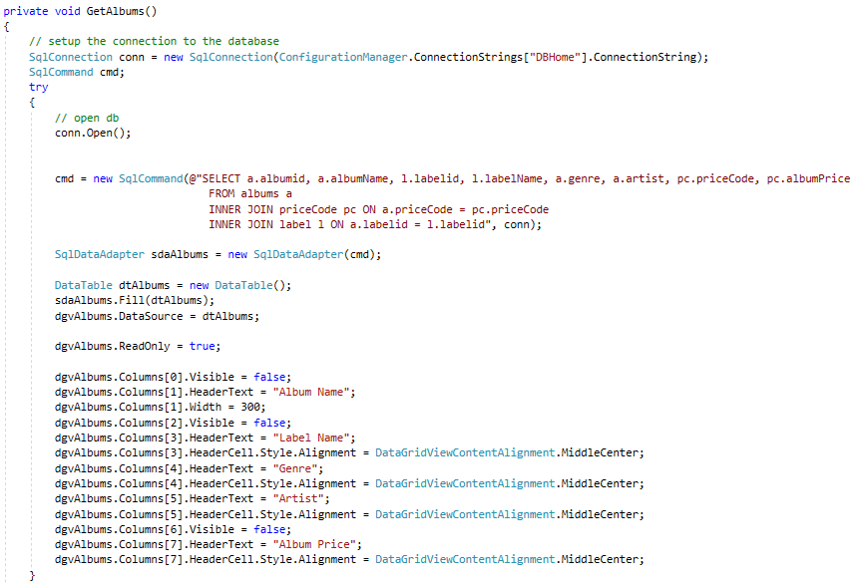
Method to get the albums to appear in the add purchases tab.
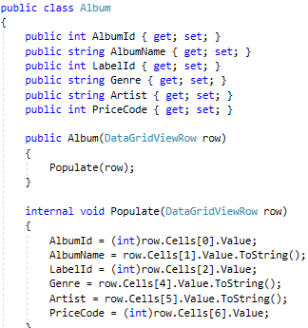
Created an album class to make the data grid properly show the album fields since they were not working at first.

Evaluation

Testing

Login system

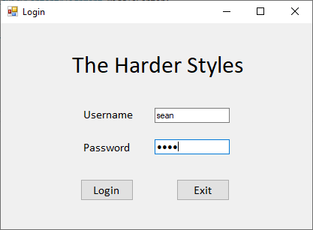
To test this, I am going to enter the correct login details to see if it allows me to go to the dashboard. If not, then the details are either incorrect or the connection to the database is not set up. I was able to get through the dashboard using the username “sean” and the password “sean”.

Now I tried again with the login system , but this time entering the wrong details so I am hopefully going to be kicked out after 3 attempts.
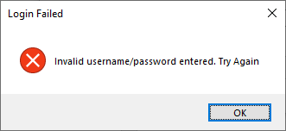
I have failed after the first attempt.

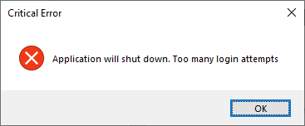
The app kicked me out for being wrong 3 times in a row.

Find and select tab

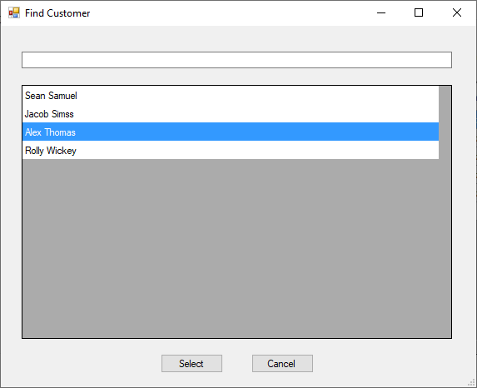
The first customer input is Jacob Sims, and when I clicked on Alex Thomas, it should change the customer tab to the customers info I just chose.

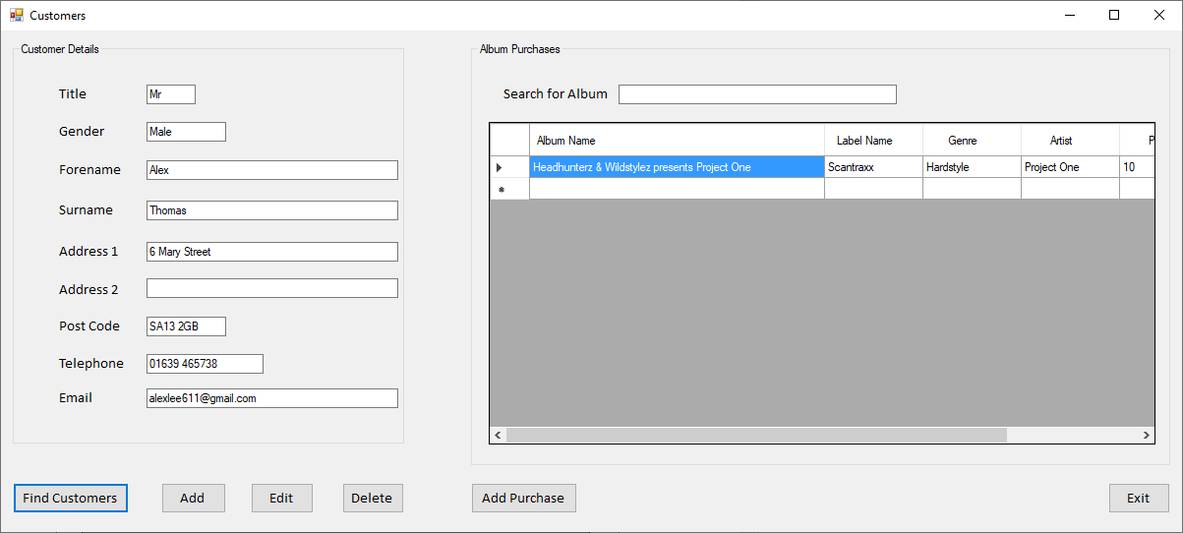
After clicking the select button, Alex’s information has shown up, with his purchases.

Add tab

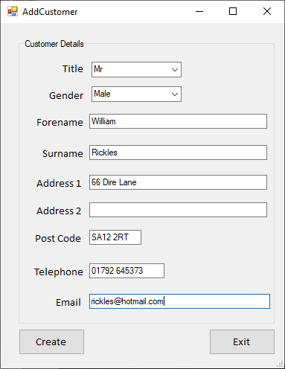
After clicking the create button, I should be able to input this customer into the database and they should be shown in the select tab as well as the customer tab.

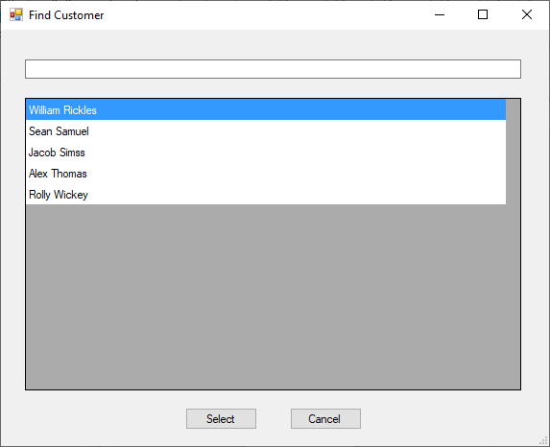
The new customer has appeared here.

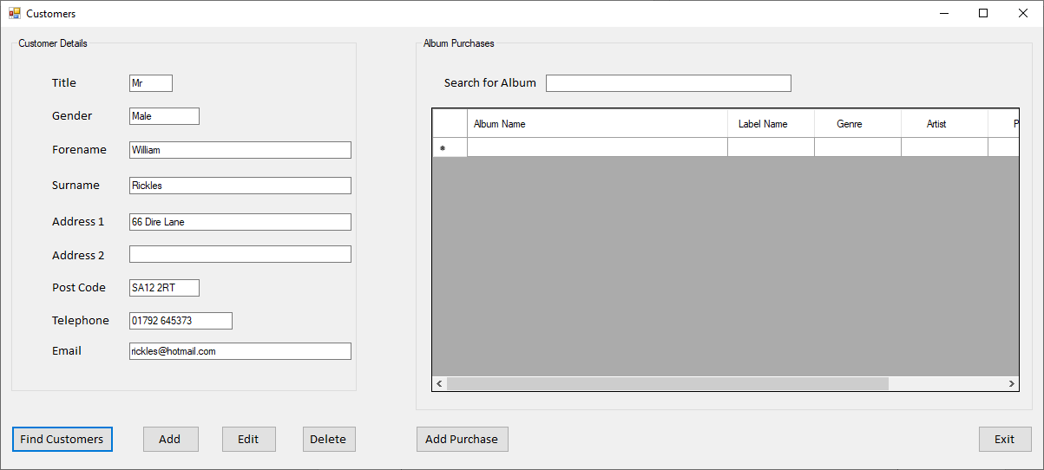
They are also in the customer tab.

Edit Tab

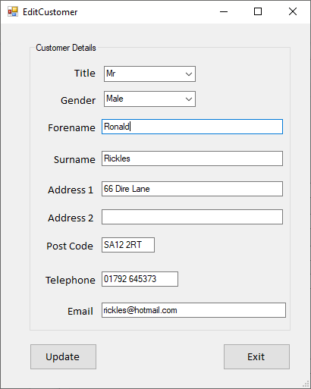
I have changed the forename of William to Ronald, this should update within the database and display within the customer tab.
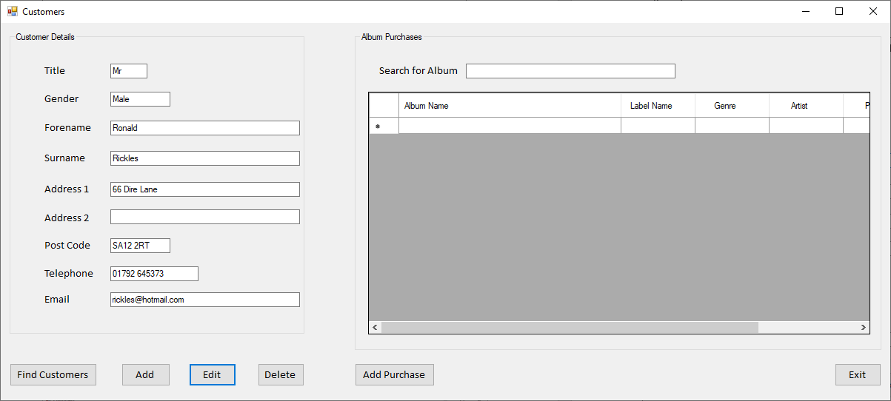

Delete Tab

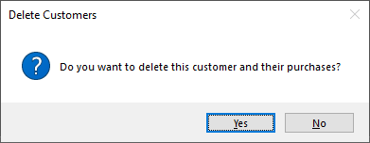
After clicking the delete button and clicking yes on this tab, it should delete the new customer from the database.
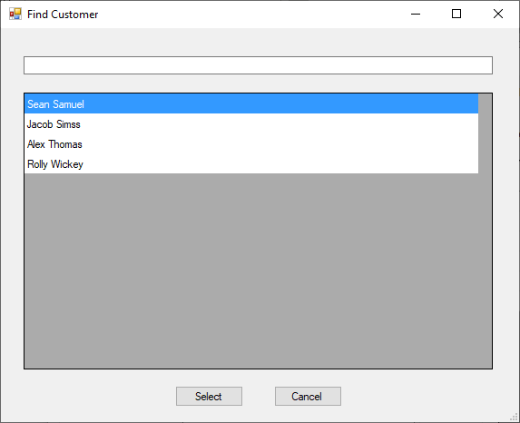
The new customer is no longer in the database.

Add Purchases Tab

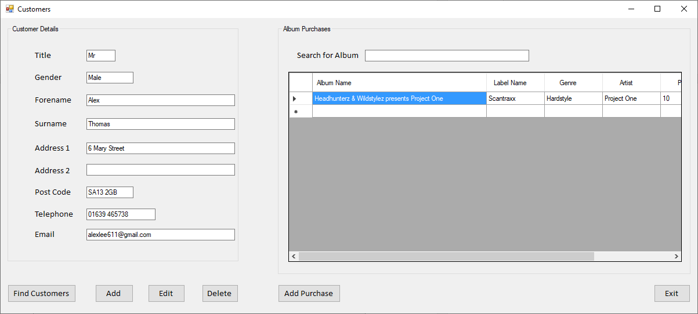
I will add an album purchase for Alex.

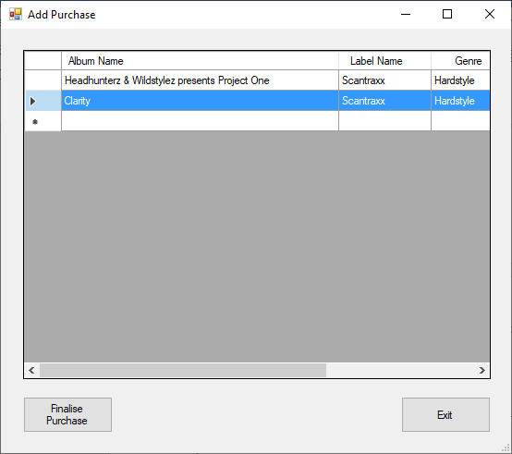

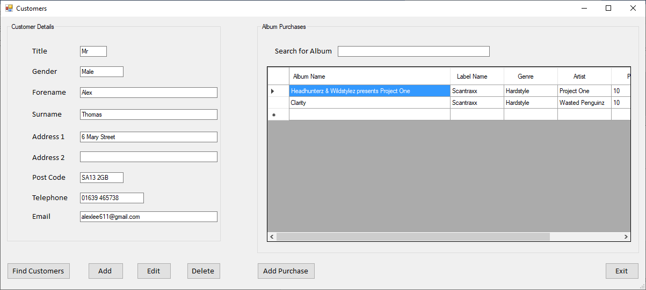
The Clarity album has been added to Alex’s purchases.

Customer Search Bar

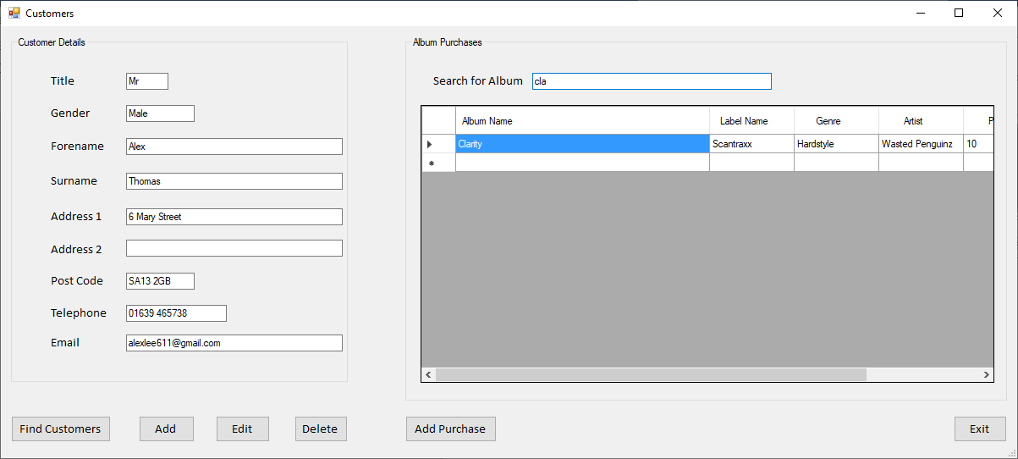
Typing “cla” only brings up the Clarity album.

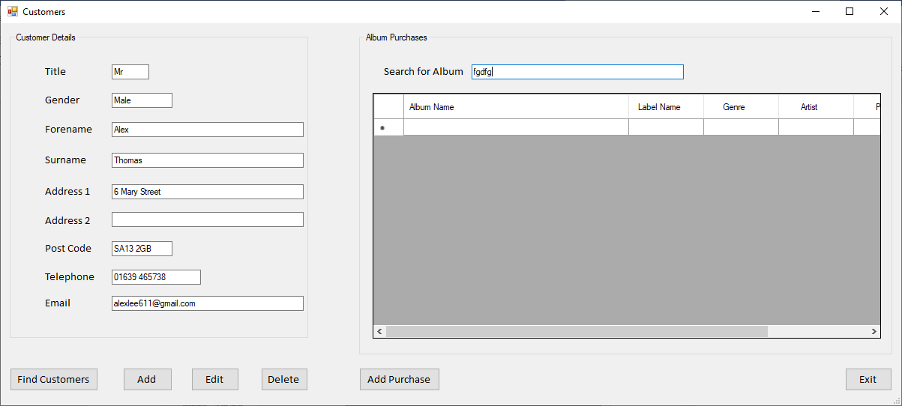
Typing gibberish brings up no albums.

