Programme: BA (Hons) Leadership and Management Skills for the Workplace

Module Code: LCLM5001

Lecturer Name: Eric

Assignment Title: Understanding the importance of Stakeholder Engagement in successful commencement and completion of project.

Student Name : Muhammad Assama Sajid

Student ID: 1714489

Executive Summary
This report examines the vital importance of stakeholder engagement in facilitating the successful initiation and completion of a project within the healthcare sector. The discussion centers on Pfizer UK and how they managed relationships with stakeholders while they were developing and launching a new wearable health monitoring device that tracks heart rate, oxygen saturation, and sleep quality. The goal of the project is to use digital health innovation to improve patient outcomes while still following medical rules, keeping data private, and following ethical standards.
The report starts with a summary of Pfizer UK and a strategic analysis using the SWOT framework to show the project's internal strengths and external challenges. It then talks about the roles, benefits, and problems of both internal and external stakeholders in relation to the launch of the wearable device. The conversation also uses well-known stakeholder management tools like the Stakeholder Matrix, Engagement Plan, Communication Plan, and RACI Matrix to show how structured engagement and clear communication channels can make project collaboration and responsibility better.
Further, the report adopts the 4Cs Model (Communication, Coordination, Cooperation, and Collaboration) to explain how conflicts can be managed effectively while fostering strong stakeholder relationships. The final sections evaluate the overall impact of stakeholder engagement on project performance and provide recommendations to enhance future engagement strategies within Pfizer UK. In general, this report shows that engaging stakeholders in a planned and active way is necessary for managing complexity, getting buy-in, and getting good results in healthcare innovation projects.

Table of Contents
Evaluation of the Company (SWOT Analysis)
Identification of Stakeholders
Positions, Duties, Advantages, and Difficulties( Internal Stakeholders + External Stakeholders )
Analytical Discussion
Frameworks and Tools for Stakeholder Engagement ( Stakeholder Matrix, Engagement Plan, Communication Plan & RACI Matrix.
Integrating Frameworks for Effective Engagement
Stakeholder Engagement Process and Conflict Management (4Cs Model)
Evaluation of Stakeholder Engagement Impact
Recommendations
Conclusion
Reference List

Executive Summary
This report examines the vital importance of stakeholder engagement in facilitating the successful initiation and completion of a project within the healthcare sector. The discussion centers on Pfizer UK and how they managed relationships with stakeholders while they were developing and launching a new wearable health monitoring device that tracks heart rate, oxygen saturation, and sleep quality. The goal of the project is to use digital health innovation to improve patient outcomes while still following medical rules, keeping data private, and following ethical standards.
The report starts with a summary of Pfizer UK and a strategic analysis using the SWOT framework to show the project's internal strengths and external challenges. It then talks about the roles, benefits, and problems of both internal and external stakeholders in relation to the launch of the wearable device. The conversation also uses well-known stakeholder management tools like the Stakeholder Matrix, Engagement Plan, Communication Plan, and RACI Matrix to show how structured engagement and clear communication channels can make project collaboration and responsibility better.
Further, the report adopts the 4Cs Model (Communication, Coordination, Cooperation, and Collaboration) to explain how conflicts can be managed effectively while fostering strong stakeholder relationships. The final sections evaluate the overall impact of stakeholder engagement on project performance and provide recommendations to enhance future engagement strategies within Pfizer UK. In general, this report shows that engaging stakeholders in a planned and active way is necessary for managing complexity, getting buy-in, and getting good results in healthcare innovation projects.

Introduction
Pfizer UK is one of the leading biopharmaceutical organisations in the United Kingdom, known for its extensive portfolio of prescription medicines, vaccines, and biotechnological products. Founded in 1952 and headquartered in Tadworth, Surrey, Pfizer UK operates as part of the global Pfizer Inc. group, which has a presence in over 125 countries. The company’s mission is to apply science and global resources to deliver innovative therapies that improve patients’ livesPfizer has made a growing investment in data-driven patient care and digital health technologies in recent years after realizing the potential of wearable medical technology in preventive healthcare. The Pfizer Smart Health Band, a gadget that continuously tracks cardiovascular activity and sleep quality to aid in the early detection of heart-related conditions, is the subject of the proposed project's design, testing, and market introduction.
Stakeholder engagement in healthcare projects involves the systematic inclusion of individuals and organisations affected by or able to influence project outcomes, ensuring transparency, trust, and shared decision-making (Berlin Institute of Health, 2024).
It is my duty as the project manager to make sure that this endeavor complies with Pfizer's operational and ethical standards in addition to meeting technical and commercial goals. A wide range of stakeholders, including R&D scientists, regulatory agencies, medical professionals, technology suppliers, investors, and end users, must be involved in the project's management. This report's goal is to examine the significance of stakeholder involvement throughout the wearable health device project's lifecycle. The study will assess how Pfizer UK can successfully identify, prioritize, and manage stakeholder expectations to ensure successful project delivery in the healthcare context by utilizing strategic frameworks and useful tools.
Evaluation of the Company (SWOT Analysis)
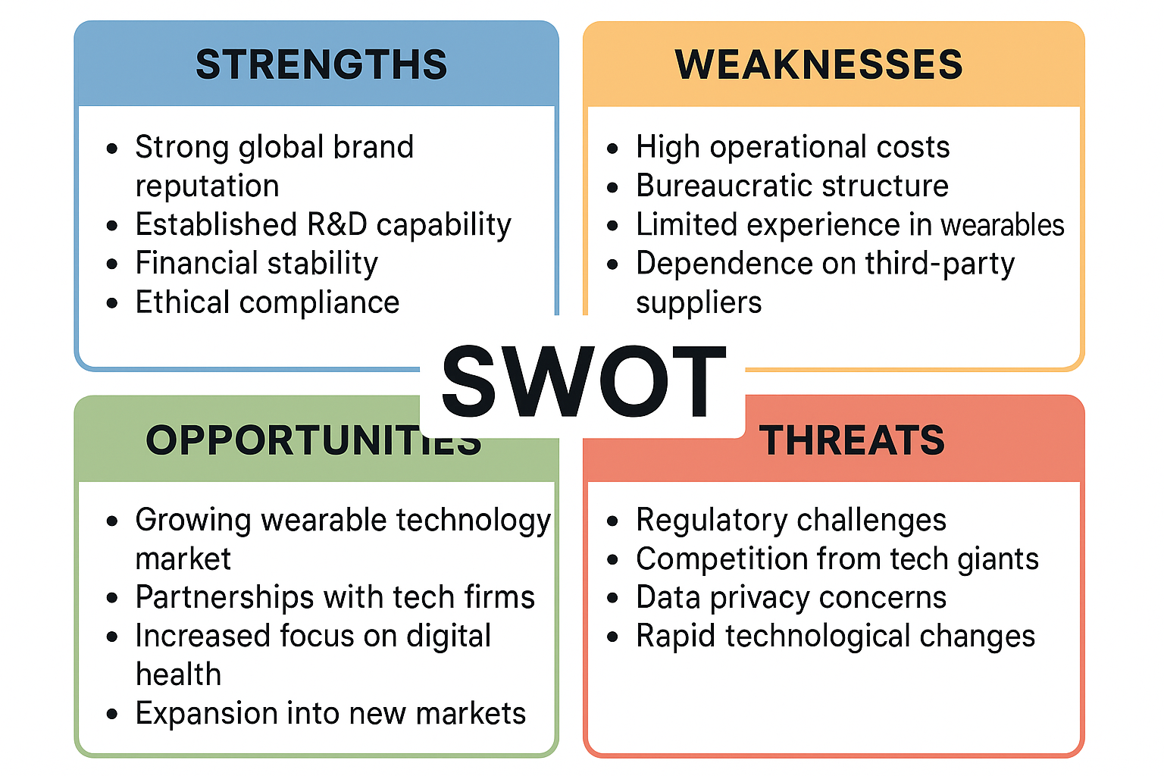

SWOT Analysis refers to an organisation’s evaluation of its internal Strengths and Weaknesses, and external Opportunities and Threats (Gürel & Tat, 2017).
In healthcare innovation projects, engagement ensures that ethical, clinical, and technological perspectives are integrated early, which enhances adoption and legitimacy (Maureen Maurer et al., 2022; AHRQ, 2023).
By identifying variables that may affect the wearable device project's success, a SWOT analysis offers a comprehensive view of Pfizer UK's internal and external environments.
The SWOT analysis highlights that Pfizer’s key strength lies in its reputation, research capability, and regulatory experience, which provide a solid foundation for the development of a medical-grade wearable. However, one notable weakness is the company’s limited experience in consumer-focused technology markets, where competitors already dominate. To overcome this, Pfizer must form strategic collaborations with experienced technology firms, ensuring that hardware and software meet both medical and user-friendly standards.
Given the rising public interest in digital health solutions and the UK government's promotion of innovation in preventive healthcare, the opportunities are substantial. Threats like worries about data privacy and the speed at which technology is developing, however, necessitate constant adaptation. Therefore, throughout development, the project team must maintain regulatory alignment and implement robust cybersecurity measures.
Pfizer can use the SWOT analysis to inform project goals by using a SMART approach (Specific, Measurable, Achievable, Relevant, Time-bound):
• Specifically: Create and introduce a wearable medical device with medical certification to track cardiovascular functions.
• Measurable: Obtain approval from the Medicines and Healthcare Products Regulatory Agency (MHRA) and attain a minimum of 90% accuracy in health monitoring.

• Achievable: To guarantee technical and clinical validity, leverage Pfizer's R&D experience and digital partnerships.
• Pertinent: Encourages Pfizer's objective of using innovation to enhance patient health.
• Time-bound: The project must be finished and launched in six months.
Pfizer UK can make sure that its strategic planning is in line with both internal strengths and market opportunities by combining SWOT and SMART, which will provide a solid foundation for stakeholder engagement and project success.

Identification of Stakeholders
A stakeholder is any individual or group that can affect or is affected by an organisation’s objectives (Freeman, 1984).
Effective stakeholder identification is crucial for the Pfizer Smart Health Band project in order to guarantee that the objectives of the project and the expectations of all stakeholders are in line. Freeman's (1984) Stakeholder Theory states that organizations succeed when they attend to the needs of those who have the power to influence or be impacted by business outcomes. Stakeholders in this context can be divided into two categories: internal (those directly involved in project operations within the organization) and external (those outside the company who influence or are impacted by the project).
The main internal and external stakeholders for the wearable health device project at Pfizer UK are listed in the following table:
As will be covered later, this identification stage lays the groundwork for prioritizing and controlling stakeholder expectations through the use of structured engagement tools like the RACI Matrix and Stakeholder Matrix.
The complexity of healthcare innovation, where several parties—scientific, commercial, and regulatory—must successfully collaborate, is reflected in Pfizer's extensive network of stakeholders.

Positions, Duties, Advantages, and Difficulties
Every stakeholder makes a unique contribution to the project's development. It is easier to establish clear communication and accountability when everyone is aware of their roles, expected benefits, and potential challenges.
Internal Stakeholders
Project Manager
As the project manager, it is my job to supervise the Smart Health Band project's planning, resource distribution, and progress monitoring. Facilitating departmental communication, controlling risks, and making sure stakeholder interests are balanced are all part of my job. Having direct control over resource management and decision-making is the primary advantage of this position. The difficulty, though, is in keeping diverse teams with disparate priorities in alignment.
R&D Department
Clinical standards are met by the wearable thanks to the R&D team. Their knowledge enhances the credibility and dependability of the product's performance. Pfizer can profit from its reputation as a scientific company. The main obstacle is combining user-friendly technology with medical accuracy, which calls for cross-functional cooperation with UX designers and software engineers.
Regulatory Affairs Team
They are in charge of making sure that healthcare laws like the General Data Protection Regulation (GDPR) and MHRA guidelines are followed. This team gains from enhancing Pfizer's standing for moral business practices, but they also confront difficulties because digital device compliance regulations are evolving quickly.
IT & Data Security Team
This team oversees patient data storage systems, encryption protocols, and cybersecurity. They gain from creating cutting-edge data security solutions that can be applied to other projects in the future. The main difficulty is maintaining interoperability with healthcare systems such as the NHS while protecting sensitive medical data.
Marketing & Communications Department
This division raises awareness, maintains brand integrity, and makes sure that the product's medical dependability is communicated clearly to the general public. The expansion of Pfizer's consumer-facing presence is advantageous to them. It can be challenging to strike a balance between medical accuracy and clear language for promotional materials.
Finance Department
The budget, cost analysis, and investment forecasting are all under the control of the finance team. Enhancing Pfizer's financial planning for related innovation initiatives benefits them. Controlling costs in the face of shifting technology costs and regulatory fees is their challenge.
Human Resources (HR)
HR controls internal engagement, supports a positive workplace culture, and makes sure the project has the right talent. Maintaining employee morale under pressure and coordinating across departments is a challenge, but the reward is a skilled and driven workforce.
External Stakeholders
NHS and Private Healthcare Providers
These institutions may partner with Pfizer to use the wearable for patient monitoring. The benefit for them is better patient data and preventive care insights. Their main challenge is integrating the new technology with existing digital systems and ensuring data privacy compliance.
Patients and End-Users
Real-time health insights and early risk detection are the most immediate benefits to end users. Understanding how data fits into frameworks for medical advice and having faith in its accuracy are their challenges. Priorities for user education and training are crucial.
Technology Suppliers
Software integration, processors, and sensors are supplied by suppliers. Long-term collaboration and income potential are advantages for them. Meeting Pfizer's exacting medical standards and making sure deliveries are made on time to prevent delays are obstacles, though.
Regulatory Authorities
Patient safety and privacy are protected by organizations like the Information Commissioner's Office (ICO) and the Medicines and Healthcare Products Regulatory Agency (MHRA). Although they guarantee compliance, their thorough review procedures frequently cause project delays.
Investors and Shareholders
Investors anticipate a profit as well as brand expansion driven by innovation. Their gain is correlated with Pfizer's market performance. They face risk exposure as a result of erratic technological or regulatory obstacles.
Retail Partners and Pharmacies
The public can access products through these channels. Increased sales are their advantage, but providing adequate staff training to explain device use and technical support to customers is a challenge.
Academic and Research Institutions
Medical research facilities and universities work together to verify the wearable's precision and therapeutic advantages. They gain from increased awareness of the research. However, different timelines for corporate objectives and academic goals create coordination issues.

Analytical Discussion
Pfizer's stakeholder network is diverse, which brings with it both opportunities and challenges. Three characteristics—power, legitimacy, and urgency—can be used to prioritize stakeholders in accordance with Mitchell, Agle, and Wood's (1997) framework of stakeholder salience. Due to their direct reliance on the device's results, patients and healthcare providers exhibit high urgency in this project, while investors and regulatory bodies hold high power and legitimacy.
This aligns with evidence from recent studies showing that structured engagement improves healthcare innovation efficiency, regulatory compliance, and stakeholder satisfaction (Woudstra et al., 2023; Landers et al., 2023).
Therefore, balanced attention across groups will be necessary for effective stakeholder engagement:
• Clarity, cooperation, and common goals are necessary for internal stakeholders.
• Transparency, dependability, and participation in the testing and feedback phases are necessary for external stakeholders. In my role as project manager, I have to take a cooperative stance that supports Bourne's (2015) stakeholder relationship management model, which emphasizes mutual value creation, trust, and communication. Pfizer can avoid misunderstandings, sustain motivation, and guarantee seamless project progress by acknowledging the expectations of each group.
The foundation for the communication tools and engagement frameworks that will be used in the report's next phase is laid by this thorough understanding of stakeholders. These tools will offer organized ways to control the exchange of information, responsibility, and collaboration among all parties.
Frameworks and Tools for Stakeholder Engagement
A methodical approach to setting priorities, interacting with stakeholders, and communicating with them is necessary for effective stakeholder management. Stakeholder management is most effective when it blends analytical tools with effective interpersonal communication and trust-building, claims Bourne (2015). The Pfizer Smart Health Band project employs the following frameworks to organize engagement throughout all project phases: the Stakeholder Matrix, Engagement Plan, Communication Plan, and RACI Matrix.
Stakeholder management in healthcare is most effective when analytical tools are supported by active communication, inclusivity, and co-design with clinical and patient partners (MuSE Consortium, 2023).
Stakeholder Matrix
Based on each stakeholder's power (influence over project decisions) and interest (level of involvement or concern), the Stakeholder Matrix, also called a Power-Interest Grid, is a straightforward but useful tool for assessing how much attention each stakeholder needs.
The most important stakeholders who need close supervision and ongoing involvement, according to this analysis, are the project manager, NHS partners, and regulatory bodies. Regular updates on technological and financial advancements are necessary to satisfy investors, while patients, despite their lack of influence, require a high level of trust and transparency to guarantee credibility and adoption.
By concentrating more resources on those whose influence and interest have the biggest direct impact on success, the project manager can more efficiently allocate time and communication efforts.

Stakeholder Engagement Plan
Each stakeholder's involvement in the project is outlined in a stakeholder engagement plan, which also specifies the goal, mode of engagement, and frequency of communication. This methodical approach lowers the possibility of misunderstandings or disengagement while assisting in the maintenance of steady relationships.
The engagement plan emphasises structured, proactive communication, ensuring that key stakeholders remain involved and informed. It reflects Bourne’s (2015) view that engagement is not a one-time task but a continuous process of building trust through consistent interaction.

Communication Plan
In order to engage stakeholders, communication is essential. Effective information exchange between the project team and stakeholders is ensured by a communication plan. According to PMI (2021), a major contributor to project failure is poor communication, so this plan makes sure that there is clarity, frequency, and transparency.
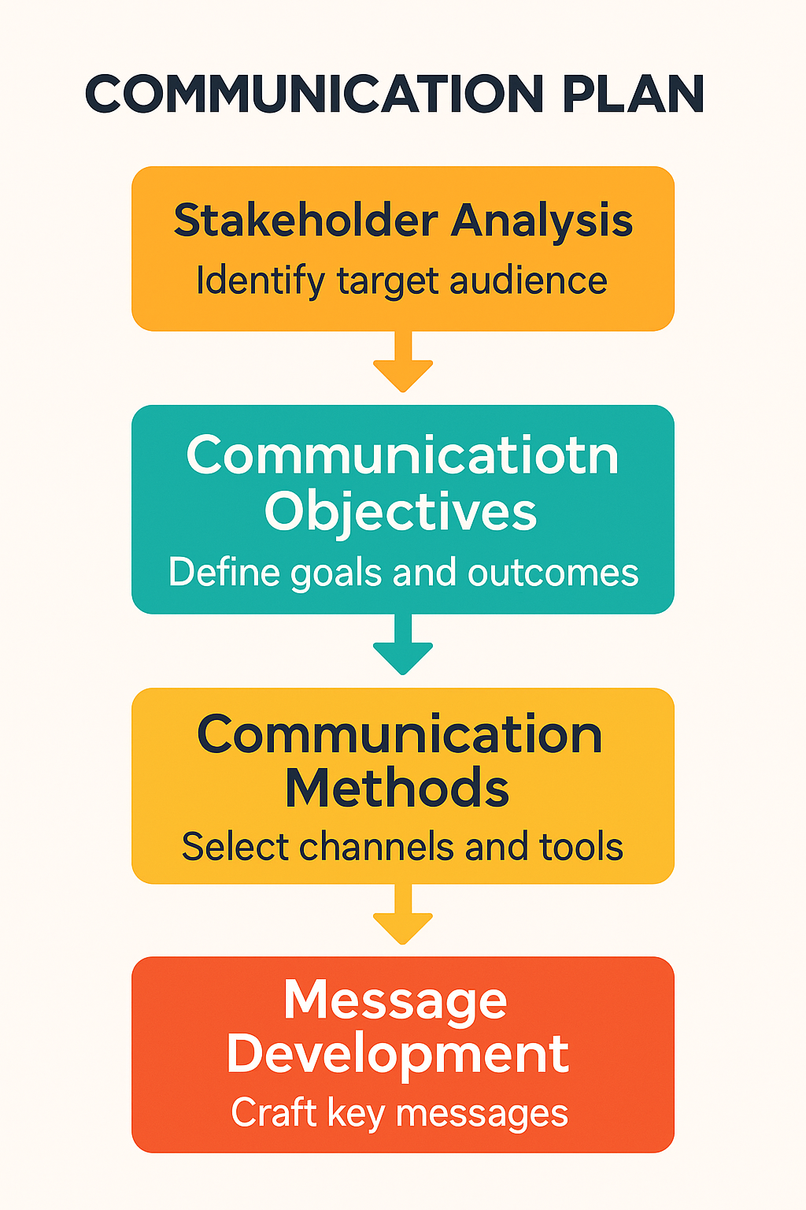

Transparency and accountability are guaranteed throughout the project with this plan. Crucially, it facilitates two-way communication, enabling stakeholders to exchange ideas and opinions in addition to receiving information. NHS representatives, for instance, can draw attention to clinical usability issues early on so that the project team can address them prior to launch.
According to Ashcroft (2017) in The Relational Lens, regular updates via visual dashboards and feedback loops also foster a sense of shared ownership and inclusion, which are essential components of effective stakeholder collaboration.
RACI Matrix
The RACI Matrix (Responsible, Accountable, Consulted, Informed) clarifies who is responsible for what, helping avoid confusion or overlapping duties during the project. It provides transparency and ensures everyone understands their level of involvement.
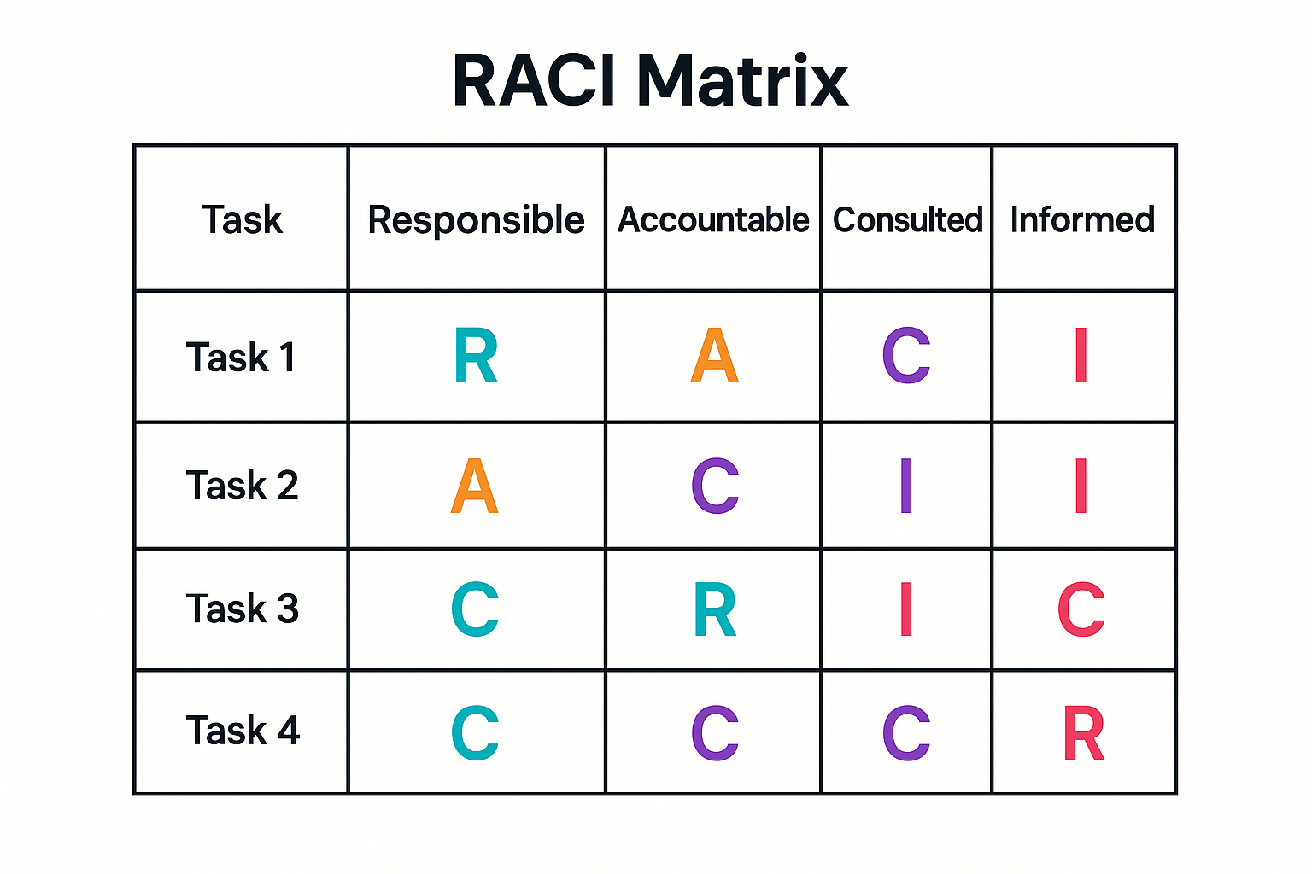
By designating specific roles, the RACI matrix improves operational clarity. It guarantees that while teams are responsible for carrying out their tasks, the project manager is still held accountable for overall progress. In large organizations like Pfizer, where coordination can easily become fragmented, clear accountability is essential for reducing delays, improving decision-making, and fostering cross-departmental trust.
Integrating Frameworks for Effective Engagement
These frameworks work together to form an all-inclusive stakeholder management system. Priority levels are determined by the Stakeholder Matrix, relationships will be maintained by the Engagement Plan, accountability and structured collaboration are ensured by the RACI Matrix, and transparency and responsiveness are guaranteed by the Communication Plan.
The RACI Matrix is a project responsibility tool formally recognised in PMBOK guidelines (PMI, 2021).
The PMI (Project Management Institute, 2021) guidelines, which emphasize stakeholder communication as one of the most important factors in project success, are in line with these tools. Together, they foster an environment of transparency, cooperation, and respect for one another—all of which are critical in a healthcare innovation setting where mistakes or delays can have a direct effect on patient care.
Since different stakeholders have varying preferences for information levels and engagement formats, it is my responsibility as a project manager to maintain an adaptable communication style. Throughout the project lifecycle, Pfizer UK can make sure that all stakeholders are informed, involved, and dedicated to reaching common goals by regularly assessing the efficacy of these tools.
Stakeholder Engagement Process and Conflict Management (4Cs Model)
Tension and conflict are rarely absent from stakeholder engagement, especially in intricate healthcare projects where partners and departments may have different expectations, levels of expertise, and objectives. Effectively handling this is crucial to preserving teamwork and guaranteeing project success. I will use the 4Cs Model—Coordination, Collaboration, Cooperation, and Communication—created by Ellis, Gibbs, and Rein (1991) to direct this.
Communication
Establishing clear and consistent communication is the first step towards effective engagement. Digital dashboards, planned meetings, and direct feedback loops are some of the ways that the Pfizer Smart Health Band project communicates. As project manager, I ensure that updates are regular and transparent, using plain but accurate language that suits each audience. For instance, patients and end users gain from easily accessible updates outlining the wearable's safety features and health benefits, even though regulatory agencies demand technical documentation and compliance data.
Stakeholders feel more involved in decision-making when there is open communication, which also lowers uncertainty. Additionally, it backs Ashcroft's (2017) idea of relational transparency, which fosters mutual understanding and openness to increase trust. All communications are recorded and disseminated among teams to guarantee efficacy, ensuring information continuity even in the event that staff or project priorities shift.
Coordination
The smooth operation of the project's many moving components is ensured by coordination. Cross-functional cooperation between R&D scientists, IT experts, marketing teams, and outside suppliers is a component of Pfizer's wearable device project. Integrated project management software, which monitors development, detects dependencies, and highlights delays, keeps coordination intact.
In addition, I schedule coordination meetings with department heads every two weeks to go over the project schedule, delegate tasks, and talk about possible bottlenecks. This strategy is in line with PMI's (2021) advice that project managers serve as key intermediaries to keep teams and strategic goals aligned. Efficiency is increased and duplication of effort is reduced through coordination, especially in large organizations where departments may function independently.

Cooperation
Fostering a common goal among stakeholders is a key component of cooperation. Pfizer's inclusive culture, which values knowledge sharing and respect for expertise, fosters collaboration. For instance, the IT and R&D departments work together to integrate secure software architecture with medical data sensors.
Partnership agreements with academic institutions and the NHS are used to foster external cooperation. These partnerships lend legitimacy and guarantee that Pfizer's wearable satisfies ethical and clinical standards. Cooperative stakeholder relationships improve long-term value creation because stakeholders feel invested in the project's success, claim Christopher, Payne, and Ballantyne (2013). By acknowledging contributions, promptly resolving issues, and encouraging a culture of problem-solving rather than blame, I uphold cooperation.
Collaboration
The greatest degree of stakeholder engagement is collaboration, in which all participants actively share risks, offer ideas, and celebrate successes. In order to enhance usability and user interface design, Pfizer will hold cooperative workshops with NHS clinicians, technology partners, and patients during the project's last phase.
This degree of involvement guarantees that the finished product is not only technically sound but also useful and user-centered. Working together supports Freeman's (1984) stakeholder theory tenet that inclusiveness and shared value produce long-term success. As a project manager, I view collaboration as a continuous process that continues after the launch, involving ongoing product updates and feedback.

Evaluation of Stakeholder Engagement Impact
Assessing stakeholder engagement's effects aids in figuring out how well the procedure aided in the project's success. Four factors can be used to evaluate the impact on Pfizer UK: reputation, stakeholder satisfaction, organizational learning, and project performance.
1. Project Performance
Decisions are made more quickly and with fewer delays when stakeholders are actively involved. The MHRA's early involvement, for instance, helps identify regulatory issues prior to testing, preventing rework later. In a similar vein, incorporating the R&D and IT teams early on guarantees the smooth integration of technical and medical elements. This is in line with Bourne (2015), who highlights how stakeholder involvement lowers project risk and improves quality results.

2. Organisational Learning
Knowledge sharing between departments that previously operated independently is encouraged by the wearable device project. Frequent communication promotes an environment of open discussion about both successes and failures. Future developments in digital health can benefit from the lessons learned from this project, which will help Pfizer's long-term digital transformation plan.
3. Stakeholder Satisfaction
Stakeholder confidence is increased through active participation. Following the device's launch, patients, healthcare professionals, and regulators are more likely to support and promote it when they feel heard. Feedback loops and surveys can be used to gauge satisfaction levels and pinpoint areas that need work. This is in line with Mitchell, Agle, and Wood's (1997) theory of stakeholder salience, which holds that stakeholders with high levels of engagement have the ability to influence public acceptance and trust.
4. Organisational Reputation
When stakeholders witness ethical engagement and transparency, Pfizer's standing as a conscientious and inventive healthcare provider is reinforced. Pfizer's credibility is increased by good relations with regulatory bodies and healthcare providers, and brand loyalty is increased by patient trust. Long-term competitive advantage is supported by this relational impact, which extends beyond immediate financial gain.
Stakeholder engagement offers both concrete and intangible advantages, according to the evaluation's overall findings. It boosts Pfizer's standing in the dynamic digital health market, increases project efficiency, fosters organizational learning, and fosters trust.

Recommendations
Based on the analysis of Pfizer’s stakeholder engagement practices in the Smart Health Band project, the following recommendations can improve future initiatives:
Implement Continuous Feedback Mechanisms
Even after launch, Pfizer should set up a continuous digital feedback system that enables stakeholders, especially patients and clinicians, to exchange real-time insights. This guarantees that updates are grounded in actual user data rather than conjecture.
Develop a Stakeholder Relationship Management (SRM) Platform
Pfizer might use a specialized SRM system to map relationship health, communication frequency, and engagement levels, drawing inspiration from Bourne's (2015) maturity model. Managers would be able to keep an eye on stakeholder sentiment and take proactive measures with this data-driven approach.
Enhance Training and Awareness
Training in stakeholder communication, conflict resolution, and cultural sensitivity ought to be provided to every member of the project team. This supports Ashcroft's (2017) assertion that relational awareness and empathy are essential leadership traits.
Formalise a Conflict Escalation Framework
Provide a clear, detailed procedure for resolving conflicts within departments or with outside partners. Early mediation helps preserve trust and keeps minor conflicts from getting worse.
Strengthen Ethical and Data Governance Communication
Pfizer should make its data protection policies more widely known in light of the public's growing concern over digital privacy. Consumer confidence and compliance can be increased by publishing privacy statements in plain language.
Promote Long-Term Collaboration with Healthcare Providers
Pfizer should create long-term co-innovation agreements rather than approaching the NHS partnership as a project-based one. Pilot projects and collaborative research initiatives can guarantee continued applicability and integration in the healthcare system.
These suggestions center on sustainability, making sure that involving stakeholders is not just a one-time project but rather a continuous organizational capability.
Conclusion
Stakeholder engagement is essential to the success of healthcare innovation, as the analysis of Pfizer UK's Smart Health Band project shows. Pfizer can more successfully negotiate difficult ethical, technical, and regulatory issues by methodically identifying, prioritizing, and managing stakeholders.
Throughout the project lifecycle, clarity, accountability, and transparency are provided by the use of frameworks like the RACI Matrix, Stakeholder Matrix, Engagement and Communication Plans, and SWOT analysis. Furthermore, using the 4Cs Model guarantees that cooperation, coordination, communication, and collaboration are interrelated processes that foster shared ownership and trust among all parties involved rather than being discrete acts.
The RACI Matrix is a project responsibility tool formally recognised in PMBOK guidelines (PMI, 2021).
My duties as a project manager go beyond simply completing the work; they also include fostering an atmosphere in which all parties involved feel appreciated, informed, and committed to the project's goals. Effective engagement results in more than just a successful launch; it lays the groundwork for ongoing innovation, better patient outcomes, and enhanced organizational reputation.
To sum up, stakeholder engagement is a strategic capability that allows Pfizer UK to provide patient-centered, high-quality, and ethical digital health solutions. It is not just a managerial tool.
Reference List
AHRQ (Agency for Healthcare Research and Quality) (2023) Patient-Centeredness, Diversity, and Stakeholder Engagement.
Ashcroft, J. (2017) Project Communication and Stakeholder Engagement. London: Routledge.
Berlin Institute of Health (2024) What is stakeholder engagement?
Bourne, L. (2015) Stakeholder Relationship Management: A Maturity Model for Organisational Implementation. 2nd edn. Farnham: Gower.
Christopher, M., Payne, A. and Ballantyne, D. (2013) Relationship Marketing: Creating Stakeholder Value. Oxford: Butterworth-Heinemann.
Freeman, R. E. (1984) Strategic Management: A Stakeholder Approach. Boston: Pitman.
Hosszú, D. (2024) ‘Engagement of Medication Users in the Development and Implementation of Digital Medication Adherence Technologies (DMATech).’ Journal of Technology in Health Services.
Kennedy, S. (2025) ‘Engaging Stakeholders in the Development of a National Digital Mental Health Strategy.’ Journal of Medical Internet Research.
Landers, C., Reuzel, R., Rovers, M. and Tummers, M. (2023) ‘Stuck in Translation: Stakeholder Perspectives on Impediments to Responsible Digital Health.’ BMC Medical Ethics.
Maureen Maurer, R., Mangrum, R., Hilliard-Boone, T. et al. (2022) ‘Understanding the Influence and Impact of Stakeholder Engagement in Patient-centred Outcomes Research: a Qualitative Study.’ Research Involvement and Engagement.
Mitchell, R. K., Agle, B. R. and Wood, D. J. (1997) ‘Toward a Theory of Stakeholder Identification and Salience: Defining the Principle of Who and What Really Counts.’ Academy of Management Review, 22(4), pp. 853–886.
MuSE Consortium (2023) ‘Key Issues for Multi-Stakeholder Engagement in Guideline Development.’ Research Involvement and Engagement.
PMI (Project Management Institute) (2021) A Guide to the Project Management Body of Knowledge (PMBOK® Guide). 7th edn. Pennsylvania: PMI.
Woudstra, K., Reuzel, R., Rovers, M. and Tummers, M. (2023) ‘An Overview of Stakeholders, Methods, Topics, and Challenges in Participatory Approaches Used in the Development of Medical Devices: A Scoping Review.’ International Journal of Health Policy and Management, 12(1), pp. 1–8.
Additional References
Gürel, E. & Tat, M. (2017). SWOT Analysis: A Theoretical Review.
Freeman, R.E. (1984). Strategic Management: A Stakeholder Approach.
PMI (2021). A Guide to the Project Management Body of Knowledge (PMBOK Guide).

