

Task 1 – Reading Task Template
Upload your photo of your A3 in-class notes here:
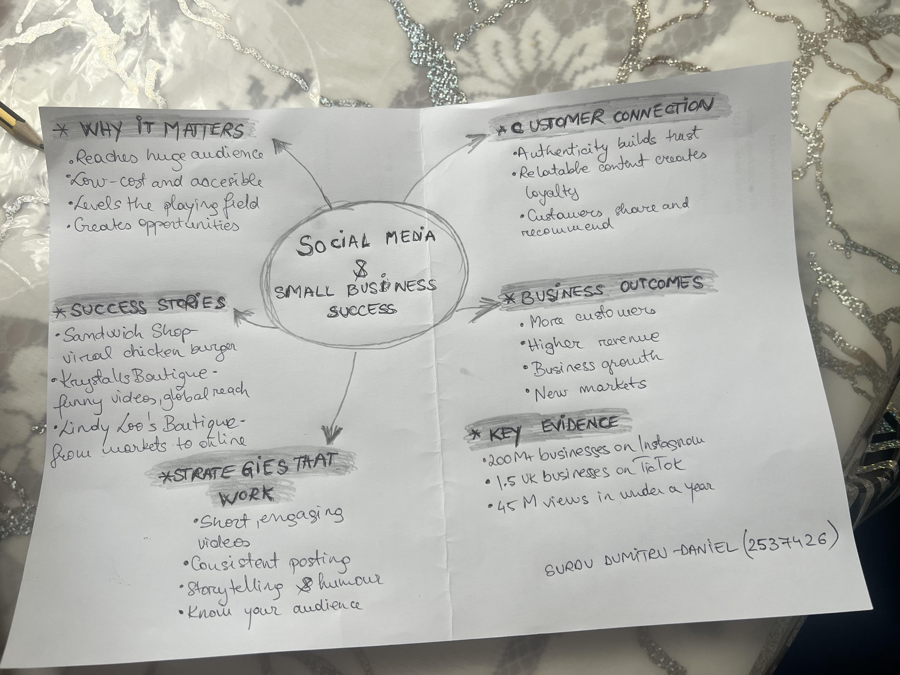

1. Answer these questions using the sentence starters below
a. What is the main idea of the text?
The main idea is that popular social media platforms like TikTok, Instagram, and Facebook are valuable tools for helping small businesses expand their reach and increase their customer base.
b. What are two key points?
One key point is that social media marketing can generate more visibility for small businesses, leading to higher sales.
Another key point is that creating genuine, relatable posts helps build trust with customers, encouraging loyalty and ongoing support.

c. What part of the text did you find most important? Why?
The example about Little Love’s Pamper Bus stood out because it clearly shows how social media can lead to rapid success by connecting a business with a large audience quickly.

d. Was anything unclear or difficult to understand?
I found it a bit confusing how quickly social media can transform a small business’s success without much offline marketing involved.

e. How did your group help you understand the text better?
My group contributed by explaining complex ideas, debating different viewpoints, and helping to clarify parts of the text that I initially found confusing.

3. One sentence reflection
Question: What did you find challenging about this task?
The most challenging aspect was pinpointing exact data and facts because the numbers mentioned were quite large and sometimes hard to relate to.

