Device | Interface | IP Address | Subnet Mask | Default Gateway
PCA | Fa0/1 | 192.168.1.1 | 255.255.255.0 | 192.168.1.3
PCB | Fa0/2 | 192.168.1.2 | 255.255.255.0 | 192.168.1.3
Switch | Vlan1 | 192.168.1.4 | 255.255.255.0 | N/A
Wireless Router | LAN | 192.168.1.3 | 255.255.255.0 | N/A
LaptopA | Wireless0 | 192.168.1.100 | 255.255.255.0 | 192.168.1.3
LaptopB | Wireless0 | 192.168.1.101 | 255.255.255.0 | 192.168.1.3
Lab 4 – Task 2 Documentation

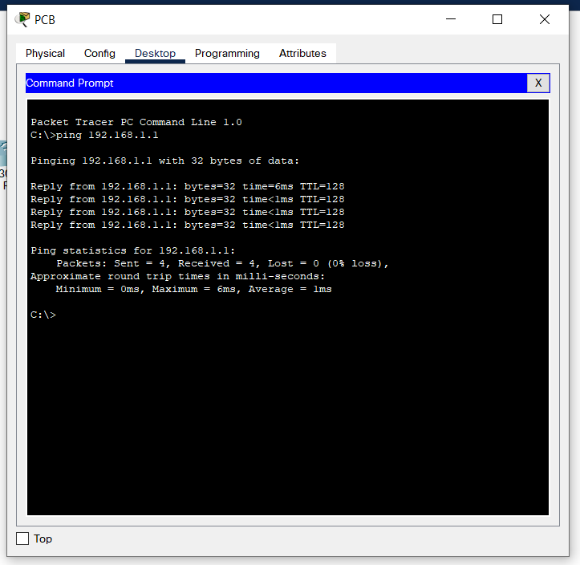
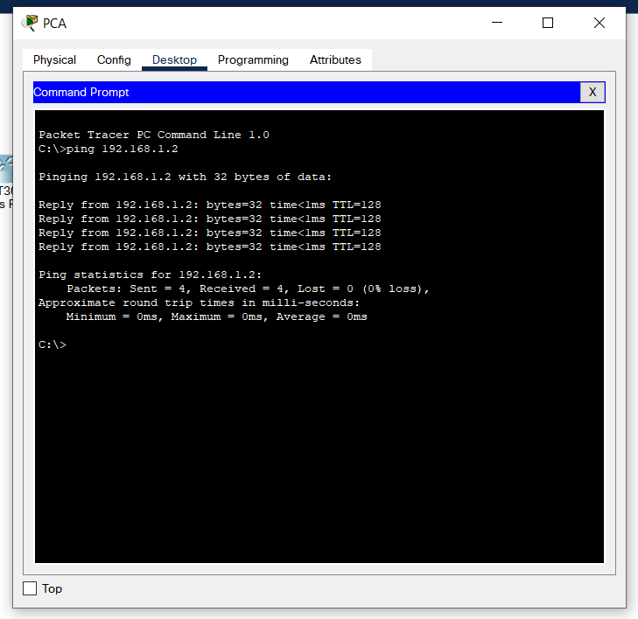
Ping results (PCA – PCB):

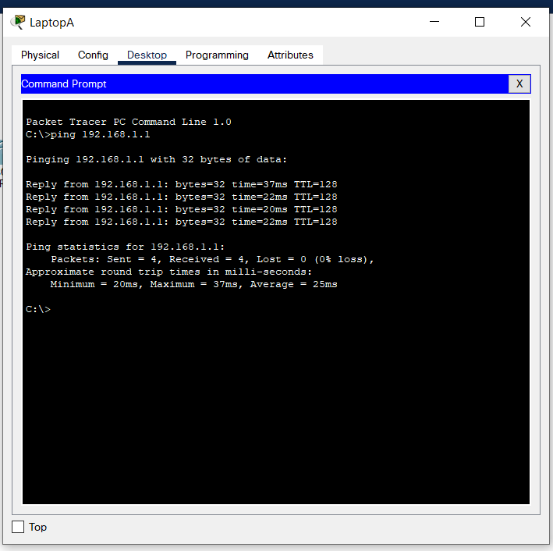
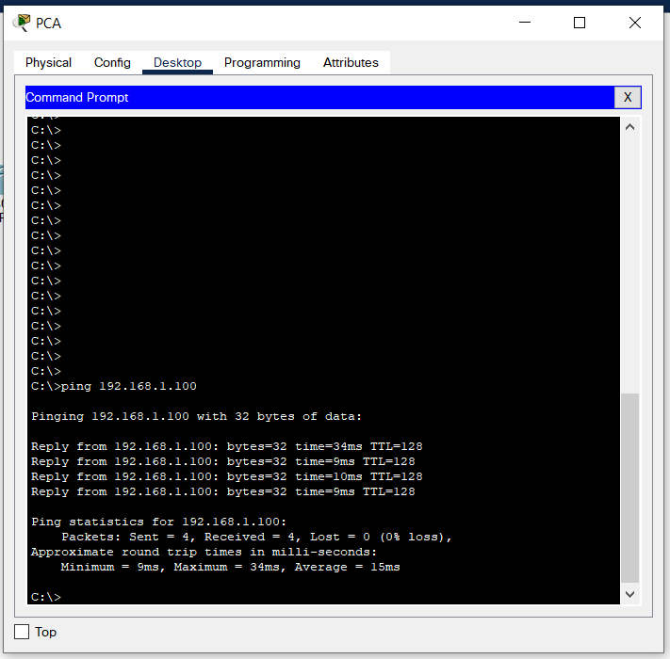
Ping results (PCA – LaptopA):
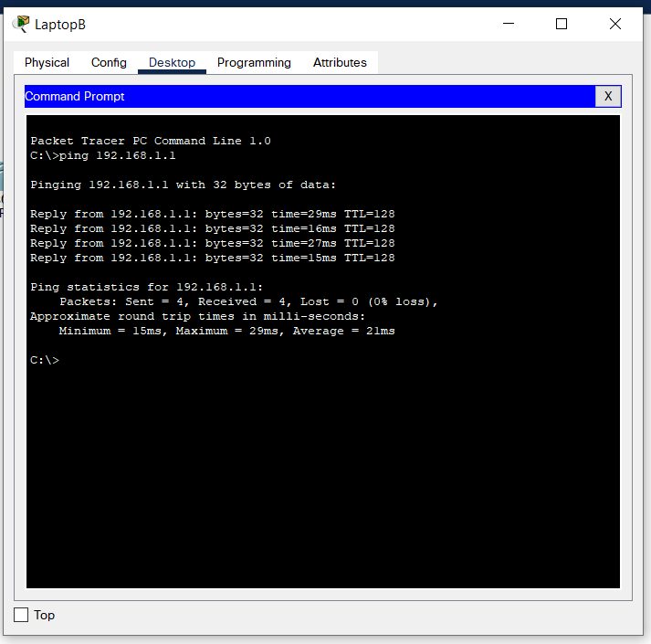
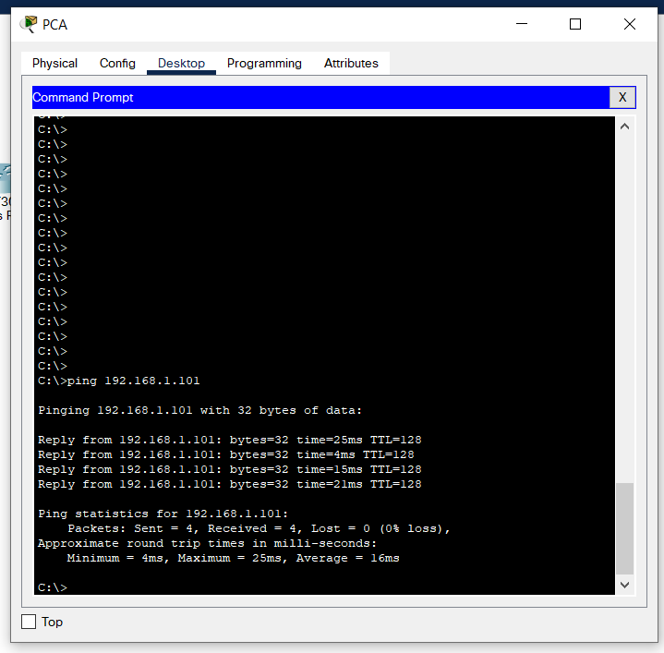
Ping results (PCA – LaptopB):

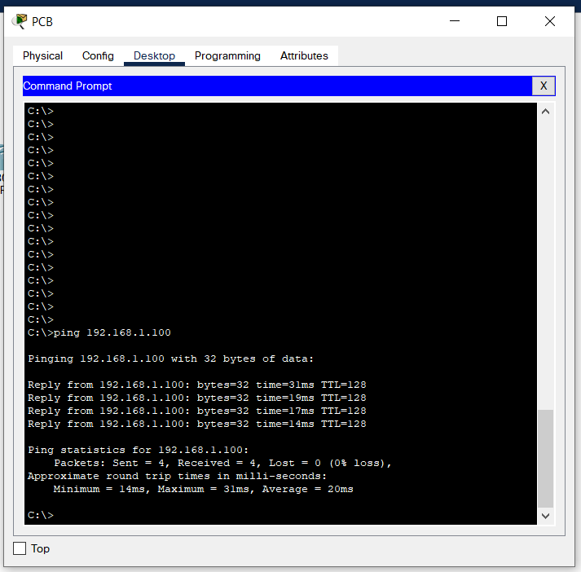
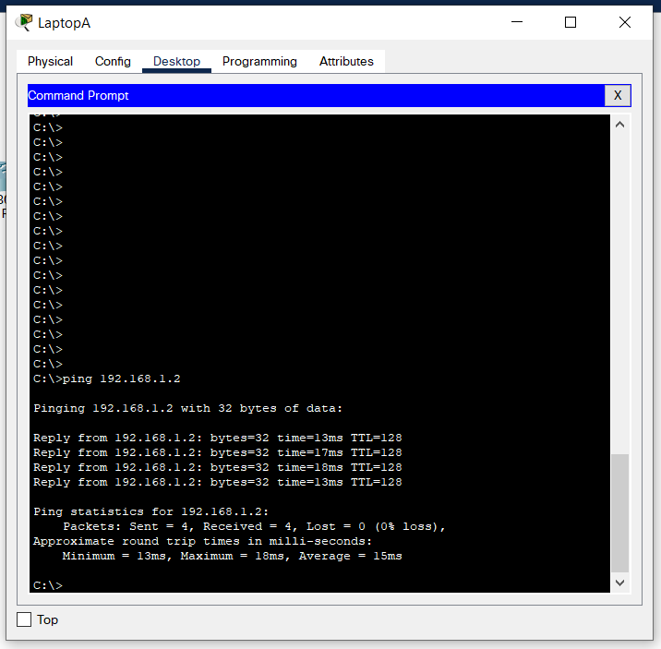
Ping results (PCB – LaptopA):

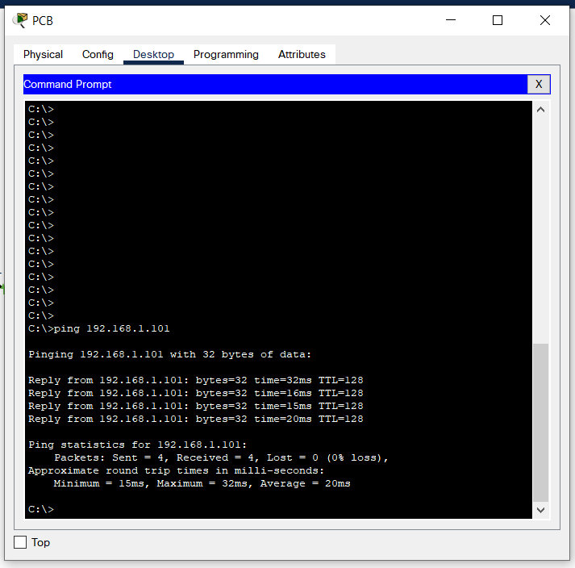
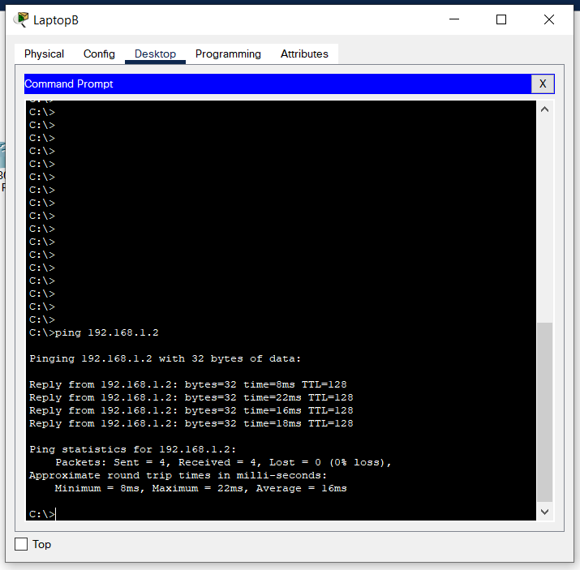
Ping results (PCB – LaptopB):

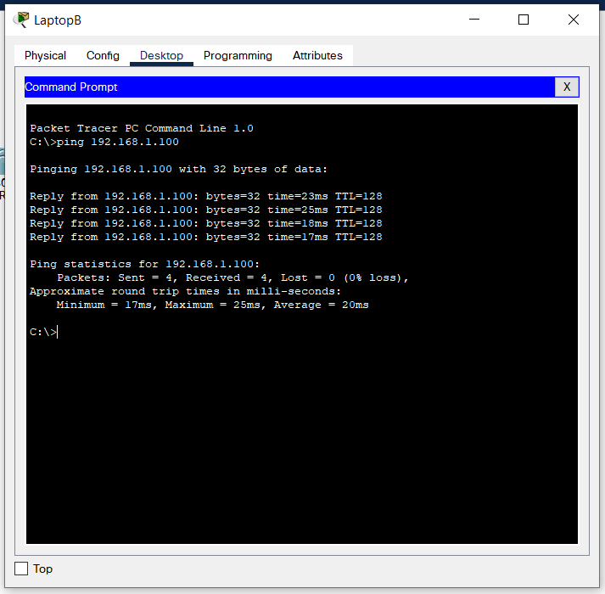
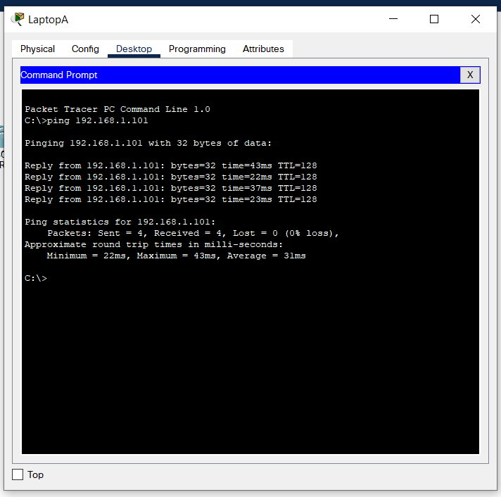
Ping results (LaptopA – LaptopB):

Logical Topology:
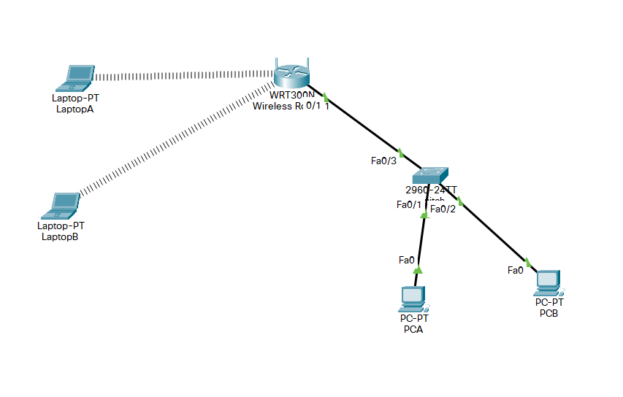

Physical Topology:


