Act 6 Doc 1
Task 1
A
My steps to using a method of transmitting the phishing link involve using 2 of my personal emails as senders and recipients. The sender is on Hotmail, the recipient is on Google Mail
- Making the link: I have made the link, with the POST back address being the Kali attacker machine.
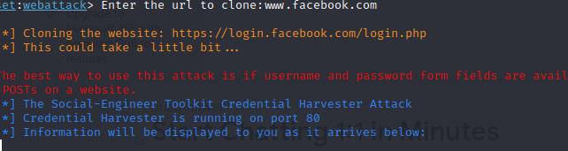
- Using emails: Using the Hotmail sender, I have written an email; with the name “URGENT: Facebook Payment Issues”, embedding the link in the email, that lies about outstanding fees on Facebook. It will be sent to the Google recipient. The hyperlink is the Attacker IP, not the Facebook login site.

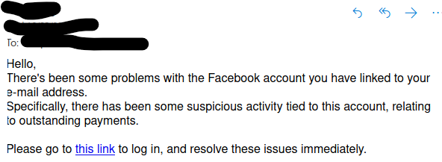
- Email received, anybody receiving this type of email would assume that the issues are serious enough to immediately attempt to open the link and log in, as shown.
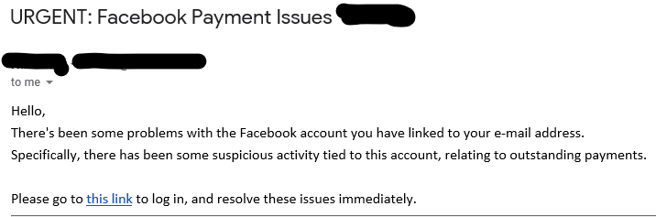

As seen below, the URL of the normal login page is not present, showing only the IP of the attacker address. This proves that it is a phishing site.
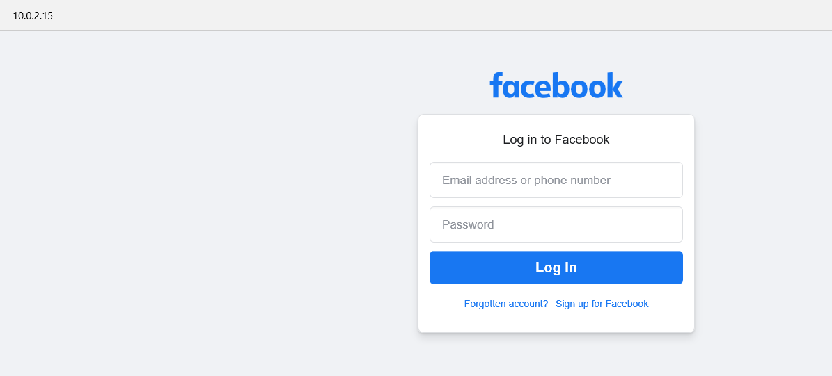
- “Logging in”. Using false credentials to test the program, I have used “Innocent” and “pretty” as the username and password, respectively. After pressing the login button, to goes to the actual Facebook login page, meaning that the credentials have been stolen.
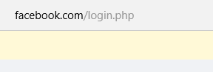
- Going back to the attacker, it has become evident that the victim has not only accessed the page, but the credentials have also been inputted and submitted.
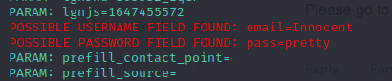
B
With my observations on the site cloner, it seems as if the cloned site is sijmply set up to send the data back to the target system. This is prevalent, due to the responses gained from the process achieved above in the Kit’s report.
Additionally, looking through the Inspect Element functions on the browser shows that the networking functions are clearly different. The official page has names and paths leading to the appropriate authenticating systems. The GETs show that data is to be collected from the page, and POST leads to the inner Facebook URLs.
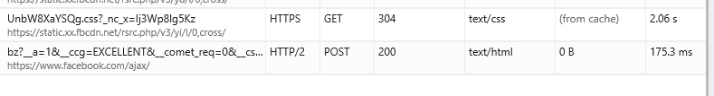
The fake address has each of the GET methods to obtain the information, but the last GET and the POST show that the next destination is the actual Facebook login page, as well as showing the attacker IP, meaning that the data is to be sent there. This is notable, since the program itself stated that it collects all POSTS
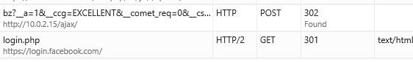
C
To target a system outside of the network, the IP address that the POST will be sent to will have to be the system’s External/Public IP address, not the inner NAT addresses. This is because the external address is how the external networks see the attacker system, still counting as the Attacker’s local address, and being the only system receptive of POSTs sent back externally this way, as the entire network is seen this way, as either different ports on the same net address, or different dynamic addresses in the net. This way, the external addresses will acknowledge each other.
D
Using the WebJacking attack method with the site cloner, with have using the same email addresses as before, but have put the “malicious” link into a hyperlink into a new email, shown below.
Facebook was also cloned again, with the POST address being the attack’s again, to receive feedback.

As before, the email was received on the other end, meaning the chances of success have gone up, since it is now visible to the victim in their email.
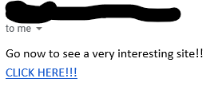
Clicking the email shows feedback back in the tool, showing that the address has indeed opened the link.
For the victim, it simply goes to an empty page in which a hyperlink that goes to the Facebook is present. This hyperlink is what opens a window, leading to any site chosen by the attacker, like sites that puts the security of the PC in jeopardy. This is known as a Web Jacking Attack, due to steering the user to the malicious link through the email link.
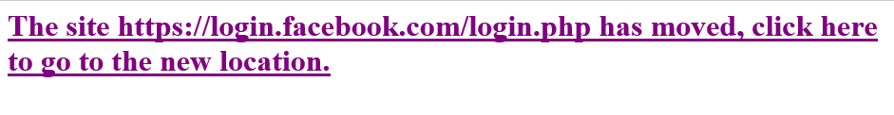
The first page, note the hyperlink that appears to be legitimate. The link leads to the Facebook page below, emphasising the function of the link.
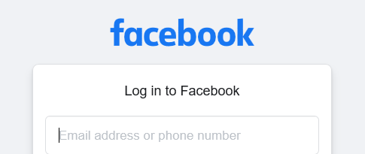

In my personal opinion, the URL when visiting the faked site should never be the actual URL, but instead the IPv4 address of the attacker, always in a “0.0.0.0” format. Additionally, when dealing with emails that lead to phishing links, the sites that they are trying to imitate should have their organisation show that they never send emails with login links, but instead to log on normally with a browser every time. If an organisation were to alert users of something that needs immediate attention on their account, they would be told to log in normally.

