Table of Contents
Section | Title | Pages
1 | Introduction | 2 - 3
2 | Potential Causes of Youth Unemployment | 4 – 5
3 | The Impact of Youth Unemployment on the Economy and Young People | 6 - 7
4 | How Unemployment affects Young People’s Well-Being | 8 - 9
5 | How can Youth Work Support Young People into Employment | 10 – 11
6 | How Youth Workers can support their own Well-Being | 12 - 13
7 | Conclusion | 14
8 | Reference List | 15

Introduction
There are many issues affecting young people in modern day society such as poverty, unemployment, substance misuse, debt, obesity, homelessness, mental health, bullying and teenage pregnancies. As the paper continues its discussion, it will demonstrate that a lot of these issues can and do interlink. However for the purpose of this paper it will focus on unemployment in young people, how this may affect their well-being and how youth work can be a support.
To support this debate, the essay will be categorised into five sections and will have in mind the NAOMIE planning model to determine the needs, aims, objectives, methods, implementation and evaluation. With the need and aim being to get young people into sustainable employment.
The first section will look at potential causes of youth unemployment, reflecting and considering such aspects as employer’s views, young people’s expectations of the workplace considering theories and statistics from various sources.
The paper will continue by looking at the impact that youth unemployment has on the economy and young people in past years as well as contemporary society researching theories and statistics from sources such as the Department for Work and Pensions.
The third part will look into how unemployment affects young people’s well-being for example, depression and substance misuse, focusing on numbers of young people who have mental health issues due to unemployment using research from the British Government website.
Section four will discuss how youth work can support young people into employment, such as signposting them to organisations and/or projects, advising, guiding and empowering young people with employability skills as well as continually supporting them with their well-being, the implementation and method stage of the NAOMIE model.
The final section will consider the well-being of youth workers, looking at reflection, being mindful of resources and using such methods as supervision and/or undertaking continuous professional development, looking at the evaluation stage of the NAOMIE model.
The paper will conclude with a summary considering the theories, policies, legislation discussed throughout linking into the National Occupational Standards for Youth Work focusing at all times on ethics, confidentiality and safer working practices.

Potential Causes of Youth Unemployment
To open the paper it may be worth considering what causes youth unemployment, this could be for any number of reasons and may include:
- Gaps between education and employment
- Young people lacking skills they need for work
- Employers prefer to work with experienced staff
- Young people’s expectations
- Lack of qualifications
- Lack of accurate and engaging careers information
- Rise in retirement age legislation
- Employer’s perceptions of young people.
According to Casson, (Theories of Youth Unemployment, 1979, Pg. 48), there are two job searching hypothesises for young people. The first being that the lesser able young people tend to leave school as early as possible, so in the first few years of their working life they are economically dependent on their family. The second being because of their inexperience of the work environment and their youth, young people struggle to adjust to the working environment.
Being mindful of the above statement, it may be worth considering that this was wrote in 1979 - some forty years ago and times have changed somewhat. To debate this, in the present time young people tend to stay on in school going into sixth form, go to college and into higher education of university. To concur with this statement, Lightfoot wrote an article in the Guardian in June 2016 suggesting that in the early 1960’s only 4% of school leavers went to university, rising to around 14% by the end of the 1970’s and in the modern day, more than 40% of young people start undergraduate degrees. However, this does come with its own problems; as Lightfoot continues to imply that today’s students leave with debts from approximately £40,000 in which they have to pay back over their working lives. This could leave a sense of worry before entering the world of work for these young people.
Considering both views, whether a young person leaves school and attempts to go straight into employment, an apprenticeship or a young person has been to college and university it is worth allowing for that for all avenues of going into employment young people may not necessarily have the employment preparation that an older person may have had. These could include application writing, interview techniques, communication skills, and experience, which could put these young people at a slight disadvantage in the world of work.

The Impact of Youth Unemployment on the Economy and Young People
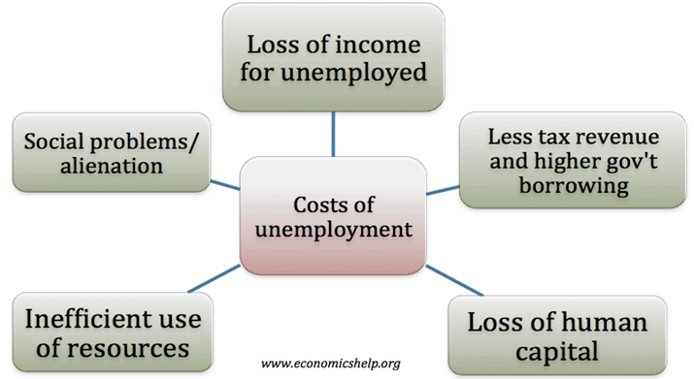
(Economicshelp.org. 2020).
To look at the diagram above, it suggests that there are five main areas of the costs around unemployment.
One of which, is fewer taxes being paid into the system resulting in less money for vital public services such as the National Health, Police and Fire Services. This could mean that young people wanting a career in any of these services maybe limited due to not enough revenue being accumulated for such professions.
Another factor in this concern is that more individuals claim benefits. To support this statement, according to the Department for Work and Pensions in their latest statement of expenditure and forecasts published spring of 2019, it suggests that 177.6 billion pounds was the total benefits expenditure for 2017/18, with a forecast of 183.5 billion for the financial year of 2018/19 and 185.1 billion forecast 2019/20.
This information suggests that each year more public money is being spent on benefits, which heightens the need to support sustainable employment to increase revenue for our essential services, may also potentially frees up new professions for the youth and reduce outgoings of benefits supporting the economy.
To discuss a further impact would be less income for those unemployed – including young people. This could mean that these individuals may source borrowing money from payday lenders. These loans appear to be more accessible to people who have a low income, having a higher interest rate due to fact of the individual’s income being low thus them being a risk to repay the debt.
With this in mind, young people who are unemployed and potentially inexperienced in money management this may put them in a vulnerable financial situation. This factor could put them into further poverty, which in turn could lead onto the youth suffering mental health concerns such as depression, anxiety or substance dependency.
According to Dr Henderson, the lead author for a study by The Centre for Longitudinal Studies, which was cited in an article written by Frymorgen for the BBC in September 2017, suggests that if you are young and unemployed you are more than twice as likely in having poor mental health. Dr Henderson continued by suggesting,
‘Millennials have faced a number of challenges as they enter the world of work. They joined the labour market at the height of the most recent financial crisis and faced higher than ever university fees and student loan debt’.

In view of the above, it suggests that the impacts of youth unemployment has tremendous effects on a variety of costs, not to mention young people’s mental health, therefore youth work professionals working within their National Occupational Standards could have a vital part to play in potentially bringing unemployment down as well as supporting young people with their well-being.

How Unemployment affects Young People’s Well-Being
There could be many ways that unemployment effects young people. Mental health effects such as stress, anxiety, depression, loneliness, suicidal thoughts, low self-esteem, feeling of worthlessness, and lack of concentration; with physical effects for example headaches, chest pain, palpitations, health problems due to lack of exercise/activity, sleep disorders, eating disorders and substance misuse.
As briefly discussed in the previous section, Dr Henderson, the lead author of a study by The Centre for Longitudinal Studies, believes that the stress surrounding risky employment conditions could be triggering mental and physical health problems.
“One explanation for these findings is that financial stress or the stress associated with having a low-status job increases the risk of poor mental health. It may also be that the worry of having no work or irregular work triggers physical symptoms of stress - including chest pain, headaches and muscle tension.”

Being unemployed could result in an emotional void in one’s life. This can affect their health – both physically and mentally affecting their well-being. To fill this void, one tends to overeat and overeating leads to obesity. The emotional instability may also lead one to the opposite and ignore eating. Both factors may cause nutritional deficiencies, physical fatigue, and weakness. Thus, eating disorders whether overeating or undereating could lead to metal health issues such as anxiety, depression and/or disorders such as bulimia or anorexia.
According to a survey of 2,265 16 to 25-year-olds published in a report by youth charity the Prince’s Trust cited in an article written by Gani for the Guardian in June 2015,
‘nearly six out of ten unemployed young people polled said anxiety had stopped them from sleeping well, over half said feeling anxious stopped them from asking for help while 41% said it stopped them from leaving the house.

While 20% of young people polled agreed to the statement that they were “falling apart” emotionally on a regular basis, the figure increases to 33% among unemployed young people.’

These statistics suggest that unemployment on young people plays a significant part on their mental and physical well-being.
To concur with these findings, young people and adults who are in employment are more likely to have less mental and physical health concerns. The UK Government implies that being in employment is better for your health than being out of work. It continues by saying that there is clear evidence that employment improves health and wellbeing across people’s lives and protects against social exclusion. Conversely, unemployment is bad for health and wellbeing, as it is associated with an increased risk of mortality and morbidity.
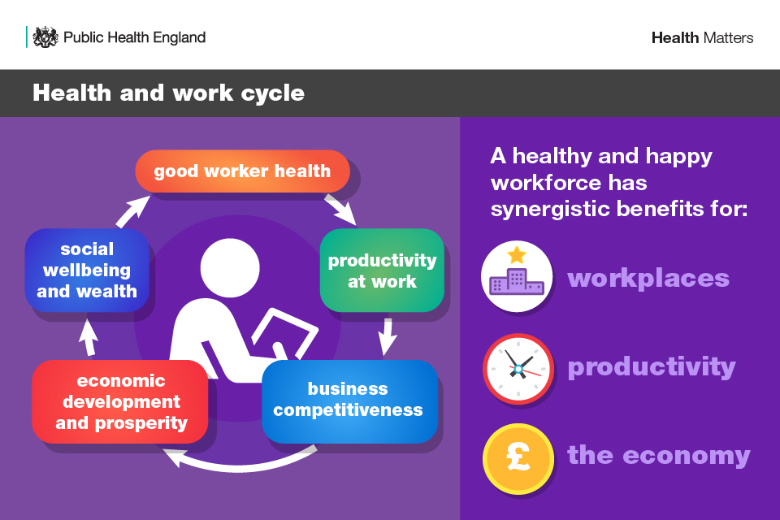
(Health matters: health and work, 2020).
This is where Youth Work, partner agencies and organisations can work together to support young people to gain abilities such as employability skills, help remove barriers such as low aspirations and guide, advise and empower them in an informal way adhering to the key purpose of youth work.
‘To enable young people to develop holistically, working with them to facilitate their
personal, social and educational development, to enable them to develop their voice,
influence and place in society and to reach their full potential’.

Nya.org.uk. (2020).
How can Youth Work Support Young People into Employment
Maybe a good place to start in how youth work can support young people gain employment is how youth work is undertaken and where by its workers. The basics for good youth work is being able to build up professional relationships by being non-judgemental, gaining young people’s trust, informally educating them in a location that is comfortable to them encouraging voluntary participation, skills to be gained, knowledge to be grown and empowerment to happen.
These sessions could be in a variety of venues for example youth club, outreach work – going out into the community or undertaking home visits if the young people are comfortable with this, as well as projects that have been set up such as beach cleans, Education for Sustainable Development an Global Citizenship (ESDGC) projects or sporting activities. All these contexts of youth work enhance communication skills, team working, working on initiative and build up confidence, all the skills that are needed for the world of work.
To discuss how youth work can support young people into the world of work it can happen by a number of ways. As stated in the previous section, youth work professionals work alongside a number of other agencies and organisations such as Careers, Job Centre Plus, and other projects, for example Cam Nesa – a youth service project operating in South West Wales supporting young people into education, training or employment.
All organisations complement one another with their uniqueness and are able to give young people better chances in gaining employment in their chosen career creating more opportunities for the young people to sustain the employment that they gain and supporting the economy.
With this in mind, Youth Work’s uniqueness is the fact that workers are able to build, adapt and maintain relationships with young people thus young people trusting workers and accepting their help, knowledge and skills.
To give am example of youth work supporting employment, the Cam Nesa project, since its launch in March 2018, has successfully engaged approximately 250 participants in the Pembrokeshire region with approximately 70 of those young people gaining full time sustainable employment and 20 young people going into further or higher education.
In January 2020, Pembrokeshire’s Cam Nesa team was able to support and get one of their young people into employment within 15 days of them being signed up to the project and it being it’s 62 young person to get full time employment. This success was published in the local papers and social media by Pembrokeshire County Council, which stated,
‘The scheme has supported its 62nd young person into employment since the scheme launched at the beginning of March, 2018.
Former student XX aged 22, was referred to the Cam Nesa project at the beginning of November by XX Job Centre Plus.
Within a month she was in a job in her chosen career path and within two miles of her home!’

In March 2018, the same month the project was launched Pembrokeshire’s Cam Nesa team again supported a young person into full time employment within a week of signing up to the project.
‘A Saundersfoot man has gained full-time employment within a week of his initial assessment with Cam Nesa - a project supporting young people into work who are not in education, employment or training.
XX, 23, had been out of work since October 2015 and was very keen to gain employment. He worked closely with XX who advised him on resources, support tools and how to create a CV and covering letter’.

Since both good news stories being published, along with other success stories that have been circulated has encouraged other young people to enquire and sign up to the project to support them gain employment. The above shows that youth work can be positive and supportive for young people to move forward into the world of work.

How Youth Workers can support their own Well-Being
In order for youth workers to undertake their role professionally and efficiently, it is always important for one to be able to reflect, when to seek appropriate support and guidance, to use supervision effectivity and undertake continuous professional development in order to keep up-to date with young people, practice, policies, procedures and legislation.
As Herman suggests in a policy written on Reflective Practice Meets Youth Work Supervision in September 2012 (pg. 118),
‘Supervisors are essential to nurturing organisational and employee success in the field of youth work. Supervisors who take the time to incorporate a reflective practice and critical inquiry approach to supervision may deepen positive change in their youth work practice as well as the relationship with those they supervise’.

This may suggest that supervision is just as important as practice to ensure that effective and efficient youth work occurs. A worker who has a nurturing supervisor may more likely critically analysis each positive or negative piece of work, ask questions and always seek to improve through the prompts of their supervisor.
Supervision also supports one’s professional development, having this one to one time with their supervisor to request any training that they feel they need in order to carry out their role or indeed the supervisor suggesting training, such examples may be suicide prevention training or radicalisation.
Supervision is also key to workers well-being. Working in the field of youth work can be emotionally challenging at times for workers. For example, when a young person discloses sensitive information that would need to be reported to other agencies, such as the Adult or Child Care Assessment Team, or Police. As a worker it is imperative that a supportive supervisor is available, not only to support and guide but also to de-brief after what may have been a traumatic piece of work and to offer services if needed such as counselling.

It is equally important however for youth worker professionals to ensure they maintain their own well-being being aware of the five ways in order to carry out their role to the best of their ability. Knowing limitations, such as lack of certain training and strengths to maintain their role as a youth worker and not to ‘burn out’ for the young people to get a continual supportive service.

Conclusion
To summarise this paper, it is evident that there are many factors to consider when looking to support and empower young people into sustainable employment.
By considering the NAOMIE model looking at the potential reasons for youth employment, the impact this has on the economy, how unemployment can effect young people’s well-being and how youth work could support narrow the gap of youth unemployment is key for the aim and objective of gaining employment for young people to take place.
Another key factor is for workers to know their own limitations, strengths, knowledge of projects and agencies both locally and nationally, and by keeping up to date with their own training and development as well as having a supportive supervisor.
In view of the research and findings, it is clear that there is examples of good youth work projects and practice that has enabled young people to gain employment.
There are also some indicators that employment is good for well-being. That employment gives one a ‘purpose’ encourages social communication as well as confidence and protects against social exclusion.

References
BBC Three. (2020). Young Unemployed People Are Twice As Likely To Suffer Mental Ill Health - BBC Three. [online] Available at: https://www.bbc.co.uk/bbcthree/article/05fa5b92-5281-4fa2-a817-ecd7b31f4e84. [Accessed 13 March 2020].

Casson M. (1979). Theories of Youth Unemployment. In: Youth Unemployment. Palgrave Macmillan, London.

Economicshelp.org. (2020). [online] Available at: https://www.economicshelp.org/wp-content/uploads/2017/12/costs-of-unemployment.png [Accessed 13 March 2020].

Gani, A. (2020). More Than Half Unemployed Young People Anxious About Life – Report. [online] the Guardian. Available at: https://www.theguardian.com/society/2015/jan/14/more-than-half-unemployed-young-people-anxious-about-life-report. [Accessed 6 April 2020].

GOV.UK. (2020). Benefit Expenditure And Caseload Tables 2019. [online] Available at: https://www.gov.uk/government/publications/benefit-expenditure-and-caseload-tables-2019. [Accessed 13 March 2020].

GOV.UK. (2020). Health Matters: Health And Work. [online] Available at: https://www.gov.uk/government/publications/health-matters-health-and-work/health-matters-health-and-work. [Accessed 6 April 2020].

Nya.org.uk. (2020). National-Occupation-Standards-for-Youth-Work. [online] Available at: http://www.nya.org.uk/wp-content/uploads/2014/06/National-Occupation-Standards-for-Youth-Work.pdf. [Accessed 6 April 2020].

Pembrokeshire.gov.uk. (2020). Cam Nesa Finds A Job For Its 62Nd Young Person In Just 15 Days. [online] Available at: https://www.pembrokeshire.gov.uk/newsroom/cam-nesa-finds-a-job-for-its-62nd-young-person-in-just-15-days. [Accessed 12 April 2020].

Pembrokeshire.gov.uk. (2020). Success For Daryl, Thanks To ‘Cam Nesa’. [online] Available at: https://www.pembrokeshire.gov.uk/newsroom/success-for-daryl-thanks-to-cam-nesa. [Accessed 12 April 2020].

Psychologenie. (2020). How Unemployment Affects Mental And Physical Health - Psychologenie. [online] Available at: https://psychologenie.com/how-unemployment-affects-mental-physical-health. [Accessed 31 March 2020].

Youthandpolicy.org. (2020). Reflective Practice Meets Youth Work Supervision.
[online] Available at: https://www.youthandpolicy.org/wp-content/uploads/2017/06/herman_reflective_practice_meets_youth_work_supervision.pdf. [Accessed 12 April 2020].

