Module Code: LCBB6006

Module Title: Project Management

FICTIONAL PROJECT PLAN: DEVELOPMENT OF A COMMUNITY MENTAL HEALTH AND WELLBEING CENTRE

Component 1: Coursework: Essay

Student Name: Victoria Francis
Student ID: 2329070

Table of Contents
1. Introduction 3
2. Project Aim, Objectives and Scope 3
2.1. Project Aim 3
2.2. Project Objectives 3
2.3. Project Scope 4
3. Project Outputs 4
4. Activities Required to Deliver the Outputs 5
5. Work Breakdown Structure (WBS) 7
6. Deliverables, Milestones and Project Timeline 8
7. Resource Requirements 8
7.1. Personnel Resources 8
7.2. Material Resources 9
8. Project Management Methodology 10
9. Conclusion 10
References 11

1. Introduction
Demand for services supporting mental health has increased over time and this is becoming a high priority for public health across England. Existing national mental health policies such as the Health and Wellbeing Strategy reinforces the need for an accessible, preventative and person-centred service delivery model to offer support to individuals prior to their experiences of mental health difficulties reaching a crisis point (Birmingham and Solihull Mental Health NHS Foundation Trust, 2026; Birmingham City Council, 2022). The increased demand for mental health services in Birmingham when combined with a shortage of existing services suggests the need for more services in the community that can offer early intervention, counselling, wellbeing programmes, and referral services (NHS, 2025).

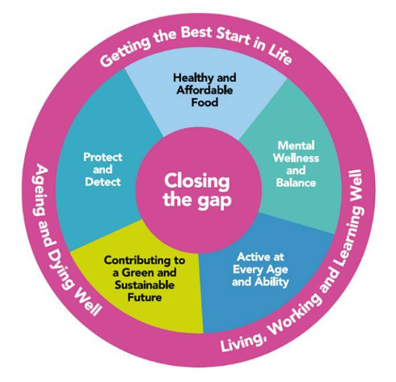
Figure 1: Health and Wellbeing Strategy of England
(Source: Birmingham City Council, 2022)

This project focuses on developing a Community Mental Health and Wellbeing Centre in Birmingham, England. In terms of project management, the project must be well planned, managed, communicated, and monitored to deliver the project within a particular time, cost, and quality. This project plan therefore refers to the purpose, goals, scope, outputs, tasks, work breakdown structure and resources needed for the establishment and launching of the proposed facility to be successful.

2. Project Aim, Objectives and Scope

2.1. Project Aim
The project aims to design, build, equip and launch a Community Mental Health and Wellbeing Centre in Birmingham within the timeframe of 18 months, as well as supporting mental health support services and early intervention initiatives by providing a supportive environment at the community level, thus improving the psychological wellbeing and social inclusion of individuals (Birmingham City Council, 2022).

2.2. Project Objectives
The project will achieve the following SMART objectives:
- Secure planning permission and all required regulatory approvals within the first five months of the project.
- Complete the construction and commissioning of the facility within an 18-month timeframe.
- Deliver the project within the approved budget while maintaining quality and safety standards.
- Recruit and train all operational and support staff at least one month before the official opening.
- Install and test all healthcare, information technology, and security systems before project handover to ensure operational readiness.
These objectives are specific, measurable, achievable, relevant, and time-bound, providing clear indicators of project success.

2.3. Project Scope
The project involves site selection, feasibility studies, architectural and engineering designs, planning approval, procurement of contractors, materials and equipment, construction, utility installation, interior finishing, installation of health care and IT equipment, recruitment and training of staff, operational testing and opening the facility. There is also a stakeholder consultation and a project governance process throughout the project lifecycle.

The project does not include future expansion of buildings, new facilities outside the scope of the approved design, future operation and management of the centre after the project is officially completed and handed over, new services to the centre, and future health care delivery after the project has been completed and handed over.

3. Project Outputs
Project delivery is dependent on several project outputs that must be achieved (Figure 2). The first deliverable is a feasibility study report which assesses both the feasibility of the project and the costs and benefits, risks, and community needs. This is followed by formally authorising the project with an approved project charter that creates governance arrangements.
Architectural and engineering designs are also a key output, which specify the construction activities (Buede and Miller, 2024). Approval for planning of construction works must also be secured prior to the beginning of construction. One of the main physical deliverables of the project will be the completed building which will include dedicated mental health consultation rooms that will allow for safe and confidential provision of support services.

Other services of key deliverables involve the installation of the required medical equipment, information technology systems and security infrastructure for the effective operation. Clinical and administrative personnel are recruited and trained and the facility is ready to provide services when opened (Endalamaw et al., 2024). The key elements of an operational readiness report will be able to confirm that all systems, equipment, staffing and compliance requirements have been successfully met.

The successful completion of the project is the official opening of the Community Mental Health and Wellbeing Centre. Together, these outputs will help to achieve good project outcomes and ensure the facility is operational, meets the regulatory requirements, is properly staffed and can provide accessible mental health services to the Birmingham community (Birmingham City Council 2022).

Figure 2: Project Outputs
(Source: Author)

4. Activities Required to Deliver the Outputs
The project will be delivered in 6 stages (Figure 3). In the initiation phase, consultation with stakeholders, including healthcare professionals, local authorities, community organisations and potential service users, will take place. A needs assessment will be used to determine gaps in current mental health services and a feasibility study will be conducted to assess the viability, cost and benefits of the project.

The planning & design stage includes the selection of an appropriate site, architectural & engineering design development, detailed project budget and risk assessment. The activities establish the foundation in place for successful project execution and regulatory compliance.
The procurement process involves tender documentation, contractor tendering, tender assessment, contractor selection, and material and specialist equipment procurement. Good procurement provides for value for money and timely availability of resources.

The construction process involves site preparation, excavation and ground works, structural construction, utility installation and interior finishing works. This phase is used to transform project designs into a working physical facility.

Healthcare equipment, IT systems and security systems will be installed and tested during the commissioning phase. Safety checks will be carried out to meet regulatory requirements. At the same time, staff recruitment and training activities will be carried out to prepare staff for their operational work.

The final phase of the launch process features a detailed inspection of the facility, transfer of the project to the client and an official opening ceremony. These activities will lead to a fully operational Community Mental Health and Wellbeing Centre that will enable the Birmingham’s Government's aims for accessible and community based mental health services (Birmingham City Council, 2022).

Figure 3: Phases of Activities
(Source: Author)

The delivery of the Community Mental Health and Wellbeing Centre project will require careful stakeholder management. As stakeholders have varying levels of interest and power over the success of the project, they require individualised approaches for engagement (Figure 4). High power/high interest stakeholders are to be managed very closely, for example Birmingham City Council, representatives of NHS England, the sponsor and the CQC, since they will greatly influence the decisions about the project and so will directly affect project delivery. Those with high power/low interest should be kept satisfied and low power/high interest groups (local residents and service users) should be kept informed and consulted throughout the whole project lifecycle (PMI, 2021; Birmingham City Council, 2022).

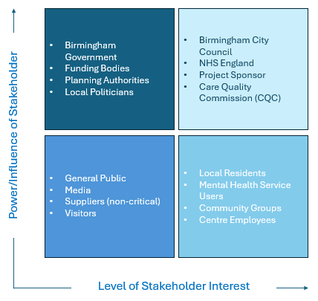
Figure 4: Power-Interest Grid for Stakeholder Analysis
(Source: Author)

5. Work Breakdown Structure (WBS)
A Work Breakdown Structure (WBS) is a project management tool in a hierarchical structure that breaks down a project into smaller and more easily manageable parts (Odedairo, 2024). The WBS involves dividing the project into different phases, activities, sub-activities and tasks, which helps in planning, scheduling, resource allocation and monitoring performance. It also aids project managers in determining project dependencies and makes sure that all necessary work is considered prior to project execution.

The proposed Community Mental Health and Wellbeing Centre has the following WBS (Figure 5). The WBS provides an excellent framework for project activity planning, control over project budget, allocation of responsibilities and project tracking throughout the lifecycle.
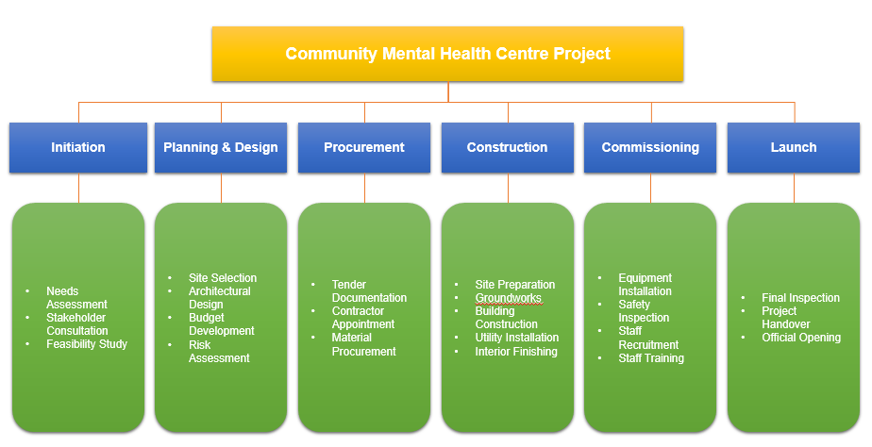
Figure 5: Work Breakdown Structure for the Community Mental Health and Wellbeing Centre Project
(Source: Author)

6. Deliverables, Milestones and Project Timeline
The project time has been planned on 18 months to achieve proper planning, execution, monitoring and control (Table 1). Deliverables and milestones help to keep stakeholders updated on the progress of the project and help them determine if they are still on track. The Project Management Institute says milestones are major points in a project's life cycle that help to manage a project and to assess whether the project has been carried out properly (PMI, 2021).

Table 1: Project Timeline
(Source: Author)
Timeline | Deliverable | Milestone
Months 1-2 | Feasibility Study | Project Approval
Months 3-5 | Design Package | Design Approval
Months 6-7 | Procurement Contracts | Contract Award
Months 8-14 | Completed Building Structure | Construction Completion
Months 15-16 | Installed Equipment | Operational Readiness
Months 17-18 | Fully Functional Centre | Official Opening

The feasibility study is done in the first two months that leads to the project approval. Once approved, architectural and engineering designs are created and formally approved. Construction is then preceded by procurement activities that ensure contractors and necessary resources are obtained. Construction is the longest phase, and is most complex because it includes the construction of works and the installation of utilities. Commissioning involves activities like equipment installation and testing of readiness before opening; the next phase will be the opening of the Community Mental Health and Wellbeing Centre, signalling the end of the project, and indicating the readiness of the services it is to provide to the people of Birmingham.

7. Resource Requirements

7.1. Personnel Resources
The implementation of a project requires a multidisciplinary team and its task needs to be defined and clarified (Adeleke and Olajide, 2024). A Project Manager plans, coordinates, communicates and controls the execution and performance of the project during its life cycle. Civil Engineers and Architects are responsible for facility designing; to design structurally efficient buildings and that comply with building regulations. Quantity Surveyors are required to produce a cost estimation and manage its budget. Procurement Officers are responsible for the selection of contractors and purchasing of materials. Onsite construction workers will perform the manual construction works and IT staff will install and test the technical and clinical systems; IT staff together with a Healthcare Equipment technician will install and test technological systems. The Human Resource Officers oversee recruitment and Mental Health Professionals offer specialist input on the design of the facilities to ensure they meet the needs of the service user and clinical requirements (PMI, 2021).

7.2. Material Resources
But the project does need a considerable amount of physical and technical resources as well. They include the appropriate development site, building materials, furniture, medical equipment, computers, computer software, security and staff training resources. The materials used in building the facility are the foundation, and the furniture and equipment facilitate the operation of the facility. Information technology infrastructure helps to deliver services effectively, maintain records and communicate. Security systems ensure safety of staff, visitors and assets. The management and allocation of both personnel and material resources are critical to meeting the project objectives within the defined scope, schedule and budget (AXELOS, 2017).

Figure 6: Resource Requirements for the Project
(Source: Author)

8. Project Management Methodology
PRINCE2 is the main methodology which has been chosen for this project. This approach is used across many projects in the UK public sector as it offers a structured approach with defined roles and responsibilities, stages and control mechanisms (AXELOS, 2017). The use of PRINCE2 for the mental health centre would be very appropriate as it would enable good governance, risk management, quality assurance and stakeholder engagement in the entire project lifecycle.

PRINCE2 has its drawbacks. The process has the potential to be time-consuming and document-heavy, placing extra burdens on administration (Haraké, 2025). It is also less flexible if major design changes are needed in the implementation of the project. However, agile methodologies are more flexible and iterative, and work better for software and service-development projects. PRINCE2 is the more suitable methodology for this project as the scope of the project is fixed, the project work must comply with certain regulations and the activities are sequential in nature.

9. Conclusion
This project plan describes the execution of a Community Mental Health and Wellbeing Centre in Birmingham, and identified the resources, milestones, project activities, key deliverables, Work Breakdown Structure etc. The suggested timeline sets out clear performance targets and PRINCE2 is an appropriate method for managing and delivering the project within agreed constraints.

References
Adeleke, O. and Olajide, O. (2024). Conceptual framework for health-care project management: past and emerging models. Int J Multidisciplinary Res Growth Evaluation, 5, pp.1685-700. https://doi.org/10.54660/.IJMRGE.2024.5.3.1084-1099
‌AXELOS (2017). Managing Successful Projects with PRINCE2. [online] Google Books. Available at: https://books.google.co.uk/books/about/Managing_Successful_Projects_with_PRINCE.html?id=oE2dtAEACAAJ&redir_esc=y [Accessed 11 June 2026].
‌Buede, D.M. and Miller, W.D. (2024). The engineering design of systems: models and methods. John Wiley & Sons. https://books.google.com/books?hl=en&lr=&id=yWX7EAAAQBAJ&oi=fnd&pg=PP13&dq=Architectural+and+engineering+designs,+detailed+specifications+for+construction+activities&ots=ZbG91jNHzb&sig=syuYAWiLEAzy-Fjiwq0rbiYCsho
Endalamaw, A., Khatri, R.B., Erku, D., Zewdie, A., Wolka, E., Nigatu, F. and Assefa, Y. (2024). Barriers and strategies for primary health care workforce development: synthesis of evidence. BMC primary care, 25(1), p.99. https://doi.org/10.1186/s12875-024-02336-1
‌Haraké, M.F. (2025). Project management and business modeling: Methodologies, frameworks, and strategic alignment. https://pmworldlibrary.net/wp-content/uploads/2025/05/pmwj152-may2025-Harake-Project-Management-and-Business-Modeling.pdf
Odedairo, B.O. (2024). Assessing the influence of various work breakdown structures on project completion time. Engineering, Technology & Applied Science Research, 14(2), pp.13773-13779. https://doi.org/10.48084/etasr.7023
PMI (2021). The standard for project management and a guide to the project management body of knowledge. Project Management Institute, Pennsylvania (US).
NHS (2025). Understanding the Mental Health Needs of Birmingham and Solihull - Birmingham and Solihull Mental Health NHS Foundation Trust. [online] Birmingham and Solihull Mental Health NHS Foundation Trust. Available at: https://www.bsmhft.nhs.uk/about-us/news/understanding-the-mental-health-needs-of-birmingham-and-solihull/ [Accessed 14 June 2026].
Birmingham and Solihull Mental Health NHS Foundation Trust. (2026). Welcome - Birmingham and Solihull Mental Health NHS Foundation Trust. [online] Available at: https://www.bsmhft.nhs.uk/ [Accessed 14 June 2026].
‌ Birmingham City Council (2022). Health and wellbeing strategy | Birmingham City Council. [online] Birmingham.gov.uk. Available at: https://www.birmingham.gov.uk/info/50119/health_and_wellbeing_board/1300/health_and_wellbeing_strategy [Accessed 14 June 2026].
‌

‌

