
Figure 1 (Logo, 2020)

Motion Simulation and FEA
  - Advanced Computational Methods
Milo Ward | Motorcycle Engineering | January 2020
Contents
Introduction 2
Research 2
Creating the CAD Parts 3
Creating the Assembly 4
Motion Simulation 5
Load Bearing 6
Results 8
Iteration One 10
Results 11
Iteration Two 13
Results 14
Evaluation 16
Conclusion 17
Link to CAD 17
Bibliography 18
Appendices 18
Solid Works Generated Report 18
Model Information 20
Study Properties 21
Units 21
Material Properties 22
Loads and Fixtures 23
Mesh information 24
Mesh information - Details 24
Sensor Details 26
Resultant Forces 31
Reaction forces 31
Reaction Moments 31
Study Results 32

Introduction
The aim for this task is to produce a motion simulation on Solidworks that can then be taken further forward and a finite element analysis completed on one of the parts in the simulation. Once this is the complete, the part should then be modified and changed to improve the part, either by making the part stronger or lighter while still allowing the part to complete the job that it has been designed to do.

Research
It is believed that ‘Computer Aided Design’ (CAD) was created around the mid-1950s, when the first commercial numerical control program was created by Dr. Patrick J. Hanratty. However, it wasn’t until a few years later that it got moved further forwards by a program called SKETCHPAD, created by Ivan Sutherland, this program started to show some of the principles and basic concepts that are a key part in modern day CAD. (En.wikiversity.org, 2020)
Modern day CAD is on the other hand very different to the original created in the middle of the century, today there is many different software’s that can be used to help design parts on the computer, such as: Solidworks, AUTOCAD and Solid Edge. In this report, the CAD and FEA will all be done using SolidWorks, released at the end of 1995 Solidworks was one the first software’s that brought 3D modelling of parts into the main stream, focusing on being more affordable than their counterparts and developed to run on Windows. These meant that medium sized companies to gain access to the CAD rather than it just being a tool for the larger corporations. Since its creation, Solidworks has gone through 26 versions, with each version building on the previous and adding in better capabilities than before. With full finite element analysis (FEA) now being included in Solidworks, this will also be the program used to analyse the parts. (Scan2CAD, 2020)
FEA has been around a similar time to CAD, first created in the 1950s by Boeing and Rolls Royce to aid in developing stronger and better parts for aero planes. In the mid-1960s NASA then developed a more capable and advanced FEA software, this was later then sold to the public and became one of the earliest mass produced FEA models. In modern day software’s, many of the CAD packages have a FEA element already built in. These software’s are a lot more accessible and achievable for even smaller companies to get involved with and starting to create a variety of products. The basic theory of FEA is that by creating a mesh, “the software then calculates the coordinates of the nodes” (Jones, 1992) Then by using calculations that are multiple simultaneous equations that can’t be solved accurately by hand. It is then able to generate stress patterns of the part suggesting if it is capable to deal with the stresses.

Creating the CAD Parts
To get this assignment started the first task was to decide and create parts to what the motion simulation would use. It was decided that a motion simulation of a piston in a cylinder would be the way to go.
The parts were modeled off the Kawasaki ZX6R engine, these were accurately measured and created in Solidworks, these parts that were created were: Crankshaft, con rod, gudgeon pin and piston.

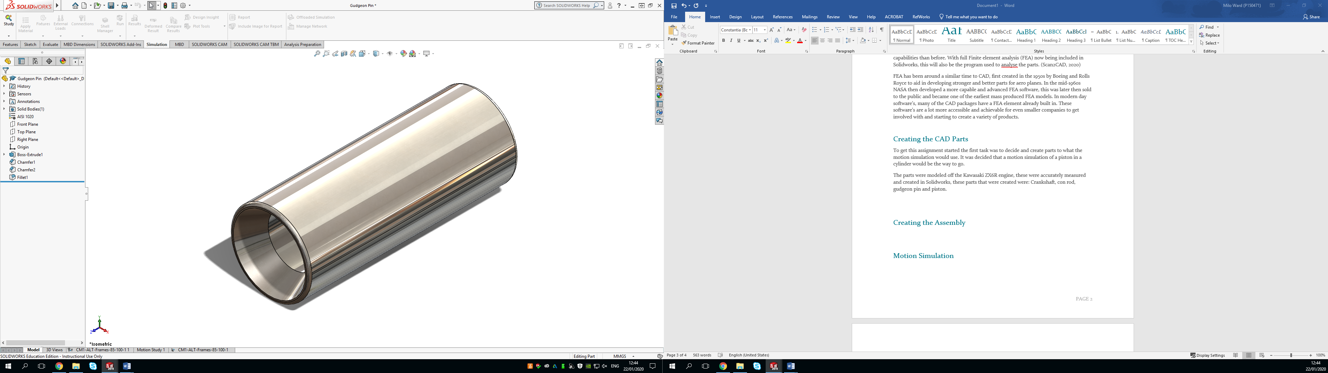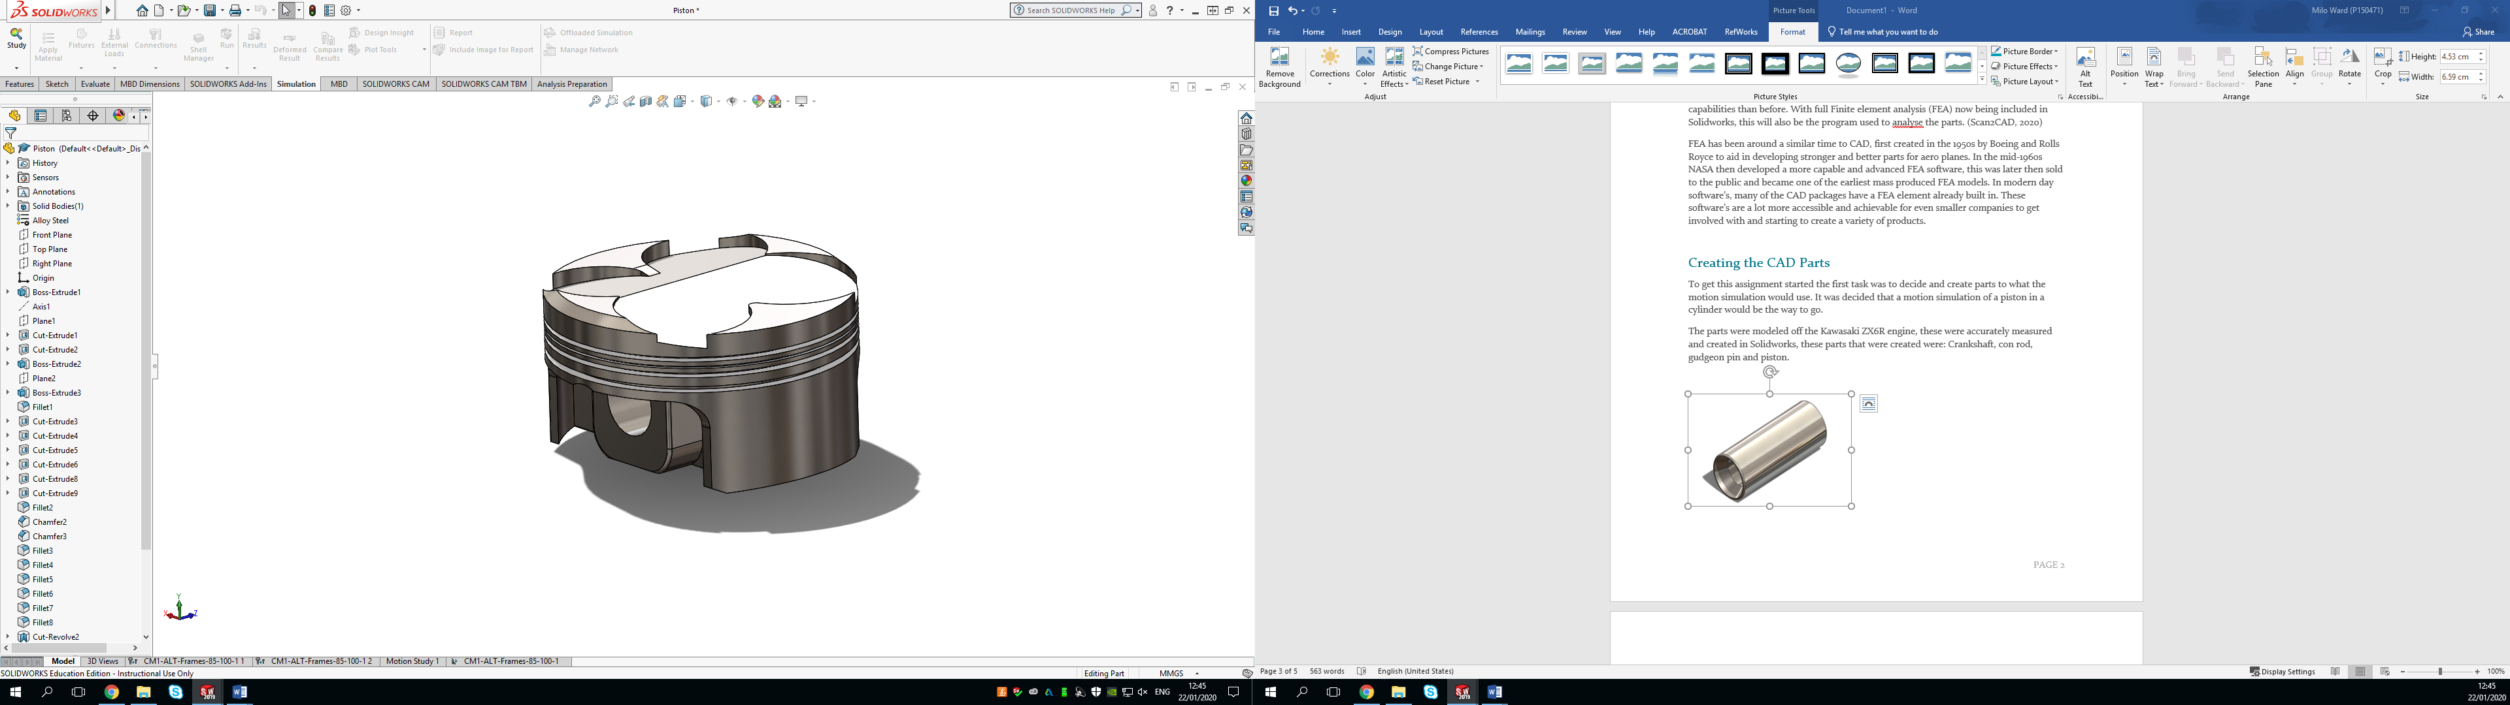
Figure 2 Gudgeon Pin and Piston ZX6R

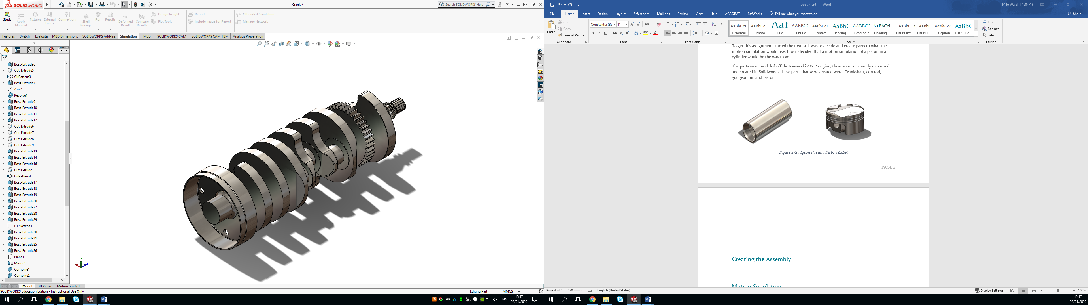
Figure 3 Crankshaft ZX6R
Early on in this assignment it was decided that the gudgeon pin was going to be the main focus for the motion load and the part of the engine that was going to be devloped further. This meant that more accuracy was put into the gudgeon pin, piston and con rod and a more simplified version of the crankshaft was used. These were all measured using vernieer calipers on real life parts provided by G&S Racing to make sure that these CAD developed parts could be as accurate as possible.

Creating the Assembly
Now that all the parts are made, the next step was to create an assembly of all the parts in Solidworks, the first step of this is to import all the components that is require into the assembly. Although this assignment is only going to focus on the one piston and gudgeon pin, all four pistons, con rods and gudgeon pins are to be included into the assembly to replicate the real engine.
Once all the parts have been imported in to the assembly, a crank shaft holder that was made was fixed and then the crank was mated in. Once this was in the crankshaft holder was then hidden so that it couldn’t be seen. The next step was to mate the con rods to the crank, this was completed by using hinge mates, these allowed the concentric mate between the bottom of the con rod and the journals and the other mate goes onto the side of the con rod to the side of the crank. This is slightly incorrect as in real life they would be free to move until the piston was on the conrod and lined into the cylinder which would then guide the rod, however for this simulation this was done.
The next part that was attached was the piston into the ‘cylinder.’ This was done by a concentric mate to a simple rectangle that had four holes the same size as the piston cut into it. Concentric mates were then added so that the piston went up and down inside these holes and then the holder was hidden.
The final part that was added was the gudgeon pin, these were first mated into the con rod using a lock mate, holding the gudgeon pin perfectly in the middle on the con rod top. After this, a concentric mate was added so that the gudgeon mated with the hole in the piston created for it. With all this done, it looked like below.
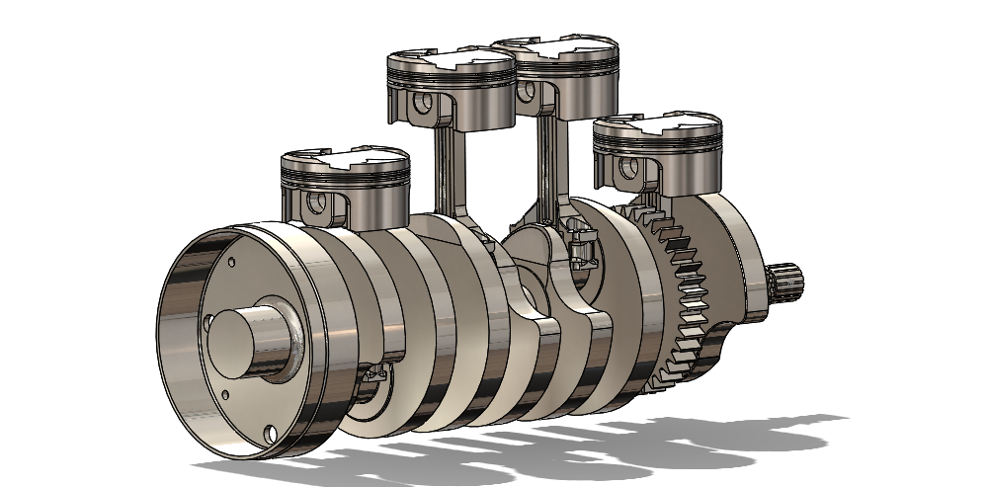
Figure 4 Full Assembly

Motion Simulation
Following the assembly being built, the next stage was to start to run the motion study, as the aim for this was to run a cylinder styled simulation and seeing the force that would be put onto the gudgeon pin. Making sure the motion study add in was applied and that it was set to motion analysis first, then a solid body contact force was applied to all the parts in the assembly. This meant that when a force was applied to one part, they would react as if they were in real life and should rotate with each other.
Once this was done, a 40,000N force was applied to the crown of piston one, as this was the only the part that would be focused on in the study it was only applied to the one piston. The next step was to the lower the time that the motion study would be working, the reason for this was that after the force had been applied to the piston, it only needed to run briefly to see the effect that this force would have on the gudgeon pin. So, by reducing the time down it allowed it to solve faster for the same results. The time was reduced to around 0.25 of a second, however the playback time was then extended to 5 seconds so that it could be seen rotating.
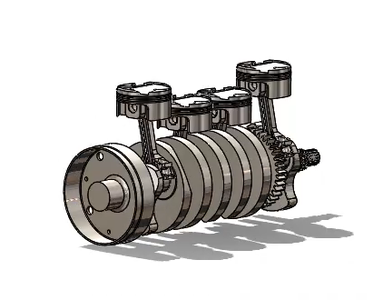
Figure 5 Screen grab during operation

Load Bearing
To be able to FEA the gudgeon pin from this point, load bearing faces need to be put into the model, this is done through the mates that have been put in. By going into the concentric mate of the first gudgeon pin to the piston, there is another tab called “Analysis” Clicking on this then opens up another interface, then click on load bearing faces. The two faces that need to be analsyed should then be added to the box, this is the face of the piston and the face of the gudgeon pin, once these are in the box as below, it can then be confirmed and click off the mates.
Now the load bearing faces are in, the model should be run again to make sure that everything is working as it should. When this is complete, the next stage is to click onto the “simulation” tab at the top and the “import motion loads” tab used. “Piston 1” and “Gudgeon Pin 1” should then be moved into0 the selected components screen. When these are in there, the “multiple frame study” should be clicked, the number of cases can then be selected.

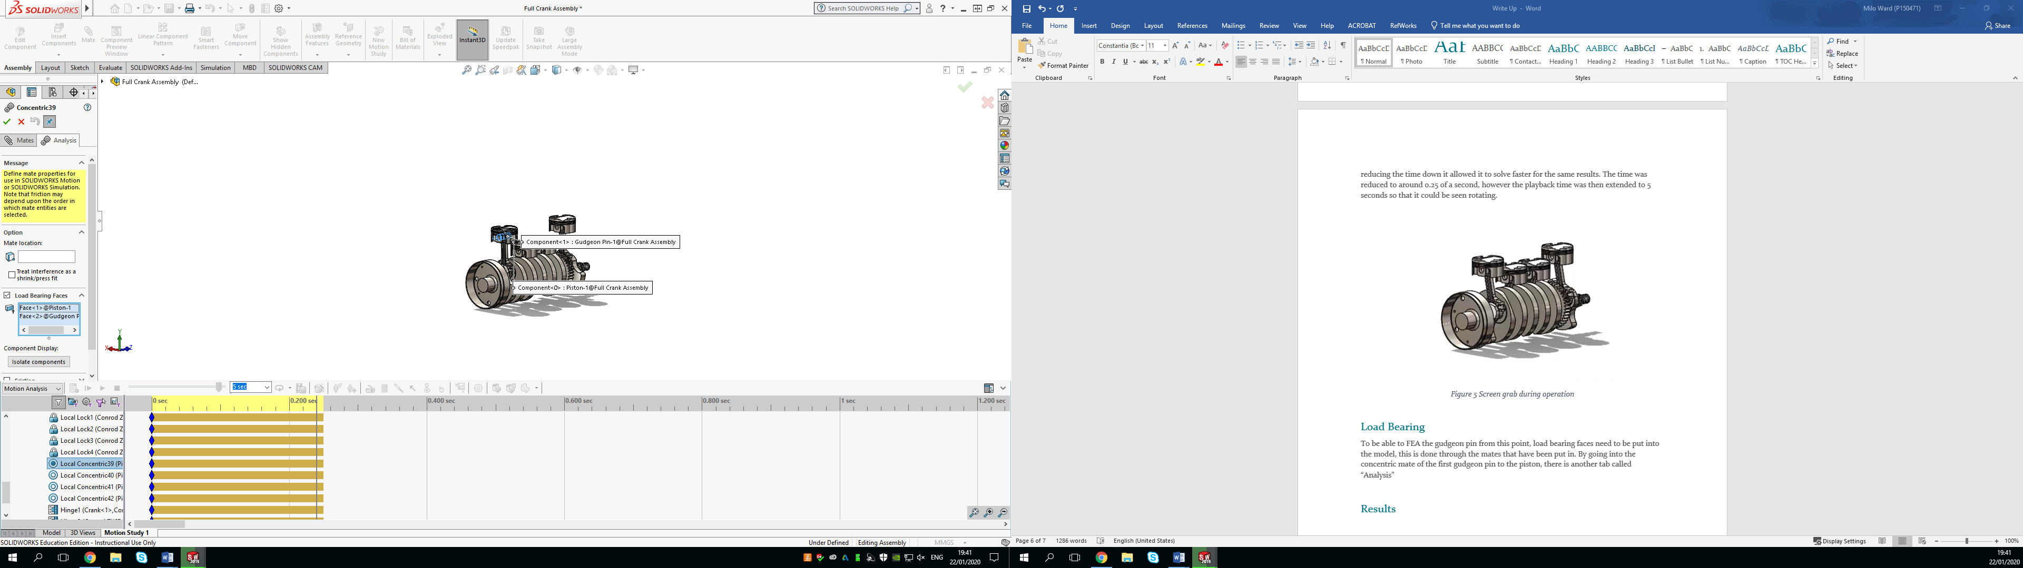

Figure 6 Showing how to add load bearing faces
Choosing the amount of cases depends on how detailed the FEA will be on the gudgeon pin, to start with this was first done with 17 scenarios to make sure that it would work correctly. Once it had, it was then repeated, however this time it was with 22 scenarios that occur in part of the 0.25 seconds of the run.

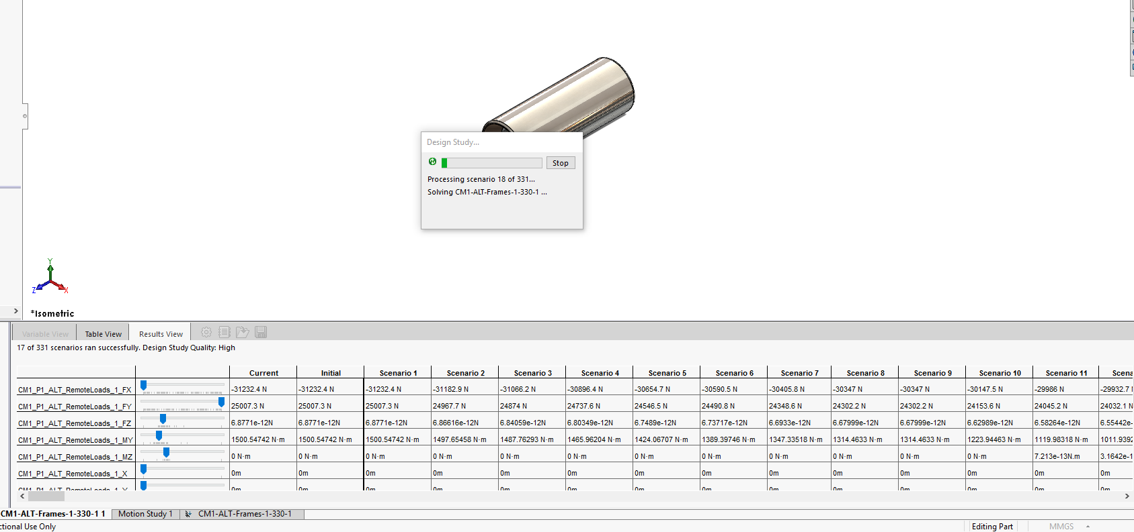
Figure 7 Mid run of the scenarios

Results
Once the above has been calculated, by opening the gudgeon pin file and and clicking the new tab at the bottom, it then gives an option to mesh the gudgeon pin. This was put to its finiest setting to get as much detail as possible from the study. This gudgeon pin weighs 27.46grams. Once the mesh is complete and run, it will produce a FEA model of the part like below.
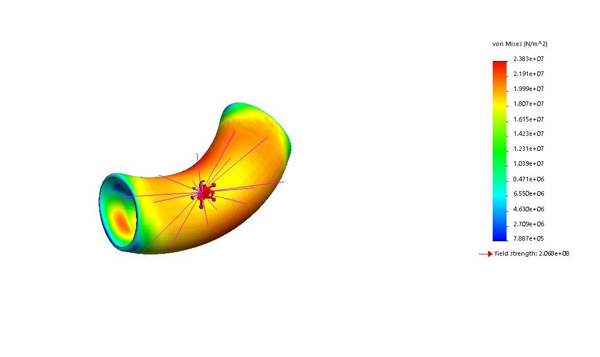
Figure 8 Standard Gudgeon Pin with VonMises stress with deformation on
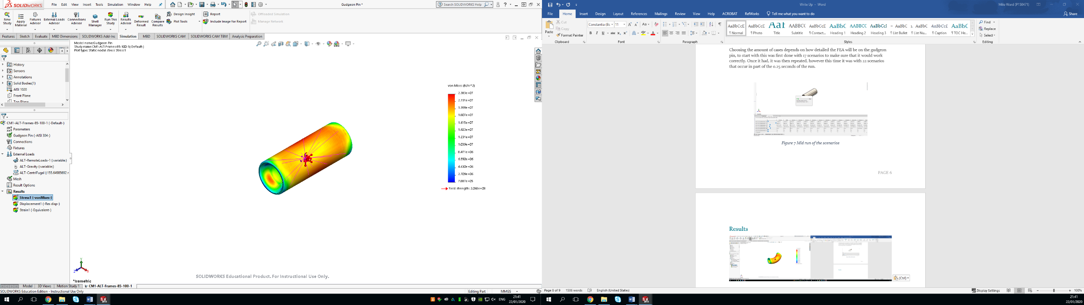
The FEA above shows the deformation of the standard gudgeon pin, however Solidworks does over emphasize the amount of flex that the part would actually be under. From the VonMises stress, it shows that the yield stress for this would be 2.068e+08N/M^2, however the standard gudgeon pin is only reaching 2.383e+07N/M^2 so this part is currently not going into yield. Below is the same FEA however with no deformation shown.
Figure 9 Standard Gudgeon Pin with VonMises stress with deformation off
The FEA also produces displacement model, this is shown below.

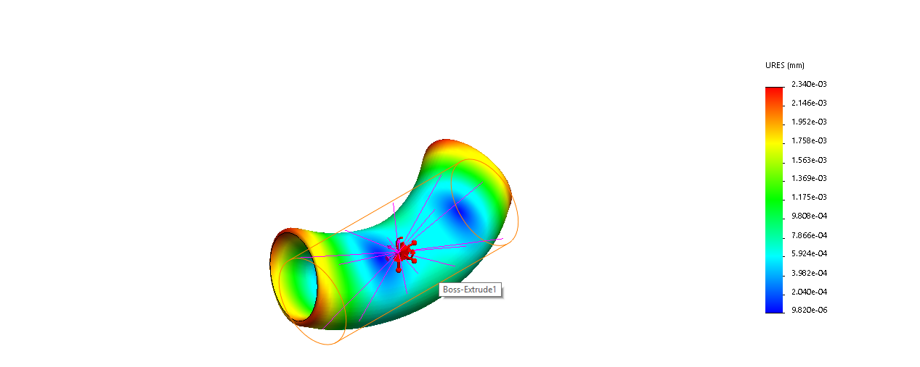
Figure 10 Displacement FEA of Standard with deformation
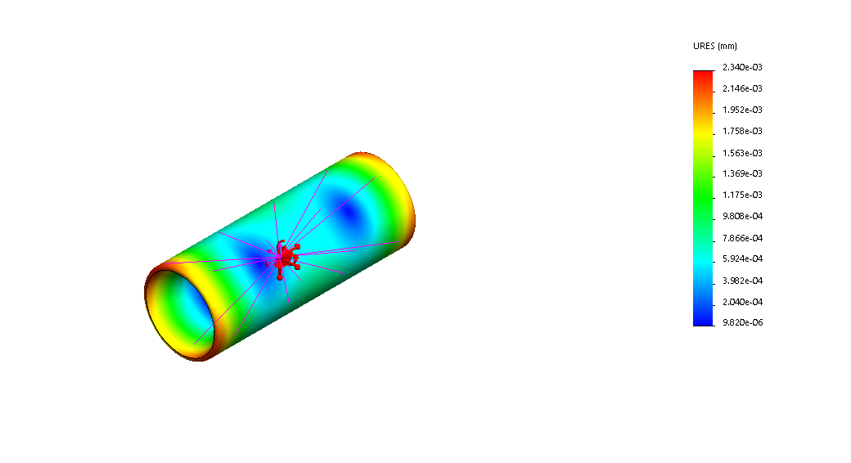
Figure 11 Displacement FEA without deformation
These FEAs show how much displacement the gudgeon deflects during the process, the highest deformation that the gudgeon pin is put under is 2.34e-03mm or 0.00334mm. Which is a tiny amount of deformation when compared to the deformation FEA that Solidworks suggests in the image.

Iteration One
For the first iteration, the material of the con rod was changed from Aisi 1020 to Titanium (Ti-6AI-4V). Once this material was selected, a further modification was made, this was a series of 3mm holes being cut through the entire gudgeon pin, in total 12 holes were cut into the gudgeon pin. This gudgeon pin weighs 14.18grams which is around 13 grams lighter than the standard gudgeon pin.
An equation was used to produce these holes, a 3mm hole was set to start with called “Cut Out”, the smart dimension for the other holes were then used of this, so if one hold was changed the others would follow suit. (Lombard, 2013)

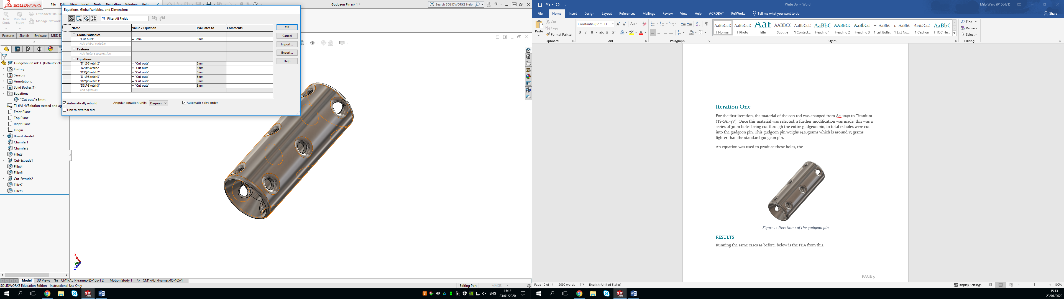
Figure 12 Showing the equation being used for the gudgeon pin

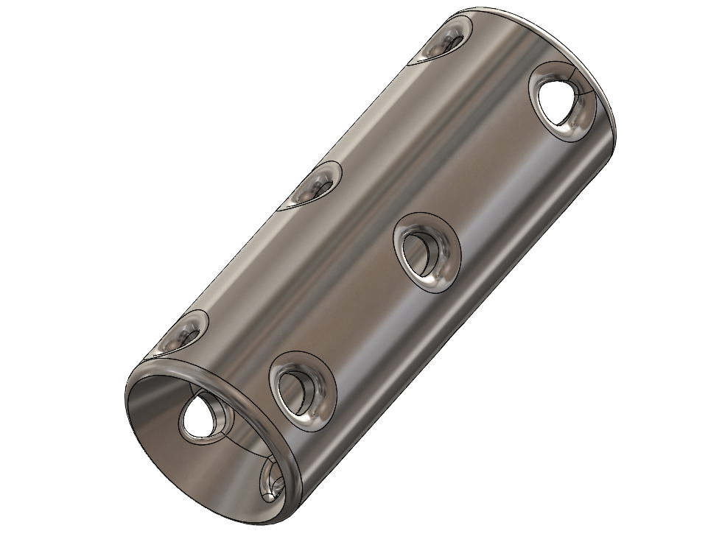
Figure 13 Iteration 1 of the gudgeon pin

Results
Running the same cases as before, below is the FEA from this.
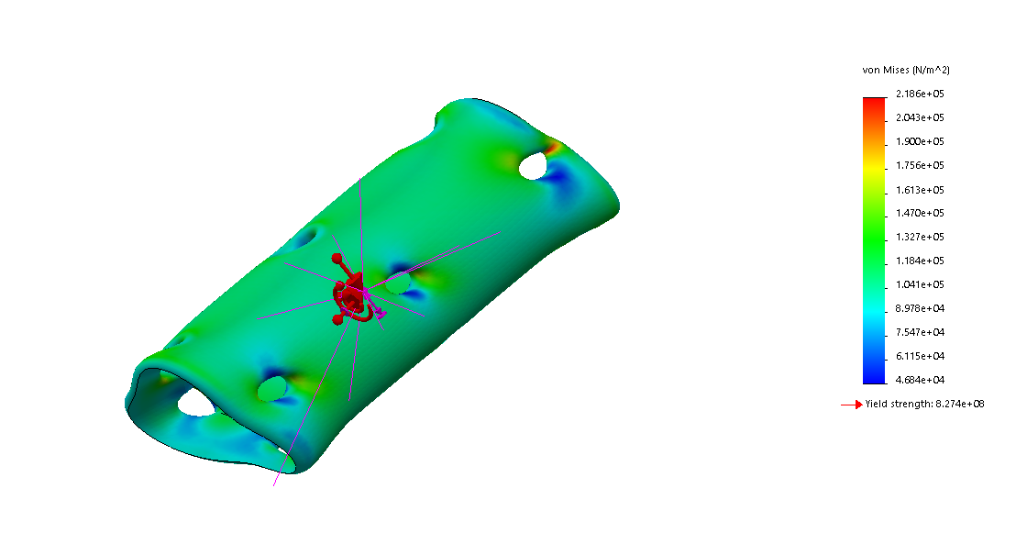
Figure 14 FEA Deformation of iteration 1 (VonMises)
Solidworks has shown that the deformation of the gudgeon pin to be quite high, however it has not reached the yield strength of the material yet which is 8.274e+8N/M^2, when the highest stress felt on the gudgeon pin is 2.186e+05N/M^2.

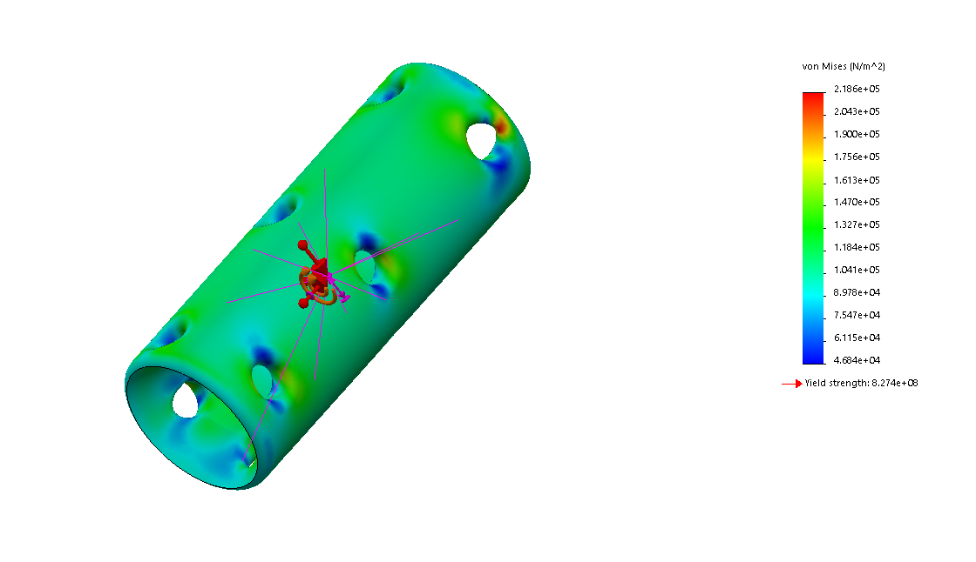
Figure 15 VonMises Stress without deformation
With this data, it could be suggested that this gudgeon pin design is still well within the yield strength of the material, meaning that it would be able to survive the pressure that is currently being put on it.

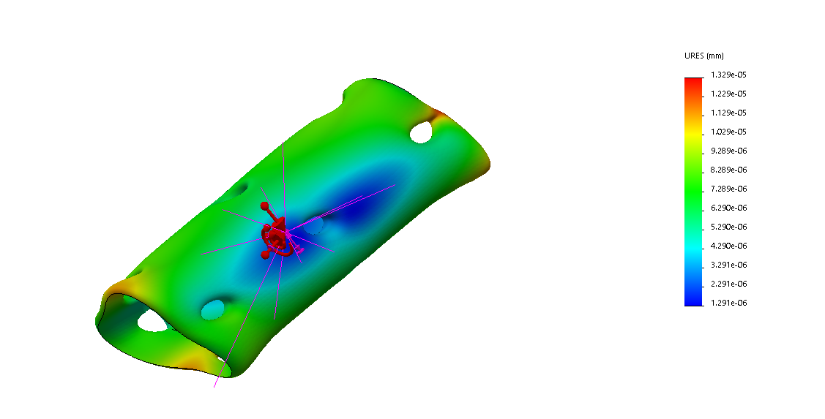
Figure 16 Deformation showing the displacement

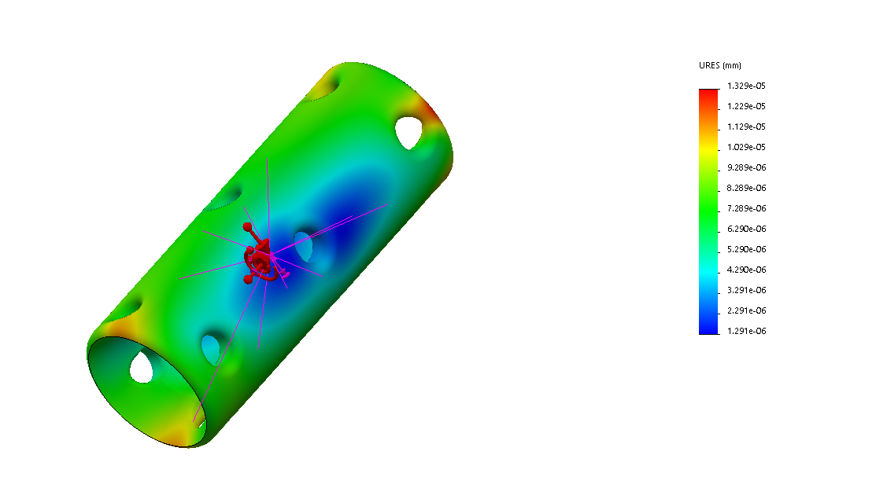
Figure 17 No deformation of displacement
The displacement of this gudgeon pin was 1.329e-05mm or 0.000013mm, with these results show that this design displaces even less than the original gudgeon pin and has less flex while saving 13g of weight.
When compared to the standard gudgeon pin, this modified gudgeon pin seems to be able to deal with the force that has been put onto the piston incredibly well and better than the standard one. By flexing less and having a much lower Von Mises stress concentration, however this may be different if the holes that were cut into the piece were not filleted and left as sharper edges.

Iteration Two
For this change, the sidewalls of the gudgeon pin have been thinned down, this has been done to 1mm thick walls compared to the standard 2.75mm of the original gudgeon pin. With this change, the gudgeon pin now weighs 10.58g, dropping around 17g when compared to the standard gudgeon pin while using the same Aisi 1020.

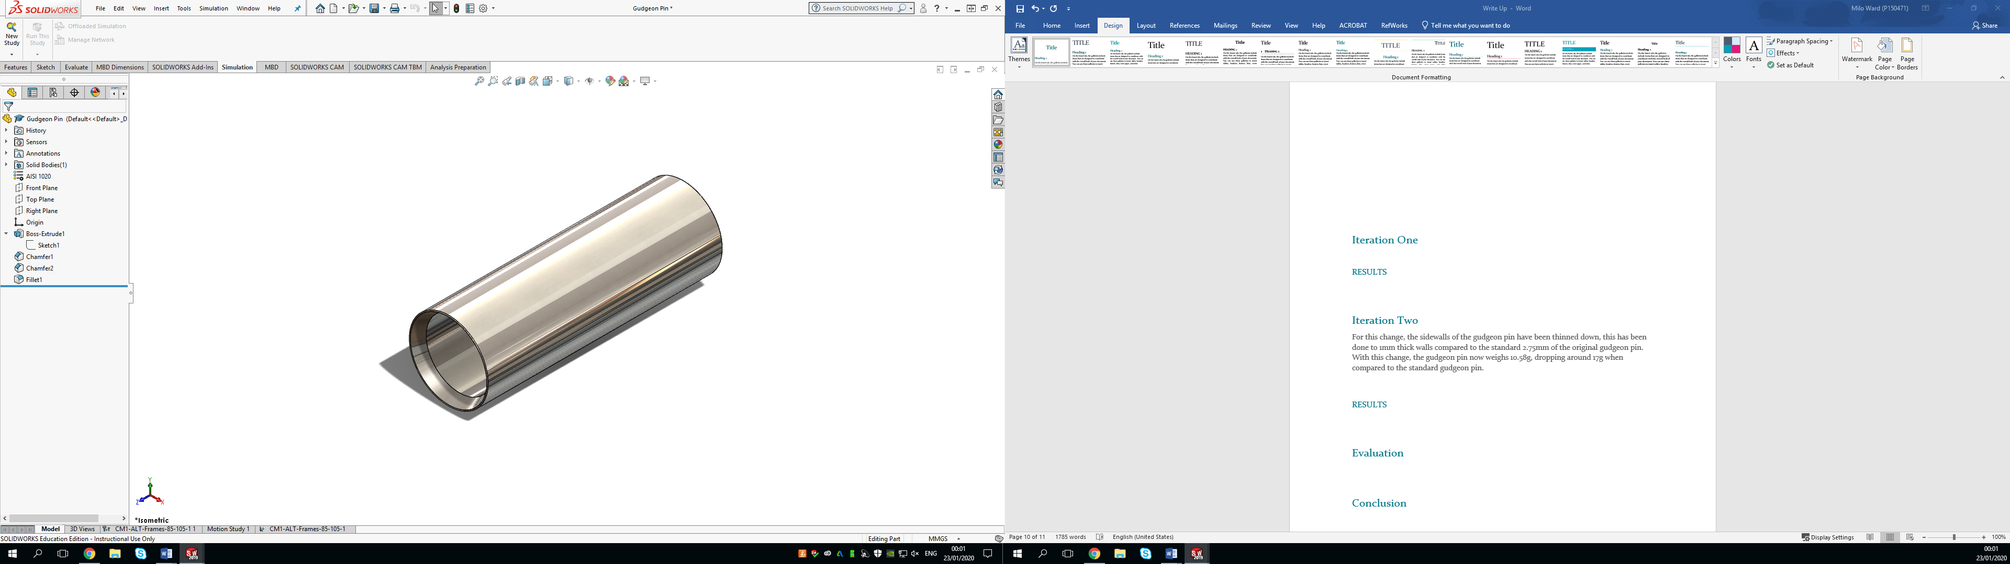
Figure 18 Redesigned Gudgeon Pin with 1mm thick walls

Results
Originally it was expected that this gudgeon pin would fail with such thin walls, however the results below suggested differently.

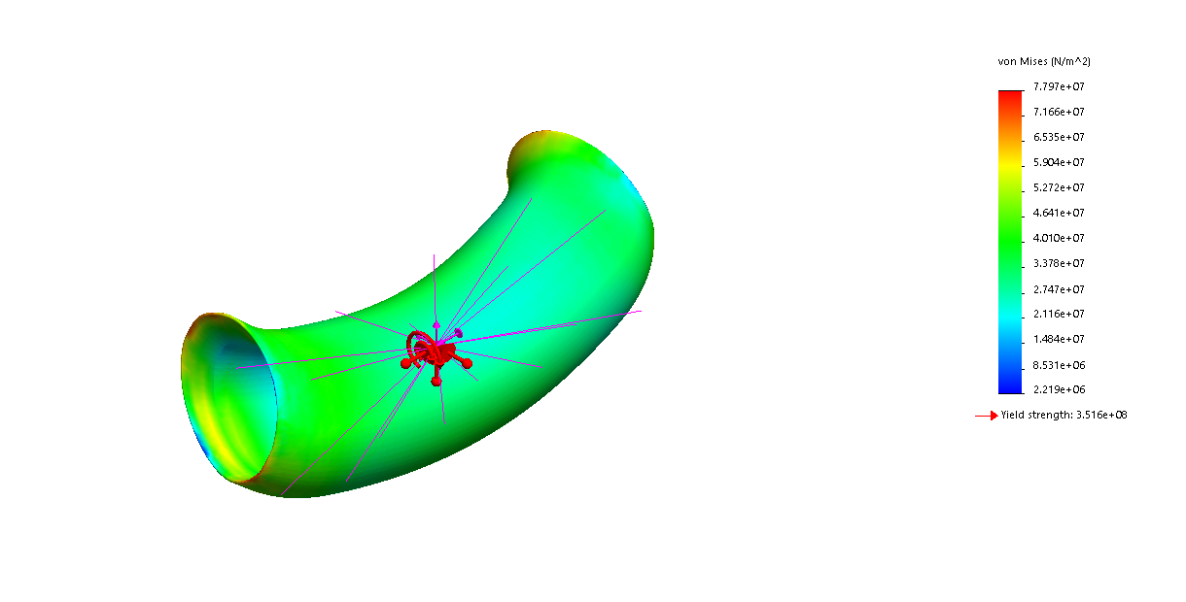
Figure 19 VonMises Stress with Deformation

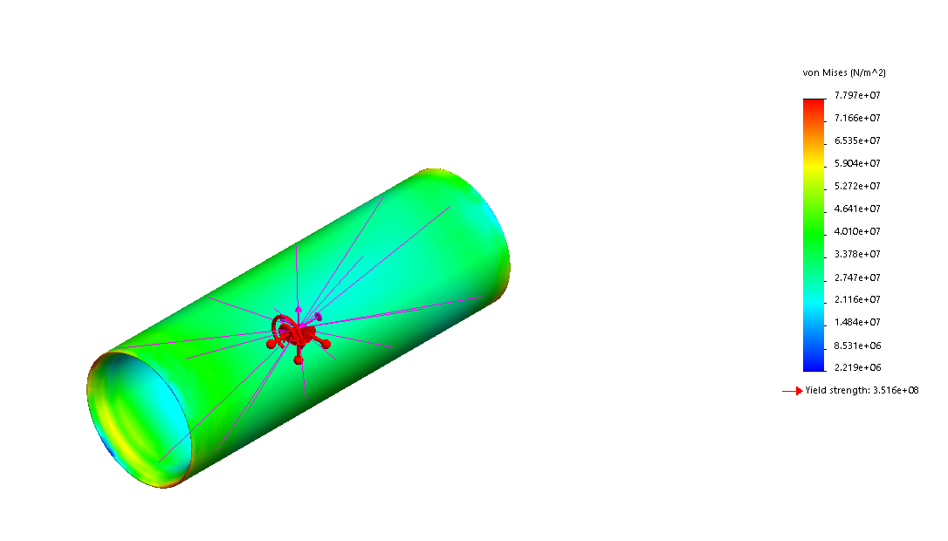
Figure 20 VonMises Stress with no deformation
Surprisingly, even with the 1mm thick walls this part still does not go into yield, with yield being 3.156e+08N/M^2 and the highest stress on this part being 7.797e+07N/M^2, with the highest stress being on the edges where the 0.1mm chamfer is, being the sharpest point, this is the highest stress concentration for the part.
In terms of displacement, the following FEA shows that.

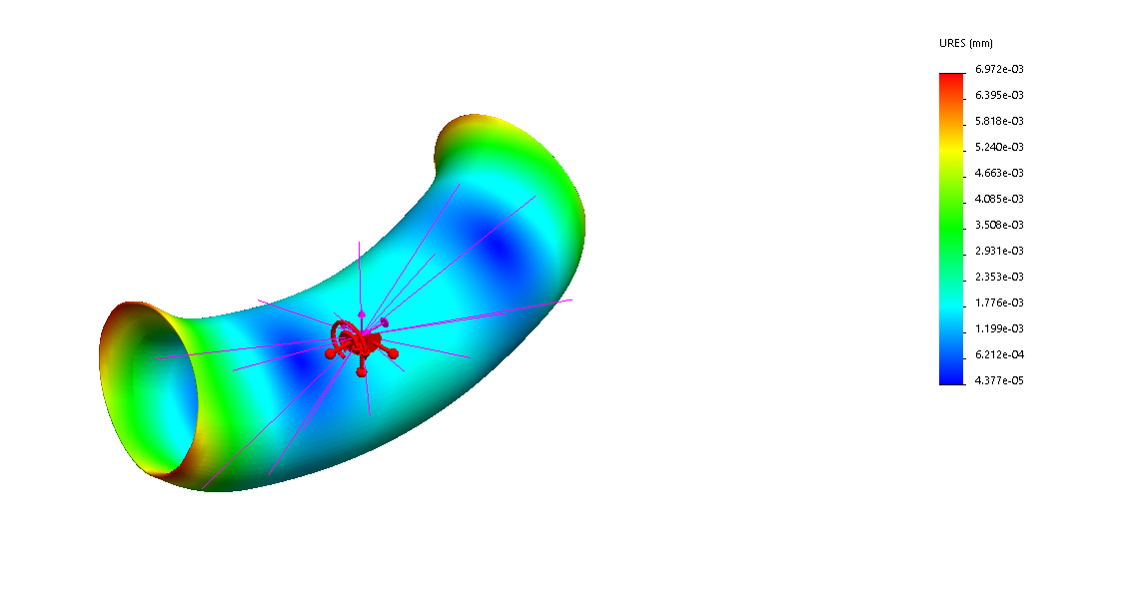
Figure 21 A displacement FEA on the 1mm sidewall with deformation

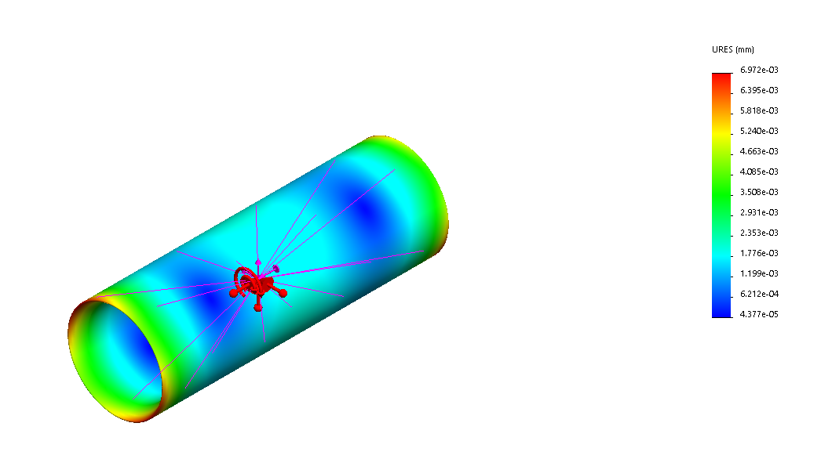
Figure 22 Displacement on the 1mm sidewall with no deformation
The displacement for this 1mm wall gudgeon pin is 6.972e-3mm or 0.0069mm. Although this has double from the standard gudgeon pin, 0.0069mm is still a very small amount of displacement, small enough to not have to worry about it breaking during this process.
These FEA’s on the 1mm thick sidewalls would suggestion that this design would work in a real-life situation with just the downward force of 40,000N on the piston.

Evaluation
From the FEA that has been done on this gudgeon pin, it seems as if there is room for improvements on the part, with the ability to make it lighter through a different material or through using less material and having thinner sidewalls on the part.
With the first iteration being considerably lighter than the standard and having less displacement than the standard, using Titanium and cutting and filleting holes into the part did make for a better part. However, with these changes this would make for a more expensive part, with the increase of material cost and time in producing the part.
Iteration number two with the 1mm thick walls reacted better than expected, it was thought that with the thin sidewalls that the part would bend more under the force Although it did bend more, double the standard gudgeon pins distance, it was still an incredibly small amount of displacement at only 0.0063mm. Reducing the weight down by 17grams at the same time, through this motion simulation and FEA this part would seem to be a better option than standard as well.
However, it should also be considered that this model does not consider the inertia forces with an increase in RPMs and the force that would be put onto the gudgeon pin when the piston is trying to pull up. This model currently only considers a 40,000N combustion force occurring linearly on top of the piston, rather than all forces that would be occurring during the combustion process.
With this extra force being considered it is unlikely that one or both of the changes would work in real life, as the part would be in constant stress and strain, the thinner sidewalls would displace more and at 14,000RPM the inertia force from the weight of the piston, rings, gudgeon pin and 1/3 of the conrod would be incredibly high.

Conclusion
Overall, the FEA models and the motion simulation of the gudgeon pin was a success, seeing how the current gudgeon pin experiences forces from combustion and it deals with this from the piston was incredibly interesting. By making changes to the gudgeon pin and seeing what effect these would have during the same process also showed that under the current model that is being completed on the part that they could work.
However, these iterations could not be put into production without completing another FEA on the part and a new motion simulation to see how the parts would react when put under the inertia forces that would occur at the high RPM in the Kawasaki ZX6R engine. If this model was to be taken further, replicating these forces in a motion simulation and FEA the three gudgeons pin should be completed to see the difference in VonMises stress and the displacement at the higher RPM. This model should be completed at the highest RPM to see if it could survive this or how much displacement would occur.
A further improvement would be to use data points, allowing the pressure on the top of the piston to be more accurately loaded on top of the piston, attempting to replicate a real-life simulation. This is done by exporting the data from a real-life model and adding this in to Solidworks on data points.
As well as this, the extra cost that would be occurred by using Titanium and cutting the holes in the gudgeon pin would be to high for a very minimal loss in weight in the engine. Making it commercially unviable in a mass production bike like this.

Link to CAD
https://uowtsd-my.sharepoint.com/:u:/g/personal/mward_150471_student_uwtsd_ac_uk/Ea0mrKVrZO5BqseYODSSPm8BIJ7--latxqSVhKBfxVyJjA?e=yxU90U

Bibliography
Jones, P. F. (1992). CAD/CAM:features, Application and Management . Houndmills, Basingstoke, Hampshire and London: The Macmillan Press LTD.
Lombard, M. (2013). Solidworks 2013 Bible . Indianapolis: John Wiley & Sons, Inc.
Scan2CAD. (2020). A Brief History Of SolidWorks | Scan2CAD. [online] Available at: https://www.scan2cad.com/cad/solidworks-history/ [Accessed 22 Jan. 2020].
En.wikiversity.org. (2020). Computer-aided design/History, Present and Future - Wikiversity. [online] Available at: https://en.wikiversity.org/wiki/Computer-aided_design/History,_Present_and_Future [Accessed 22 Jan. 2020].
Logo, S. (2020). SOLIDWORKS Vector Logo. [online] SeekLogoVector. Available at: https://seekvectorlogo.net/solidworks-vector-logo-svg/ [Accessed 22 Jan. 2020].

Appendices

Solid Works Generated Report
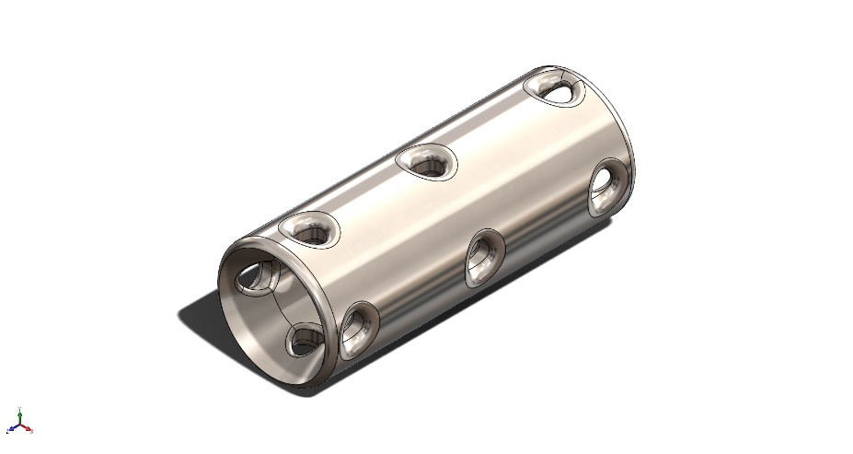
  Simulation of Gudgeon Pin mk 1.2
  Date: 26 January 2020
  Designer: Solidworks
  Study name: CM1-ALT-Frames-85-105-1
  Analysis type: Static
  Table of Contents
  Model Information 2
  Study Properties 3
  Units 3
  Material Properties 4
  Loads and Fixtures 5
  Connector Definitions 5
  Contact Information 6
  Mesh information 7
  Resultant Forces 13
  Study Results 15

Model Information

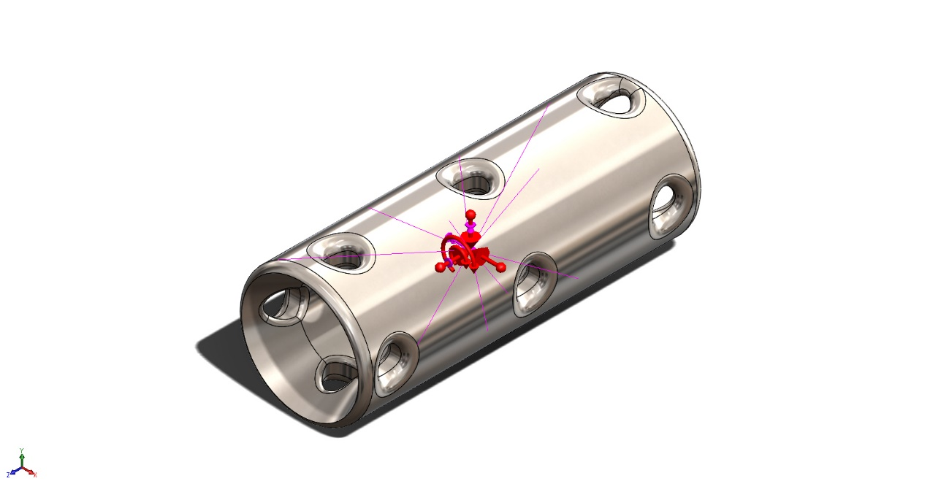
Model name: Gudgeon Pin mk 1.2
Current Configuration: Default
Solid Bodies
Document Name and Reference | Treated As | Volumetric Properties | Document Path/Date Modified
Fillet5  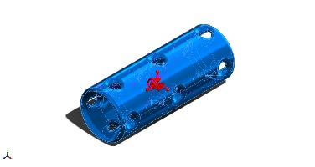 | Solid Body | Mass:0.0141789 kg  Volume:3.20153e-06 m^3  Density:4,428.79 kg/m^3  Weight:0.138953 N | V:\Year 3\Solid Works\Crank Assembly\Gudgeon Pin mk 1.2.SLDPRT  Jan 24 12:36:45 2020

Study Properties
Study name | CM1-ALT-Frames-85-105-1
Analysis type | Static
Mesh type | Solid Mesh
Thermal Effect: | On
Thermal option | Include temperature loads
Zero strain temperature | 298 Kelvin
Include fluid pressure effects from SOLIDWORKS Flow Simulation | Off
Solver type | FFEPlus
Inplane Effect: | Off
Soft Spring: | Off
Inertial Relief: | On
Incompatible bonding options | Automatic
Large displacement | Off
Compute free body forces | On
Friction | Off
Use Adaptive Method: | Off
Result folder | SOLIDWORKS document (V:\Year 3\Diss\Kawasaki CAD\Engine Parts)

Units
Unit system: | SI (MKS)
Length/Displacement | mm
Temperature | Kelvin
Angular velocity | Rad/sec
Pressure/Stress | N/m^2

Material Properties
Model Reference | Properties | Components
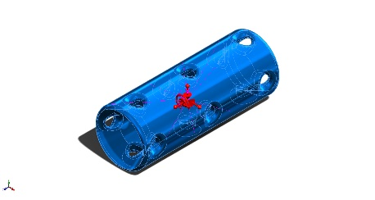 |  | SolidBody 1(Fillet5)(Gudgeon Pin mk 1.2)
  Name: | Ti-6Al-4VSolution treated and aged (SS)
  Model type: | Linear Elastic Isotropic
  Default failure criterion: | Unknown
  Yield strength: | 8.27371e+08 N/m^2
  Tensile strength: | 1.05e+09 N/m^2
  Elastic modulus: | 1.048e+11 N/m^2
  Poisson's ratio: | 0.31
  Mass density: | 4,428.78 kg/m^3
  Shear modulus: | 4.10238e+10 N/m^2
  Thermal expansion coefficient: | 9e-06 /Kelvin
Curve Data:N/A

Loads and Fixtures

Load name | Load Image | Load Details
ALT-RemoteLoads-2 | 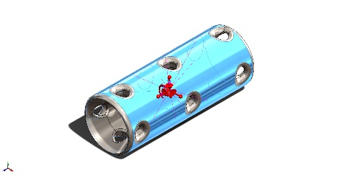
  Entities: | 1 face(s)
  Connection Type: | Distributed
  Weighting Factor: | Default (Constant)
  Coordinate System: | Global cartesian coordinates
  Translational Components: | 236.965 N,-1,446.31 N,-1.2522e-13 N
  Rotational Components: | 1.39909 N.m,0.217936 N.m,2.84983e-14 N.m
  Reference coordinates: | 0 0 0 m
ALT-RemoteLoads-1 | 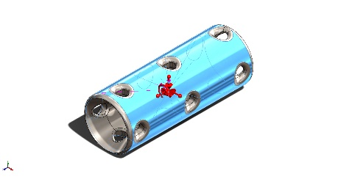
  Entities: | 1 face(s)
  Connection Type: | Distributed
  Weighting Factor: | Default (Constant)
  Coordinate System: | Global cartesian coordinates
  Translational Components: | -238.424 N,1,394.95 N,-2.18727e-13 N
  Rotational Components: | -1.39896 N.m,-0.217928 N.m,3.84484e-15 N.m
  Reference coordinates: | 0 0 0 m
ALT-Gravity | 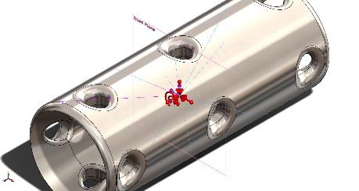
  Reference: | Front Plane
  Values: | -102.882 -3,622.12 -4.12426e-11
  Units: | m/s^2
ALT-CentriFugal
  Centrifugal, Ref: | Front Plane
  Angular Velocity: | 0.0606621 rad/s
  Angular Acceleration: | 31.9381 rad/s^2

Mesh information
Mesh type | Solid Mesh
Mesher Used: | Standard mesh
Automatic Transition: | Off
Include Mesh Auto Loops: | Off
Jacobian points | 4 Points
Element Size | 0.551403 mm
Tolerance | 0.0275701 mm
Mesh Quality Plot | High

Mesh information - Details
Total Nodes | 186073
Total Elements | 124887
Maximum Aspect Ratio | 22.351
% of elements with Aspect Ratio < 3 | 99.5
% of elements with Aspect Ratio > 10 | 0.0184
% of distorted elements(Jacobian) | 0
Time to complete mesh(hh;mm;ss): | 00:00:08
Computer name: | S1451
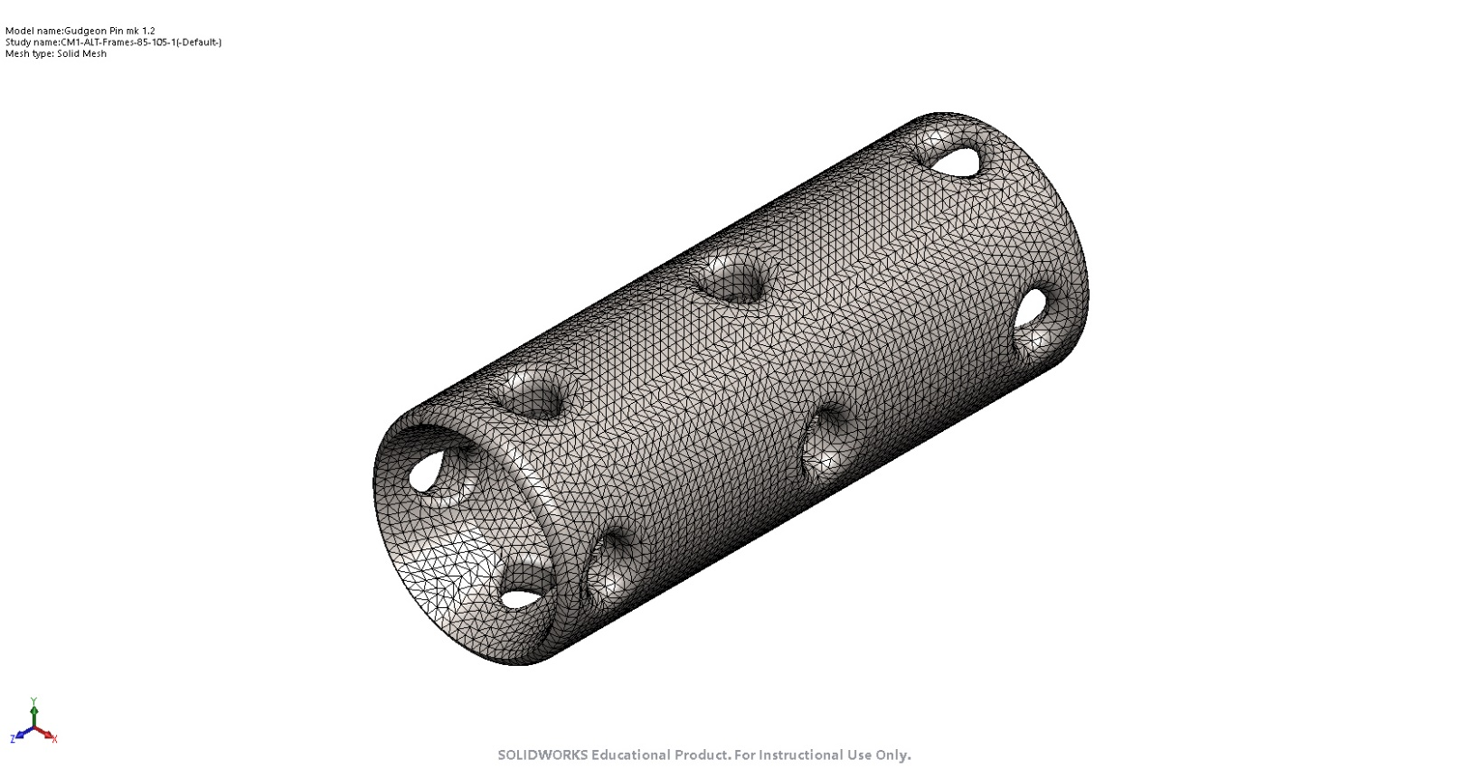

Sensor Details

Sensor name | Location | Sensor Details
VON: von Mises Stress |  | Value : 2.200e+05 N/m^2  Entities :  Result :Stress  Component :VON: von Mises Stress  Criterion :Model Max  Step Criterion : Across all Steps  Step No.:0  Alert Value: NA
P1: 1st Principal Stress |  | Value : 2.121e+05 N/m^2  Entities :  Result :Stress  Component :P1: 1st Principal Stress  Criterion :Model Max  Step Criterion : Across all Steps  Step No.:0  Alert Value: NA
P2: 2nd Principal Stress |  | Value : 6.779e+04 N/m^2  Entities :  Result :Stress  Component :P2: 2nd Principal Stress  Criterion :Model Max  Step Criterion : Across all Steps  Step No.:0  Alert Value: NA
P3: 3rd Principal Stress |  | Value : 1.007e+04 N/m^2  Entities :  Result :Stress  Component :P3: 3rd Principal Stress  Criterion :Model Max  Step Criterion : Across all Steps  Step No.:0  Alert Value: NA
URES: Resultant Displacement |  | Value : 1.332e-05 mm  Entities :  Result :Displacement  Component :URES: Resultant Displacement  Criterion :Model Max  Step Criterion : Across all Steps  Step No.:0  Alert Value: NA
INT: Stress Intensity(P1-P3) |  | Value : 2.325e+05 N/m^2  Entities :  Result :Stress  Component :INT: Stress Intensity(P1-P3)  Criterion :Model Max  Step Criterion : Across all Steps  Step No.:0  Alert Value: NA
ESTRN: Equivalent Strain |  | Value : 1.533e-06  Entities :  Result :Strain  Component :ESTRN: Equivalent Strain  Criterion :Model Max  Step Criterion : Across all Steps  Step No.:0  Alert Value: NA
VON: von Mises Stress |  | Value : 2.200e+05 N/m^2  Entities :  Result :Stress  Component :VON: von Mises Stress  Criterion :Model Max  Step Criterion : Across all Steps  Step No.:0  Alert Value: NA
P1: 1st Principal Stress |  | Value : 2.121e+05 N/m^2  Entities :  Result :Stress  Component :P1: 1st Principal Stress  Criterion :Model Max  Step Criterion : Across all Steps  Step No.:0  Alert Value: NA
P2: 2nd Principal Stress |  | Value : 6.779e+04 N/m^2  Entities :  Result :Stress  Component :P2: 2nd Principal Stress  Criterion :Model Max  Step Criterion : Across all Steps  Step No.:0  Alert Value: NA
P3: 3rd Principal Stress |  | Value : 1.007e+04 N/m^2  Entities :  Result :Stress  Component :P3: 3rd Principal Stress  Criterion :Model Max  Step Criterion : Across all Steps  Step No.:0  Alert Value: NA
URES: Resultant Displacement |  | Value : 1.332e-05 mm  Entities :  Result :Displacement  Component :URES: Resultant Displacement  Criterion :Model Max  Step Criterion : Across all Steps  Step No.:0  Alert Value: NA
INT: Stress Intensity(P1-P3) |  | Value : 2.325e+05 N/m^2  Entities :  Result :Stress  Component :INT: Stress Intensity(P1-P3)  Criterion :Model Max  Step Criterion : Across all Steps  Step No.:0  Alert Value: NA
ESTRN: Equivalent Strain |  | Value : 1.533e-06  Entities :  Result :Strain  Component :ESTRN: Equivalent Strain  Criterion :Model Max  Step Criterion : Across all Steps  Step No.:0  Alert Value: NA
VON: von Mises Stress |  | Value : 2.200e+05 N/m^2  Entities :  Result :Stress  Component :VON: von Mises Stress  Criterion :Model Max  Step Criterion : Across all Steps  Step No.:0  Alert Value: NA
P1: 1st Principal Stress |  | Value : 2.121e+05 N/m^2  Entities :  Result :Stress  Component :P1: 1st Principal Stress  Criterion :Model Max  Step Criterion : Across all Steps  Step No.:0  Alert Value: NA
P2: 2nd Principal Stress |  | Value : 6.779e+04 N/m^2  Entities :  Result :Stress  Component :P2: 2nd Principal Stress  Criterion :Model Max  Step Criterion : Across all Steps  Step No.:0  Alert Value: NA
P3: 3rd Principal Stress |  | Value : 1.007e+04 N/m^2  Entities :  Result :Stress  Component :P3: 3rd Principal Stress  Criterion :Model Max  Step Criterion : Across all Steps  Step No.:0  Alert Value: NA
URES: Resultant Displacement |  | Value : 1.332e-05 mm  Entities :  Result :Displacement  Component :URES: Resultant Displacement  Criterion :Model Max  Step Criterion : Across all Steps  Step No.:0  Alert Value: NA
INT: Stress Intensity(P1-P3) |  | Value : 2.325e+05 N/m^2  Entities :  Result :Stress  Component :INT: Stress Intensity(P1-P3)  Criterion :Model Max  Step Criterion : Across all Steps  Step No.:0  Alert Value: NA
ESTRN: Equivalent Strain |  | Value : 1.533e-06  Entities :  Result :Strain  Component :ESTRN: Equivalent Strain  Criterion :Model Max  Step Criterion : Across all Steps  Step No.:0  Alert Value: NA
VON: von Mises Stress |  | Value : 2.200e+05 N/m^2  Entities :  Result :Stress  Component :VON: von Mises Stress  Criterion :Model Max  Step Criterion : Across all Steps  Step No.:0  Alert Value: NA
P1: 1st Principal Stress |  | Value : 2.121e+05 N/m^2  Entities :  Result :Stress  Component :P1: 1st Principal Stress  Criterion :Model Max  Step Criterion : Across all Steps  Step No.:0  Alert Value: NA
P2: 2nd Principal Stress |  | Value : 6.779e+04 N/m^2  Entities :  Result :Stress  Component :P2: 2nd Principal Stress  Criterion :Model Max  Step Criterion : Across all Steps  Step No.:0  Alert Value: NA
P3: 3rd Principal Stress |  | Value : 1.007e+04 N/m^2  Entities :  Result :Stress  Component :P3: 3rd Principal Stress  Criterion :Model Max  Step Criterion : Across all Steps  Step No.:0  Alert Value: NA
URES: Resultant Displacement |  | Value : 1.332e-05 mm  Entities :  Result :Displacement  Component :URES: Resultant Displacement  Criterion :Model Max  Step Criterion : Across all Steps  Step No.:0  Alert Value: NA
INT: Stress Intensity(P1-P3) |  | Value : 2.325e+05 N/m^2  Entities :  Result :Stress  Component :INT: Stress Intensity(P1-P3)  Criterion :Model Max  Step Criterion : Across all Steps  Step No.:0  Alert Value: NA
ESTRN: Equivalent Strain |  | Value : 1.533e-06  Entities :  Result :Strain  Component :ESTRN: Equivalent Strain  Criterion :Model Max  Step Criterion : Across all Steps  Step No.:0  Alert Value: NA

Resultant Forces

Reaction forces
Selection set | Units | Sum X | Sum Y | Sum Z | Resultant
Entire Model | N | 0 | 0 | 0 | 1e-33

Reaction Moments
Selection set | Units | Sum X | Sum Y | Sum Z | Resultant
Entire Model | N.m | 0 | 0 | 0 | 0

Study Results

Name | Type | Min | Max
Stress1 | VON: von Mises Stress | 4.815e+04 N/m^2  Node: 522 | 2.200e+05 N/m^2  Node: 8
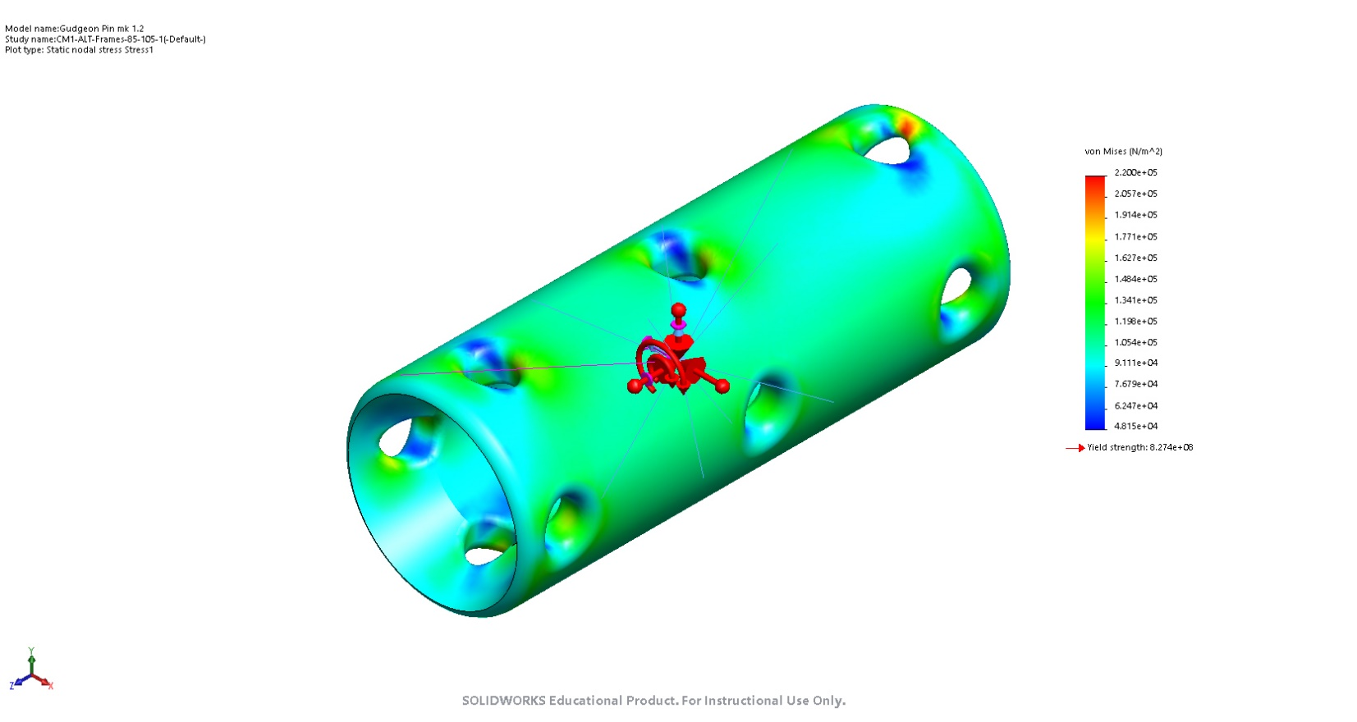
Gudgeon Pin mk 1.2-CM1-ALT-Frames-85-105-1-Stress-Stress1

Name | Type | Min | Max
Displacement1 | URES: Resultant Displacement | 1.307e-06 mm  Node: 5884 | 1.332e-05 mm  Node: 1677
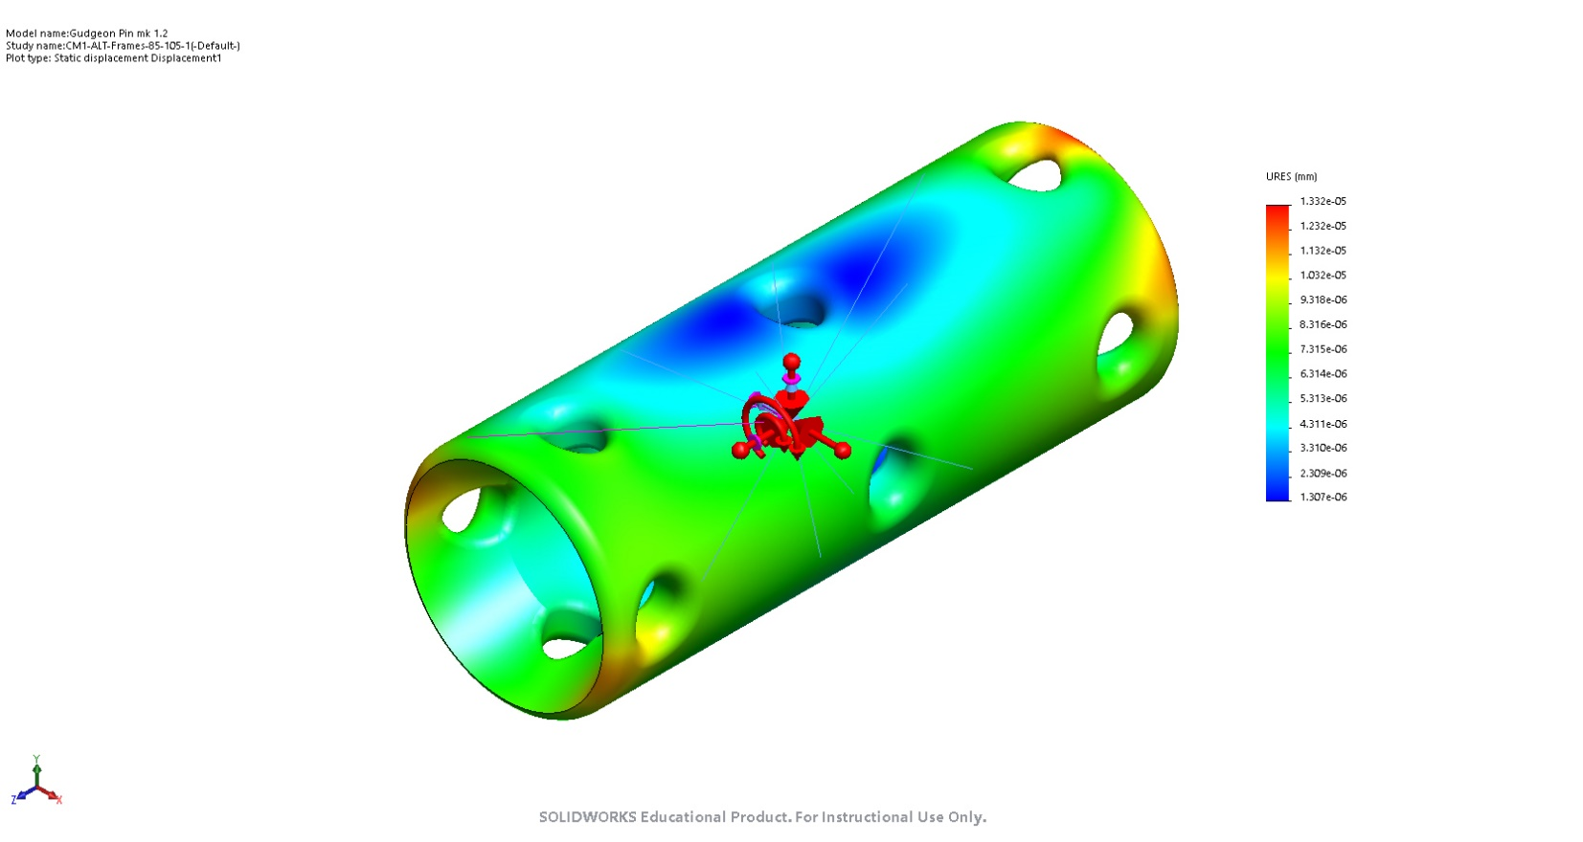
Gudgeon Pin mk 1.2-CM1-ALT-Frames-85-105-1-Displacement-Displacement1

Name | Type | Min | Max
Strain1 | ESTRN: Equivalent Strain | 4.419e-07  Element: 49971 | 1.533e-06  Element: 15673
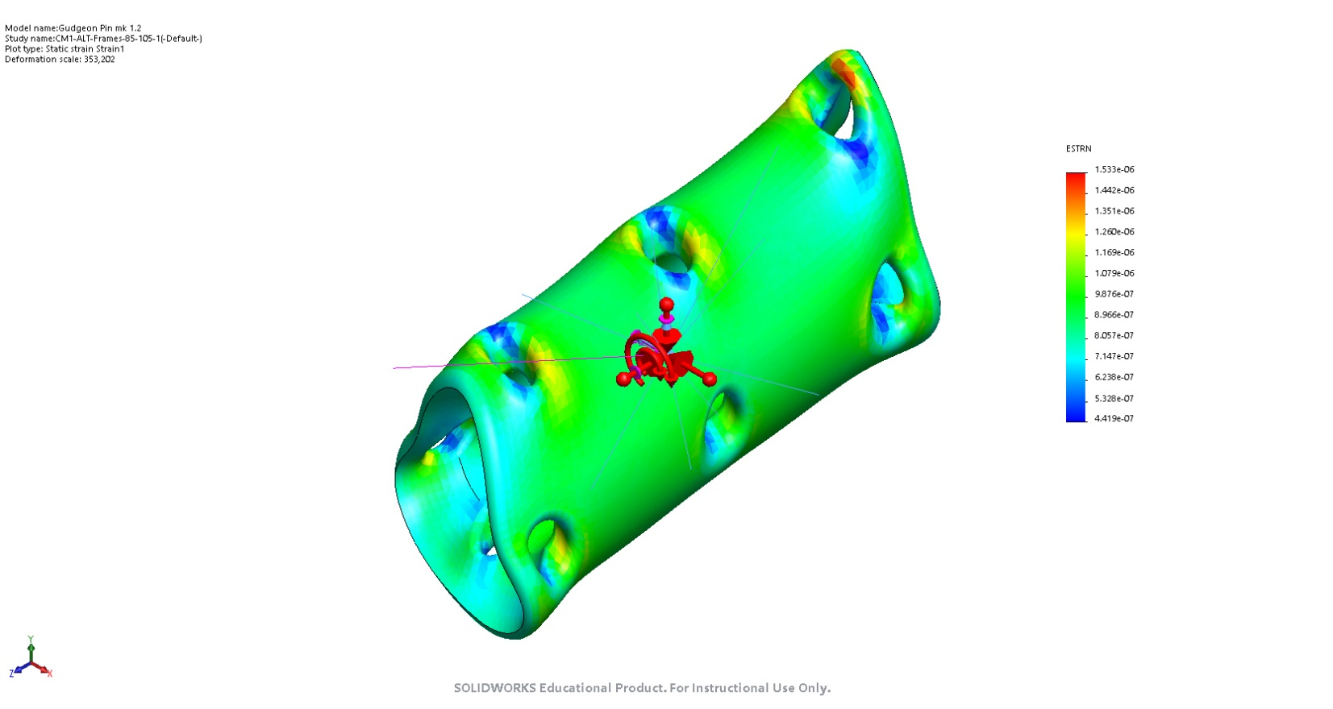
Gudgeon Pin mk 1.2-CM1-ALT-Frames-85-105-1-Strain-Strain1

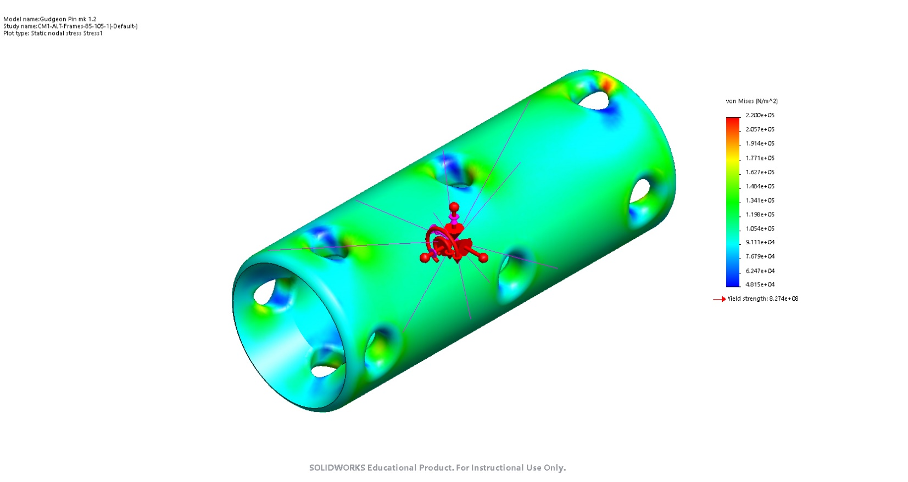
Image-1

