Nisreen Mubarik
2506382

Module: Introduction to Health and Social Care
Module Code: LCHS4003
Tutor: Dr Helen Parsons
Assignment: Portfolio – Two Tasks

Task 1: Academic Poster – Ambulance Services in the UK
AMBULANCE SERVICES IN THE UK  Every second counts: expert clinical care that begins before the hospital. | 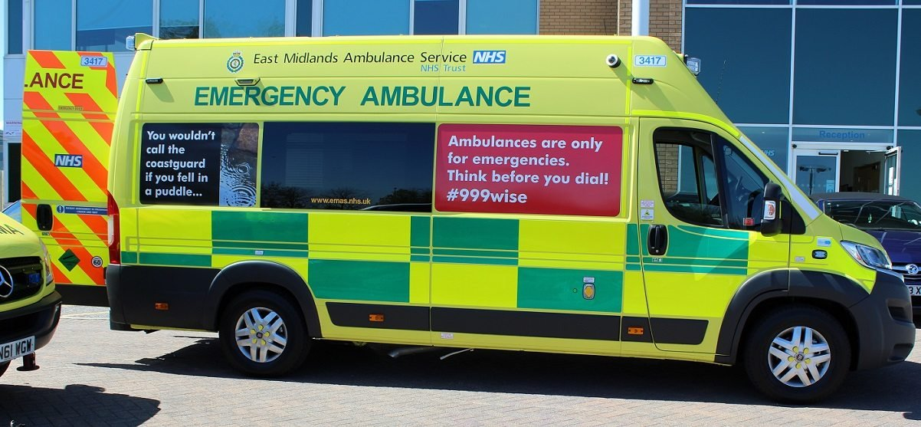  Fig: A modern NHS emergency ambulance (East Midlands Ambulance Service NHS Trust, 2024).

What is the ambulance service?  The ambulance service is the public's main route to urgent and emergency healthcare. People reach it by dialling 999, or through NHS 111 for less urgent advice. In England it is delivered by ten NHS ambulance trusts, with separate services in Scotland, Wales and Northern Ireland (The King's Fund, 2025). Calls are triaged into four categories, from Category 1 for life-threatening emergencies such as cardiac arrest to Category 4 for less urgent problems (London Ambulance Service, 2024). Crews led by paramedics now assess and treat patients at the scene, deciding whether someone needs hospital or can be cared for at home, rather than simply transporting them (NHS England, 2024). | 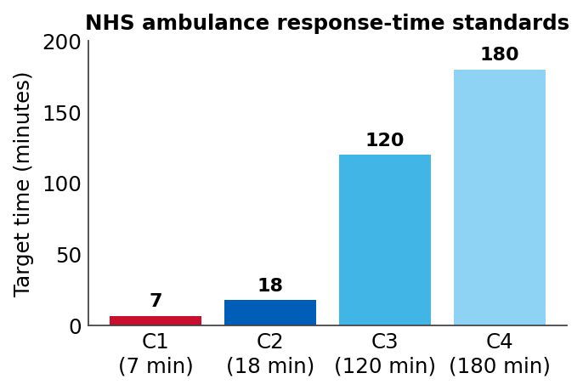  Fig: NHS ambulance response-time standards by category (data: Nuffield Trust, 2026).

A brief history of the service
A national ambulance service only became a legal duty with the National Health Service Act 1948, which required ambulances to be available to everyone who needed them (London Ambulance Service, 2025). The role of the paramedic emerged later: the first British schemes began in Brighton in 1971, training ambulance staff in advanced skills for cardiac patients, and in 1973 ambulance services were brought into the NHS (Ambulance CPD, 2025). Over time the service shifted from a simple 'scoop and run' approach, which aimed only to move patients to hospital quickly, towards delivering advanced clinical care on scene, effectively turning the ambulance into a mobile treatment unit.

How the service works today  Demand has risen sharply. In 2024 England averaged around 79,500 Category 1 incidents each month, roughly 37% more than before the pandemic (NHS Providers, 2024). National standards require a mean response of 7 minutes for Category 1 and 18 minutes for Category 2 calls (Nuffield Trust, 2026), yet these targets are regularly missed: the Category 2 average reached 34 minutes 38 seconds in June 2024 (NHS Providers, 2024). Modern crews work closely with GPs, mental health teams and community services, treating many patients at home through 'hear and treat' and 'see and treat' responses to keep emergency departments free for the most serious cases (NHS England, 2024). | 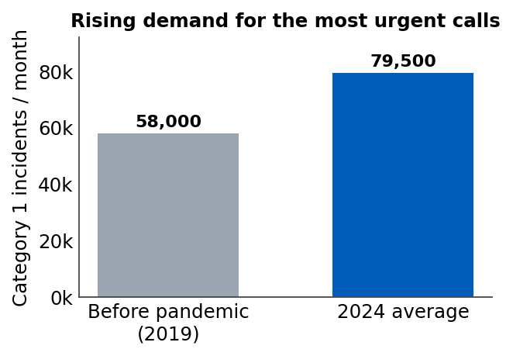  Fig: Average monthly Category 1 incidents (data: NHS Providers, 2024).  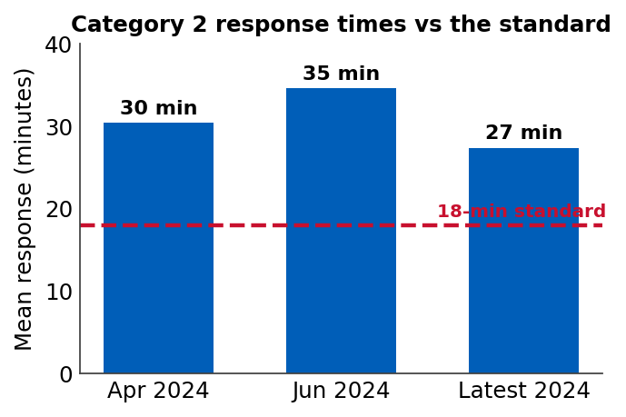  Fig: Category 2 response times against the 18-minute standard (data: NHS England; NHS Providers, 2024).

Challenge 1: Hospital handover delays  When emergency departments are full, crews cannot hand over their patients and are forced to wait outside hospitals. In May 2024 alone there were around 104,000 handover delays of thirty minutes or more, and the Association of Ambulance Chief Executives estimated that about 32,000 patients suffered potential harm as a result (AACE, 2024). These delays tie up ambulances that should be answering new 999 calls in the community. They are driven by wider system pressures, especially a shortage of social care that stops hospitals discharging medically fit patients safely (AACE, 2024). | 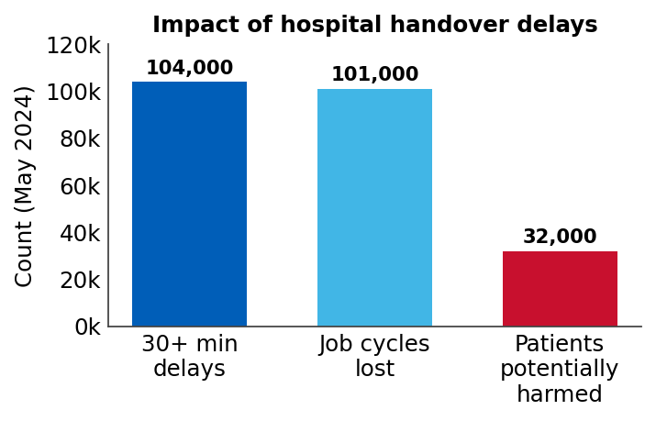  Fig: Impact of hospital handover delays, May 2024 (data: AACE, 2024).

Challenge 2: Workforce pressures
In 2024, approximately 43% of all ambulance staff reported experiencing harassment, bullying or abuse (Care Quality Commission, 2025).
The service also has a difficulty in retaining sufficient staff. Ambulance work is stressful and the risk of safety has become paramount with 31% of staff also stating that they suffer violence within the workplace (Care Quality Commission, 2025). This, coupled with burnout and lack of advancement within the profession, drives experienced paramedics to leave the field. With fewer staff, there will be slower responses and reduced quality of care, with the impact on vulnerable patients waiting at home being the greatest (The King's Fund, 2025).
Task 2: Academic Essay – Domiciliary Care Services
Maintaining Autonomy within the Community: A Critical Evaluation of the Origins, Modern Operation and Quality-of-Life Effects of Domiciliary Care Services
Introduction, historical origins and legislative milestones
Home care (also known as domiciliary care) is a social care service that is designed to help individuals in their own homes. The UK's approach to people who were vulnerable was very institutionalised in the past and people were sent to workhouses. Hughes (2023) explained that early social attitudes considered care to be something that needed to be hidden in institutional spaces and not provided in the home. However, social reforms in the twentieth century gave rise to deinstitutionalisation, whereby the emphasis moved towards helping individuals to live independently at home. This change brought to light the historic distinction between health and social care. In the UK healthcare is free under the NHS, social care is means-tested and devolved to local authorities as explained by Glasby (2026).
Critical evaluation of contemporary functioning
In reality, today's domiciliary care services struggle to reconcile the management of care with care for the individual. Today many local authorities commission home care in a very transactional way – sometimes known as ‘task and finish visits’ – and allocate a carer just 15 minutes to assist a client. In Bengtsson's (2024) opinion, this commercialised way of connecting can result in older individuals feeling isolated, as it is more about speed than about social interaction. Low pay and high turnover of care staff exacerbate this. Palmer (2026) uses personal accounts to illustrate that for many service users, a lack of continuity in their daily lives and a sense of less safety can result from a succession of different carers. These failures also have a direct impact on the overall healthcare system. If community home care is not available, vulnerable people lack support, which puts them at risk of major incidents like falls. This in turn increases the amount of emergency 999 calls and overloads ambulance crews and inadequate care packages means that hospitals don't have the capacity to discharge patients safely, leading to bed blockages and delayed handovers. Consequently, the ineffective functioning of modern domiciliary care has a direct negative impact on the efficiency and safety of the whole health and social care network.
The impact on service user quality of life
Despite these challenges, the impact of effective domiciliary care is enormous in the quality of life of those who receive the services. Keeping older people in their own homes helps to preserve their independence, identity and dignity, which are most likely to be lost when they move into residential care. Care at home allows a person to maintain their identity and control over their daily activities, both of which are an important part of emotional health in old age, according to Hughes (2023). Additionally, home care is a crucial part of preventive care, allowing individuals to remain physically active in their own environment. Genaro et al. (2024) show that structured home care visits can help maintain cognitive ability and slow physical decline in older populations, reducing the need for more intensive institutional care. Home care workers can help prevent depression and physical deterioration by providing assistance with daily activities and regular socialisation. The importance of domiciliary care is thus more than just a convenient service; it is a vital part of a long-term strategy to maintain vulnerable people healthy, happy and independent.
References
Ambulance CPD (2025) The history of the UK paramedic.
Association of Ambulance Chief Executives (AACE) (2024) Latest UK NHS ambulance sector data shows there can be no complacency over hospital handover delays. Available at: https://aace.org.uk/news/latest-uk-nhs-ambulance-sector-data-shows-there-can-be-no-complacency-over-hospital-handover-delays-as-32000-people-estimated-to-have-come-to-potential-harm-in-may-2024/ (Accessed: 17 June 2026).
Bengtsson, M.N. (2024) An exploration of older people's perspectives of future homecare in the United Kingdom and principles for its design: a participatory approach. Doctoral dissertation. Bournemouth University.
Care Quality Commission (2025) The state of health care and adult social care in England 2024/25: secondary care. Available at: https://www.cqc.org.uk/publications/major-report/state-care/2024-2025/access/secondary (Accessed: 17 June 2026).
East Midlands Ambulance Service NHS Trust (2024) #999wise emergency awareness campaign. Available at: https://www.emas.nhs.uk/ (Accessed: 17 June 2026).
Genaro, L.E., Marconato, J.V., Tagliaferro, E.P.D.S., Pinotti, F.E., Valsecki Júnior, A., Adas Saliba, T. and Rosell, F.L. (2024) 'Home care for the elderly: an integrated approach to perception, quality of life, and cognition', International Journal of Environmental Research and Public Health, 21(5), p.539.
Glasby, J. (2026) Understanding health and social care. Bristol: Policy Press.
Hughes, S. (2023) Domiciliary care, self and older age. Doctoral dissertation. Anglia Ruskin Research Online (ARRO).
London Ambulance Service NHS Trust (2024) Ambulance response categories. Available at: https://www.londonambulance.nhs.uk/calling-us/ambulance-response-categories/ (Accessed: 17 June 2026).
London Ambulance Service NHS Trust (2025) Our history: a timeline. Available at: https://www.londonambulance.nhs.uk/about-us/our-history/our-history-a-timeline/ (Accessed: 17 June 2026).
NHS England (2024) Monthly operational statistics – September 2024. Available at: https://www.england.nhs.uk/long-read/monthly-operational-statistics-september-2024/ (Accessed: 17 June 2026).
NHS Providers (2024) NHS activity tracker 2024/25: ambulance sector. Available at: https://nhsproviders.org/nhs-activity-tracker-202425/july-2024/ambulance-sector (Accessed: 17 June 2026).
Nuffield Trust (2026) Ambulance response times. Available at: https://www.nuffieldtrust.org.uk/resource/ambulance-response-times (Accessed: 17 June 2026).
Palmer, D. (2026) ‘"Behind every visit is a life, my life": listening to home care recipients through oral history', International Journal of Ageing and Later Life.
The King's Fund (2025) NHS key facts and figures. Available at: https://www.kingsfund.org.uk/insight-and-analysis/data-and-charts/key-facts-figures-nhs (Accessed: 17 June 2026).

