Developing Relationship and Workplace Achievement
Student name: Marin Adrian Mirancea
Student ID: 1811973

Table of Contents
Slide 1: Training and Development Needs for HR Officers 2
Slide 2: Introduction 2
Slide 3: Task 1 Determining the appropriate knowledge, skills, and behaviours (KSB) that are required by HR professionals across the department 3
Slide 4: Skills and Behaviours required by the HR Professionals 4
Slide 5: Task 2 Conducting a personal skills audit to identify the training and development needs considering the knowledge, skills, and behaviors identified in Task 1 4
Slide 6: Communication Skills 5
Slide 7: Problem Solving and Supervisory Management Skills 6
Slide 8: Task 3 Critically assessing the potential benefits to the organization of developing me as an HR officer through effective training and development 7
Slide 9: potential benefits to the organization of developing me as an HR officer through effective training and development 8
Slide 10: Conclusion 9
Slide 11: References 9
Appendix: Personal Skill Audit 10

Slide 1: Training and Development Needs for HR Officers

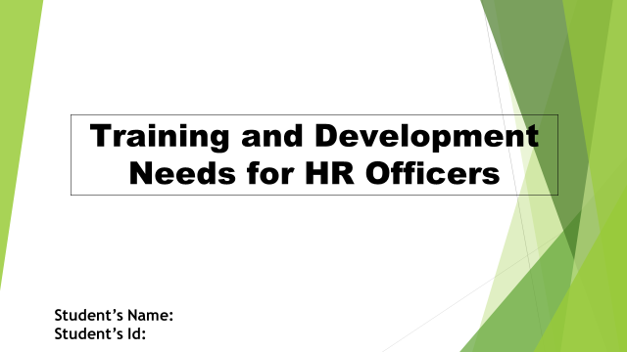

Slide 2: Introduction
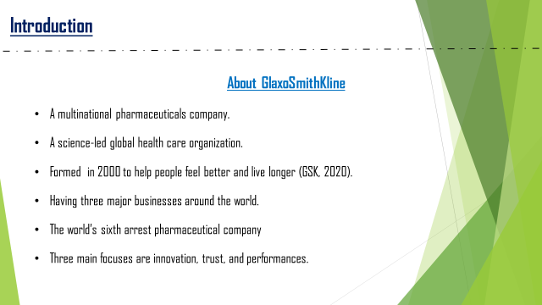
I have been appointed as a graduate trainee Human Resource officer in GlaxoSmithKline. My role as a human resource officer is really interesting and full of responsibility. My company has huge self-development facilities available for us.
About the company:
GlaxoSmithKline is a multinational pharmaceuticals company. It is a science-led global health care organization formed with a purpose to help people feel better and live longer. The company has basically three major businesses around the world. The company was formed in 2000 by a merger of two companies (GSK, 2020). It is the world’s sixth arrest pharmaceutical company. Their three main focuses are innovation, trust, and performances.
GlaxoSmithKline does research activities. They also develop and manufacture pharmaceuticals medicines and other consumer healthcare products. The company is doing good in its research.

Slide 3: Task 1 Determining the appropriate knowledge, skills, and behaviours (KSB) that are required by HR professionals across the department
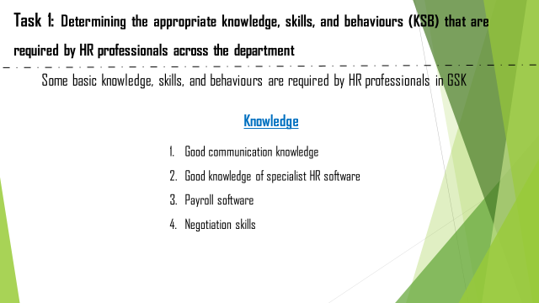
HR professionals need to maintain a good relationship with all departments. They are in charge to find out the employee requirements in every department, recruit new employees according to the requirements and train them to become skilled employees for the company. Some basic knowledge required by HR professionals in GSK (GSK, 2020) is given in the slide.

Slide 4: Skills and Behaviours required by the HR Professionals
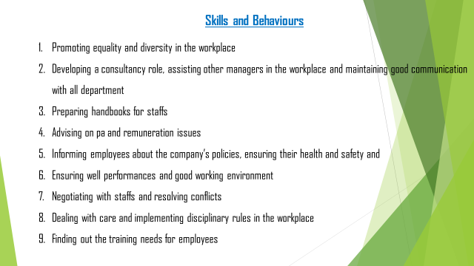
Some skills and behaviours are required by HR professionals in GSK (GSK, 2020). HR officers must promote equality in the workplace. They need to prepare handbooks for staff and deal with utmost care with them. They have to inform others about what they can do and what they are forbidden. In the case of negotiation, they should remain empathetic and calm. They should make people aware of the organization’s policies. The slide has shown all the responsibilities of an HR officer in GlaxoSmithKline.

Slide 5: Task 2 Conducting a personal skills audit to identify the training and development needs considering the knowledge, skills, and behaviors identified in Task 1
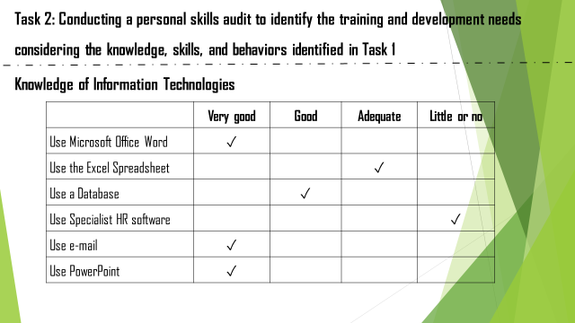
Throughout my academic life, I have to write many reports and essays as a part of course requirements. So, I have a good knowledge of Microsoft Word. I have worked with MS Excel but to a basic extent. It has behaviour huge application that I need to learn. Working with a large database is not easy but I have the experience. I have never used any HR-related software. So, I need to earn it, I have to use e-mail and PowerPoint very frequently. Enriching knowledge is important because, it develops the creativity of a person (Baer, 2018).

Slide 6: Communication Skills
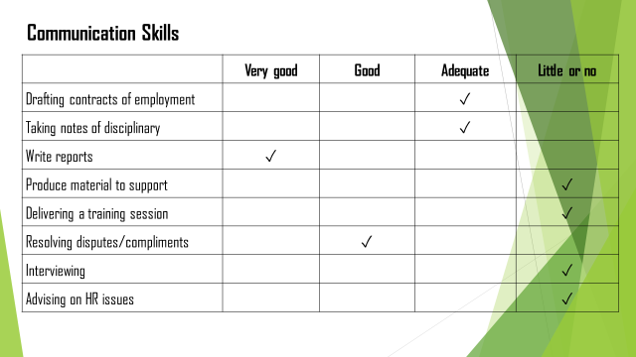
I need training in developing my communication skills from the perspective of an HR officer. Because such officers require specialized communication needs. From the chart, it has been found that I have no knowledge of how to produce supporting materials, deliver training sessions, interview, and give advice on HR issues. These are fully new areas of learning for me.

Slide 7: Problem Solving and Supervisory Management Skills
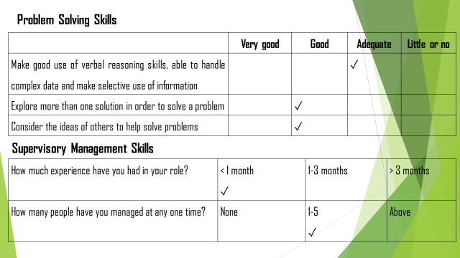
I have worked in a group of four to five members. Working in a group has developed my problems solving skills. In case-solving conflicts among group members or in case of any other problems, I have always listened to others and applied their solutions to resolved problems. But, I need to develop my verbal reasoning skills and my analytical ability in case of working with complex data.
It will be less than one month to my joining in this post of HR officer in GSK. In my academic life, I performed many group tasks were, I dealt with two to three members.

Slide 8: Task 3 Critically assessing the potential benefits to the organization of developing me as an HR officer through effective training and development
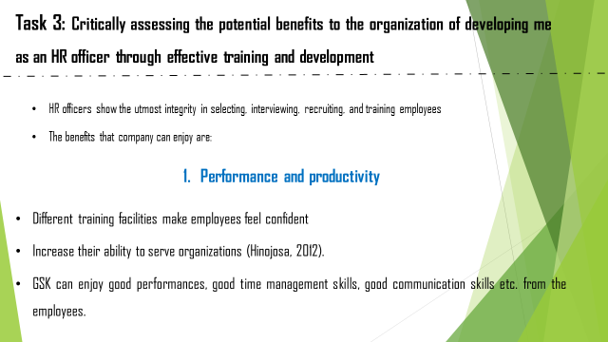
HR officers show the utmost integrity in selecting, interviewing, recruiting, and training employees to make them fit for the organization so that the company can enjoy some probable benefits. They are:
I need some training to acquire some skills and knowledge required to perform my role efficiently. GSK has proper training facilities for all of its employees based on their needs. The company receives some potential benefits from employees like me after providing them with effective training facilities.
- Performance and productivity
HR professionals introduce different training facilities for new and existing employees. These facilities make employees feel confident about their position and ability to serve organizations (Hinojosa, 2012). GSK can enjoy good performances, good time management skills from the employees, good communication skills etc.
I can feel the confidence within me after receiving some training from the company. Initially, I was given two teams which I found difficult to manage and ow I can work with two teams simultaneously. The company has arranged some seminars which I have found very helpful. Discussions held in seminars have helped me increase my knowledge level as well (Yorks, 2015).

Slide 9: potential benefits to the organization of developing me as an HR officer through effective training and development
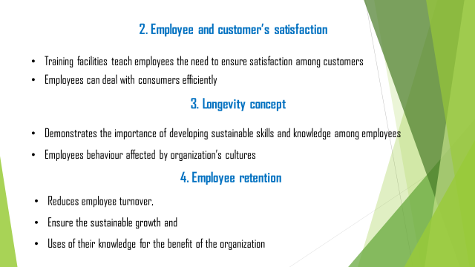

- Employee and customer’s satisfaction
By providing effective training, organizations teach employees the need to ensure satisfaction among customers and other employees. Trained employees understand how to deal with other employees with proper gestures and attitudes. They can deal with very complicated issues with effective solutions as well. Thus they can ensure satisfaction within all the stakeholders related to the organization.
- Longevity concept
The concept demonstrates the importance of developing sustainable skills and knowledge among employees. The HR Professionals, therefore, focuses on developing an effective environment where employees get to learn a lot about the company’s norms and cultures through working (Simon, 2016).
My behaviours in the organization are affected by the culture and norms of the company. The whole organizational culture helps me work efficiently and managing my time.
- Employee retention
To reduce employee turnover, proper training facilities should be given to both new and existing employees to ensure the sustainable growth and use of their knowledge for the benefit of the organization. Motivating them with proper reinforcement and learning facilities may reduce the turnover rate.

Slide 10: Conclusion
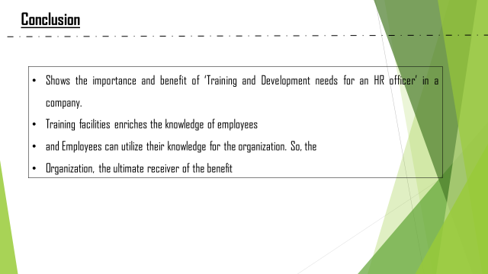
The purpose of this presentation is to show the importance and benefit of ‘Training and Development needs for an HR officer’ in a company like GlaxoSmithKline. Undoubtedly training facilities enrich the knowledge of employees and they can utilize their knowledge for the benefit of the organization. So, the organization is the ultimate receiver of the benefit acquired by developing employees’ knowledge through proper training facilities.

Slide 11: References
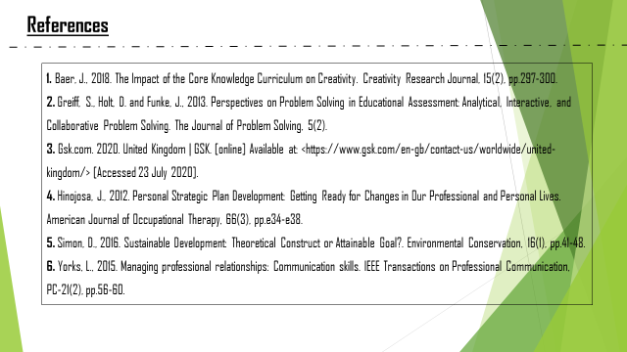

Appendix: Personal Skill Audit
Personal Skill Audit
Name
Job role: Human Resource Officer

 | Very good | Good | Adequate | Little or no
Information Technology
Use Microsoft Office Word | ✓
Use Excel Spreadsheet |  |  | ✓
Use a Database |  | ✓
Use Specialist HR software |  |  |  | ✓
Use e-mail | ✓
Use PowerPoint | ✓

 | Very good | Good | Adequate | Little or no
Communication Skills
Drafting contracts of employment |  |  | ✓
Taking notes of disciplinary |  |  | ✓
Write reports | ✓
Produce material to support |  |  |  | ✓
Delivering a training session |  |  |  | ✓
Resolving disputes/compliments |  | ✓
Interviewing |  |  |  | ✓
Advising on HR issues |  |  |  | ✓

 | Very good | Good | Adequate | Little or no
Problem Solving Skills
Make good use of verbal reasoning skills, able to handle complex data and make selective use of information |  |  | ✓
Explore more than one solution in order to solve a problem |  | ✓
Consider the ideas of others to help solve problems |  | ✓

Supervisory Management
How much experience have you had in your role? | < 1 month  ✓ | 1-3 months | > 3 months
How many people have you managed at any one time? | None | 1-5  ✓ | Above

I declare that the information given in this form is true
Signed | Marin-Adrian Mirancea
Date | 20/08/2020

