

ASSESSMENT 2 (LAMB7001)

MARKETING MANAGEMENT

Program name: MBA (Master of Business Administration)
Lecturer name: Tushara Balendran
Student name: Ghanchi Kinjal Arjunkumar
Student id: 2124033

Executive summary
External and internal environmental factors matters to every organization, irrespective of their size or the industry type they belong to. Assessing internal and external environment is therefore a reasonable approach for organizations like Starbucks to find opportunities, as well as challenges in existing market. Analysis of this business environment in this report, using model frameworks, such as Porter’s model, SWOT model and PESTEL model revealed that the marketing management strategy of Starbucks is associated with effective management of the business structure. The customer-centric approach of Starbucks helps in improving product diversity and geographical emergence management of the organization. On the other hand, using the online promotional strategy helps in developing better growth in customer-centric management approaches.

Table of Contents
1. Introduction 4
2. PORTER’s five forces 4
3. External environmental analysis 6
4. Internal environmental analysis 9
5. Role of marketing in organization 10
6. Recommendations 12
7. Conclusion 13
Reference: 14

1. Introduction
Marketing management is a multidisciplinary approach to the developmental aspects of the business structure. It is associated with the market orientation, techniques management, situational assessment, internal and external market condition analysis and competitive business environment analysis procedure. Starbucks’ marketing strategy is associated with representing it as a “third place” between work and home structure. Increasing the market sharing structure of Starbucks rapidly improves product portfolio and customers engagement level. On the other hand, competitor analysis of Starbucks provided the idea related to the present marketing scenario. It helps in developing strategic planning for better growth in the business structure. Excellent principle management approaches and unwavering commitments of the organization improved the market control management activities.

2. PORTER’s five forces
There have been exemptions regarding the essentials for the brand image of Starbucks. It can be effective for the development of the brand image of the company. The value of the brand Starbucks has been 4.4 billion dollars (Starbucks.com, 2022). The PORTER’s five forces are efficacious to mend the market environmental analysis of PORTER’s. It can be possibly the most effective and the resilience related to the exasperated decisions of Starbucks for the improved brand image.
Threat to New Entrants
The brand image of Starbucks has been strong. The CEO of the company Howard Schultz have precedential allowed the brand to be the most used brand by the consumers (Cooper and Nguyen, 2020 p.101692). This has allocated the brand to be one of the well-known brands with the power that is created in it. Therefore, the consumer’s susceptibility has been reduced with the utmost efficacies that are mended in the context of the struggles that are relatable with the utmost effectivity for the success (Nab and Maslin, 2020 p.e00096). Hence, it has made the competitors proximity to Starbucks and has lowered the new entrants in the market.
Power of Buyers
Innovations has been adopted by the company of Starbucks that has been more relevant to the coffee products that are basically observed in the company (Carballo, 2018 pp.179-214). The consumers have been attached to the improvements to be mended for the creation of brand attributes in the context of the successful attempts made for the consumer's attraction.
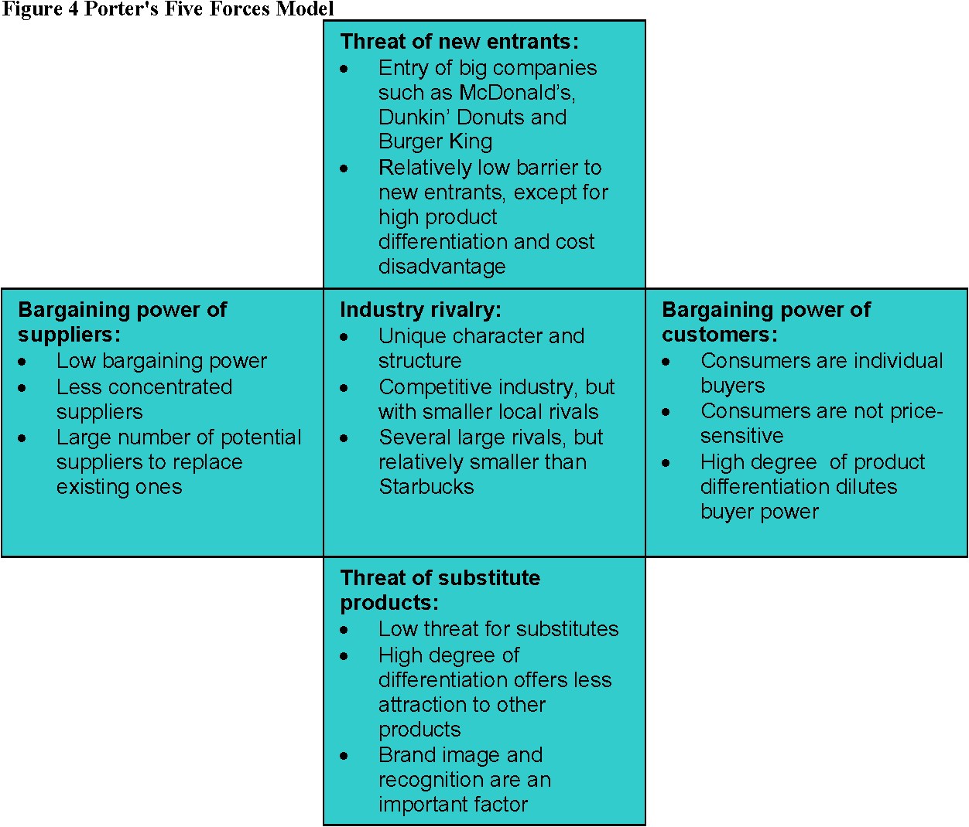
Figure 1: PORTER’s analysis
(Source: semanticscholar.org, 2021)
Power of Suppliers
The raw materials that are used by Starbucks have been most effective for the captivation of the suppliers. An ample number of suppliers are attached to the Starbucks Company. It can be beneficial for the development of the requirements for the products that are necessary for the company to proceed (Carballo, 2018 pp.179-214). Except for a few of the coffee beans that are traded rarely, the other coffee beans required by Starbucks are easily available. It can be observed that the engagements of the suppliers have increased the prices of beverages for the Starbucks Company.
Threat of Substitutes
The products that are sold to the consumers from the Starbucks Company have been regarding the development of the beverage company (Carballo, 2018 pp.179-214). This has also allowed the company to reach out to consumers. It can be a threat for the company to have substitutes for the products that are generally accepted by the consumers (Carballo, 2018 pp.179-214). The increase in the substitutes of the products can have adverse impacts on Starbucks Company in its sturdy growth in the global market.
Competitive Rivalry
Starbucks has been a leader company in the global competitive market that has held 40% of the shares in the market (Richey and Ponte, 2021 p.105193). The continuous upgradation of innovation and technologies have been benefited the development of the statures that are related to the company perspectives to have achieved for the development of the company. The competitive advantages that are visualised in the global market have lowered the switching costs via intense competition (Richey and Ponte, 2021 p.105193). The uniqueness of the products has helped the company to hold brand loyalty to the consumers. This has allowed the company to have a higher competitive rivalry.

3. External environmental analysis
The external analysis of the company has allied the company with the aspects that are mostly observed in the context of the company of Starbucks to have urged for the initiation of the company in the global market.
Political
- Increased taxation imposed on farmers.
- Predominant trade issues implied on Starbucks for the export and import of goods
- Reduced permitting and the licencing costs
- Changes in the government taxation rates (Salsabila, 2021 p.35).
Economic
- The rise in the interest rates along with the expansion of the prices resulted in reduced sales of products to the consumers.
- Lack of economic conditions in the consumers to have lacked the confidence in the company for the economic conditions.
- Globalization in the market of beverages has affected the sale of the products in the company of Starbucks. It can have impacts on Starbucks that are related to the drowning of the supply of products in the company (Reyes Uribe and González Flores, 2021 pp.1-11).
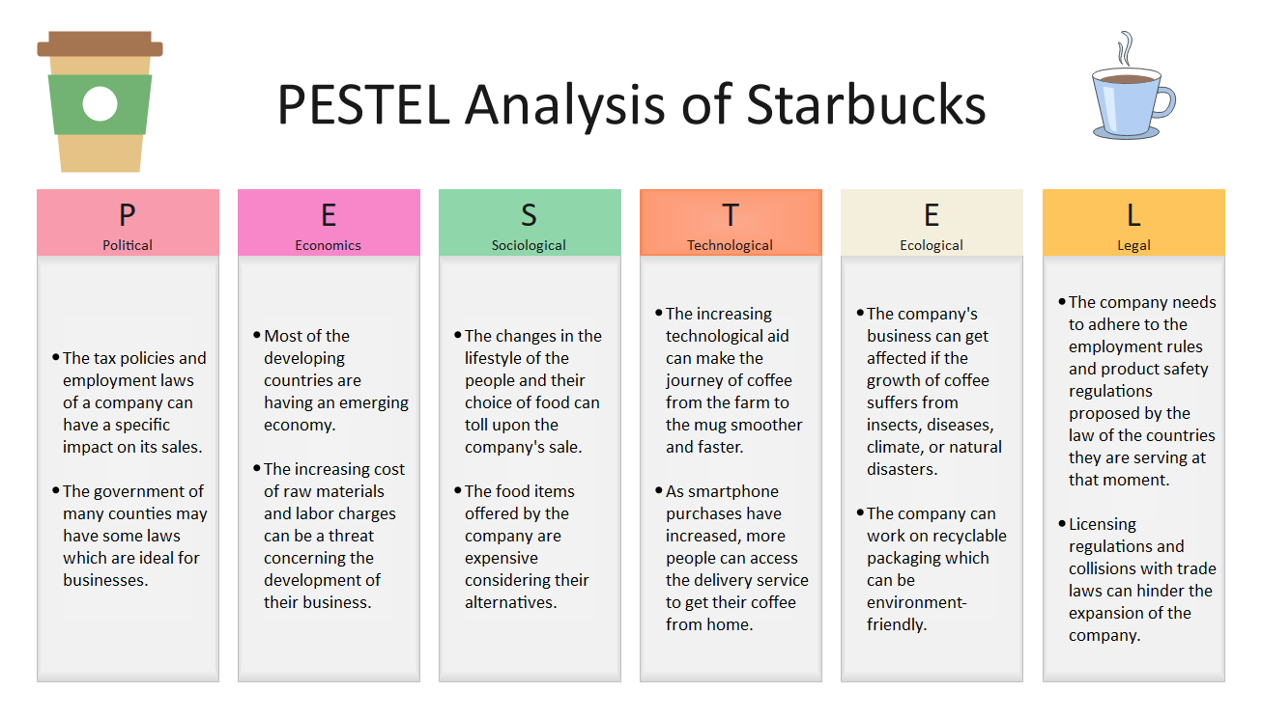
Figure 2: PESTLE analysis of Starbucks
(Source: edrawmax.com, 2021)
Social
- The location of the stores.
- Consideration of the transportation for the employees and the consumers has been efficacious to be impacted (Salsabila, 2021 p.35).
Technological
- Rate of technological interventions has been higher with the innovative aspects required for the Starbucks Company.
- AI and Data Science technologies are implemented in the company.
- The technological interventions have been beneficial for the sturdy growth of the Starbucks Company in the global competitive market.
- The indulgence of technologies has allowed a larger amount of competitors against the company in the global market (Starbucks.com, 2022).
Legal
- The taxes and tariffs are maintained by the Starbucks Company.
- Employment laws and Trade laws are maintained by the Starbucks Company (Starbucks.com, 2022).
Environmental
- Maintain the environment for the continuation of the company and its sale of the products.

4. Internal environmental analysis
The internal analysis of the company of Starbucks has been done for the benefit of the company to have a higher indulgence of the company to have identified the strengths and the weaknesses that are related to the opportunities that can be opted by the Starbucks Company for the benefit of the company (Starbucks.com, 2022). It can be observed that the weaknesses and the threats are related to the development of the company in the global competitive market. The strengths have to be more efficacious regarding the innovation and the technological interventions that are mostly seen in the context of the company (Reyes Uribe and González Flores, 2021 pp.1-11).
Strengths  - Maintenance of higher quality raw materials for products  - Can achieve better profitability  - Have efficiency in the strategy.  - Better treatment of employees | Weakness  - Higher prices concentrated on the products  - Lack of uniqueness in the products of Starbucks.
Opportunities  - Higher expansion of the company in the global market.  - Introduction of new products  - Increase in co-brands of the company of Starbucks | Threats  - Increase in the intense competition of Starbucks company  - Offers the products in a specific products
Table 1: SWOT Analysis on Starbucks

5. Role of marketing in organization
The marketing management of Starbucks has been managed based on target customers and orientation management procedures. As per the opinion of Tien et al. (2020, pp.44), the market circulation and orientation strategy of Starbucks have been developed based on effective analysis of the target customers. Identification of the need of the customers and sustainable strategic planning helps in improving the customer’s engagement rate of the organization. In addition, products variety management and service developmental strategy enhanced performance growth rate in the market situation. Successful settlement of Starbucks in market conditions depends upon the customer's orientation management procedure. Diversity, equity, Inclusionary approaches and pay equity approaches are associated with the market management approaches of Starbucks (Starbucks, 2021). Leading high performance network management procedures and developmental approaches helps in increasing the sustainable development of market orientation in the business approaches. However, an analysis of the 4P marketing mix identified the market orientation associated with the strategic planning of Starbucks.
Price
Starbuck has used a premium pricing strategy for the effective development of marketing developmental aspects. Customer’s loyalty management improved the market satisfaction rate of the customers (Thanabordeekij and Syers, 2020, pp.35). Behavioral tendency management aspects of Starbucks improve sustainable aspects of the market management policies. Premium high price management of the products has managed with better quality of the product services. Their high price management strategy is incorporated the geographical analysis of the customer's situation. However, the effective discounts management strategy of Starbucks increases customers' engagement rate with the organization. As per the financial year 2021, Starbucks coffee has managed the third position and managed 1025 outlets in the UK’s market (statista, 2022).
Product
The diversity products management strategy of the organization developed based on customers of the organization improves better developmental aspects in the business organization. Therefore, business innovation developmental aspects of Starbucks are associated with innovative product management strategies. Marketing research is based on the different geographical lines associated with product line management approaches. The total revenue of Starbuck as per the financial year 2021 was £243 million (Starbucks, 2021).

Figure 3: 4P marketing analysis
(Source: self-created)
Place
Venus management for the customer's engagement related to the marketing management plan of Starbucks. Commercial market management and retailer shops of Starbucks increased the customer's engagement in the competitive market situation. Starbucks has systematically managed an effective service strategy based on an analysis of the geographical location (Lombardi et al. 2021, pp.177). On the other hand, using the online retail management services of Starbucks improved customers' engagement rate with the organization. According to the geographical analysis of customers, its management strategy has been changed by Starbucks.
Promotion
The sales promotional strategy management of Starbucks has been managed by an online platform and sample promotional management procedure. Using the digital platform for effective sales strategy management approaches improves better growth in the market management sectors of Starbucks. The total aggregated revenue of Starbucks as per the financial year 2021 was $168 million (Starbucks, 2021). Therefore, the competitive marketing management strategies of Starbucks have been effectively managed to store the growth rate in the competitive business market.

6. Recommendations
Understanding the needs of the local market
Identification of the need of the customers in the local market improves better managers and approaches to market developmental policies. Therefore, sustainable supply chain management of the organizational structure is associated with the participation of the customers (Hu et al. 2019, pp. 177). Customers' intention management and effective sustainable developmental process improved better market management structure of Starbucks.
Increases communication with customers
Analysis of the customer's service management and improving strategies for better managerial approaches help in managing sustainable growth in the market sectors. Business competency structure has been increased based on the effective analysis of the customer managerial services (Mariani and Borghi, pp.119752). Bibliometric analysis of the participation of the customers towards the organizational structure improved the marketing strategies of the organization. On the other hand, the customer service process improves the promotional attributes of the organization. The industrial revolution and manufacturing process enhanced the market control strategies of Starbucks.
Key marketing matrices analysis
Key marketing matrices analysis procedure provided the extensive idea associated with financial analysis and customer acquisition rate of the organization. Meta-analysis associated with the market analyzing procedure helps in developing better growth in the business structure (Edeling and Himme, 2018, pp. 1). Market share management and developmental aspects improve better managerial approaches to organizational structure. Net promotional management and conservation rate analysis process improved better developmental growth in the business management structure of Starbucks. Analysis of the key performance indicator based on price and product managerial approaches provided a high-level idea of market management strategy development.

7. Conclusion
High quality product management approaches improved customers' engagement level with Starbucks. On the other hand, the marketing strategies of Starbucks are associated with a premium level of promotional approaches to the organizational structure. Starbucks has faced challenges of increasing competition in the market. However, their high-cost management of the products has created a theatre of market emergence level of the organization. In addition, identification of the needs of the customers and improvement of coexistence in the market situation developed better marketing strategy in the competitive business market situation. Porter’s analysis of the organization involved the idea related to the competitors of the organization. Identification of the threats and competitors in the strategic analysis procedure improves Sustainable business strategy developmental aspects.

References
Articles
Cooper, M. and Nguyen, Q.T., (2020). Multinational enterprises and corporate tax planning: A review of literature and suggestions for a future research agenda. International Business Review, 29(3), p.101692.
Mariani, M. and Borghi, M., (2019). Industry 4.0: A bibliometric review of its managerial intellectual structure and potential evolution in the service industries. Technological Forecasting and Social Change, 149, p.119752.
Nab, C. and Maslin, M., (2020). Life cycle assessment synthesis of the carbon footprint of Arabica coffee: Case study of Brazil and Vietnam conventional and sustainable coffee production and export to the United Kingdom. Geo: Geography and Environment, 7(2), p.e00096.
Journals
Carballo, C.G., (2018). Identidad digital: losefectos de losmensajes de RR. PP. traducidosen la era de la comunicaciónglobalizada. El caso de Starbucks España y Starbucks UK. Razón y palabra, (102), pp.179-214.
Edeling, A. and Himme, A., (2018). When does market share matter? New empirical generalizations from a meta-analysis of the market share–performance relationship. Journal of Marketing, 82(3), pp.1-24.
Hu, J., Liu, Y.L., Yuen, T.W.W., Lim, M.K. and Hu, J., (2019). Do green practices really attract customers? The sharing economy from the sustainable supply chain management perspective. Resources, Conservation and Recycling, 149, pp.177-187.
Lombardi, C.V., Chidiac, N.T. and Record, B.C., (2021). Starbucks coffee corporation’s marketing response to the COVID-19 pandemic. Innovative Marketing, 17(2), p.177.
Reyes Uribe, A.C. and González Flores, S.C., (2021). Furthering Productive Aging through Public-Private Sector Alliances: The Case of the Mexican Government and Starbucks Company. Journal of Aging & Social Policy, pp.1-11.
Richey, L.A. and Ponte, S., (2021). Brand Aid and coffee value chain development interventions: Is Starbucks working aid out of business?. World Development, 143, p.105193.
Salsabila, M., (2021). STARBUCKS TOOK A MAJOR HIT DUE TO COVID-19. ENGLISH DIPLOMA 3 JOURNAL COMPILATION, p.35.
Thanabordeekij, P. and Syers, K., (2020). The effect of marketing mix factors and brand image toward customer satisfaction and customer loyalty of liquefied petroleum gas for household use in Thailand. Journal of ASEAN PLUS Studies, 1(1), pp.35-43.
Tien, N.H., Jose, R.J.S., Mai, N.P., Van Thoi, B. and Van Hai, T.,(2020). Analysis of Starbucks’ entry strategy into Vietnam market, 5(3), pp. 44-48.
Websites
Starbucks, 2021, Fiscal 2021 Annual Report, available at:https://investor.starbucks.com/financial-data/annual-reports/default.aspx, [accessed on: 21/04/2022]
Starbucks.com (2022). Starbucks. Available at: https://www.starbucks.com/ [Accessed on: 21.4.2022]
Statista, 2022, Selected leading coffee shop chains in the United Kingdom (UK) as of February 2021, by number of units, Available at:https://www.statista.com/statistics/297863/leading-coffee-shop-chains-in-the-united-kingdom-uk-store-number/, [accessed on: 21/04/2022]

