Kamil Kazimierz Lenczowski
Student number 2120445

Effective Team Working and Communication (BMSW4002_BIRM)

Yohan Mendis
Component 1
Report Effective Teamworking for team success

Executive summary

Undermentioned report is demonstrating the various possibilities of how deeply managers can look into the roles of teamwork.

The report exposes the methods, using an example at next company Ltd and passed guidance to them, on how to implement some of the tactics into the teamwork. Problems they struggle with are typical for managing the team efficiently.

How can you develop an effective team and what theoretical model can be used?

What are the types of roles that are needed to create an effective team?

What type of impact can effective teamworking have on team success?

What are the barriers to effective teamworking identified in this scenario?

The above questions have been considered.

This report mentions :

Definitions (group, team)

Belbin’s team roles model

Tuckman’s Model of Development

Hofstede’s model

Coyle’s Code and team composition

Table of contents
Effective Team Working and Communication (BMSW4002_BIRM) 1
Executive summary 2
Table of contents 3
Introduction 4
Overview of Team working 5
Group 5
The formal group 5
Examples of formal groups 5
Command group 5
Task group 5
Project group 5
Committees 5
The informal group 6
Informal group: 6
Friendship group 6
Interest group 6
Reference group 6
Group advantage: 6
Group disadvantages: 6
The team 6
Team advantage 7
Team disadvantages 7
Models of team development 8
Tuckman’s model 8
Team roles 10
Discussion. 12
Hofstede’s model 12

Introduction
The purpose of this report is to assist in developing an effective team that will have an impact on Next Plc’s success, and is based on clearly stated models of effective teamwork. It includes relevant examples and theories of particular segments regarding teamwork and is going to demonstrate achievements in this branch of science by using different models or diagrams to support visualisation.
The teamwork process can be hard to overcome, and this magnificent toll is adopted by many corporations and involves the owner indoctrinating into team leaders and develop their knowledge regarding their roles. The report contains Tuckman’s model of team development in addition to the models like Wheelman’s model of development, which is very similar. This model reveals specific pieces of information, and clearly shows the strategy and how certain stages look in the mentioned models. The content of report is to confront this scenario which affects many companies, including Next Plc.
This work also includes characteristics of team roles by using Belbin’s team roles model. This work is dedicated to bringing a relative overview of strategies and dealing with difficulties like ethnicity, religion, beliefs, and culture, (Tuckman’s model, Belbin’s team roles, Coyle’s code, and team composition, Hofstede’s model).

Overview of Team working
In this particular discussion it is necessary to extract two concepts that are fundamental to understanding and providing business with high performance, which is supported and accordable to a few sources. According to an article written by Team Asana which explains the definitions of team and group and the main differences, but also advantages and disadvantages.
To summarise teamwork, there are two separate formations. To be looking at the aspects and definition of teamwork, the formulation of teamwork is divided into two catgories: group and team.
Group
Is a collection of people who, in most cases, do not know each other, however, they share a common purpose but do not depend on each other: Their effort is as an individual. In order to improve a good working strategy and relationships, it is good to understand and develop working dynamics. In business it’s important to implement workplace communication and be able to see differences between leading a group or leading a team. The group also can be divided further:
The formal group
Launched by organisations by giving a special task, where the group needs to contribute to their task by delegating all of the members and achieving the goal.
Examples of formal groups
- Command group
- Task group
- Project group
- Committees
Command group
Is usually a manager or supervisor and is clearly visible along with the corporation’s structures where the organisational chart is applied. Staff have different obligations and tasks, and they can collaborate and form groups at lower grades and different offices and instances.
Task group
Is a group of individuals to achieve a common goal. However, it can also cross a command line at some point.
Project group
Is a group of people launched to do a special task, such as a project, for example, launch a new line of children’s wear across Next Plc stores around the world.
Committees
Are a short- or long-term formed group out of the standard groups, most of the time they appear when solving disciplinary problems.
The informal group
Unlike formal groups, organisations cannot control informal groups. This type of group can also form in the work environment. The informal groups can also be divided further:

Informal group:
- Friendship group
- Interest group
- Reference group
Friendship group
When people find similarities such as political beliefs, religious values, hobbies, or other shared characteristics.
Interest group
People who don’t have to be friends or support in different tasks, but in some scenarios or sociology issues they co-operate as one group with the same goal, for example scientists or professors.
Reference group
A group of people who gather together such as students talking about experiences, courses, suggestions, or anything that allows them to consider the same topic.
Group advantage :
- Shared goal is visible
- Members are focused on personal productivity

Group disadvantages :
- Some members can feel behind, building up anxiety or alienation
- No strong connection towards shared goal
The team
Comparing it to a group, the team demonstrates sharing and putting in effort to work together and achieve a shared goal together, not as an individual unit. While the phrases are similar, it comes to decision making to see differences. The team will depend on each other and support other members when needed.

Team advantages
- When it comes to problem-solving there is better performance
- The team is more focused on their task and everybody is supporting each other. They are independent, and interrelationships are supplied within the team. All these aspects support effective team working and communication.

Team disadvantages
- It can dismiss possible individual growth as a single unit in the team.
- It can block the abilities and potentials of efficient individuals.
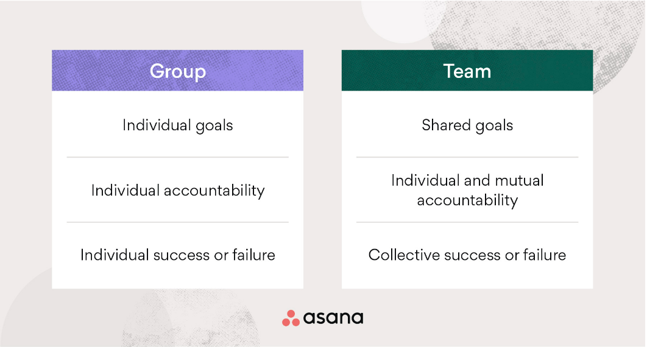
In ‘The teamwork concept’, written by Beach R B, we do not even know how deeply it has been ingrained in our society. This author shows how the teamwork works and compares that to prehistoric cave drawings. The pictures tell us how important it is to have high performance of skills collaborating well within the group, in this example the author uses a hunters team to express that only good teamwork, and team management, results in great success. Many types of research are based on experiences. Theories are based on observation of our society. Over the years there were a few people interested in this instant.
“Belbin’s team role model has been applied generally most to the European countries and used as a counselling and development tool” (Beach, Ronald B. 2009).
There are several models of teamwork and the purpose of this is to find contributions to effective teamwork and apply them to teamwork.
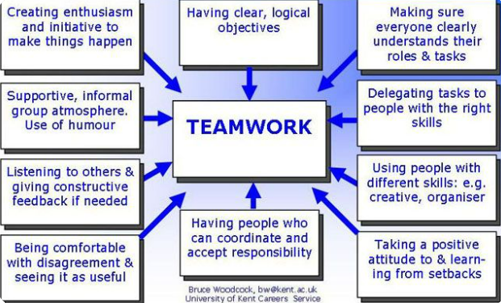
To understand Teamwork relative to the business, the well-performing management needs to see the impact of effective teamwork and identify advantages and disadvantages while the tasks are assigned to the team.
Belbin’s model is connected to Next Plc in that there is a project group created based on Belbin’s model between all branches. Well-performing management should be able to confront the current group and compare it to the right model. When the team’s having difficulties it is essential to make changes and swap people around as people can have different attributes. This kind of attempt could have an impact for a teamwork especially if there are difficulties with communication. The barriers could be easily relieved by adopting the Hofstede’s theory, that should adequately show the barriers such as having problem with power, distance, or what type of people the team have, like individualists or more collectivists.

Models of team development
The most known model of team development is:

Tuckman’s model
The majority of the team development model is to implement a plan on how to improve the teamwork as one single independent unit. This model would be adopted as a ‘strong spine’ for Next Plc along their co-ordinator and launching plans.
According to Dan McCarthy who recommends using team development tools for leaders, only one of them if consistently used, can cure teamwork on high performance.
Tuckman’s model presents five stages. Each of the stages is different and each of them is equally important. To imagine the power, it is necessary to compare it to human life beginning from birth, going through the next steps, until we achieve our goals.
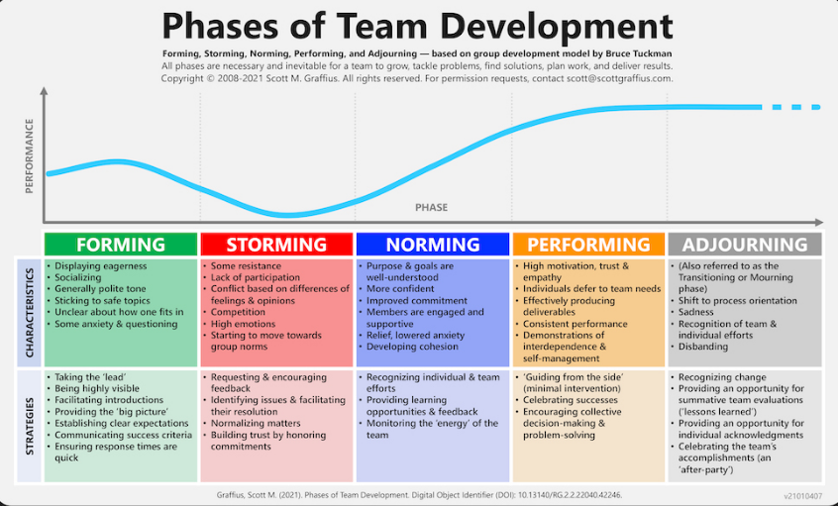

- FORMING (gathering together and knowing each other forming the frames of achievements)
- STORMING (people showing and seeing differences between them, some conflicts, the leader can be chosen)
- NORMING (settling down and focusing on the group task, the leader is still needed)
- PERFORMING (the leader is not that important in this stage, the group is performing great. It is the highest level of performing. Members feel belonging to what they created)
- ADJOURNING (individual efforts, disbanding, group feels “lesson learned ’’)

Models of team development are directly connected to a leadership process:
Tuckman’s model is only a base for others who try to define their framework . The whole process is relatively difficult as time changes. With the passage of time the perception can differ.
The purpose of generating a tool is to help in the process, but it needs to be connected to the current expectations, and should involve every aspect of society.
Leaders need to choose appropriate models, or aspects of models, in order to upgrade their teamwork. By using the different ‘tools’ available, not to shy away from gaining understanding and increasing knowledge of the team, teams are able to incorporate ideas and remain relevant, guaranteeing success.
As a manager at Next Plc, you should be able to contribute and summarise how your team/group is appearing in this case.

Team roles
According to Belbin’s team roles, the team is to be broken into nine roles. The above roles need to be divided into three categories, which have a numeral impact on co-ordinating, as people have got different ranges of behaviour that can be implemented into the teamwork.
It is crucial to know the team roles. There can be incredible profits when it is about team management and creating teamwork.
Specific skills and character traits contribute to reliable profit in achieving a shared goal.
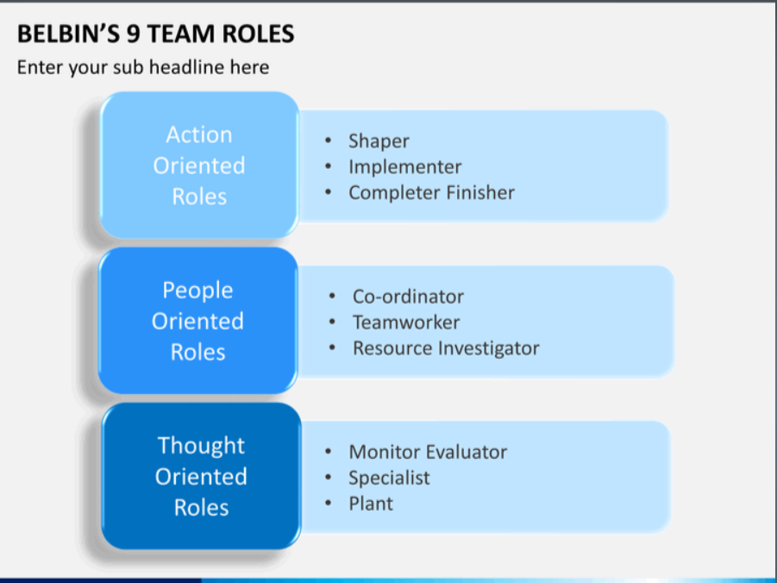
A good team leader should include the best candidates according to their character traits, which would accelerate the whole process of solving or creating and achieving the goal.
Belbin assumes nine roles, but it does not mean that every group has to have a total of nine members. The ideology of Belbin’s theory is to show that every aspect is equally important.
These nine roles have been divided into the three following categories:
- ACTION-ORIENTED ROLES
- PEOPLE-ORIENTED ROLES
- THOUGHT-ORIENTED ROLES
These types of roles can, altogether, build up a good team.
According to the Journal of Management Department 1 November 1999 study, it appears that Belbin’s proposal has not been completely studied and implemented yet. However, there are still people seeking to find the most satisfactory proposal. Belbin’s role model is highly recommended for leaders to consider and implement before the institution hires staff to make sure they will get the best combination of people for particular tasks.
The main concern for Next Plc now is to look into the different methods, models, as well as the team’s abilities and skills, to consider whether the team needs any changes, additions, or reductions to ensure the necessary components will improve the teamwork.

Discussion.

Coyle’s Code and Team Composition

By using an example we can see that there is a full range of different tolls on the team during the team’s launch. It is important to gather knowledge about team development and being able to achieve performance at the highest grades. According to literature, leadership, different institutions are seeking to achieve the best standard in their own developments. It is highly recommended to follow the existing relevant programs. One of the advantages for a business is that it helps with correct and effective teamwork. Referring to Daniel Coyle, it is good to think about habits and the ‘step by step’ process to try to change them and become more powerful within ourselves. The purpose of becoming more educated in this instance is measurable, which can be visible in achieving the goals. The point of view is that the team can go up and down, but the team needs to be open to adapting more. In the way how Daniel Coyle supportively suggests to us that we need to find the tool within ourselves to control successes or failure and be able to balance them respectively, where you can see indicators of whether something implemented will help or not.
These following aspects would be the key to good teamwork, as they are connected when it comes to the team:
- The way how humans connect with each other is by creating safety
- Sharing vulnerability
- Establishing purpose

Hofstede’s model
The model was created by social science Geert Hofstede. Hofstede has formed a specific framework regarding cultural communication, such as ” individual’s behaviour to cultural values and norms depending on their home country (Geert-hofstede.com, 2014).’’
Hofstede’s model shows a few variants:
- Power distance index
- Collectivism vs individualism
- Uncertainty avoidance index
- Femineity vs masculinity
- Short-term vs long- term orientation
- Restraint vs indulgence

Based on these six difficulties above, Next Plc can adopt variants of people to the existing team.

Conclusion
As a project launch manager, you might be facing a multitude of various problems. To be more specific, the main role of leading the team is to focus on the size of the team which helps the tasks be managed easily, looking deeply into the skills of the team’s members will bring you the possibility to be an effective leader (Belbin’s team role).
While building up the team, paying attention to the quality and variety of the team’s skills, abilities, and what each person brings to the table will be more influential to the overall success, in comparison to increasing numbers and focusing on quantity.
Tuckman’s model, for example, can be used to create an effective team. According to the current teamwork situation at Next Plc, it would appear that they are still in the storming stage, so the leader still needs to be present, until the team manage to move onto a following stage in the model. Some of the barriers which could affect communication are different cultures, religion, or nationality (Hofstede’s model). To be sure that there is visible good performance overall, it is essential to look into the people comprising the team, as well as their skills and consider the possibility of change to their roles within the team, where possible.

Referencing
Griffith, B.A. (2015) Working in teams : moving from high potential to high performance . SAGE, Los Angeles, [California]available at :https://whelf-uwtsd.alma.exlibrisgroup.com/leganto/readinglist/citation/6527115350002421?institute=44WHELF_UWTSD&auth=SAML

Team Asana, (October 14 th,2021) Group vs. team: What’s the difference? Available at: https://asana.com/resources/group-vs-team

Jane S .Prichard, Neville A.Stanton (1 November 1999) Testing Belbin’s team role theory of effective groups. Journal of Management Development Available at:https://www.emerald.com/insight/content/doi/10.1108/02621719910371164/full/html?fullSc=1&fullSc=1&fullSc=1&mbSc=1&fullSc=1&fullSc=1
Belbin, R. (2000) ‘Beyond the Team’, Team performance management, 6(3/4), pp. 73–76. doi:10.1108/tpm.2000.6.3_4.73.4. available at :
https://librarysearch.uwtsd.ac.uk/discovery/fulldisplay?docid=cdi_emerald_primary_10_1108_tpm_2000_6_3_4_73_4&context=PC&vid=44WHELF_UWTSD:44WHELF_UWTSD_VU1&lang=en&search_scope=MyInst_and_CI&adaptor=Primo%20Central&tab=Everything&query=any,contains,Beyond%20the%20Team%20R.%20Meredith%20Belbin&offset=0
BEACH, R.B.,( 2009). Employee acceptance of team role profiling as a management tool: A survey of a high technology manufacturing environment, Capella University. Available at https://www.proquest.com/pagepdf/305161349/Record/643B364BCE1E4A58PQ/2?accountid=130472
Hass M, Mortensen M (June 2016 )Harvard business review . The secrets of great teamwork available at https://hbr.org/2016/06/the-secrets-of-great-teamwork
Rickards T, Susan M. (2002). Creative Leadership Processes in Project Team Development: An Alternative to Tuckman's Stage Model. British Journal of Management. 11. 273 - 283. 10.1111/1467-8551.00173. available online at : https://www.researchgate.net/publication/227644219_Creative_Leadership_Processes_in_Project_Team_Development_An_Alternative_to_Tuckman's_Stage_Model
Rickards T. Susan M. (2000) ‘Creative Leadership Processes in Project Team Development: An Alternative to Tuckman’s Stage Model’, British journal of management, 11(4), pp. 273–283. doi:10.1111/1467-8551.00173. available at : https://librarysearch.uwtsd.ac.uk/discovery/fulldisplay?docid=cdi_proquest_journals_229486803&context=PC&vid=44WHELF_UWTSD:44WHELF_UWTSD_VU1&lang=en&search_scope=MyInst_and_CI&adaptor=Primo%20Central&tab=Everything&query=any,contains,Creative%20Leadership%20Processes%20in%20Project%20Team%20Development:%20An%20Alternative%20to%20Tuckman%27s%20Stage%20Model%20Tudor%20Rickards,Susan%20Moger&offset=0

Mark R,(28 oct, 2011)the enemy of engagement’ Enemy of Engagement: Put an End to Workplace Frustration--and Get the Most from Your Employees’
(081443908X). Available at: https://librarysearch.uwtsd.ac.uk/discovery/fulldisplay?docid=cdi_proquest_reports_906484230&context=PC&vid=44WHELF_UWTSD:44WHELF_UWTSD_VU1&lang=en&search_scope=MyInst_and_CI&adaptor=Primo%20Central&tab=Everything&query=any,contains,The%20Enemy%20of%20Engagement:%20Put%20an%20End%20to%20Workplace%20Frustration--and%20Get%20the%20Most%20from%20Your%20Employees%20Hardcover%20%E2%80%93%20October%2028,%202011&offset=0
Cassidy, K. (2007) ‘Tuckman Revisited: Proposing a New Model of Group Development for Practitioners’, Journal of Experiential Education, 29(3), pp. 413–417. doi: 10.1177/105382590702900318. Available at; https://journals.sagepub.com/doi/abs/10.1177/105382590702900318
Åkerlund, M., Jacobsson, C. and Tilin, F. (2021) ‘The Legacy of Susan Wheelan’, Small group research, 52(1), pp. 103–109. doi:10.1177/1046496420956713. Available online at: https://librarysearch.uwtsd.ac.uk/discovery/fulldisplay?docid=cdi_swepub_primary_oai_gup_ub_gu_se_299297&context=PC&vid=44WHELF_UWTSD:44WHELF_UWTSD_VU1&lang=en&search_scope=MyInst_and_CI&adaptor=Primo%20Central&tab=Everything&query=any,contains,Wheelan%E2%80%99s%20Integrated%20Model%20Of%20Group%20Development
Belbin, R.M. and Jay, A. (1981) Management teams : why they succeed or fail. Oxford: Butterworth-Heinemann.
BULLOCK, J., 2004. Management Teams: Why They Succeed or Fail. Leadership & Organization Development Journal, 25(5), pp. 477-479. Available at: https://www.proquest.com/docview/226915547?accountid=130472
Partington, D. and Harris, H., 1999. Team role balance and team performance: an empirical study. The Journal of Management Development, 18(8), pp. 694-706. Available at: https://www.emerald.com/insight/content/doi/10.1108/02621719910293783/full/html

Griffith, B.A. and Dunham, E.B. (2014) Working in Teams: Moving from High Potential to High Performance, Working in Teams: Moving from High Potential to High Performance. Thousand Oaks: SAGE Publications, Incorporated. doi:10.4135/9781506300153. Available at: https://librarysearch.uwtsd.ac.uk/discovery/fulldisplay?docid=cdi_askewsholts_vlebooks_9781483355931&context=PC&vid=44WHELF_UWTSD:44WHELF_UWTSD_VU1&lang=en&search_scope=MyInst_and_CI&adaptor=Primo%20Central&tab=Everything&query=any,contains,Griffith%20%20BA%20%20%26%20Dunham%20%20EB%202014%20%20Working%20in%20Teams%20:%20Moving%20from%20High%20Potential%20to%20High%20Performance%20%20SAGE%20Publications%20%20Incorporated%20%20Thousand%20Oaks.%20Available%20from:%20ProQuest%20Ebook%20Central.%20%5B18%20June%202022%5D.chapter%207

Helpme.com, (no date). Hofstede’s Model Analysis, available at: https://www.123helpme.com/essay/Hofstedes-Model-Analysis-444164

CFT TEAM ( April 21,2022 ). Hofstede’s Cultural Dimensions Theory, What is the Hofstede’s Cultural Dimensions Theory?. Available at: https://corporatefinanceinstitute.com/resources/knowledge/other/hofstedes-cultural-dimensions-theory/

