

The impact of Virtual Learning Environment on the learning experience of the student at UWTSD. (London campus)

Digital Skills and Research Methods (BMSW4003_LON)

Name of student: Fabio Rizzi (2119361)
Name of lecturer: Koushik Modak
Date: 4th of May, 2022

Abstract.
In this report of Digital Skills and Research Method I am going to present the impact of Virtual Learning Environment on the learning experience of the student at UWTSD. I will be using a combined methodology of research between qualitative, and quantitative. The data that I will consider will be both primary, and secondary, and I will present this by using different charts and graphs, both personally made and found throughout my research.

Table of Contents.
- Introduction………………………………………………………………………...….……page 3

- Rational……………………………………………………………………………………..page 3

- Research objective…………………………………………………………………….…..page 3

- Literature review/Review of existing literature………………………………..…….…...page 3
  - Review of the researcher works…………………………………………..…………page 3
  - Differences between their works and mine……..……………………….…………page 4

- Research methodology………………………………………………………….…..…….page 4
- Research method and the methodology…………………………………………….page 5
- Qualitative, quantitative, and combined approach………………………………….page 5
- Data. Primary and secondary data…….……………………………………………..page 5
- Data collection process……………………………………………………………..…page 5
- Population. Sample and sample size………………………………………………...page 5
- Ethics……………………………………………………………………………..…….page 5

- Results/Finding, analysis and discussion…………………..…………………………..page 6
  - Primary data analysis…………………………………………………………………page 6
  - Secondary data analysis……………………………………………………………..page 8
  - Summary of the findings…………………………………………………………...…page 9

- Conclusion and Recommendation………………………………………………………page 9

- References………………………………………………………………………………page

- Appendices………………………………………………………………………………….page
  - Appendix 1 (Class activity 1 - Questionnaire)……………………………………….page
  - Appendix 2 (Class activity 2 – Excel result table)……………………………………page

- Introduction.
A Virtual Learning Environment is a designed information space, where students can find most of what they need thru research. Thanks to the huge number of books, articles, and information gathered in years, the Virtual Learning Environment became a very important source for the students, as it enhances the learning experience. Is a place where teachers benefit from it as well, as they can effortlessly do assessments, give feedback, review works, and they can even share and monitor information. (Dillenbourg, P. Schneider, D. Synteta, P. 2007). Another very important feature, if not the most important, is that as name explains, is virtually done, which means that to be used , are only needed an internet connection and of course, a device. Some of the most famous Virtual Learning Environment are: Google Classroom, Blackboard Learn, and Moodle. (Dalton, W. Turner, B. DeMuro, J. 2022).

- Rational.

All my life I have been studying with pen and paper, and whenever I needed an information from school or from a teacher, I have always had to be physically there. But now, as I have started this course at the UWTSD, I have found out that the learning experience changed and updated in a much better way, thanks to the Virtual Learning Environment. But obviously not everyone has the same way of thinking, so it is very interesting to see what the other people think about it.

- Research Objective.

I am conducting this research because first, is part of the assessment, so for me is compulsory to do it, and to do it in the best way I possibly can. Secondary, because I want to check how is the Virtual Learning Environment, (Moodle in this case) changing the way of studying for the UWTSD’s students. Which are the positive and negative sides of it, what could be improved, and should be changed, or if it is perfect the way it is now.

- Literature review/Review of existing literature.

In the following point I will take five famous works, and I will talk about what research method they have used, what was their research based on and what they have managed to achieve.

  - Review of the researcher works

The first work I will talk about is an online article from Melanie Evans. Here she is trying to elucidate what is a Virtual Learning Environment. The research method she has used is clearly a combination of qualitative and quantitative research, as the type of information she is giving is wide and most probably she has used different sources. In her work she has used primary and secondary data, in where she is elucidating what is a Virtual Learning Environment and trying to make it very much understandable for everyone. Overall, in my opinion she has managed to achieve her goal of explaining what a VLE is, as she has used a very clear structure and the data that she has gathered makes the whole work easier to understand. (Evans, M. 2021)

The second work I will talk about is a journal article from Ryan Eimar and Claire Poole. In this journal article they have used mostly a quantitative research, as quote, “A randomized control trial was conducted with students randomly attending on of two teaching sessions about radiation therapy” (Eimar, R. and Poole, C. 2019). They have used the most reliable way of gathering data, the primary source, as they have personally collected those information. Their work have is perfectly done from my point of view, because the article is short and highly professional, with specific and detailed statistics.

The third work I will talk is another article, from Peter Demian, a lecturer in Construction management, and James Morrice, a BEng graduate. In this article they have explained the impacts on academic performance of using a Virtual Learning Environment. They have clearly used a combination of qualitative and quantitative research, as their work is beautifully empowered with detailed graphs showing their points. They have used a combination of primary and secondary data. In this article, I think they have achieved their goal of explaining in detail the impacts of using a Virtual Learning Environment, although at the same time, there is very large amount of information, that sometimes can be overwhelming. (Demian, P. and Morrice, J. 2015)

The fourth work I will talk about is a website, FunTechBlog. In this website are listed eight positive sides of using a Virtual Learning Environment. This work has been done with qualitative and quantitative research, hand-picked from many sources, and so, it is clear that only secondary data has been used. Although there are only positive sides, the scope of this website is to list why VLE is a good thing, and for me is very well done.

The fifth and last work I will talk about is blog article from Virtual College. In this blog is explained the reason why students and teachers benefit from a VLE. In this work the research that has been used the most is the quantitative one, and only secondary data has been considered. The goal was to explain why both students and teacher can benefit from a VLE, and although this blog article is quite short, it goes straight to the point, so Is very clear for the reader to understand the scope of it.

  - Differences between their works and mine.

Overall, those five work are brilliantly done. My report is similar over the data used and the topics, but the structures are completely different. My work is mainly about what are the impact of using a VLE, but looking to it with a critical eye, as there are as well some advice on how, Moodle in my case, could be improved.

- Research methodology.

There are many different kind of ways about how to do a research, and in the following point, I will elucidate the differences between them all.

  - Research method and the methodology

When doing a research or collecting data, there are many ways of doing it. In the following points I will explain all the different ways of doing so.

  - Qualitative, quantitative, and combined approach.

There are three types of research methods, qualitative, quantitative, and combined. A quantitative research is based on numbers and graphs and is mostly used to generalize facts about a topic. Common quantitative methods include experiments, observations recorder as numbers, and surveys with closed-ended questions. The qualitative research is based on words, thus is much more in depth. Is mainly used to give in-sight on a topic that is not well understood. Common qualitative methods include interview with open-ended questions, observations described in words, and literature reviews that explore concepts and theories. And finally, the combined research, is self-explanatory, it uses a mix a both.

  - Data. Primary and secondary data.

There are two kinds of data that can be used. Primary and secondary. The primary data is a much more reliable source, as the researcher himself gather data thru experiments, surveys, questionnaire, personal interview, et cet. A positive side is that is very involved, a negative side is that it can be extremely time consuming. Data is called secondary when it is collected by someone else, like a government survey, a website, a journal, articles, et cet. A positive side is that data is quick and easy, a negative side is that is debateable about the provenience of it, thus it might be not as reliable.

  - Data collection process.

Data collection process is a five steps procedure. First step is to determine what is the information that is needed to be collected, so you will need to decide what topics the information will cover. Second step is to determine a timetable for collecting data, so, you should start formulating your plan for how you will collect your data. The third step is the method to use to collect data. To do this you will need to consider the type of information you want to collect, the timeframe over which you will obtain it and the other aspects you determined. The fourth step is to collect the data, so you will implement the data collection strategy. You can store and collect your data in your DMP. The fifth and last step is to analyse the data and explain findings. Once you have collected all of your data, it is time to analyse it and organise your results.

  - Population. Sample and sample size.

A population, in data gathering, is the entire group that you want to analyse and collect data, and a sample, is just, as the word says, is just a sample of it, as sometimes the can an extremely large amount, impossible to collect it all.

  - Ethics.

Throughout all process of doing this report, the General Data Protection Regulation (GDPR), has been followed

- Results/Finding, analysis and discussion

In the following points, I will show, with graphs and analysis, the results of my questionnaire. This has been done accordingly with the answers received from the students of my group.

  - Primary data analysis.

Question 1:
How virtual learning environment changed your way of studying?

Result 1:
Most of students replied saying that is easier and better when looking for books or articles.

Question 2:

Question 3:

Question 4:
Why do you think that most universities and schools, uses Virtual Learning Environment?

Result 4:
Most of student replied saying that it has been helpful especially due to the pandemic, and because it's handy.

Question 5:

Justify your answer
Most of student replied saying that students benefit from it as you can find a lot of information.

Question 6:
What could be mode to improve today's virtual learning environment?

Result 6:
Most of students replied saying that it should be easier to use.

Question 7:

  - Secondary data analysis.

In this point, I will compare a chart taken online, with the last pie chart shown in question 7.

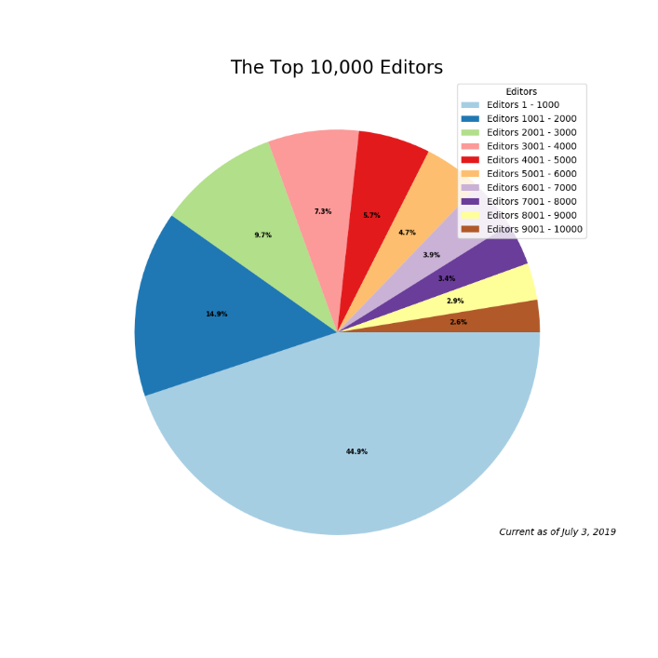
From my point of view, both pie chart looks quite similar, although data information in the chart taken from an online source might looks a bit flat, with too small numbers, thus it is harder to understand.

  - Summary of the findings.

Overall, most of students think that the Virtual Learning Environment is a very good way to learn, possibly even more than the classic way, and that there are just few minor things to improve.

- Conclusion and Recommendation.

This course has been extremely helpful and fun to learn. I have finally learnt how take the best out extremely intelligent software, like Microsoft Word, Power Point and Excell. It made me seen surveys in a very different way, how to make concise questions but still able to catch the reader attention, and finally, to do better research, The only recommendation I have is that we should be able to send our questionnaire to larger amount a people, because by doing so we could have better results.

- References.

- LOTAME (2021) What are the method of data collection? Available at: https://www.lotame.com/what-are-the-methods-of-data-collection/ (Accessed: 02/05/2022)
- Qualtrics. (2022) What is sample size. Available at: https://www.qualtrics.com/experience-management/research/determine-sample-size/ (Accessed: 02/05/2022)
- Wagh, S. (2022) Benedictine University. Available at: https://researchguides.ben.edu/c.php?g=282050&p=4036581#:~:text=Primary%20data%20refers%20to%20the,collected%20by%20someone%20else%20earlier.&text=Surveys%2C%20observations%2C%20experiments%2C%20questionnaire,journal%20articles%2C%20internal%20records%20etc. (Accessed: 02/05/2022)
- FunTechBlog (2022) 8 Benefits of virtual learning environments (importance of virtual classrooms. Available at: https://funtech.co.uk/latest/benefits-virtual-learning-environments-classrooms (Accessed: 02/05/2022)
- Virtual College (2012) Virtual learning environments ’benefit students and teachers’. Available at: https://www.virtual-college.co.uk/resources/virtual-learning-environments-benefit-students-and-teachers Accessed: 02/05/2022)
- Demian, P & Morrice, J. (2015) ‘The use of virtual learning environments and their impact on academic performance’. Engineering education. Vol7. Page 11-19. Available at: https://www.tandfonline.com/doi/full/10.11120/ened.2012.07010011
- Ryan, E & Poole, C. (2019) ‘Impact of virtual learning environment on student’s satisfaction, engagement, recall, and retention’. Journal of medical imaging and radiation sciences. Vol 50, issue 3. Page 408-415. Available at: https://www.sciencedirect.com/science/article/abs/pii/S1939865418304636
- Evans, M. (2020) ‘What is a VLE (Virtual Learning Environment)? – 2021 guide’. Learning Ladders. Available at: https://www.learningladders.info/news/what-is-a-vle/
- Firefly (2022) What is a virtual learning environment (VLE)? Available at: https://fireflylearning.com/what-is-a-virtual-learning-environment-vle (Accessed: 02/05/2022)
- Scribbr (2019) Qualitative vd. Quantitative research l examples & methods. Available at: https://www.scribbr.com/methodology/qualitative-quantitative-research/#:~:text=and%20qualitative%20methods%3F-,Quantitative%20research%20deals%20with%20numbers%20and%20statistics%2C%20while%20qualitative%20research,and%20experiences%20in%20more%20detail. (Accessed: 02/05/2022)

- Appendices.

Here I will attach my past works done.

  - Appendix 1 (Class activity 1 – Questionnaire)
In-Class exercise: Questionnaire Design
Student Name: _________Fabio Rizzi_________ Student ID: ____2119361_________
Module Name: Digital Skills and Research Methods (SFTW) Group: CertHE T1G2_____

Aim: This exercise is aimed to help you in your questionnaire design. Please note, you need to use this questionnaire to conduct a survey which is also one of the important parts of your research report. You will also need to attach this questionnaire to your final report.

Please write down your questions that you are going to use for your primary data collection. Try to have different types of questions such as open-ended questions and close-ended questions like (YES/NO) question (s), multiple choice question(s) and Likert-scale question (s). All together you need to make 6-10 questions of different types for data collection.

Question 1: How virtual learning environment changed your way of studying?

Question 2: Will virtual learning environment replace completely the way of studying, at some point in the future?

YES No

Question 3: Do you prefer a virtual learning environment over the old school pen and paper?

Strongly Disagree/Disagree/Neither Agree nor Disagree/Agree/Strongly Agree

Question 4: Why you think most of universities and schools, uses the Virtual Learning Environment?

Question 5: Do students benefits from using virtual learning environment?
(Justify your answer)
Yes No

Question 6: How long did you take to master a virtual learning environment? (For example, Moodle)

Very Long/Long/Average/Short/Vey short

Question 7: What could be done to improve today s virtual learning environment?

  - Appendix 2 (Class activity 2 – Excel result table)

In-Class exercise: Questionnaire Design
Student Name: Fabio Rizzi
Student ID: 2119361
Modul Name: Digital Skills and Reasearch Method
Group: CertHE T1G2
1) How virtual learning enviroment changed your way of studying?
Most of students replied saying that is easier and better when looking for books or articles.

2) | Yes | No
 | 4 | 1
3) | Strongly Disagree | Disagree | Neither Agree nor Disagree | Agree | Strongly Agree
 | 1 | 1 | 2 | 4 | 0
4) Why do you think that most universities and schools uses virtual learning environment?
Most of student replied saying that it has been helpful especially due to the pandemic, and because it's handy.

5) | Yes | No
 | 5 | 0
  Justify your answer
 |  |  |  |  |  | Most of student replied saying that students benefits from it as you can find a lot of information.
6) What could be mode to improve today's virtual learning environment?
Most of students replied saying that it should be easier to use.

7) | Very Long | Long | Average | Short | Very Short
 | 0 | 1 | 3 | 1 | 0

