

Postgraduate/Distance Learning
Assignment coversheet & feedback form

THIS SHEET MUST BE THE FIRST PAGE OF THE ASSIGNMENT YOU ARE SUBMITTING (DO NOT SEND AS A SEPARATE FILE)

For completion by the student:
Student Name: Gemma Cook
Student University Email: 2517984@student.uwtsd.ac.uk
Module code: HPCA7015  Module title: Foundations in Cultural  Astronomy and Astrology | Student ID number:  2517984 |  |  | Educational support needs:  Yes/No
Assignment title: Essay based on a Sky Journal

Assignment due date: 27th November 2025
This assignment is for the 1st 2nd 3rd 4th 5th 6th module of the degree
I confirm that this is my original work and that I have adhered to the University policy on plagiarism.
Signed …………Gemma Cook…………………………………
Email submission:if you are submitting this form via email, please tick this box □
(as a substitute for your signature) to confirm that you agree to the above declaration.
Assignment Mark
1st Marker’s Provisional mark
2nd Marker’s/Moderator’s provisional mark
External Examiner’s mark (if relevant)
Final Mark

NB. All marks are provisional until confirmed by the Final Examination Board.

For completion by Marker 1 :
Comments:

Marker’s signature: |  |  | Date:
For completion by Marker 2/Moderator:

Comments:

Marker’s Signature: |  | Date:
External Examiner’s comments (if relevant)

External Examiner’s Signature: |  | Date:
Essay based on a Sky Journal

Introduction
This essay discusses a twelve-day long project, during the month of November, in which I kept a sky journal focussing on the night skyscape. In this project the sky was treated as a Primary source and my observations, emotional and creative responses were recorded and critically analysed in reference to a quote made by Vincent Van Gogh in a letter to his brother Theo. ‘Be clearly aware of the stars and infinity on high. Then life seems almost enchanted after all.’
Methodology
For twelve nights, at 11pm, during the month of November I observed the night skyscape. All observations were undertaken by stepping out of my house through the west facing living room patio doors and out into my garden. On each occasion, I gave my myself a few minutes (not timed) to observe, before returning indoors to record my responses. My methodology was not to focus on any specific aspect of the night skyscape but to just be open to, and aware of my environment. My intention was to discover which subjects garnered my attention and how these observations might manifest; whether in written form, drawings, emotional or creative responses. Upon completion of my sky journal, I reviewed the content grouping together similar ideas and then analysing the frequency of words to ascertain my key themes. The themes that I will investigate and analyse in relation to Vincent Van Gogh’s quote will be: Connection, Light as inspiration and Poetry.
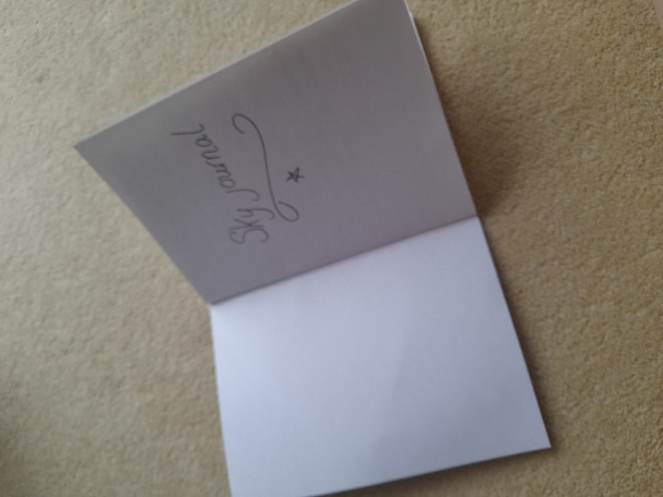
Fig. 1. My Sky Journal. 1st Nov 2025. Photo: Gemma Cook
Connection
The first theme I will be investigating is Connection. It became apparent when re-reading my journal that on almost every entry I was either seeking a connection with the skyscape or felt connected to it. On the 3rd Nov I wrote,
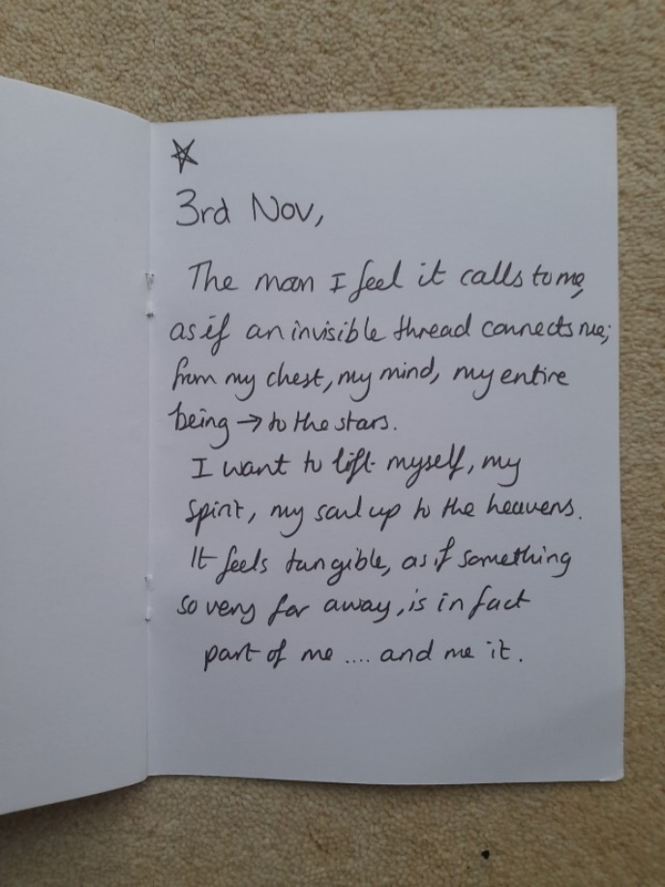
Fig 2. My Sky Journal. 3rd Nov 2025. Photo: Gemma Cook
It was on this night that I felt compelled to reach up physically, as if somehow with enough will power, the hundreds of thousands of miles distance could be bridged.
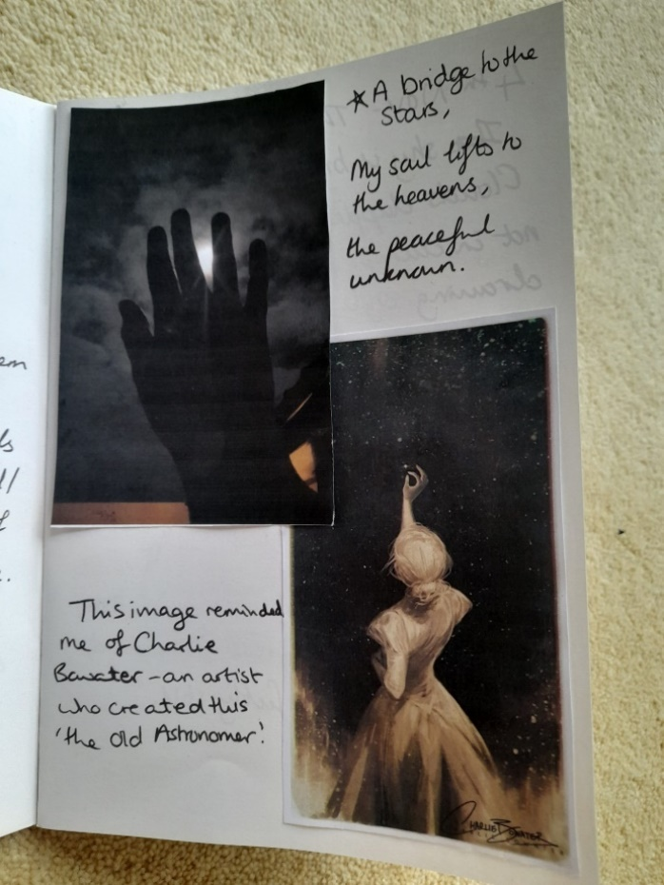
Fig 3. My Sky Journal. 3rd Nov 2025. Photo: Gemma Cook
Upon seeing this photo, I realised the similarities between this and ‘The Old Astronomer’ by Charlie Bowater. I think there is something almost romantic, divine and hopeful about it; reaching up as if to connect two lost souls together, or perhaps bridging one soul divided. This is similar to the concepts stated in the Greek philosopher Plato’s (c.428-348 BCE) work Phaedrus where the idea of a transcendental soul, that originated from the sphere of the stars and incarnates is expressed. (The Soul) ‘travels around all the heavens appearing in different forms at different times.’ My fascination with the night sky I feel comes from the awe of which I consider that light I am seeing in the sky is light energy travelling/still radiating out from perhaps eons past combusted stars burnt to nothingness. For as we see the light of other stars so too does our star emit; it is a network of interconnectedness. I suppose it gives me hope that just like those stars, when we as humans cease to exist in a carbon corporal form, our energy will continue to exist; we would still be connected to the universe, just now in a different form.
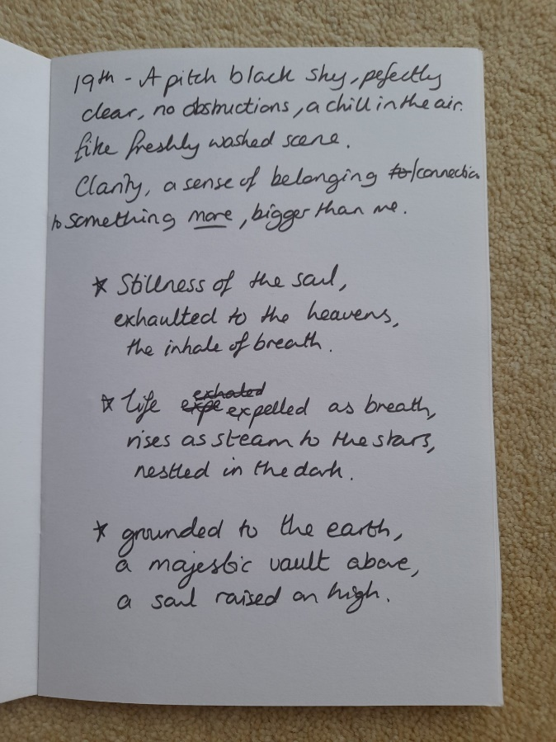
Fig. 4. My Sky Journal. 19th Nov 2025. Photo: Gemma Cook
My thoughts shared a number of key features with some indigenous perceptions of the natural world. Clive Ruggles claimed that for many indigenous populations the natural world, ‘does not exist as a separate objective reality in which the individual can be conceived as a passive observer but as something that one’s consciousness is submerged with.’ I acknowledged a perceptual awareness of the stars through my visual sense but I was also trying to have a clearer awareness of the skyscape by trying to understand the subject’s complexity and my relationship to it. However, Clive Ruggles argued that we as humans make assumptions about our own world. We assume that ‘it exists and an objective reality, that we, as intelligent entities, can observe, describe and attempt to understand’.
In summary, this section has investigated the theme of Connection. Through examination of the vocabulary choices within my sky journal, it prompted me to self-reflect on my views on my own relationship with the night sky. In addition, to consider my thoughts, on how my soul might fit within the creation and existence of the universe, assuming that such concepts are within the reach of human capabilities. In the next section I will focus on what subjects within the night sky enabled me to feel connected to it.

Light as inspiration
I started the keeping of the sky Journal with huge enthusiasm. Having lived nearly all of my life near the coast, since childhood, I have been able to view the night skyscape with relative ease. Yet, despite my enthusiasm the reality of keeping a journal in Autumn, with a typical British weather system, bought its own challenges, namely that of clouds, and lots of them! My first realisation in the writing and reviewing of my journal was of my very obvious distaste for clouds. In fact, there was a very apparent and robust correlation with the absence of light and an absence of inspiration in my writing. On the 8th November after three consecutive nights of full grey cloud cover I wrote, ‘The clouds are just hanging there. It’s chillier than last night, a slight breeze. It’s so still and close and I feel trapped’ I was ‘clearly aware of the stars and infinity on high’ but they were out of reach, frustratingly so, for nothing I could do could change this. I contemplated this lack of clarity might be the same feeling that industrialised cities and nations must face when the population has limited or no access to a truly dark sky. Clive Ruggles states ‘Light pollution has served to remove them from, ‘their’ sky as a source of inspiration.’ I realised that although the dark provided me with a ‘clear mind’, as Van Gogh stated, with minimised cognitive demands due to less sensory input, depleted visual colour and tone to perceive and less noise due to slower pace of human activity, my mind felt almost too clear, blank and devoid of inspiration. On the 12th November, there was a stunningly clear sky, which correlated with a mental clarity; my mind felt free to fly. I wrote ‘A full moon, a stunning ethereal heavenly ring swaddles the moon, cocooned in its glow. Is the glow embracing the moon or it’s the moon sharing its reflected radiance?’
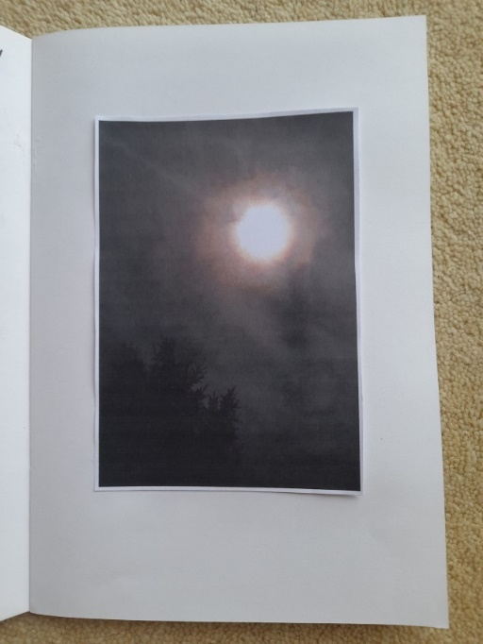
Fig 5. My sky Journal. 12th Nov 2025. Photo: Gemma Cook
The importance of the night sky as stated by Adam Mann is similar to my thoughts. ‘Long ago, before recorded history, humans looked to the Sky… the heavens above have inspired peoples of all colors and creeds since time immemorial.’ This can be seen in a wide variety of cultural forms. Although, as Raymond William stated the word ‘Culture’ is complicated to explain, in this example I am referring to ‘Culture’ as ‘the works and practices of intellectual and especially artistic activity…music, literature, painting, sculpture, theatre and film.’ The night sky and the lights seen within, have inspired a variety of forms; from land art, either calendrical in purpose or attempting to evoke healing and peace through meditation, to diverse and rich oral based societies creation stories, to multi million worth franchises of television and film including Star Trek and Star Wars, to popular literature with fictional retellings of mythology, to paintings and sketches, like those of Vincent Van Gogh himself.
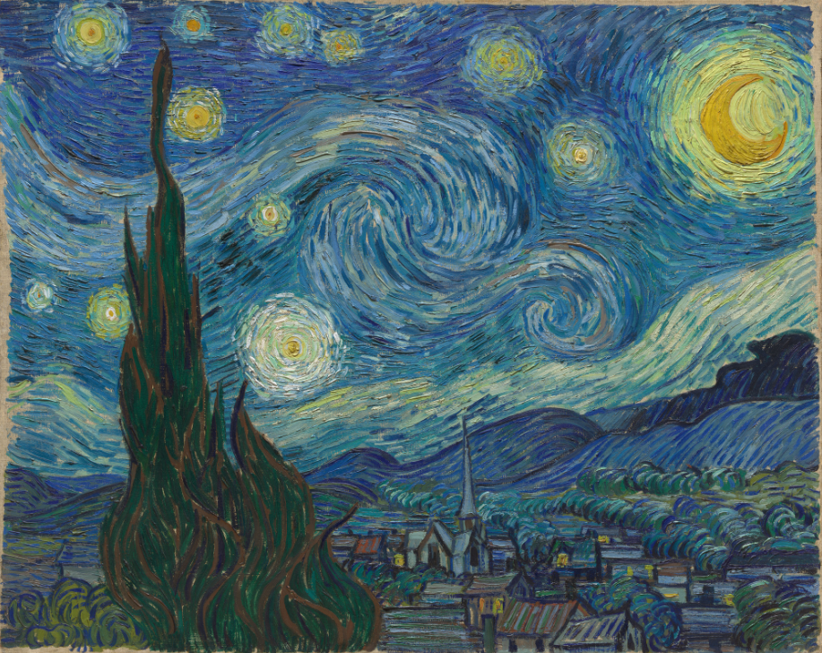
Fig 6. Vincent van Gogh. The Starry Night. Saint Rémy, June 1889.
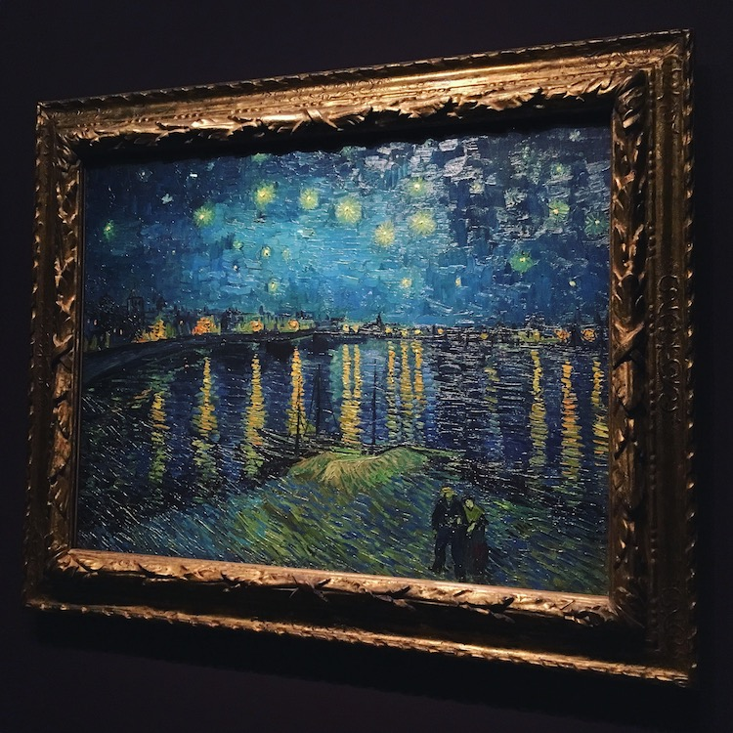
Fig 7. Vincent Van Gogh. Starry Night over the Rhone, 1888.
In conclusion, this section has examined my observations that it was the light set against the nebulous dark sky scape that provided me with inspiration. With the light I was inspired, I felt mindful and had clarity to express myself. My language was effusive, expressive and animated. In the next section I will move on to consider how once inspired, how I then expressed that inspiration, in my final theme of Poetry.

Poetry
Approaching this essay using the methodology of reflexivity, as described by Tamar Wilson as ‘awareness of how self and the process of research… is central to the process of writing’. I was hardly surprised when taking time to observe the night sky led me to feel inspired to write poetry. My undergraduate degree was English Creative writing and I have had several poems published, however what did surprise me was the ease of which writing poetry came back to me, as I have not actively taken on a writing challenge or felt inspired to write at such frequency in over a decade. This is perhaps where I can truly engage with Van Gogh’s quote ‘…Then life seems almost enchanted after all.’ Firstly, to examine Van Gogh’s choice of language- enchantment. Vincent Van Gogh would have written his letters to his brother in French, the entomology of the word enchantment, from Old French which originated from Latin, would have held the meaning ‘to be in song’. My choice of expression through poetry seems appropriate given that poetry and music share many features, such as rhythm, rhyme, and imagery.
However, today, like the word ‘culture’, enchantment can be seen as having many different meanings and aspects. According to the Cambridge dictionary online, it is a noun associated with pleasure and attraction as well as being associated with magic; the ability to hold or be under magical power and influence. My personal understanding to be enchanted, is to be filled with charm, delight, wonder and awe. Patrick Curry states that ‘enchantment is not something you do: it’s something that happens to you.’ I agree with his statement, on the nights where I felt inspired by the sky scape it felt as if my words were overflowing inside my mind, impatient to burst forth onto the page. However, with all that enthusiasm strangely my mind moulded my words and outpouring of ideas into the form of Haiku poetry. Haiku is a form of Japanese poetry that became popular in the Tokugawa period (1600-1868). It is made up of 17 jion (sounds/ symbols) most commonly arranged in a pattern of 5, 7, 5. So, strangely whilst feeling overcome with ideas my rational brain decided to formulate these into a more linear, mathematical structure bound form. I reflected on this conundrum. The Haiku form fascinated me during my university years as the complexity and paradoxical nature of the Haiku was to try and capture a spontaneous single moment of time or essence within 17 syllables. It appeared that I am fond of a paradox, for in the analysis of my sky journal it occurred to me that in order to appreciate the night sky I needed complimentary opposites, the dark and the light. I required the dark to be able to discern the light and its value, but without the light, the dark was meaningless. The irony and paradox were not lost on me; I was reminded of the poem Auguries of Innocence by William Blake.
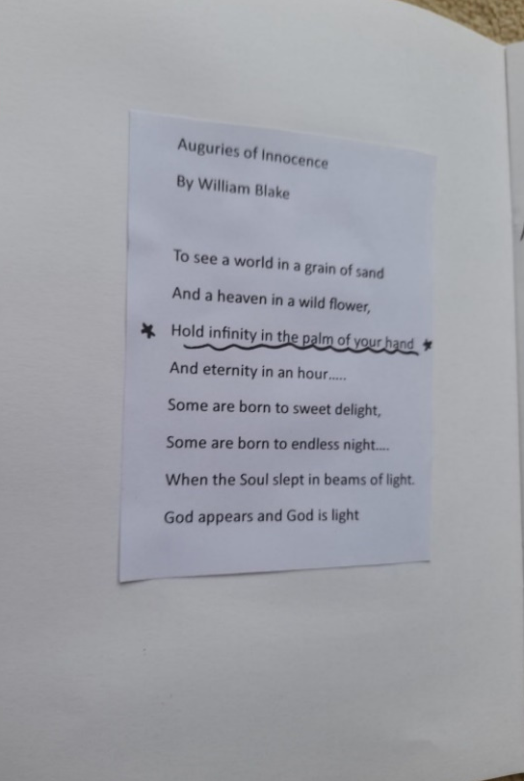
Fig. 8. My Sky Journal. 19th November. Photo: Gemma Cook. Poem accessed from website PoetryFoundation.org.
The idea that you could inspired enough by the world to see so much more than is physically present, to see as Van Gogh suggested ‘infinity on high’ is something to which I aspire to.
In summary, this section has examined and analysed that my creative endeavours, apart from light prose, was very much weighted towards poetry. This artistic outlet gave me the ability to verbalise my thoughts and emotional responses to a range of subjects within the night skyscape. My language choices in my poetry I felt were more imaginative and inventive than the prose, however my choice to write in the more regimented Haiku form limited the scope of length of my writing, it did however impose a self-challenge of choosing the ‘right words’.

Conclusion
This essay discussed my observations, and emotional and creative responses in my Sky journal and these were critically analysed in regards to the themes of Connection, Light as inspiration and Poetry. My fascination to find a connection with the vastness of space and stars as something more than just a mere observer, and well as the realisation that it is the light from the stars that inspired me to write poetry lead me to believe that ‘I am clearly aware of the stars and infinity on high.’ My childlike joy and enthusiasm to express myself through the powerful medium of words, after such a creative decade of drought has delighted me. Perhaps ‘life does seem enchanted after all.’

Bibliography
Primary Sources
Gemma Cook My Sky Journal (November 2025)
Secondary Sources
Bertol, Daniela, ‘Framing the Land and Sky: Art Meets Cosmology in a Sustainable
Environment ‘, Leonardo, Vol.39, no. 2 (2006), pp.125-130, p. 126. JSTOR,
http://www.jstor.org/stable/20206183. [Accessed 20th November 2025].

Bowater, Charlie. Charliebowater <https://www.charliebowater.net/ > [accessed 3rd
November 2025].

Cambridge Dictionary Online, (2025)
https://dictionary.cambridge.org/dictionary/english/enchantment [accessed 21st November]

Campion, Nicholas ‘The Importance of Cosmology in Culture: Contexts and Consequences’ in
Abraao Jesse Capistrano de Souza (ed.) Cosmology (Rijeka: IntechOpen, 2017),
doi.org/10.5772/67976

Curry, Patrick, Art and Enchantment: How Wonder Works, (Routledge, 2023), p.8.

Ellis Harr, Lorraine, ‘Haiku Poetry.’ Journal of Aesthetic Education, vol. 9, no. 3, (1975) pp.
112–19. JSTOR, https://doi.org/10.2307/3331909.

Mann, Adam, ‘Looking at a Shared Sky, through the Lens of Art.’ Proceedings of the National
Academy of Sciences of the United States of America, vol. 113, no. 50, (2016) pp. 14165–67. JSTOR, https://www.jstor.org/stable/26472807. [Accessed 21 Nov. 2025.]

Poetry Foundation, PoetryFoundation.org. (2025)
https://www.poetryfoundation.org/poems/43650/auguries-of-innocence, [accessed 19th November, 2025).

Plato. Lysis. Symposium. Phaedrus. Edited and translated by Christopher Emlyn-Jones,
William Preddy. Loeb Classical Library 166 (Cambridge, MA: Harvard University Press, 2022) P412-413

Ruggles, Clive, Indigenous astronomies and progress in modern astronomy. (2010).
029. 10.22323/1.099.0029.

van Gogh, Vincent, and de Leeuw, Ronald, The Letters of Vincent Van Gogh. (London:
Penguin Books, 1997) p.392.

Williams, Raymond, Keywords: a vocabulary of culture and society, new edition, second
edition, (Oxford University Press., 2015), p 46-47.

Wilson, Tamar, Reflexive Ethnography: A Guide to Researching Selves and Others. American
Anthropologist. (2001). 103. 10.1525/aa.2001.103.2.566.

Figures

Fig. 1. My Sky Journal. 1st Nov 2025. Photo: Gemma Cook
Fig 2. My Sky Journal. 3rd Nov 2025. Photo: Gemma Cook
Fig 3. My Sky Journal. 3rd Nov 2025. Photo: Gemma Cook
Fig. 4. My Sky Journal. 19th Nov 2025. Photo: Gemma Cook
Fig 5. My sky Journal. 12th Nov 2025. Photo: Gemma Cook
Fig 6. van Gogh, Vincent, (1889) The Starry Night. New York, The Museum of Modern Art, https://www.moma.org/collection/works/79802 , [accessed 22nd November 2025].
Fig 7. Van Gogh, Vincent (1888) Starry Night over the Rhone, Paris, Musee d’Orsay,
https://mymodernmet.com/starry-night-over-the-rhone. [accessed 22nd November 2025]

Vincent van Gogh, and Ronald de Leeuw. The Letters of Vincent Van Gogh. (London: Penguin Books, 1997) p.392.
Charlie Bowater, Charliebowater <https://www.charliebowater.net/ > [accessed 3rd November 2025].
Plato. Lysis. Symposium. Phaedrus. Edited and translated by Christopher Emlyn-Jones, William Preddy. Loeb Classical Library 166 (Cambridge, MA: Harvard University Press, 2022) P412-413
Clive Ruggles, (2010). Indigenous astronomies and progress in modern astronomy. 029. 10.22323/1.099.0029.
Ibid. 029. 10.22323/1.099.0029.
Gemma Cook My Sky Journal (November 2025)
Vincent van Gogh, and Ronald de Leeuw. The Letters of Vincent Van Gogh. (London: Penguin Books, 1997) p.392.
. Clive Ruggles, (2010). Indigenous astronomies and progress in modern astronomy. 029. 10.22323/1.099.0029.
Gemma Cook My Sky Journal (November 2025)
Adam Mann, ‘Looking at a Shared Sky, through the Lens of Art.’ Proceedings of the National Academy of Sciences of the United States of America, vol. 113, no. 50, (2016) pp. 14165–67. JSTOR, https://www.jstor.org/stable/26472807. [Accessed 21 Nov. 2025.]
Raymond Williams. Keywords: a vocabulary of culture and society, new edition, second edition, (Oxford University Press., 2015), p 46-47.
Daniela Bertol, ‘Framing the Land and Sky: Art Meets Cosmology in a Sustainable Environment ‘, Leonardo, Vol.39, no. 2 (2006), pp.125-130, p. 126. JSTOR, http://www.jstor.org/stable/20206183. [Accessed 20th November 2025].
Nicholas Campion, ‘The Importance of Cosmology in Culture: Contexts and Consequences’ in Abraao Jesse Capistrano de Souza (ed.) Cosmology (Rijeka: IntechOpen, 2017), doi.org/10.5772/67976
Tamar Wilson. (2001). Reflexive Ethnography: A Guide to Researching Selves and Others. American Anthropologist. 103. 10.1525/aa.2001.103.2.566.
Patrick Curry, Art and Enchantment: How Wonder Works, (Routledge, 2023), p.8.
Cambridge Dictionary Online, (2025) https://dictionary.cambridge.org/dictionary/english/enchantment [accessed 21st November]
Patrick Curry, Art and Enchantment: How Wonder Works, (Routledge, 2023), p.8.
Lorraine Ellis Harr, ‘Haiku Poetry.’ Journal of Aesthetic Education, vol. 9, no. 3, (1975) pp. 112–19. JSTOR, https://doi.org/10.2307/3331909.
Vincent van Gogh, and Ronald de Leeuw. The Letters of Vincent Van Gogh. (London: Penguin Books, 1997) p.392.
Ibid. p392.

