DS 1 Template

My Screenshots/Photos
- Please add 4–6 screenshots or photos of your digital life.
- You can use your phone or laptop.
- For each screenshot, write one or two sentences explaining what it shows.

Screenshot/Photo 1
[Insert Photo/Screenshot below]
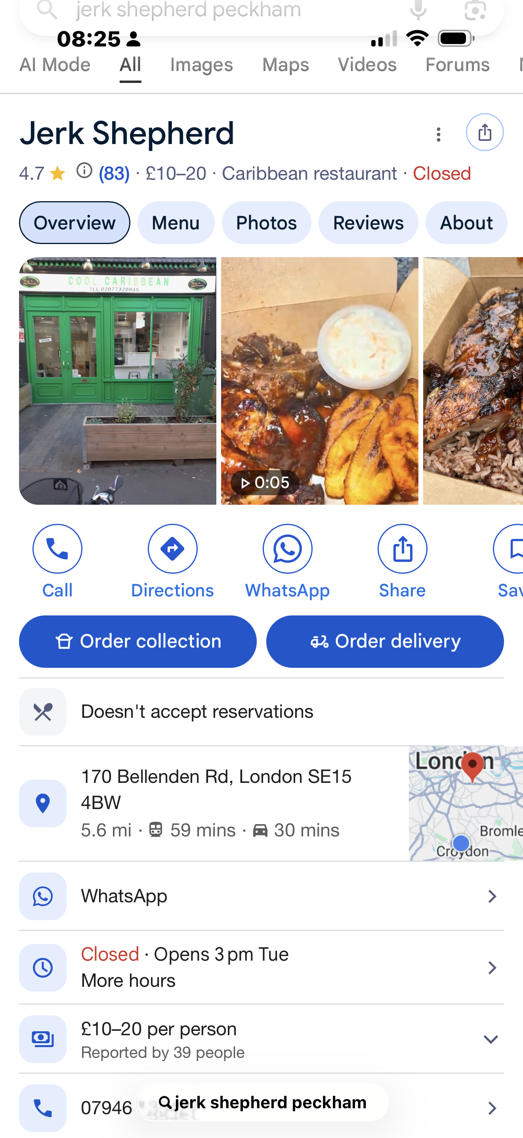
This is a interestuing one I found out about this shop on tiktok its one of best jrek shop in croydon im I great cook I don’t really eat out but thi one made headilne

Screenshot/Photo 2
[Insert Photo/Screenshot below]
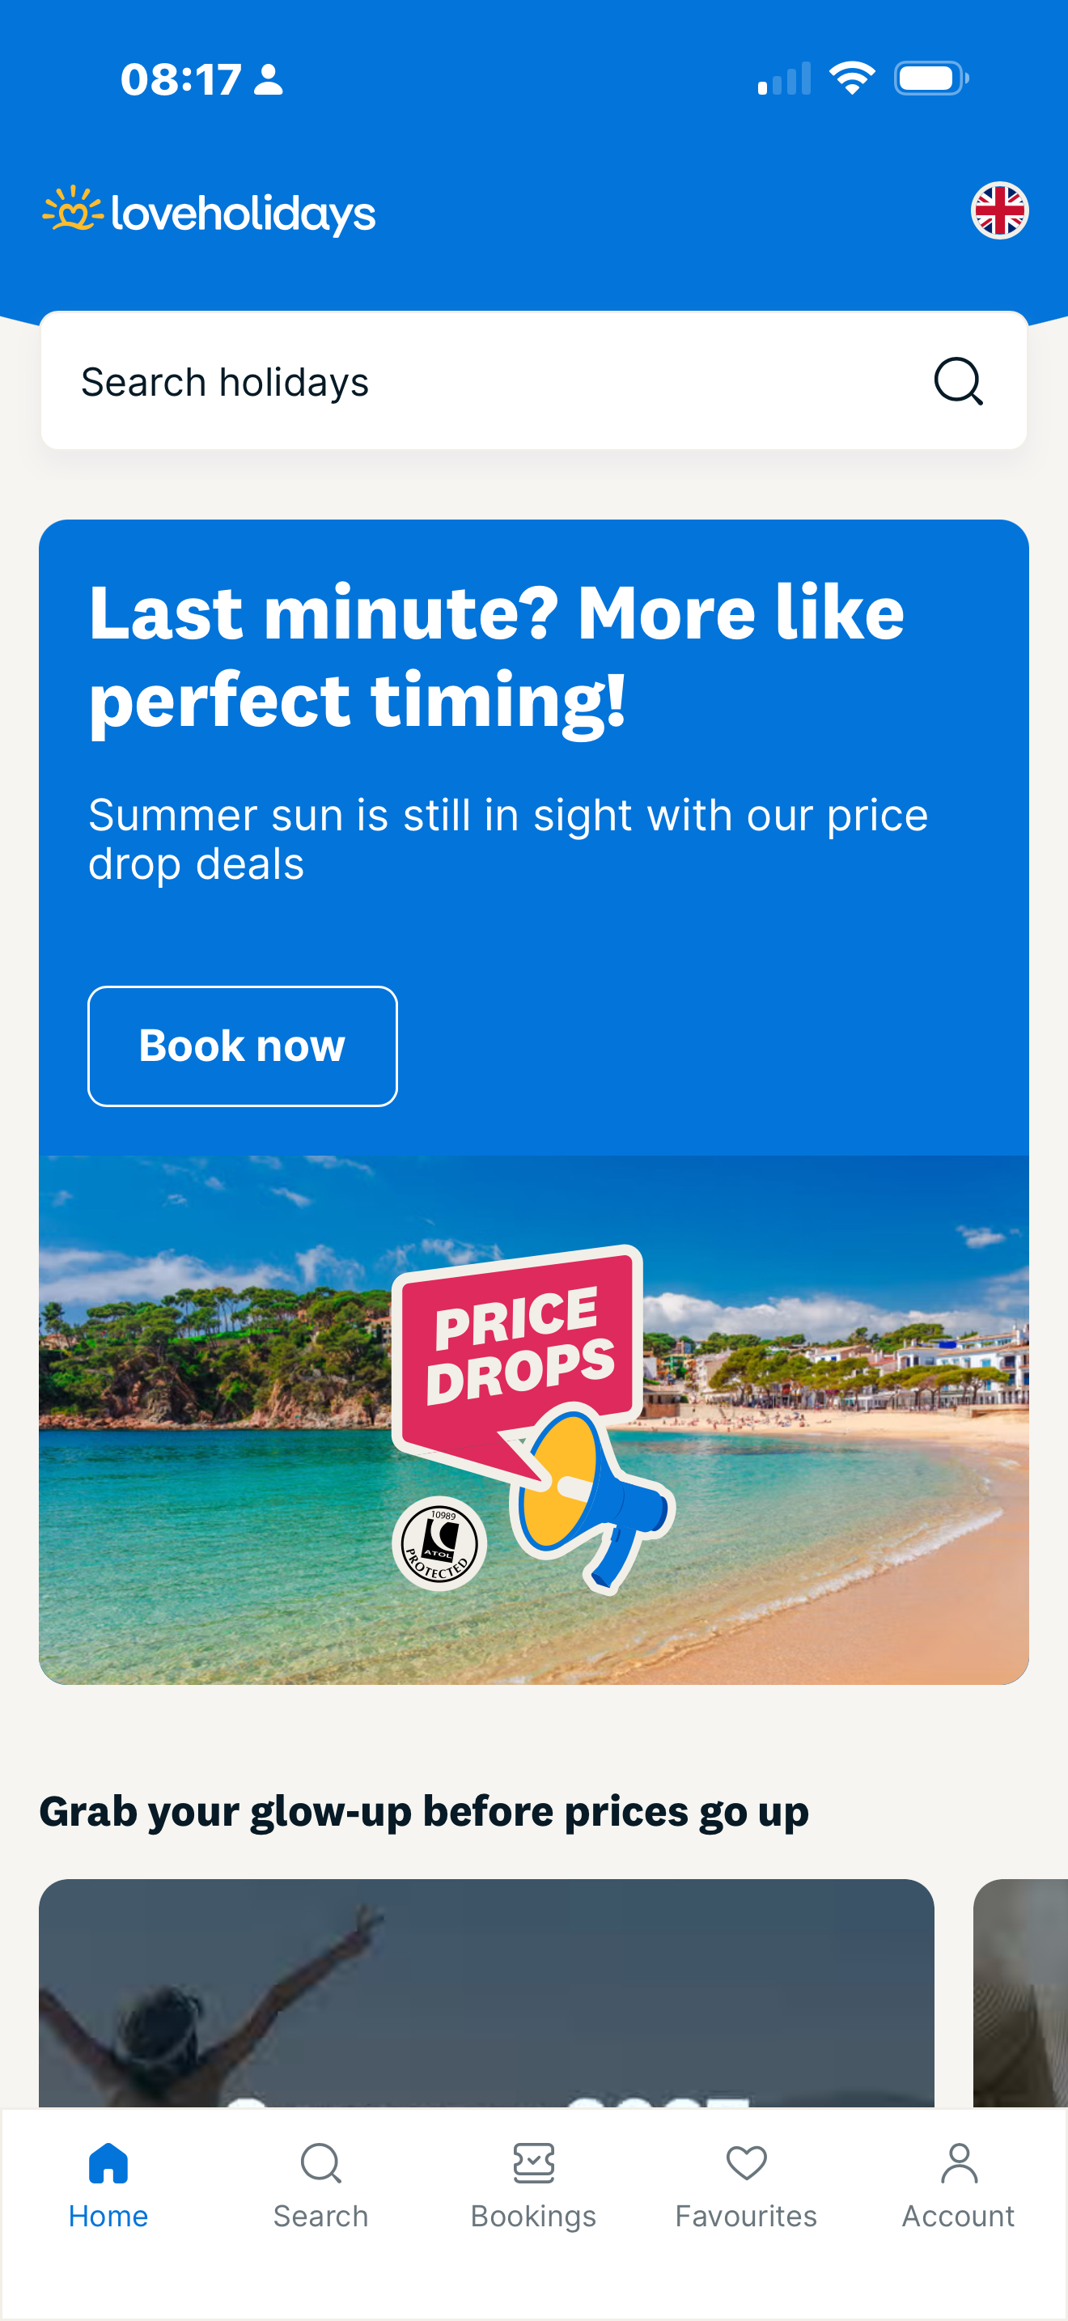
This is a very good website I found it a few years ago and it allows people to pay every month on their holiday that they're going to book for helps families and people that are in poor situations 0 to go on holiday and be able to pay off for it it's all over social media

Screenshot/Photo 3
[Insert Photo/Screenshot below]
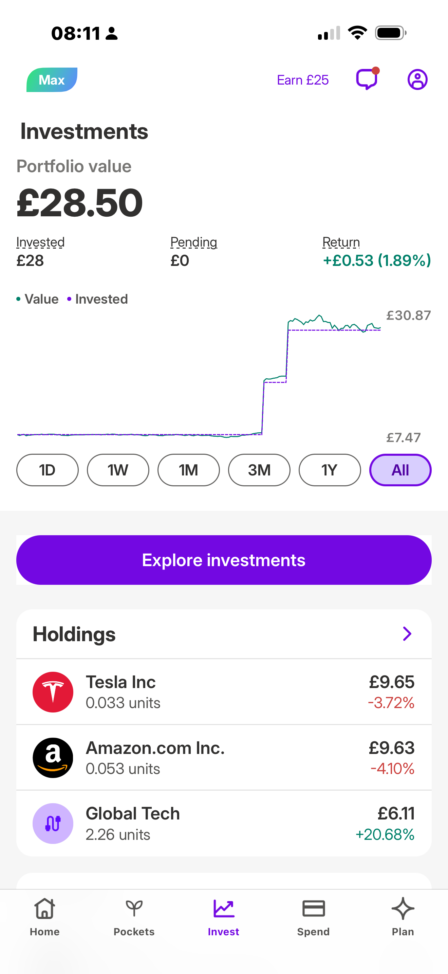
I found out about plum through my son it is an investment page where you can invest into different things Tesla Amazon and get back some money if you put some money in it's a little bit of you making money online it's what's going on in the industry people are investing and getting money back

Screenshot/Photo 4
[Insert Photo/Screenshot below]
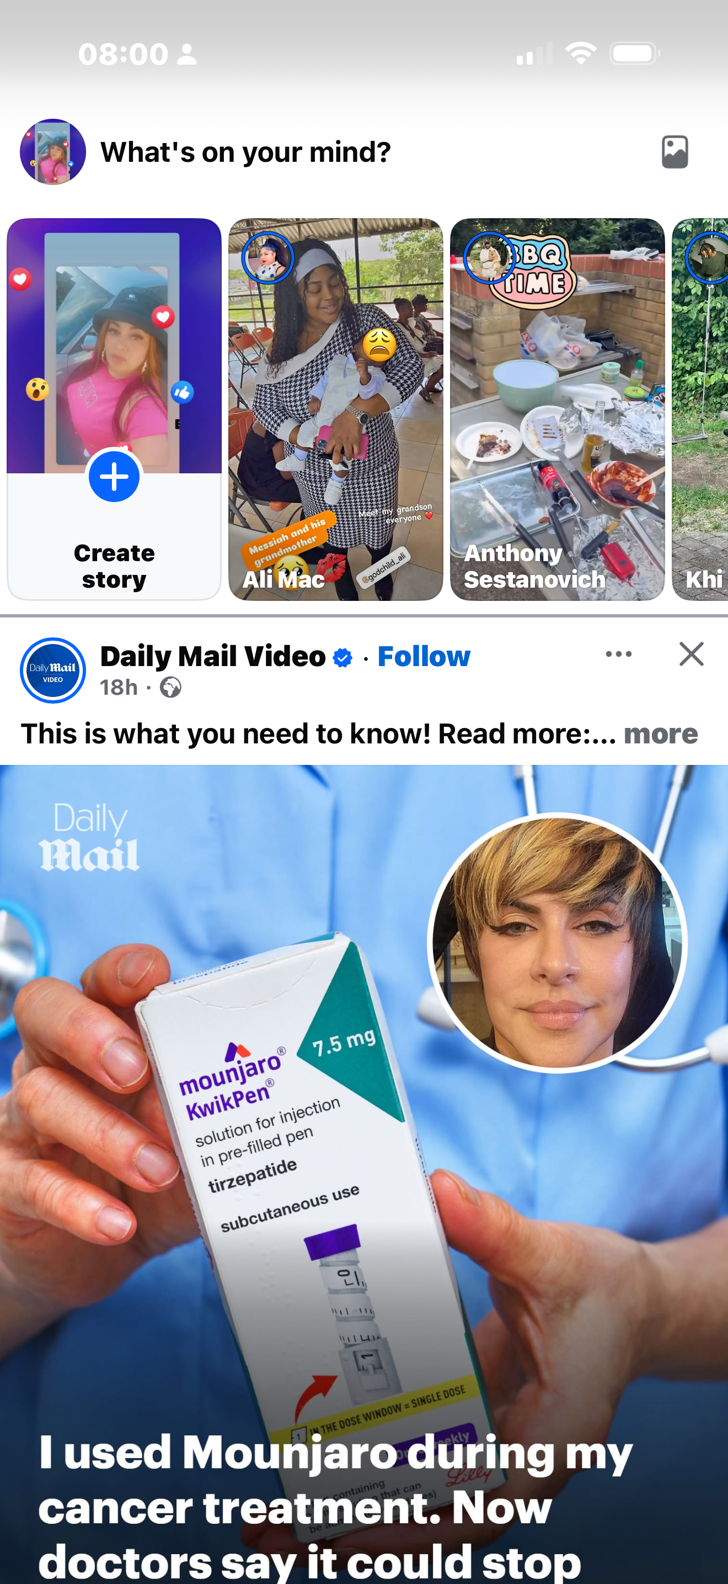
I found out about this weight loss programme on social media Facebook everybody is introducing their self with this skinny pen and I tried it myself and it definitely works I've lost 3 stone taking this monjiro pin social media clams its safe and best Weight loss programme.

Screenshot/Photo 5 I got one more and I'm done
[Insert Photo/Screenshot below]
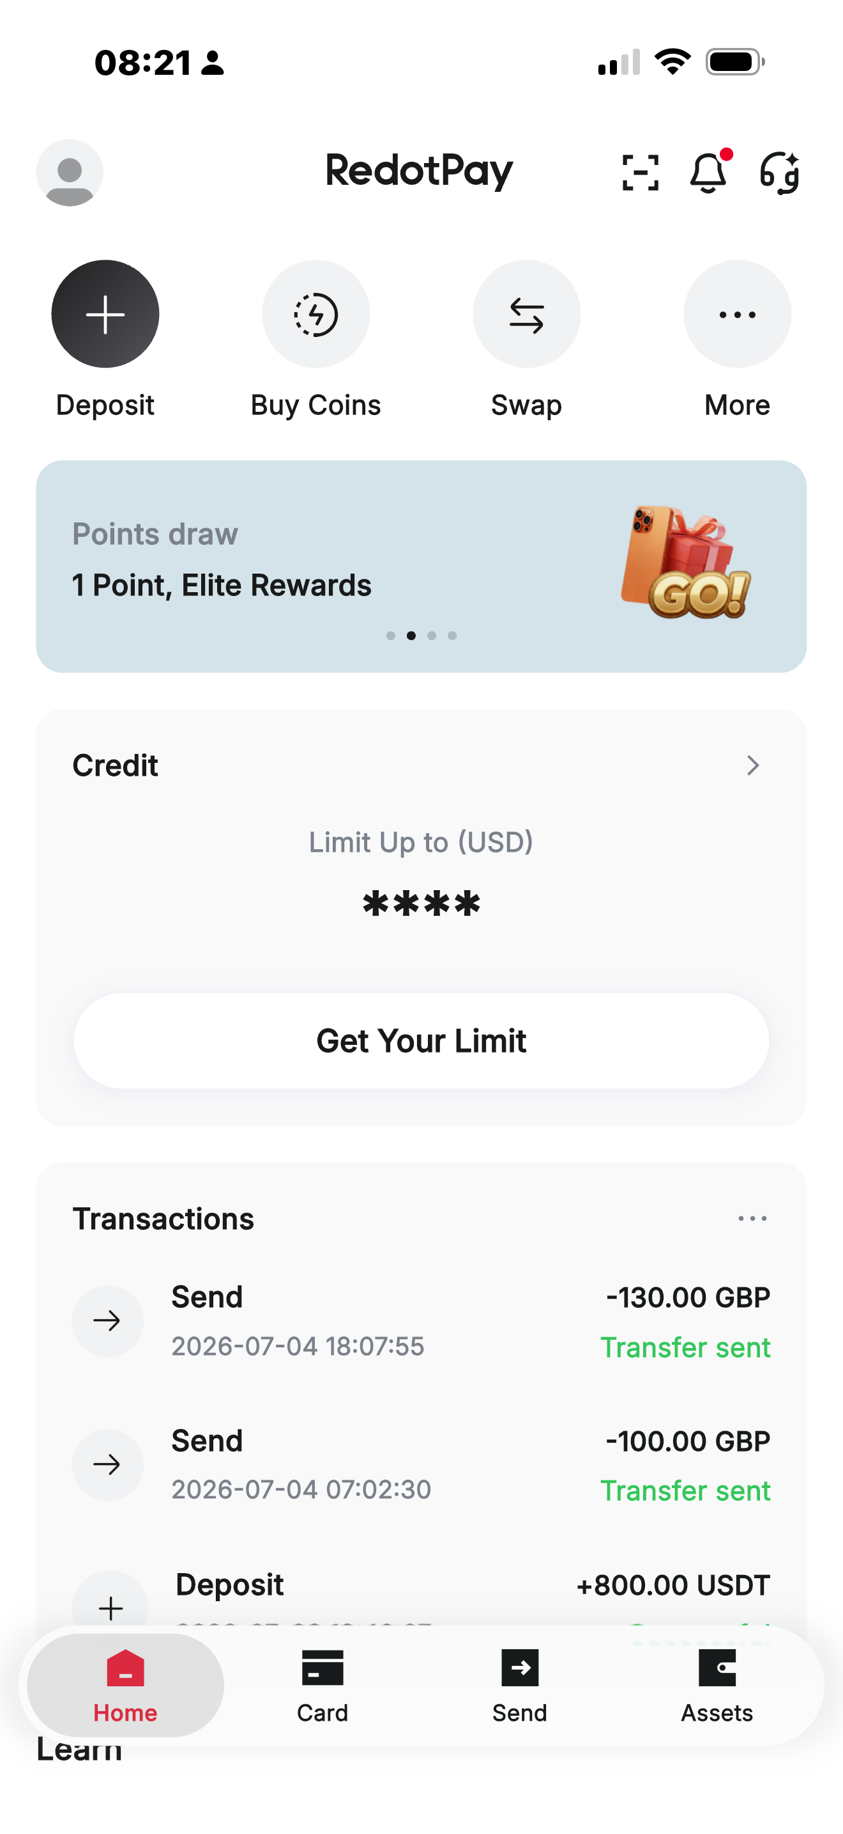
Found out about this I found out about this red dot pay through my son my son lives in Dubai and it is the way he sends money to me and I can buy cryptocurrency if I wanted to it's a very easy and fast way of receiving money from abroad and sending money to others but it is in U.S. dollars it's very good.

Screenshot/Photo 6
[Insert Photo/Screenshot below]
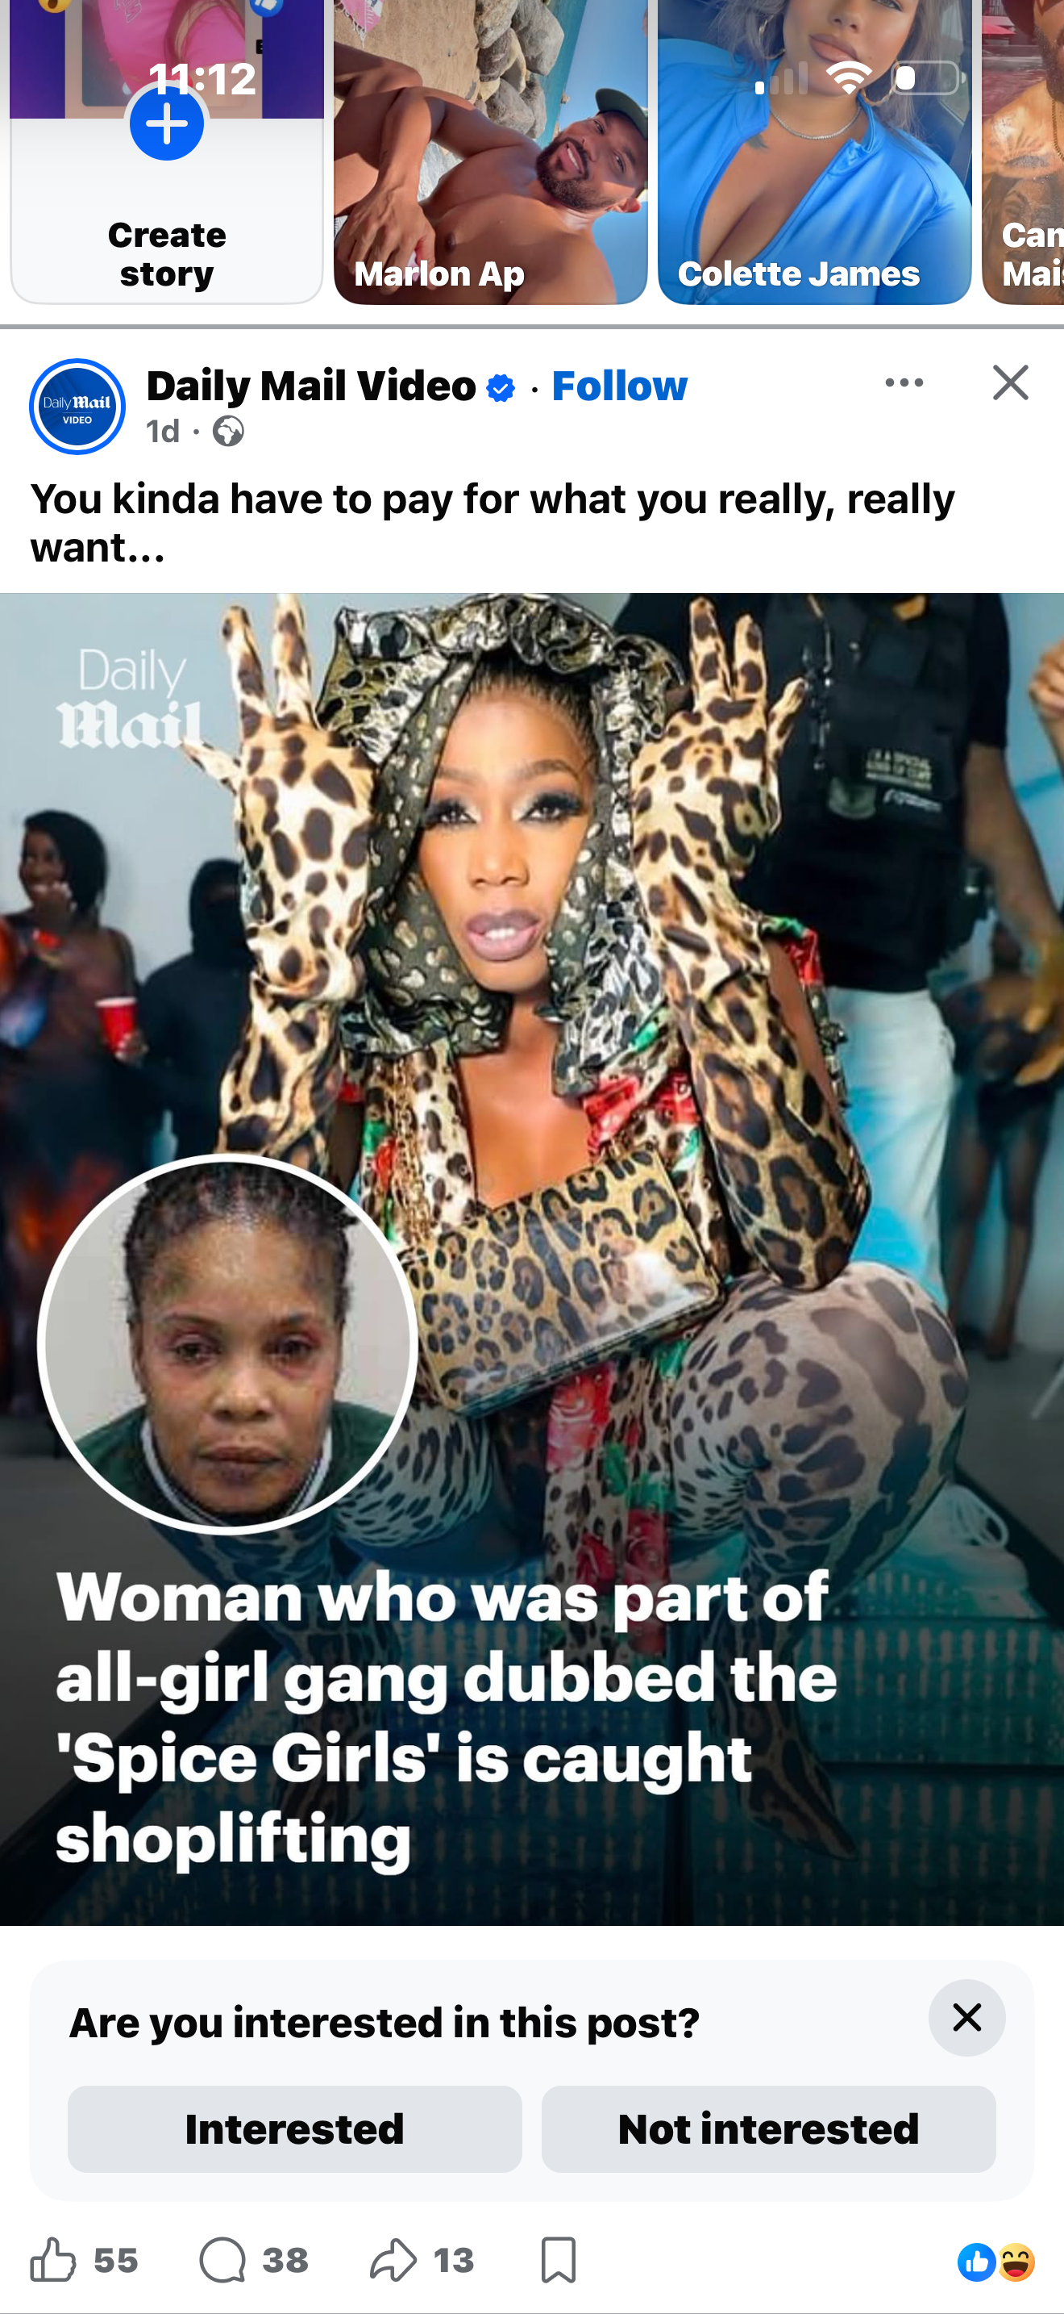

My Short Reflection
- Write 5–8 simple sentences about your digital life.
- You can use the sentence starters below if helpful.

Sentence starters
- I use digital tools to …
- I feel confident when I …
- I want to improve …
- I often use these tools: …
- I sometimes feel nervous about …
- I hope this module will help me …
- Digital skills are important for me because …
You can write more if you want.

Submission Checklist
Before you submit, please check:
​​​ ☐ I added 4–6 screenshots
☐ I wrote short sentences for each screenshot
☐ I wrote my short reflection
☐ My work is my own
☐ My file opens correctly
​​☐ My file opens correctly

