Documentation Table
Device | Identified Problem | Problem | Proposed Solution | The commands used | Resolved?
R1 | First, ping PC1 to PC2, we can see that we are not getting replay:  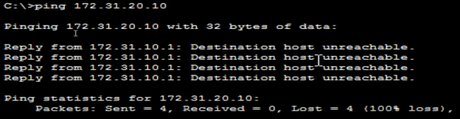  Then, I use tracert command:  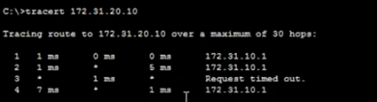  The message will only reach the default gateway, after which the message will not reach any other device.  After that, I check each router configuration using the show running-config command, and I identified as autonomous EIGRP is difference in R1.  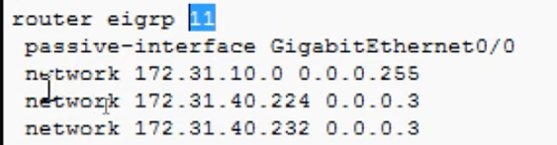  Here is also auto-summarization is enabled and is not passive interface, which means that routes are summarized at the class boundary in routing updates. | It did not establish any adjacencies | Remove EIGRP 11,  Configure EIGRP 1,  Advertise the directly connected networks,  Set Passive Interface,  Disable automatic summarization | R1(config)#no router eigrp 11  R1(config)#router eigrp 1  R1(config-router)#network 172.31.10.0 0.0.0.255  R1(config-router)#network 172.31.40.224 0.0.0.3  R1(config-router)#network 172.31.40.232 0.0.0.3  R1(config-router)#passive-interface g0/0  R1(config-router)#no auto-summary  For verifying, we use show ip protocols:  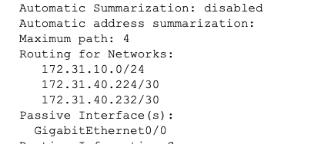 | YES
R2 | Fist, ping PC1 to PC3, we can see that we are not getting replay:  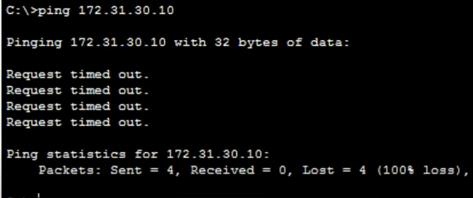  Then, I use tracert command:  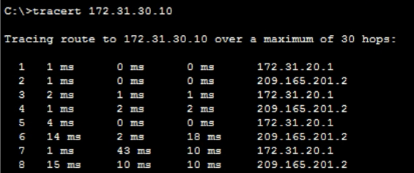  We can see only two addresses, the message comes to R2 and then goes to the Internet. It is not coming to PC3.  Using the show running-config command, we can see that the network (172.31.40.228) going to PC3 is not configured:  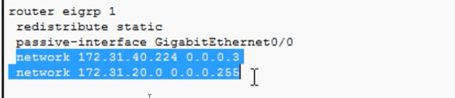 | Adjacency with R3 is not formed. | Advertise the 172.31.40.228/30 network | R2(config)#router eigrp 1  R2(config-router)#network 172.31.40.228 0.0.0.3  For verifying, we use show running-config:  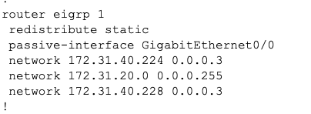 | YES
R3 | When checking the EIGRP configuration we can see it is being done auto-summarization:  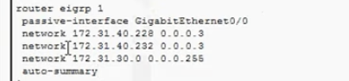 | Performing automatic summarization. | Disable automatic summarization | R3(config)#router eigrp 1  R3(config-router)#no auto-summary  For verifying, we can use show running-config or show ip protocols:  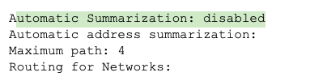 | Yes

