JohnHughes
1708241
January 14th 2020

Practical Test Analysis of Systems Requirements
Information Engineering
Bsc Computing
ACCB4013

Having reviewed the requirements for the new childcare system, the context diagram is pictured below;

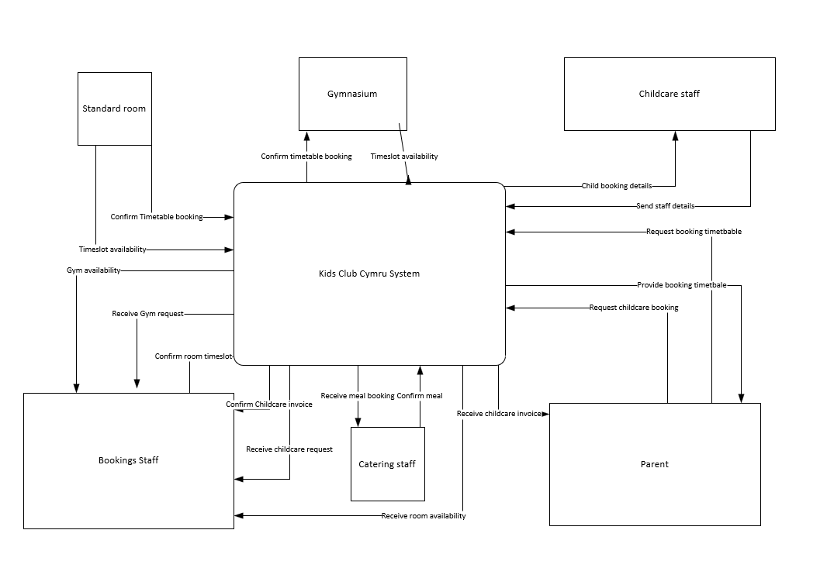

The level 0 data flow diagram is as follows;

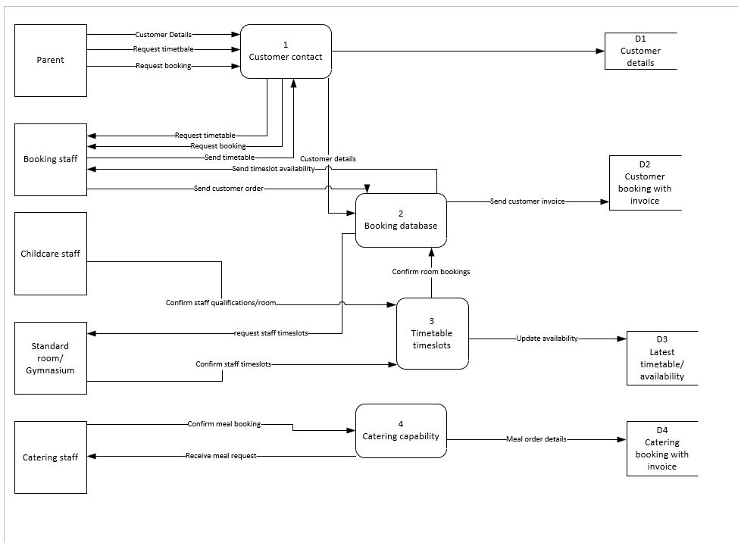

A level 1 data flow diagram is as follows;

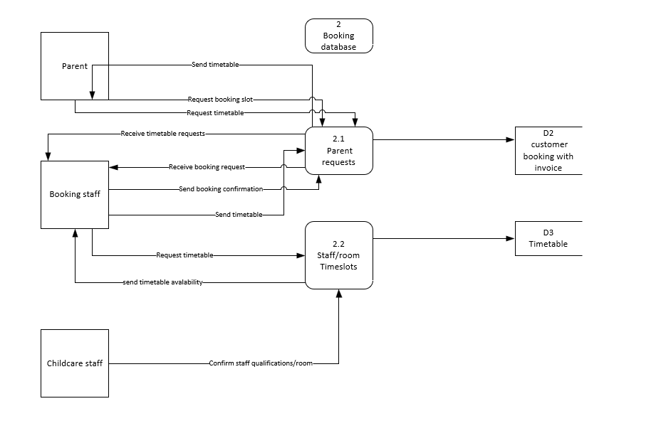

The Entity relation diagram is provided below;



