

Electrical and Electronic Principles

Name: Iolo Williams

Student No: 2508067

L4-Electrical and Electronic Principles

ACCA4006

Electrical and Electronic Degree Apprenticeship

ABSTRACT
Within this assignment, the student was tasked with simulating, building and testing an RLC circuit by gathering results across a wide range of frequencies to determine Q factor, attenuation, and resonant frequency, then comparing the results between simulation and breadboard test. Upon completion of the experiment, the results were recorded in a table and transformed into a graph for comparison with the theory and practical tests. Between the simulation and breadboard test, a drastic difference in the result outcome was observed. This caused the student to research the many possibilities on why this difference had occurred and discovered multiple reasons as to why these differences appeared.

TABLE OF CONTENTS
ABSTRACT 2
TABLE OF CONTENTS 3
LIST OF FIGURES 4
LIST OF TABLES 5
LIST OF EQUATIONS 6
LIST OF ABREVIATIONS 7
1 INTRODUCTION 8
2 EXPERIMENT PLAN 9
3 PROTEUS SIMULATION 10
3.1 PROTEUS RESULTS 11
4 BREADBOARDING 13
4.1 BREADBOARD PREPARATION 13
4.2 BREADBOARD RESULTS 14
5 DISCUSSION 17
CONCLUSION 20
REFERENCES 21

LIST OF FIGURES
Figure 1: Proteus simulation RLC circuit layout 10
Figure 2: Screen grab of Proteus simulation for 4 kHz 10
Figure 3: semi-log graph formed from Table 1 results of Attenuation against Frequency 12
Figure 4: Components installed on breadboard. Note – Each component is labelled in the table below. 13
Figure 5: Breadboard with oscilloscope and signal generator connected 14
Figure 6: Signal generator used for breadboard test 14
Figure 7: Oscilloscope readings from breadboard 15
Figure 8: semi-log graph formed from results of breadboard test. 16
Figure 9: Resistance vs Length of wire graph [11] 19

LIST OF TABLES
Table 1: Proteus results 11
Table 2: Table of components and location used in breadboard simulation 13
Table 3:Results from breadboard test 15

LIST OF EQUATIONS
Equation 1: Resonant frequency formula (Hz) 8
Equation 2: Q Factor formula 8
Equation 3: Expected Q factor in a circuit formula 8
Equation 4: Formula for attenuation (dB) 9
Equation 5: Bandwidth (Hz) calculation formula 12
Equation 6: Percentage accuracy equation 17

LIST OF ABREVIATIONS
Abbreviation | Meaning
RLC | Resistor Inductor Capacitor
Ω | Resistance unit (Ohms)
F | Capacitance unit (Farads)
H | Inductance unit (Henries)
V | Voltage unit (Volts)
Hz | Frequency unit (Hertz)
Vin | Input Voltage
VL | Output voltage across inductor
dB | Attenuation unit (Decibels)
Q | Quality Factor
BW | Bandwidth
$$f_{r}$$ | Resonant frequency
$$f_{r2}$$ | Resonant frequency test result
$$F_{h}$$ | Frequency high cut-off
$$F_{L}$$ | Frequency low cut-off
PCB | Printed Circuit Board
k | Kilo $10×{10}^{3}$
m | Milli $10×{10}^{-3}$
µ | Micro $10×{10}^{-6}$
A | Attenuation (Decibels)

1 INTRODUCTION

For this assignment, the student was tasked with creating, simulating and testing an RLC circuit using Proteus software and a breadboard. This RLC circuit involved a 1 kΩ resistor connected in series to a 1 µF capacitor and a 1 mH inductor, both connected in parallel, as shown in Figure 1 below. A common feature of all RLC circuits is that they feature a resonant frequency occurring when inductive reactance and capacitive reactance are equal in magnitude. There are multiple types of RLC circuits: parallel and series. In a series RLC circuit, current is equal between each component, and voltage differs; unlike in a parallel circuit, the voltage will stay the same, and current will vary. A common use for RLC circuits is band-pass filters, where the resonant frequency will determine the frequency of the passband, being the range of frequencies that are passed with minimal attenuation [1]. Band-pass filters are often used in wireless transmitters and receivers or audio electronics [1]. For this experiment, the student will use the resonant frequency formula shown below in Equation 1.
Equation 1: Resonant frequency formula (Hz)
$$f_{r}=\frac{1}{2π\sqrt{LC}}$$
Moreover, the student will also determine the Q Factor of the circuit using Equations 2 and 3 shown below. Q factor or quality factor is a metric that quantifies the selectivity of a signal at resonant frequency [2].
Equation 2: Q Factor formula
$$Q=\frac{f_{r}}{Bw}$$

Equation 3: Expected Q factor in a circuit formula
$$Q=R\sqrt{\frac{c}{L}}$$
Using these formulas, the student will compare the different results gathered from the breadboard tests and Proteus simulation by recording the data in tables and from that make a semi-log graph. Using these two sets of results, the student will compare the breadboard test and Proteus simulation, looking for any similarities or differences. Lastly, the student will research any similarities or differences with the aim of gaining further knowledge on each possible cause.

2 EXPERIMENT PLAN
In this experiment, the circuit's output voltage was measured across a range of frequencies from 500 Hz to 60 kHz. Using these voltage measurements, the attenuation can be calculated for each frequency using Equation 4 below.
Equation 4: Formula for attenuation (dB)
$$A=20\log_{10}{\frac{V_{L}}{V_{in}}}$$
For this experiment, the input voltage would be kept at a constant 2 V peak-to-peak sine wave across the range of input frequencies. More readings were taken when approaching the resonant frequency to account for the large change in output voltages with only a minor change in frequency. Using the resulting semi-log graphs, the -3 dB points, also known as the half-power points, were located using the largest attenuation result for both the Proteus simulation and breadboard. After finding the -3 dB point, the student measured the intersection points to find the bandwidth and the Q factor.

3 PROTEUS SIMULATION
Shown below in Figure 1 the RLC circuit was created in Proteus.
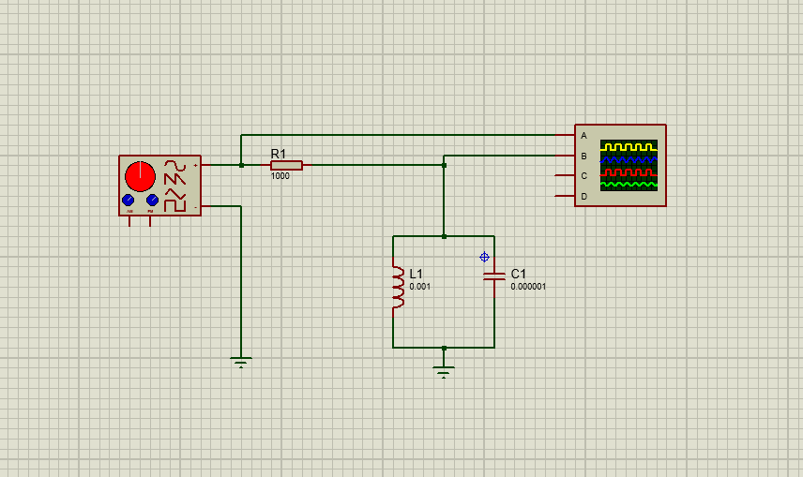
Figure 1: Proteus simulation RLC circuit layout
Next, the circuit needed to be simulated to gain results, shown below in Figure 2.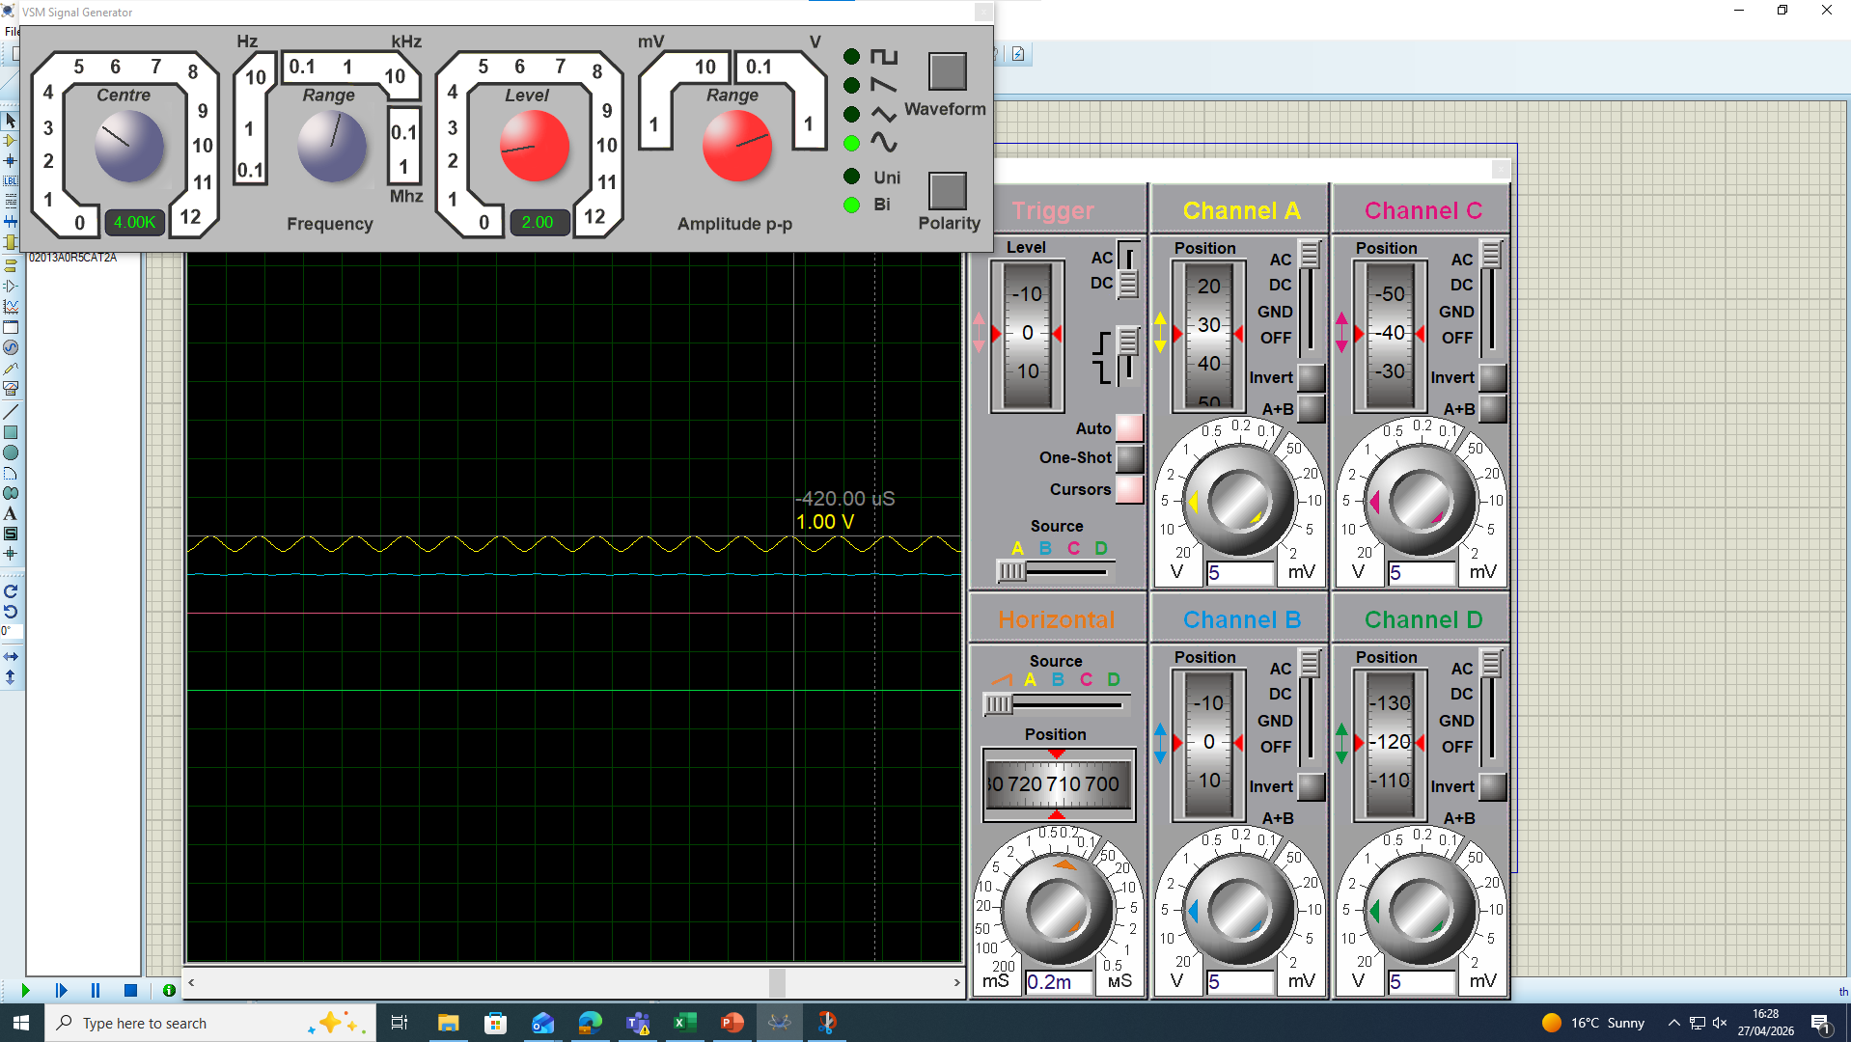
Figure 2: Screen grab of Proteus simulation for 4 kHz
As shown in Figure 2, Channel A outputs a frequency of 4 kHz and an amplitude of 2 V peak-to-peak, while Channel B reads a small output of corresponding output of 0.15 V as listed in Table 1.

3.1 PROTEUS RESULTS
Table 1: Proteus results
Frequency (Hz) | Vin (V) | VL (V) | Gain (Ratio) | Attenuation (dB)
500 | 2 | 0.01 | 0.005 | -46.02059991
1000 | 2 | 0.01 | 0.005 | -46.02059991
2000 | 2 | 0.03 | 0.015 | -36.47817482
3000 | 2 | 0.06 | 0.03 | -30.45757491
4000 | 2 | 0.15 | 0.075 | -22.49877473
4500 | 2 | 0.32 | 0.16 | -15.91760035
4800 | 2 | 0.84 | 0.42 | -7.535014192
4900 | 2 | 1.43 | 0.715 | -2.913879164
5000 | 2 | 1.61 | 0.805 | -1.884082393
5100 | 2 | 0.96 | 0.48 | -6.375175252
5200 | 2 | 0.63 | 0.315 | -10.03378892
5300 | 2 | 0.46 | 0.23 | -12.76544328
5400 | 2 | 0.36 | 0.18 | -14.8945499
6000 | 2 | 0.16 | 0.08 | -21.93820026
7000 | 2 | 0.09 | 0.045 | -26.93574972
10000 | 2 | 0.04 | 0.02 | -33.97940009
20000 | 2 | 0.02 | 0.01 | -40
30000 | 2 | 0.01 | 0.005 | -46.02059991
40000 | 2 | 0.01 | 0.005 | -46.02059991
50000 | 2 | 0.01 | 0.005 | -46.02059991
60000 | 2 | 0.01 | 0.005 | -46.02059991
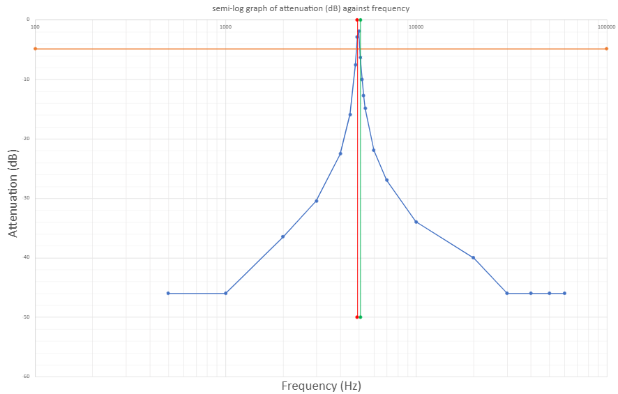
Figure 3: semi-log graph formed from Table 1 results of Attenuation against Frequency
As we can see from the graph in Figure 3, our peak attenuation is reached at a frequency of 5 kHz with a value of -1.88 dB. Shown on the graph in orange is our -3 dB point, and the red and green lines show each intersection. The green line is the $F_{h}$ (frequency higher) while the red line represents $F_{L}$ (frequency lower). Using these two vertical lines along the graph and their intersection points at 5100 Hz and 4900 Hz, the student will then use Equation 5 to calculate the bandwidth.
Equation 5: Bandwidth (Hz) calculation formula
$$BW=F_{h}-F_{L}$$
The student used Equation 1 to calculate the expected resonant frequency, which was equal to 5032 Hz. Then, using Equation 5, the student calculated the bandwidth to be 200 Hz. From Table 1, the student can see that the resonant frequency is 5000 Hz, which is extremely close to the expected result. To calculate the expected Q factor, the student used Equation 3, giving a Q factor of 31.62. The student used the resonant frequency obtained from the graph, gaining a value of 5 kHz and a bandwidth of 200 Hz using these results and Equation 3, giving a Q factor of 25.

4 BREADBOARDING

4.1 BREADBOARD PREPARATION
Firstly, the student gathered the components required for completing the practical test, which included a 1 µF capacitor, a 1 kΩ Resistor and a 1 mH inductor. Next, following the Proteus schematic shown in Figure 1, the student arranged them on the breadboard as shown in Figure 4 below.
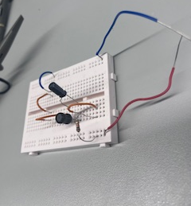
1
5
4
2
3
Figure 4: Components installed on breadboard. Note – Each component is labelled in the table below.
Table 2: Table of components and location used in breadboard simulation
Component number | Component
1 | 1 kΩ Resistor
2 | 1 µF Capacitor
3 | 1 mH inductor
4 | Input
5 | Ground

After the student connected up the components as shown in Figure 4, the circuit needed to be tested. This was done by connecting the signal generator to the input wire and the oscilloscope probes before and after the resistor, and also to ground. These connections can be seen below in Figure 5
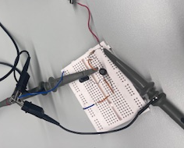
Figure 5: Breadboard with oscilloscope and signal generator connected

4.2 BREADBOARD RESULTS
After the student finished setting up the breadboard test, they began to test it by changing the frequency across the same range of numbers as the Proteus test. Shown below in Figure 6 is the signal generator used to operate this experiment.
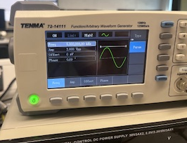
Figure 6: Signal generator used for breadboard test
As shown in Figure 6, the peak-to-peak voltage is set to 2 volts, which remained constant throughout the experiment.
When testing, the oscilloscope was used to gather measurements for the output voltage, an example of this is shown below in Figure 7.
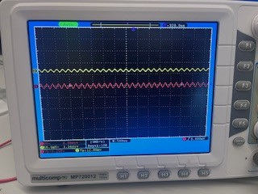
Figure 7: Oscilloscope readings from breadboard
After testing, Table 2 was produced, as shown below.
Table 3:Results from breadboard test
Frequency (Hz) | Vin (V) | VL (V) | Gain | Attenuation (dB)
500 | 2 | 0.04 | 0.02 | -33.97940009
1000 | 2 | 0.04 | 0.02 | -33.97940009
2000 | 2 | 0.06 | 0.03 | -30.45757491
3000 | 2 | 0.08 | 0.04 | -27.95880017
4000 | 2 | 0.12 | 0.06 | -24.43697499
4500 | 2 | 0.16 | 0.08 | -21.93820026
4800 | 2 | 0.2 | 0.1 | -20
4900 | 2 | 0.2 | 0.1 | -20
5000 | 2 | 0.22 | 0.11 | -19.1721463
5100 | 2 | 0.24 | 0.12 | -18.41637508
5200 | 2 | 0.24 | 0.12 | -18.41637508
5300 | 2 | 0.24 | 0.12 | -18.41637508
5400 | 2 | 0.24 | 0.12 | -18.41637508
6000 | 2 | 0.2 | 0.1 | -20
7000 | 2 | 0.14 | 0.07 | -23.0980392
10000 | 2 | 0.08 | 0.04 | -27.95880017
20000 | 2 | 0.04 | 0.02 | -33.97940009
30000 | 2 | 0.04 | 0.02 | -33.97940009
40000 | 2 | 0.04 | 0.02 | -33.97940009
50000 | 2 | 0.04 | 0.02 | -33.97940009
60000 | 2 | 0.04 | 0.02 | -33.97940009

From Table 3, the student formed the graph shown below in Figure 8.
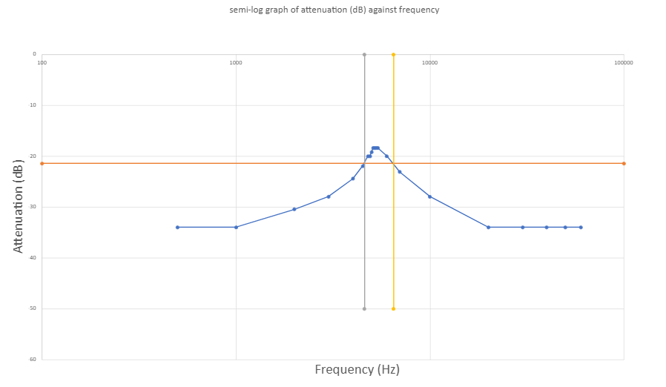
Figure 8: semi-log graph formed from results of breadboard test.
As shown in Figure 8 and Table 3, our peak attenuation is reached between 5100 Hz and 5400 Hz with a value of -18.42 dB. Shown on the graph in orange is the -3 dB point, the yellow. ${(F}_{h})$ and grey ${(F}_{L})$intersection lines at 4600 Hz and 5900 Hz. Using these values and Equation 5, the student calculated the bandwidth as 1900 Hz.
The expected resonant frequency is 5032 Hz, however, from the table produced by the breadboard results, the resonant frequency is 5250 Hz. Then, using Equation 2 to calculate a Q factor of 2.76, far away from the students expected result of 31.62.

5 DISCUSSION
Considering the student's Proteus simulation and the difference between the expected calculated results, the student is inclined to trust the accuracy of the simulated results. The slight difference in resonant frequency between the expected calculation result and the simulation is because of the increments the student used to measure the specific area. To improve accuracy, if the student had used 10 Hz increments instead of 100 Hz increments, this result would have been more accurate. With the expected resonant frequency at 5032 Hz and the simulated resonant frequency result of 5000 Hz, from these values, the student can use Equation 6 below to determine the accuracy of the result.

Equation 6: Percentage accuracy equation
$\left(1-\frac{\left(F_{r}-F_{r_{2}}\right)}{F_{r_{2}}}\right)×100$
Using the formula shown above in Equation 6, with $F_{r}$ equal to the expected resonant frequency from the results, and $F_{r2}$being the actual result the student obtained from the simulation or test. The student can hence determine the percentage accuracy to be 99.36% or a percentage error of 0.64%. Highlighting the accuracy of the result. Unlike the Proteus simulation, the breadboard test does not share a similar standard of accuracy, with a resonant frequency of 5250 Hz, which is a different result from what the student expected. With the percentage accuracy at 95.67% and the percentage error 4.33%. Commonly, resistors have a 5% percentage error[3], with this being the same for inductors and capacitors, resulting in a worst-case scenario total error of 15% this means a range of 4277.2 Hz to 5786.6 Hz [4]. The actual range is likely much less than this, but the student decided to find the greatest range possible to also account for other inaccuracies [4]. As we can see, the student's result is within this margin, allowing for confidence in this specific result.

Secondly, both the $F_{h}$ and $F_{L}$ points are utilised to calculate the RLC circuit's bandwidth. With the students Proteus simulation, the results of 5100 Hz and 4900 Hz allow for the use of Equation 5 to calculate a bandwidth of 200 Hz. Comparing this to the breadboard test, the student saw a drastic difference. The $F_{h}$ and $F_{L}$ points from the breadboard tests are 6500 Hz and 4600 Hz, respectively, this leaves a bandwidth of 1900 Hz. The student can also determine this difference from the shapes of the graphs in Figure 3 and Figure 8. This is down to the Graphs in Figure 3 and Figure 8, following the same curve, but Figure 8 contains the breadboard test, having a lower peak and a wider -3 dB point, implying the actual circuit has a larger selectivity range than expected.

This difference in bandwidth could be caused by a variety of things, one being parasitic capacitance. With breadboards made using multiple horizontal metal strips that carry current between individual components [5], it is possible that they resemble a capacitor. Put simply, a capacitor is two current-carrying plates separated by an insulator. Using this definition, the student realised that all the individual metal strips act as little capacitors. As a result of this similarity, a phenomenon called parasitic capacitance can occur. This can result in impedance modification, which happens when a displacement current is produced in nearby conductors, hence skewing the student's results [6]. To eliminate this, the student could test using a PCB due to it having less parasitic capacitance and inductance, improving the accuracy of the results [7]. Although a PCB is more expensive and time-consuming to produce, the use of one to properly test the RLC circuit will be beneficial, as this will yield a more accurate result [7]. Moreover, this difference in bandwidth may also be affected by the internal resistance of each wire or component. The sum of these internal resistances could potentially lead to a large gap between the expected resistance and actual resistance. All without being considered by the Proteus simulation affecting the accuracy.

With Q factor being the ratio between resonant frequency and bandwidth, the student was expecting a Q factor of 31.62. However, the Proteus simulation produced a Q factor of 25. All in all, this result is promising as it is not far away from the expected and could be improved with more accurate measuring increments. On the other hand, the breadboard test produced a drastically different Q factor result of 2.76. As previously determined by the student, the resonant frequency was accurate; the issue causing the small Q factor is the extremely large bandwidth of 1900 Hz. Theoretically, if this were the same size bandwidth as the Proteus simulation, the Q factor produced would be 26.25, which would be considered a strong result.

Additionally, both graphs produced in Figure 3 and Figure 8 are similar, as they follow the same structure. In the low frequencies, both graphs have minimum attenuation and as the frequency gradually increases, so does the attenuation, peaking at roughly 5000 Hz. After this, both graphs begin to dip until they hit minimum attenuation again at roughly 20000 Hz. Conversely, as can be seen from Table 1 and Table 3, there is a large difference in the resulting attenuation of roughly 15 dB.

A factor that may affect the students results is the skin effect. The skin effect occurs at high frequencies and is caused by the tendency of alternating current to flow near the outer surface of a conductor, decreasing current density at the core of the cable [8]. As a result of this, the effective cross-sectional area for current flow is reduced, increasing the resistance of the conductor [8]. As a result of this increased resistance, the RLC circuit is more damped and thus has a lower peak attenuation and a wider bandwidth [9]. This could explain the difference between the students graphs, highlighting an important learning point for the young engineer.

Furthermore, with all conducting components having an internal resistance, it's safe to assume this will affect the students' results, as the Proteus simulation does not take this into account. With a large number of wires connecting the signal generator to the breadboard, and all the components inside the circuit connected with wires and with the tracks inside the breadboard, and finally, the oscilloscope probes connecting to the circuit to allow for measurements. Overall, this results in the circuit being connected with a very long wire. With resistance being directly proportional to wire length, and due to the combined length of these wires, a large internal resistance will be generated [10]. Shown in Figure 9 below is a graph highlighting resistance Vs length of wire.
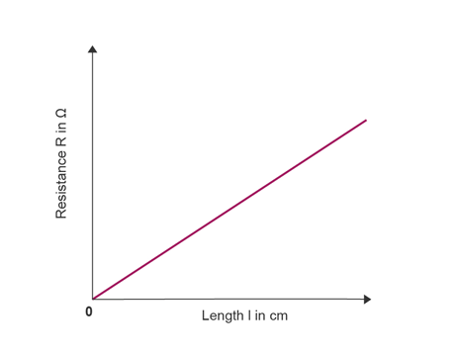
Figure 9: Resistance vs Length of wire graph [11]
As a result of this greater resistance, damping will be increased. Damping is considered as the dissipation of energy in a vibrating system in an RLC circuit, the extra resistance causes Joule heating due to the current flowing through the circuit. This Joule heating dissipates energy, which affects the attenuation of the vibrations [12].
Like previously mentioned, there is a difference in selectivity between the simulation and the breadboard test. A high selectivity means there is a strong opposition to current flow at resonant frequency but allows current to flow easily at non-resonant frequencies [13]. On the other hand, a low selectivity RLC circuit will oppose current over a wider range of frequencies [13]. Selectivity also relates to Q factor, which is determined by the resonance peaks, a sharp resonance peak indicates a high selectivity, and a broad resonance peak for a lower Q factor [13]. We see this occur in both Figure 3 and Figure 8, highlighting the difference between the two.

CONCLUSION
Throughout the course of this assignment, the student had discovered that there can be major differences between simulation and actual tests, all occurring from a multitude of reasons, many of which are not taken into account by many simulation software. This assignment highlights how necessary it is to test circuits in real-world conditions before they are fully built, as the issues found on the breadboard test were not picked up by the simulation. These differences could be down to the smallest of details, like parasitic capacitance or the internal resistance of a wire. Or even affected by something much larger, like the tolerances on each component. Furthermore, as seen from the results, the Proteus circuit was far more selective due to its narrow bandwidth, which entailed it having a large Q factor, unlike the breadboard. Similarly, they had resonant frequencies lying in the same area, both being close to the expected frequency gained from the calculation.

REFERENCES
[1]
“What is an RLC Circuit? - Keysight Oscilloscope Glossary - Keysight Technologies,” Keysight.com, 2024. https://www.keysight.com/used/us/en/knowledge/glossary/oscilloscopes/rlc-circuit
[2]
“Resonant Circuits: Resonant Frequency and Q Factor | Basic Alternating Current (AC) | TechWeb,” Rohm.com, 2024. https://techweb.rohm.com/product/circuit-design/electric-circuit-design/18332/
[3]
“Resistor Tolerance and Preferred Values - Wilderness Labs Developer Portal,” developer.wildernesslabs.co. https://developer.wildernesslabs.co/Hardware/Tutorials/Electronics/Part4/Resistor_Tolerance/
[4]
S. Parsons, “Tolerance Stack-Up Analysis — Worst Case vs RSS (Statistical) Methods - *ficient design,” *ficient design, Feb. 25, 2026. https://ficientdesign.com/tolerance-stack-up-analysis/ (accessed May 06, 2026).
[5]
SparkFun, “How to Use a Breadboard - learn.sparkfun.com,” Sparkfun.com, 2020. https://learn.sparkfun.com/tutorials/how-to-use-a-breadboard/all
[6]
“What’s the Difference Between Stray and Parasitic Capacitance?,” resources.system-analysis.cadence.com. https://resources.system-analysis.cadence.com/blog/msa2021-what-s-the-difference-between-stray-and-parasitic-capacitance
[7]
Antti PCBSync, “Introduction In the world of electronics and circuit design, two fundamental tools stand out: the Printed Circuit Board (PCB) and the breadboard. While both serve the purpose of connecting electronic components to create functional circuits, they differ significantly in their design, application, an,” Linkedin.com, Jul. 05, 2024. https://www.linkedin.com/pulse/whats-difference-between-pcb-breadboard-antti-rayming-l99nc/ (accessed May 05, 2026).
[8]
“Skin Effect: Definition, Factors & Reduction Methods,” Electrical Tutorial, Jan. 25, 2026. https://electricaltutorial.com/skin-effect-definition-factors-reduction-methods/ (accessed May 06, 2026).
[9]
“23.3: RLC Series AC Circuits,” Physics LibreTexts, Jul. 24, 2016. https://phys.libretexts.org/Bookshelves/College_Physics/College_Physics_1e_(OpenStax)/23%3A_Electromagnetic_Induction_AC_Circuits_and_Electrical_Technologies/23.03%3A_RLC_Series_AC_Circuits
[10]
Stephen Holt, “The Resistance of Wire Explained - Scott Precision Wire,” Scott Precision Wire, Apr. 28, 2022. https://www.scottprecisionwire.com/the-resistance-of-wire-explained/
[11]
BBC Bitesize, “Graph - Resistance - CCEA - GCSE Combined Science Revision - CCEA Single Award - BBC Bitesize,” BBC Bitesize, May 31, 2022. https://www.bbc.co.uk/bitesize/guides/zkvbg7h/revision/3
[12]
“RLC Circuit: Series and Parallel, Applied circuits | Basic Alternating Current (AC) | TechWeb,” Rohm.com, 2025. https://techweb.rohm.com/product/circuit-design/electric-circuit-design/23194/
[13]
“What does the quality factor (Q) represent in a parallel RLC circuit,” Truegeometry.com, 2025. https://blog.truegeometry.com/api/exploreHTML/39e43a4a3ca416cb454395bcc986fafd.exploreHTML?utm_source=copilot.com (accessed May 13, 2026).

