

ACADEMIC SKILLS: REFLECTIVE REPORT
Lecturer: Sylvia Hoffmann
Name of the Student: Slevoaca Vasile
Student's ID:2332190
Name of the University: University of Wales Trinity Saint David

Executive summary
The report has focused on conducting a reflective analysis on the ways in which the academic writing skills, note-taking skills and research skills have been developed. The different types of tasks that have supported me in developing my skills have been evaluated in this particular paper. The overall analysis has therefore promoted my understandings regarding the areas that i need to further develop for better career development.
Contents
Introduction 4
Gibbs Reflective Cycle 4
Conclusion 9
References 10

Introduction
Academic writing tends to refer to a style of writing that is expressive. With the help of research, there is a definition of boundaries that are intellectual in different areas of expertise. It gives the writer and reader a clear focus on problems in research. It gives it a clear view and simplifies it as well. the report will focus on conducting a reflective analysis on the academic writing skills, note-taking skills and research skills.

Gibbs Reflective Cycle
Descriptive
Through this study, I developed knowledge and insights regarding the concepts of academic writing and the whole term as a whole. However, there was a lot of practical application of the idea. I could still grasp a lot of information about the topic in theory as well. With the assignments, I was able to understand the topic much better and was able to put my learnings into practice as well. Through this skill, I was able to pick up and learn about skills that were related to academic skills. The skills that I have learnt are note-taking, research skills and academic writing. The assessments that I have given for this course as well as the assignments that I was assigned helped me develop my academic skills and improve what I already had. I was able to follow through with the class and take notes without getting disturbed. I was able to focus and follow what the lecturer was reading without any problems.
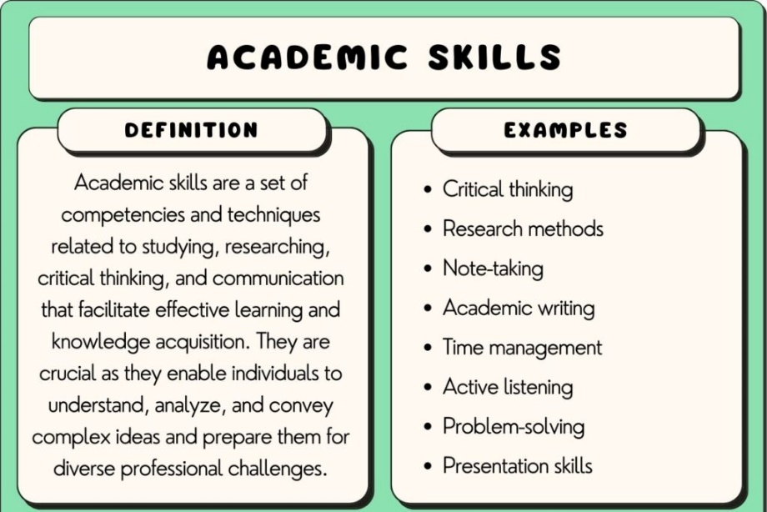
Figure: Academic Skills
(Source: Granziera et al., 2022)
Feelings
The information did seem like a lot initially so I was a bit overwhelmed that I had to process all of this knowledge in the first two semesters. I was scared that I would not be able to cope with the others and be left behind. There was a very high standard required for academic writing and there were others who had an issue following up (Granziera et al., 2022). It is very important to meet the requirements and standards as one's work has to always be better than before. Improvements are being made all the time, if there is an issue, those areas are to be improved instantly with help. As time went on, I was able to catch up on the pace and make my own. I was able to progress through the difficulty, it is now the best thing I have done. At that moment I felt scared and a bit pressured.
Evaluation
The learnings did help me form or create a properly structured base of knowledge for the academic skills I needed to learn. There was enough theory and practical knowledge for me to learn from this course and it has helped me ever since. The things that I have learnt from this course as well as the skills that I have developed have been very effective. It not only helped me graduate and give me good marks but it will also ensure that my future looks promising, giving me skills that will help me do well in life as well. Even though I was able to get so much knowledge with this module and course in general. There was no knowledge about each of the skills in depth (Peng and Kievit, 2020). It is not a bad thing but if things were explained to me in more detail, I would appreciate it more. The overall environment was very positive as well which helped my learning journey.
Analysis
Through this analysis, I was able to find out about the structures that I had been following throughout my time in class. It was clear enough for me to interpret and comprehend without any issues. It has helped me build up a foundation for academic writing that I did not possess before. I was able to have a clear mind and think differently. If there were any issues, I was able to communicate and interact with the lecturer in charge. With the help of different methods of research, I was able to improve my skills and understand the information that I was taking in. When it came to taking notes, I was able to understand what to note down and what not to do. I was able to differentiate between the important points and the less important ones. I was able to keep my notes organised and clean in a way as well as maintain them. I was able to develop my way of taking notes, it helped me be more efficient. Another skill that I developed overtime was research. In the beginning, there were a lot of issues but I was able to create strategies that would help me with important research information.
Conclusion
The experience that I have had during my learning journey in this course has helped me develop my academic skills. Even though I was faced with many issues and challenges along the way, I was able to do my best in the situation and get back up by working hard. I made great progress throughout the time that I was learning this module which has now helped improve my future as well. I can take on any challenge, academic-related at any time and anywhere in the future. With these newly equipped skills, I feel more confident and prepared for future tasks and work. I will try and improve these skills further and develop new skills to help me achieve new goals and objectives. This has helped me improve my skills in terms of academics. I have developed three new academic skills but I have realised that all three of them are related to one another as well. All three of these skills act as contributors to a successful performance in one's academics (Schillings et al., 2023). This is how all three of them are connected.
Action Plan
Academic Skills | Strategies to Develop | Time Frame
Academic writing skills | - I will focus to try different kinds of writing during my experience. Different aspects of writing will be practised that helped me develop this skill effectively.  - I used to submit my essays and reports to the lecturer in charge. I was given a lot of strong and effective feedback that helped me fix and rectify my mistakes and improve accordingly. | 4-6 months
Note-taking skills | - I was able to research the different techniques that one could use to take notes in class effectively and choose the best one for me.  - Through this, I will be able to develop my learning style and became comfortable with it over time.  - Throughout the semester, I will try to update the notes if they needed to be added. | 4-6 months
Research skills | - With the help of methods, I will be able to find one right for me. Meta-analysis can help me write well when I was stuck facing issues in my assignments (Carberry et al., 2021).  - When in need, I will focus on visiting the lecturer in-charge for clearing of doubts and answers to questions I did not have.  - I used to look up for more information and more insights all the time. Through this, I became good at researching. | 3-4 months
Table: Action Plan
(Source: As created by the author)

Conclusion
After the implementation of the Gibbs Reflective Cycle, there was an analysis on the three chosen skills that were based on academics. There was a discussion of how the three different skills were developed throughout the journey of a student in a module of academic skills. It shows how students are able to develop skills in their courses.

References
Carberry, C., McCombe, G., Tobin, H., Stokes, D., Last, J., Bury, G. and Cullen, W., (2021). Curriculum initiatives to enhance research skills acquisition by medical students: a scoping review. BMC Medical Education, 21(1), p.312.
Granziera, H., Liem, G.A.D., Chong, W.H., Martin, A.J., Collie, R.J., Bishop, M. and Tynan, L., (2022). The role of teachers' instrumental and emotional support in students' academic buoyancy, engagement, and academic skills: A study of high school and elementary school students in different national contexts. Learning and instruction, 80, p.101619.
Peng, P. and Kievit, R.A., (2020). The development of academic achievement and cognitive abilities: A bidirectional perspective. Child Development Perspectives, 14(1), pp.15-20.
Schillings, M., Roebertsen, H., Savelberg, H. and Dolmans, D., (2023). A review of educational dialogue strategies to improve academic writing skills. Active Learning in Higher Education, 24(2), pp.95-108.

