Module Code: BMHP5015

Module Title: Changemakers: Building Your Personal Brand for Sustainable Employment
Assignment: Component 2 – Written Report

Student Name: Diana Constantin
Student ID: 2331926

Table of Contents
Introduction 3
Job Role Overview and Vacancy Analysis 4
Employability Skills Required for the Role 5
Self-Evaluation of Current Skills 6
Personal Brand 7
Professional Identity 8
Networking for Successful Employment 8
Action Plan and Timeline 9
Conclusion 11
References 12

List of Tables
Table 1: Key Employability Skills for Health and Social Care Managers 6
Table 2: Five-Year Career Development Timeline 10

Table of Figures
Figure 1: Health and Social Care Manager Vacancy – British Red Cross 4

Introduction
The health and social care sector in the United Kingdom plays an important role in supporting the well-being of individuals and communities. Health and social care organisations require competent professionals to coordinate teams and manage services effectively. The combination of health and social care services has also made the need for competent managers even greater (Reed et al., 2021). The present report examines the employability skills required for the Health and Social Care Manager position. It assesses personal competencies and a development plan as means of fulfilling this career goal.

Job Role Overview and Vacancy Analysis
The Health and Social Care Manager is a position that deals with healthcare services and includes control over the teams that are involved in the provision of care to service users. An open position that is advertised by the British Red Cross indicates the role duties and competencies of the post. The post is in the Aberdeen Royal Infirmary and requires the prospective employee to manage controlled services and manage healthcare provision in various sites.
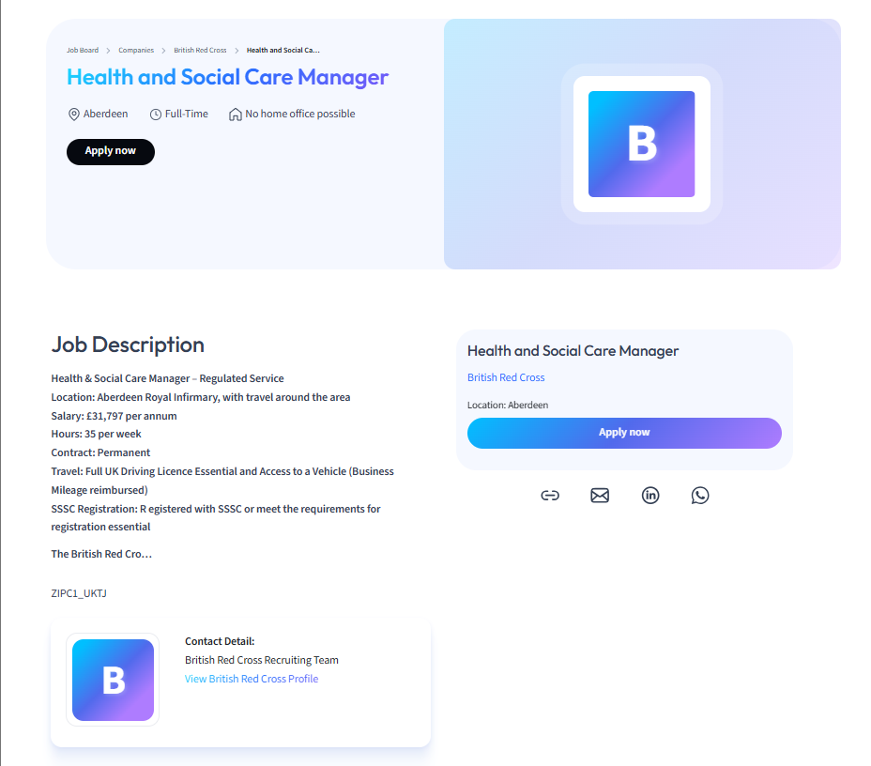
Figure 1: Health and Social Care Manager Vacancy – British Red Cross
(Source:https://talents.studysmarter.co.uk/companies/british-red-cross/health-and-social-care-manager-11455727/?utm_campaign=google_jobs_apply&utm_source=google_jobs_apply&utm_medium=organic, 2026 )
The vacancy identifies a number of key tasks such as staff management, organisation of the work of the healthcare facilities and adherence to the rules of professional activities. Professional accreditation is also significant in the healthcare management roles, as the role also entails travelling to the service points and registering with the Scottish Social Services Council (SSSC).
The models of integrated services are more and more utilised in health and social care and are used to integrate healthcare and social services to enhance patient outcomes and service effectiveness (Reed et al., 2021). Managers are thus important to make sure that the healthcare professionals work in liaison to provide coherent care services.
The vacancy also underscores the protection of duties in a way that those vulnerable people who are getting care services are not hurt or neglected. The practises of safeguarding play a central role in health and social care settings, as they safeguard and maintain ethical practises of services and protect service users (Chambers et al., 2021).

Employability Skills Required for the Role
Health and social care managers require a broad set of employability skills to manage services and support healthcare teams effectively. The concepts of employability skills outline the abilities and qualities that allow people to work effectively in the professional setting (Hussain, 2023). In the health and social care sector, these skills are needed in the area of coordination of services, staff support and high standards of service delivery.
Among the health and social care managerial skills that are most essential is leadership. Managers have a role to lead the healthcare teams to control the service delivery, as well as to make sure that organisational goals are fulfilled. Good leadership also assists organisations in reacting to complicated healthcare obstacles and organisational change (Curry et al., 2022).
Communication skills are also vital since the managers would have to communicate with healthcare professionals, service users and family members. Effective communication ensures that the teams in the healthcare work together and that the service users get accurate information regarding their care. (Reith-Hall, 2022).
In healthcare, teamwork and collaboration are core since patient care involves the use of several professionals, such as doctors, nurses and social workers, in order to coordinate with each other. The interdisciplinary collaboration of teams will lead to the improvement of service coordination and patient outcomes because it will allow professionals to exchange their knowledge and pursue shared objectives (Bendowska and Baum, 2023).
Another major principle in health and social care management is person-centred care. This will make sure that the healthcare services are centred on the needs, preferences and dignity of service users. Person-centred care models encourage healthcare practitioners to engage service users in the decision-making process and provide care that is responsive to the situations of individuals (McCormack et al., 2021).
EI is also the factor that makes good leadership in healthcare organisations possible. High emotional intelligence of managers helps them in better comprehending the feelings of the staff and service users, thereby ensuring positive relationships in the workplace and enhanced organisational performance (Awe et al., 2023).
The ability to make decisions is also necessary since healthcare managers are often required to make decisions that are complex in nature, in terms of service delivery, allocation of resources and organisational strategy (Khosravi et al., 2024).
Table 1: Key Employability Skills for Health and Social Care Managers
Skill | Importance
Leadership | Managing healthcare teams
Communication | Coordinating services and staff
Teamwork | Collaboration among professionals
Person-centred care | Improving patient outcomes
Emotional intelligence | Supporting staff wellbeing
Decision-making | Managing complex organisational challenges

Self-Evaluation of Current Skills
Evaluating personal skills in relation to the requirements of the Health and Social Care Manager role provides an opportunity to identify strengths and areas for improvement. Knowledge of healthcare policy can be significant to future managers since the policies determine the way services will be provided and structured within the United Kingdom (Aujla et al., 2023).
One of the most important strengths that I gained in the course of academic activities and group projects is communication skills. Being part of collaborative learning activities has improved the skill of sharing ideas effectively and cooperating with other people. Healthcare managers should have communication as a key skill as they have to organise the services and give clear directions to employees.
Academic group assignments have also enabled teamwork skills. These experiences highlight the importance of teamwork in healthcare. Teamwork facilitates effective collaboration among healthcare professionals to pool their knowledge and provide holistic care services.
However, the field of leadership experience is one that has to be developed. Although academic research offers one the theory of leadership, leadership practise is required to gain confidence and management skills. The healthcare managers should control personnel and address issues within the work environment, and see to it that services run smoothly.
Experience in the health care environment would be an eye-opener to service provision and organisational procedures. Part-time and volunteering activities in medical institutions might thus contribute to the acquisition of the practical skills necessary to work in management positions in healthcare.

Personal Brand
Personal branding can be defined as the manner in which individuals market themselves to other people in the line of work and career that they are interested in. This is the reason in the health and social care sector, building a good personal brand is significant as employers are interested in hiring professionals who can demonstrate their competence, ethical responsibility and commitment to high-quality care services. The presence of a personal brand makes people identify themselves to their prospective employers in terms of professionalism and special skills.
In the case of an ambitious Health and Social Care Manager, a personal brand must demonstrate leadership and skill, as well as a human trait of care and devotion to person-centred care. These values show that the professional will uphold the well-being and dignity of the service users and, at the same time, promote effective service delivery. The use of person-centred healthcare methods highlights the need to respect the individual needs and to engage the patients in making decisions about the care (McCormack et al., 2021).
An additional factor that may involve the development of personal branding may be developing a professional online identity using LinkedIn and participating in constant professional growth. Through such activities, people are able to present their capacity, experiences and professional success to employers.

Professional Identity
Professional identity can be defined as the values, behaviours, and professional standards that define the way people view themselves and are identified in their profession. Professional identity, in the health and social care industry, is achieved through both educational and professional training and work experiences. It affects the interaction of professionals with their colleagues, service users, and organisations in the healthcare setting.
To be a Health and Social Care Manager, one should strive to build a good professional identity since the position will demand leadership, ethical accountability and responsibility. To keep the trust in healthcare organisations, managers should be able to prove their professionalism in decision-making, communication and service delivery.
The process of professional identity formation is common in higher education, where learners acquire knowledge, skills and professional values that relate to their profession of choice (Tomlinson and Jackson, 2021). Academic education and real-world experiences have a way of developing the competencies needed to practise professionally.
Proper professional identity can thus help healthcare managers to undertake their responsibilities well without compromising ethical principles and offering quality health and social care services.

Networking for Successful Employment
Professional networking is relevant to the enhancement of career and employment opportunities in the health and social care sector. Networking entails making professional contacts with people who are able to offer advice, knowledge and career. In health facilities, networking enables the professionals to share knowledge, learn about job opportunities and understand the practises in the industry.
The process of building professional networks may include contact with lecturers, healthcare professionals, industry organisations and other students. Such relationships can assist people in getting critical tips on career pathways and professional development. Networking also enables people to be informed of the existing developments in the health and social care sector and be aware of possible employment opportunities.
Professional networking via online platforms like LinkedIn has gained significance in the professional networking profession since one can now network with other professionals and organisations in the healthcare sector. Career opportunities can thus be enhanced by creating good working networks and facilitating the eventual development in the long run profession.

Action Plan and Timeline
The role of Health and Social Care Manager is a role that needs to be planned in terms of career; there must be constant development of professionalism and gaining of hands-on experience in the healthcare settings to be able to hold the position. The competencies that would be developed in this position include enhancing leadership, organisational and communication knowledge and experience in the workplace setting of healthcare services provision. The strategies of workforce development have been identified as significant strategies to enhance participation and career advancement among the workforce in health and social care (Hussain, 2023). Thus, a definite action plan may help the gradual acquisition of professional skills needed to work in management.
The initial phase of the career development plan is related to the acquisition of practical experience in the health and social care settings. Part-time work or volunteering in care organisations gives a chance to learn the process of delivering services and to gain communication skills and teamwork. Real-life experience can also enable one to note the leadership practises in healthcare organisations.
The second phase will be to reinforce leadership and management skills through professional training programmes. Knowledge that could be used in the supervisory role can be developed through leadership training, safeguarding courses and healthcare management workshops. Continuous professional development, which these learning opportunities help with, is another factor that is critical in career development in healthcare organisations.
Another significant factor of career development is establishing a professional network. The healthcare professionals, such as lecturers and industry organisations, would also offer guidance and support, as well as raise awareness of the job opportunities in the sector. The individuals may also use professional networking sites like LinkedIn to enable them to create networks with healthcare professionals and organisations.
Lastly, supervisory experience in healthcare organisations will equip individuals with a management role. An advance to the junior level of management also enables professionals to acquire leadership experience and the ability to make decisions in an organisation. Training on quality improvement is useful as well since, in many cases, healthcare organisations carry out improvement programmes to improve service provision and patient outcomes (Russ et al., 2023). The plan of action is as shown in the following timeline that will help achieve the objective of becoming a Health and Social Care Manager within five years.

Table 2: Five-Year Career Development Timeline
Year | Development Focus | Activities | Expected Outcome
Year 1 | Healthcare exposure | Volunteer in care homes, community health centres or support organisations | Basic understanding of care service delivery and patient interaction
Year 2 | Skill development | Complete short courses in safeguarding, communication and health and social care management. | Improved professional knowledge and employability skills
Year 3 | Leadership preparation | Attend leadership and management training programmes and participate in professional workshops. | Development of leadership and decision-making skills
Year 4 | Supervisory experience | Apply for senior care worker or team leader roles within healthcare organisations. | Practical management experience and team supervision
Year 5 | Career advancement | Apply for Health and Social Care Manager positions and continue professional training. | Achievement of a management role within the health and social care sector
.

Conclusion
The number of employability skills required to perform the Health and Social Care Manager role is great because it implies leadership, communication, teamwork and decision-making. The examination of the British Red Cross job advertisement proves that managers have to organise healthcare delivery, control employees, and maintain their adherence to professional norms.
Self-assessment implies that the level of academic knowledge and communication skills is a good basis for career advancement in the future. Nevertheless, the practical work on leadership and the opportunity to obtain professional networking will be crucial in training towards the healthcare management tasks.
Professional identity and personal brand are two potential areas that could help improve employability in the health and social care sector. The competencies to attain the management position in the healthcare organisations can be obtained through the constant professional development, practical practise and career plans.

References
Aujla, N., Frost, H., Guthrie, B., Hanratty, B., Kaner, E., O'Donnell, A., Ogden, M.E., Pain, H.G., Shenkin, S.D. and Mercer, S.W. (2023). A comparative overview of health and social care policy for older people in England and Scotland, United Kingdom (UK). Health Policy, 132, p.104814.
Awe, A.O., David-Olawade, A.C., Ayodele-Awe, I., Feng, H., Odetayo, A., Afolalu, T.D., Ladan, H. and Olawade, D.B. (2023). Predictors and influencing factors of emotional intelligence among nurses in the North East England, United Kingdom. Journal of Education and Health Promotion, 12(1), p.236.
Bendowska, A. and Baum, E. (2023). The significance of cooperation in interdisciplinary health care teams as perceived by Polish medical students. International journal of environmental research and public health, 20(2), p.954.
Chambers, D., Cantrell, A. and Booth, A. (2021). Recognition of risk and prevention in safeguarding of children and young people: a mapping review and component analysis of service development interventions aimed at health and social care professionals. BMC Health Services Research, 21(1), p.1241.
Curry, L., Ayedun, A., Cherlin, E., Taylor, B., Castle-Clarke, S. and Linnander, E. (2022). The role of leadership in times of systems disruption: a qualitative study of health and social care integration. BMJ open, 12(5), p.e054847.
Hussain, M. (2023). A review of the implementation of employability interventions through employers to increase entrants into adult social care in Scotland.
Khosravi, M., Zare, Z., Mojtabaeian, S.M. and Izadi, R. (2024). Artificial intelligence and decision-making in healthcare: a thematic analysis of a systematic review of reviews. Health services research and managerial epidemiology, 11, p.23333928241234863.
McCormack, B., McCance, T., Bulley, C., Brown, D., McMillan, A. and Martin, S. eds. (2021). Fundamentals of person-centred healthcare practice. John Wiley & Sons.
Reed, S., Oung, C., Davies, J., Dayan, M. and Scobie, S. (2021). Integrating health and social care. Nuffield Trust: London, UK.
Reith-Hall, E. (2022). The teaching and learning of communication skills for social work students: a realist synthesis protocol. Systematic Reviews, 11(1), p.266.
Russ, S.J., Green, J., de Winter, L., Herrington, E., Hughes-Hallett, A., Taylor, J.M. and Sevdalis, N. (2023). An introduction to quality improvement. Journal of Clinical Urology, p.20514158221075405.
Tomlinson, M. and Jackson, D. (2021). Professional identity formation in contemporary higher education students. Studies in Higher Education, 46(4), pp.885-900.

