This chapter presents an analysis of the data collected through a survey, aimed at addressing the central research question: ‘A look into how police investigations of Rape and Serious Sexual Assaults prioritise victims’.

This question is grounded in growing public, academic and institutional concern about the way victims of sexual violence experience the criminal justice process; particularly in the early investigative stages. Victim-centered policing has become a key principle in national guidance and police documents, yet concerns persist regarding how this is implemented into operational practice. By capturing the views and experiences of front line officers who are directly involved in RASSO investigations, this study provides insight into how officers perceive, understand and implement victim prioritisation within real-time constraints.

This survey data offers a valuable insight into current attitudes, perceived barriers and routine practices within RASSO investigations. The analysis that follows is structured thematically, highlighting how officers balance investigative priorities with victim welfare, the extent to which procedural justice is maintained, and how institutional and cultural factors influence frontline decision making. These findings are interpreted in relation to the principles of trauma-informed policing and existing literature on institutional responses to sexual violence. My survey has used a variety of questions such as the Likert-scale to allow for trend analysis across the sample group, as well as open-text responses to provide a deeper insight into the reasoning and attitudes behind investigative decision making. The respondent group was made up of 24 participants which have all provided valuable, and confidential data into a summary of themes which I will further detail and expand on the findings below. The sample group consisted of mostly police officers, 3 detectives in specialised departments, and the remainder were supervisors of the rank Sargeant or above.

Officer bias toward victim credibility
One of the primary themes emerging from the survey responses was the presence of varied perceptions among officers regarding the credibility of the victims reporting RASSO cases. A significant portion of respondents highlighted that implicit biases sometimes influence how they assess the initial credibility of complainants. Several officers indicated that factor’s such as the victims engagement, social stigma surrounding false allegations of RASSO and inconsistencies in a survivors account could affect investigative priorities. For example, when participants were asked to rate on a scale of 1 to 5 the statement ‘some victims lie or embellish the truth for personal gain’ (1 being strongly disagree and 5 strongly agree), only 30.4% of participants stated that they disagreed with this statement however 26.1% agreed whilst a further 39.1% remained neutral which in interpretation leans towards the bias that majority of respondents felt that allegations of RASSO are reported by victims for personal gain. Further to this, respondents were provided with the statement of ‘false allegations of rape are common’ to which a total of 26.1% either disagreed or strongly disagreed, with a total of 30.4% either agreeing or disagreeing and nearly half of respondents (43.5%) remained neutral to this statement.

Further to this, when asked if participants have ever witnessed bias by a colleague into a RASSO investigation, majority of the respondents (15 people) stated “no”, whilst 23% stating that they have. This question gave participants selecting “yes” to the question to further expand in free text to help identify the biases that have been witnessed. A common theme to these responses were down to the sexual history of a complainant with one response stating “I have noticed in cases where the victims are sex workers, some officers will form a preconceived idea that it is unlikely it has happened the way they have reported and is often because they haven't been paid etc.” as well as the level of intoxication of the complainant at the time of the offence with another participant reporting that “I have before witnessed officers outright refuse to believe an alleged victims account purely due to their level of intoxication…”. Whilst some officers have witnessed officer bias towards a victim based on their level of intoxication, and therefore the early decision making on prioritising these cases as unreliable, an earlier question posed on whether respondents agreed or disagreed with the statement that ‘intoxication through drink and/or drugs reduces the credibility of a victims allegation’ proved that more than half (73.9%) either disagreed or strongly disagreed with this statement.

These findings corelate with existing literature on victim credibility bias, highlighting how such perceptions can impact the progression and prioritisation of investigations. This part of the survey data suggest that while many officers strive for impartiality, structural and cultural factors within policing may inadvertently provide scepticism towards a victims report.

Resource Demands and Challenges in Investigations
Another significant theme identified in this survey related to the practical constraints officers face when investigating RASSO cases. Majority of survey participants agreed that limitations within the job – including low staffing resources, lack of funding into specialised departments to manage and investigate RASSO cases, as well as other competing policing priorities – as being key barriers that hinder the early evidence gathering and victim confidence in providing a thorough investigation. 81.9% of respondents agreed that low resourcing contributes to the challenges faced by front line officers in gathering the appropriate Golden Hour enquiries with a further 76.2% agreeing that officers are unable to provide adequate care and time with a victim at the point of initial contact due to other policing demands. A low 9.5% of respondents felt that this was not the case, however those who disagreed with this were from specialist departments such as detectives within the Rape Investigation Team who do not have the challenges of other real-time emergency calls that require prioritisation.

Furthermore, only 4.8% of respondents felt that front line teams of officers were young and inexperienced, and lacked the knowledge that is required in dealing with RASSO cases. Majority of respondents strongly agreed that this is a major contributing factor into victim attrition and early evidence gathering to secure a case.

These responses highlight systemic challenges within policing structures that can contribute to delays, attrition, and inconsistent investigative quality. The data underscores the need for dedicated resources and specialist teams to manage the unique demands of RASSO cases effectively.

Training to Investigate RASSO Cases

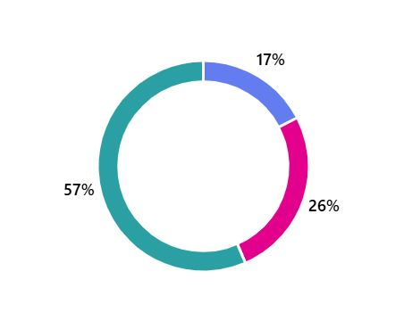
Training emerged as a critical factor influencing officers’ confidence and competence in handling RASSO investigations. Survey results indicated variability in the extent and quality of training received, with some officers reporting comprehensive specialist training, whilst others described minimal or outdated training. One officer shared “Training is basic and has no practical exercises for officers to attempt to deal with victims of the offences or on how to actually gain the evidence required to obtain convictions. Training is purely PowerPoint led and we are told just read the instructions on the packet of an EEK (Early Evidence Kit)”, which appeared to be a common recollection of respondents experiences of their initial RASSO input. Those who detailed more thorough training, were officers who had either independently sought further training, or who were given specialised training as part of their role in dedicated departments.

The sample pool of respondents were asked how they would rate their experience of RASSO input during initial training, which scored an overall average score of only 2.35.

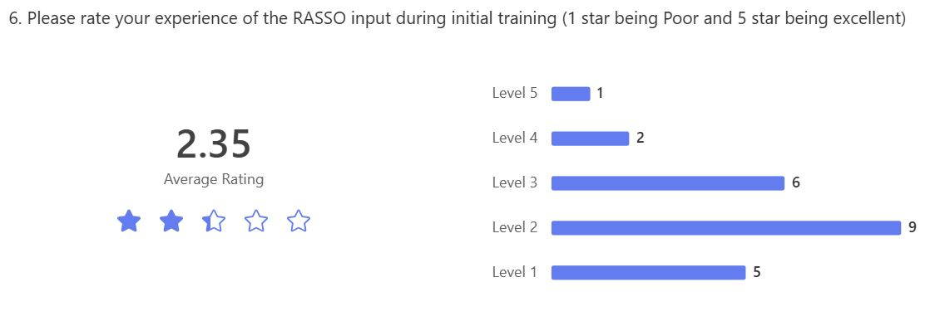

This theme reflects a broader concern about the adequacy of training programs to equip officers with the skills needed for sensitive interviewing, evidence collection, and victim support. The findings suggest that enhancing specialised training could improve investigative outcomes and victim experiences.

Understanding of National Policy and Trauma Informed Approaches

Findings indicate that frontline officer’s understanding of national policies such as Operation Soteria Bluestone and broader RASSO national police is inconsistent. While supervisory and senior leaders who participated in this survey were generally aware of policy goals – such as suspect-focused and victim-centered approach – this understanding is not always effectively communicated or even embedded at an operational level. Many officers remain unclear about what a “suspect-focused” investigation entails and when asked if their training to date was delivered as a “victim-focused approach” - which is an investigative method which tests the credibility of the victim rather than focuses on the tactics used by a perpetrator in carrying out their abuse - 48% answered yes with a further 26% being unsure which indicates that their training has been basic and unable to support officers in identifying the difference between “victim-focused” and “victim-centered”.
Whilst 73.9% of respondents stated that they recognised RASSO as being a national policing priority, only 8 respondents stated that they were aware of Operation Soteria Bluestone; majority of these 8 were again from specialised departments who had also selected that they had received further and more specialized training into RASSO investigations.
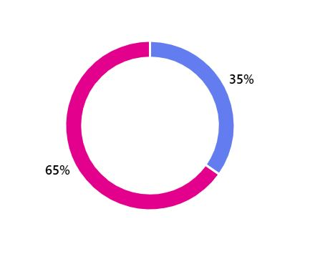

This highlights that even where officers are aware of national principles, findings show a disconnect between understanding and consistent application of policy. Victim credibility continues to be scrutinised early on in an investigation, despite national policy guidance discouraging this, and that investigations remain reactive and victim-led rather than proactively targeting suspect behaviour and patterns. This suggests that policy principles are not fully integrated into routine investigation decision making.

Whilst Operation Soteria Bluestone sets out a clear national vision for improving RASSO investigations, frontline officer training and understanding remains inconsistent. In order to close the gap between policy and practice, these results highlight the needs for a standard and mandatory RASSO training which aligns with national strategy, given across all 43 UK police forces, and that there needs to be a greater emphasis on cultural change and trauma informed methods. Without these, the potential impact of national policy will continue to be limited at ground level.

Participants were asked to rank in order what they individually believed to be the reasons why victims/survivors of RASSO do not report to police; these findings showed an understanding by officers that majority felt the barriers to reporting was down to not being believed (highest ranking first choice), and through a generalised lack of trust in the criminal justice system and police. Many participants placed perpetrator influence and control over the victim, as well as trauma and self-blame lower ranking than the faith in the police.

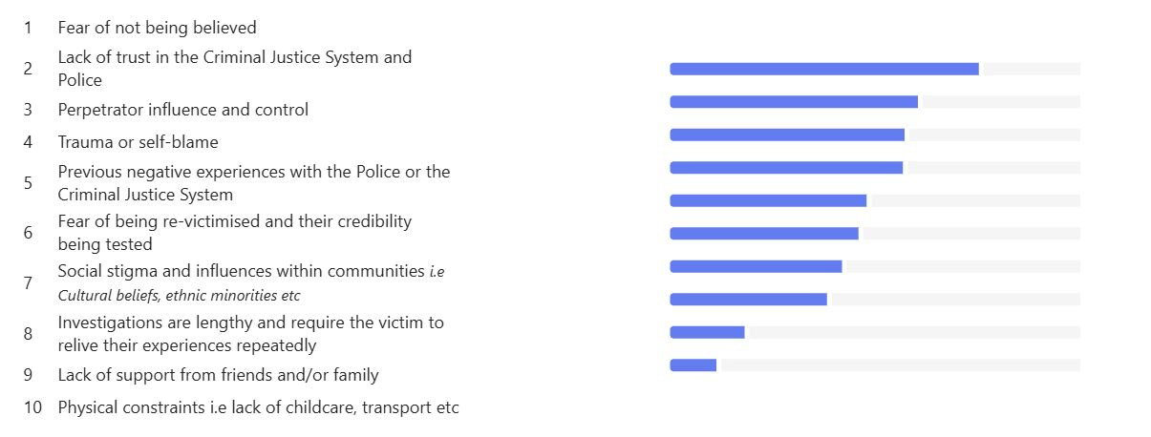
The decision for a victim not to report RASSO is very rarely down to a single contributing factor and these results show that until police forces address these barriers to reporting, there is a strong demand for structural reform and cultural change in policy to ensure that officers are trauma-informed and can offer this level of support at every stage throughout the investigation in order to maintain victim engagement.

Conclusion

The results of this analysis show that police forces are making progress, but significant work remains to ensure that national RASSO policy is embedded in day to day practice. Officers at all levels are working in complex environments with increasing operational demands, yet are not always adequately supported to meet the expectations as set out in Operation Soteria Bluestone.

Many investigations still place weight on victim credibility and willingness to pursue a case, rather than focusing on suspect behaviour, patterns and evidenced based decision making. This approach continues to attribute to low victim engagement, reduced reporting and high levels of victim attrition.

I have identified through my research that in order to deliver a consistently high standard of RASSO investigation, police forces must:
- Embed consistent and mandatory RASSO training across all ranks, ensuring it is aligned with national standards and operational guidance
- Implement more resourcing and funding into specialist roles and departments to ensure continuity and victim relationship building for higher engagement rates
- Ensure officers receive trauma-informed led training to shift the cultural change in officer bias

Overall, effective RASSO investigations require more than procedural compliance; they demand a shift in culture, practice and mindset. Police play a central role in driving that change and by embedding national standards consistently across all teams is essential to restoring public confidence and delivering justice for victims.

