University Of Wales Trinity Saint David

Module: Cloud Computing Architecture acca5025
Lecturer: Suneth Fernando. Student name: Asan Rafail Student number: 2112905 Submission deadline: 03.05.2023

Assignment 2:
Practical

Table of Contents
Introduction 2
1. Virtual Hard Drives 2
2. Creating and Managing Azure VMs 2
3. vNets 2
3.1 What is vNets in Azure 3
3.2 Benefits of vNets 3
3.3 vNets Features 4
4. Network Security Groups 4
4.1 NSG in Azure 5
4.2 Benefits and Features of NSG in Azure 5
4.3 How do NSG work in Azure 6
5. Use of Images in Azure 6
5.1 Benefits of Images in Azure 8
5.2 How Images are used in Azure 8
Conclusion 9
Reference: 11
‌ 11

Figure 1 Virtual machines and Virtual Networks have been created 3
Figure 2 Choosing a disk 7
Figure 3 Created virtual machine 7
Figure 4 Ping between the virtual machines 8

Introduction

Users may construct and operate virtual machines (VMs) in the cloud using the Azure cloud computing platform. Virtual servers called Azure VMs may be used to host a wide range of programmes and services. This post will cover the resources connected to an Azure VM, the creation and management process, as well as the function of vNets and Network Security Groups in Azure.

Virtual Hard Drives

The operating system, data, and applications on an Azure VM are all stored on virtual hard drives (VHDs) on this cloud computing platform. VHDs are readily transferred, backed up, and recovered since they are stored in Azure Storage as page blobs. The user has the option to use an existing VHD or construct a new one when establishing an Azure VM [1].

Creating and Managing Azure VMs

Through the Azure Portal, Azure PowerShell, or Azure CLI, Azure VMs can be created and managed. The following steps are commonly involved in building and administering Azure VMs.

Choosing the right VM size, picking an image, setting up the network settings, and defining the storage account and VHD for the VM are all steps in the creation process. There are several distinct VM sizes available in Azure, each with varying CPU, memory, and storage capacities [1].

The user can customise the VM's settings, including the operating system, apps, and data, once it has been created. Users have the option of installing their own software or using pre-configured images from the Azure Marketplace on Windows or Linux-based Azure VMs [1].

The Azure Portal, Azure PowerShell, or Azure CLI may all be used to administer Azure VMs. This comprises operations like starting and stopping the virtual machine (VM), changing its hardware setup, and backing up its data [1].

vNets

A virtual network (vNet) in Azure represents a network connecting Azure VMs and other Azure resources logically. The VMs receive network access through vNets, enabling them to interact with other VMs and services running on the same network. The user can choose the address space, subnets, and gateway settings while constructing a vNet in Azure [2].

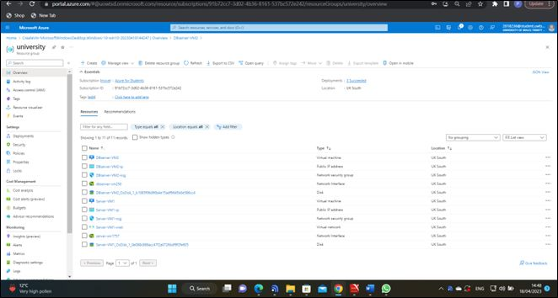
Figure 1 Virtual machines and Virtual Networks have been created

A key element of Azure networking, Azure vNets offer security, segmentation, and isolation for Azure resources. They include capabilities including subnets, virtual network peering, network security groups, and VPN gateways and enable the establishment of private network environments within the Azure cloud. Users may design unique network topologies that satisfy their particular needs and guarantee the security of their Azure resources by utilising vNets [2].

What is vNets in Azure

A software-defined network (SDN) called Azure vNets makes it possible to build private network environments inside the Azure cloud. They enable customers to divide their Azure infrastructure into many subnets, each with its own IP address range, and they offer logical isolation of Azure resources. This segmentation allows for the development of intricate network topologies while enhancing security .

In Azure, vNets are created by specifying a vNet's IP address range and then creating one or more subnets inside of it. Each resource contained within the vNet receives a virtual IP address from Azure automatically. Using their virtual IP addresses, resources within a subnet can communicate with one another [3].

With the help of VPN Gateways or Virtual Network Peering, vNets may be linked to one another or to on-premises networks. To manage inbound and outgoing traffic, network security groups may be applied to vNets, and routing can be adjusted to meet particular needs [3].

Benefits of vNets

Segmentation and logical isolation of Azure resources are provided via vNets, allowing customers to build private network environments inside the Azure cloud.

Security: By separating Azure resources from other resources and the internet, vNets improve the security of those resources [4].

Customization: vNets may be tailored to meet particular needs, including those related to IP address ranges, subnets, and routing [4].

Network connectivity is flexible because to vNets' ability to link to other vNets, on-premises networks, and the internet [4].

vNets Features

Subnets: vNets can be split up into several subnets, each with a unique set of IP addresses. This maintains network isolation while enabling communication between resources inside a vNet [5].

Peering across a virtual network allows vNets to communicate with one another. Resources from various vNets may now connect with one another as if they were on the same network thanks to this [5].

Network Security Groups: To manage inbound and outgoing traffic, vNets may be configured with Network Security Groups (NSGs). Security rules in NSGs have the power to accept or reject communication depending on its IP address, port number, and protocol [5].

A virtual private network (VPN) gateway is a device that connects a virtual network (vNet) to an on-premises network or another virtual network (vNet). This makes it possible for resources in various networks to communicate securely [5].

Network Security Groups

Network traffic to and from Azure VMs is managed by Network Security Groups (NSGs) in Azure. NSGs function as a firewall, permitting or blocking traffic in accordance with user-defined rules. Through the Azure Portal, Azure PowerShell, or Azure CLI, NSGs can be created and managed. The user can select the source and destination IP addresses, ports, and protocols that are approved or disapproved while building an NSG [6].

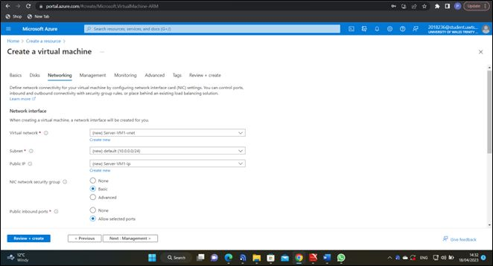

A crucial element of network security in Azure is Network Security Groups (NSGs), which offer fine-grained control over incoming and outgoing traffic to Azure resources. We will go through the advantages, functionality, and operation of NSGs in Azure in further depth in this study.

NSG in Azure

Network Security Groups (NSGs) are a security feature in Azure that gives resources access to network traffic management. NSGs are a set of security rules that specify how IP address, port number, and protocol-based incoming and outgoing traffic should be permitted or prohibited. Azure resources including virtual machines, load balancers, and virtual network interfaces may use NSGs [6].

Benefits and Features of NSG in Azure

Granular control: NSGs give customers the ability to establish particular security policies for each resource by giving them control over inbound and outgoing traffic to Azure services.

Security: NSGs let users manage who has access to Azure resources, preventing unauthorised access [7].

NSGs can assist users in adhering to security regulations like the HIPAA and PCI DSS.

The ability to implement security policies across many resources is made possible by centrally managing NSGs with Azure Resource Manager [7].

Security rules: Based on IP address, port number, and protocol, NSGs specify how inbound and outgoing traffic should be permitted or refused.

NSGs feature default rules that, by default, let outbound traffic and block inward traffic. Users can add more rules as needed to accept inbound traffic.

The sequence in which NSG rules are evaluated is determined by their priority value. Initially, the rule with the highest priority value is assessed [7].

Logging: NSG rules can be set up to record traffic that complies with them. The logs may either be forwarded to Azure Event Hubs for processing or saved in Azure Storage [7].

How do NSG work in Azure

A collection of security rules that specify how inbound and outgoing traffic should be allowed or refused depending on IP address, port number, and protocol are used to construct Network Security Groups in Azure. The Azure resources like virtual machines, load balancers, and virtual network interfaces are then subject to the rules [8].

The NSG rules are prioritised when deciding whether to accept or deny a packet when it arrives at an Azure resource that has an NSG applied to it. The packet is transmitted to the resource if it complies with a rule that permits it. The packet is discarded if it matches a rule that rejects it [8].

Users may manage traffic between resources within a subnet by applying NSGs to subnets within Azure Virtual Networks. By applying NSGs to a virtual machine's virtual network interface that is linked to another virtual network, NSGs may also be used to regulate traffic between virtual networks [8].

A crucial element of network security in Azure is Network Security Groups, which offer fine-grained control over incoming and outgoing traffic to Azure services. Users may regulate access to Azure resources using NSGs, helping to protect them from unauthorised access by defining particular security rules for each resource. Users may comply with security requirements and administer security rules across several resources from a single location by utilising NSGs [8].

Use of Images in Azure

The management of virtual machines and other cloud resources depends heavily on images in Azure. An operating system, a collection of apps, and other software elements are included in preconfigured templates called Azure images. Azure deployment times may be sped up by using predefined images, which also make infrastructure setup and management easier. Other advantages of using Azure images include consistency and flexibility, as standardisation guarantees that VMs and other resources are consistent and configured properly. Additionally, users have the freedom to select the configuration that best suits their needs thanks to the availability of Azure images for a variety of operating systems and software components [9].

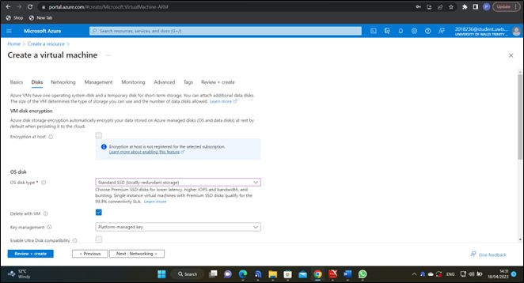
Figure 2 Choosing a disk

As users do not have to manually install and configure software, using prebuilt configurations from Azure images can also lower the cost of deploying and managing VMs in Azure. Overall, Azure images are a crucial tool for building, deploying, and managing virtual machines (VMs) and other cloud resources. They offer efficiency, consistency, flexibility, and cost savings [9].

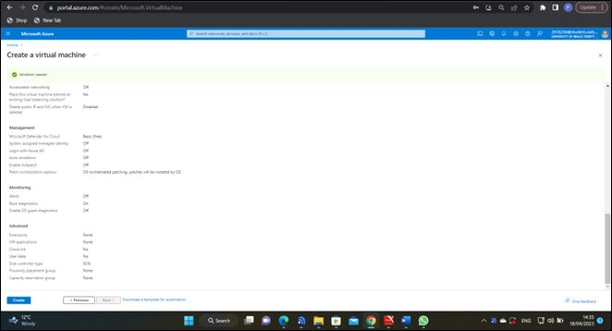
Figure 3 Created virtual machine

Virtual machines (VMs) and other cloud resources may be created, deployed, and managed with ease by using images in Azure. We will describe what pictures are in Azure, their advantages, and how they are utilised in this report.

Images in Azure are predefined templates that include a collection of apps, an operating system (OS), and other software elements. Users may easily deploy and manage their infrastructure in the cloud by using these images to build new VMs, scale sets, and other resources in Azure [10].

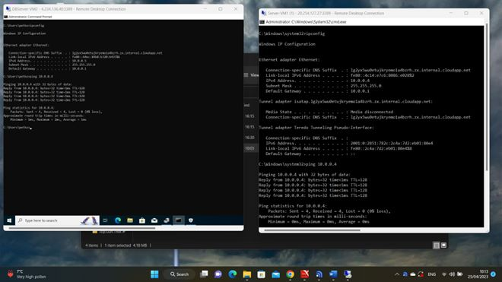
Figure 4 Ping between the virtual machines

Benefits of Images in Azure

Speed and simplicity of deployment: By using pre-set images in Azure, customers may easily deploy virtual machines (VMs) and other resources in the cloud, saving time and effort on infrastructure setup and management.

Consistency: By utilising standardised images, users can be sure that their virtual machines (VMs) and other resources are consistent and set properly, lowering the chance of configuration mistakes and security flaws.

Flexibility: Users have the freedom to select the configuration that best suits their needs thanks to the availability of Azure images for a wide range of operating systems and software components.

Savings: By utilising prebuilt settings rather than having to manually install and configure software, using defined images can assist to lower the cost of installing and operating virtual machines in Azure.

How Images are used in Azure

New VMs and other cloud resources are frequently created using images in Azure. Using an image, users can create a new VM by performing the following steps:

Choose a picture: Users have the option of using a bespoke image they have developed themselves or selecting an image from the Azure Marketplace.

Users may build a new VM using the Azure Portal, Azure CLI, or other tools after choosing an image. Users define the image they wish to use during creation and set additional parameters like VM size, network configuration, and storage.

The VM may be customised once it has been established by adding software, adjusting settings, and carrying out other actions as necessary.

Save the VM as an image: After it has been set up, users can save the VM as a fresh image that can be used to build future instances of the virtual machine or other resources.

Images in Azure may be used to build scale sets, which are groupings of VMs that can be scaled up or down in response to demand, in addition to building new virtual machines. Users may rapidly and simply deploy and manage many VMs in the cloud by leveraging images to create scale sets.

Conclusion

The usage of virtual hard drives, virtual networks, network security groups, and pictures, as well as other elements of establishing and maintaining virtual machines and resources in Azure, have all been covered in this paper.

In the last section, we learned how virtual hard drives in Azure are used as the storage for virtual machines (VMs) and how to build and manage them using the Azure Portal, PowerShell, or Azure CLI. The paper also covered the advantages of Azure's several virtual hard drive kinds, including regular and premium discs.

The next topic we covered was virtual networks, which let users link and separate their VMs and other Azure services. To set up the network settings for virtual machines (VMs) and other resources, we learnt how to construct and administer virtual networks, subnets, and IP addresses.

Following that, we looked at network security groups, which in Azure are used to provide the inbound and outgoing traffic policies for virtual networks. We have covered the creation and administration of network security groups, their use with VMs and other resources, and how they might enhance cloud security.

Finally, we looked at images in Azure, which are preconfigured templates containing operating systems, applications, and software components. We have discussed how to create and use images in Azure, and how they can help to speed up deployment time, ensure consistency, and reduce costs.

Overall, this report has given an overview of the various Azure features and tools that can be used to build, deploy, and manage virtual machines and other cloud resources. With Azure, users have a flexible and powerful platform for developing and growing their infrastructure, with several options and tools available to fit their needs.

Reference:

[1] J. HU and T. Yamasaki, “Getting Started with Cloud Computing (1); Introduction of Microsoft Azure,” The Journal of the Institute of Image Information and Television Engineers, vol. 69, no. 4, pp. 336–340, 2015, doi: https://doi.org/10.3169/itej.69.336.
[2] M. Armbrust et al., “A view of cloud computing,” Communications of the ACM, vol. 53, no. 4, p. 50, Apr. 2010, doi: https://doi.org/10.1145/1721654.1721672.
[3] J. HU and T. Yamasaki, “Getting Started with Cloud Computing (2); Advance of Microsoft Azure,” The Journal of the Institute of Image Information and Television Engineers, vol. 69, no. 5, pp. 453–456, 2015, doi: https://doi.org/10.3169/itej.69.453.
[4] T. Erl, Zaigham Mahmood, R. Puttini, Dorling Kindersley, and Pearson, Cloud computing : concepts, technology & architecture. Noida: Dorling Kindersley (India, 2018.
[5] R. Jennings, Cloud Computing with the Windows Azure Platform. John Wiley & Sons, 2010.
[6] A. Mazumdar and H. Alharahsheh, “Insights of Trends and Developments in Cloud Computing,” South Asian Research Journal of Engineering and Technology, vol. 01, no. 03, pp. 98–107, Nov. 2019, doi: https://doi.org/10.36346/sarjet.2019.v01i03.003.
[7] F. Jamal, “Emerging Technologies and Developments in Cloud Computing: A Systematic Review,” International Journal of Emerging Trends in Engineering Research, vol. 8, no. 3, pp. 894–905, Mar. 2020, doi: https://doi.org/10.30534/ijeter/2020/46832020.
[8] H. Bai, Zen of Cloud. CRC Press, 2019.
[9] B. The, Cloud Computing - Moving IT Out of the Office. British Informatics Society Ltd, 2012.
[10] K. Milan, “MICROSOFT AZURE - ONE OF THE POSSIBLE WAYS TO VIRTUALIZATION,” Trends in Education, vol. 9, no. 1, pp. 139–147, Jul. 2016, doi: https://doi.org/10.5507/tvv.2016.019.

‌

