

Name | Francisca Lerka Fernandes
Student No. | 2510888
Course Name | CertHE Computing Skills for Workplace
Module Name | Computer Architecture and Operating  Systems

Table of Contents
Introduction 4
Task 1: OS Functions 4
Process Management 4
Memory Management 5
File System Management 6
Device Management 7
User and Security Management 8
Network Management 8
Task 2: Windows Commands 9
Command 1: tasklist 9
Command 2: taskkill 10
Command 3: dir 11
Command 4: mkdir 11
Command 5: copy 12
Command 6: del 12
Command 7: ipconfig 13
Command 8: ping 13
Command 9: netstat 14
Command 10: net user 14
Command 11: whoami 15
Command 12: schtasks 15
Task 3: Linux Commands 16
Command 1: ps 16
Command 2: top 16
Command 3: kill 17
Command 4: ls 17
Command 5: mkdir 18
Command 6: cp 18
Command 7: rm 19
Command 8: ip 19
Command 9: ping 20
Command 10: ss 20
Command 11: whoami 20
Command 12: id 20
Task 4: Windows Scripts 21
Batch Script 1: Simple Calculator 21
Batch Script 2: Folder Existence Checker 22
Task 5: Linux Scripts 23
Bash Script 1: Simple Calculator 23
Bash Script 2: File Existence Checker 25
Conclusion 26
References 27

Introduction
The OS holds an important place in modern computing as it acts as the medium that connects the computer hardware with the user. The OS is involved in managing all system resources, facilitating program execution, and enabling efficient and safe operation of the computers. Commonly utilized OS such as the Microsoft Windows and Linux provide a wide range of features like process management, memory management, file management, and networking [1].
Apart from graphical user interfaces, another important feature provided by operating systems is command line interface (CLI), which helps in interacting with the system through commands in an easier way. Command line interfaces are very helpful in performing system administrator tasks. This paper highlights some of the basic features of an operating system as well as their implementation through command line interfaces on both the Windows and Linux platforms. It also highlights the importance of using scripts for the automation of various tasks.

Task 1: OS Functions
Modern operating systems, including Microsoft Windows and Linux, perform a variety of tasks that are integral to their functioning [1].

Process Management
Process management refers to the ability of the operating system to handle various processes running at the same time. The OS controls and coordinates the process creation, process scheduling, and process termination; it also manages the effective use of CPU time [1]. The Task Manager on a Windows system shows all running processes along with CPU and memory utilization rates, allowing users to keep track of system performance and control its activities. The same way, a Linux operating system provides tools like top and ps commands that allow monitoring processes' performance in real time.
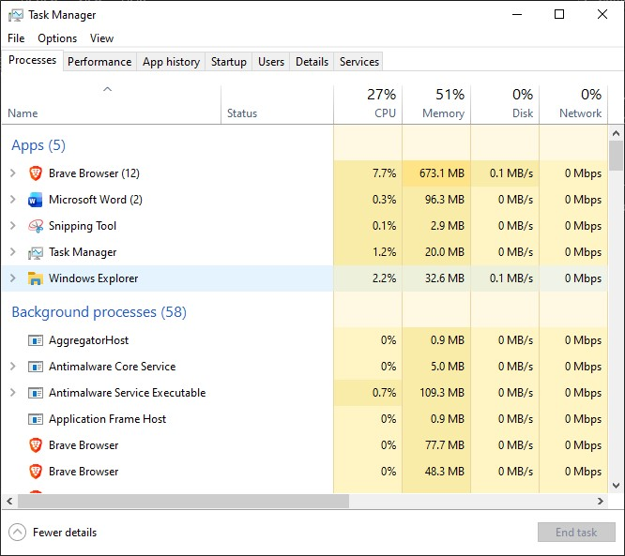
Figure 1 Windows Task Manager showing active processes and CPU usage

Memory Management
Memory Management involves the proper management of system memory (RAM) for various processes. This process makes sure that each process has enough memory assigned while still keeping each process isolated from each other [1]. Memory usage is determined using the Performance tab in the Task Manager for Windows operating systems. In Linux systems, commands like free -h provide comprehensive details on memory usage. Efficient memory management not only improves computer performance but also reduces the chances of system crashes due to insufficient memory.
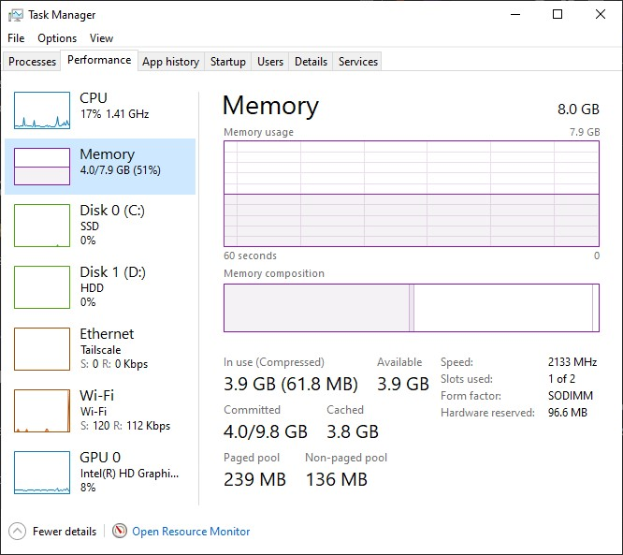
Figure 2Memory usage monitoring in Windows Task Manager

File System Management
The purpose of the file system is to manage data storage on storage media. It controls access rights and ensures data security. It enables users to employ systematic procedures for managing data storage and retrieval operations [2]. File Explorer allows for file and folder manipulation in the Windows operating system through its graphical user interface. Files and folders are managed using commands like ls, cp, and rm in the Linux operating system environment. Proper file system management helps ensure secure storage and easy access to files.
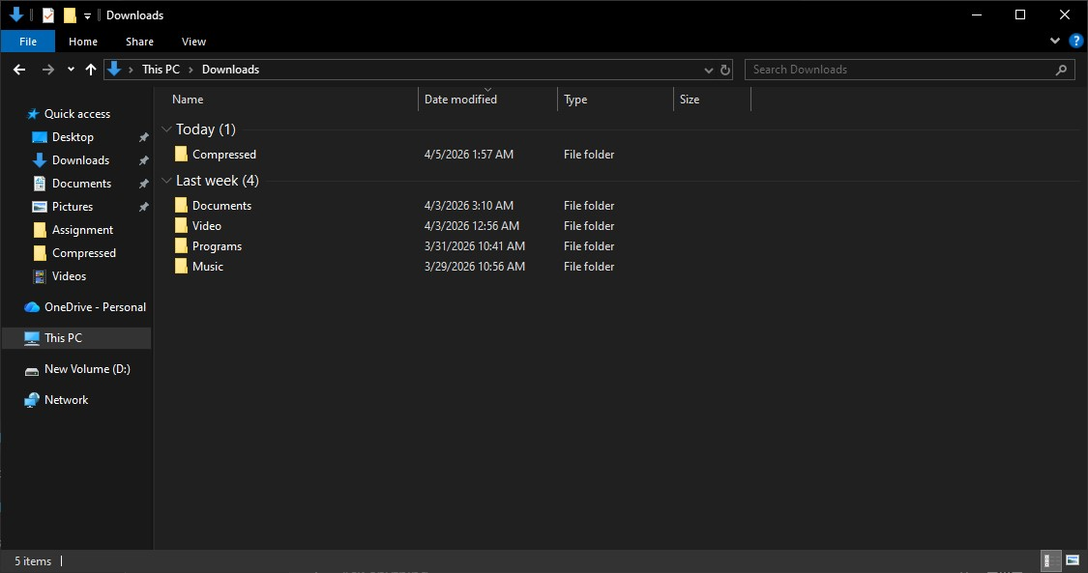
Figure 3File system management using Windows File Explorer

Device Management
Device Management allows the operating system to communicate with the various hardware components such as the printer, keyboard, and disk drive. This is done using device drivers that allow communication between hardware and software [1]. The Device Manager in Windows operating systems provides an integrated way of managing and monitoring hardware devices. The Linux operating system employs kernel modules, along with commands like lsusb and lspci, to manage and detect hardware devices. Proper device management guarantees that hardware is compatible and effectively utilized.
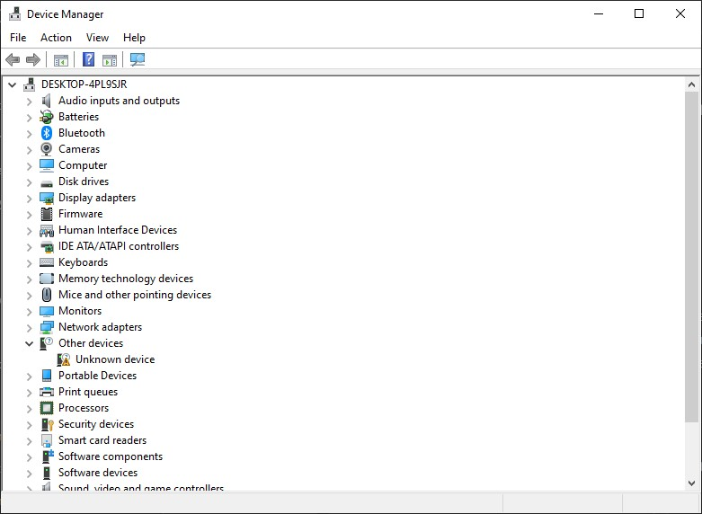
Figure 4Hardware management through Windows Device Manager

User and Security Management
Operating systems provide mechanisms for user authentication and access control to ensure system security. They manage user accounts, enforce permissions, and protect sensitive data from unauthorized access [2]. In Windows, user accounts and permissions can be managed through the Control Panel or Settings application. Linux systems use files such as /etc/passwd and commands like id to manage user information. Security features such as authentication and authorization help maintain system integrity and protect against cyber threats.

Network Management
Network management involves controlling and managing the network connections and communication between devices. It manages the IP configuration and interfaces within the OS to guarantee that there will be no interruption during communication through the network [2]. In Windows, you can use ipconfig command to check the network configuration, while Linux uses ip a and ping for determining the connectivity. Network management is very important in communicating over the internet.
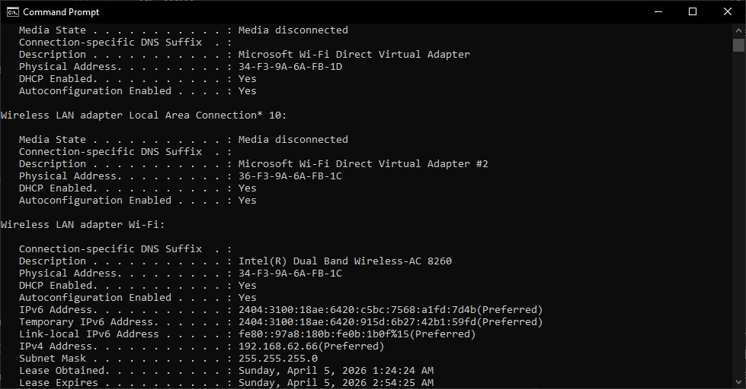
Figure 5Network configuration details using ipconfig command

Task 2: Windows Commands
The Windows Command Line Interface (CLI), available through Command Prompt and PowerShell, provides an efficient interface to work directly with the operating system. It allows you to accomplish many administrative tasks and automate operations effectively. Commands on the command line interface are preferred in system administration for being faster, flexible, and capable of performing complicated tasks using simple syntax [1]. This chapter highlights how important the commands on the Windows CLI are used in many fields such as processes, files, network, users, and scheduling.

Command 1: tasklist
The “tasklist” command provides a list of all the active processes that are currently running within the system. It displays each process ID (PID), its memory usage, and its associated session[3].
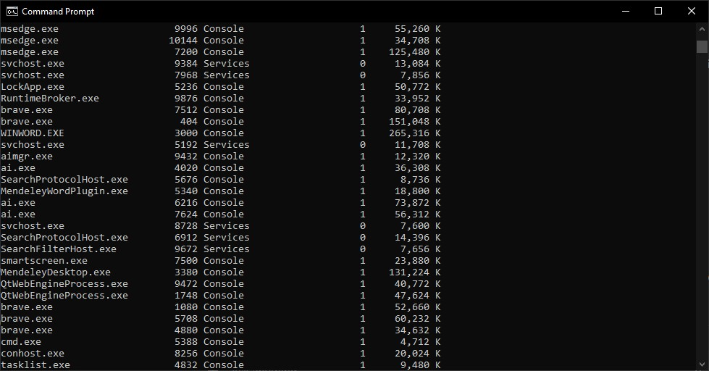
Figure 6 Display of running processes using tasklist command

Command 2: taskkill
The taskkill command has the function of terminating a process based on the Process Identifier (PID). By using the /F flag, you can force the process to end without going through the regular shutdown sequence [3].
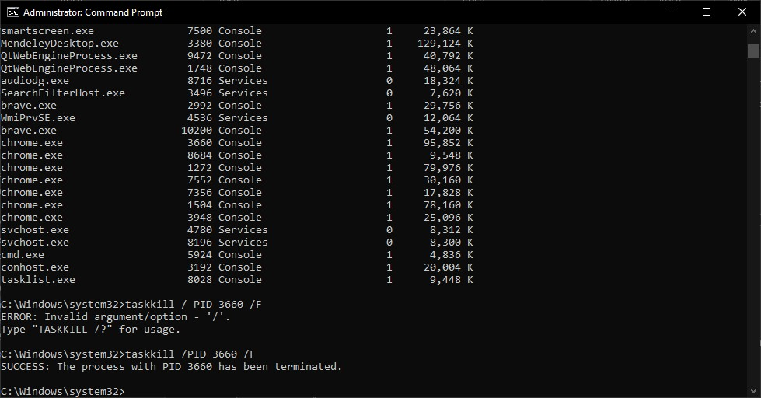
Figure 7 Terminating a process using taskkill with force option

Command 3: dir
Likewise, the dir command can be used to list the files contained in a folder. By specifying the /a option, you will ensure that both hidden and system files are listed [1].
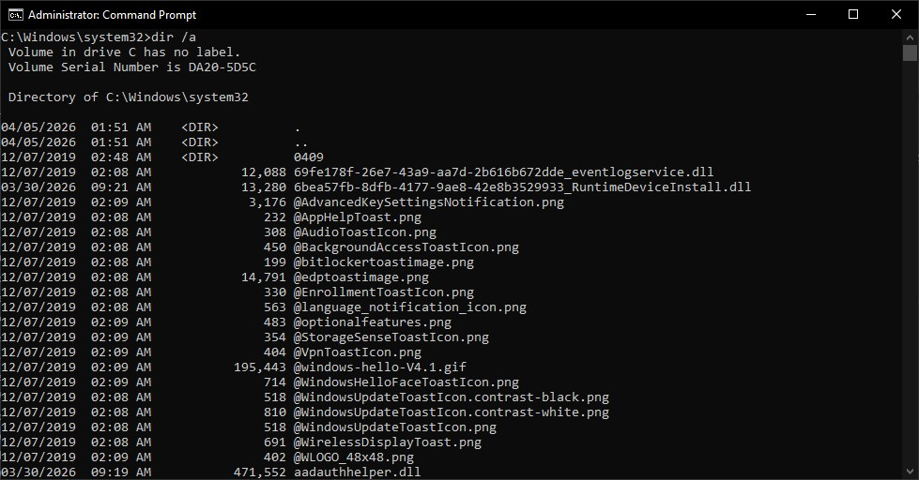
Figure 8 listing all files including hidden files using dir command

Command 4: mkdir
It is used to create a new folder in the present directory.
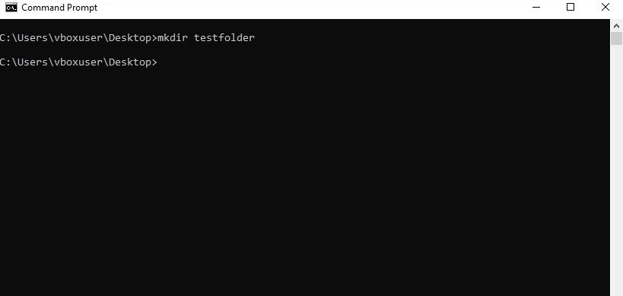
Figure 9 Creating a new directory using mkdir command

Command 5: copy
This command allows users to copy their files from one location to another.
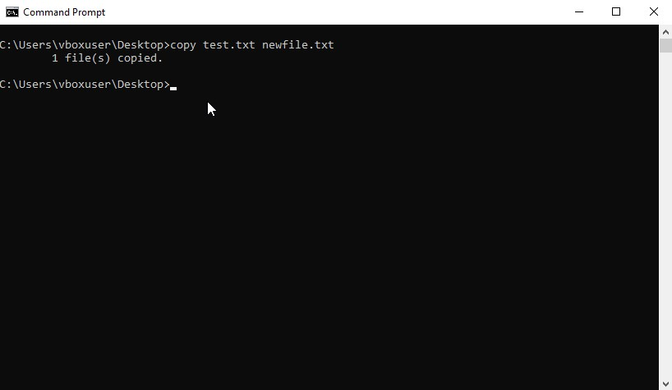
Figure 10 Copying a file using copy command

Command 6: del
The del command deletes files from the system. The /q switch enables quiet mode, suppressing confirmation prompts.
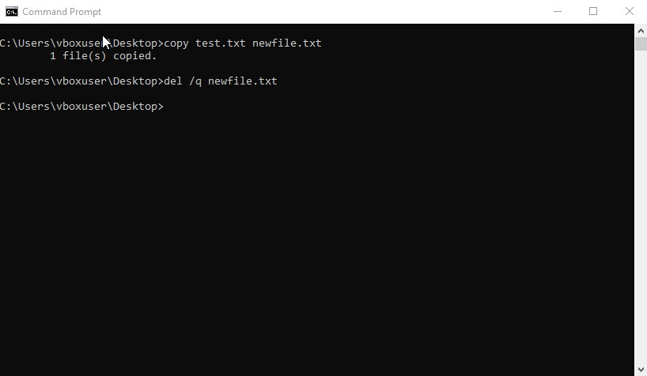
Figure 11 Deleting a file using del command with quiet mode

Command 7: ipconfig
The ipconfig command displays detailed network configuration information, including IP address, subnet mask, and DNS settings [1].
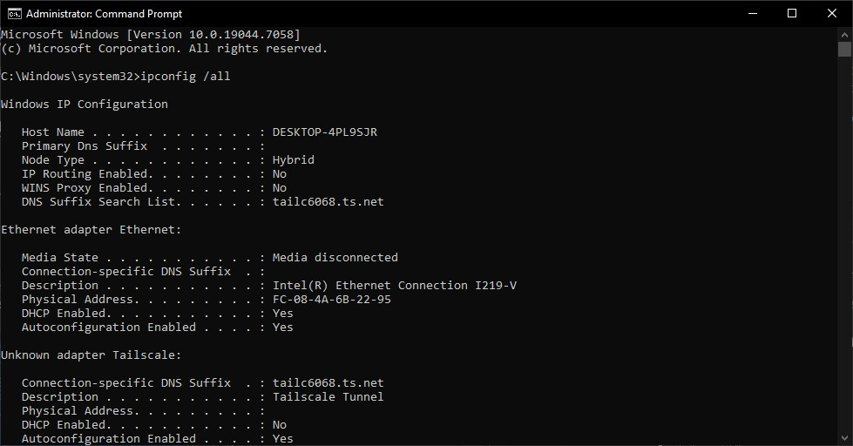
Figure 12 Viewing detailed network configuration using ipconfig command

Command 8: ping
The ping command checks connectivity between the local system and a remote host. The -n 4 option sends four packets.
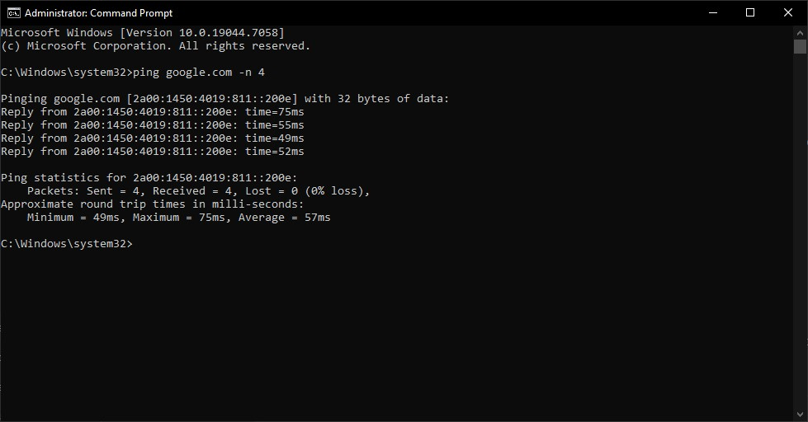
Figure 13 Testing network connectivity using ping command

Command 9: netstat
The netstat command displays active network connections and listening ports. The -ano option shows all connections along with process IDs [3].
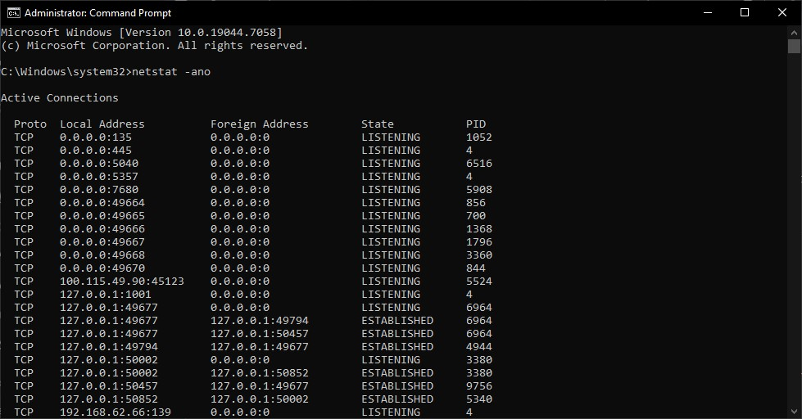
Figure 14 Monitoring active network connections using netstat command

Command 10: net user
The net user command displays all user accounts configured on the system.
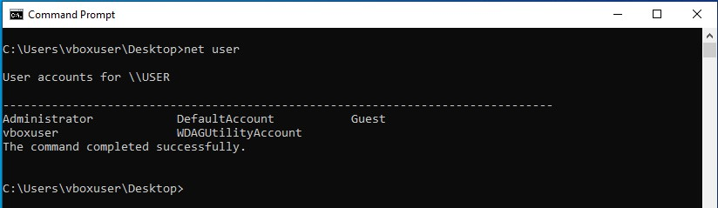
Figure 15 Listing user accounts using net user command

Command 11: whoami
The whoami command displays detailed information about the currently logged-in user, including privileges and security identifiers.
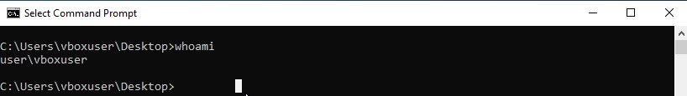
Figure 16 Displaying detailed user identity information using whoami command

Command 12: schtasks
The schtasks command displays all scheduled tasks configured in the system.
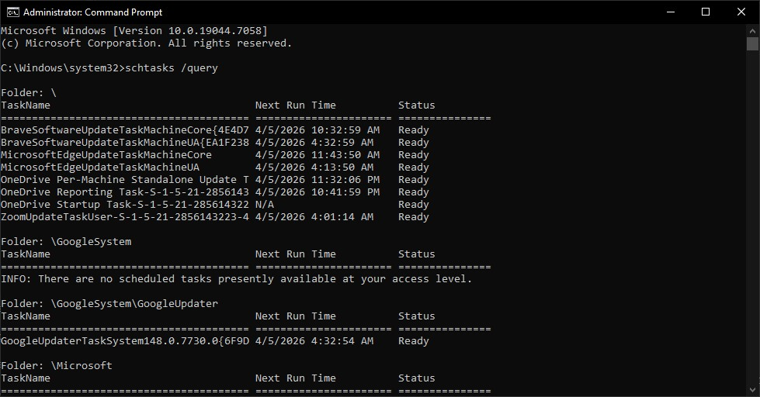
Figure 17 Viewing scheduled tasks using schtasks command

Task 3: Linux Commands
The Linux OS provides a powerful command-line interface (CLI) through the Bash shell, which allows direct interaction with the OS. Unlike GUIs, CLIs offer enhanced control, better performance, and increased flexibility while dealing with various kinds of system functionalities. Linux commands find extensive use in fields such as system administration, networking, and automation, as they can be executed fast and efficiently [2]. This chapter demonstrates the usage of various Linux CLI commands in different sectors including processes, files, networking, users, and task scheduling.

Command 1: ps
The ps command displays information about currently running processes. The aux options show all processes for all users along with detailed information such as CPU and memory usage [4].
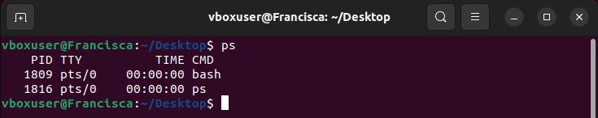
Figure 18 Display of running processes using ps command

Command 2: top
The top command provides real-time monitoring of system processes, including CPU and memory usage.
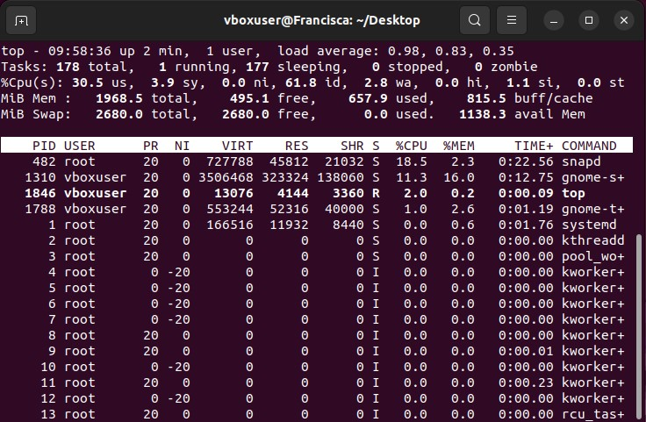
Figure 19 Real-time process monitoring using top command

Command 3: kill
The kill command terminates a process using its Process ID. The -9 option forcefully stops the process.
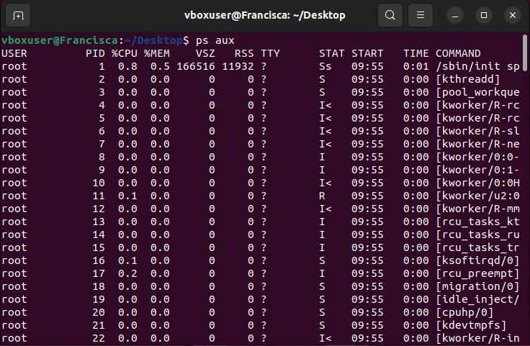
Figure 20 Terminating a process using kill command

Command 4: ls
The ls command lists files and directories. The -la options display detailed information including hidden files.
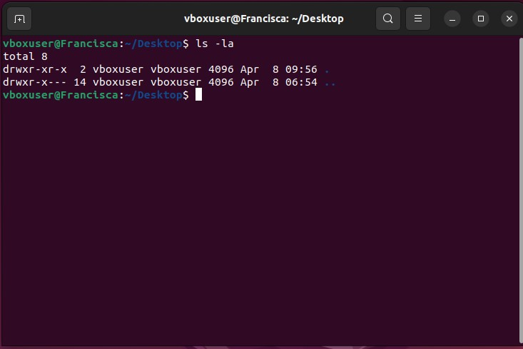
Figure 21 Listing files including hidden files using ls command

Command 5: mkdir
The mkdir command creates a new directory.
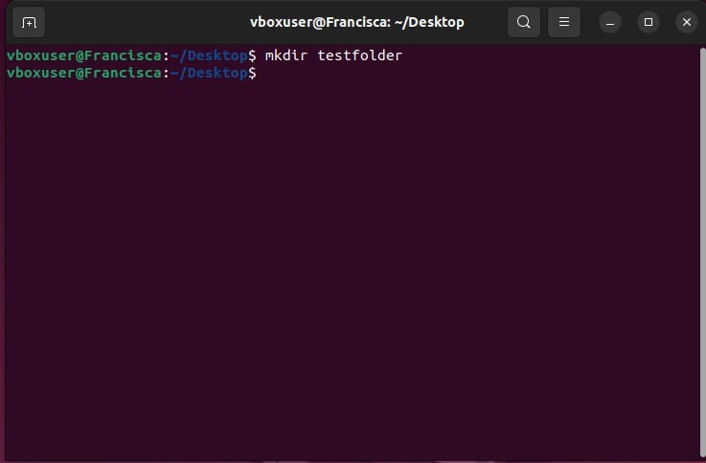
Figure 22 Creating a directory using mkdir command

Command 6: cp
The cp command copies files from one location to another.
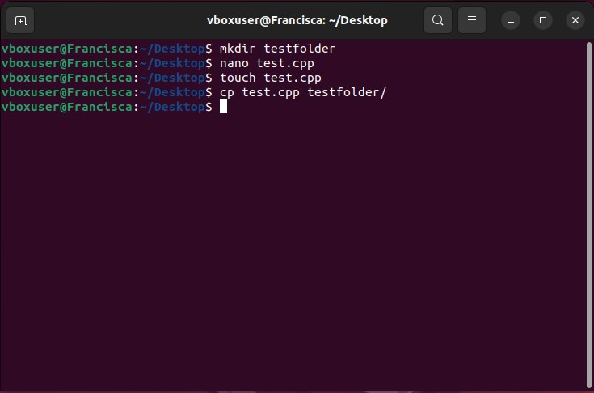
Figure 23 Copying files using cp command

Command 7: rm
The rm command removes files or directories. The -r option enables recursive deletion.
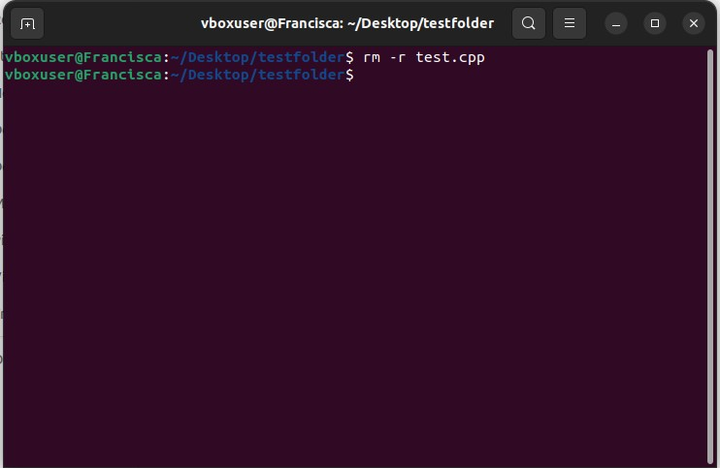
Figure 24 Removing a file using rm command

Command 8: ip
The ip command displays network interfaces and IP addresses.
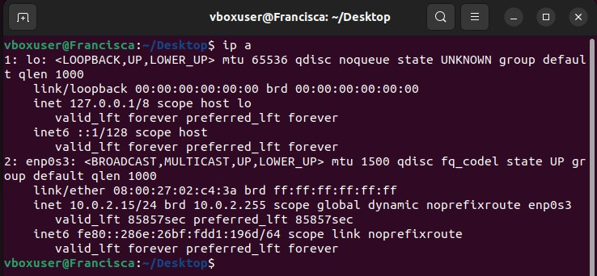
Figure 25 Displaying network interface details using ip command

Command 9: ping
The ping command checks network connectivity. The -c 4 option sends four packets.
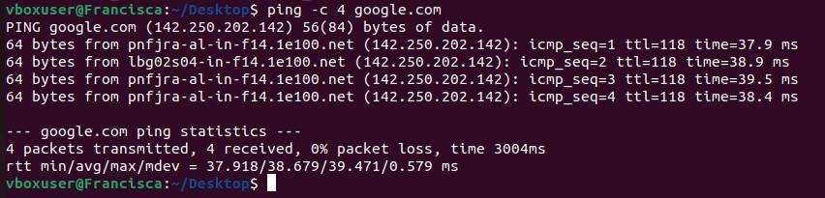
Figure 26 Testing network connectivity using ping command

Command 10: ss
The ss command displays socket statistics.
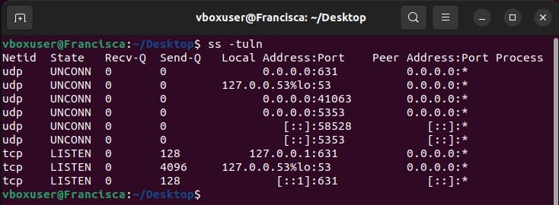
Figure 27 Viewing network sockets using ss command

Command 11: whoami
Displays the username of the currently logged-in user.
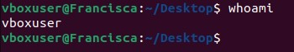
Figure 28 Displaying current user using whoami command

Command 12: id
Displays user ID (UID), group ID (GID), and associated groups.
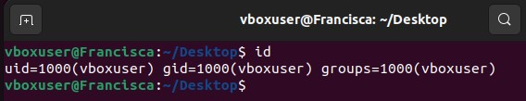
Figure 29 Displaying user and group information using id command

Task 4: Windows Scripts
Windows Batch scripting provides an easy-to-use but highly effective method of automating mundane command line jobs. This is achieved by creating a script containing many commands in a file with a .bat extension and then executing the script through Windows Command Prompt. Batch scripts are helpful as they save time through eliminating unnecessary manual work, ensuring consistency in output and streamlining processes. Features commonly used in batch scripts include variables, asking for user input, basic math functions, conditional logic and loops [1], [3]. Here are two simple examples of Batch scripting to provide insights into command-line automation. Both scripts make use of basic Batch scripting syntax and have accompanying images showcasing their source code and output.

Batch Script 1: Simple Calculator
This script accepts two numbers from the user, adds them together, and displays the result. It demonstrates the use of variables, user input, and arithmetic operations in Batch scripting.
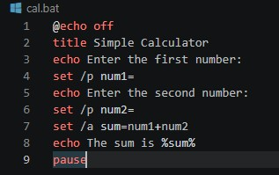
Figure 30 Batch script code for a simple calculator

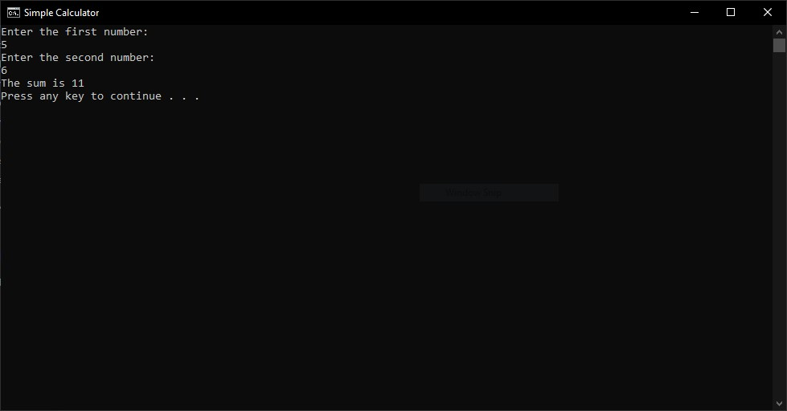
Figure 31 Execution of Batch calculator script showing user input and result

Batch Script 2: Folder Existence Checker
This script asks the user to enter a folder name and checks whether that folder exists in the current directory. It demonstrates the use of variables, user input, and conditional statements.
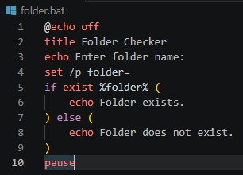
Figure 32 Batch script code for checking folder existence

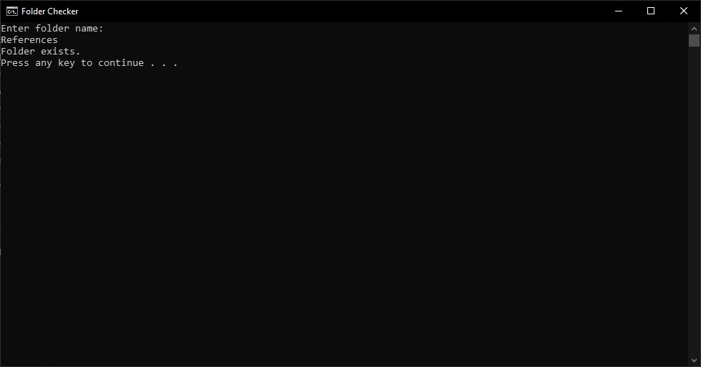
Figure 33 Execution of folder-checking Batch script
This is an indication of how Batch scripts enable automation of simple processes in the Windows environment. Despite their simplicity, the scripts are used to demonstrate basic principles of scripting that are vital for administrative purposes. Batch scripts are beneficial since they help execute multiple tasks in a single instance rather than using different commands [3], [5].

Task 5: Linux Scripts
Linux Bash Scripting represents an effective tool for automating activities in the system. The Bash shell allows the user to write scripts that can perform a series of actions, thus increasing the efficiency of system maintenance. Bash scripts offer various functionalities, including the ability to use variables, get input from the user, perform calculations, create loops, and use conditionals, among others, which help automate activities that may be repetitive and complex[2], [4]. This section demonstrates two simple Bash scripts that illustrate automation and control flow in a Linux environment.

Bash Script 1: Simple Calculator
This script takes two numbers as input from the user, adds them, and displays the result. It demonstrates the use of variables, user input, and arithmetic operations in Bash scripting.
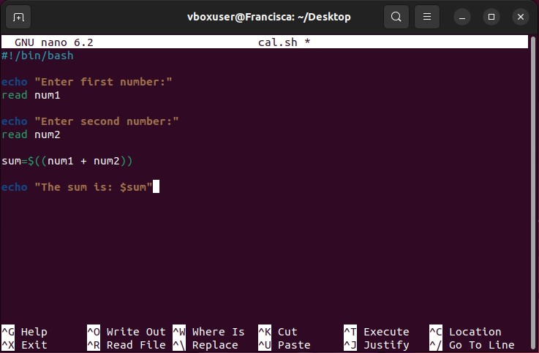
Figure 34 Bash script code for simple calculator
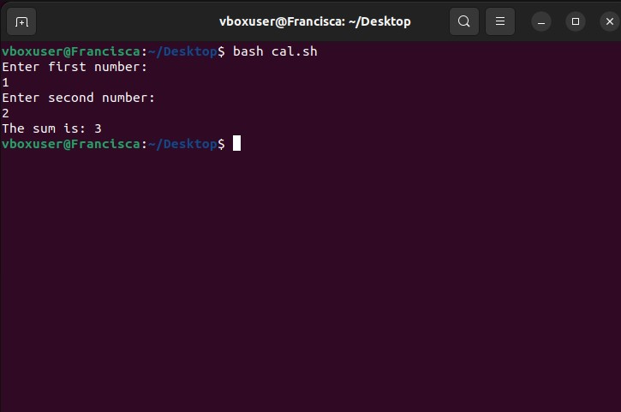
Figure 35 Execution of Bash calculator script showing user input and result

Bash Script 2: File Existence Checker
This script checks whether a file exists in the current directory. It demonstrates the use of user input and conditional statements in Bash.
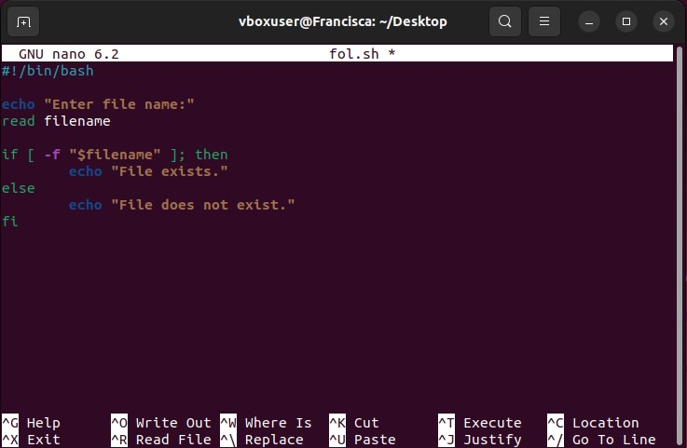
Figure 36 Bash script code for file existence checking
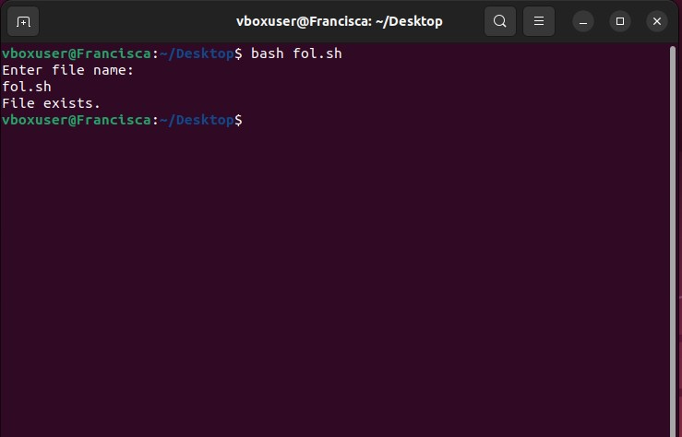
Figure 37 Execution of file-checking Bash script
Bash scripting has been widely used in system administration automation, including backup procedures, monitoring systems, and file manipulation. The scripts that have been shown above are a clear example of how basic programming techniques can be applied to boost productivity.
Even though the scripts might not seem complex, they are indeed effective. [4], [6].

Conclusion
The current report entails comprehensive study of the working principle of operating systems as well as their practical applications through command-line interfaces and scripting. In the first place, this work discusses basic principles that include process management, memory management, file handling, device handling and networking functions performed by any operating system. It is essential to stress that all these aspects form the core of modern computers that help effectively interact with hardware.
Secondly, this report covers practical use of Windows CLI commands that can manage processes, files, networks and users. For instance, tasklist, ipconfig and netstat are among important CLI commands that demonstrate how important this instrument is for system administrators. Likewise, there are various useful commands available in Linux environment such as ps, top and ping that prove how flexible is the command interface used in UNIX.
Thirdly, it is possible to observe implementation of batch files and bash script that show the effectiveness of automated processes that are performed by means of these scripting languages. Thus, scripts are useful tools for programmers that allow integrating into OS such features as variables, user prompts, arithmetic operations, and conditions.
Overall, one may conclude that command-line interfaces and scripts play a significant role in contemporary computing world. The above mentioned practical illustrations show how vital is to be acquainted with both theoretical and practical aspects associated with OS in order to succeed in IT industry.

References
- A. Silberschatz, P. B. Galvin, and G. Gagne, “Operating System Concepts Seventh Edition,” Fundam. Bases Datos, 2005.
- C. Negus, Linux® Bible. 2020. doi: 10.1002/9781119578956.
- W. R. Stanek, Microsoft Windows Command-line Administrator’s Pocket Consultant. in Admin Pocket Consult Series. Microsoft Press, 2004. [Online]. Available: https://books.google.com.pk/books?id=WdDLOgAACAAJ
- W. E. Shotts, The Linux Command Line, 2nd ediTion., vol. 91, no. 5. 2019.
- B. Svidergol, V. Meloski, B. Wright, S. Martinez, and D. Bassett, Mastering Windows Server® 2016. 2018. doi: 10.1002/9781119549277.
- E. Nemeth and G. S. T. R. H. Ben Whaley, UNIX and Linux system administration handbook — 4th ed., vol. 7, no. 11. 2015.

