Managing Digital Identities

James Dexter (1907923)
Tutor: Anthony Burns

Organisation’s Digital Identity Management

Introduction

This paper will discuss organisations digital identity management and the way they use the internet to their advantage but also what risks come along with using this type of promoting or presence. During this technological age more and more organisations are using digital presence to advertise and to help create a stronger online due to the high number of users that are found across all the worldwide web.

There will be two parts to this paper outlining and break down different aspects of creating a digital identity.

The first part talk about what a digital identity is and also will evaluate why and how a company would use a digital identity using various social medias to promote itself and what risks they face and how they can prevent or lower these risks.

The second part will discuss why a company would choose to go ahead with creating a digital identity in order to reach its customers online. How is this going to help them have a better online identity and brand image. What risks would this company be up against and how to overcome them.

Part one

There are so many contributors towards digital identity and most user will not be aware that what they are doing online is being collected to help create their digital identity. The information collected is known as data, this is collected from any online interactions. Social media is a great example of a way in which a digital identity can be made, this is from your name, where you live, what you like or follow on these social medias, comments and even the websites that is visited (Trulioo).

Digital identity broken down is all the interactions and information that has been collected being provided online that once all put together would lead to a certain person or company or brand (Lifelock).

Digital identity is playing a massive part in how company’s and brands can project their image almost anywhere on the internet and across most smart device. The way in which they do this can be through websites and digital platforms. The internet enables people and businesses to create websites and pages for users to become customers or bring people with the same ideas and knowledge together. These types of platforms can help promote themselves and the products and services being provided (Accenture).

There are millions of people online now a days and the vast majority of them will have some sort of social media account whether it be Facebook, Tumblr, twitter or anything you can share content on. Information can be shared downloaded and advertised all over the internet and social media is playing a huge part for brands and businesses to gain engagement from wider audiences also to create more value and consumers.

Main social medias used by companies over the internet would mainly include Facebook, Twitter and Instagram. These companies tend to use these sites as they are the most popular with millions of users across the globe.

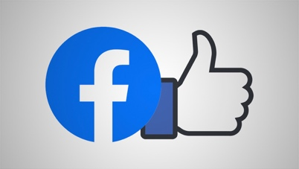
Facebook
Figure 1
Facebook is a social media site that can be accessed on most smart devices from an app or the webpage itself. Users can create personal and business profiles and share content through many methods. Main ways to share information on Facebook is through posts, these can be made up of pictures, opinions, shares of others.
Facebook allows the user to create a page or profile and will ask many questions about themselves or the business to create an identity. Through information provided people are able to search and find an individual or page more efficiently. Information can be shared publicly or options to share for a selected audience (Nations).

The ability to have friends and the feature of following a person or page can also indicate how successful the person or brand is with their online identity as the more followers they have the bigger audience they have to promote themselves or products means a bigger digital presence. Although privacy settings can also come into play where there has to be a judgement made to be accepted into certain groups so an open group is more likely to become more popular but can cater for wider audiences instead of closed groups.

Instagram
Figure 2

Instagram is another social media many people have flocked to in order to project their digital identity. Iphone and android users can upload photos and videos for free and share them with followers or with a selected group of friends to gain view, likes, comments (Instagram).

Instagram has become much more interactive than it first used to be allowing it to stay relevant in todays digital society. This social media being around for so long has created a massive user base over the millions. Having hashtags and being able to tag other profiles allows ease of access to information or content. As its mainly photos and videos that are posted to this social media makes it more of a visual way of promoting an image or products or services being shown. Some posts you can come across profiles have done collaborations helping expand the audience on other popular pages helping promote themselves further.


Twitter
Figure 3
Twitter is a social media networking site that limits posts with up to 140 characters which can also include images and links (economic and social research council) . This has also been one of the most popular social medias that has managed to stick around, and many people have been utilising its features. Millions of people also use this communication site or their app to post content to people around the world with other smart device users.
This site differs from Facebook and Instagram by restricting characters this is a great method to keep things short and sweet. A company would look into creating one of these pages and hopefully gain a good presence so that its products and services are spread even further. The more followers help show the success of the image being portrayed on the profile.

The internet is the best and fastest way in the way today works for anyone to get their message across to anyone anywhere and it truly is an amazing tool for any organisation as long as it used in the correct way with precautions. These social medias can get a business product to people who may not have the chance to get these offers in store helping them be more competitive. The bigger their following on the sites the more popular they are meaning more value and attention can stay with that brand.

Although the internet has its advantages for advertisement and promotion for their image there are still many risks that any company or individual can face and there are some big consequences for these risks when it comes to creating and upholding a digital identity.

The internet is not always a safe place and there can always be many issues that can arise whilst having a digital presence. As most people know the internet can share anything very fast and the internet can take it and make thing viral, can go in a good way or a bad way.

Cyber crime
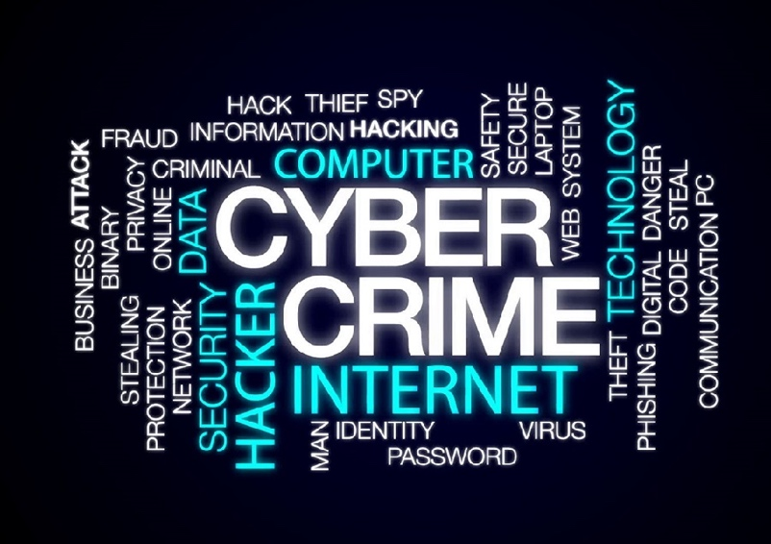
Cyber-crime has been around since the development of the internet for a wide range of reasons and a y person or company with a digital identity. Some of the ways in which these cyber criminals are:
Hacking – this can include emails and social medias.
Phishing – gaining personal details through messages.
Malicious software – this would include hijacking files through ransomware.
Attacks against websites – mainly done for extortion.
Figure 4
(NCA).

Hacking refers to accessing a computer without permission, this can lead to a lot of risks for the company. Sensitive information can be stolen from another person’s computer whether it is personal or business-related including secrets or contact information (Melendez).

Phishing is a cyber-crime that aims to target people’s personal information. Scammers will gain contact by emails, telephone and text messages. These will pose under legitimate names or brands that lure people into giving over personal data such as bank details and passwords (Phishing).

When it comes to malicious software there are many kinds out there designed for different purposes, the main use it to take control over another device without the owner’s permission to try and break the computer overtime or access certain information and possibly steal identities (Avast). Sometimes ransomware can be used in which they will hold information for a reason mainly being extortion.

Cyber crimes can lead to many risks to organisations such as:
- Valuable customer database
- Customer information seen as confidential
- Information on employee’s
- Digital cloud information stored assets
- Social media accounts
(Coe LLP & Aviva).

With the loss of this information known about cyber security businesses who now have a digital identity to maintain can make it become more frightening to start online. Through the advances of technology there are ways to help protection this important data. Not just technological advances but advancements in legal acts that helps individuals or businesses control the way the data stored is used.

Technological advances now enable security software to be installed that can help fight against any cyber criminals trying to access data. With any sort of account on the internet there will always be a password, and this can be set with a big amount of characters for better security. Along with a strong password can be two factory authentications which is a system put in place for security that needs two specific types of identification to gain access (Kenton).

GDPR also known as The General Data Protection Regulation is an act that was enforced to allow people to become more in control of their digital presence. This means that anyone wanting to collect data for a number of reasons will have to ask users or consumers to consent to information being obtained from using their interactions (GOV). Any misuse of data can result in a £2M fine.

Human error can also lead to loss of equipment and leakage of information this is something that cannot be controlled as easily but methods can be put in place to minimise risks but not eliminate them.

.Part 2

There are many reasons to why an organisation would turn to social media to help create a digital identity. One of the main reasons is advertising and to help engage more people into becoming consumers or followers of what the organisation is offering. Along with wanting a popular good named digital identity there will always be issues tat arise.

Social media profiles for organisations are normally strategically run and very careful with the content they post and what they interact with. This is because these organisations have to act in a way that does not damage their bran reputation. By posting good content for users to read, watch or comment on allows more engagement of their audience allowing them to expand further. Following the right pages and other business can help the business seem more professional. Posting pictures and offers will allow attention to be bought to them by likes and shares making them more popular.

Technology has made security a top subject when it comes to protecting anyone’s data, businesses who set up any accounts online should always be aware of what can happen. If made aware, security software and firewalls can be put into place to protect the data that is being stored. Biometrics and two factor authentications is also making businesses feel more confident in the service provider as it shows they care about others data and this added step adds all the more security.

Human error can also occur so polices and training, existing employees will already have been made aware of any social media policies set by the company, but new employees will have to be trained or made aware before signing. The policy will outline ways in which to interact online in the best appropriate manner. If the policy is updated all employees must re-read and sign a declaration.

Below is an example of a social media risk management and the way in which some risks can be interrupted and what measures could be taken.
Threat | Risk Value = Probability of Event x Cost of Event | How to Manage Risk Strategy | Specifics of strategy
Confidential information leaks | 0.8 x £500,000 = £400,000 | Mitigate | - Encryption  - Invest in internet security and ensure these defences are up to date
Social media having a negative impact on a brand’s reputation | 0.6 x £100,000 = £60,000 | Accept risk
Intellectual property theft | 0.5 x £200,000 = £100,000 | Control | - Training on Social Media use  - Monitoring Social Media Feeds
Legal ramifications | 0.4 x £100,000 = £40,000 | Share risk | Third party insurance against risk happening

Social Media Risk Assessment Matrix

References

Trulioo, Identity insights, data attributes as the new digital identity, 3/5/2018, https://www.trulioo.com/blog/data-attributes-identity

LifeLock, what’s your digital identity?, LifeLock, 27 April 2018, https://www.lifelock.com/learn-identity-theft-resources-whats-your-digital-identity.html

Accenture, G20 young Entrepreneurs alliance, five ways to win with digital platforms, 2016, https://www.accenture.com/us-en/_acnmedia/pdf-29/accenture-five-ways-to-win-with-digital-platforms-full-report.pdf

Figure 1, Newcastle studio, How Facebook’s new logo design affects broadcasters, M hill 04/11/2019, https://www.newscaststudio.com/2019/05/01/new-facebook-logo/

Lifewire, What is Facebook?, D Nations, 19/12/2019, https://www.lifewire.com/what-is-facebook-3486391

Figure 2, Shutterstock, Instagram logo images, 2020, https://www.shutterstock.com/search/instagram+logo

Instagram, Help Centre, Privacy and Safety Centre, 2020, https://help.instagram.com/424737657584573

Figure 3, Flaticon, Twitter free icon, 2020, https://www.flaticon.com/free-icon/twitter_124021

Economic and social research council, what is Twitter and why should you use it?, 2020,
https://esrc.ukri.org/research/impact-toolkit/social-media/twitter/what-is-twitter/

National crime agency, cyber crime, https://www.nationalcrimeagency.gov.uk/what-we-do/crime-threats/cyber-crime

Chron, S Melendez 2019, the effect of computer hacking on an organisation, https://smallbusiness.chron.com/effects-computer-hacking-organization-17975.html

Phishing, Phishing, what is phishing?, https://www.phishing.org/what-is-phishing

Avast business, Avast, what is malicious software, https://smb.avast.com/answers/malicious-software-malware

Figure 4, IT supply chain, 19 alarming cybercrime statistics for 2019, 2020, https://itsupplychain.com/19-alarming-cybercrime-statistics-for-2019/

E Coe LLP & Aviva, Rigby financial, cyber crime – a real risk to business, https://www.rigbyfinancial.co.uk/news_and_case_studies_links/news/cyber_crime_-_a_real_risk_to_businesses/

Investopedia, W Kenton 2020, What is two-factor authentication (2FA)?, https://www.investopedia.com/terms/t/twofactor-authentication-2fa.asp

Gov, Data Protection, https://www.gov.uk/data-protection

Social media risk assessment matrix, https://moodle.uwtsd.ac.uk/mod/resource/view.php?id=268574

