The Psychological Contract
'The Psychological Contract' is an increasingly relevant aspect of workplace relationships and wider human behaviour.
Descriptions and definitions of the Psychological Contract first emerged in the 1960s, notably in the work of organizational and behavioural theorists Chris Argyris and Edgar Schein. Many other experts have contributed ideas to the subject since then, and continue to do so, either specifically focusing on the the Psychological Contract, or approaching it from a particular perspective, of which there are many. The Psychological Contract is a deep and varied concept and is open to a wide range of interpretations and theoretical studies.
Primarily, the Psychological Contract refers to the relationship between an employer and its employees, and specifically concerns mutual expectations of inputs and outcomes.
The Psychological Contract is usually seen from the standpoint or feelings of employees, although a full appreciation requires it to be understood from both sides.
Simply, in an employment context, the Psychological Contract is the fairness or balance (typically as perceived by the employee) between:
- how the employee is treated by the employer, and
- what the employee puts into the job.
The words 'employees' or 'staff' or 'workforce' are equally appropriate in the above description.
At a deeper level the concept becomes increasingly complex and significant in work and management - especially in change management and in large organizations.
Interestingly the theory and principles of the Psychological Contract can also be applied beyond the employment situation to human relationships and wider society.
Unlike many traditional theories of management and behaviour, the Psychological Contract and its surrounding ideas are still quite fluid; they are yet to be fully defined and understood, and are far from widely recognised and used in organizations.
The concept of 'psychological contracting' is even less well understood in other parts of society where people and organisations connect, despite its significance and potential usefulness. Hopefully what follows will encourage you to advance the appreciation and application of its important principles, in whatever way makes sense to you. It is a hugely fertile and potentially beneficial area of study.
At the heart of the Psychological Contract is a philosophy - not a process or a tool or a formula. This reflects its deeply significant, changing and dynamic nature.
The way we define and manage the Psychological Contract, and how we understand and apply its underpinning principles in our relationships - inside and outside of work - essentially defines our humanity.
Respect, compassion, trust, empathy, fairness, objectivity - qualities like these characterise the Psychological Contract, just as they characterise a civilized outlook to life as a whole.

The Psychological Contract - definitions and usage
In management, economics and HR (human resources) the term 'the Psychological Contract' commonly and somewhat loosely refers to the actual - but unwritten - expectations of an employee or workforce towards the employer. The Psychological Contract represents, in a basic sense, the obligations, rights, rewards, etc., that an employee believes he/she is 'owed' by his/her employer, in return for the employee's work and loyalty.
This notion applies to a group of employees or a workforce, just as it may be seen applying to a single employee.
This article refers to 'the organization' and 'leaders' and 'leadership', which broadly are the same thing in considering and describing the Psychological Contract. Leadership or 'the leader' is basically seen to represent the organization, and to reflect the aims and purposes of the owners of the organization. Leaders and leadership in this context refer to senior executive leaders or a chief executive, etc., not to team leaders or managers who (rightly) aspire to be leaders in the true sense of the word.
Accordingly on this webpage, where the term applies to the employment situation, it is shown as the Psychological Contract, or the Contract. This also seeks to differentiate it from a more general sense of 'psychological contracting' or 'contracts' or 'contracting' in wider human communications, mutual understanding and relationships.
The concept of the Psychological Contract within business, work and employment is extremely flexible and very difficult (if not practically impossible) to measure in usual ways, as we might for example benchmark salaries and pay against market rates, or responsibilities with qualifications, etc.
It is rare for the plural form 'Psychological Contracts' to be used in relation to a single organisation, even when applied to several employees, because the notion is of an understanding held by an individual or a group or people, unlike the existence of physical documents, as in the pluralized 'employment contracts' of several employees.
The Psychological Contract is quite different to a physical contract or document - it represents the notion of 'relationship' or 'trust' or 'understanding' which can exist for one or a number of employees, instead of a tangible piece of paper or legal document which might be different from one employee to another.
The singular 'Psychological Contract' also embodies very well the sense of collective or systemic feelings which apply strongly in workforces. While each individual almost certainly holds his or her own view of what the Psychological Contract means at a personal level, in organizational terms the collective view and actions of a whole workgroup or workforce are usually far more significant, and in practice the main focus of leadership is towards a collective or group situation. This is particularly necessary in large organizations where scale effectively prevents consideration of the full complexities and implications of the Psychological Contract on a person-by-person basis.
That said, it is usual for the Psychological Contract to refer to one employee's relationship with an employer, or to an entire workforce's relationship with the employer.
The term 'contracting' (lower-case 'c') in the context of communications is not clearly defined yet, and does not normally refer to the Psychological Contract. As discussed later 'contracting' does specifically refer broadly to 'agreeing mutual expectations' within Transactional Analysis (a specialised therapeutic or coaching/counselling methodology), and conceivably within other forms of therapy too. (TA 'contracting' is specifically described within modern TA theory.)
The nature of the relationship in Transactional Analysis is somewhat different to that of employee and employer, although significantly the sense of agreeing mutual transparent expectations within Transactional Analysis is very similar in spirit and relevant to the Psychological Contract in employment.
The term 'psychological contracting' is not typically used in referring to the Psychological Contract in the workplace, but may arise in the context of therapy. It would be helpful to us all for this expression and its related theory, as an extension of the Transactional Analysis usage, to become more generally used in human communications and understanding. In life, relationships and communications generally operate on a very superficial level. Opportunities to explore, understand, explain and agree mutual expectations are largely ignored or neglected - mostly through fear or ignorance. It is a wonder that humans manage to cooperate at all given how differently two people, or two parties, can interpret a meaning, and yet be seemingly incapable of seeking or offering better transparency or clarity.
The Psychological Contract is becoming a powerful concept in the work context. Potentially it is even more more powerful when we consider and apply its principles more widely.

Definitions of the Psychological Contract
A basic definition of the Psychological Contract appears in Michael Armstrong's excellent Handbook of Human Resource Management Practice (10th Ed., 2006): "...the employment relationship consists of a unique combination of beliefs held by an individual and his employer about what they expect of one another..."
Armstrong references Edgar Schein's 1965 definition of the Psychological Contract, as being (somewhat more vaguely) an implication that: "...there is an unwritten set of expectations operating at all times between every member of an organization and the various managers and others in that organization..."
Armstrong highlights other references, within which these points are especially notable:
"...Because psychological contracts represent how people interpret promises and commitments, both parties in the same employment relationship can have different views..." (DM Rousseau and KA Wade-Benzoni, 1994)
"...a dynamic and reciprocal deal... New expectations are added over time as perceptions about the employer's commitment evolve... concerned with the social and emotional aspects of the exchange..." (PR Sparrow, 1999)
Notice how those three definitions of the Psychological Contract cited by Armstrong progressively increase in their subtlety and sophistication.
Schein's view reflects the early identification of the concept in the 1960s. Later Rousseau/Wade-Benzoni acknowledge the significance of different perceptions of employee and employer. Later still Sparrow recognises the dynamic quality, and the social and emotional factors. This is not to say the respective writers did not all in some way appreciate the depth of the concept; but it is a helpful illustration of the tendency for the conceptual thinking about the Psychological Contract to evolve, which in part reflects the increasing complexity of the essential employer/employee relationship.
The definition of the Psychological Contract on Wikipedia (April 2010) is: "A psychological contract represents the mutual beliefs, perceptions, and informal obligations between an employer and an employee. It sets the dynamics for the relationship and defines the detailed practicality of the work to be done. It is distinguishable from the formal written contract of employment which, for the most part, only identifies mutual duties and responsibilities in a generalized form."
The UK Chartered Institute of Personal Development, which takes a keen interest in the concept of the Psychological Contract, defines the concept as follows (as at April 2010, in a paper revised in January 2009): "...It [the Psychological Contract] has been defined as '…the perceptions of the two parties, employee and employer, of what their mutual obligations are towards each other'. These obligations will often be informal and imprecise: they may be inferred from actions or from what has happened in the past, as well as from statements made by the employer, for example during the recruitment process or in performance appraisals. Some obligations may be seen as 'promises' and others as 'expectations'. The important thing is that they are believed by the employee to be part of the relationship with the employer..." The quoted extract in the above larger excerpt is referenced: 'Guest, D E and Conway, N. (2002) Pressure at work and the psychological contract. London: CIPD'. Professor David Guest of Kings College London is a leading figure in modern thinking about the Psychological Contract. You will see his ideas and models commonly referenced if you research the subject in depth.
Within these referenced definitions you will see already that the concept is open to different interpretations, and has a number of complex dimensions, notably:
              - There are a series of mutual obligations on both sides (which include, crucially, intangible factors that can be impossible to measure conventionally).
              - It is a relationship between an employer on one side, and on the other side an employee and/or employees (which by implication distorts the notion of a formal contract between two fixed specified parties).
              - The obligations are partly or wholly subject to the perceptions of the two sides (which adds further complexities, because perceptions are very changeable, and as you will see, by their subjective 'feeling' and attitudinal nature perceptions create repeating cause/effect loops or vicious/virtuous circles, which are scientifically impossible to resolve).
              - Overall the Contract itself has a very changeable nature (being such a fluid thing itself, and being subject to so many potential influences, including social and emotional factors, which are not necessarily work-driven).
- And an obvious point often overlooked, within any organization the Psychological Contract is almost never written or formalised, which makes it inherently difficult to manage, and especially difficult for employees and managers and executives and shareholders to relate to (the Psychological Contract is almost always a purely imaginary framework or understanding, which organizational leadership rarely prioritises as more real or manageable issues - or leadership regards the whole idea as some sort of fluffy HR nonsense, and anyway, "Let's not forget who's the boss... etc etc" - so that the whole thing remains unspoken, unwritten, and shrouded in mystery and uncertainty).
Work used to be a relatively simple matter of hours or piece-rate in return for wages. It is a lot more complicated now, and so inevitably are the nature and implications of the Psychological Contract.

At this point a couple of diagrams might be helpful..

Psychological Contracts Models - diagrams
Much of the theory surrounding Psychological Contracts is intangible and difficult to represent in absolute measurable terms. Diagrams can be helpful in understanding and explaining intangible concepts. Here are a couple of diagram interpretations, offered here as useful models in understanding Psychological Contracts.

psychological contracts - venn diagram
Here is a Venn diagram representing quite a complex view of the Psychological Contract, significantly including external influences, which are often overlooked in attempting to appreciate and apply Psychological Contracts theory. Venn diagrams (devised c.1880 by British logician and philosopher John Venn, 1834-1923) are useful in representing all sorts of situations where two or more related areas interact or interrelate. The Venn diagram below provides a simple interpretation of the factors and influences operating in Psychological Contracts.
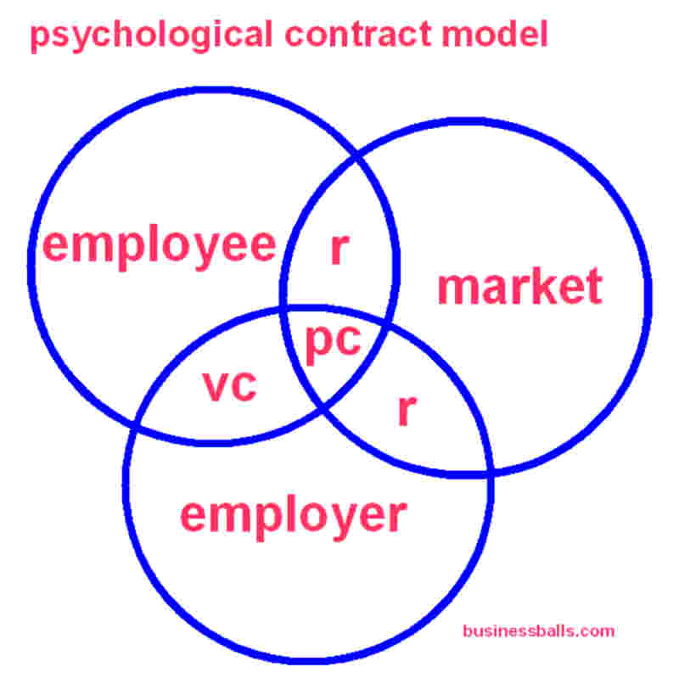
PC = Psychological Contract
VC = Employment contract - visual
R = relational to context.

the psychological contracts 'iceberg' model
This Psychological Contracts 'iceberg' diagram below is a helpful way to illustrate some of the crucial aspects and influences within Psychological Contracts theory.
For team-builders and trainers, and leaders too, it's also potentially a useful tool for explaining and exploring the concept and its personal meaning for people.
An iceberg is said to be 90% hidden beneath the water. This metaphor fits the Psychological Contract very well, in which most of the Contract perceptions are unwritten and hidden, consistent with its definition.
This is especially so for junior workers in old-fashioned 'X-Theory' autocratic organizations, where mutual expectations typically have little visibility and clarity. Here we might imagine that the iceberg is maybe 95% or 99% submerged.
By contrast the Psychological Contract between a more modern enlightened employer and its employees, especially senior mature experienced and successful staff, is likely to be much more clearly understood and visible, with deeper inputs and rewards, formally and mutually agreed. Here the iceberg might be only 60% or 70% submerged.
These percentage figures are not scientific - they merely explain the way the model works.
The iceberg metaphor extends conveniently so that the 'sky' and the 'sea' represent external and market pressures acting on employee and employer, affecting the balance, and the rise or fall of the iceberg.
As the iceberg rises with the success and experience of the employee, so does the contract value and written contractual expectations on both sides. Increasingly deeper inputs and rewards emerge from being hidden or confused perceptions below from the water-line, to become visible mutual contractual agreement above the water-line.
The process can also operate in reverse, although in a healthy situation the natural wish of both sides is for the iceberg to rise.
An example of a very basic employee/employer relationship in which only work and pay are formally agreed and contracted. In reality a representation of the Psychological Contract for most modern work relationships would include several more mutual obligations with work and pay 'above the water-line', i.e., formally contracted and agreed.
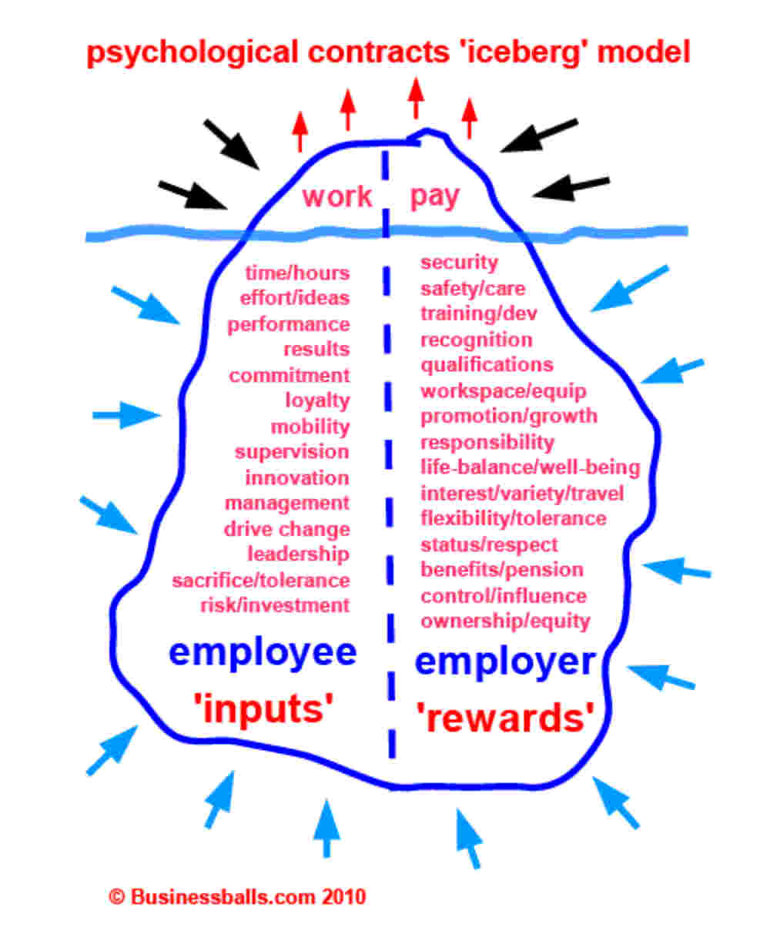

Summary - the Psychological Contract
The Psychological Contract is fascinating for many reasons because it offers so many different perspectives.
It's not a tool or a process. The Psychological Contract is a model and a philosophy which can guide us in the way we structure and manage organizations, and deal with employees within them.
At a basic level it helps us understand more about the 'give and take' that characterises working for an organization, and particularly leading an organization.
It is very useful in understanding why employees are 'difficult to motivate', or 'difficult to manage' - especially when this is an ongoing or widespread challenge.
The Psychological Contract helps leaders understand better how to align their people's needs with those of the organization, which is a very elusive notion.
The concept also offers a powerful way to expand thinking and possibilities for people and work, in some distinctly separate and important ways:
- individual employee motivation and management
- motivation and management of workgroups and departments
- entire workforce motivation and management
- review of grading, management hierarchy, succession
- recruitment and selection and induction
- training and development
- assessment of leadership - vision, style, capability
- assessment of traditional workplace terms and conditions, contracts, etc
- organizational communications
- organizational philosophy and culture
- fundamental organizational purpose, constitutional rules and ownership
- new business purpose and legal structure
- markets and societies - types of organizations that will work best in the future
At a deeper level the Psychological Contract questions the significance of fairness in the way organizations are run and established.
There is no single right way.
There are ways which are bound to fail, because in essence they become uncompetitive.
The world changes, and as it does, work and business changes too.
From the tone of this article, and the website surrounding it, you may gather that I am not a great fan of old-style business and management.
It seems to make an awful lot of money for a very few people, and provide a relatively unhappy and unfulfilled working life for a big proportion of everyone else.
Most people still live for the weekends and their annual holidays; many hate their work and are not truly connected to or aligned with their employer, which often is a bigger problem for the employer than it is to the staff.
Meanwhile many big businesses are making a mess of the world in all sorts of ways, because profits come first.
All the indications seem to be that there are better ways to do things.
The Psychological Contract gives us a guide to the answers.

http://www.businessballs.com/psychological-contracts-theory.htm#psychological-contract-working-model
(Accessed and Adapted 19/03/2012)

