

Module: Managing Projects in the Organisation
BMSW5104
Assignment Title: Managing Projects in the Organisation
Task 2- Evaluation of Project Management Plan- 60% - (2,500 words +10%)
Lecture name: Charles Nwaogwugwu
Student name: Maria Vitoroi 2023024

PROJECT MANAGEMENT PLAN
Training Development Programme

TABLE OF CONTENTS
INTRODUCTION: 4
STAKEHOLDERS ANALYSIS: 5
WORK BREAKDOWN STRUCTURE: 5
PROJECT’S COSTS AND RESOURCES: 7
GANTT CHART 9
RISK MANAGEMENT: 10
CONCLUSION: 11
REFERENCES: 12

INTRODUCTION:
Organizations are constantly impacted by ongoing difficulties posed by their macro environment. The COVID-19 epidemic has significantly changed how customers, staff, and businesses interact in a relatively short period, shaking worldwide markets. The epidemic has expedited their change on a behavioural, cultural and organisational level (Camilleri, 2021).
Many organizations experienced devastating impacts from COVID-19's early phase in various circumstances. According to Xiang et al. (2020), the perception of safety, threats, risk of contagion, fear of the unknown (Garfin et al., 2020), social isolation, financial damage, and employment uncertainty, were the key pressures during the pandemic (Brooks et al., 2020).
According to WHO (2020), one of the physical measures that were required in the workplace was the physical distance, also commonly known as social distancing. Physical distancing measures had a detrimental effect on employees' mental health, despite their acknowledged effectiveness in decreasing the spread of COVID-19 (Fischer et al. 2020).
The social-distancing practices have changed the workplace and hampered communication. Mustajab et al. (2020) point out that the problem in the workplace due to Covid-19 is unusual. It has significantly changed how people connect and work in organizations.
Due to the above-mentioned factors, a training development program based on the business "Real Greek" will be introduced. The "The Real Greek" company owns and manages 22 restaurants across the UK. It is a company whose primary goal is to share Greek culture with its customers through traditional Greek cuisine. Because a company with 22 branches must deal with a large number of employees, proper workforce management is critical. Every restaurant employs a manager who is in charge of tasks such as staffing, directing, controlling, and planning. All of these tasks are essential for successfully managing a restaurant and meeting company goals.
The purpose of this training development program is to improve the relationships between the employees and integrate them into the workplace after COVID-19. The primary qualities of people working together are interaction, communication, and connection within the workgroup. According to Williams et al. (2020), consistent, unambiguous communication helps employees feel more trusted and relieves their stress.
The desired achievements through this training development programme are for the employees to improve their communication skills, to acquire new knowledge, to boost their connection, to be motivated to pursue professional development. The training development programme will be considered successful if the amount of positive customer feedback increases, the employees' productivity and work quality rise, employee retention is increased and there is a pleasant work environment where staff enjoys working together.

STAKEHOLDERS ANALYSIS:
First of all, it is crucial to define the target group and then develop the messages that must be delivered to that group. According to Jepsen and Eskerod (2009) stakeholder analysis refers to the practice of gathering important stakeholders involved with a certain project problem and explaining from their viewpoint. The stakeholders that are involved in the described case are the upper management and the employees, who have high priority because they belong to the internal part of the company and are directly involved with the company and the customers, who have low priority because they belong to the external part and are indirectly involved with the company.
From the perspective of the upper management, the advantages they will experience from this training program will be the enhanced performance of the personnel, as well as their increased job satisfaction, which will provide the business with an advantage over competitors. Their actions will revolve around communicating and showing up to collect feedback on the work of the staff
From the viewpoint of the employees, the benefits that they will obtain are the development of their knowledge and abilities, the improvement of their sense of teamwork, and the motivation for professional development. They will have to participate in the training programme regularly and be willing to develop themselves.
From the point of view of the customers, they will benefit from improved service quality, and all they need to do is take pleasure in it.
According to Keeman et al. (2017) employee well-being correlates to several performance measures, such as productivity, employee turnover, job satisfaction, stress, and work-life balance, it is a crucial factor for how businesses might gain a competitive advantage. Although it is critical in all work environments, the service sector, where frontline staff is at the heart of customer service interactions, prioritises employee well-being.

WORK BREAKDOWN STRUCTURE:
According to Devi and Reddy (2012), the Work Breakdown Structure (WBS) separates the whole project into its constituent parts to create a framework for efficient management control over the project's scope, schedule, and budget. A project WBS is a product-focused grouping of project work components that identifies and organizes the project's overall scope. The WBS is a multi-level structure that logically combines and graphically shows parts that indicate the work that needs to be done. Each level that goes below represents a more in-depth definition or division of a project component. It is the framework and programming that connects and unifies all project work and is used throughout a project's life cycle to define, allocate, and monitor particular work scopes. Each control account will have a distinct WBS element since the WBS will be developed in sufficient detail.
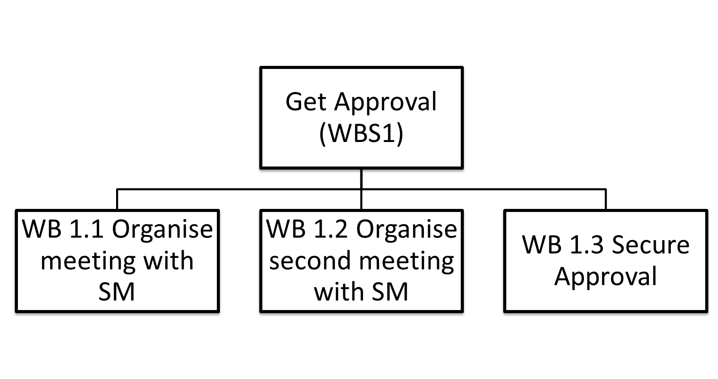
Figure 1: First step in the Work Breakdown Structure of the Training Development Programme
As it appears in the first figure the first step in the work breakdown structure of the training development programme is to obtain permission from the upper management. To receive the approval, it is necessary to organise meetings with the upper management to clarify the benefits that can obtain from the company. It is possible to schedule various meetings until authorization.
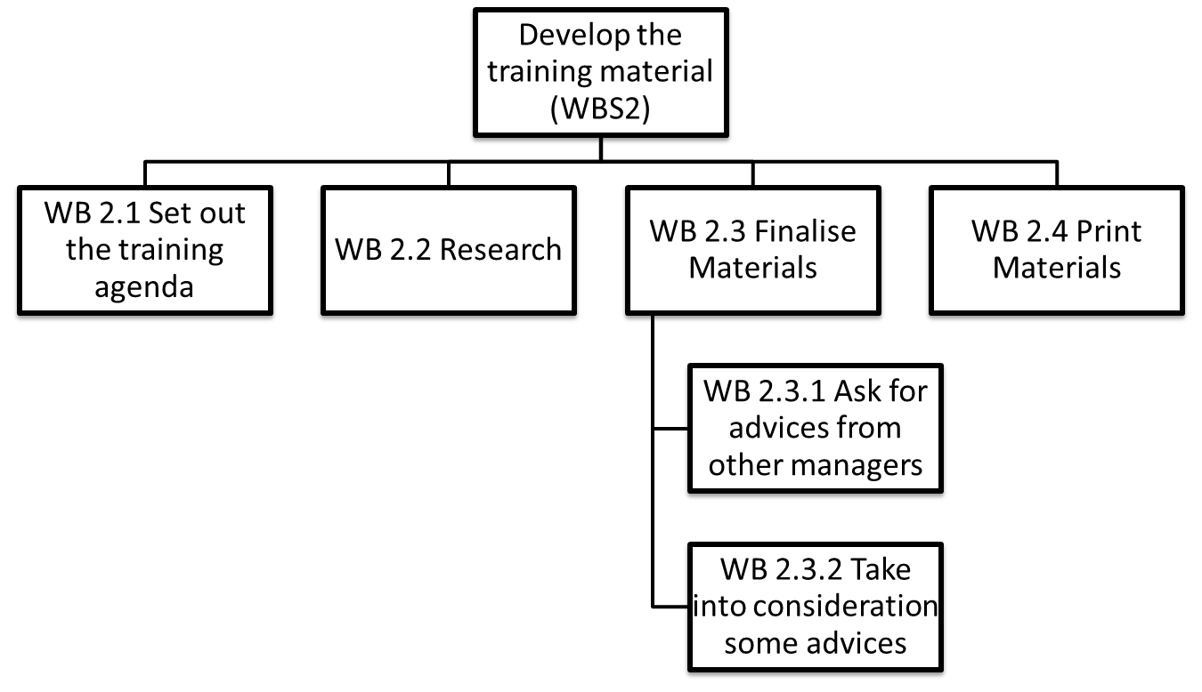
Figure 2: Second step in the Work Breakdown Structure of the Training Development Programme

Getting the approval, the second step in the work breakdown structure is the creation of the training materials. This phase it is begun with the training agenda and it is conducted through thorough research. At this moment, it's significant to clarify that the employees will take part in different training programmes based on their future career prospects. In other words, the employees that are engaged in the service will participate in sales training programs to strengthen their sales skills. In addition, the kitchen staff will participate in a Greek cooking class to develop their techniques and acquire new knowledge and the supervisors will take part in a seminar about leadership, team-building and coaching skills for managers and supervisors for further development.
On the other hand, all employees independent of their field of work will take part in team development and team building training to enhance their connection and their team spirit. After the research and as the materials are finalised, it is necessary to collect advice from other managers. Finally, we can be taken into consideration some advice from the other managers and print the materials.
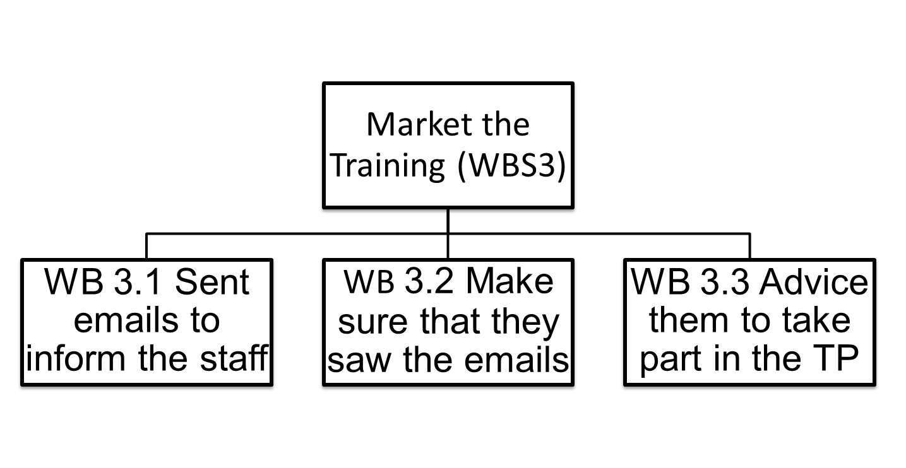
Figure 3: Third step in the Work Breakdown Structure of the Training Development Programme
During the final phase of marketing the training, the staff will be notified by email to get informed about the training. In addition, it is significant to ensure that the employees have received the emails and to be urged to participate in the training program for further professional development.

PROJECT’S COSTS AND RESOURCES:
As it seems in the fourth figure, appears a cost management plan, which helps in mapping out and controlling the budget of the training development programme. It enables forecasting expenses, distributing resources to the appropriate places, and keeping overall expenditures under control (Asfoor et al. 2022). Furthermore, the fourth figure's table describes which course each employee will attend, how each course will be executed, the cost, the duration of the course, and the participation dates. The total cost of the training development programme is 2893£ for 15 employees, with courses specialised in their professional needs and by obtaining a certificate.

Staff | Courses | Procedure | Cost | Duration | Dates
Kitchen Staff (4 Persons) | Greek cooking Class | Face-to-face | 110£ per person + public transport  (5£ per person) | 7:30 pm-10:30 pm | 1/March/2023  3/April/2023
Supervisors (2 persons) | Leadership, team-building and coaching skills for managers and supervisors | Online | 299£ per person | 9:00 am – 4:00 pm | 9/February/2023 - 22/ February /2023
Service (8 persons) | The Art of Sales: Mastering the Selling Process Specialization | Online | Free ($95 for certificate) | Five weeks; three to five hours of work per week  7:00 pm-10:00 pm | Start date: 13 February 2023  End date: 6 March 2023
All Staff members | Team Development and Team Building | Face–to–face | Group price 1000£ + public transport (5£ per person) | 10:00 am-13:00 | 9 April 2023 (Sunday)
Figure 4: The Costs and the Resources for the training development programme.
To achieve the manager to create the training development plan was necessary the following main activities take place:
- Developing the strategies, methods, and information that will be utilized for project planning, execution, and control.
- Identifying the particular actions that the employees and stakeholders should do to achieve training development programme objectives.
- Finding and recording the connections between training development programme activities.
- Calculation of the resources an employee will need to complete training development programme requirements.
- Calculation the amount of time required to perform individual courses.
- Evaluation of activity sequences, activity resource estimations, and activity duration estimates.
- Management and monitoring modifications of the training development programme's timeline.
For this purpose, the preparation of the training development plan was created two months before.

GANTT CHART
According to Zhong et al. (2019), a Gantt chart is a project management tool in the form of a graphical chart that represents the quantity of work or production completed during specific periods in comparison to the amount scheduled for those times. It usually contains two parts, the left side is a series of requirements, and the right side is a timetable with schedule lines that illustrate the activity.
In addition, the Gantt chart can incorporate task start and finish dates, milestones, task dependencies, and assignees. Gantt charts can be used to maintain track of a project's management. Job dependencies ensure that a new task can begin only after the previous task has been completed. Dependent issues are automatically rescheduled if a task is postponed. Moreover, Gantt Charts facilitate the creation of complex plans, particularly those involving organisations with multi-person teams and shifting deadlines. Finally, they assist teams in properly allocating resources and planning work around deadlines.
As shown in the fifth figure, the training development program begins with planning, which lasts two months. This phase includes not just the project plan, but also all steps till approval from higher management.
The research follows which lasts 29 days and goes approximately parallel with the planning. All procedures for developing training materials are included in this method. These procedures operate almost simultaneously so that upper management is aware of what is happening and can interfere in case of disagreement.
The next part is creation, which is the transformation of theory into practice and lasts 10 days. More specifically, after researching and validating the availability, the manager begins the process of reserving tickets for the courses. The application of the activities follows, which includes all of the courses in which the employees must participate, with a total duration of two months.
Finally, the monitor and control phase follows, which lasts five months and three weeks. This procedure is the longest and starts at the beginning of the courses. At this point, we monitor the program's progress and take action if anything changes. Furthermore, the control continues long after the training has ended, evaluating the employees' productivity and progress.
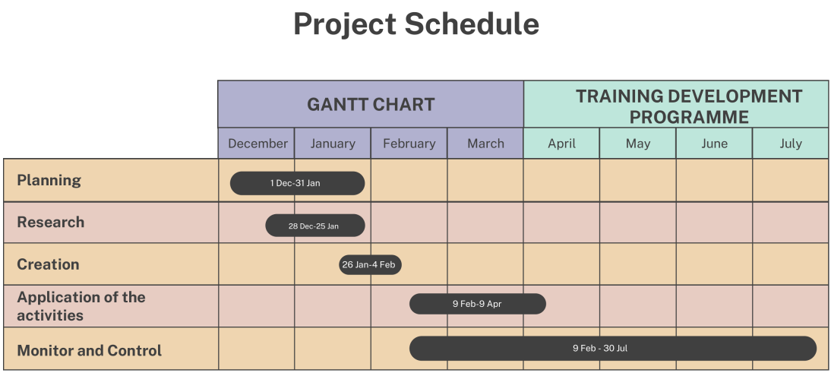
Figure 5: Gantt chart of the Training Development Programme

RISK MANAGEMENT:
According to Naeem et al. (2018), risk management is connected to all stages of project planning. It is normally used to demonstrate a project's believable or difficult condition. A project risk may also be viewed as a probable bad outcome that could make it difficult to achieve other structure goals, like quality, requirements etc. Early recognition of urgent threats is crucial to the successful completion of a project. Various aspects predict and influence project success. Nevertheless, failure or disappointment is more likely when proper risk management is not taken into account.
Teacher and Sander (2018) support, that a risk matrix is an essential tool in risk management. It can assist organizations in developing a thorough awareness of the risk environment and managing threats before they manifest.
More specifically a risk matrix allows for prioritizing the most severe risks that a company may face. Having a comprehensive view of today’s modern threat landscape is critical for preventing value losses.
In addition, the risk matrix helps experts to develop a focused plan for handling high-risk occurrences by prioritizing the most urgent risks. Since these risks have the greatest impact, concentrating focus and resources on them will help the company's overall strategy. Last but not least, the risk matrix makes it possible to detect specific risk categories, as well as their probability and the level of impact, and to keep track of how the risk environment is changing in actual time.
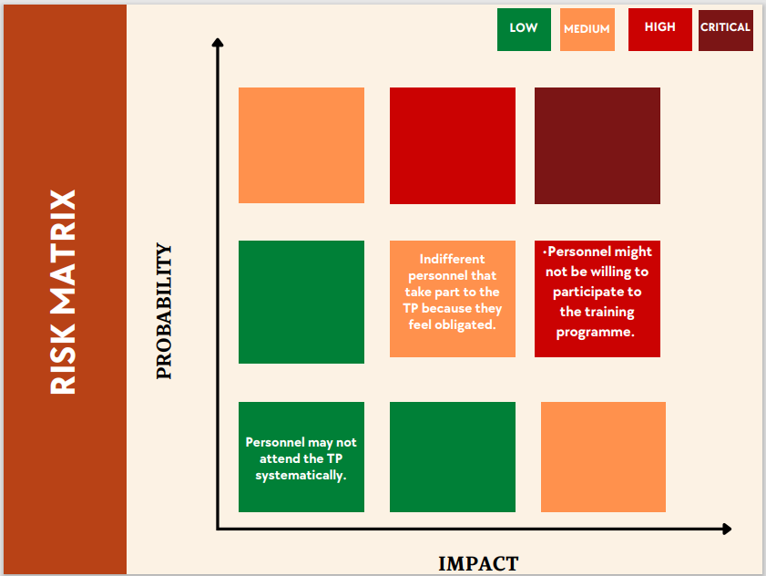
Figure 6: Risk Matrix of Training Development Programme.

As seen in the risk matrix's sixth figure, the biggest risk, but one with a medium likelihood is that the staff may not want to take part in the training program. This may occur as a result of a lack of time, duties to somebody's family, boredom, a lack of motivation, etc. The employees may not be interested in participating in the training program but yet participate because of obligation. The staff may also not consistently attend the training session, which has a low probability and minimal impact.
To avoid these issues, a conversation will be conducted in which it will be clarified the staff's chance for continued professional growth and the benefits they will experience. In addition, they will be notified that participation is required and that a bonus will be awarded based on how well they perform following the training course.
An anonymous survey will be provided to the staff to monitor and manage the process. Because respondents are less afraid to express their opinions and are also more truthful in this setting, the survey will be conducted anonymously. As a result, the person will receive feedback, which can be used to assess and compare the training program's success and progress. The employees that took part in the training program will also receive a bonus or promotion, but it will be based on how well they perform. People are motivated by rewards, and they also feel like their effort is valued when they receive them.

CONCLUSION:
Provide-19 changed our life and our perception. People need time and help to adjust again to the “new” normal life. Managers are critical to a company because they serve as the bridge between the upper management and the employees, forming a consistent team that can carry out important tasks. They manage a company's everyday operations and production while encouraging employees in achieving their goals. More qualified and self-assured people are one of management's major contributions to business success. A manager should encourage his staff to take advantage of training and educational opportunities to help them realize their maximum potential (Ozkeser, 2019).
People set goals and objectives and work hard to achieve them. As a result, an organization's performance is determined by the sum of the performances of its members. Human capital is the most important resource for any company to maintain a competitive advantage. The quality of an organization's human resources serves as its foundation and is directly related to its ability to thrive, grow, make money, and achieve excellence.

REFERENCES:
Asfoor, H. M. A., AL-Jandeel, A. A. T., Kozhevnikov, K., & Lykova, A. (2022). Construction Project Management by Controlling the Time, Cost and Quality. In Building Life-cycle Management. Information Systems and Technologies (pp. 319-327). Springer, Cham.
Brooks, S. K., Webster, R. K., Smith, L. E., Woodland, L., Wessely, S., Greenberg, N., & Rubin, G. J. (2020). The psychological impact of quarantine and how to reduce it: a rapid review of the evidence, The Lancet. 395 (10227), 912-920.
Camilleri, M. A. (2021). The Employees’ State of Mind during COVID-19: A Self-Determination Theory Perspective, Sustainability, 13(7), 3634.
Devi, T. R., & Reddy, V. S. (2012). Work breakdown structure of the project. International journal of engineering research and applications, 2(2), 683-686.
Teacher, M., & Sander, P. (2018). Improving risk matrix design using heat maps and accessible colours. The Journal of Modern Project Management, 6(1).
Fischer R., Karl J., Bortolini T., Zilberberg M., Robinson K., Rabelo et al. (2020). Rapid review and meta-meta-analysis of self-guided interventions to address anxiety, depression and stress during COVID-19 social distancing. PsyArXiv, 1- 33.
Garfin, D. R., Silver, R. C., & Holman, E. A. (2020). The novel coronavirus (COVID-2019) outbreak: Amplification of public health consequences by media exposure. Health Psychology, 39(5), 355–357.
Jepsen, A. L. and Eskerod, P. (2009). Stakeholder analysis in projects: Challenges in using current guidelines in the real world. International journal of project management, 27(4), 335-343.
Keeman, A., Neaswall, K., Malinen, S. and Kuntz, J. (2017), “Employee wellbeing: evaluating a well-being intervention in two settings”, Frontiers in Psychology, Vol. 8, April, pp. 1-14.
Mustajab D., Bauw A., Rasyid A., Irwan A., Akbar M.A. & Hamid M.A.(2020), Working From Home Phenomenon As an Effort to Prevent COVID-19 Attacks and Its Impacts on Work Productivity. HIJAB, 4, 13-21.
Naeem, S., Khanzada, B., Mubashir, T., & Sohail, H. (2018). Impact of Project Planning on Project Success with Mediating Role of Risk Management and Moderating Role of Organizational Culture. International Journal of Business and Social Science, 9(1), 88-98.
Ozkeser, B. (2019). Impact of training on employee motivation in human resources management. Procedia Computer Science, 158, 802-810.
Williams S.N., Armitage C.J., Tampa T. & Dienes K. (2020). Public perceptions and experiences of social distancing and social isolation during the COVID-19 pandemic: A UK-based focus group study. MedRxiv, 1-27.
Zhong, Q., He, Q., Huang, W., Xu, Z., & Wenbo, C. (2019). Calculation of Process Immunity Time with Gantt Chart.
Xiang, Y. T., Yang, Y., Li, W., Zhang, L., Zhang, Q., Cheung, T. & Ng, C. H. (2020). Timely mental health care for the 2019 novel coronavirus outbreak is urgently needed. The lancet psychiatry, 7(3), 228-229.
INTERNET SOURCES:
WHO, (2020). Considerations for public health and social measures in the workplace in the context of COVID-19 [Online]. Geneva: World Health Organization. (Accessed 18/11/2022). Available at: file:///C:/Users/vitor/Downloads/WHO-2019-nCoV-Adjusting_PH_measures-Workplaces-2020.1-eng.pdf

