Assessment 1
Student Name: 1916908
STUDENT NAME: Diana velikova
LCBB4004 MARKETING FUNDAMENTALS
Module Leader:Tushara Balendran

Table of Contents
Introduction 2
Overview of the Marketing Process 2
PESTLE analysis 3
Porter Forces 4
Marketing Positioning and Marketing Mix Analysis 5
Marketing Analysis 5
Marketing Mix 5
Product 6
Place 6
Price 6
Promotion 6
Conclusion 6
Reference List 7

Introduction
Advertising is a key part of any business association. It is the piece of the association that decides how the association gets acquainted with the market, as far as the details of the value it offers in its articles and at what value it does so. The display is additionally responsible for ensuring that the item will reach the buyer, as expected at the planned time (Russell, 2018). The advertisement clarifies what the item generally offers to the customer. This is why it is imperative to understand top-down advertising from a hierarchical point of view. Zara is an association that has some experience in selling clothing and accessory product in the global fashion industry.

Overview of the Marketing Process
While crucial goals and statistical research reveal the “what” or “why” of activity, the system is the answer to the “how” section (Hooley, 2017). The technique is a point and strategic notebook for arranging activities used by superiors to achieve their goals. For example, Dell computers have moved to an online store to sell their items, making it easier to track transactions, orders, and various boundaries, allowing them to devise a "no time to spare" frame that they never hand over. . Not available so far, everything is legally delivered from suppliers to the assembly office and sent directly to buyers. This procedure of selling computers on the Internet and using the information to dispose of certain operating costs is what is considered a strategy.
Use has more to do with coordination and HR. When creating the technique, it is important to think about how to finance the methodology, how many people will be photographed, in what capacity things will be observed, etc. (Heizer, Render and Munson, 2016). Continuing with the model of Dell computers, whether we realize that we need to make a smooth and consistent operating framework, the study still survives on what we need to do. How will we build a product that researches the information and chooses how many parts to arrange and coordinate the creation. How many people will be needed to create it, how long it will take to create it and how much money it will cost, what will be the time for compensation, the omission continues.
Once the implementation is complete, it is necessary to assess whether the goals or sometimes the overall strategic goal that the association aims to achieve are met or not. As a result, there is no evaluation, no improvement. The control also includes checking the aperture, if any, and improving the device depending on the said check.

PESTLE analysis
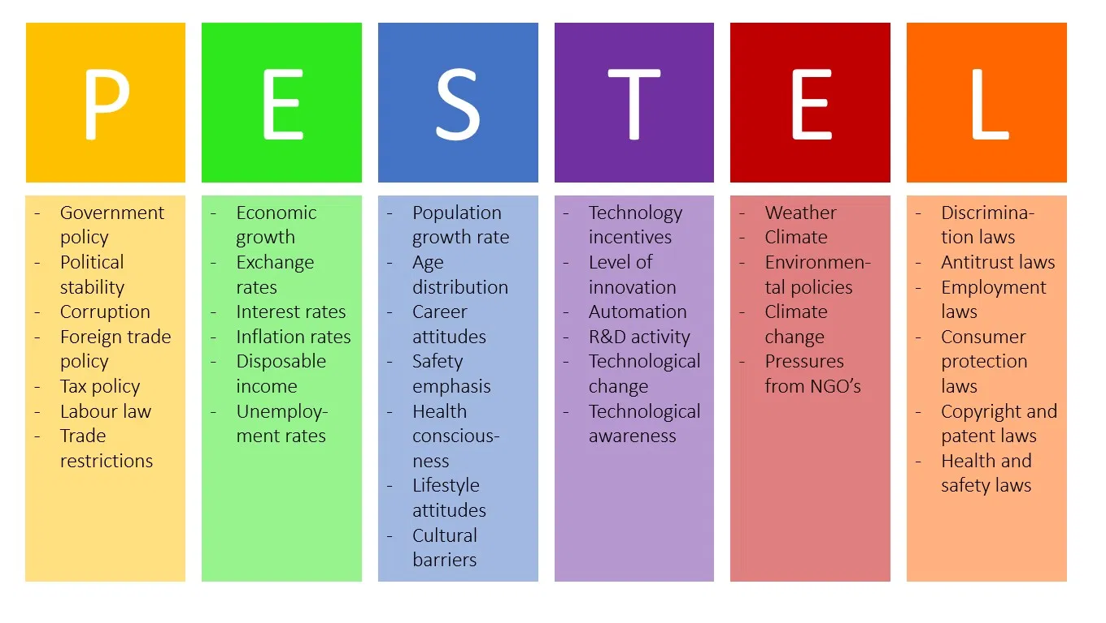
(ThemeGrill, 2018).
Political force: The world of politics includes government guidelines for vehicles and the arrangements they make with various governments. Ultimately, most states create guidelines that either punish people for requesting fossil fuel vehicles or products which are produced unethically, especially in the fashion market (Sampson and Chambers, 2000). This direction has some implications for a company like Zara. Apparently, customers are currently hoping to buy all the products. That is why they have built skills with s own line and a half and clothing produced ethically so that they can adapt to more current trends but still remain known. Brexit would have adversely affected Zara if it were not for the way they are not local suppliers of textile in the UK, for instance. As all things are considered, postponing a smooth and consistent Brexit would have an antagonistic effect on its activities. As Zara spends a lot of time selling unfamiliar, used cars, Brexit is less affected. Despite the fact that there will be an inconvenience if Britain decides on Brexit "Unconditionally".
Economic and financial force: Europe is currently in a terrible financial situation. The dire financial situation leads to a wage deficit, which becomes a lack of interest. This lack of interest is especially true for extravagance products. In addition, in financially unfavourable cases, governments usually evaluate extravagant things at high speed.
Social: Social status is an integral part of an advertising request. Individuals have tendencies and assumptions and both change over time in different societies. Every association that sells vehicles needs to know about the wide range of things that people partner with vehicles with. What configuration they like, what utilitarian needs they suggest the product should meet, what type of product it needs (Harrison, 2014). Zara also needs to consider the foundation, social economy, and requirements of its customers. Just getting amazing value clothing will not be enough. They need to understand if the type of production and approach they receive is the thought their customers need.
Technological force: An internal race in the mammoths of the automotive world continues to see who can make the perfect electronic vehicle or if nothing else that can show improvement over any other person. All organizations invest billions of dollars in innovative work with the goal that their clothing line can be better than others in the market. Audi is the real article on this situation.
Legal force: Germany and the United Kingdom have different directions for cars and subsequently competing companies has to make the clothing in respect of two. As the United Kingdom is undoubtedly a productive market, other competitors of Zara will quickly adhere to the legislative guidelines in order to be able to battle the market. Although it is an extremely important component of nature for a manufacturer or brand, Zara does not have to deal much in this regard, as it supplies textiles from a fully capable and reliable manufacturer who has occasionally had some problems (Harrison, 2014).
Environmental force: All components in the full-scale state are tightly interconnected and it becomes clear as our conversation is pushed forward and we continue to look at the topic of EVs (Harrison, 2014). Traditional clothing that use petroleum products for distribution have a negative impact on our environment, which prompted a point where we have to choose between limited options but the overall development of clothing products.

Porter Forces
This model was created together for an association that quickly evaluates key parts of the market and whether it is productive to enter or stay in the said window. This model will currently be used for fashion business organisations such as Zara to assess its serious condition.
1. Competition in the industry: This is the strength that characterizes the number of associations in the business and how much interest they are fighting. In case there are too many members and the interest is low, this is a very serious market (Warner, 2010). Whether the interest is high, it is still significantly serious.
2. The potential of new entrants: The potential for another section of the market in which Fontan Motors operates is small. In light of the main huge obstacle to entering this industry with the huge cost plan needed to experience and start a vehicle exchange in the UK. It used to be easier to shoot extremely little and develop from that point on, but now, with more rivalry and manufacturers having their own business, it is extremely difficult for another association to enter this market (MacKay, 2011). In addition, there are a large number of guidelines and legal groups must go through to open a vehicle sales centre in the UK.
3. Vendor power: Vendor power is impressively high for this situation, as they can take steps to enter the business on their own. Recently, autonomous suppliers have come under pressure as brands open their own businesses, especially residential brands. Over the years, these organizations have gained notoriety and constructed their brands and do not hesitate to enter the business on their own.
4. Customer power: Customer intensity is not extremely easy to determine with the clothing sales centre industry. Each brand of production and distribution has one of a kind after and respect. In virtually all cases, the reasons why people buy clothing are elusive, especially in extravagant or popular and following current trends. This model thinks about the number of substitutes and options. As far as Zara brand replacements go, there are many.
5. The danger of substitutes: There are different brands that are more common than Zara currently in the fashion showcase in the UK, as indicated by studies. This means that the danger of substitutes is great. In any case, this does not affect transactions without a doubt. As each brand of fashion is committed afterwards, it changes from time to time in size or in different respects. Therefore, in general, for Zara, the danger of substitutes is small.

Marketing Positioning and Marketing Mix Analysis

Marketing Analysis
With a limited ability to focus time, Zara has become a notable name in the field of fast design. The reasons are moderation and style. Although Zara is known for the latest styles, it is also known for its moderate design. Most people love the clothes of the planners but strive to get them because of their high sticker prices. Zara overcame this issue for mid-level buyers. It offers similar plans with lower costs, faster for the market. The result is higher deals and a larger chunk of the entire industry. In any case, it is not known that the brand itself advertises the way the various brands do. Once again, she diligently uses a technique that separates her from different brands and helps to find greater receptivity, fame and fidelity to the brand. In view of the lower costs and the adequately high quality, Zara had the opportunity to gain steadfastness. It doesn't invest so much in the advertising itself, but the brand manifests itself in manners that are unlikely to be obvious.

Marketing Mix
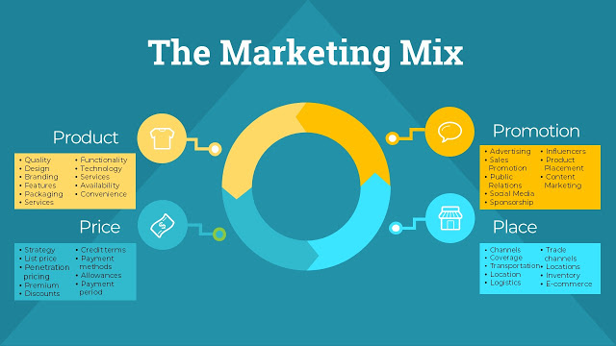
(Business2Community, 2020).

Product
Zara is a fast designer brand - a clothing manufacturer that has gained great development and fame in a short period of time. It recognizes the latest models in design and delivers them quickly to its stores at a reasonable cost. As far as possible, the items cannot be the same as the advertising market, which is based on the fact that Zara conducts its research before delivering any item to specific markets around the world. He sells items that suit the close culture and taste of the people. He is most popular with his latest styles and sloping plans (Harbott, 2011).

Place
Zara has spread to several countries with over 7,000 stores. His 7,000th store opened in Hawaii in 2015. In addition to his stores, he also sells online. In any case, online offers are not extended to all business sectors and are limited to explicit ones. In India, people can't shop from his site, but they can still check out the latest plans and models on their official site. Zara currently hopes to further develop its online deals.

Price
Zara's evaluation procedure is committed to the normal customer, who needs the latest style at a reasonable cost. Zara is a fast style brand that sells smart clothing. His clothing is valued to consider the valuable touching buyers who need the most popular trend, but not at significant cost. A reasonable rating system helped him meet the requirements of an extremely large fragment of stores. The most stylish trend at a reasonable price is extremely mainstream among millennials. This type of assessment methodology also helped in two different focuses. He made an exceptional picture of the brand and developed part of the whole industry faster.

Promotion
Zara's advertising costs are much lower than those of retailers in the normal style. It does not manifest itself as strongly as the others. However, this does not mean that Zara has not committed to promotion in any way. Nevertheless, it offers its image and objects on the market. Tons of advertising happen through verbal. Given the huge choice of styles and reasonable costs, the brand's commitment is high. Zara kept her clients excellent.

Conclusion
Much of the advertising happens through a large number of stores around the world. Customers who visit the stores, which are located mostly in first-class areas, can choose from a large number of styles. Zara's evaluation and dissemination process are indeed a significant part of its progress. They helped him achieve the picture of a reasonable and smooth brand. This helped build fame. Nevertheless, in terms of progress, the brand has skilfully and successfully used various channels such as online life. Thus, people who accept that Zara is not advertising or promoting her image may not really be right.

Reference List
Business2Community (2020), The Marketing Mix – Is It Still Relevant Today? [online] Business 2 Community. Available at: https://www.business2community.com/marketing/the-marketing-mix-is-it-still-relevant-today-02298017. [Accessed: 14/08/2020].
Coomber, S. (2015). Branding. Oxford, U.K.: Capstone Pub.
Daum, J. (2003). Intangible assets and value creation. Chichester, West Sussex, England: J. Wiley.
Hanson, W. and Kalyanam, K. (2014). Principles of Internet marketing. Mason, Ohio: South-Western.
Harrison, A. (2014). Business environment in a global context. Oxford: Oxford University Press.
Heizer, J., Render, B. and Munson, C. (2016). Operations Management. Pearson Australia Pty Ltd.
Hooley, G. (2017). Marketing Strategy and Competitive Positioning. Pearson Education Canada.
Law, C. (2007). Restructuring the global automobile industry. London: Routledge.
Lee, A. (2015). The strategy of global branding and brand equity. Abingdon, Oxon: Routledge.
MacKay, C. (2011). Effective Marketing in Easy Steps. Southam: In Easy Steps Limited.
Russell, E. (2018). The fundamentals of marketing. Lausanne: AVA Publishing SA.
Saarinen, T., Tinnilä, M. and Tseng, A. (2006). Managing business in a multi-channel world. Hershey PA: Idea Group Pub.
Sampson, G. and Chambers, W. (2000). Trade, environment, and the millennium. New York: United Nations University Press.
Schindehutte, M., Morris, M. and Pitt, L. (2009). Rethinking marketing. Upper Saddle River, N.J.: Pearson Prentice Hall.
ThemeGrill (2018). PESTEL Analysis (PEST Analysis) EXPLAINED with EXAMPLES | B2U. [online] B2U - Business-to-you.com. Available at: https://www.business-to-you.com/scanning-the-environment-pestel-analysis/. [Accessed: 14/08/2020].
Warner, A. (2010). Strategic analysis and choice. New York [N.Y.]: Business Expert Press.

