Changemakers: Creativity and Value Creation
Professions (BMHP0514)
Lecturer: Laila Surani
Student mane: Deborah Flores Rodrigues
Student number: 2336878

Table of Contents
- TASK 1 – Key Concepts in Health and Social Care
Introduces innovation, creativity, value creation, and change in health and social care practice…………………………………… 2-3
- TASK 2 – Mind Map on Long Wait Times
Visual representation of causes, impacts, and solutions for delays in healthcare services…………………………………...4-5
- TASK 3 – Group Creativity Exercise
Explores idea generation and selection through divergent and convergent thinking activities…………………………………6-7
- TASK 4 – Case Study: NHS Virtual Wards
Examines a creative NHS innovation providing home-based care and improving patient outcomes………………………...7-8
- TASK 5 – Staff Burnout in London
Analyses causes, impacts, and strategies to reduce burnout among healthcare professionals…………………………...9
- TASK 6 – Digital and Wearable Technologies
Discusses the role of technology in monitoring, prevention, and improving communication in care…………………9-10
- TASK 7 – NHS Leadership Framework & Reflective Journal
Reviews leadership behaviours, encouraging creativity, empathy, and continuous improvement in practice………………….10-11
- Reference list ………………………………………….11-12
TASK 1
Key Concepts in Health and Social Care: Innovation, Creativity, Value Creation, and Change
In health and social care, the ability to adapt, improve, and respond to the needs of individuals and communities is essential. Four key concepts that support effective and sustainable practice are innovation, creativity, value creation, and change. These ideas are closely linked and together promote continuous improvement in the quality, safety, and efficiency of care services.

Innovation
Innovation is the process of developing and applying new ideas or technologies to improve care and efficiency (West and Farr, 1990). In health and social care, it enables services to meet modern challenges. For example, online consultations in the NHS improved access and safety, showing how innovation enhances patient outcomes and service effectiveness.

Creativity
Creativity means generating new and useful ideas to solve problems or improve practice (Amabile, 1996). In health and social care, creativity allows flexible thinking and personalised care. For instance, nurses conducting virtual consultations asked patients to show wounds via video, ensuring accurate assessments and demonstrating how creativity supports problem-solving and quality care.

Value Creation
Value creation focuses on achieving outcomes that matter most to patients while efficiently using resources (Porter, 2010). In health and social care, it promotes sustainable and patient-centred services. For example, telehealth reduced travel time, improved satisfaction, and allowed clinicians to prioritise urgent cases, creating measurable value for both patients and organisations.

Change
Change enables improvement and adaptation through structured processes. According to Lewin’s model, it includes unfreezing, implementing, and refreezing new practices (Burnes, 2017). In care settings, adopting electronic health records replaced paper systems, improving accuracy and safety. This demonstrates how well-managed change enhances quality, efficiency, and long-term organisational development.
Definition: In health and social care, innovation is developing and applying new ideas or technologies to improve outcomes (West and Farr, 1990).
Example from Patrice: For example, NHS online consultations allowed remote access, reducing infection risks. Creativity involves generating useful ideas to solve problems (Amabile, 1996); nurses used video calls to assess wounds. Value creation ensures outcomes matter to patients while optimising resources (Porter, 2010), as telehealth reduced travel time and improved satisfaction.

Why it matters: innovation, creativity, value creation, and change are essential in health and social care. Innovation, such as online consultations, improves access and safety. Creativity allows flexible problem-solving, like video wound assessments. Value creation ensures efficient, patient-centred care, and change, such as adopting electronic records, embeds improvements, enhancing quality and long-term outcomes.
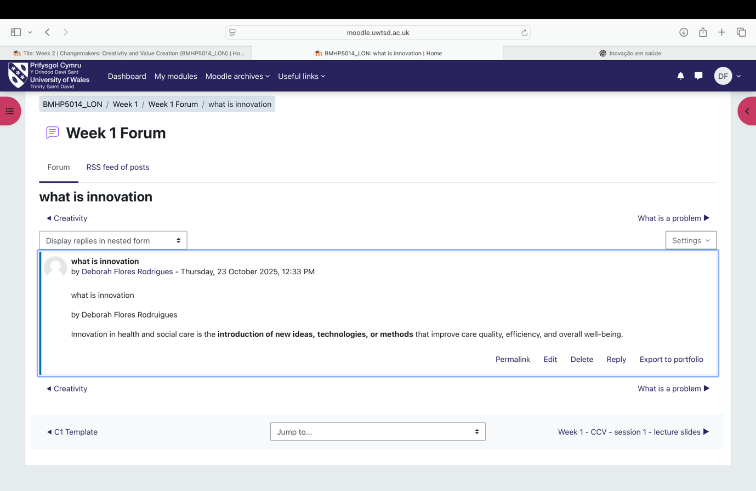

Task 2
Mind Map
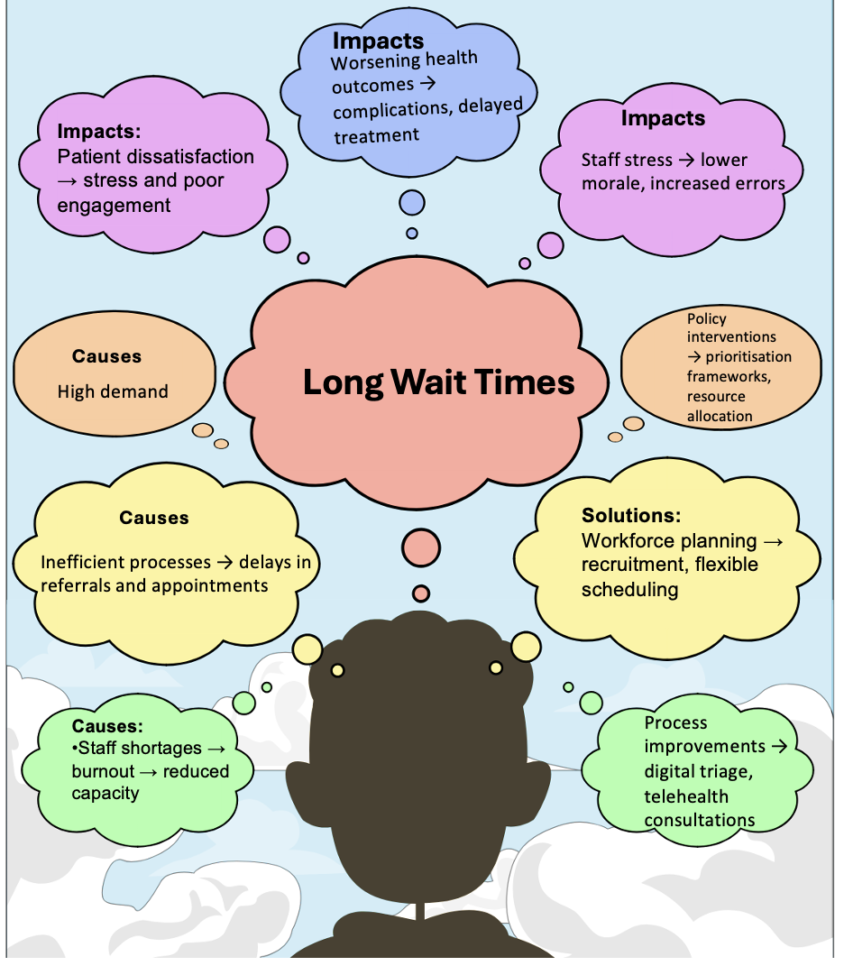
The mind map on long wait times in health and social care visually organises the problem, its causes, impacts, and possible solutions. By placing the problem at the centre, it highlights interconnected factors such as staff shortages, inefficient processes, and high demand, which collectively contribute to delays (NHS England, 2022). Branching out to impacts shows how patient outcomes, satisfaction, and staff wellbeing are affected, creating a cycle of stress and reduced care quality. The solutions branch demonstrates actionable interventions, including workforce planning, telehealth, and prioritisation frameworks. Using the Social Determinants of Health framework emphasises how vulnerable populations, such as older adults or digitally excluded patients, are disproportionately affected (Marmot, 2010). This structured approach clarifies relationships, supporting decision-making and targeted improvement strategies.
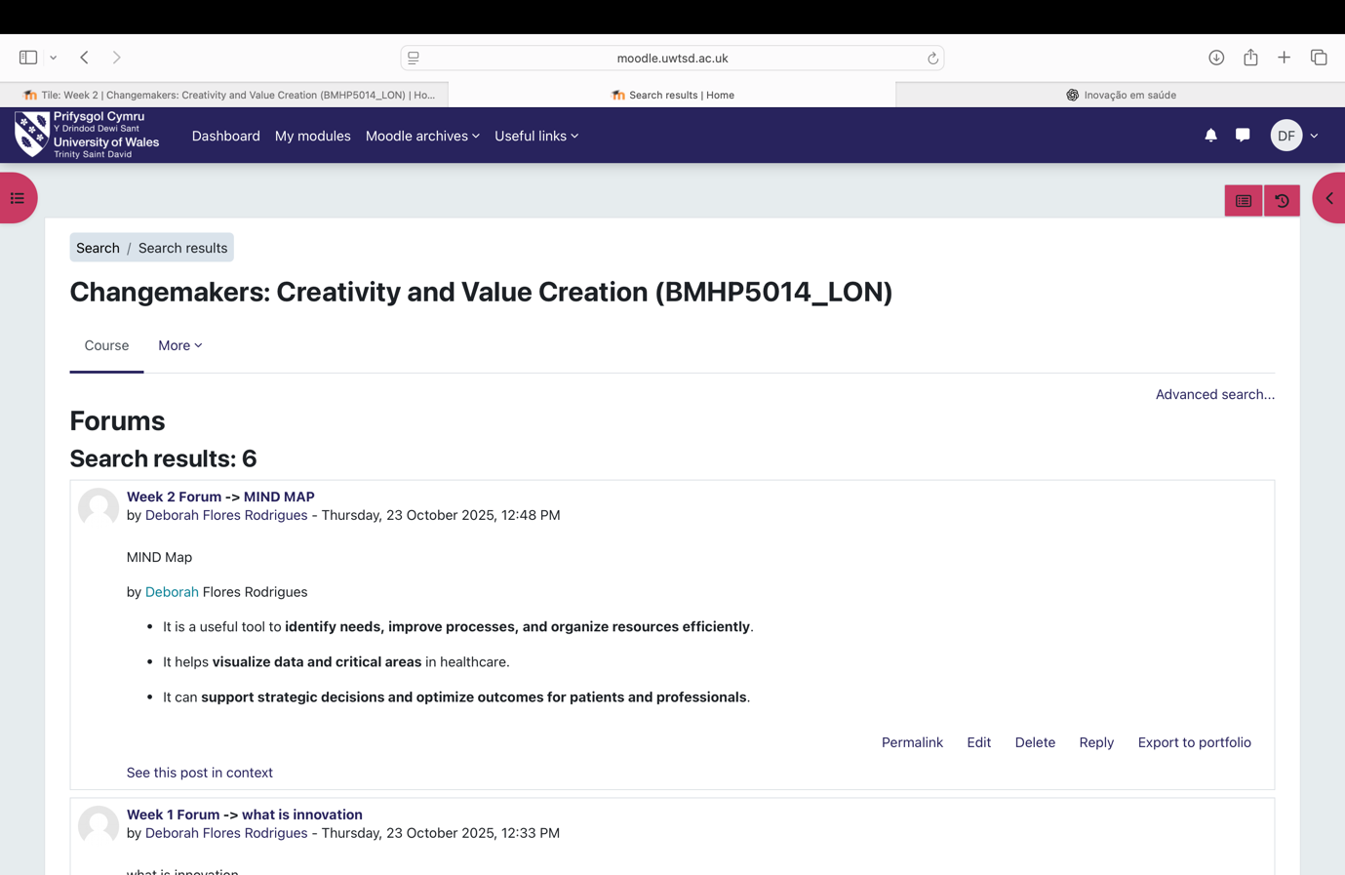

Task 3
Description:
In the group activity, we first used divergent thinking to generate as many ideas as possible and then convergent thinking to select the most practical solution.
Feelings:
At first, I felt insecure, worried that my ideas might seem “out of place.” But as the group created a more open environment, I started feeling more comfortable contributing. During the convergent phase, I felt the need to be more critical, concerned about choosing something unrealistic, which made me a bit tense.
Evaluation:
I enjoyed the divergent process because it encouraged imagination and collaboration. In the convergent phase, we managed to narrow down ideas, but we may have discarded some alternatives too early.
Analysis:
I learned that divergent thinking expands possibilities, while convergent thinking organizes and selects viable paths — processes recognized as complementary in creativity studies (Guilford, 1967; Runco, 2014). Runco & Acar (2012) emphasize that creativity depends on balancing idea generation and evaluation.
Conclusion:
I realized that I can be more confident sharing initial ideas and that my analytical side can help but also limit if used too early.
Action Plan:
Next time, I want to trust my initial ideas more, encourage the group to explore without immediate judgment, and save my critical thinking for the right moment. I also plan to suggest actions that help everyone feel safe sharing ideas, making the process lighter and more balanced

what the solution mortality whit people have a depression
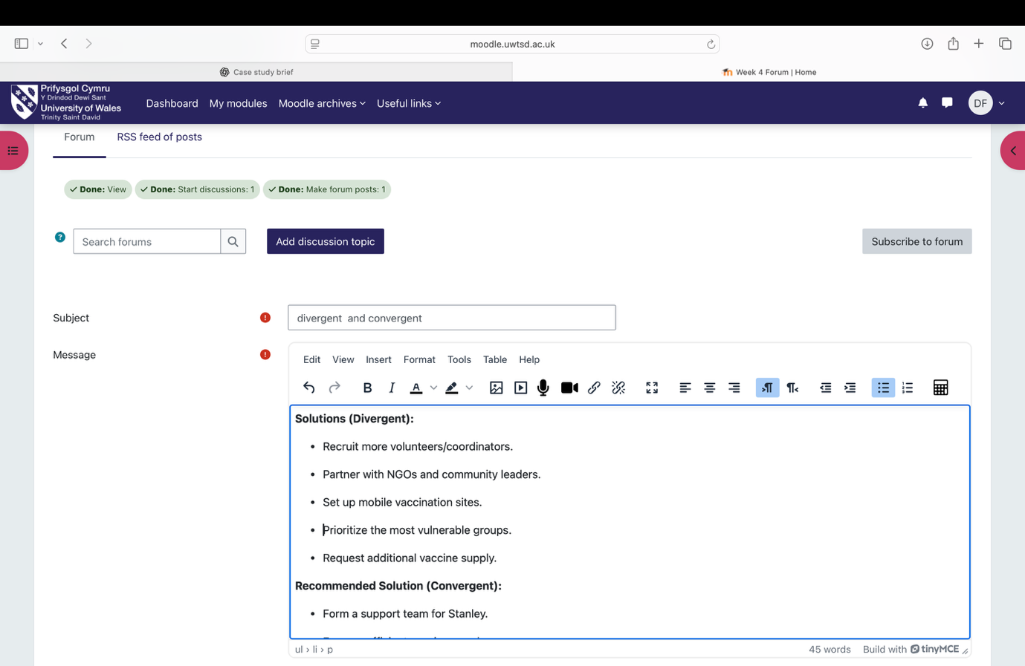\

TASK 4
Case Study Analysis of a UK Innovation
Humanising Innovation in the NHS: Virtual Wards
Virtual wards are an NHS innovation designed to care for patients at home who would otherwise require hospital admission. The problem they address is the strain on hospital beds and the stress patients experience during long stays, particularly older adults and those with chronic conditions (NHS England, 2021). Hospital environments can increase anxiety, reduce independence, and negatively affect wellbeing (Greenhalgh et al., 2020).
Creativity was central in developing virtual wards. Clinicians designed systems combining remote monitoring, digital communication, and coordinated multidisciplinary teams, allowing patients to feel supported in their own homes (Greenhalgh et al., 2020). For example, nurses tracked vital signs remotely and contacted patients promptly if issues arose, providing reassurance and personalised guidance. This creative approach blends technology with compassionate care.
The value created is both practical and human. Patients benefit from comfort, autonomy, and continuity of care, while staff deliver more targeted interventions without overwhelming hospital resources. The system gains efficiency, freeing beds for the most acute cases (NHS England, 2021).
Reported outcomes include reductions in hospital admissions, shorter lengths of stay, and high patient satisfaction. Virtual wards exemplify how innovation and value creation models can improve experiences, safety, and efficiency in health and social care, offering potential for broader adoption across the UK (Porter, 2010).

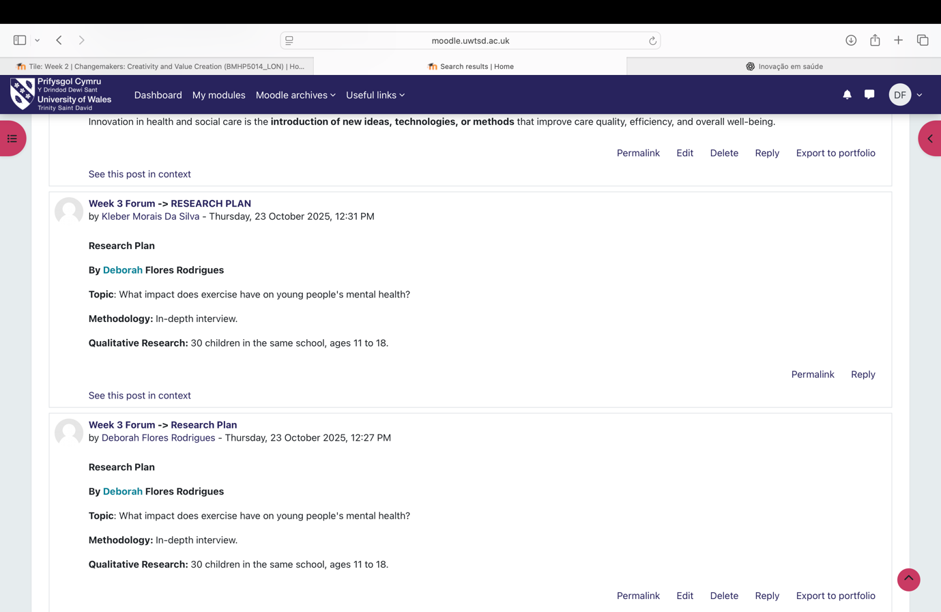
Task 5
One of the main current issues in health and social care in London (and the UK) is staff burnout, particularly among NHS professionals. A prospective cohort study by Gupta et al. (2023) at Queen Mary University of London followed healthcare workers in the UK between 2020 and 2023. The researchers found that higher perceived workplace support and healthier lifestyle habits were associated with reduced emotional exhaustion and depersonalization. Moreover, poorer mental health increased the likelihood of staff intending to leave their role (Gupta et al., 2023).
Another relevant study is a mixed-methods systematic review from King’s College London, which analysed frontline healthcare worker burnout in disaster contexts, including pandemics. The review identified structural factors such as high workload, lack of resources, and insufficient organisational support as main drivers of burnout (Smith et al., 2022). It also evaluated interventions, such as peer support and resilience training, used to mitigate burnout before, during, and after crises (Smith et al., 2022).
These studies show that systemic issues, including excessive demands and weak support structures, drive burnout in London healthcare settings. Addressing this problem requires organisational changes, such as supportive leadership, adequate staffing, and long-term wellbeing strategies (Gupta et al., 2023; Smith et al., 2022).

TASK 6

1) Benefit of using wearable technologies to manage chronic health conditions
Wearable devices, such as smartwatches, allow continuous real-time monitoring, helping patients with chronic conditions make informed decisions about their health and adhere to treatment. For example, a systematic review showed that wearables can reduce emotional exhaustion, improve functional capacity, and even lower healthcare costs by remotely monitoring patients with heart disease, diabetes, and hypertension (Patel et al., 2022). Additionally, self-management devices encourage patients to maintain healthy habits, such as regular physical activity and glucose monitoring, improving adherence to treatment regimens (Hussain et al., 2023). These devices can also send alerts to patients or caregivers when vital signs reach concerning levels, allowing timely and preventive interventions. Wearables thus provide both empowerment for patients and support for healthcare providers.

2) How electronic health records (EHRs) improve communication and collaboration
EHRs enable multiple professionals to access the same record simultaneously, regardless of specialty, significantly improving care coordination. A study demonstrated that EHRs facilitate collaboration between doctors, nurses, and other healthcare professionals, avoiding duplicate tests, reducing medical errors, and promoting shared communication (Jones et al., 2020). In the NHS, EHR interoperability increases patient safety and enhances the patient experience, as critical information about allergies, medications, and medical history can be easily shared among providers (Smith et al., 2024). Additionally, EHRs support data-driven clinical decision-making, helping teams identify health patterns and plan more effective interventions.

3) How digital technology can support preventive care and health promotion
Digital technology reinforces prevention and health promotion through continuous monitoring, data analysis, and personalized alerts. For example, smartwatches can prompt users to increase physical activity, monitor sleep, and encourage healthy habits, helping prevent chronic diseases (Nguyen et al., 2024). A hypothetical program in London could provide smartwatches to people at risk of hypertension. These devices would monitor heart rate, blood pressure, and sleep patterns, sending alerts to healthcare professionals about concerning changes. Integrated with EHRs, this data enables early intervention, prevents cardiovascular complications, and provides personalized support, ultimately improving population health and reducing hospital pressure.
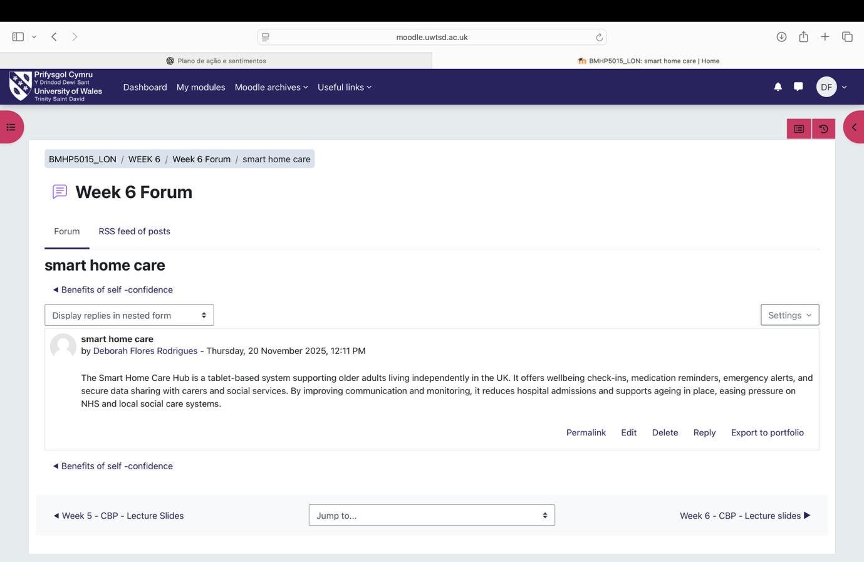
Task 7

Leadership Framework
The NHS Leadership Framework outlines behaviours expected from effective leaders in health and social care. It focuses on creating safe, compassionate, and high-quality services by encouraging professionals to work collaboratively, act with integrity, and continually improve care (NHS Leadership Academy, 2011). Key behaviours include inspiring shared purpose, leading with care, evaluating information, engaging the team, and being accountable. These behaviours are crucial for building trust, promoting innovation, and ensuring person-centred care in diverse communities, such as those in London (West et al., 2015).
One behaviour, inspiring shared purpose, helps leaders encourage creativity and improve patient care. By clearly communicating a vision of high-quality care, leaders motivate staff to share ideas, try new approaches, and support service users empathetically. This behaviour creates psychological safety, enabling teams to problem-solve effectively in fast-paced NHS environments and deliver meaningful improvements for patients (West et al., 2015).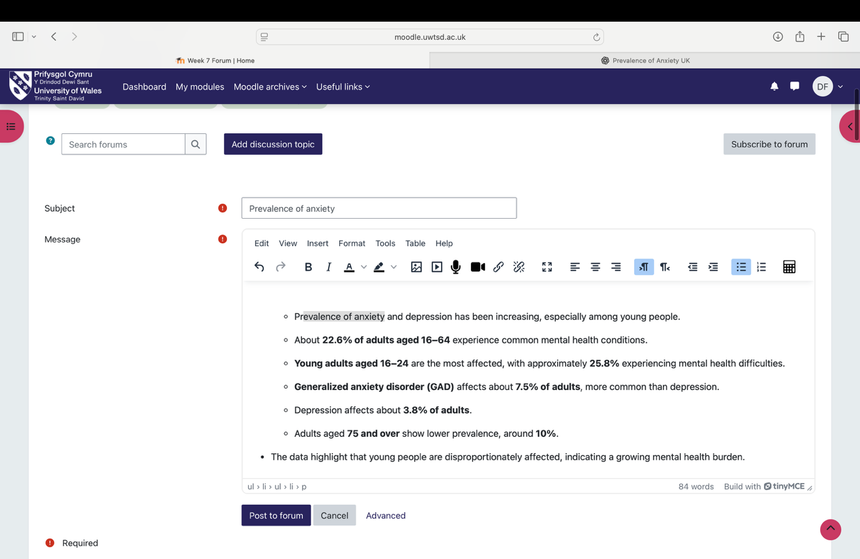

Reflective
During this module, I realized that creativity in health care is not just a desirable skill but something essential to truly make a difference in patients’ lives. I used to think innovation was only about big ideas, but now I understand that small everyday changes like improving communication or finding new ways to support colleagues and patients also matter. Participating in case studies and group discussions made me reflect on my own experiences and showed me that valuing different perspectives is key. I felt how important it is to create an environment where everyone feels safe to share ideas and try new solutions. This has changed the way I see my future role: I want to be someone who listens actively, supports my team, and constantly seeks ways to improve care. I have learned that every action, every decision, can create real value for patients and the team. I feel more confident applying these lessons in my future practice, always balancing care, empathy, and innovation.
REFERENCIAS
Burnes, B., 2004. Kurt Lewin and the Planned Approach to Change: A Re-appraisal. Journal of Management Studies, 41(6), pp.977–1002 [online]. Available at: https://doi.org/10.1111/j.1467-6486.2004.00463.x [Accessed 04 Oct 2025].
Healthwatch Lancashire, 2025. From Innovation to Inclusion, Virtual Wards [online]. Available at: https://healthwatchlancashire.co.uk/report/from-innovation-to-inclusion-virtual-wards/ [Accessed 20 Nov 2025].
MDDUS, 2023. Virtual wards in action [online]. Available at: https://www.mddus.com/resources/publications/publications-library/insight-secondary/q1-2023/innovation-virtual-wards-in-action [Accessed 22 Nov 2025].
NHS Confederation, 2023. Realising the potential of virtual wards [online]. Available at: https://www.nhsconfed.org/system/files/2023-05/Realising-the-potential-of-virtual-wards.pdf [Accessed 26 Nov 2025].
NHS England, 2021. A guide to setting up technology-enabled virtual wards [online]. Available at: https://www.england.nhs.uk/long-read/a-guide-to-setting-up-technology-enabled-virtual-wards/ [Accessed 15 Nov 2025].
NHS England, 2023. Virtual wards enabled by technology: Guidance on selecting and procuring a technology platform[online]. Available at: https://www.england.nhs.uk/long-read/virtual-wards-enabled-by-technology-guidance-on-selecting-and-procuring-a-technology-platform/ [Accessed 22 Nov 2025].
NHS Transformation Directorate, 2022. Tech-enabled virtual wards: relieving pressure on the NHS while caring for patients at home [online]. Available at: https://transform.england.nhs.uk/key-tools-and-info/data-saves-lives/improving-individual-care-and-patient-safety/virtual-wards-relieving-pressure-on-the-nhs-while-caring-for-patients-at-home/[Accessed 18 Nov 2025].
Porter, M.E., 2010. What is value in health care? [online]. Available at: https://scispace.com/papers/what-is-value-in-health-care-45gvn3055z [Accessed 12 Oct 2025].
Porter, M.E., 2010. What is value in health care? The New England Journal of Medicine, 363(26), pp.2477–2481 [online]. Available at: https://www.nejm.org/doi/full/10.1056/NEJMp1011024 [Accessed 10 Oct 2025].

