A written assignment critically evaluating how Assessment for Learning can be utilised in a series of learning opportunities to aid progression across chosen areas of learning and experience.

Introduction
In this written assignment I will be discussing three different AFL (Assessment for Learning) strategies across three different learning scenarios. In my experience I have found it to be very important to vary my AFL strategies. Certain pupils simply do not respond as well as others when using some AFL strategies, for example, more often than not, written feedback and book marking tend to be lost on most ALN pupils as they are less inclined to read the feedback left for them. Another reason that it is crucial to differentiate AFL is that some learning scenarios simply do not allow for some AFL strategies, such using T-mail; an AFL strategy where pupils draw an envelope and colour it green, orange or red and then leave a written comment in the pupils’ books when assessing a PE lesson. It is reasons like these that make it paramount to differentiate AFL strategies in teaching in order to be a successful and effective teacher. I will be planning my lessons based around a control group of 6, Year 4 pupils, aged 8 and 9. They will be labelled as pupils A, B, C, D, E, F. This control group of pupils contains a variety of different needs. Pupil A is ASD, they struggle to speak in front of their peers and find it difficult to ask for help as a result of this. Pupil B has ADHD, making it extremely difficult for them to focus on tasks for extended periods of time. Pupils C and D have no additional needs but do have slightly lower than expected reading and numeracy skills. Pupils E and F are both MAT pupils and tend to need little to no help for the majority of tasks. In my planned scenarios I will plan around these needs and assess the pupil’s learning accordingly. The three AoLEs that I will be discussing are; Mathematics and Numeracy; Languages, Literacy and Communication; Humanities. I have chosen to use these three AoLEs in particular as the topic being worked on is ‘Money Saving Experts’, therefore, the three lessons will all be based around saving money or money as a whole. For the Mathematics and Numeracy lesson the pupils will be completing a work sheet of addition and subtraction, problem solving, questions based around money, this starts the use of decimal places with the pupils as well as giving context to real life scenarios. In the Languages, Literacy and Communication session the pupils will be writing an argument and persuasion text using a title that they have chosen related to saving money, such as, “Should people drive cars?” they will then be writing about positives and negatives around driving cars, for example, rising fuel costs as a negative but convenience as a positive. In Humanities the pupils will be presented with a Google Earth screenshot with a grid over the top, they will then be making a note of which squares have houses with solar panels and the number of houses per square that have solar panels. The group of pupils has already learned the basics of addition and subtraction for the Mathematics and Numeracy lesson and they have already written a plan for their piece of extended writing using a template that was given to them. They have also learned the basics of coordinates, such as the names of the axes and the order to display the numbers, for their mapwork in Humanities. The lessons that I have planned show clear progression but are challenging enough that the pupils will have to use skills that they have learned in recent sessions in addition to skills that they have learned in previous years. It is extremely important to show this combination of existing knowledge and new skills to show continued progression in the pupils.
Literature Review
In this section of the assessment I will be discussing the literature surrounding Assessment for Learning. It is stated that effective teachers “are knowledgeable about their students, adapting instruction to their needs and anticipating misconceptions in their existing knowledge” (Sammons and Bakkum, 2013). I would argue that this statement implies the importance of AFL as it would be impossible to adapt to different pupil needs and to understand their existing knowledge without using AFL. This point is supported by Black and William (1998) when they wrote “Assessment is essential for improving the quality of education and learning”. I believe that Assessment for learning is vital in the progression of pupils; “AFL helps create a sense of self-efficacy (a learner's confidence in their ability to reach targets through hard work and determination). This is an essential quality for learners to develop.” (cambridge-community.org.uk, n.d.). This extract supports my belief. It is also believed that AFL increases pupil confidence, as supported by cambridge-community.org.uk when they stated “AFL techniques, such as peer feedback, can help more able learners to reinforce their learning by explaining ideas to less able classmates.” (cambridge-community.org.uk, n.d.). This statement does, however, imply that pupils should be willing and able to explain concepts to less able peers. This idea, that pupils will share their knowledge with less able peers, is an excellent one, it is further supported by Tullis and Goldstone (2020) when they wrote “students’ answers are more frequently correct following discussion than preceding it … research on peer instruction shows the same patterns: 41% of incorrect answers are switched to correct ones, while only 18% of correct answers are switched to incorrect (Morgan & Wakefield, 2012)”. These statistics truly show the benefit of sharing knowledge with one’s peers as a 41% increase in correct answers after sharing is staggering. The main reasons that Assessment for Learning is used in welsh education are to develop “Ambitious, capable learners”; “Enterprising, creative contributors”; “Ethical, informed citizens”; “Healthy, confident individuals” (hwb.gov.wales, 2020). Hwb.gov.wales (2020) also states that the reason we use assessment is to support the progression of all learners from the age of 3-16. It is becoming increasingly apparent that the primary purpose of AFL in Wales is all about pupil progression. It is also stated that “Assessment has three main roles in the process of enabling learner progression:
- supporting individual learners on an ongoing, day-to-day basis
- identifying, capturing and reflecting on individual learner progress over time
- understanding group progress in order to reflect on practice.”
(hwb.gov.wales, 2020). This piece of information is crucial to anybody becoming a teacher because it illustrates the sheer importance of AFL in the Curriculum for Wales 2022. It tells us that a single assessment cannot accurately show the abilities of the learner and that it must be a continued process. This point then brings up a rather pertinent question. Why do we assess older pupils within the 3-16 continuum using singular examinations? If the Welsh government website itself states that pupil assessment must be carried out over time. In relation to this the website, debatewise.org (2009) states “what this system encourages is practicing … in the hopes of mastering tests and not the subject” and if the true goal is to assess a pupil’s learning in different subject areas then surely the use of examination papers to assess students is outdated and does not coincide with the AFL guidance in the Curriculum for Wales 2022. Based on a paper by Nortvedt, Santos and Pinto (2015) it can be seen that “teachers seemingly struggle to develop and use AfL practices. This phenomenon is not country or culture specific (Black & Wiliam, 1998).” If this is the case then maybe the current format of AFL is not the way forward in education in Wales. They do also, however state “it is well known that systematic AfL helps students learn” (Nortvedt, Santos and Pinto, 2015). It is important to use a variety of Assessment for Learning strategies when teaching because a varied approach ensures that the pupils are experiencing a holistic learning approach which ensures that pupils who do not benefit as much as others when using a certain AFL strategy will not get left behind but will still benefit from another strategy. It is also important to note that, in my personal experience, many pupils engage very well when they feel that the teacher really cares about their learning and engages on a deeper level than simply ticking a book and writing a comment. For this reason, strategies such as the traffic light system; a method whereby pupils state green for happy; orange for not there yet and red for little to no understanding, are very effective in encouraging pupil engagement. It is also, however, important to remember to use other strategies in order to assess less confident pupils who are not as confident speaking up in front of their peers. Even though it is important to encourage all pupils to be confident but that some pupils need more support than others.
Discussion of lesson planning decisions
In this section of the assessment I will be discussing the three AoLEs I have chosen for Pupils A, B, C, D, E and F and why I have chosen them. Before I begin discussing these AoLEs it is important to note that the topic being investigated by the pupils for the term is ‘Money Saving Experts’. Throughout the term the pupils have worked across multiple AoLEs to produce their final product which is an information booklet about saving money, conserving energy and using fewer fossil fuels.
The first AoLE that I have planned a lesson for is Mathematics and Numeracy. The lesson is an addition and subtraction lesson using pounds and pence. The introduction to the lesson is a segment where I, the teacher, stand in front of the class and write an example question on the whiteboard. I then ask the pupils to take me through step by step of what needs to be done. Baring in mind that the pupils have already done work on addition and subtraction. The pupils will be working on these questions at the same time on their whiteboards so that they are repeating the process. After this introductory section of the lesson the first AFL strategy of the lesson, I simply ask the pupils to put their thumbs up, to the middle or down to display how well they understand. Once I have done this the pupils who put their thumbs up will put their whiteboards away and collect their books and a worksheet. There are three differentiated worksheets, labelled as “*”, “**”, “***”. In my experience using a system where the pupils can choose their own worksheets greatly improves independent learning as if the pupils do not understand the sheet they have chosen they can choose one of a lower difficulty. While the pupils who put their thumbs up are beginning to do the work I will be doing another example question with the pupils who did not. Once this is complete these pupils will choose a worksheet and begin their work. I will then sit with Pupils A and B, who are both ALN, to assist them with their work. Pupil A struggles to ask for help as they are uncomfortable speaking up around their peers. As a result of this I find it particularly effective to perform progress checks on them regularly. Pupil B has difficulty focusing on written tasks in their book, because of this I find that allowing them to work questions out using plastic coins is an effective tool in their learning. Throughout the lesson I will be moving around the classroom, intermittently, practicing my second AFL strategy. The second strategy is ‘Live Marking’. I find that moving around the classroom and marking books while the pupils work allows me to prevent the pupils from misunderstanding the task and get anyone who has made a few mistakes back on track. It also allows me to asses less confident pupils, such as Pupil A, who struggle to ask for help. While I am sat with Pupils A and B, Pupils C and D who are slightly below expected level will be sat with Pupils E and F who are MAT pupils so that they can share ideas when needed. As the session is coming to a close the pupils will put their books away and sit down on the carpet. At this point I will employ my third AFL strategy which is using ‘Our Learning Journey’, a traffic light system that is displayed on a mountain. I will ask three different pupils how confident they are with the topic. I find this strategy useful as it allows me to understand where the pupils are with their learning to give me a strong basis on how to plan for the next lesson based in this AoLE.
The second lesson I will be discussing is part of the Languages, Literacy and Communication AoLE. In this lesson the pupils will be writing an argument and persuasion text. Pupils A and B will be given the title, ‘Should people drive cars?’. Pupils C and D will have the choice of three titles; “Should people drive cars?’; ‘Should people use electricity?’; ‘Should people use solar panels?’. Pupils E and F will be allowed to pick a title of their choice provided it is relatable to the topic of ‘Money Saving Experts’. All pupils have already written a plan for the piece of extended writing. To begin the lesson, I will explain the task to the pupils. I will then utilise the first AFL strategy of the session by explaining the success criteria to the pupils and having a discussion with them to ensure that they understand it. The success criteria that the pupils will use has two blank circles next to each point for use in alignment with another AFL strategy later in the session. Once the success criteria has been discussed with the pupils they will collect their work books and glue in the success criteria. The pupils will then utilise their plans that they have previously made whilst following the success criteria in order to ensure that they are on the right track. I have found that using a success criteria is particularly effective in extended writing tasks within the Languages, Literacy and Communication AoLE as it gives the pupils a concise guideline of what should be included in their work. While completing other tasks within this AoLE I found that Pupils A and B respond better when they have something to look at and work from so I have found that working with these two pupils on a whiteboard is particularly effective. I will have a discussion with them and write their ideas into sentences for them to structure into their text. While Pupil A does struggle with speaking in front of their peers, they are more easily engaged when it is a discussion as opposed to asking for help. Pupil B will need a lot of encouragement in order to complete this task in the form of reminders to concentrate on the task. Pupils C, D, E and F will be working from their plans independently. I will once again employ the use of ‘live marking’ in this session by moving around the classroom and reading pupils work as they progress to ensure that they are correctly understanding the task. Once the pupils have completed the task they will then be asked to colour in circles on the success criteria sheet that they have glued into their books in either green, orange or red to display how they felt they did with each point on the success criteria. I will then fill in the second circle next to each point in the success criteria in order to show the pupils how I felt their work has gone in the session. I find that the use of this ‘traffic light’ strategy alongside the success criteria works perfectly as it allows all pupils to receive feedback in a way that does not require for them to read a written comment. I will then once again use ‘our learning journey’ once the pupils are settled back on the carpet by selecting three different pupils to tell me how they feel the lesson as a whole. The reason I will use a traffic light system twice in the same lesson is that one is for specific points on the success criteria while the other is for how they feel about their work and the lesson that has been delivered.
The third AoLE I will be discussing is Humanities with cross curricular links to Mathematics and Numeracy. The lesson that I have planned for the pupils is based around map work, primarily grid-references. The pupils will be have a sheet with a screenshot of their local area taken from Google Earth with a grid superimposed over it. To begin the lesson, I will activate prior learning by doing a simple grid-referencing activity with the pupils on the interactive whiteboard to ensure that the pupils have a solid understanding of the topic and the orders in which to display them (X, Y). All six pupils already have a good understanding of the axes. The pupils will then choose a worksheet. As with the Mathematics and Numeracy lesson the sheets will be differentiated and will be marked with “*” or “**”. Once the pupils have their sheets they will collect their work books and will begin working. They will be examining the maps and finding which grid-references contain houses with solar panels and then writing how many houses in each square have solar panels. The purpose of this task is to improve their real-life skills such as map skills while also linking to their topic of finding ways to save money. Pupils A and B will be presented with the “*” sheet to give them the best chance at completing the task successfully. I will be mainly situated with these pupils throughout the lesson to make sure that they are on track. I will, however, be moving around the classroom once I have established that Pupils A and B have a good understanding of the task. I will once again be using ‘live marking’ as a strategy in this lesson as it gives me the best chance to rectify any issues quickly and explain to the pupils where they went wrong. Pupils C and D will be working cooperatively as I believe they will share good ideas with each other and provide their best work in this way. Pupils E and F will be working independently in order to challenge themselves and provide good evidence of what they are capable of. Once the pupils have completed the task I will ask them to glue their sheets into their books. When the pupils are ready I will go through the answers with them so that they can self-assess, the second AFL strategy of the session. I believe self-assessment will be the perfect tool for this session as the work is not expected to take too long for the pupils to complete and will be a good way to end the lesson. I do, however, believe that self-assessment needs to be cross-examined to avoid the alteration of answers or cheating. For this reason, the final thing I will do in this session is to check the pupils’ marking to make sure they have been honest in their self-assessments.
Over the course of this section of my assessment I have discussed a few different AFL strategies, however, the three I would like to highlight specifically are ‘live marking’, ‘our learning journey’, and the ‘thumbs up strategy’. The reason I wish to highlight these three in particular is because I feel that they simply work the most effectively. I think ‘live marking’ is an amazing tool due to the fact that it allows me to engage with pupils on a one-to-one basis quickly and efficiently while also allowing me to help pupils who are uncomfortable or embarrassed to raise their hands. I also believe ‘our learning journey’ is an excellent tool as it allows for the pupils to voice their opinions on how they feel the lesson went rather than me telling them and as it is used at the end of a lesson it allows for me to plan the next session in the AoLE accordingly. Finally, I believe the simplicity of the ‘thumbs up strategy’ is excellent, it allows me to get a real feel for the understanding of the pupils about a topic without having to have pupils who are uncomfortable speaking speak. I think all three are excellent but especially when used alongside other AFL strategies.
Conclusion
Throughout this assessment I have discussed AFL in depth and discussed how I have used it in practice. I have discussed different literature and also explained how I have employed different AFL strategies in my own teaching. It is important to note that teachers will find that they notice the best results when using a variety of strategies. Using different strategies has assisted my growth as a teaching professional immensely, especially when pupils are sharing their thoughts on a particular lesson. I have also discussed the literature surrounding assessment for learning and used quotes from a variety of sources in order to support my opinions. I have also found that while teaching I find myself using AFL strategies that I have not planned for and that they occur naturally when not thinking of them as a strategy but simply talking to pupils. For this reason, I will continue to use AFL both intentionally and unintentionally in my teaching as I feel that all of the pupils that I have taught have developed and progressed while in my lessons. I have found that regardless of what AoLE I am delivering there is an effective AFL strategy to go alongside it which, once again truly benefits all of the pupils. I have shown that AFL can be used by anyone for everyone. In my personal experience, as long as the lesson is tailored to a pupil’s ability, they can and will succeed with the right amount of support.

Appendices
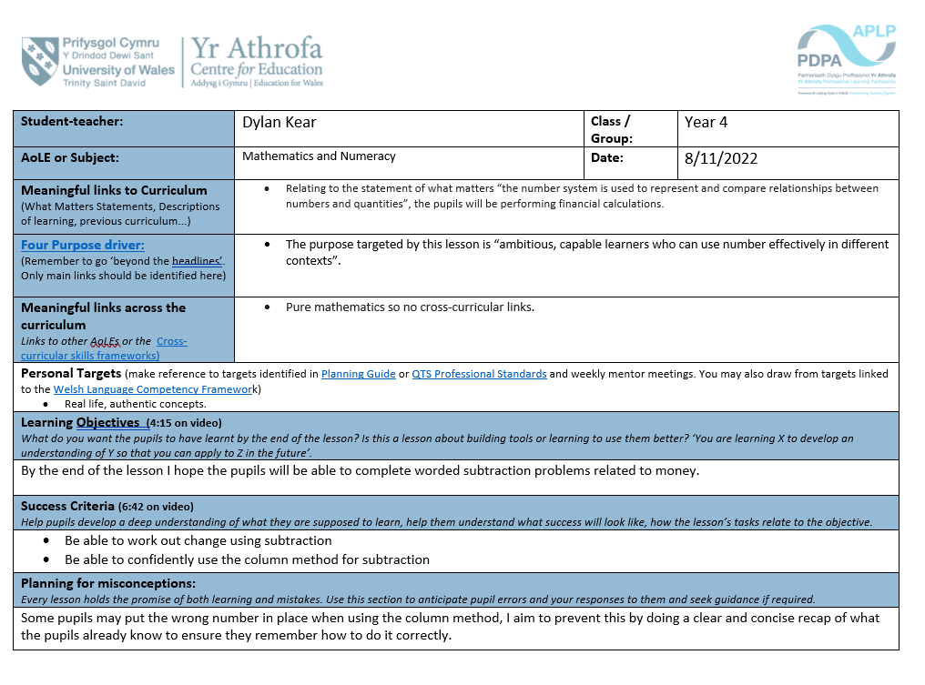
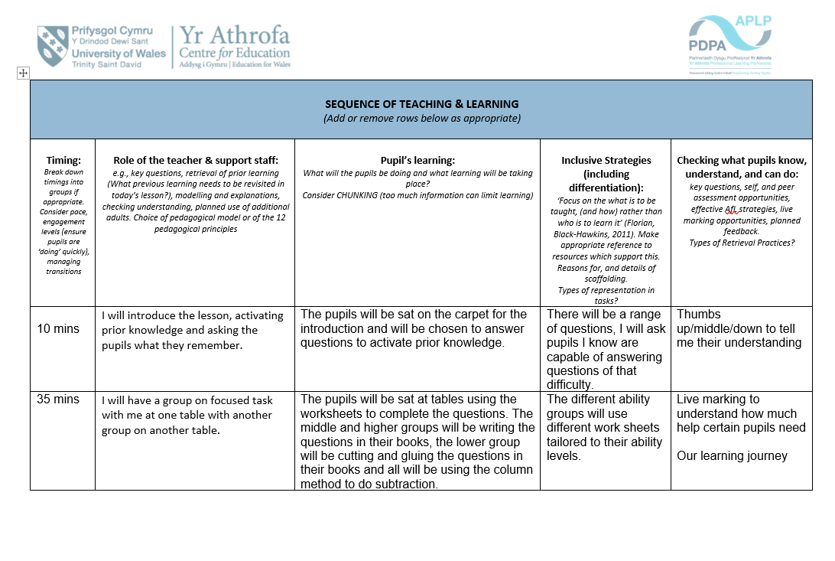
- Mathematics and Numeracy

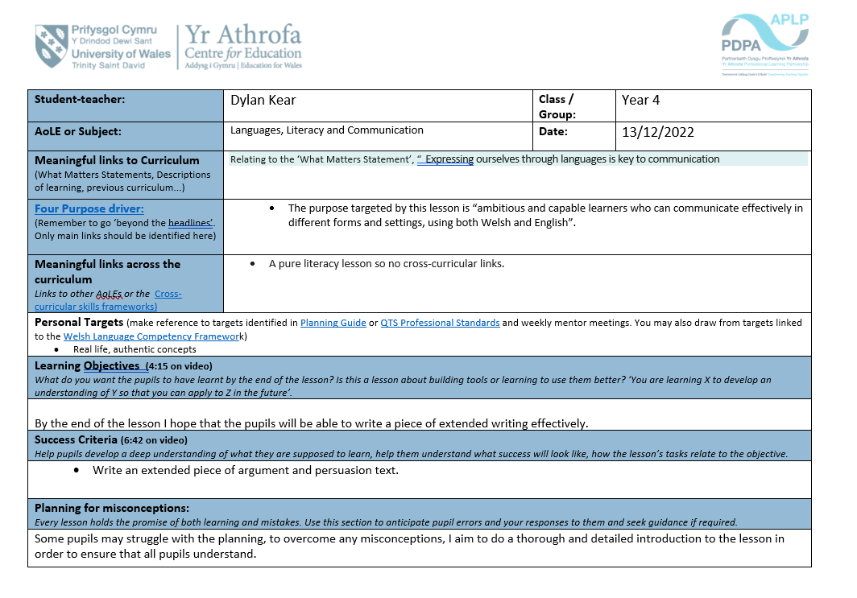
- Languages, Literacy and Communication

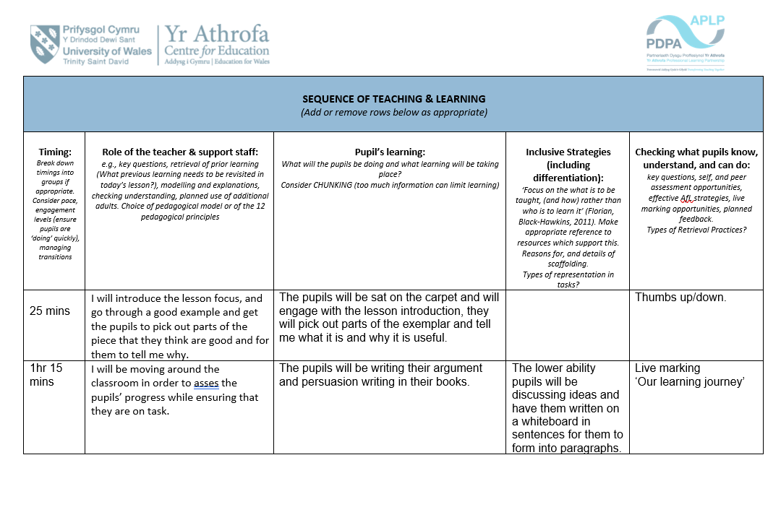

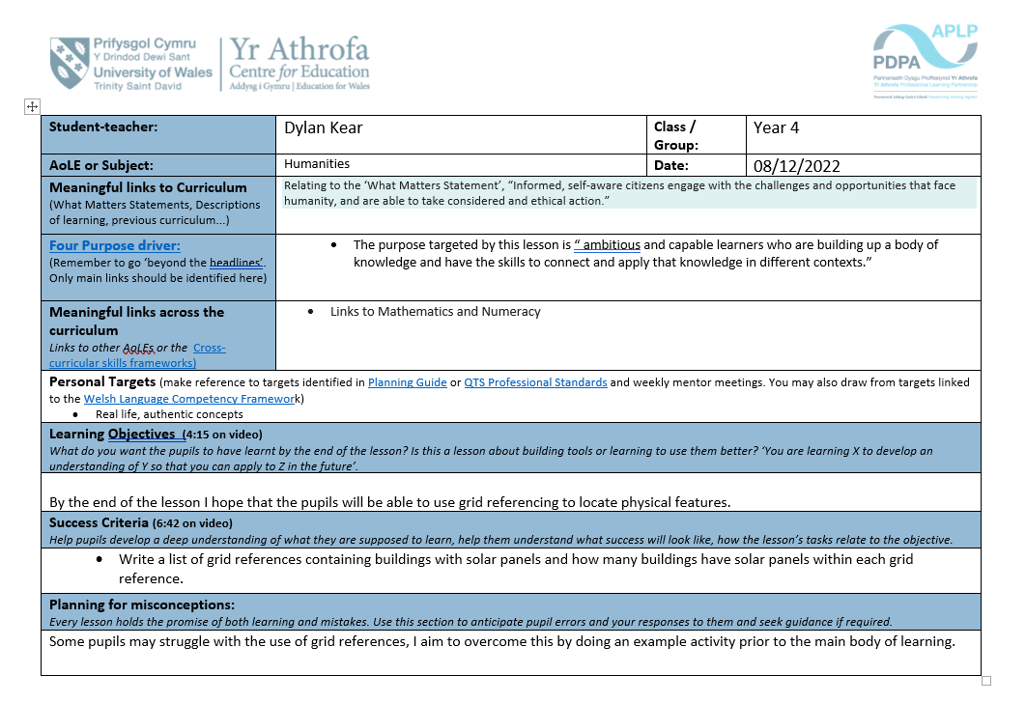
- Humanities

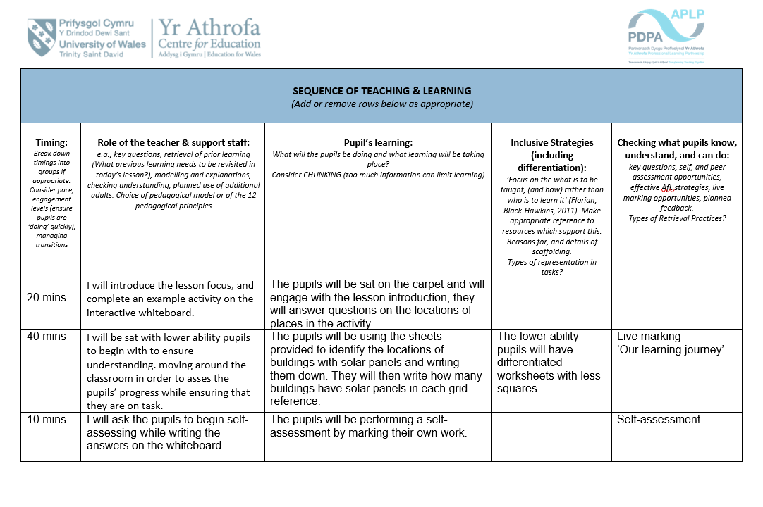

Bibliography

Black, P. and Wiliam, D. (1998). Assessment and Classroom Learning. Assessment in Education: Principles, Policy & Practice, [online] 5(1), pp.7–74. doi:10.1080/0969595980050102.
cambridge-community.org.uk. (n.d.). Getting started with Assessment for Learning. [online] Available at: https://cambridge-community.org.uk/professional-development/gswafl/index.html#:~:text=AFL%20helps%20create%20a%20sense [Accessed 6 Jan. 2023].
DebateWise. (2009). Are Examinations a Fair Way of Testing Our Knowledge? [online] Available at: https://debatewise.org/1215-are-examinations-a-fair-way-of-testing-our-knowledge/.
hwb.gov.wales. (2020). Supporting learner progression assessment guidance - Hwb. [online] Available at: https://hwb.gov.wales/curriculum-for-wales/assessment-arrangements/supporting-learner-progression-assessment-guidance#key-principles-and-purpose-of-assessment [Accessed 7 Jan. 2023].
Morgan, J.T. and Wakefield, C. (2012). Who Benefits From Peer Conversation? Examining - ProQuest. [online] www.proquest.com. Available at: https://www.proquest.com/docview/1021183548?pq-origsite=gscholar&fromopenview=true [Accessed 6 Jan. 2023].
Nortvedt, G.A., Santos, L. and Pinto, J. (2015). Assessment for learning in Norway and Portugal: the case of primary school mathematics teaching. [online] Taylor & Francis Online. Available at: https://www.tandfonline.com/doi/citedby/10.1080/0969594X.2015.1108900?scroll=top&needAccess=true&role=tab.
Sammons, P. and Bakkum, L. (2013). Effective teaching: a review of research and evidence. [online] Available at: https://files.eric.ed.gov/fulltext/ED546794.pdf.
Tullis, J.G. and Goldstone, R.L. (2020). Why does peer instruction benefit student learning? Cognitive Research: Principles and Implications, [online] 5(1). doi:10.1186/s41235-020-00218-5.

