Programme | CertHE Skills for the Workplace
Module | Effective Team Working and Communication
Student’s ID | 2018315
Module code: | BMSW4002
Lecturers Name | Lloyd Beharry
Submission Date | 05 September 2021

Table of Contents
Introduction 1
What is Communication 1
Why Communication is Important 1
History of Communication 1
How Communication works 2
Models of communication 2
Shannon Weaver 2
Schramm’s Model 3
Berlo’s Model 4
Case study 1 4
Case Study 2 5
Communication Skills 6
Speaking 6
Verbal Communication 6
Non – Verbal Communication 6
Listening 7
Types of Listening 7
Barriers 8
Conclusion 8
References: 9

Introduction
Communication is as old as human civilization. In the early days, man use to communicate with his fellow beings by means of sounds, signals, gestures in the absence of language. Communication changed the way we live today. With communication, mankind has been transformed to be the most developed group on the earth. Effective Communication - (Tutorialspoint 2021).
In Good Communication skills – (In Businesstopia 2018). Stated that “The world cannot go round without communication, it is a must in every aspect of life” they went on to say despite this, people still have difficulties communicating.

What is Communication
What exactly is communication (MOOC ICS 2013). “Communication is each act of transmitting information – including thoughts, ideas, and emotions”. Effective Communication - (Tutorialspoint 2021). “Communication is the activity of conveying information.”
Ben Davies (2021). Defines communication as “Giving, receiving or exchanging ideas, information, signals or messages through appropriate media, enabling individuals or groups to persuade, to seek information, to give information or to express emotions.”

Why Communication is Important
The importance of communication is being able to communicate with people without distortion or distraction. But Ben Davies (2021). Said communication is the most important life skill in which, people with good interpersonal skills are strong in verbal and non-verbal and tend to be good in interacting with people.

History of Communication
According to Alhazred A. (2019). States that before the formation of a telephone and telegraph company in 1885 in America, there have been other forms of communication like oral stage communication, writing printing through the electronic age to the present-day communication.
The oral communication by human beings was by gesticulation and instincts used in a way they could understand each other. The writing was first used by the Sumer in Mesopotamia in 34000 BC. It also helps in trade and was used as passing messages.

How Communication works
Communication works by using the following components to transmit the message.
- Sender – the deliverer of the message
- Messenger – the content of the message
- Channel of communication – the method or transmission of how the message is delivered
- Decoding – the interpretation of the message by the receiver
- Receiver - the person getting or receiving the message
- Feedback – Feedback is normally optional but, in some cases, the receiver might want to give feedback
According to the indeed editorial team (2021), “Steps and communication of the communication process” explained how communication works as follows.
The sender develops an idea to be sent.
The sender encodes the message by translating it into a form that could be understood by someone else.
The sender decides how the message is to be sent by choosing a channel or medium
After the medium or channel has been chosen the message then begins the process of transmission
The message is then received by the receiver either by hearing, seeing, feeling, or any other type of reception.
The receiver decodes the senders’ message by interpreting and converting it into thought by analysing it and trying to get meaning out of it.
The receiver gives feedback if necessary to complete the two-way communication process.

Models of communication
There are three models are as follows:
- Shannon Weaver
- Schramm
- Berlo

Shannon Weaver
Businesstopia (2018). Describes Shannon Weaver Model as the complete process of sending and receiving the message but said that noise as physical disturbances could distort the message this they attribute to the environment, people, and so on thereby not allowing the message to get to their receiver.
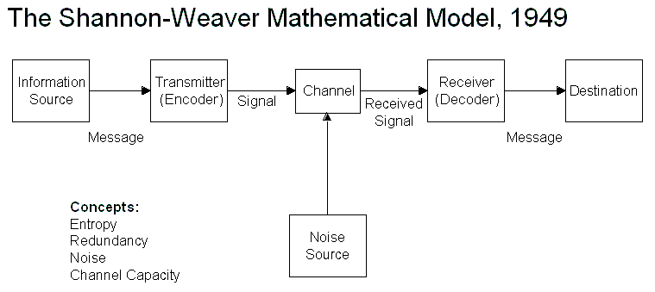
Source: Businesstopia (2018).

Schramm’s Model
Schramm’s model was formulated in 1954 after the Shannon Weaver Model. Schramm argued that there should be feedback after the message has been received for a clearer understanding of the context of the message. He described the message as a loop from the sender to the receiver. See below diagram.
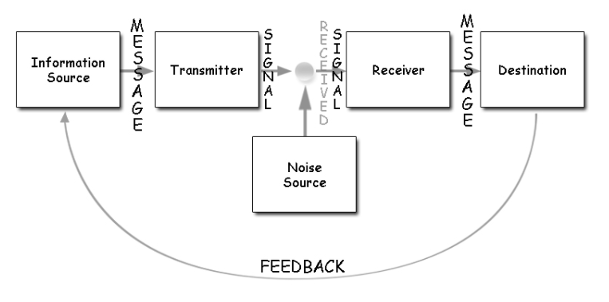
Source: businesstopia in Communication (2018).

Berlo’s Model
David Berlo develops this model in 1960 after both Shannon Weaver and Schramm have been formulated.
He describes factors affecting the different components in communication – sender, message, channel, and receiver. He said that all these components are affected separately for effective communication. See the below diagram.



Case study 1
Teacher and the Student
A home teacher called one of his students to tell him that they will be clearing and completing the “Mess” Maths topic today but because the student was hurrying into the class from the break, he hurriedly answered the call. But after the call, he was wondering what mess the teacher wants him to clear and finish. But when he got home, he asked the teacher where the mess are he wanted to clear. The teacher said he did say “Mess” I said Maths that we have to clear the remaining topic to finish the maths teaching.

Q: Why did the student misunderstand the teacher
He was hurrying not listening to what the teacher was saying
Q: Whose Model of communication explains this confusion and why
Shannon Weaver. There was no feedback from the student and there was outside noise.
Q: Whose model of communication explains how it could have been avoided
Schramm’s model. There should have been feedback to confirm the message
Q: How could this have been prevented
Berlo’s Model. It could be a social or cultural thing. Different cultures pronounce things differently

Case Study 2
Professor and the Village people
The Professor’s house was on fire he ran to the village people for help.
But because of the level of his education and the type of English spoken by the professor the village could not understand him hence his house burnt to the ground.
The professor’s words were
“‘The edifice is being consumed by a great conflagration!’
‘The edifice is being consumed by a great conflagration!’
The village people looked at him and continued doing what they were doing
‘Don’t you understand?’ He said. ‘‘The edifice is being consumed by a great conflagration!’
They ignored him.

Q: Why didn’t the village people help the Professor?
Because they did not understand what the professor was saying
Q: What could he have done to get them to help him?
He would have communicated to them in a simple language they understand or better still use sort of sign language
Q: Whose model of communication do you think can explain this situation and why?
Berlo’s and Schramm’s Model would have explained this. He would have used one of the communication skills of sign language or come down to the villager’s knowledge/level so they could understand what he was trying to say. There is no feedback in case of Schramm

Communication Skills
Indeed, Editorial Team (2020). Defined Communication skills as a process to allow someone to understand and be understood by others during communication. They iterated further to say that it could be communicated to others, friends, and confident disposition. for communication to be effective there should be clarity, empathy, relaxation, and appearance. Communication skills could be used in giving and receiving various kinds of information. This could include speaking – Verbal and Non-Verbal, Written, and listening.

Speaking

Verbal Communication
(Quintanilla and Wahl in Maund et al., 2017) As defined, Verbal communication encompasses both our words and our verbal fillers. By Editors (2018) Verbal communication is the use of words and language to convey messages. Although verbal messages are created through words through speaking or written, the speaker should be able to convey the meaning to the listener in an effective way for both parties to understand each other. Both should understand that speaking words could be conveyed wrongly due to many factors thereby leading to listeners’ inability to understand what the speaker is talking about. Examples of verbal communications are speech, presentation, phone calls. Giving information, group discussion, and giving a presentation or a report

Non – Verbal Communication
According to (Quintanilla and Wahl in Maund et al., 2017) Non – Verbal communication does not use words for passing messages instead it uses body language – or better still is a communication other than written or spoken language like signs and signals that creates meaning for someone. (Ivy & Wahl, 2014, p.5 cited in Andrew M, 2017 p. 69). According to (Lavan, 2002 cited in Andrew M, 2017 p. 67) stated that “about 55% of interpersonal messages are conveyed nonverbally, he said this seems logical because most human beings are visually dominant and live in a society dominated by visual images and always believe the evidence as seen.
According to (Argyle 1988 cited in Quintanilla, Kelly M p. 25) suggested that non-verbal behavior serves four purposes – emotion, interpersonal attitude, one’s personality like character, disposition, and temperament, and accompanying verbal communication. (Ekram 1965 cited in Quintanilla, Kelly M p. 25) stated that, verbal and non-verbal can complement each other by repeating what has been said in verbal in non-verbal communication. Non-verbal communication includes nodding the head, facial expression, Eye contacts, and gestures.

Thumbs up and smiling
Happiness and things are looking good – example of Non-Verbal communication

Listening
According to (Crockett 2011 cited in Maund, Andrew, 2017) says that the average person remembers between 25% and 50% of what he or she hears. That means that when you talk to friends and family members or your boss or customers, they are likely to retain less than half of the conversation. this is due to the ability to listen well. It could also mean different diversity of people and the environment and, Listening is a fundamental and complex part of the communication process.
In Andrew M. (2017) listening requires someone to concentrate on the verbal and non-verbal messages being sent and to determine the meaning of those messages. Listening is very important in business and professional communication thus allowing effective communication to play out. Effective communication comes with active listening which includes, putting aside any preconceived ideas, creating an open mind and active engagement with the speaker. For active listening to be more effective it requires attention, commitment, and availability on the part of the listener. During active listening, there are techniques that should be followed, these include reflecting, showing support, checking, and clarifying whatever the speaker has to say.

Types of Listening
There are three types of listening – Informational, Critical, and Empathetic. informational is when you listen for acquiring knowledge e.g., student learning. Critical is where you listen to make decisions. Empathetic is for somebody to be able to understand how someone else feels by putting yourself in someone else’s place.

Barriers
Below are a few listening barriers that can occur during communication.
Noise – this could be external such as audible talking, shuffling of papers, and a phone ringing. They are always very difficult to eliminate this noise but do whatever is possible to reduce or limit them.
Failing to Focus – this usually happens when someone is reading or going through the phone when someone is speaking to you.

Conclusion

Beside words in communication, there is also the combinations of tone, body, and sign languages. All these could also be used effectively in communication in sending messages across to the receiver. Eye to eye contact is another form of indirect communication for passing or conveying message across.
Communication is useful in all form of gathering like the society, schools, and workplaces using different ways in communicating. Words that are not effectively communicating may cause misunderstanding, damage, or conflicts. Accepting yes as a response should be done with caution as it could mean No pending on how the question is relayed and how the receiver understands it. Because of this, three model - Shannon Weaver,Schramm, and Berlo were used to describe how communication could be used and understood.
These models help to break barriers in communication for easier classification and understanding.
Finally, communication is a culture thing – the way one culture view or understand a message and received it is different to another culture of different believe and value.

References:
Alhazred A. (2019) A brief history of communication. Available at: https://www.historyandheadlines.com/a-brief-history-of-communication/ (Accessed 25 October 2021).
By Editors (2018) Verbal communication definitions Business Terms Available at: https://businessterms.org/verbal-communication/ (Accessed on 27 October 2021).
Effective Communication -(Tutorialspoint 2021) Available at: https://www.tutorialspoint.com/effective_communication/effective_communication_introduction.htm (Accessed: 24 October 2021).
Good Communication Skills (in Businesstopia, 2018) Available at: https://www.businesstopia.net/blog/good-communication-skills. (Accessed 24 October 2021).
Indeed, Editorial Team (2020) What are communication skills? Available at: https://uk.indeed.com/career-advice/career-development/communication-skills (Accessed on 28 October).
indeed editorial team (2021) “Steps and communication of the communication process” Available at: https://www.indeed.com/career-advice/career-development/communication-process (Accessed 25 October 2021).
Maund, Andrew, (2017) Certificate in higher education: skills for the workplace student yearbook SAGE Publications.
What exactly is communication (MOOC ICS 2013) [video]. Available at: https://www.youtube.com/watch?v=S7CN9Trw43w&t=3s. (Accessed: 24 October 2021).
(Quintanilla and Wahl in Maund et al., 2017) Certificate in higher education: skills for the workplace student yearbook SAGE Publications Ch. (4), pp. 67.

