Fozia Shabir (2019385)
UNIVERISTY OF WALES TRINITY SAINT DAVID
BMHP5014_BIRM
Task- 1
Lecturer- Robert Nartowski

BSc Health and social care
Changemakers: creativity and value creation
E-portfolio evidence of learning comprising of 2 separate artefact items

Table of Contents

Introduction 2
Poster 0
Mental Health in Employees and Student - Blog 0
What is mental health? 0
What is the cause (Risks and effects)? 0
What support is available? 1
How to raise awareness for people with mental health? 1
Summary 2
Poster 2
Blog 2
Reference list 4

Introduction

In the following assignment, the author will be showing two different ways of raising awareness in mental health by using the campaign such as poster and blog to set goals and clearer understanding and knowledge about mental health and how it effects people in their day to day life and how is it serious and dangerous. By doing this campaign, the author wants to give people a understand about the support that is available for them and how it can easily help them in discovering how to help themselves and families and friends could help their loved ones by showing them that the support is available for them and there are not alone, by doing this the author believe that it will help prevent people in having mental health, such as depression, self- harm, anxiety & panic attack, PTSD (post-traumatic stress disorder), PMDD (premenstrual dysphoric disorder), SAD (seasonal effective disorder), OCD (obsessive- compulsive disorder) and many more these could be found on the NHS websites.

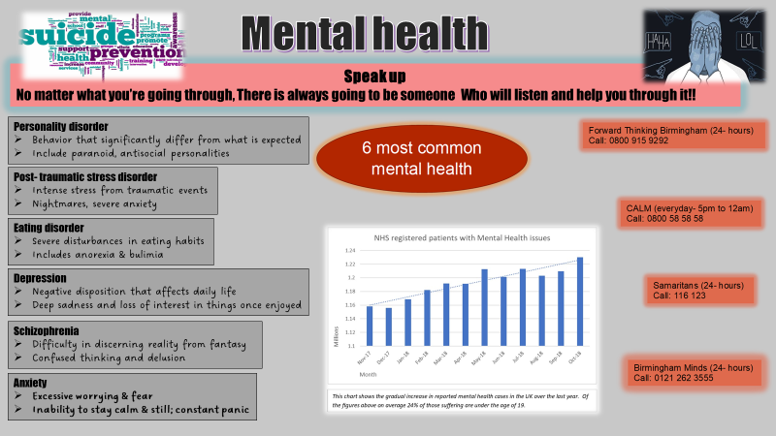

Mental Health in Employees and Student - Blog

What is mental health?
Health problems are caused by large workloads which can cause employees to stress, when stressing this causes the employees to loss interest faster on their work and makes it difficult for them to continue their day to day routines. The main health problem that can be cause by stressing are lack of exercises, poor diet plans and high level of stress causes many employees to have high blood pressure and a unhealthy lifestyle. This will also cost employees a lot of money as their would need to paid for they medical treatment.

What is the cause (Risks and effects)?
Having uncontrollable workload at the work place, can cause stress to many employees as they have to take the work home to complete after working hours and this impacts them negatively between their relationships as some employees main worry will be their workload before their family. This increases stress and anxiety that makes it hard for the employee’s to focus or have motivation for long term. Some employees are unable to focus on time management or changes in the work routine or have difficulties in manging the change this causes stress as they have to go out of their comfort to complete their task and to meet deadlines as well as to maintain their change. Such as Minds (2017), said “ Although lifestyle factors including work, diet, drugs and lack of sleep can all affect your mental health.”
The main changes that causes conflicts and stress for employees during their work place are environment change being moved to a different section of work or having to move places to another business office, working hours as employees could find it difficult in maintaining their personal life when having to change plans because of change of their working hours for example having to work in the evening when the employee use to work morning, this will cause them stress in cancelling their future plans as well as them having to change their routine to fit around the work life.
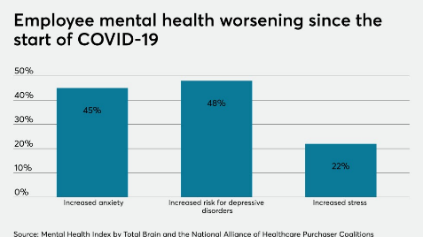
In the bar chart below, it shows how covid-19 has worsened mental health in employees such as anxiety, depressive disorder and stress levels.

Image by Place (2021)

What support is available?
There are many resources available to support people with mental health. For young adults and children there are several counselling available for them at schools, college and could also find them by a private counsellor. Support is available face-to-face as well as online people who find it difficult or feel uncomfortable to communicate others face to face their helplines available within Birmingham for example; Samaritans, Birmingham minds, CALM, Forward thinking Birmingham. There are therapies available for people with long term or short term mental health as well as medicine and psychiatry to help people with mental health as said on the NHS (2022) website, “Talking therapies, or psychological therapies, are effective and confidential treatments delivered by fully trained and accredited NHS practitioners. They can help with common mental health problems like stress, anxiety and depression.”

How to raise awareness for people with mental health?
Learning about the different signs that can help people in showing and alert them about mental health and what are the causes and effect of them. This will help them understand how to help themselves or people around them with mental health and how their can encourage them in finding a better way to tackle their mental health and help them emotionally and physically by encouraging them in going to therapies and mentors to help them see a better point of view.
Mental health could start as small as not sleeping on time (also known as sleeping disorder) to the worst suicide and self-harm. These could be prevented from early stages looking for signs such as mood changes, being more lonely and eating less or more than usually, sleeping more or less, not at all. These are some common ways of checking if you or people around you have mental health and how to find help are easy online or text or by call they are many ways of finding the right help that is required.
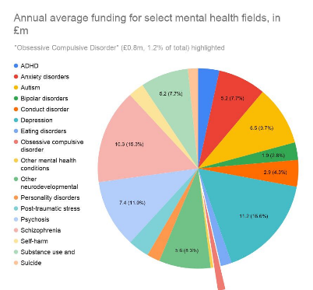
As Felman and Tee-melegrito, (2022) said “Mental health is a state of mental well-being that enables people to cope with the stresses of life, realize their abilities, learn well and work well, and contribute to their community.”
In the Chart, as it shows the amount of funding raised for people with mental health, it shows the quantity and different type mental health.

Image by Guiness (2020)

Summary

Overall in the following e-portfolio, the author has shown reasons of the mental health and how it can people could find help and why it is important for everyone to know the different signs of mental health and find ways to prevent them from getting worst or serious within adults, young adults and children. Generally many people are victims of mental health that are caused by many reasons such as personal (families, relationship), Social isolation (loneliness), Childhood Abuse (Trauma or neglect), employment (over- working, unemployment or losing your job), domestic violence (bullying) and bereavement (losing someone close to you).

Poster
In the poster, the author is giving some common information of mental health on people as well as the available helplines for people with mental health to receives free support and have more privately, free less stressed or worried about their personal information being shared with anyone. The author would go forward with collecting the funding that is required to successfully alert people with mental health, how and where their can find information and help for their situation. The author would be raising funds by donation such as; go fund me websites and charity donations. Organising events that are based around awareness about mental health and this will help people in discovering all the different help available for them, Some of the helplines that are available within Birmingham are known as;
- CALM (This campaign is available for men aged 15- 35 who are living miserably)
- Samaritans (This campaign is a confidential support for people experiencing feelings of distress)
- Birmingham Mind (This campaign promotes the views and needs of those with mental health problems)
- Forward thinking Birmingham (This campaign is a mental health service for children and young people aged between 0- 25 years old)
By using this campaign as a poster around the UK, we will be able alert more people of where they can find help and what are most 6 common mental health that effect people and there are many more as on the NHS they have showed or listed 31 different type of mental health and on the website it shows other support available as well.

Blog
The author has written in the blog why there is higher level of mental health in employment and schools, colleges and university students. As young adults and adults find it difficult in maintaining work and students at the same time as their personal and social life. As the author has mention within the blog the different reasons about employees and student mental health and how this can be prevented correctly and in the right full manner. By doing such, the author has set a awareness about mental health and how these effect their life day to day and their routine can be effected by doing such.
People with mental health can receive lots of support, the awareness that the author want to raise between adults and young adult at their work placement and their school, college and university is to make sure that their have the correct knowledge about the support available for them at their work and school, college and university. Such as having; welling being support available for them, having more frequently meeting with their students and employees and having any cause or reasons for stress that could start mental health, as there are many forms of mental heath and many causes of them, these could start as simple as overworking, stress and depression to prevent them or catch them in early stages is making sure to check any symptoms and effects that you can find on many websites such as NHS and Government.
In the blog, the author has also showed a few charts, graphs about how mental health has only gotten worse than before covid-19 in employees and it causes and effects people a lot because they are unable handle more task in hand, such as change of environment, over working and many more causes stress, anxiety and depression that could also transfer into more worse and dangerous. This blog is setting awareness to people about mental health in the work placement and how it can affect them in their day to day life and how it can cause them to lose truth within themselves and get moody and aggressive towards others and prefer being alone rather then other people. Isolating themselves from others and becoming alone, not meeting dates or attending work.
In general raising awareness in mental health is important, as people need to understand how dangerous mental health is and why it effects people’s day to day life. They are many people who believe mental health does not affect them because of age but that’s not true because young children could go through Trauma such as parents fighting or argument within families that leads to more adulthood trauma, mood swings, anger and does not trust easily that causes problems between work and studies. Knowing there is support available for them that they would not be judged and will receives the right help that’s available for them and how it will impact them in a positive way for a better future.

Reference list

Minds, (2017), Mental health problems- an introduction [Website] Available at: https://www.mind.org.uk/information-support/types-of-mental-health-problems/mental-health-problems-introduction/causes/ (Accessed: 24/10/2022)
NHS, (2022), Talking therapies, medicine and psychiatry [Website] Available at: https://www.nhs.uk/mental-health/talking-therapies-medicine-treatments/ (Accessed:24/10/2022)
NHS, (2022), Mental health conditions [Website] Available at: https://www.nhs.uk/mental-health/conditions/ (Accessed: 24/10/2022)
Felman. A, Tee-melegrito. R. A, (2022), What is mental health? [Website] Available at: https://www.medicalnewstoday.com/articles/154543 (Accessed: 27/10/2022)
Guiness, E (2020), “its like a lottery for the mind”- added pressure of mental health care during covid-19 [Website] Available at: https://www.swlondoner.co.uk/news/06072020-its-like-a-lottery-for-the-mind-added-pressures-on-mental-health-care-during-covid-19 (Accessed: 27/10/2022)
Place, A (2021), best of the week: time for a workforce mental health check-up [Website] Available at: https://www.benefitnews.com/list/checking-in-on-employee-mental-health (Accessed: 27/10/2022)
Government, (2022), mental health support [Website] Available at: https://www.gov.uk/search/all?keywords=mental+health&order=relevance (Accessed: 27/10/2022)
Minds, (2022), Types of mental health problem [website] Available at: https://www.mind.org.uk/information-support/types-of-mental-health-problems/ (Accessed: 27/10/2022)

