UWTSD
WISA

Evolution of aerodynamics in motorsport
Academic skills, ACHA4005
By Kairan Bennett (2305389)
11, oct, 2023

Contents
1 Introduction ii
2 Background iii
3 Discussion iv
4 Conclusion vii
5 References viii

Introduction
This report will discuss the importance of constant evolution in motorsport but really focused on the aerodynamics of the vehicles. Also, this will compare multiple different sources to look at not only the accuracy of the sources but if they agree on the importance of certain developments. Some of the areas this report will touch on is performance, materials used, process of design (CAD) and the environmental factor. This report will aim to highlight the reasons and how aerodynamics has improved in motorsport over time. I am also going to discuses how big of a factor aerodynamics has on the bigger picture of motorsport such as lap times or are other factors the reasons for most of the change. And if that evolution will continue at the same right or will it become stationary. And its wider impact on the motor industry.
I am also weighting this to hopefully further my own knowledge and understanding of the topic as aerodynamics is one of my interests.

Background
1950s, the average lap speed of F1 car was around 70 mph by the 1990s, that number had risen to more than 190 mph. The reason behind this is the advancements in the aerodynamics of the cars. The reason this race for higher cornering speeds came about was the engines at the time had hit a sort of ceiling with the naturally aspirated engines although they would move to a twin turbo design in the 60s and 70s the performance gain from ground affect and body aero kits had been put on show for the world to see and could not be ignored.
The wings are one of the most important arrears of the cars they create downforce, The front wings on the car can produce 25-40% of the car’s downforce. www.formula1-dictionary.net and the diffuser, increases the amount of airflow under the car.*www.azom.com The materials used in these components nowadays is manly carbon fibre this is because it is lightweight and yet can withstand high louds in most directions this is ideal because of course the lighter the better but a modern day carbon fibre wing can produce 2000 N of force at 250 kph *www.azom.com In 1968 Monaco Grand Prix Colin Chapman fitted a small curved sheet of metal to the front of Graham Hill’s Lotus to add balance it is unknown how much this improve the car but this was the start of adding aero packages to improve lap time but he did go ahead and win that race and later the season this was mainly down to Colin Chapman understanding of ground affect and balance in the car under high loads. CAD (computer-aided-design) CAD was first used in the 1990 season by Tyrrell and since then every team use some form of CAD. The benefits of CAD are it allows designs to be tested under real race conditions without building; it also allows the part to be tested on its own and as a unit.
The use of wind tunnels in Formula 1 has been a crucial aspect of aerodynamic development since the early days of the sport. Wind tunnels are specialized facilities that simulate the aerodynamic conditions a race car experiences on the track, allowing teams to study and refine the design of their vehicles for optimal performance.
In the 1970s, wind tunnel testing became more prevalent in Formula 1 as teams sought to gain a competitive edge through aerodynamic advancements. The ability to control and manipulate airflow over a scale model of a car provided valuable insights into the impact of various design elements, such as wings, diffusers, and body shapes.
The FIA (Fédération Internationale de l'Automobile), the governing body of Formula 1, has implemented regulations to control the use of wind tunnels and prevent an arms race in aerodynamic development. These regulations limit the size and capabilities of wind tunnels, as well as the amount of time teams can spend testing in them.

Discussion
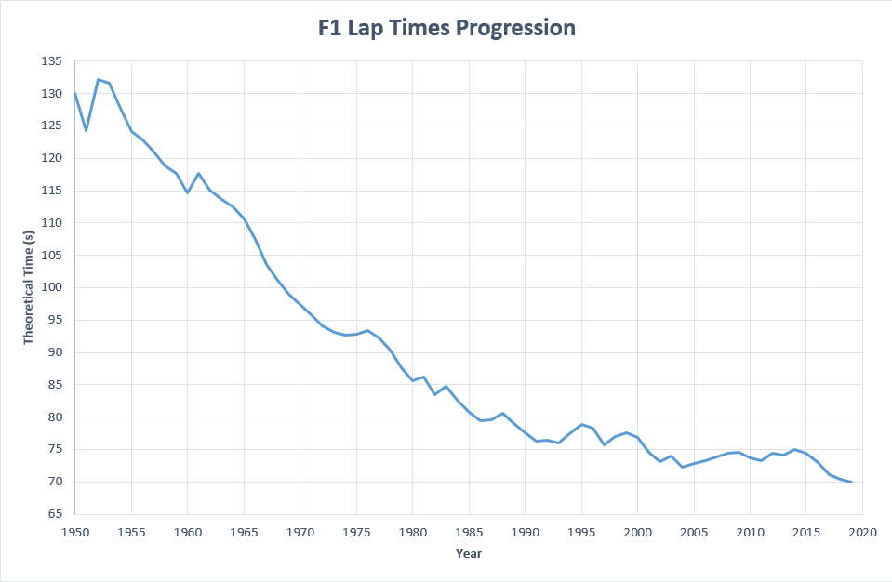
figure 2-1 show the average theoretical lap times over 50 years in f1.
Figure 2—1
As we can see the lap time have dropped significantly. So why is this? In my opinion it has a massive part of that decrease is due to the technological advancements in aerodynamics. I think this because the tracks are roughly the same as 50 years ago, yes, the track surface has got better but the fiscal shape/distance are vertical the same now as they were back then. The teams have become so efficient at manipulating the air flow over and under the car that corning speeds have drastically gone up. And these lap times have been set with a decrease in engine size from v12s to v10s to v8s and now v6s and the modern cars weigh a lot more than the older cars, due to the wight limit. The wight limit is to accommodate all the safety equipment and ensure drivers and spectators are always safe. These safety process where not as prevalent back in the 50s to 70s so the cars were a lot to run a lot lighter.
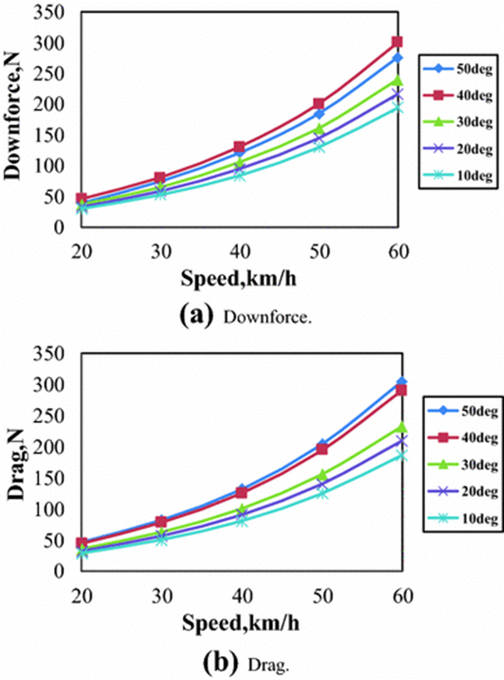
Figure 2—2
Figure 2-2 shows the number of newtons of downforce a car produces against has quick its speed was around the corner. And the bottom shows drag in N against cornering speed and the variation in colour signifies the angel of the corner in degrees.
As we can see the more downforce the car has the faster it goes around the cornet this sports my clam earlier on when I suggested the same theory. But these graphs also show a correlation between more downforce and more drag. So, this means there must be a balance between how much downforce to apply onto the car because a higher amount of downforce around corners is grate but on strengths the drag will slow the car right down. This is the case for almost all of the cars aerodynamical parts. Most of an f1 cars aerodynamics comes from the principle of pushing the car into the ground (downforce) but something called ground affect channels airflow under the car and creates a low-pressure zone which pulls the car to the ground allowing grater grip and traction though those corners but doesn’t have the same amount of drag slowing the car down on the straights. This idea has only just come back to f1 due to it being band after Ayrton senna’s fatal crash in 1994. Ground affect was blamed for a lot of the crashes back then due to the cars bottoming out and becoming unstable. https://www.sportshistoryweekly.com/
However, the progression of aerodynamical parts are usually restrained or altogether band by motorsports governing bodies as we saw with ground effects and the blown diffuser/double diffuser in 2009 and 2010s f1 seasons. So we could say that could be one of the reasons progression has been slowing down as it gets harder and harder to gain lap time with the same restrictions
Figure 2-1 https://www.reddit.com/
Figure 2-2 https://www.researchgate.net

Conclusion
In this report I have covered the background of aerodynamics in motorsport; where and when it came from, its prosses and the evolution of them, why there is a serious demand for better aerodynamics and the results/ improvements stems from having more developed aerodynamics.
In my opinion aerodynamics has come so far from back in days where they would stick a massive wing on top of the car. The understanding of the finest details in aerodynamics can lead to grate success. I chose to mainly talk about f1 because it is the most competitive environment and the pinnacle of aerodynamical evolution. All the teams are competing to make the fastest race car under the regulations so the tiniest breakthrough can lead to championships.
I think we can see that the massive gains in lap time have tailed off. So yes, the evolution has slowed down, but this means we are extracting almost the full potential that there is available under the rules.
The effect of the development of aerodynamics on the wider motoring industry is massive mainly the manufacturing prosses such as CAD and CAM machines these are now used in almost all engineering company’s now and a lot of, they came from motorsport or at least was heavily improved in motorsport.

References

(Page 2 downforce) Seas (no date) Formula 1 dictionary, Formula 1 Dictionary. Available at: https://www.formula1-dictionary.net/ (Accessed: 17 November 2023).

(Page 2 downforce) Dam, S. et al. (2023) Material science: News: Materials engineering: News, AZoM.com. Available at: http://www.azom.com/ (Accessed: 17 November 2023).
(Page 2 newtons) Dam, S. et al. (2023) Material science: News: Materials engineering: News, AZoM.com. Available at: http://www.azom.com/ (Accessed: 17 November 2023).
(Page 3 background) Agathangelou, B. and Gascoyne, M., 1998. Aerodynamic design considerations of a Formula 1 racing car. SAE International, 724, pp.1-4.
(Page 6) Sports history weekly (no date) sportshistoryweekly.com. Available at: https://www.sportshistoryweekly.com/ (Accessed: 17 November 2023).
(Page 6 figure 1) (No date) Reddit. Available at: https://www.reddit.com/ (Accessed: 17 November 2023).
(Page 6 figure 2) Find and share research (no date) ResearchGate. Available at: https://www.researchgate.net/ (Accessed: 17 November 2023).

