Case Study: Mapping Cancer prevalence in Wales
Data Requirements:
- Cancer Data
- Epidemiological Data
- Population Data
- Geospatial Datasets such as boundary data, geographic units for wales
- Health data

Data Acquisition
The data were acquired online from data available on open database compiled by Government Health Organizations and NGOs’
The data sources explored are
- The Welsh Cancer Intelligence and Surveillance Unit’s (WCISU)
- DataMapWales – Gov.wales (Welsh Government services and information)
- StatsWales – Gov.wales (Welsh Government services and information)

Data Formats:
Geographic Data – Shapefiles – Easy to use, and compatible with the software to be used (Boundary data and geographic units)
Attribute Data: Data presented in Excel sheets/formats. They can contain geographic coordinates which can be used to represent the data attributes geographically - Cancer Data, Population data, socio economic data.
Data Source | Data Obtained | Purpose in GIS Workspace
The Welsh Cancer Intelligence and Surveillance Unit’s (WCISU) | Cancer incidence data | Analyze the spatial distribution of cancer cases across Wales.
The Welsh Cancer Intelligence and Surveillance Unit’s (WCISU) | Cancer mortality data | Examine cancer-related deaths and survival rates.
StatsWales – Gov.wales (Welsh Government services and information) | Population estimates by local health boards and age | Offers population data, demographic information, and socioeconomic indicators that can be linked with cancer data for spatial analysis and identifying patterns.
DataMapWales – Gov.wales (Welsh Government services and information) | Geospatial datasets, shapefiles: Local Health Boards - LHB Post Apr 2019 (Low Water Mark) | Provides authoritative geospatial datasets, including boundaries for administrative units (e.g., local authorities, health boards), necessary for spatial analysis.
StatsWales – Gov.wales (Welsh Government services and information) | Adult lifestyles by local authority and health board | Provides data on lifestyle of adult, including data of smokers across Wales to assess their relationship with cancer prevalence in different areas

Table showing explored data sources, data obtained and how it would help build GIS workspace

Data Type | Data | Data Source | Data format | Link
Cancer Incidence | Cancer Incidence In Wales, 2002-2019 | The Welsh Cancer Intelligence and Surveillance Unit’s (WCISU) | Excel | https://phw.nhs.wales/services-and-teams/welsh-cancer-intelligence-and-surveillance-unit-wcisu/cancer-incidence-in-wales-2002-2019/cancer-incidence-data-tables-2002-2019/
Cancer  Mortality | Cancer Mortality In Wales, 2002 – 2021 | The Welsh Cancer Intelligence and Surveillance Unit’s (WCISU) | Excel | https://phw.nhs.wales/services-and-teams/welsh-cancer-intelligence-and-surveillance-unit-wcisu/cancer-mortality-in-wales-2002-2021/cancer-mortality-wales-data-tables-2002-2021/
Boundary | Local Health Boards - LHB Post Apr 2019 (Low Water Mark) | DataMapWales – Gov.wales (Welsh Government services and information) | Shapefile | https://datamap.gov.wales/layers/geonode:lhb_low_water_mark_post_apr_2019
Population | Population estimates by local health boards and Sex | StatsWales – Gov.wales (Welsh Government services and information) | Excel | https://statswales.gov.wales/Catalogue/Population-and-Migration/Population/Estimates/Local-Health-Boards/populationestimates-by-lhb-sex
Wellbeing data | Adult lifestyles by local authority and health board, 2016-17 to 2019-20 | StatsWales – Gov.wales (Welsh Government services and information) | Excel | https://statswales.gov.wales/v/NUDb

Table showing dataset and their formats to be used in GIS build.
Cancer Incidence Data:
The dataset contains breakdowns for all malignancies excluding non-melanoma skin cancer (NMSC), along with the 36 other cancer sites classed under malignant neoplasms. This dataset contains cancer incidence data for various cancer diagnosed by single and three-year rolling periods for men, women and persons from 2002 to 2019 for:
- Wales
- Health Boards
- Local Authorities
- Area deprivation fifths (2017-2019 only)
Reported Characteristics
- Geographical area
The data is presented by geographical area, namely local authority, health board and at an all-Wales level, and is based on an individual’s area of residence at time of diagnosis. There are seven health boards within Wales. As of 1st April 2019, these are: Aneurin Bevan University Health Board, Betsi Cadwaladr University Health Board, Cwm Taf Morgannwg University Health Board, Cardiff and Vale University Health Board, Hywel Dda University Health Board, Powys Teaching Health Board and Swansea Bay University Health Board.
- Area deprivation
Analysis by deprivation is presented by deprivation fifths. The Welsh Index of Multiple Deprivation (WIMD) is the official measure of relative deprivation at small area level in Wales. WIMD is made up of eight separate domains of deprivation: income; employment; health; education; housing; access to services; environment; and community safety. The income domain is used for all the WCISU’s Official Statistics publication. The deprivation fifths (1 = least deprived; 5 = most deprived) are based on the population, with an equal number of residents in each fifth, rather than equal number of LSOAs in each fifth.
- Staging
This publication reports on the counts and proportion of cancers diagnosed at stage 1, stage 2, stage 3, stage 4 and unknown stage for 30 cancer types, by health board and at an all-Wales level.
Reported measures
- Count: In this publication, this refers to the number of cancers diagnosed over a particular period of time. Incident cases of cancer are counted for each separate primary tumour; one person may be diagnosed with more than one primary tumour and would then appear twice in the incidence statistics; secondary tumours and recurrences of a previous cancer are not counted as new incident cases.
- Crude rates: A crude rate is the number of events occurring in a population over a specific time period, often expressed as the number of events per 100,000 of the population.
- Age-standardised rates
- Proportions
- Confidence Intervals

For the GIS build, the Cancer incidence count and crude rates were extracted for the year 2019.

Lung Cancer Incidence Data
Cancer type | Geography level | Geography | Period | Year | Sex | Count | Crude rate
Lung | Health board | Aneurin Bevan UHB | One year | 2019 | Men | 219 | 75.03
Lung | Health board | Aneurin Bevan UHB | One year | 2019 | Women | 222 | 73.44
Lung | Health board | Aneurin Bevan UHB | One year | 2019 | Persons | 441 | 74.22
Lung | Health board | Betsi Cadwaladr UHB | One year | 2019 | Men | 285 | 82.38
Lung | Health board | Betsi Cadwaladr UHB | One year | 2019 | Women | 273 | 77.21
Lung | Health board | Betsi Cadwaladr UHB | One year | 2019 | Persons | 558 | 79.76
Lung | Health board | Cardiff and Vale UHB | One year | 2019 | Men | 180 | 73.02
Lung | Health board | Cardiff and Vale UHB | One year | 2019 | Women | 166 | 65.36
Lung | Health board | Cardiff and Vale UHB | One year | 2019 | Persons | 346 | 69.13
Lung | Health board | Cwm Taf Morgannwg UHB | One year | 2019 | Men | 182 | 82.43
Lung | Health board | Cwm Taf Morgannwg UHB | One year | 2019 | Women | 192 | 84.27
Lung | Health board | Cwm Taf Morgannwg UHB | One year | 2019 | Persons | 374 | 83.36
Lung | Health board | Hywel Dda UHB | One year | 2019 | Men | 183 | 96.21
Lung | Health board | Hywel Dda UHB | One year | 2019 | Women | 151 | 76.62
Lung | Health board | Hywel Dda UHB | One year | 2019 | Persons | 334 | 86.24
Lung | Health board | Powys THB | One year | 2019 | Men | 71 | 108.33
Lung | Health board | Powys THB | One year | 2019 | Women | 49 | 73.25
Lung | Health board | Powys THB | One year | 2019 | Persons | 120 | 90.61
Lung | Health board | Swansea Bay UHB | One year | 2019 | Men | 192 | 99.09
Lung | Health board | Swansea Bay UHB | One year | 2019 | Women | 150 | 76.32
Lung | Health board | Swansea Bay UHB | One year | 2019 | Persons | 342 | 87.62

Table showing Lung Cancer Incidence Data by Health board for men, women and persons for 2019.
Data extracted from “Cancer Incidence In Wales, 2002-2019” data table from The Welsh Cancer Intelligence and Surveillance Unit’s (WCISU) website available at https://phw.nhs.wales/services-and-teams/welsh-cancer-intelligence-and-surveillance-unit-wcisu/cancer-incidence-in-wales-2002-2019/
Lung Cancer Mortality Data
Cancer type | Geography level | Geography | Period | Year | Sex | Count | Crude rate
Lung | Health board | Aneurin Bevan UHB | One year | 2019 | Men | 219 | 75.03
Lung | Health board | Aneurin Bevan UHB | One year | 2019 | Women | 222 | 73.44
Lung | Health board | Aneurin Bevan UHB | One year | 2019 | Persons | 441 | 74.22
Lung | Health board | Betsi Cadwaladr UHB | One year | 2019 | Men | 285 | 82.38
Lung | Health board | Betsi Cadwaladr UHB | One year | 2019 | Women | 273 | 77.21
Lung | Health board | Betsi Cadwaladr UHB | One year | 2019 | Persons | 558 | 79.76
Lung | Health board | Cardiff and Vale UHB | One year | 2019 | Men | 180 | 73.02
Lung | Health board | Cardiff and Vale UHB | One year | 2019 | Women | 166 | 65.36
Lung | Health board | Cardiff and Vale UHB | One year | 2019 | Persons | 346 | 69.13
Lung | Health board | Cwm Taf Morgannwg UHB | One year | 2019 | Men | 182 | 82.43
Lung | Health board | Cwm Taf Morgannwg UHB | One year | 2019 | Women | 192 | 84.27
Lung | Health board | Cwm Taf Morgannwg UHB | One year | 2019 | Persons | 374 | 83.36
Lung | Health board | Hywel Dda UHB | One year | 2019 | Men | 183 | 96.21
Lung | Health board | Hywel Dda UHB | One year | 2019 | Women | 151 | 76.62
Lung | Health board | Hywel Dda UHB | One year | 2019 | Persons | 334 | 86.24
Lung | Health board | Powys THB | One year | 2019 | Men | 71 | 108.33
Lung | Health board | Powys THB | One year | 2019 | Women | 49 | 73.25
Lung | Health board | Powys THB | One year | 2019 | Persons | 120 | 90.61
Lung | Health board | Swansea Bay UHB | One year | 2019 | Men | 192 | 99.09
Lung | Health board | Swansea Bay UHB | One year | 2019 | Women | 150 | 76.32
Lung | Health board | Swansea Bay UHB | One year | 2019 | Persons | 342 | 87.62

Table showing Lung Cancer Mortality Data by Health board for men, women and persons for 2019.
Data extracted from “Cancer Mortality in Wales, 2002-2021” data table from The Welsh Cancer Intelligence and Surveillance Unit’s (WCISU) website available at https://phw.nhs.wales/services-and-teams/welsh-cancer-intelligence-and-surveillance-unit-wcisu/cancer-mortality-in-wales-2002-2021/
Local Health Boards Data - LHB Post Apr 2019 (Low Water Mark)
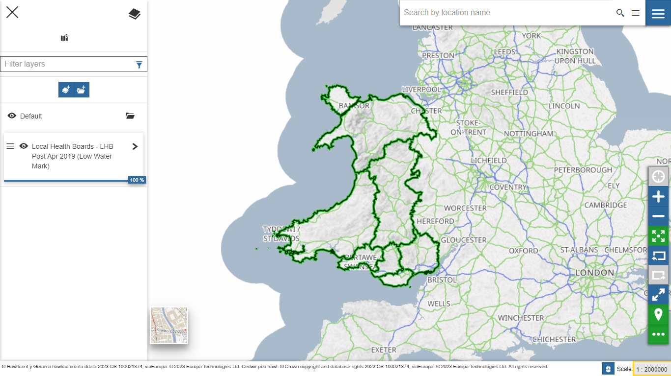
Fig: Map view of LHB boundaries on StatsWales https://datamap.gov.wales/layers/geonode:lhb_low_water_mark_post_apr_2019
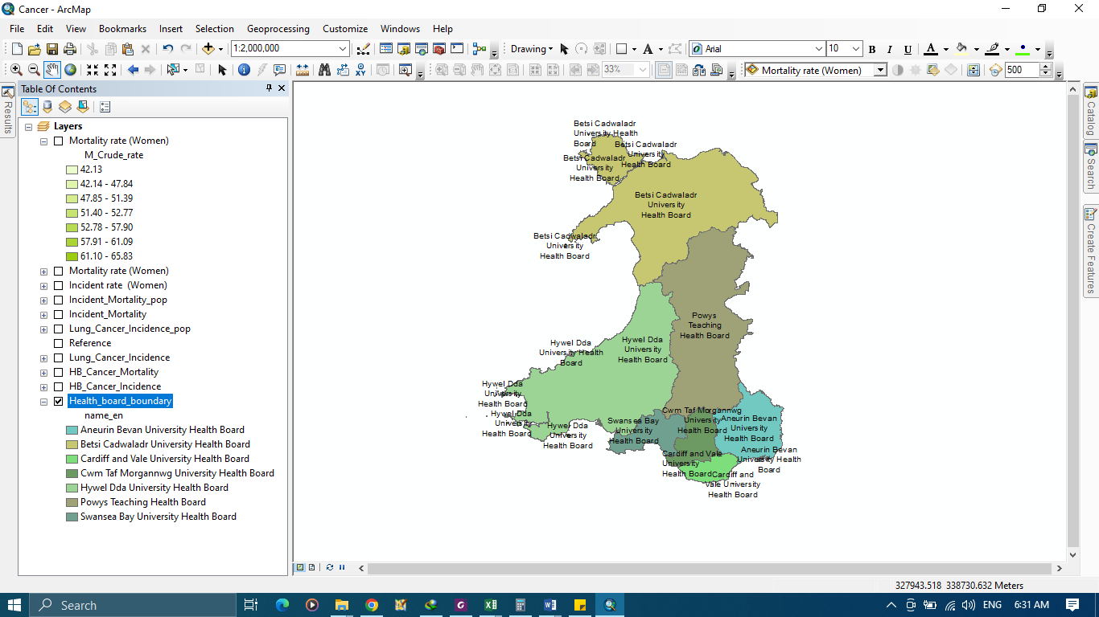
Data View of LHB boundaries in ArcMap.

Population Estimates by Local Health Boards and Sex
 |  |  | Persons |  | Persons
 |  |  | Male | Female | Persons
Wales |  |  | 1563524 | 1606062 | 3169586
Wales | Betsi Cadwaladr University Health Board | W11000023 | 347846 | 355515 | 703361
 | Powys Teaching Health Board | W11000024 | 65849 | 67181 | 133030
 | Hywel Dda University Health Board | W11000025 | 191368 | 198351 | 389719
 | Swansea Bay University Health Board | W11000031 | 193888 | 197061 | 390949
 | Cwm Taf Morgannwg University Health Board | W11000030 | 221209 | 228627 | 449836
 | Aneurin Bevan University Health Board | W11000028 | 293960 | 304234 | 598194
 | Cardiff and Vale University Health Board | W11000029 | 249404 | 255093 | 504497

Data showing Population estimates by local health boards and sex for 2020
Data available at https://statswales.gov.wales/Catalogue/Population-and-Migration/Population/Estimates/Local-Health-Boards/populationestimates-by-lhb-sex

TASK 2: CASE STUDY REPORT
CASE STUDY: PREVALENCE OF LUNG CANCER IN WALES.

Introduction
Every year, around 2,500 people are diagnosed with lung cancer in Wales. Before the covid pandemic started in 2020, 75% of lung cancer cases in Wales were diagnosed at a late stage (stage 3 or 4). (Cancer Research UK, 2020). In common with the rest of the UK, lung cancer is the biggest cancer killer, claiming over 1,800 lives in Wales each year. One-year survival rates lag slightly behind those for England and Northern Ireland. (Roy Castle Lung Cancer Foundation, 2020). From data published on public health Wales website we can see that in 2019, there were 2,512 new cases and 1,872 deaths from lung cancer in Wales. The age-standardized incidence rate of lung cancer in Wales was 78.6 per 100,000 population, which was higher than the UK average of 65.7 per 100,000 population. The age-standardized mortality rate of lung cancer in Wales was 58.6 per 100,000 populations, which was also higher than the UK average of 46.5 per 100,000 population (Public Health Wales)
The most important risk factor for the development of lung cancer is cigarette smoking. It is estimated that eliminating cigarette smoking could prevent up to 90% of lung cancer diagnoses. Nonsmokers are more likely to develop lung cancer if they are exposed to certain industrial substances such as arsenic, some organic chemicals, radon, asbestos, radiation exposure, air pollution, tuberculosis, and environmental tobacco smoke (John Hopkins Medicine). The prevalence of lung cancer varies by geographic region, reflecting the differences in risk factors, such as smoking, air pollution, occupational exposure, genetic susceptibility, and socio-economic status.
Geographic information system (GIS) analysis is a useful tool for mapping and comparing the spatial distribution and patterns of lung cancer prevalence across different areas. It can also help explore the relationships and associations between lung cancer prevalence and other variables of interest, such as smoking prevalence, air quality, and cancer survival. A map is a visual information system that helps people to interpret and understand geographic data. In the case of healthcare, a map can help to display and analyze health data, such as disease patterns, risk factors, health outcomes, and health services (Antonacci et al. 2018). A map can also help to communicate health information to different audiences, such as policy makers, health professionals, and the public (Musa GJ et al. 2013). Visual interpretation of maps can be used; to identify areas with high or low prevalence of a disease or condition, and to monitor changes over time, locate and evaluate the accessibility and quality of health facilities and resources, and to plan for their improvement or expansion, compare and contrast the health status and needs of different populations or regions, and to identify disparities or inequalities, illustrate the spatial distribution and relationships of various determinants of health, such as environmental, social, economic, and behavioral factors (Musa GJ et al. 2013).
This case study aims to use GIS to analyse and visualize the prevalence of Lung cancer in Wales by Local Health Boards (LHBs) for the year 2019. There are seven LHBs in Wales: Aneurin Bevan University Health Board, Betsi Cadwaladr University Health Board, Cardiff and Vale University Health Board, Cwm Taf Morgannwg University Health Board, Hywel Dda University Health Board, Powys Teaching Health Board, and Swansea Bay University Health Board.

Data
Cancer Incidence in Wales (1995-2019): This dataset provides information on the number of new cases of cancer in Wales over a 25-year period. The data is available on the Welsh Cancer Intelligence and Surveillance Unit (WCISU) website. The data is in Excel format.
Cancer Mortality in Wales (1995-2019): This dataset provides information on the number of deaths from cancer in Wales over a 25-year period. The data is in Excel format.
Boundaries of Local Health Boards (LHBs) in Wales: This dataset provides the boundaries of the Local Health Boards (LHBs) in Wales.
Population: Population estimates by local health boards and Sex for 2019-2020
Wellbeing data (Adult lifestyles by local authority and health board, 2016-17 to 2019-20): Contains data on smokers in Wale. Data for 2019 was used for the analysis.
Data Type | Data | Data Source | Data format | Link
Cancer Incidence | Cancer Incidence In Wales, 2002-2019 | The Welsh Cancer Intelligence and Surveillance Unit’s (WCISU) | Excel | https://phw.nhs.wales/services-and-teams/welsh-cancer-intelligence-and-surveillance-unit-wcisu/cancer-incidence-in-wales-2002-2019/cancer-incidence-data-tables-2002-2019/
Cancer  Mortality | Cancer Mortality In Wales, 2002 – 2021 | The Welsh Cancer Intelligence and Surveillance Unit’s (WCISU) | Excel | https://phw.nhs.wales/services-and-teams/welsh-cancer-intelligence-and-surveillance-unit-wcisu/cancer-mortality-in-wales-2002-2021/cancer-mortality-wales-data-tables-2002-2021/
Boundary | Local Health Boards - LHB Post Apr 2019 (Low Water Mark) | DataMapWales – Gov.wales (Welsh Government services and information) | Shapefile | https://datamap.gov.wales/layers/geonode:lhb_low_water_mark_post_apr_2019
Population | Population estimates by local health boards and Sex | StatsWales – Gov.wales (Welsh Government services and information) | Excel | https://statswales.gov.wales/Catalogue/Population-and-Migration/Population/Estimates/Local-Health-Boards/populationestimates-by-lhb-sex
Wellbeing data | Adult lifestyles by local authority and health board, 2016-17 to 2019-20 | StatsWales – Gov.wales (Welsh Government services and information) | Excel | https://statswales.gov.wales/v/NUDb

Methodology
The methodology involved a series of steps taken to extract meaningful insights from the dataset, using GIS techniques.
Data Preparation
The health board boundaries data were projected to the British National Grid coordinate system using the Project tool. This coordinate system is suitable for mapping data in Great Britain and preserves distance and area measurements.
Table Join
The lung cancer incidence and mortality data were joined to the health board boundaries data using the Join Field tool. The health board name was used as the common field to match the records from both tables. The join added the number of cases, deaths, and population estimates to the health board boundaries attribute table.
The smoking prevalence data were joined to the health board boundaries data using the Join Field tool. The health board code was used as the common field to match the records from both tables. The join added the smoking prevalence percentage to the health board boundaries attribute table.
Field Calculator
The lung cancer incidence and mortality rates per 100,000 population were calculated using the Calculate Field tool. The rates were calculated by dividing the number of cases or deaths by the population estimates and multiplying by 100,000. The rates were added as new fields to the health board boundaries attribute table.
Spatial Queries
Spatial queries were run on the data depending on the information needed. The data was queried to extract Lung cancer form the cancer dataset for the year 2019. Spatial query was also run on the extracted lung dataset to filter data by sex, local health boards.
Geospatial visualization
The lung cancer incidence and mortality rates and the smoking prevalence proportion were mapped using graduated colors symbology. Graduated colors symbology assigns different colors to features based on their values for a numeric variable. A color scheme with dark colors for high values and light colors for low values was used for each variable. A legend was added to show the range of values and colors for each variable.

Results

Lung Cancer Incidence across Local Health Boards in Wales
In order to analyse the lung cancer incidence across the local health boards, the joined data containing the cancer incidence, mortality and health board was queried to extract the data for persons (male and female). The extracted data was symbolized by using graduated colours to present the incidence rates across the health boards.
The choropleth map in fig. 1 shows the distribution of lung cancer incidence rate across the seven Local Health Boards in Wales. The incidence rate is measured in cases per 100,000 population. The incidence rate is depicted by color gradient that ranges from yellow (low incidence rate) to dark red (high incidence rate). The map shows that the highest incidence rates are found in Powys Teaching Health Board (90.61 cases per 100,000 population), Swansea Bay University Health Board (87.62 cases per 100,000 population), Hywel Dda University Health Board (86.24 cases per 100,000 population) and Cwm Taf Morgannwg University Health Board (83.36 cases per 100,000 population), while the lowest incidence rate is found in Cardiff and Vale University Health Board (69.13 cases per 100,000 population) with Aneurin Bevan University Health Board (74.22 cases per 100,000 population) and Betsi Cadwaladr University Health Board (79.76 cases per 100,000 population) coming after respectively
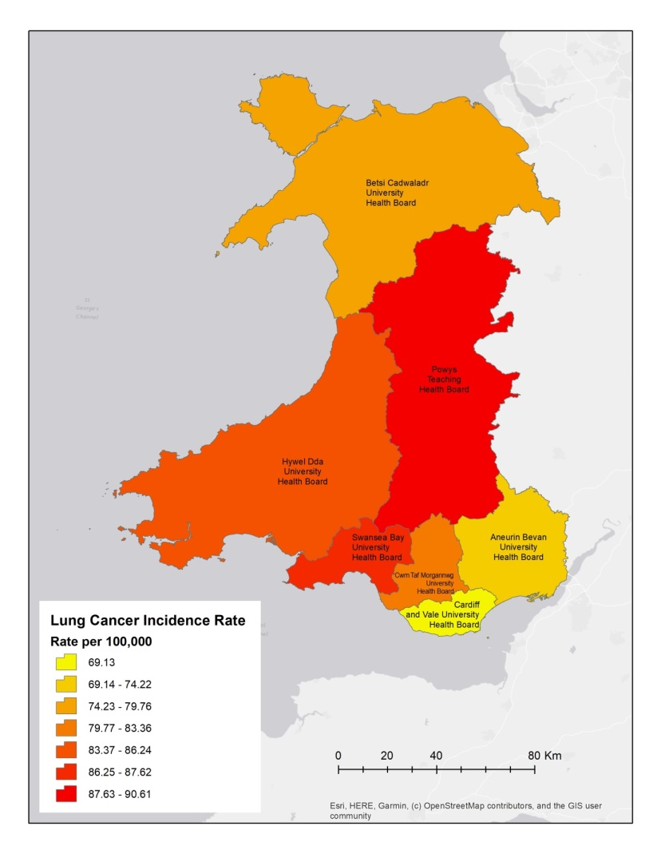
Fig. 1 Choropleth map showing the distribution of Lung Cancer Incidence across Local Health Boards in Wales

Lung Cancer Incidence among Males across Local Health Boards in Wales
In order to analyse lung cancer incidence in males across the local health boards, the joined data containing the cancer incidence, mortality and health board was queried to extract the data for male. The extracted data was symbolized by using graduated colours to present the incidence rates for males across the health boards.
The choropleth map in fig. 2 shows the distribution of lung cancer incidence rate across the seven Local Health Boards in Wales. The incidence rate is measured in cases per 100,000 population. The incidence rate is depicted by color gradient that ranges from yellow (low incidence rate) to dark red (high incidence rate). The map shows that the highest incidence rates are found in Powys Teaching Health Board (108.33 cases per 100,000 population), Swansea Bay University Health Board (99.09 cases per 100,000 population) and Hywel Dda University Health Board (96.21 cases per 100,000 population), Cwm Taf Morgannwg University Health Board (82.43 cases per 100,000 population) and Betsi Cadwaladr University Health Board (82.38 cases per 100,000 population) have almost the same rate, while the lowest incidence rate is found in Cardiff and Vale University Health Board (73.02 cases per 100,000 population) and Aneurin Bevan University Health Board (75.03 cases per 100,000 population).
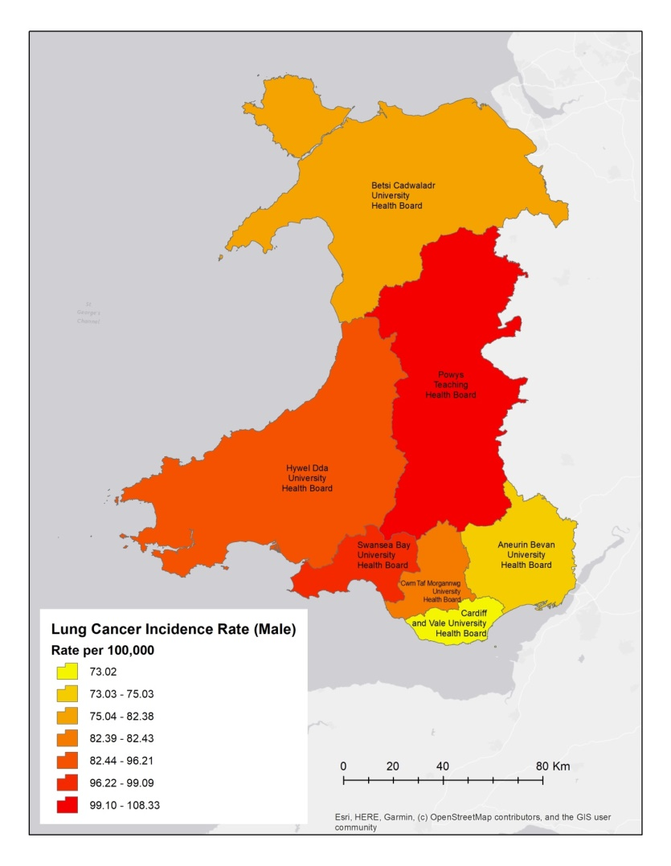
Fig. 2 Choropleth map showing the distribution of Lung Cancer Incidence among males across Local Health Boards in Wales

Lung Cancer Incidence among Females across Local Health Boards in Wales
In order to analyse lung cancer incidence in females across the local health boards, the joined data containing the cancer incidence, mortality and health board was queried to extract the data for female. The extracted data was symbolized by using graduated colours to present the incidence rates for females across the health boards.
The choropleth map in fig. 3 shows the distribution of lung cancer incidence rate among females across the seven Local Health Boards in Wales. The incidence rate is measured in cases per 100,000 population. The incidence rate is depicted by color gradient that ranges from yellow (low incidence rate) to dark red (high incidence rate). The map shows that the highest incidence rates are found in Cwm Taf Morgannwg University Health Board (84.27 cases per 100,000 population) followed by Betsi Cadwaladr University Health Board (77.21 cases per 100,000 population), then Hywel Dda University Health Board (76.62 cases per 100,000 population) and Swansea Bay University Health Board (76.32 cases per 100,000 population) then Aneurin Bevan University Health Board (73.44 cases per 100,000 population) and Powys Teaching Health Board (73.25 cases per 100,000 population). The lowest incidence rate is found in Cardiff and Vale University Health Board (73.02 cases per 100,000 population)
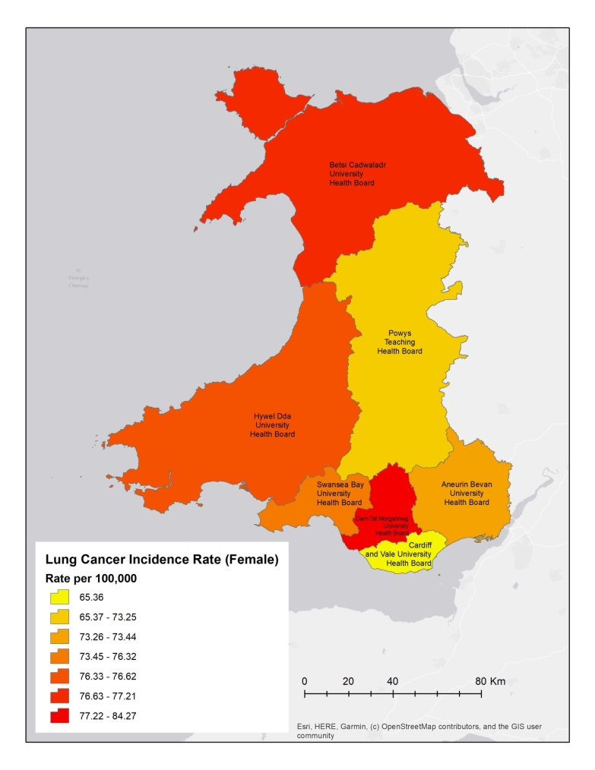
Fig. 3 Choropleth map showing the distribution of Lung Cancer Incidence among females across Local Health Boards in Wales

Lung Cancer Mortality across Local Health Boards in Wales
In order to analyse lung cancer mortality across the local health boards, the joined data containing the cancer incidence, mortality and health board was queried to extract the data for persons (male and female). The extracted data was symbolized by using graduated colours to present the mortality rates across the health boards.
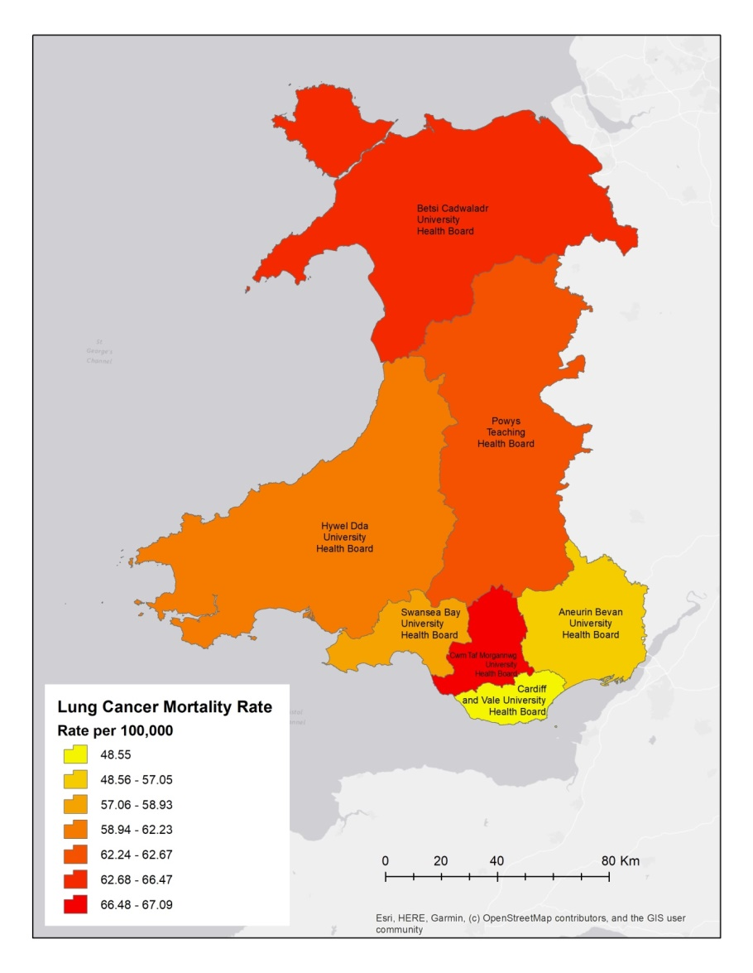
Fig. 4 Choropleth map showing the distribution of Lung Cancer mortality rates across Local Health Boards in Wales
The choropleth map in fig. 4 shows the distribution of lung cancer mortality rate across the seven Local Health Boards in Wales. The mortality rate is measured in cases per 100,000 population. The mortality rate is depicted by color gradient that ranges from yellow (low mortality rate) to dark red (high mortality rate). The map shows that the highest mortality rates are found in Cwm Taf Morgannwg University Health Board (67.09 cases per 100,000 population) and Betsi Cadwaladr University Health Board (66.47 cases per 100,000 population), closely followed by Powys Teaching Health Board (62.67 cases per 100,000 population) and Hywel Dda University Health Board (62.23 cases per 100,000 population), then Swansea Bay University Health Board (58.93 cases per 100,000 population) and Aneurin Bevan University Health Board (57.05 cases per 100,000 population). Cardiff and Vale University Health Board (48.55 cases per 100,000 population) has the lowest mortality rate

Lung Cancer Mortality among Males across Local Health Boards in Wales
In order to analyse lung cancer mortality in males across the local health boards, the joined data containing the cancer incidence, mortality and health board was queried to extract the data for male. The extracted data was symbolized by using graduated colours to present the mortality rates for males across the health boards.
The choropleth map in fig. 5 shows the distribution of lung cancer mortality rate among males across the seven Local Health Boards in Wales. The mortality rate is measured in cases per 100,000 population. The mortality rate is depicted by color gradient that ranges from yellow (low incidence rate) to dark red (high incidence rate). The map shows that the highest mortality rate is found in Powys Teaching Health Board (77.82 cases per 100,000 population) followed by Hywel Dda University Health Board (72.03 cases per 100,000 population), Betsi Cadwaladr University Health Board (71.97 cases per 100,000 population), Cwm Taf Morgannwg University Health Board (68.39 cases per 100,000 population), Swansea Bay University Health Board (66.57 cases per 100,000 population), and Aneurin Bevan University Health Board (56.18 cases per 100,000 population), while the lowest mortality rate is found in Cardiff and Vale University Health Board (55.17 cases per 100,000 population).
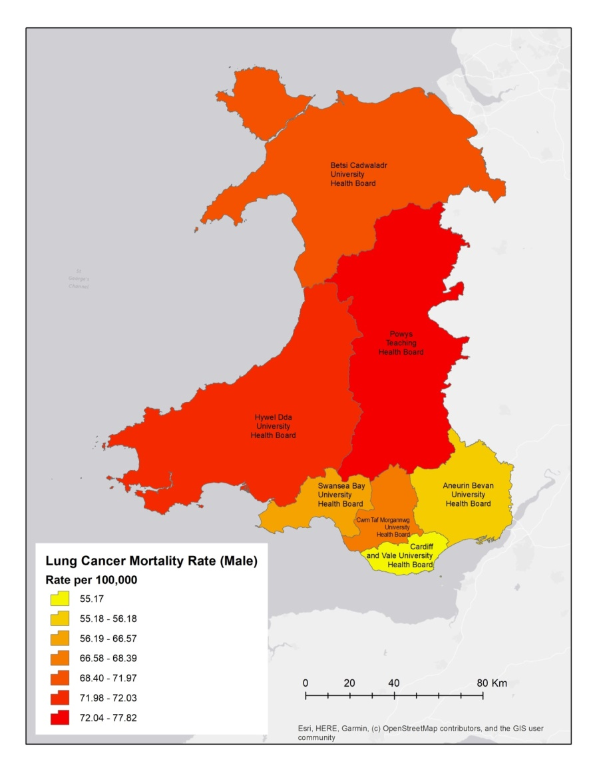
Fig. 5 Choropleth map showing the distribution of Lung Cancer mortality rates among males across Local Health Boards in Wales

Lung Cancer Mortality among Females across Local Health Boards in Wales
In order to analyse lung cancer mortality in females across the local health boards, the joined data containing the cancer incidence, mortality and health board was queried to extract the data for female. The extracted data was symbolized by using graduated colours to present the mortality rates for females across the health boards.
The choropleth map in fig. 6 shows the distribution of lung cancer mortality rate among females across the seven Local Health Boards in Wales. The mortality rate is measured in cases per 100,000 population. The mortality rate is depicted by color gradient that ranges from yellow (low incidence rate) to dark red (high incidence rate). The map shows that the highest mortality rate is found in Cwm Taf Morgannwg University Health Board (65.83 cases per 100,000 population), followed by Betsi Cadwaladr University Health Board (61.09 cases per 100,000 population), Aneurin Bevan University Health Board (57.9 cases per 100,000 population) Hywel Dda University Health Board (52.77 cases per 100,000 population), Swansea Bay University Health Board (51.39 cases per 100,000 population), Powys Teaching Health Board (47.84 cases per 100,000 population), while the lowest mortality rate is found in Cardiff and Vale University Health Board (42.13 cases per 100,000 population).

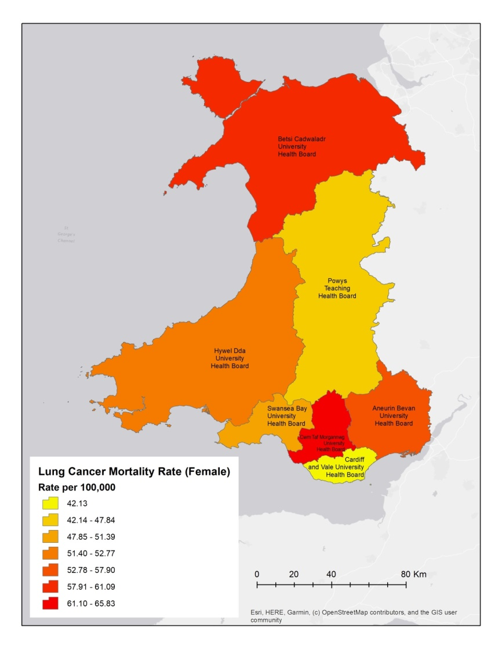
Fig. 6 Choropleth map showing the distribution of Lung Cancer mortality rates among females across Local Health Boards in Wales

Lung Cancer Incidence vs Mortality Rates across Local Health Boards in Wales
The maps shows the visualization of lung cancer incidence rate and mortality rates among the Welsh population, the two variables were map using different characteristics. Green colour gradient was used to map the incidence rate, the color ranging from light green (lowest incidence rate) to deep green (highest incidence rate), and the Mortality rate was visualized in graduated red colour symbol, the size of the relative to the value of the mortality rate. Overlaying the layer of the two variables, we are able to make comparison between the incidence rate and mortality rate of each LHBs.
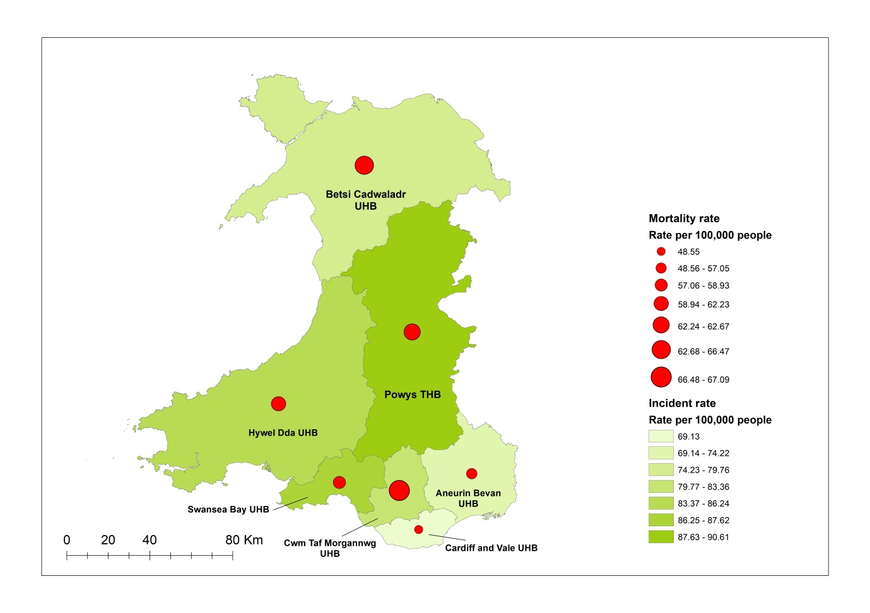
Fig. 7 Multivariate map showing the of Incidence and Mortality rates across Local Health Boards in Wales
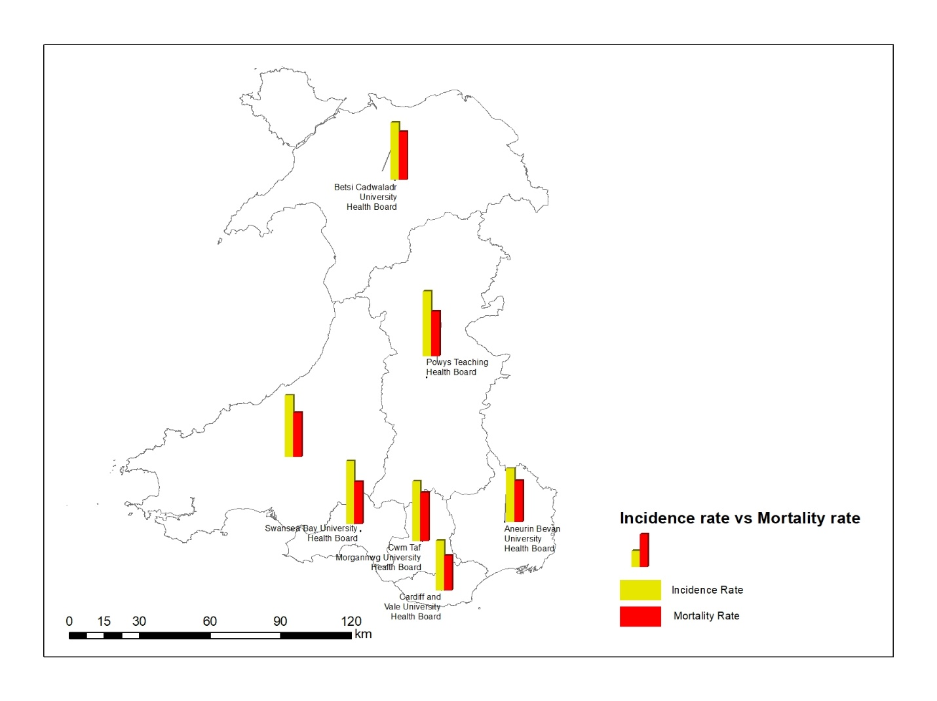
Fig 7a Map Chart showing the of Incidence and Mortality rates across Local Health Boards in Wales
Making comparisons, we from fig. 7 and 7a, Powys Teaching Health Board ranking first in incidence rate and third in mortality rate, Swansea Bay University Health Board ranking second in incidence rate and fifth in mortality rate, Hywel Dda University Health Board ranking third in incidence rate and fourth in mortality rate, Cwm Taf Morgannwg University Health Board ranking fourth in incidence rate and first in mortality rate, Betsi Cadwaladr University Health Board ranking fifth in incidence rate and second in mortality rate, Aneurin Bevan University Health Board ranking sixth in both incidence rate and mortality rate, and Cardiff and Vale University Health Board ranking last in both incidence and mortality rate

Lung Cancer Incidence vs Mortality Rates among Males across Local Health Boards in Wales
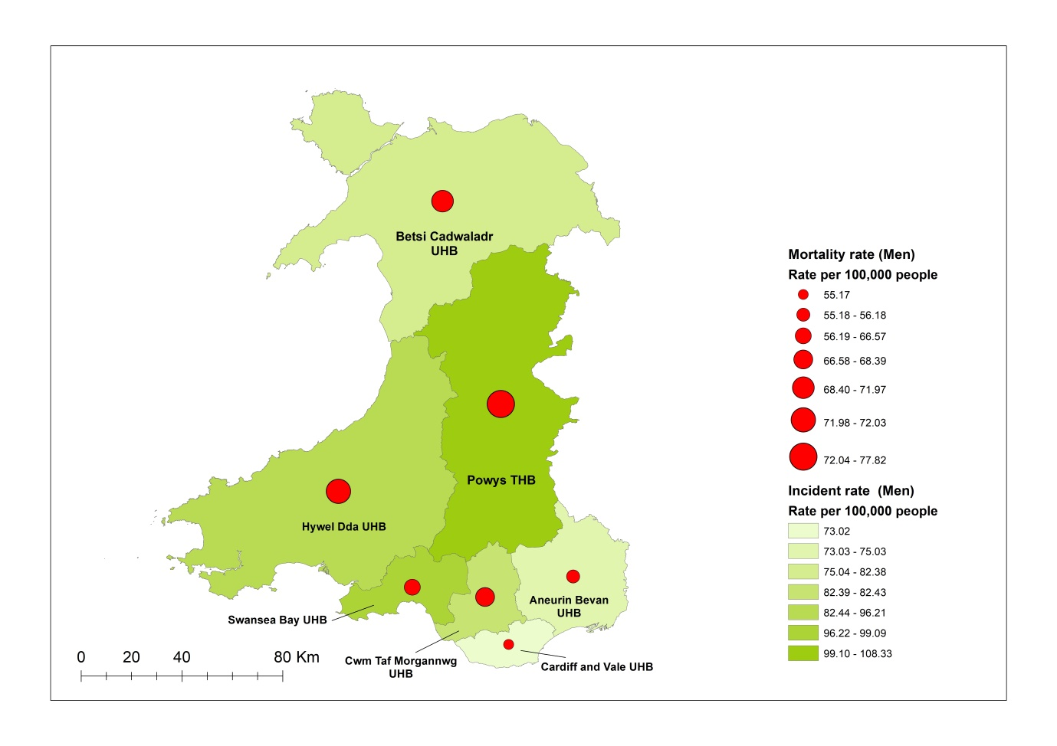
Fig. 8 Multivariate map showing the of Incidence and Mortality rates (Male Population) across Local Health Boards in Wales
In the male population, according to the map in fig. 8, Powys Teaching Health Board ranking first in incidence rate and first in mortality rate, Swansea Bay University Health Board ranking second in incidence rate and fifth in mortality rate, Hywel Dda University Health Board ranking second in incidence rate and fourth in mortality rate, Cwm Taf Morgannwg University Health Board ranking fourth in incidence rate and fourth in mortality rate, Betsi Cadwaladr University Health Board ranking fifth in incidence rate and third in mortality rate, Aneurin Bevan University Health Board ranking sixth in both incidence rate and mortality rate, and Cardiff and Vale University Health Board ranking last in both incidence and mortality rate

Lung Cancer Incidence vs Mortality Rates among Females across Local Health Boards in Wales
Fig. 9 Multivariate map showing the of Incidence and Mortality rates (Female Population) across Local Health Boards in Wales
In the female population, according to the map in fig. 9, Cwm Taf Morgannwg University Health Board ranking first in incidence rate and first in mortality rate, Betsi Cadwaladr University Health Board ranking second in incidence rate and second in mortality rate, Hywel Dda University Health Board ranking third in incidence rate and fourth in mortality rate, Swansea Bay University Health Board ranking fourth in incidence rate and fifth in mortality rate, Aneurin Bevan University Health Board ranking fifth in incidence rate and third in mortality rate, Powys Teaching Health Board ranking sixth in incidence rate and sixth in mortality rate, and Cardiff and Vale University Health Board ranking last in both incidence and mortality rate.

Smoking and Lung Cancer
Smoking tobacco is the leading contributor to lung cancer in the UK, responsible for approximately 70% of all cases. This includes not only smoking directly but also being exposed to second-hand smoke from others. Even light or occasional smoking poses a risk of developing lung cancer. However, the risk escalates with the duration and intensity of smoking. Quitting smoking is the most beneficial action you can take to safeguard your health. (Cancer Research UK)
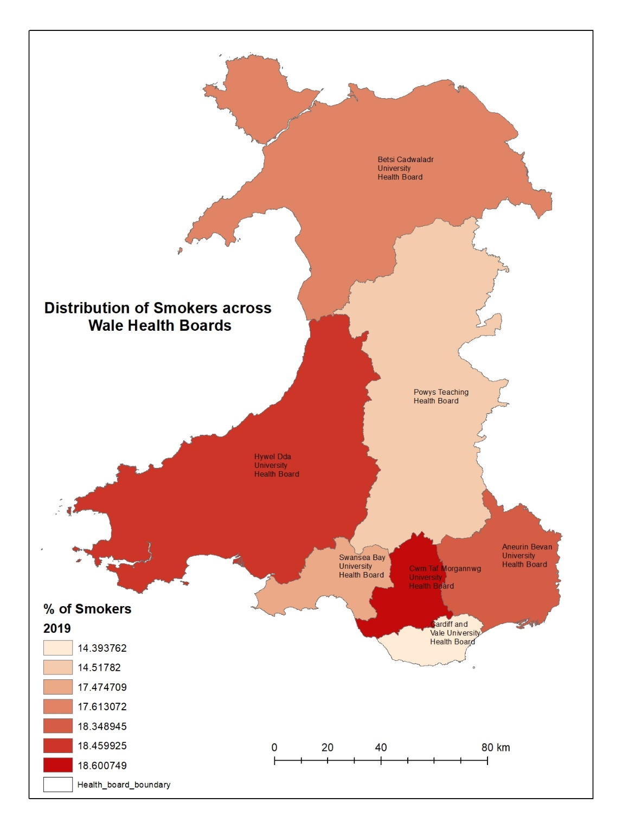
Fig 10. Data showing the distribution of smokes in each Health Board across wales
The map in fig 10 shows the percentages of smokers across Wales’s health boards. The Cwm Taf Morgannwg UHB has the highest percentage of smokers with approximately 18.6%, next is Hywel Dda University Health Board Aneurin Bevan University Health Board Betsi Cadwaladr University Health Board, Swansea Bay University Health Board Powys Teaching Health Board with approximate percentages of 18.5%, 18.4%, 17.6%, 17.4%, 14.5% respectively and Cardiff and Vale University Health Board has the lowest percentage of 14.4%
The following figures visualizes the Lung cancer incidence and mortality rate against percentage of smokers. 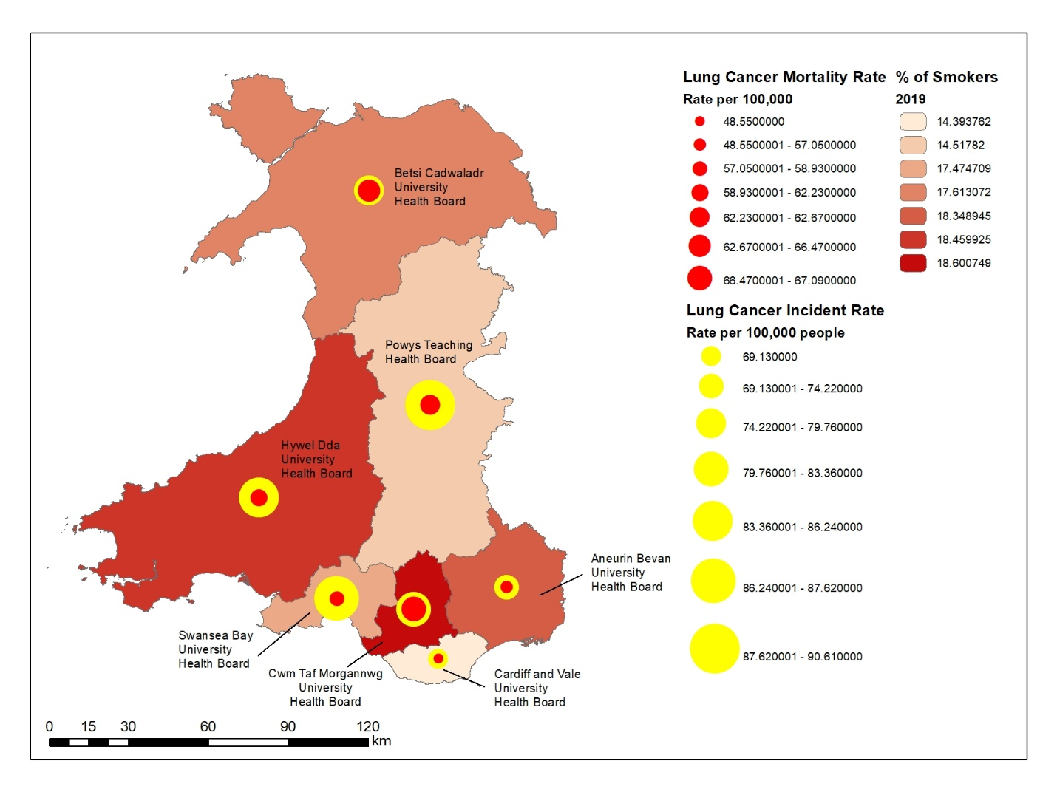
Fig 11. Lung cancer incidence and mortality rate against percentage of smokers.

Fig 12. Graph showing Lung cancer incidence and mortality rate and percentage of smokers.

Conclusion
This case study has been able to demonstrate the use of geodemographic analysis in healthcare systems in this case Lung cancer prevalence in Wales. It takes into consideration important data acquisition principles in acquiring the data. The data used were acquired from reliable open sources in this case the Wales government databases in format compatible with a GIS software. GIS operations such as table joins were employed. Spatial queries were used to filter the data, and was visualized using thematic maps. These thematic maps carries the visual information on lung cancer prevalence and can help healthcare professional in making decisions.

References
Antonacci, G., Reed, J. E., Lennox, L., & Barlow, J. (2018). The use of process mapping in healthcare quality improvement projects. Health services management research, 31(2), 74–84. https://doi.org/10.1177/0951484818770411
Cancer Mortality in Wales, 2002-2021 data (2022), Public health wales, available online on: https://phw.nhs.wales/services-and-teams/welsh-cancer-intelligence-and-surveillance-unit-wcisu/cancer-mortality-in-wales-2002-2021/ Accessed on 30/04/2023
Cancer Research UK. (n.d.). Risks and causes of lung cancer. Retrieved from https://www.cancerresearchuk.org/about-cancer/lung-cancer/risks-causes#:~:text=Smoking%20tobacco%20is%20the%20biggest,risk%20of%20developing%20lung%20cancer. Assessed on 01/07/2023
COVID-19 referral drop fears for lung cancer patients in Wales, https://news.cancerresearchuk.org/2020/11/20/covid-19-referral-drop-fears-for-lung-cancer-patients-in-wales/
Dixon, B. and Uddameri, V. (2015). GIS Analysis: Fundamentals of Spatial Query. In GIS and Geocomputation for Water Resource Science and Engineering (eds B. Dixon and V. Uddameri). https://doi.org/10.1002/9781118826171.ch9
Esri 1998, ESRI Shapefile Technical Description, availiable online at https://www.esri.com/content/dam/esrisites/sitecore-archive/Files/Pdfs/library/whitepapers/pdfs/shapefile.pdf Accessed 29/04/2023
George J. Musa, Po-Huang Chiang, Tyler Sylk, Rachel Bavley, William Keating, Bereketab Lakew, Hui-Chen Tsou, and Christina W. Hoven. Use of GIS Mapping as a Public Health Tool–-From Cholera to Cancer. Health Services Insights. 2013;6. doi:10.4137/HSI.S10471
Lung cancer in Wales, Roy Castle Lung Cancer Foundation available online: https://roycastle.org/lung-cancer-in-wales/#:~:text=Unfortunately%2C%20Wales%20also%20has%20a,lives%20in%20Wales%20each%20year Retrieved 29/04/2023
Lung Cancer Risk Factors, John Hopkins Medicine. Availiable online at https://www.hopkinsmedicine.org/health/conditions-and-diseases/lung-cancer/lung-cancer-risk-factors Accessed on 30/04/2023
Ricotti A, Sciannameo V, Balzi W, Roncadori A, Canavese P, Avitabile A, Massa I, Berchialla P. Incidence and Prevalence Analysis of Non-Small-Cell and Small-Cell Lung Cancer Using Administrative Data. Int J Environ Res Public Health. 2021 Aug 28;18(17):9076. doi: 10.3390/ijerph18179076. PMID: 34501665; PMCID: PMC8431612.

