


Introduction to Industry 4.0
Assignment 1 – Written Report
Smart Waste Bin Research

Student: Marcus Palisoc
Student number: 2030243

Introduction
This report will investigate how automation can be integrated into a waste recycling unit to tackle waste contamination in the UK. A company in Bridgend, South Wales is looking to explore this project’s possibilities. This can potentially be added as part of their product offering which focuses on empowering workspace recycling. Nearly one fifth of England and Wales’ waste from both household and businesses cannot be recycled due to contamination (Biffa, 2022). A study by The Waste and Resources Action Programme (WRAP) has shown the contamination rate rising from 13.4% in 2016 to 17% by the end of 2020 (WRAP, 2020).
Contamination occurs when an item is incorrectly sorted into the wrong recycling bin or recycled when not properly cleaned. This can occur due to several reasons. It can be as simple as unconsciously mixing cardboard into the plastic recycling bin or even putting a plastic yoghurt container with food residue remaining into the correct bin. This can be due to the recycler being confused when approaching a recycling bin. That confusion at the point of disposal can cause contamination (CleanRobotics, 2020). Simple things like this can make a big impact on the overall recycling rate. A whole bag of recycling materials can be moved from the recycling line to the landfill if later discovered that it has been contaminated. This can cost councils up to £49 million per year (Smulian, 2021).

Aims & Objectives
Focusing on commercial waste collection, the aim of this report is to identify how a conventional recycling unit can be turned into an automated recycling unit that can automatically segregate different waste materials into the correct waste streams. One of the main challenges is creating the ability to differentiate different waste materials and sorting automatically with 100% accuracy.
This report will research what technologies are available that may be required to make this idea work or if there are any product or system that already exist on the market. This can transform how waste is collected in the workplace with the potential of improving the process by making it easier and more efficient. This can lead to reducing waste contamination, reducing removal fees, and improving recycling rates in the workplace.

Implementation Methodology
The company exploring the automatic segregating recycling unit specialises in offering and selling recycling solutions to medium to large businesses. Therefore, it will not be necessarily designed to benefit the company’s internal recycling rate but designed to benefit its existing customers and gain new ones. The automated recycling system will be developed in-house where there is opportunity to test with internal placeholders.
Parallel operation implementation will be carried out with both the conventional recycling unit and automated recycling unit. This allows the new automated recycling unit to be tested on the market whilst still offering a simpler and cheaper solution. Running a parallel operation implementation will ensure business continuity and help identify areas for improvement (RioMed, 2020).
With the advanced technologies required to develop the automated recycling unit, the cost per unit will naturally be higher than the conventional recycling unit. Although it has the ability to reduce contamination rates, the cost will play a big factor in getting existing and new customers on board with the new system.

Existing Products
Researching the existing products is a vital part of this report as this will help define what technologies already exist on the market which will prove the project’s feasibility and viability.
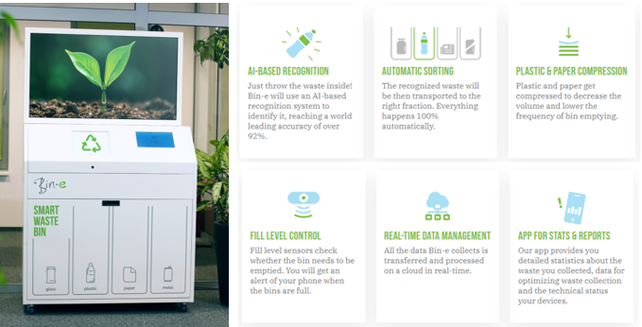
A Polish startup company has developed an AI-powered smart recycling bin that can automatically sort different types of waste. It has the ability to sort and compress the waste automatically. As well as control the fill level and collect and process data for convenient waste management (Bin-e, 2022). Featuring only one entry point for the waste, contamination will be heavily dependant on the accuracy of the system. With a world leading accuracy of 92% claimed by Bin-e, there is still that 8% chance of contamination. The main concern about this product is if it’s able to keep up when placed in high footfall areas due to it’s time consuming operation (World of Bin-e, 2020). Queues may start to build up which can put off other recyclers from waiting to use the machine.
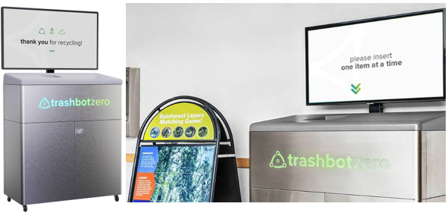
Another existing product is the Trashbot by CleanRobotics. Similar to Bin-e, the Trashbot uses artificial intelligence, computer vision and robotics to create an autonomous system to detect and separate landfills from recyclables (CleanRobotics, 2022). The company claims that Trashbot has 95% accuracy rate whilst still generating high-quality data that is partnered up with cloud connectivity.
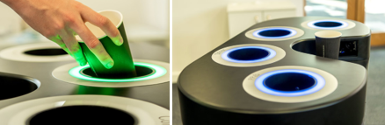
A smart recycling bin has also been developed by a team of Cambridge Consultants which mainly uses computer vision technology which can learn to recognise images or materials presented in front of its cameras (Matchar, 2017). The user is then informed where the waste should go into with LED lights going green around the correct waste aperture. The smart recycling bin is supported by a smartphone app which enable users to be identified and rewarded once the item has been correctly deposited (Trend Monitor, 2019). Points can be earned over time which can be spent somewhere or can be donated to a charity.

Technology
Computer vision (AI) is widely used in smart recycling bins. It works by using pattern recognition algorithms to try mimic the human brain’s capability of recognising visual information (Chatterjee, 2022). Other application examples of computer visions are self-driving cars, facial recognition, augmented & mixed reality etc. (Simplilearn, 2022). One of the main disadvantages of using computer vision is its dependency on existing data. Computers are still struggling to process incomplete visual data and they don’t have the same interpretation ability as humans to deal with new and difficult situations. Waste comes in different shapes, sizes and materials and the variation is limitless and trained specialists are required to train the system to try to deal with this, but success is not guaranteed. In early stages, the system require supervision to ensure that it functions properly.
Waste can be delivered to the correct waste stream with the use of robotics. After detecting the type of waste, the next step is to ensure that the waste gets segregated properly. Robotics can be reliable and consistent, but this is dependent on receiving the correct information (University of Reading, n.d.).
Fill-level sensors can be used to detect the waste level (MaxBotix, 2022). This can primarily be used to determine whether the bin needs to be emptied or not without the need to manually check the bins. This can also be supported by cloud communications to make the waste management process as efficient as possible.
Communication is also key to a better interaction and user experience. Products use lighting techniques and digital screen to communicate with the user. Instructions are clear whilst being interactive and helpful which can make a positive impact on how people recycle. This can create more opportunities compared to the conventional paper or other physical signage. Organisations can use this to get other messages or advertisement across when the product is not being used for its main functionality.

Conclusion & Recommendations
The main goal is to create and design a product that would contribute to decreasing recycling waste contamination. The background research has provided useful information which can be used as a starting point if the project was to be taken further. Exploration on the existing smart recycling stations on the market has helped define a snippet of what technologies are currently being utilised to create an autonomous system that detects and separates waste. Turning a conventional recycling station into an automated recycling bin presents a lot of challenges. A well-developed system must be created to ensure maximum accuracy and efficient operation. It is recommended to collaborate with specialists when developing this product to ensure the correct advice and information is being collected.
The expected and desired features of the product need to be clearly defined to allow the correct technology to be implemented. The more technology that is added inside the bin, the bulkier the recycling bin becomes. Unless there is a way to engineer the system to minimise the space it requires but still achieve the same or better outcome. This will give an opportunity to design a better-looking smart recycling station that would suit modern environments more. This will also increase the individual waste bin capacity.
Cost analysis is the next step to determine whether it is worth pursuing this idea or not. With the various technology required to make this work, assumptions can be made that this will require a high investment and development costs. Consumers may not be prepared to spend a lot of money on something that is not perfected yet when they can purchase a conventional recycling station for a fraction of the price. Just because it is innovative, clever, and technologically advanced, it does not mean that it will be a scalable product.
References
Biffa, (2022). Nearly one fifth of recycling ends up unrecyclable due to contamination.
Available at: https://smebusinessnews.co.uk/2022/10/25/nearly-one-fifth-of-recycling-ends-up-unrecyclable-due-to-contamination/.
Last accessed 23rd November 2022.
Bin-e, (2022). Smart Waste Bin.
Available at: https://bine.world/.
Last accessed 24th November 2022.
Chatterjee, M. (2022). What is Computer Vision? Know Computer Vision Basic to Advanced & How Does it Work?.
Available at: https://www.mygreatlearning.com/blog/what-is-computer-vision-the-basics/#:~:text=Computer%20vision%20works%20by%20trying,finds%20patterns%20in%20those%20objects.
Last accessed 24th November 2022.
CleanRobotics, (2022). Smart bins for smarter recycling.
Available at: https://cleanrobotics.com/trashbot/#introducing-trash-bot.
Last accessed 24th November 2022.
CleanRobotics, (2020). What is TrashBot? Sorting Waste with Artificial Intelligence & Robotics.
Available at: https://www.youtube.com/watch?v=O7DZcaV6MaI.
Last accessed 24th November 2022.
LibreTexts, (2021). Implementation Methodologies.
Available at: https://workforce.libretexts.org/Bookshelves/Information_Technology/Information_Systems/Information_Systems_for_Business/02%3A_Information_Systems_for_Strategic_Advantage/10%3A_Information_Systems_Development/10.04%3A_Implementation_Methodologies.
Last accessed 23rd November 2022.
Matchar, E. (2017). A Smart Recycling Bin Could Sort Your Waste for You.
Available at: https://www.smithsonianmag.com/innovation/smart-recycling-bin-could-sort-your-waste-you-180964848/.
Last accessed 24th November 2022.
MaxBotix, (2022). Smart Waste Management, Using Trash Level Sensors.
Available at: https://www.digikey.com/Site/Global/Layouts/DownloadPdf.ashx?pdfUrl=80EFB049A8464963AD73CBB965F90FBC.
Last accessed 24th November 2022.
RioMed, (2020). Parallel Implementation – Working out the best option.
Available at: https://www.riomed.com/parallel-implementation-working-out-the-best-option/.
Last accessed 23rd November 2022.
Simplilearn, (2022). What Is Computer Vision : Overview, Applications, Benefits and How to Learn It.
Available at: https://www.simplilearn.com/computer-vision-article.
Last accessed 24th November 2022.
Smulian, M. (2021). Contaminated plastics sent for EfW costs councils £49m a year.
Available at: https://www.mrw.co.uk/news/contaminated-plastics-sent-for-efw-costs-councils-49m-a-year-29-03-2021/.
Last accessed 23rd November 2022.
Trend Monitor, (2019). Smart Recycling – a way to navigate the recycling maze.
Available at: https://trend-monitor.co.uk/smart-recycling/.
Last accessed 24th November 2022.
University of Reading, (n.d.). Advantages and disadvantages of robots.
Available at: https://www.futurelearn.com/info/courses/begin-robotics/0/steps/2845#:~:text=In%20many%20situations%20robots%20can,example%20in%20manufacturing%20of%20microelectronics.
Last accessed 24th November 2022.
World of Bin-e, (2020). Bin-e - the smartest waste bin worldwide.
Available at: https://www.youtube.com/watch?v=LJYWRTRJThY.
Last accessed 24th November 2022.
WRAP, (2022). Biffa study shows extent of unrecyclable waste in England and Wales.
Available at: https://www.packaging-gateway.com/news/biffa-recycling-contamination/.
Last accessed 23rd November 2022.

