
Skills for the Workplace
Module Assignment Submission
Student Name: | A. N. Other
Student Number: | 1234567
Module No: | BMSK4005
Module Title: | Professional career development

Statement of Confirmation of Authenticity
By the act of making this submission, the student declares that this is the work of the student named above. The work has not, in whole or in part, been knowingly presented elsewhere for assessment, or where assessment has been built on a previous assessment, this has been identified. Where materials have been used from other sources it has been properly acknowledged. If this statement is untrue, the student acknowledges that an assessment offence has been committed.
Attention is drawn to the plagiarism and unfair practice policies of both the University and of ILM.

Table of Contents

Introduction 2
Lifeline 2
Self-evaluation review 3
Overview of learning styles: 3
Skills and knowledge for self-motivation 4
Application of skills to make performances better 4
Personal Development plan 5
SWOT Analysis 5
Smart Objectives 7
JohariWindow……………………………………………………………………..8Review of understanding and expectation on world of employment 8
Personal Development Plan 10
Conclusion 11

Introduction

This assignment is based on my own self-reflection on journey of my own learning path to the stage where I have reached today, the thirst for knowledge is the driven force where it enabled me to achieve the interpersonal skills and successfully complete my level 4 Skills for workplace qualification at UWTSD. Effective communication and practical working nature have enabled me to reach my desired platform. Self-management practices enhanced my learning and it is one strong key to one’s consciousness and assure success by implementing the interpersonal skills to a successful career path. A personal development plan highlights the skills and knowledge that are essential in working effectively and in employment. Moreover, I have identified my strengths, weaknesses, future opportunities and threats in SWOT analysis. I produced a lifeline exercise which has shown my journey from birth to present day and for future, the experiences and events took place and my future goals. A self-assessment can create an effective action plan that motivates and enhances creativity as well develop interpersonal skills.

Lifeline
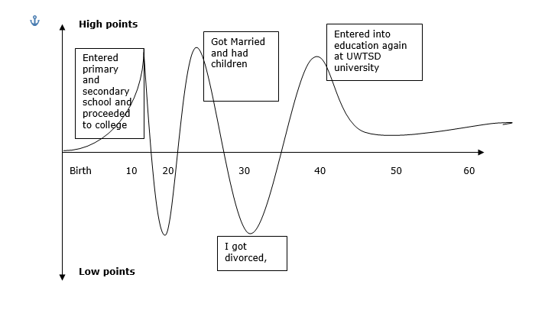

Self-evaluation review

I have visual, logical and verbal learning styles and I believe in spatial and linguistic understanding. In addition, social understanding makes learning more innovative and creative in a group as well develops interpersonal and critical analysis skills. This skill meditates my learning development into strong management and self-restraint power. Applying all those learning styles it supports me to absorb any kind of information and developing own strategies. Adapting my preferred learning techniques is beneficial to help me problem solving and critical thinking to make a strong analysis on a task. Nonetheless, I love learning through images, diagrams and making notes as where possible watching a demonstration.
Evaluating any topic using the logical learning style makes my learning easier, noting down information and highlight the key facts supports me to concentrate and learn at quick pace.

Overview of learning styles:

The term ‘Learning styles’ speaks to the understanding that every student learns differently. Technically, an individual learning styles refers to the preferential way in which the students absorbs, processes, comprehends and retain information.
Each person prefers to adapt different leaning style techniques and it is recognised through learning of individuals. Most cases mix of learning styles is applied in different circumstances.
Identifying multiple learning styles is relatively new intelligent approach in this modern society by the educators have only recently started to recognize. In most traditional schooling used mainly linguistic and logical teaching methods. In most cases lack of identifying individuals learning styles used to identify a person ‘dumb’ or ‘smart’. Applying various multiple learning styles has improved in one’s learning ability enabling a person’s personal development and career.

Seven learning styles:
- Visual (spatial) using pictures, images
- Aural (auditory-musical) using sound and music
- Verbal (linguistic) using words, speech and writing
- Physical (kinesthetics) using body and sense of touch
- Logical (mathematical) using logic, reasoning and systems
- Social (interpersonal) learn in groups or with other people
- Solitary (intrapersonal) prefer to work alone and use self-study

Skills and knowledge for self-motivation

I can appoint that I have good communication skills that helps me to execute a range of management tasks, I also have a team building capability that provides me the ability to develop leadership skills which is vital for achieving business success. Hence, I need to recognise my transitional skills with career knowledge which will alleviate me to reach my professional goals in the future. Interact positively and emphasis on core academic competences to build an effective relationship to achieve success.

Application of skills to make performances better

Applying decision making skills allows me to choose the correct option in finding the possible response in different situations. Using problem solving skills will determine a correct solution to a dilemma or giving alternative option to a plan, performing a brainstorm also allows me to elaborate on my ideas and plans and giving the best options to solve any issues accordingly. One of my major skills I have developed is self-confidence, this is evidently shown through me asking questions and delivering presentations. Team work is also considered very important to me as it is a necessary asset, this is because it incorporates individual ideas, communication and knowledge as it generates a good bond and performance. When I am wrong, I can reflect on my work and acknowledge what I have not done, I can analyse and evaluate possible factors that can impact my business and work. According to reflective dimension I still have to develop my creativity and decision-making skills to conduct an effective strategy to analyse information and development. Another asset that I am yet to achieve and develop is my linguistic and logical intelligence skills.

Personal Development plan

SWOT Analysis

Opportunities
- I can operate advance technology gadgets
- Future aspirations
- Create own business
- Gain more qualifications in higher education
- Earn good money
- Better job role

Strength
- I have good communication and interaction skills
- I have passion and enthusiasm towards my performances
- Self-motivated
- Intellectual skill
- Positive interpersonal skills
- Quick learner
- Innovative and creative

Threats
- Disorganised
- Work experiences
- Emerging new technologies
- Competitors in the work field
- Professional standards are in demand
Weakness
- I do not have enough work experiences
- Weak management skills
- Not enough qualifications
- Family commitments

As per SWOT analysis, it identifies my skills and abilities. I have good communication and interaction skills that will help me in my managerial activities as my strengths. In addition, my enthusiasm and passion attitude can help me administer and adapt changes in work organisation. As opportunities are identified, a numerous list can be mentioned though I have selected a few as those are my desired goals but can be worked through to achieve them by implementing my efforts, knowledge and commitment can elevate to that platform however, lack of work experiences and qualification can be a reject to my opportunity goals. Though, weaknesses are strongly considered as it creates a barrier to my goals and expectations. It can however be worked through diagnosing the obstacles and making the possibilities to achieve, getting a further education can help in promoting my knowledge and also contributing to voluntary work to gain more work experiences. Furthermore, family commitments are one important factor cannot be avoided but can also be worked through to engage a suitable time for work and education if can be organised. Threats are a constant obstacle in life as it goes, as modern world establishes technology is also discovered, and to keep up to the updated track I must integrate into further learning using my logical and linguistic skills, acknowledging that there is always competitors out there will always be tough to get through that barrier. SWOT analysis helps define and evaluates a person’s ability, working out its possibilities and finding a solution to a problem. This method can be created and used by every individual who wants to identify and work through its career development.

Smart Objectives
Achievable
Measurable
Specific
Time-bound
Relevant
To develop my communication and problem-solving skills
2 weeks
It is very relevant as this can be applied at any profession either at workplace or study environment
It can be achieved through communication and collaborating with students and tutors
I can communicate with my fellow students and tutors to identify learning skills and information and work out an appropriate solution to solve

Section 4
To enhance my leadership skills
I can identify my strengths and weaknesses and also prioritise my own goals
To evaluate a clear vision and negotiating with my team members
3 to 6 months studying course
Leadership skills can help me achieve to management role and promote a positive attitude

Johari window analysis
Not known to self
Known to self
Blind spot
- Intelligent
- Knowledgeable
- Independent

Open area
- Self-conscious
- Trustworthy
- kind

Known to others

Unknown
- Energetic
- Spontaneous
- Powerful

Hidden areas
- Sentimental
- Clever
- Nervous

Not known to others

I have conducted a self-analysis of my skills on a Johari Window collaborating with 2 students to assess my character and identify my skills. The results were analysed and recognised where I belong, and surprisingly I belong to the Open area where I can conduct self-assessment on myself and it is similar to the student’s decisions. However, I can develop more through logical and linguistic communication skills with fellow team mates in order for them to know my Blind spot and hidden areas by revealing my feelings and suggestions.

Review of understanding and expectation on world of employment

Morgan, 2017, (p.16), argues academic success in degree is very significant factor but not the only factor one should be achieving. A student is overlooked by an employer to an extent that if one has acquired leadership or work experiences. It is far greater to have lesser degree and more of leadership experiences in students but it’s all about balancing and developing one’s skills and what employers are in search for, making significant choices is far better on employability at the end.
I fully understand now that it is very important to equip myself with employability skills to the expectation on world of employment. Understanding what employers are thriving for in their candidates are essentially very necessary to accumulate and progress further in their business organisation.
My personal strength can develop a range of academic and managerial skills, this will enable me to develop my interpersonal communication within, however that will enhance my ability to reflect and take responsibility in the business organisation. Motivating myself into learning skills and evaluating my own performances. Reviewing to my self-evaluation analysis it clarifies my interpersonal trait needs to improvements in order to achieve success between employer and employee relationship within my profession. Educating myself into understanding diverse business activities and logical intellectual skill and developing my managerial and problem-solving skills can support me to better job opportunities in the future.
I have passion and enthusiasm to develop my performance to support me to execute business organisational activities without struggle and difficulties, however, I learn as I progress to next step as it passes by. The world of employment is very competitive and high in demand thriving for highly experienced candidates. Therefore, I must embrace myself with efficient interpersonal, logistic and linguistic learning skills prepare for the challenges ahead. My critical analysis and visual learning skill may develop my professional performances as an employee. Working through strategies on learning various skills while studying and applying learnt knowledge independently within employment. Hence, I do lack many professional skills however, self-motivation is one strong key to achieving my aspirations and my career goals and becoming successful.

Personal Development Plan
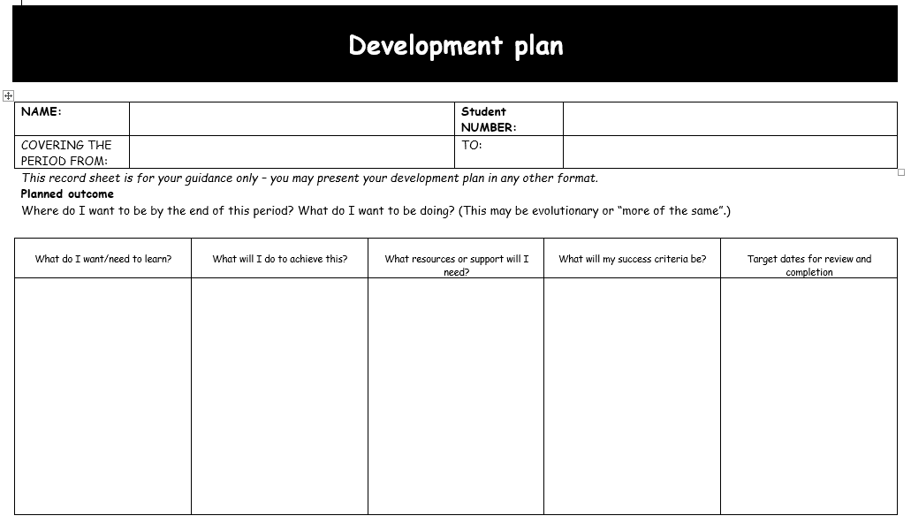
Be able to achieve management role or successful entrepreneur
Complete level 4 management and leadership in 1 year, and progress to 5 and 6 to complete learning
Interpersonal and management skills will help me improve body language and become more optimistic and perform better
In order to achieve the goal, I would need to develop my interpersonal and management skills
To improve problem solving skills
1707399
Fatima Islam

Conclusion

I understand that reflective practice should be often practiced throughout life reflecting in its simplest form on my learning from experiences, what can be done differently in terms of my learning. Critical thinking and reflective practice should be made a regular habit a form of practice to change the concept of learning both at home and work. Developing and using reflective practice is a dynamic and ethical set of skills that I apply in the real difficult situations. The essence of personal development and reflective practice is set of skills designed for me and every individual to help us reach our full potential at work, in study or in our personal life. Performing a set of tasks have identified my weaknesses and strengths such as SWOT analysis, Johari Window and Smart Objectives. It can be concluded that I have good communication and meta-cognitive skills that help me to highlight the logical thoughts and find a possible understanding in the area. I have good observational skills allowing me to acknowledge and perform better academically. I have learnt to implement my previous knowledge within my performances to elaborate more formal and informal in communication and emphasis on core academic competencies.

