BSc Health and Social Care
Changemakers: Building your Personal Brand for Sustainable Employment
BMHP5015
Component 1: Online Portfolio of Set Exercises
Raheela Shaikh
Samia Zeb
2323633

BMHP5015 Building your Personal Brand
Task 1. Personal Brand

Task 1: Personal Brand (Public Health Practitioner).
Introduction:
Personal branding is the process by which one consciously craft what image and reputation they would want to be perceived in the eyes of others regarding their professional identity, values, and capabilities. In today's competitive job market, it is important since personal branding serves to boost one's employability and credibility in the professional practice of public health. To me, a personal brand defines and communicates my passion for improving community health and further shows my commitment to professional growth and lifelong learning in a clear and authentic manner. (Montoya and Vandehey, 2009).

Body:
Currently, I understand my personal brand as empathetic, dedicated, and community focused. My strengths include good communication, teamwork, and research skills; these are essential in addressing health inequalities and wellbeing. However, I realize that I need to strengthen my leadership, confidence, and data analysis abilities to stand out in the public health field. In improving my personal brand, professional workshops, leadership in group projects, and networking with professionals in the industry will help. These steps will show initiative, accountability, and resilience qualities highly valued in public health careers (Shepherd, 2005).
Conclusion: It therefore follows that continuous development of my professional image, skills, and confidence will lead to a better personal brand that is in congruence with my career vision and presents me as an able and committed Public Health Practitioner who is ready to make a difference.

References
Peters, T. (1997) ‘The brand called you’, Fast Company, 10(10), pp. 83–90.
Rampersad, H.K. (2008) Authentic Personal Branding: A New Blueprint for Building and Aligning a Powerful Leadership Brand. Charlotte, NC: Information Age Publishing.

BMHP5015 Building your Personal Brand
Assignment 1- Task 2. Network Map and Rationale

Part 1: My Personal Network Map
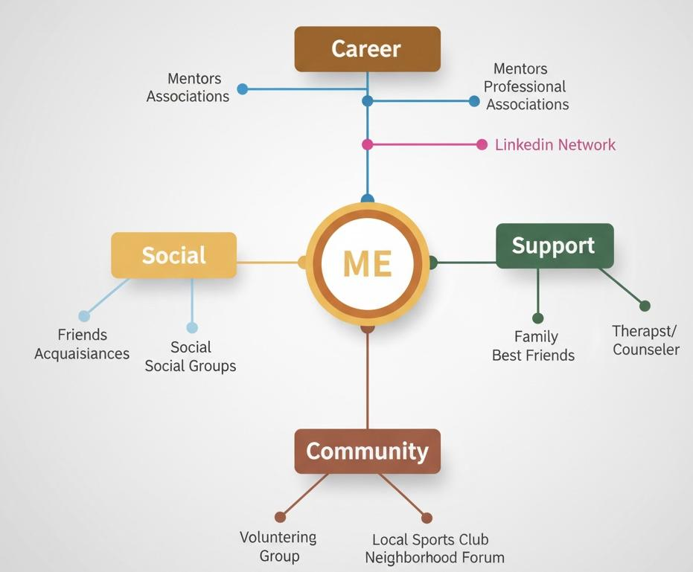
This map illustrates my personal and professional connections across four key areas: Career, Social, Support, and Community. Each area represents the people and groups who contribute to my development, wellbeing, and future career progression.

a) Type of Personal Network
Based on the set of relationships I currently possess, I would describe my personal network as a Hybrid Network: I have strong bonding connections through my family, friends, and colleagues, but also some bridging and professional links, such as my mentors and contacts through LinkedIn. As Woolcock (2001) argued, hybrid networks can enable both emotional wellbeing and career progression since close supportive ties combine with wider social exposure. Thus, my network allows both personal support and access to diverse knowledge and opportunities.

b) Areas of Weakness in My Network / Social Capital
Even though my network contains a range of meaningful relationships, there is room for development concerning bonding, bridging, and linking social capital.
Bonding Social Capital – close relationships
Although I have very good emotional support from people like me, Putnam 2000 states that too much dependence on bonding ties may restrict access to new ideas. The extension of bonding relationships to people that have different experiences will enhance my general wellbeing and resilience.

️ Bridging Social Capital – Relationships with different groups
My connections beyond those in my academic and social routine are few. As indicated by Granovetter (1973), "weak ties" with people from other backgrounds often create new opportunities and valuable information. Increasing bridging ties may therefore enhance my academic, cultural, and professional growth
Linking Social Capital – Access to people with power or influence
Currently, I don't have close relationships with senior professionals or industry leaders. Szreter and Woolcock (2004) explain that linking capital refers to the access to advice, career development resources, and upward mobility. Strengthening these links would support my future goals. Summary My overall hybrid network supports both my social and career development but bridging and linking in specific areas of my network would greatly enhance my social capital. Thus, engaging with a broader diversity of people and making links to influential professionals will lead me to greater confidence, more knowledge acquisition, and greater access to future academic or employment opportunities (Burt, 2005).

RATIONALE:
My current network would best be described as a hybrid network, combining elements of both closed and open networks. There are strong bonding connections through family and close friends that offer emotional and practical support. In addition, there is also the maintenance of professional bridging and linking relationships by way of mentors, LinkedIn contacts, university peers, and health professionals in the public health field. These relationships provide learning opportunities, career insights, and exposure to diverse perspectives. However, my network still has weaknesses in terms of bridging and linking social capital. Although I have a very strong support network, I understand that I need to extend the network I have with more senior practitioners and organizations in public health. Strengthening such links in my network will not only enable me to acquire some leadership skills but also experience job opportunities and current and future trends in the sector. To realize this, I intend to participate in various health conferences, professional associations, and community health projects. Developing a diversified and strategic professional network is critical to knowledge sharing, employability, and career advancement. This can be achieved by building and maintaining a diverse professional network, contributing to my career growth while empowering me to contribute meaningfully to the improvement of public health outcomes and community wellbeing.

References
Burt, R.S. (2000) ‘The network structure of social capital’, Research in Organizational Behaviour, 22, pp. 345–423.
Granovetter, M. (1973) ‘The strength of weak ties’, American Journal of Sociology, 78(6), pp. 1360–1380.
Putnam, R.D. (2000) Bowling alone: The collapse and revival of American community. New York: Simon & Schuster.
Burt, R.S. (2005) Brokerage and Closure: An Introduction to Social Capital. Oxford: Oxford University Press.
Granovetter, M. (1973) ‘The Strength of Weak Ties’, American Journal of Sociology, 78(6), pp. 1360–1380.
Putnam, R.D. (2000) Bowling Alone: The Collapse and Revival of American Community. New York: Simon & Schuster.
Szreter, S. and Woolcock, M. (2004) ‘Health by association? Social capital, social theory, and the political economy of public health’, International Journal of Epidemiology, 33(4), pp. 650–667.
Woolcock, M. (2001) ‘The place of social capital in understanding social and economic outcomes’, Canadian Journal of Policy Research, 2(1), pp. 11–17.

BMHP5015 Building your Personal Brand
Task 3. Blog

Blog – Breaking the Stigma: Why Mental Health Matters More Than Ever
Target Audience: Young adults and community members.
In today's world of rapid pace and digital connectivity, mental health has emerged as a top public health concern. Stress, anxiety, and depression due to academic pressure, economic uncertainty, and routine online comparisons have affected a lot of young adults. According to the World Health Organization (2023), every one-eighth person lives with a mental health disorder worldwide. Yet, stigma and misinformation lead people not to seek help despite this.
Openness on matters of mental health would make the world an empathetic and supportive one. When we can say that mental well-being is of the same value as physical health, then we will be in positions where people can share experiences without any sense of shame. Community awareness campaigns, peer-support groups, and early intervention programs serve to go a long way in minimizing stigma, hence encouraging positive health outcomes (Mind, 2023).
Technology also plays a crucial role in improving access to support: mobile apps, online therapy platforms, and digital self-help tools allow people to seek confidential help when they need it. Social media-when used positively-spreads awareness and empowers people to share real stories of recovery that encourage others to reach out for support.
Ultimately, improving mental health requires collective action. It requires promoting open conversations, providing education, and ensuring services are accessible so that seeking help is regarded as a sign of strength not weakness. With that, we can ensure mental health becomes a priority for everyone.

Figure 1: Global prevalence of mental health disorders (World Health Organization, 2023).
(Image source: WHO Mental Health: Strengthening Our Response)
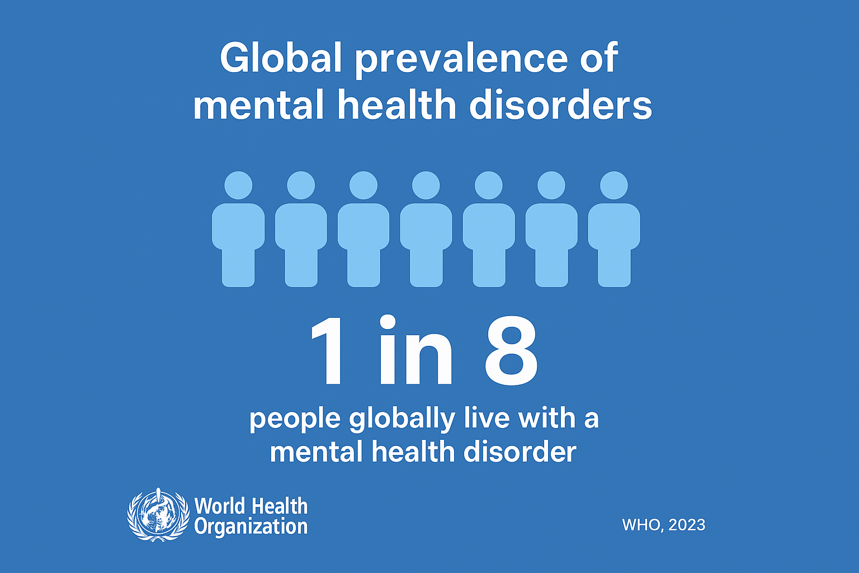

References
World Health Organization (2023) Mental health: Strengthening our response. Available at: https://www.who.int/news-room/fact-sheets/detail/mental-health-strengthening-our-response (Accessed: 6 November 2025).

Task 4- Equality and Diversity Quiz

1. What is the primary goal of the NHS Equality, Diversity, and Inclusion Improvement Plan?
A: This is to be achieved by improving equality, diversity, and inclusion across the NHS workforce, allowing staff to feel a greater sense of belonging and thereby improving their experience.
2. How does the NHS EDI Improvement Plan propose to tackle the gender pay gap?
A: It proposes the development and implementation of an improvement plan in order to eliminate pay gaps by analysing pay data by sex, among other protected characteristics, and targeting action plans to close the gap.
3. What is meant by the term ‘intersectionality’ as used in the NHS EDI Improvement Plan?
A: Intersectionality recognizes that individuals possess a variety of intertwined identities, such as gender, race, and disability, and works to address the phenomenon of combined forms of disadvantage or discrimination, not focused on isolated singular characteristics.
4. Why is it important for the NHS to create a psychologically safe work environment?
A: Because staff need to feel they belong, can safely raise concerns, ask questions and admit mistakes without fear of negative consequences, which supports well-being, retention, and improved patient care.
5. How does the NHS EDI Improvement Plan suggest improving the experience of internationally recruited staff?
A: Provide a detailed programme catering especially to the induction, development, and integration needs of NHS staff recruited from outside the UK into the workforce.
6. What role does leadership play in advancing EDI objectives according to the NHS Improvement Plan?
A: Leadership at board, chair and chief executive level must have specific measurable EDI objectives that they are personally accountable for, alongside accountability for culture and outcomes.
7. Identify one way the NHS EDI Improvement Plan aims to reduce health inequalities within the workforce.
A: One way is by developing and implementing an improvement plan to address health inequalities in the workforce-such as differential access to training, progression, wellbeing support-as one of the high impact actions.
8. Why does the NHS EDI Improvement Plan emphasise the importance of collecting and analysing data on protected characteristics?
A: Because the plan depends on robust data analysis by protected characteristics to identify gaps - such as pay gaps, progression gaps, and experience differences - to focus its action, and to monitor progress.
9. Explain how flexible working policies can contribute to equality and inclusion in the NHS workforce.
A: Flexible working policies help make opportunities available to staff with caring responsibilities, disabilities, or other commitments and help support a fair and inclusive working environment, reducing disadvantage.
10. What is one strategy mentioned in the NHS EDI Improvement Plan to combat bullying and harassment in the workplace?
A: One strategy is to create a workplace that stops bullying, discrimination, harassment, and physical violence-this is identified as one of the high impact actions in the plan.

References
NHS England (2023) NHS equality, diversity, and inclusion improvement plan. London: NHS England. Available at: https://www.england.nhs.uk/publication/nhs-edi-improvement-plan/ (Accessed: 7 November 2025).
NHS Employers (2023) ‘NHS equality, diversity and inclusion (EDI) improvement plan’. Available at: https://www.nhsemployers.org/articles/nhs-equality-diversity-and-inclusion-edi-improvement-plan (Accessed: 7 November 2025).

BMHP5015 Building your Personal Brand
Task 5. A Letter to Yourself

Dear Younger, Me,
I know it's tough for you right now, and it feels like everything in life is falling apart; you're feeling overwhelmed and uncertain. You try holding it all together, but deep inside, you're tired. What I want you to know is that this is okay, and you do not have to be strong all the time.
In the future, my only desire is that you were aware of resilience and emotional intelligence. Instead of ignoring your feelings, mental capacity would enable you to comprehend and manage them. It would teach you when to stop, to rest, and how to ask for help. You always believed showing your emotions was a sign of weakness, but now I know that's a sign of self-awareness, strength, and courage. (Salovey and Mayer, 1990).
What I have learned to appreciate is resilience. It's not evading failure or pain, but it's about getting up stronger and surer, learning from your setbacks, and trusting that you can adapt. Those tough moments you faced were forming you into a stronger, wiser, and compassionate person-one who one day would be more equipped to guide others through their own struggles. (Southwick and Charney, 2018). If I could advise you on one thing, it would be to be kind with yourself. Trust that each storm will end and each movement forward, no matter how small, is a step in the right direction. You'll get through it, and one day, you will be proud of how far you have come. (Seligman, 2011).
With love,
Your younger self.

References:
Goleman, D. (1995) Emotional intelligence: Why it can matter more than IQ. New York: Bantam Books.
Salovey, P. and Mayer, J.D. (1990) ‘Emotional intelligence’, Imagination, Cognition and Personality, 9(3), pp. 185–211.
Southwick, S.M. and Charney, D.S. (2018) Resilience: The science of mastering life’s greatest challenges. 2nd edn. Cambridge: Cambridge University Press.
Seligman, M.E.P. (2011) Flourish: A visionary new understanding of happiness and well-being. New York: Free Press.
Neenan, M. (2018) Developing resilience: A cognitive-behavioural approach. 2nd edn. London: Routledge.

Assignment 1 Task 6
Gantt Chart Template: Plan Your Tasks

Task | Start Date | End Date | Duration | Dependencies (if any)
Complete Level 5 Coursework | Jan 2025 | Jan 2026 | 1 year | None
Begin Networking on LinkedIn and Attend Career Webinars | Feb 2025 | Mar 2025 | 2 months | Level 5 Coursework
Apply for Summer Work Experience in Public Health | Mar 2025 | Apr 2025 | 2 months | Networking Complete
Undertake Work Experience Placement (6 weeks) | May 2025 | Jun 2025 | 6 weeks | Work Experience Application Approved
Update Professional CV and Cover Letter | Jul 2025 | Aug 2025 | 2 months | Work Experience Complete
Apply for Graduate Public Health Roles | Aug 2025 | Sep 2025 | 2 months | CV and Cover Letter Updated
Prepare for Job Interviews | Sep 2025 | Oct 2025 | 1 month | Job Applications Submitted
Secure Public Health Position | Oct 2025 | Oct 2025 | 1 week | Successful Interviews

Rationale – Gantt Chart for Career Progression in Public Health
This Gantt chart provides a formal timeline for my career goal of becoming a Public Health Practitioner. It breaks down the milestone dates in my journey, from completing my Level 5 coursework to gaining a graduate role in public health. Activities in the chart include networking, applying for work placements, and professional development of my CV and cover letter. This step-by-step approach builds on principles of effective time management, goal setting, and prioritization pertinent in career development as suggested by Moon (2004).
Similarly, the plan ensures that there is logic in the flow of activities. For instance, dependents are established such that certain activities are undertaken before others; for example, finishing coursework before placement. This is supported by the Health Education England guide (2021) that has emphasized continuous learning and development through experience within a health career. The use of the Gantt chart to visualize one's progress will not only enhance motivation but also facilitate frequent reflection to adjust goals for supporting employability and professional growth as stated by Yorke (2006).

References:
Health Education England (2021) Public health careers: Developing your career in public health. London: NHS Health Careers. Available at: https://www.healthcareers.nhs.uk/explore-roles/public-health (Accessed: 7 November 2025).
Moon, J.A. (2004) A handbook of reflective and experiential learning: Theory and practice. London: Routledge Falmer.
National Health Service (2023) NHS Long Term Workforce Plan. London: NHS England. Available at: https://www.england.nhs.uk/publication/nhs-long-term-workforce-plan/ (Accessed: 7 November 2025).

Task 7 – Assessment 1 Portfolio

Introduction: The explanation of the purpose and importance of the proposed change (Lewin, 1951; DHSC, 2022).

As the manager of a care home, I plan to install an electronic system for care planning to replace obsolete paper-based records. Such change will be supported by the rationale of enhancing efficiency, accuracy, and quality of person-cantered care through improvement in communication, security of data and easy access of information by care staff and management teams (Department of Health and Social Care [DHSC], 2022).

Planning the Change-Using a Structured Approach to Achieve Success: Lewin 1951; CQC 2023 The change, informed by Lewin's Change Theory, 1951, will be effected in three major steps: unfreezing existing practices by highlighting the limitations of paper records, changing where digital software along with detailed training of the staff is implemented, and refreezing by embedding digital processes into daily routines. The implementation plan involves enlightening all stakeholders, including senior carers, administrative teams, and families of the residents, to ensure buy-in. Improvement will be monitored through ongoing observation, feedback from staff, and adherence to set standards by the CQC, 2023.

Competencies Required-Skills Essential to Effectively Lead and Manage Organisational Change, (NHS Leadership Academy, 2020)

These respectively require clear communication of the reason for and method of change, leadership to guide and inspire the staff to change, and time management in organizing schedules for implementation. Other ancillary skills necessary for the managing of the staff include problem-solving, basic computer literacy, and empathy in understanding concerns and assuring morale levels within the staff (NHS Leadership Academy, 2020).

Barriers and Solutions: Addressing Challenges to Ensure a Smooth Transition (CQC 2023; DHSC 2022). The potential barriers that might arise include resistance from staff, perceived lack of confidence with technology, and lack of financial resources. Resistance will be lessened because early involvement in making decisions about the service and long-term benefits will be advocated. Skill gaps can be overcome with training sessions and digital mentoring. Funding issues can be resolved through phased implementation or from local authority grants. Ongoing supervision and evaluation will ensure that the change meets the guidelines set by CQC 2023 and national digital care priorities (DHSC, 2022).

Conclusion: Reinforcing the Value and Impact of Digital Transformation (DHSC, 2022). Introduction of digital care planning will modernize operations and improve record accuracy, enhancing person-cantered care. This transformation will support long-term sustainability and align with the Department of Health and Social Care 2022 quality improvement goals.

References
Lewin, K. (1951) Field Theory in Social Science. New York: Harper & Row.
NHS England (2023) Digital Transformation in Adult Social Care. Available at: https://www.england.nhs.uk (Accessed: 6 November 2025).

Task 8 - Self-Reflection: Step-by-Step Student Guidance

Description:
The most profound learning during this module was developing my personal brand and career plan within the health and social care sector. This development helped me in critiquing my goals, values, and professional identity, which is highly important in career progression (NHS Leadership Academy, 2020).

Feelings:
At the beginning, I was a little apprehensive and unsure because of so much deep introspection on myself. As the tasks unfolded, I started to feel motivated and inspired by realising self-awareness is a very significant part of Emotional Intelligence and professional development as well (Goleman, 1998).

Assessment:
I was able to gauge strengths in my communication and teamwork but realized that my leadership and decision-making skills were those that needed strengthening. Reflection helped me connect my academic learning to practical applications in health and social care as indicated by Kolb (1984).

Analysis:
This was a valuable experience to learn how reflection facilitates continuous learning and development. Such emotional intelligence allowed me to apply the theory of self-awareness, empathy, and resilience as part of effective leadership in care settings (Mind Tools, 2022).

Conclusion:
I learned how structured reflection can help gain confidence and highlight skill gaps. Further improvement might have been achieved through active engagement with feedback from peers and tutors to gain diverse perspectives.

Action Plan:
I will continue with reflective practice using Gibbs' model, find opportunities for mentorship, and enhance my leadership and problem-solving skills for future professional roles. (Gibbs, 1988)

References
Gibbs, G. (1988) Learning by Doing: A Guide to Teaching and Learning Methods. Oxford: Oxford Polytechnic.
Goleman, D. (1998) Working with Emotional Intelligence. New York: Bantam Books.
Kolb, D.A. (1984) Experiential Learning: Experience as the Source of Learning and Development. Englewood Cliffs: Prentice-Hall.
Mind Tools (2022) Developing Emotional Intelligence. Available at: https://www.mindtools.com (Accessed: 6 November 2025).
NHS Leadership Academy (2020) Healthcare Leadership Model. Available at: https://www.leadershipacademy.nhs.uk (Accessed: 6 November 2025).

