University of Wales Trinity Saint David

School of Engineering

Application of automation in wastewater treatment
ACMA5001 PART-TIME

Joshua Axon

2218372

7th of April

Contents
1 Introduction 1
2 Historical Context and Adoption of ICA in Wastewater Treatment 1
3 Essential Components of ICA in Wastewater Treatment 3
3.1 Sensors and Process Variables 3
3.1.1 pH Levels 3
3.1.2 Dissolved Oxygen 4
3.2 Process Controllers and Automation Strategies 5
3.2.1 Programmable Logic Controllers (PLCs) 5
3.2.2 Supervisory Control and Data Acquisition (SCADA) Systems 6
3.2.3 Proportional-Integral-Derivative (PID) Control 7
3.3 Actuators and Final Control Elements 7
3.3.1 Actuation integration 7
4 Regulatory and Standard Compliance in Wastewater ICA 8
4.1 Key bodies and Statutory Requirements 8
4.1.1 Harmonisation of Practices 8
5 Advances in Wastewater Treatment Automation 9
5.1 Smart Technologies and AI 9
5.2 Digital Twins, IoT and Wireless Sensor Networks (WSN) and edge computing 9
6 Practical Implementation and Future Outlook 10
7 Conclusion and Recommendations 10
8 References 11

Table of Figures:
Figure 1 - Population growth in Birmingham and Coventry, 1801–2001. Source: Centre for Cities (n.d.), What happened to the city of a thousand trades? Birmingham from 1901 to today. Available at: https://www.centreforcities.org/blog/what-happened-to-the-city-of-a-thousand-trades-birmingham-from-1901-to-today [Accessed 22 Mar. 2025]. 2
Figure 2 - Diagram of a glass electrode pH sensor. Source: Priyam Study Centre (2022). Glass Electrode – pH Measurement. Available at: https://www.priyamstudycentre.com/2022/05/glass-electrode-ph-measurement.html [Accessed 22 Mar. 2025]. 3
Figure 3 - Diagram of 'clark-type' dissolved oxygen sensor. Source: Deranged Physiology (2023). Principles of oxygen measurement with the Clark electrode. Available at: https://derangedphysiology.com/main/cicm-primary-exam/respiratory-system/Chapter-422/principles-oxygen-measurement-clark-electrode [Accessed 22 Mar. 2025]. 4
Figure 4 - Ladder logic diagram. Source: Automation Ready Panels (ND). What is PLC Ladder logic and how does it work? Available at: https://www.automationreadypanels.com/plc-hmi/what-is-plc-ladder-logic-and-how-does-it-work/ [Accessed 23 mar 2023]. 5
Figure 5 - Example of a SCADA Human-Machine Interface software displaying process information. Source: DOSupply 2019. Explaining HMI, SCADA, and PLCs, what they do, and how they work together. Available at: https://www.dosupply.com/tech/2019/02/04/explaining-hmi-scada-and-plcs-what-they-do-and-how-they-work-together/ [Accessed 23 Mar 2025]. 6
Figure 6 - Diagram of an electrically operated valve actuator. Source: Zhang, P. (2008). Industrial Control Technology: A Handbook for Engineers and Researchers. William Andrew Publishing. 7
Figure 7 - Diagram of an IoT enabled wastewater treatment process. Source: Temboo 2019. How to bring IoT to your wastewater treatment plant. Available at: https://blog.temboo.com/iot-and-wastewater-treatment-plants/ [Accessed: 25 Mar 2025]. 9

Introduction

Public Health and Environmental Safety are paramount to the continued prosperity of modern developed economies. Awareness of environmental issues among the population is at its highest level ever, and pressure for compliance with environmental regulations is no longer seen as a nice thing to have but a must. Public health services in the UK are struggling to meet demand, and thus, public health has also been pushed to the forefront of the public conscience. Wastewater Treatment and Management are cornerstones to tackling these issues.
Industrial Control & Automation (ICA) use in wastewater treatment plants is now commonplace. This is due in part to the complexity of operations and the treatment of wastewater has increased, so has the requirement of measurements of process control variables, and manual measurements are infrequent and cannot offer the level of precision required to optimise processes with a facility (Qasim & Guang, 2018).
This report will critically analyse ICA applications to wastewater treatment, provide a history pretext into their adoption in wastewater treatment plants, and explore the role of programmable logic controllers (PLCs), distributed control systems (DCS) and proportional-integral-derivative (PID) in process control systems. It also gives an overview of regulatory requirements, the importance of compliance with these standards—advancements in ICA, and their potential impacts on wastewater treatment plants. Finally, give insight into recommendations of ICA configurations, difficulties in their implementation, and any potential ethical or environmental considerations in their application.
This report will be structured in six distinct sections covering all aspects of report mentioned above.

Historical Context and Adoption of ICA in Wastewater Treatment

The earliest form of wastewater treatment is sewerage farms, the purpose of which was to reuse or dispose of the waste on agricultural land, this method relied on manual handling of waste with little to no way of controlling hazards or sanitation (Scholz, 2016). During the Industrial Revolution, which is often referred to as the beginning of the "age of sanitary enlightenment," the abandonment of the miasma theory of disease opened the door for modern sewage systems. The practice of using lime to dislodge solids suspended in wastewater emerged around 1700-1800. Additionally, the invention of the septic tank in 1895 and the Imhoff tank in 1906 laid the foundation for sewage treatment methods that are still in use today (Lens, et al., 2001). Broadly speaking the late 19th and early 20th century say the design saw largely only manual and some limited adoption of mechanical means for wastewater treatment through the adoption of settling tanks such as the septic tank.
From the early 20th century onward, population centres like Birmingham and Coventry experienced rapid and explosive growth, as shown in Figure 1. This surge in population required the development of improved and more expansive wastewater management systems to process wastewater more efficiently. However, it wasn't until the mid-1970s that instrumentation, control, and automation began to be widely adopted in wastewater management. Plants aimed to operate more efficiently, achieve consistent performance, and manage fluctuations in loading conditions at an affordable cost (Yuan, et al., 2019).



Figure 1 - Population growth in Birmingham and Coventry, 1801–2001. Source: Centre for Cities (n.d.), What happened to the city of a thousand trades? Birmingham from 1901 to today. Available at: https://www.centreforcities.org/blog/what-happened-to-the-city-of-a-thousand-trades-birmingham-from-1901-to-today [Accessed 22 Mar. 2025].

The widespread adoption of automated control systems in wastewater treatment plants gained significant momentum during the 1980s and 1990s. This shift was largely driven by increasingly stringent environmental regulations that imposed tighter restrictions on discharge frequency and required continuous monitoring of effluent quality. In response, treatment plants began to rely heavily on Supervisory Control and Data Acquisition (SCADA) systems, which enabled centralized monitoring, control, and reporting of plant operations. Instrumentation such as sensors and analysers facilitated real-time, continuous monitoring of critical parameters, including turbidity (wastewater clarity), nutrient concentrations, and microbial activity. These instruments were integrated with Programmable Logic Controllers (PLCs), allowing for automated adjustments and consistent process control, thereby improving operational efficiency and regulatory compliance (Olsson, et al., 2005).

Essential Components of ICA in Wastewater Treatment

Sensors and Process Variables
Effective process control relies on continuous monitoring, in wastewater treatment plants it no different. Several critical parameters ensure optimal performance and compliance with environmental regulations. The integration of sensors is done to ensure real-time data acquisition, enabling automated control and prompt corrective actions.

pH Levels
​Monitoring pH levels is crucial in wastewater treatment plants to ensure optimal microbial activity and effective chemical treatment processes. This is typically achieved using glass electrode pH sensors, which are depicted in Figure 2.
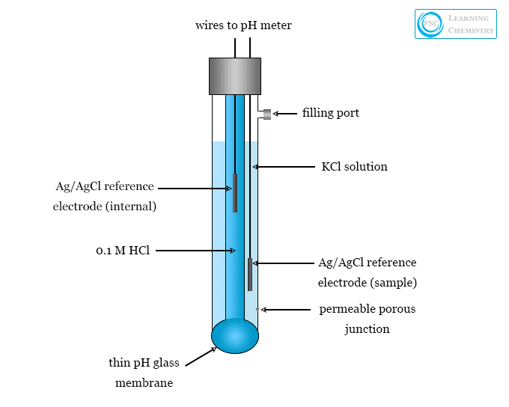
Figure 2 - Diagram of a glass electrode pH sensor. Source: Priyam Study Centre (2022). Glass Electrode – pH Measurement. Available at: https://www.priyamstudycentre.com/2022/05/glass-electrode-ph-measurement.html [Accessed 22 Mar. 2025].

These sensors function by measuring the voltage difference between a pH-sensitive glass electrode and a stable reference electrode. This voltage difference is then converted by a pH meter into pH units, providing a precise measurement of the solution's acidity or alkalinity (ICON Process Controls, 2024).

Dissolved Oxygen
Dissolved oxygen (DO) is a critical parameter in wastewater treatment, as it supports the respiration and survival of aerobic microorganisms responsible for breaking down organic matter. Electrochemical sensors are commonly employed to monitor DO levels, with the Clark-type electrode being one of the most widely used. A diagram of this sensor is shown below in Figure 3.
Clark-type electrodes operate as simple amperometric biosensors: an electrochemical reaction occurs at a platinum cathode, where oxygen is reduced. This reduction current is directly proportional to the concentration of dissolved oxygen in the wastewater, allowing for real-time monitoring and process control (Mendelson, 2012).

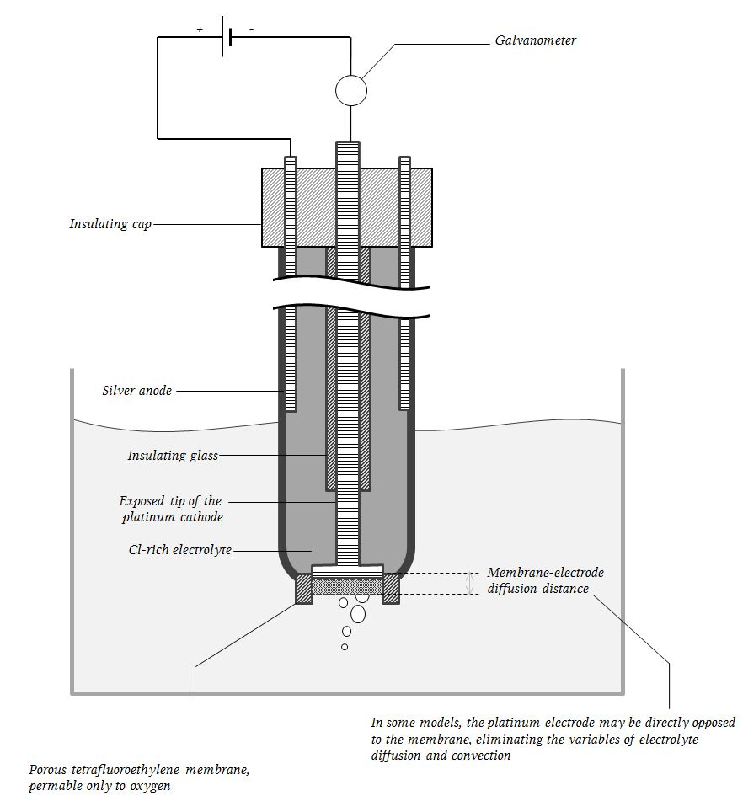

Figure 3 - Diagram of 'clark-type' dissolved oxygen sensor. Source: Deranged Physiology (2023). Principles of oxygen measurement with the Clark electrode. Available at: https://derangedphysiology.com/main/cicm-primary-exam/respiratory-system/Chapter-422/principles-oxygen-measurement-clark-electrode [Accessed 22 Mar. 2025].

Process Controllers and Automation Strategies
In wastewater treatment plants, effective process control represents the next level in the control hierarchy, building upon instrumentation and monitoring systems to ensure consistent operational performance, environmental protection, and regulatory compliance. These control systems utilize data from various sensors to actively regulate key treatment processes, maintaining optimal conditions and responding to fluctuations in real time. By integrating advanced control technologies, plants can enhance efficiency, reduce manual intervention, and improve the quality of treated effluent.

Programmable Logic Controllers (PLCs)
Programmable Logic Controllers (PLCs) are specialized industrial computers designed to automate and regulate process conditions in systems such as wastewater treatment plants. They interface with sensors and actuators to continuously monitor key parameters—such as pH, dissolved oxygen, and flow rate—and respond accordingly. PLCs operate based on pre-programmed control algorithms that execute specific actions, such as activating pumps or releasing chemical compounds to adjust pH or oxygen levels (Antonsen, 2021).
These control instructions are often written using ladder logic, a graphical programming language that resembles traditional electrical circuit diagrams. Ladder logic is structured between two vertical rails: the left rail represents the power source, and the right rail represents the output or "energized" rail. Logic is built across horizontal rungs using symbolic representations of contacts (inputs) and coils (outputs), making it intuitive for operators familiar with electrical schematics (Cybellium Ltd, 2023).
In control rooms, specialized PLC panels or ladder logic interfaces display real-time process conditions, alarms, and system responses, allowing operators to monitor and troubleshoot the system efficiently. An example of a logic diagram can be found in figure 3 below.
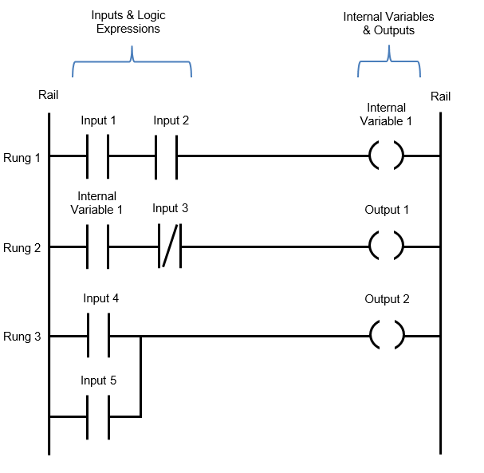

Figure 4 - Ladder logic diagram. Source: Automation Ready Panels (ND). What is PLC Ladder logic and how does it work? Available at: https://www.automationreadypanels.com/plc-hmi/what-is-plc-ladder-logic-and-how-does-it-work/ [Accessed 23 mar 2023].

Supervisory Control and Data Acquisition (SCADA) Systems
Supervisory Control and Data Acquisition (SCADA) systems provide real-time monitoring and control of processes in wastewater treatment plants. They gather data from field devices such as Programmable Logic Controllers (PLCs), Remote Terminal Units (RTUs), and various sensors, and display the information through Human-Machine Interfaces (HMIs)—most commonly accessed via desktop computers running specialized SCADA software.
SCADA systems enable remote control and supervision of equipment across the plant from a centralized operator station or control room. They also support key functions such as data logging, alarm and warning management, historical trend analysis, and system diagnostics. By consolidating process information in a user-friendly interface, SCADA enhances situational awareness and improves the decision-making capabilities of plant operators (Krutz, 2006). An example of a human-machine interface SCADA system displaying information can be seen below in figure 5.

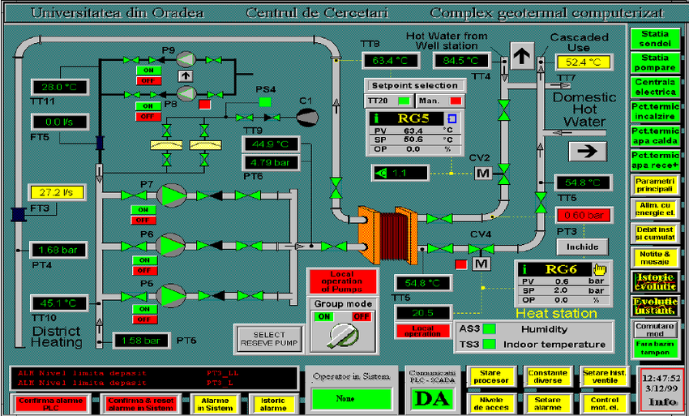

Figure 5 - Example of a SCADA Human-Machine Interface software displaying process information. Source: DOSupply 2019. Explaining HMI, SCADA, and PLCs, what they do, and how they work together. Available at: https://www.dosupply.com/tech/2019/02/04/explaining-hmi-scada-and-plcs-what-they-do-and-how-they-work-together/ [Accessed 23 Mar 2025].

Proportional-Integral-Derivative (PID) Control
Proportional-Integral-Derivative (PID) controllers act as regulators for sensor-based control systems, continuously monitoring output signals and calculating the error between the desired setpoint and the actual process value. By assessing this error in real time, PID controllers adjust process inputs to reduce steady-state error and maintain optimal conditions.
The proportional component corrects the error in direct proportion to its magnitude, the integral component addresses accumulated past errors to eliminate offset, and the derivative component predicts future trends based on the rate of change. Together, these elements improve a control system's responsiveness and stability, helping to reduce hysteresis (the lag between input and output), prevent output overshoot, and deliver smoother, more accurate responses to fluctuating process conditions (Visioli, 2006).

Actuators and Final Control Elements
In wastewater treatment plants, actuators serve as the final element in the control loop. They convert control signals into physical actions, enabling the regulation of process conditions and ensuring efficient, reliable, and compliant operations.
Common examples of actuators used in wastewater treatment include valves, pumps, and motorised gates. Valves are used to restrict or regulate the flow of fluids; pumps increase flow rates by moving water or sludge between treatment stages; and motorised gates control the passage of effluent, allowing for precise flow management within the system (Nesbitt, 2011).

Actuation integration
An actuator is a device that produces either linear or rotary motion from a power source, typically in response to signals from a control system. In wastewater treatment plants, actuators are integrated into the control loop by responding to outputs from sensors or PID controllers, enabling fully automated adjustments based on real-time data. This integration allows the system to maintain optimal process conditions, even as operational parameters fluctuate dynamically.
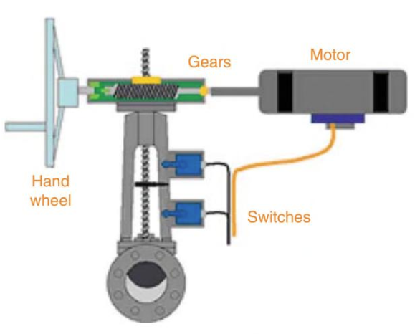
An example of an electrically operated valve actuator is shown below in Figure 6.
Figure 6 - Diagram of an electrically operated valve actuator. Source: Zhang, P. (2008). Industrial Control Technology: A Handbook for Engineers and Researchers. William Andrew Publishing.

In the context of valve automation, for example, actuators such as rotary or electrical actuators can be operated electrically or pneumatically in response to control signals. The control system identifies when a process adjustment is required, generates the appropriate signal, and sends it to the actuator. This signal prompts a physical action such as opening or closing a valve, starting or stopping a pump, or raising or lowering a gate allowing the plant to respond automatically and consistently to process demands (Zhang, 2008).

Regulatory and Standard Compliance in Wastewater ICA
Regulatory compliance is essential in the wastewater management industry, as any breaches can lead to serious public health risks and environmental damage. As wastewater treatment plants become increasingly automated, adherence to regulatory standards must become even more robust to ensure reliable and stable treatment of effluent.

Key bodies and Statutory Requirements
In the United Kingdom, the Environment Agency (EA) is responsible for regulating wastewater treatment and ensuring that the quality of treated effluent released into natural water bodies meets legal and environmental standards. The specific treatment requirements and monitoring obligations for each wastewater treatment plant depend on factors such as the size of the population it serves and the characteristics of the receiving water body (Environmental Agency , 2018).
At a higher level, wastewater management in urban areas is guided by a European directive. However, due to Brexit and the UK’s evolving relationship with the EU, the UK has not adopted the latest version of this directive, and there are ongoing concerns about how well previous requirements are enforced. As a result, regulation of the UK’s waterways now falls primarily to domestic legislation and agencies (Farmer, 2024).

Harmonisation of Practices
Governmental directives and regulations are often written in broad legal terms, which can make them challenging for wastewater treatment plants to interpret and implement in day-to-day operations. To address this, organizations such as the International Organization for Standardization (ISO) a non-governmental body develop technical standards that help harmonize practices across countries. These standards provide practical guidance and clearer frameworks for compliance, helping bridge the gap between high-level legal requirements and on-the-ground operational practices. Unlike government-issued legislation, ISO standards are typically more accessible and adaptable, reducing bureaucratic complexity while still supporting regulatory objectives a good example of this is ISO 14001 which outlines the key requirements for an Environmental Management System (EMS) (Sharron, 2024).

Advances in Wastewater Treatment Automation
Advancements in Automation have the potential to significantly transform wastewater treatment plants and their processes by enhancing efficiency, reliability and sustainability. Key technologies driving this potential innovation include but not limited to Artificial Intelligence, Machine Learning, Digital Twins and Internet of Things (IoT) enabled sensors.

Smart Technologies and AI
As machine learning (ML) and artificial intelligence (AI) continue to rise to prominence across the technology sector, their influence is increasingly being felt in wastewater treatment as well. These advanced algorithms are now being trialled and refined within plant operations to improve process efficiency and reliability. One key application is predictive maintenance, where AI and ML models analyse operational data to forecast equipment failures before they occur. This enables proactive maintenance strategies, helping to reduce unplanned downtime and lower overall maintenance costs (Hawkins, 2023).
Additionally, case studies have shown that implementing AI can significantly reduce chemical usage by dynamically analysing influent characteristics and adjusting dosing rates in real time (Refiste, 2024).

Digital Twins, IoT and Wireless Sensor Networks (WSN) and edge computing
Digital twins are virtual replicas of physical assets or systems, designed to simulate and analyse real-world processes in real time. In the context of wastewater treatment, digital twins provide detailed, dynamic models of treatment infrastructure, allowing operators to test and optimize processes virtually before applying changes to the physical system.
When integrated with live data streams and sensor feedback through the control loop, these models become dynamic—capable of adapting to real-time changes and reflecting actual operating conditions. This enables more informed decision-making, enhances risk management, and supports continuous process optimization, ultimately improving operational efficiency and system resilience (Alonso, et al., 2024).
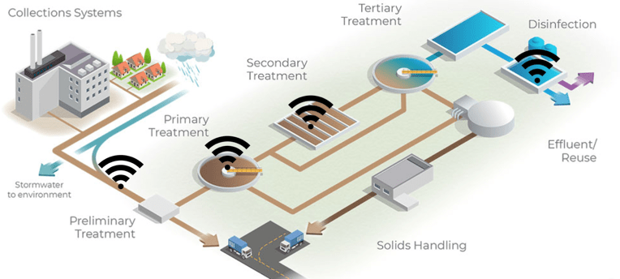
The Internet of Things (IoT) is a broad term that refers to the network of interconnected devices—including sensors, software, and actuators that communicate and exchange data. In the context of wastewater treatment, wireless sensor networks (WSNs) are a practical example of how IoT is integrated into plant operations, enabling continuous real-time monitoring of critical parameters.
Figure 7 - Diagram of an IoT enabled wastewater treatment process. Source: Temboo 2019. How to bring IoT to your wastewater treatment plant. Available at: https://blog.temboo.com/iot-and-wastewater-treatment-plants/ [Accessed: 25 Mar 2025].

When combined with edge computing a distributed computing framework that brings processing and storage closer to the data source this setup allows for faster, more efficient data analysis and decision-making with minimal latency. While edge computing reduces reliance on centralized systems, it typically requires high bandwidth to manage the volume and velocity of data generated in real time (Stankovski, et al., 2020).

Practical Implementation and Future Outlook
There is no debate that Instrumentation, Control, and Automation (ICA) systems are now fundamental to the operation of any modern wastewater treatment plant. They enable processes to be more reliable, efficient, and compliant with environmental regulations. However, implementing ICA comes with significant challenges. Establishing a full control loop requires the integration of sensors, controllers, and actuators—often across large and complex treatment facilities. This makes ICA deployment a multi-stage process involving extensive planning and assessment to ensure that existing infrastructure can support automation. Sensor placement must be carefully considered to avoid overlapping readings or interference, ensuring that measurements are accurate and representative. In addition, PLCs (Programmable Logic Controllers) and DCS (Distributed Control Systems) must be correctly specified to handle the volume of data, which is then fed into a SCADA system for real-time visualisation, analysis, and response by the operations team (Olsson & Newell, 1999).
When applying ICA to legacy treatment plants, several key challenges emerge. Ageing infrastructure—such as outdated mechanical equipment or limited space—can restrict the integration of modern control components, often requiring costly upgrades or replacement of otherwise serviceable assets. Integrating data from existing systems can be complex, requiring detailed consultation and custom configuration to ensure reliable communication within the control loop, which may significantly increase retrofit project costs. Furthermore, transitioning to even partial automation requires investment in workforce retraining and the development of new maintenance protocols to ensure the long-term reliability of automated systems (Olsson, 2012).

Conclusion and Recommendations
The integration of Instrumentation, Control, and Automation (ICA) systems in wastewater treatment plants has become indispensable in ensuring operational efficiency, regulatory compliance, and environmental sustainability. Modern ICA frameworks comprising sensors, PLCs, DCS, SCADA systems, and actuators allow real-time monitoring, data analysis, and automated control of critical treatment processes. These technologies enable operators to maintain process stability, reduce chemical and energy usage, and respond proactively to system disturbances.
Despite the clear benefits, the implementation of automation, particularly in legacy systems, presents notable challenges. Ageing infrastructure, data integration complexity, equipment compatibility, and the need for workforce retraining all contribute to higher costs and longer deployment times. Nonetheless, with careful planning and phased implementation, these obstacles can be overcome, unlocking the full potential of automated process control.
Looking ahead, the future of ICA in wastewater treatment is shaped by emerging technologies such as artificial intelligence, machine learning, digital twins, and IoT-enabled sensor networks. These innovations enable predictive maintenance, dynamic process optimisation, and more responsive control strategies. Additionally, concepts like edge computing and blockchain show promise for enhancing data integrity, security, and transparency in water quality monitoring and reporting.

References
Alonso, C., Regueiro, I. & Garcia, O., 2024. Digital Twin Platform for Water Treatment Plants Using Microservices Architecture. Sensors , 24(5), pp. 1568-1569.
Antonsen, T., 2021. PLC Controls with Ladder Diagram (LD). S.L.: Books on demand.
Cybellium Ltd, 2023. Mastering PLC Ladder Logic Programming. s.l.:s.n.
Environmental Agency , 2018. Waste water treatment works: treatment monitoring and compliance limits. [Online]
Available at: https://www.gov.uk/government/publications/waste-water-treatment-works-treatment-monitoring-and-compliance-limits/waste-water-treatment-works-treatment-monitoring-and-compliance-limits
[Accessed 25 03 2025].
Farmer, A., 2024. Diverging wastewater policy: The Implications of changes to EU policy for the UK, London: Institute for European Environmental Policy UK.
Hawkins, J., 2023. Machine Learning for Predictive Maintenance. s.l.:Independently Published .
ICON Process Controls, 2024. The Role of pH Sensors in Industrial and Chemical Applications. [Online]
Available at: https://iconprocon.com/blog-post/the-role-of-ph-sensors-in-industrial-and-chemical-applications/
[Accessed 22 March 2025].
Krutz, R., 2006. Securing SCADA Systems. Indianapolis: Wiley Publishing .
Lens, P., Zeeman, G. & Lettinga, G., 2001. Decentralised Sanitation and Reuse. s.l.:IWA Publishing .
Mendelson, Y., 2012. Biomedial Sensors. In: t. edition, ed. Introduction to Biomedical Engineering. s.l.:Elsevier, pp. 609-666.
Nesbitt, B., 2011. Handbook of Valves and Actuators. 2 ed. s.l.:Elsevier Science.
Olsson, G., 2012. ICA and me - A subjective review. Water Research, 46(6), pp. 1585-1624.
Olsson, G. & Newell, B., 1999. Wastewater Treatment Systems: Modelling and Control. s.l.:IWA Publishing .
Olsson, G. et al., 2005. Instrumentation, Control and Automation in Wastewater Systems. s.l.:IWA Publishing .
Qasim, S. & Guang, Z., 2018. Wastewater treatment and reuse : theory and design examples.. Boca Raton: Taylor & Francis, Crc Press.
Refiste, J., 2024. AI and Machine Learning for Wastewater Treatment Optimization. [Online]
Available at: https://www.jacobs.com/newsroom/onewater-reflections/ai-and-machine-learning-wastewater-treatment-optimization?
[Accessed 25 03 2025].
Scholz, M., 2016. Wetlands for water pollution control. Waltham Ma: Elsevier .
Sharron, M., 2024. Achieve Legal and Regulatory Compliancewith ISO 14001. [Online]
Available at: https://www.isms.online/iso-14001/ensuring-legal-and-regulatory-compliance-with-iso-14001/
[Accessed 25 03 2025].
Stankovski, S. et al., 2020. The Impact of Edge Computing on Industrial Automation. Sarajevo, IEEE.
Visioli, A., 2006. Practical PID Control. London: Springer.
Yuan, Z. et al., 2019. Swating the assests - The role of instrumentation, control and automation in urban water systems. Water Research, Volume 155, pp. 381-402.
Zhang, P., 2008. Industrial Control Technology: A Handbook for Engineers and Researchers. Amsterdam: William Andrew Publishing.

