Critically analyse the nature of the Roman influence on the religious life in Pannonia. Among others, critically engage with modern scholarly debate, theoretical approaches and ancient evidence (archaeological, epigraphic and literary evidence) to discuss the persistence and transformation of key cults and sanctuaries in the province between the late Republic and the 3rd century AD.

The Roman influence on the religious life of the regions it conquered has long been recognised, but the extent of this influence, why it came about, and what drove it, are debated topics. In addition, it has been all too easy to oversimplify ‘Roman Religion’ and focus on Municipia or Colonia, assume evidence from one region may be applicable in another and create a picture of provincial religion that too far emphasises ‘Romanisation’ as opposed to a more complex interplay between cultures. Throughout many of the provinces, we also expect “syncretisms” among the deities being worshiped, both from “interpretatione Romana” and “indigina”. Furthermore, it is important to recognise that any change in cults likely comes from the people living in the region, not as dictated by the state. Pannonia gives us a rich field of study, with many kinds of religious activity, from traditional Roman gods such as the Capitoline Triad and plentiful dedications to Jupiter Optimus Maximus and Jupiter Dolichenus, to Mithras, Christianity, and Egyptian influence. With debates ongoing around religion in the Roman Empire it remains crucial to try not to take one province or city and wholesale overlay that framework over another region, while also drawing useful and necessary parallels. It is in this milieu of evidence, theory and comparatives that Pannonia must be examined, without which the picture of transformation and persistence would be incomplete. One final point is worth raising, this paper will not cover every cult as some are only found in a single or very few inscriptions, but will focus on cults that seem more key, while also bearing in mind many smaller cults to be discussed together.
Firstly then we must discuss the evidence for religious activity in Pannonia during its time as a province of the Roman Empire, the Roman military and civic organisations give us plentiful epigraphy and iconography to work with. The evidence is largely “urban” from Colonia, Municipia, towns and villages, as well as military bases, but villas and sanctuaries also provide evidence. However, compared to certain sites in France, Italy, Britain or other areas the archaeology has not always been as well developed in Pannonia and we could be missing some significant evidence, with discoveries continuing to be made in the last few decades, the picture will likely to continue to evolve.

As much of this evidence is centred on “Polis Religion” it would be all too easy to focus the entirety of the paper there. However, this would risk marginalising personal dedications but also “native” religious activity. Furthermore, if we wish to understand change in a more nuanced manner we must examine the evidence for religious activity before the Roman occupation. This is by no means straightforward, as before the occupation the people of Pannonia seem to not have been nearly as interested in epigraphy or creating large iconographic religious representations as others. A further problem in judging changes in cults, such as any popularity or activity beyond the urban, is that many people will not leave any evidence in the epigraphic or archaeological record. An inevitable issue arises therefore around the persistence or transformation of cults is that although there is obviously large religious change in the province from the Roman occupation, it is hard to tell if we are getting the full picture. If we focused only on the “Urban” we might see an almost wholesale change and significant “Romanisation” both from Roman and “native” settlements. However, this term may be misleading as there is plentiful religious activity that, although shared with other parts of the Roman Empire, was far from traditionally Roman, and seeing new cults as simply ‘Roman’ may well be an oversimplification. Furthermore, it is not always easy to differentiate between local or native cults, and how they, as well as other cults, interacted and functioned. We can probably be sure that the people residing in Pannonia had their own rich and complex religious beliefs, cults, sanctuaries, and practices, before the Roman annexation. That is not to say we are completely bereft of evidence, one of the most important pieces of religious evidence we have, of a non-traditionally Roman character, is that of burial customs. These burial customs and their representations on tombstones only cease in the third century, with “Chariot Burials” and “tumuli” particularly in the north-east and north-west of the province. It seems fair to include these sites as sanctuaries or cult places, even if they do not fit the traditional Greco-Roman model, since they were surely of religious and cultural significance. Furthermore, some have argued that dedications to the “Genius” of a place, as well as Silvanae or Nymphae or “Liber Pater” may represent some continuing and evolving worship of “old indigenous gods”, although considering the evidence this is far from certain. Furthermore, we do have ‘native’ sanctuaries, some of which will also be discussed below, such as the ‘Celtic’ sanctuary at Pákozd in use into the Roman occupation. The cult of Jupiter and Juno also appears to have become popular amongst the people of Pannonia, perhaps reflecting a previous “divine couple”. This is a short survey of the state of evidence for indigenous religious activity, cults and sanctuaries before and after the Roman occupation, but it is probably fair to say that some aspects of religious life in Pannonia may have been so different compared to Rome that its expression in such a manner as turns up easily in the archaeological record would be difficult, and the expression of such beliefs in a more roman or at least Mediterranean fashion, impossible. Furthermore, how the native population interacted with the other cults outlined below may well have differed by region.
The influence of Christianity introduces a major new ‘cult’ to the province. The movement of Christians to the region and its growing popularity not only gives the region a new cult in this period, but also new cult places, such as chapels at cemeteries, baths, houses, and basilicas. However, much of the activity in the region is beyond the temporal remit of this paper, with Christianity likely not solidifying its presence in the province until the mid to late third century and much of our evidence coming from the fourth century or later. Immigration from the military was not the only type of immigration that had an effect on the religion and cult sites of Pannonia, many Greek immigrants seemed to settle there, some of whom were highly influential in the Christian life of the province. Christianity as a cult, despite its similarities to other mystery cults, does truly represent a transformative influence that one imagines would have been harder without the Roman occupation.
It has been argued, in some ways correctly, that the evidence for religion in this period in Pannonia is markedly “Roman” when compared to Gaul or Britain or elsewhere. In many areas of the Empire, we see plentiful continuation and no doubt transformation as well, but the same has often not been said of Pannonia. Non-traditional Roman cults, such as Christianity, Mithraism, or others also appear to occur in a recognisably Roman way. Having said this it is important to remember the cultural milieu of Religious activity across the Roman Empire, and that perhaps we should be cautious in labelling all as simply ‘Roman’ when many such cults had their roots far from Rome. Having said this, plenty of cults in Pannonia are distinctly Roman, in particular, we should examine the evidence for the beginning of several cults to the Capitoline Triad that occur, one example in Savaria was “not built until about the middle of the second century” another was in Scarbantia. Mocsy argues that along with amphitheatres these temples mean that “the province had been given its finishing touches and had become Roman”. Now, this seems like too much of a stretch considering that we have little idea how much these temples affected the religious life of the people living within and around these cities. However, finding such a distinctively Roman cult, or group of cults, so far from Italy seems worthy of note when considering the extent of the regions religious transformation.
Mithraism is another major cult, even if its roots are non-Roman it was through the Roman occupation that this cult appears to have become more prominent in Pannonia. There are several Mithrea in Pannonia, particularly in “Poetovio, Carnuntum and Aquincum” as well as other townships. The relationship to the military may be important here, it has been said that the 15th legion “brought the Mysteries to Carnentum” and that “the principle agent of its diffusion was undoubtedly the army”. Although there does appear to be significant links between the Roman military and the cult, inside and outside of Pannonia, we should not see the cult as purely a military one. Of all the mystery cults in Pannonia it seems Mithras was the most popular, although mystery cults made up a clear minority of inscriptional evidence, it seems to grow consistently in this time period.
Pannonia was a particularly prominent area in terms of the cult of Jupiter Dolichenus, perhaps linked to the military, at the legionary fortress of Carnuntum, a Mithraeum and Dolicheum are separated only by a single wall. Both Brigetio and Egeta had military garrisons and in turn each had a Dolichenum; this god “appears as the lord of a major religion of the Roman Empire” and he certainly appears important in Pannonia. This cult may have been particularly popular amongst the officers of the Roman military in Pannonia, perhaps with eastern soldiers spreading the cult, and highlights the importance of the military to religious transformation and cults in Pannonia. Another location for the cult, possibly linked to the Imperial cult, was at Gorsium, which has been called a “Mecca” for the cult. This cult however, seems to have suffered a mortal blow by the late third century with the looting of some of it sanctuaries earlier in the century.
The influence of Egyptian cults is also important, with Serapis and Isis in particular proving popular in Pannonia. Among those two it appears Isis was more popular, perhaps because of a “universal” appeal. Furthermore, we find her with many epithets, earning her the title “Isis of many names” but in particular she had a temple in Savaria, perhaps where a previous temple stood. Although less popular than the cult of Mithras there are plenty of inscriptions to Isis and Serapis in Pannonia. Even a few shabtis have been found in the province possibly connected to cult activity. This nicely illustrates the almost ‘cosmopolitan’ nature of cults in Pannonia and perhaps is a reflection of the wider popularity of these gods throughout the Roman empire.
Silvanus, perhaps because of some pre-roman beliefs, appears to also be popular, second only to Jupiter Optimus Maximus, and perhaps also a change for the native population, as numerous lead votive offerings have been found. Indeed what makes the cult of Silvanus in Pannonia particularly important is that more lead votive offerings have been found than stone dedications. However, questions must be asked about if those settlers making dedications, and the people who made the votive offerings, are worshiping the same deity, different epithets or something altogether different in their eyes, indeed, even if they were worshiping the same god, did they understand it in the same way? However, most of the alters found to Silvanus were without epithets in the interior with “the Limes” having more to Silvanus Domesticus, in the “Severen period”. This shows some regional variations in the way in which the cult of Silvanus was venerated. What we cannot doubt is that the cult of Silvanus (if we view it as one cult) was used by different people for different purposes but that the majority of its dedicants were civilian, followed in popularity by the military and the administration.
The greatest number of dedications are to Jupiter Optimus Maximus without any other epithets, particularly by members of the civil administration at various levels. Indeed his popularity was not confined to one region or time within the province, but was consistent. It would be very easy to see this popularity as a result of understandable favour an administration might show for this very ‘Roman’ god, or else assume that he was worshiped by the local population as a sign of loyalty or because of some relationship to a more local god. This cult indeed demonstrates possible regional or social differences that change the cults we expect to see, indeed although the majority of found inscriptions are not from officials, most of those to Jupiter Optimus Maximus were erected by officials from the “interior” of the province. Indeed, in the late 3rd century dedications to the deity fall dramatically, perhaps showing a lack of interest in the cult after various military and economic problems. However, the god being new and yet so popular demonstrates a clear transformation, even if the deity is somehow related to ‘native’ belief.
Inscriptions to Jupiter Optimus Maximus Teutates are also common, Teutates seems to have been the head deity for the Eravisci, a ‘Celtic’ tribe occupying areas around Aquincum with a possible sanctuary to the god on Gellért Hill. This cult is particularly important because it is one of the primary cases within the province for a more direct continuation and transformation of a pre-roman site, although there is some doubt over the pre-roman nature of any religious activity taking place there. Although this cult is somewhat uncertain in its nature it does nicely highlight an important ‘Celtic’ influence that helped transform Pannonian cults in (and before) this period and is almost the kind of example we might expect in Gaul.
Many of the ‘standard’ Roman deities also appear in dedications giving the region a “wide variety of Roman cults”, including ”Neptune Mars, Apollo, Vulcan, Mercury, Iuno, Minerva, Diana, Venus, Vesta and Ceres” as well as “Asklepipius, Fortuna, Hercules, Hygieia, Nemesis, the Nymphs, the Nundinae, Telesphorus, Terra Mater, Pax, Pluto and Proserpina, Urbs Romana and Victoria”. Since these cults and sanctuaries are perhaps less important or influential on their own they will be examined together, indeed many inscriptions are simply to the “Di Maiores”. Many of the dedications to are of an “official nature” and they were often apparently “venerated for their traditional Roman areas of competence”. The popularity and geographical spread of these deities changed over time but their variety remains, this plethora of deities must have been transformative for the religion of the region, with worship from all strata of society, even if native dedication numbers remain small.
The ‘Imperial cult’ is always problematic, as the term applies to a wide variety of different religious activities, and likewise different sorts of cult places and sanctuaries that show significant regional variety. Pannonia demonstrates some of these difficulties, with numerous dedications involving emperors, sometimes invoking a deity’s protection over them, and sometimes as a more direct dedication to an emperor. For example, we have a sanctuary of Hercules at Ajka that appears to be connected to the cult with Commodus as Hercules. Furthermore, many religious inscriptions and dedications include possible allusions to the Imperial ‘cult’, ergo the Imperial cult appears to be of some significant importance in the religious life of Pannonia and is a clear new ‘cult’ to the region.
It has been argued that Italians living in Pannonia worshiped local deity’s in the sense of an ‘interpritatio’ and in non-local forms, one of the most prevalent is that of Aequorna worshiped as Neptune. This is of most importance at the site of Emona, which Mocsy argues is unique, “there is no evidence for any [other] native gods or native cults”, although Morton and others questions this possibility, with other cults perhaps having native aspects. Aequorna does seem like somewhat of a special case in Pannonia but there are other possible ‘native’ or at least non Roman deities. What this demonstrates is the transformative effect of the regions own cults on the practice of those who came to live there, even if it is less obvious or common than in other regions.
As has been stated the evidence paints a different picture to that of several other provinces, to better judge issues of persistence and transformation it bears exploring some of the reasons this might be the case, although these are not mutually exclusive. Firstly, it could be that most of the cults and sanctuaries before the Roman occupation left little trace in the archaeological record, and any continuity or transformation of a ‘native’ cult or sanctuary would be missed. Secondly, we could argue that the nature of immigration, military involvement and civic government was different from other provinces, it being a border province a strong military presence and influence is no surprise. Thirdly it may be that our evidence is so incomplete that we are missing some vital piece that would explain the popularity of certain cults beyond simply the extent to which they are particularly ‘Roman’ or associated with the Roman military. Finally, Pannonia lies almost as a bridge between the eastern and western provinces, so a mixture of these elements should be expected.

It is important to recognise that transformations in religion rarely happen overnight, the popularity, cult sites and worship of the various deities discussed above change significantly over time, at least so far as the evidence is concerned. One of the important factors to consider in this transformation is the increase or decrease of garrisons or military colonies, and thus an increase in more visible cult activity. This military influence was also far from one dimensional with “Italians, Gauls, Spaniards and Noricans… Syrians, Thracians, Dalmatian Illyirans, natives of the Alps, Britons… and Germans” making up both regular and auxiliary units. Each of these peoples would have brought their own cults, as well as official Roman military ones, and as the military makeup of the province changed, so would we expect the cults to change in popularity. A second important transformation to occur is the loss of the traditions of certain symbols and wagon burials, “in all aspects of culture there becomes evident a fading of the local characteristics… this standardisation was so intensive as to cause the almost complete disappearance of local, non-Roman nomenclature” by the third century. Although this view may be defensible given the evidence, it seems to ignore the possibility of other activity outside of our surviving material. Furthermore, the destruction caused by the Marcomannic wars in the mid-late 2nd century seems to curtail religious expression in forms which survive. After the war it also seems that certain areas struggled to rebuild, as well as perhaps an increasing consolidation of wealth, which contributed to a decline in dedications. Indeed in the Severn period mystery cults reached the zenith of their popularity so far as we can tell from the epigraphic record, with significant variety and a geographical focus in “the Limes”. Even after recovering from this conflict by the late third century “the number and quality of inscriptions” was far less. Not only has that, but the variety that characterised Pannonia begun to fall away.
To conclude, the transformation of religious life, key cult sites, and sanctuary’s in Pannonia seems to have been fairly substantial, with many new cult places being constructed. However, there was significant continuation in some cases, such as burials or Aequorna, and we can probably expect that there was more continuation than what we can be certain of based on our evidence. Of particular importance were cults of Jupiter Optimus Maximus and other similar deities and epithets, as well as mystery cults, particularly Mithras and Isis. Furthermore, the relative importance of cults seems to change with time, with the various wars, immigrations and changes elsewhere (particularly the importance of said mystery cults and Christianity) influencing Pannonia. Furthermore, different regions in Pannonia may have seen different changes and we should bear in mind the milieu of different peoples and their contexts, from farmers to soldiers to the elite and Italians to Illyrians. In short, Pannonia exists almost as a microcosm of religion in the Roman Empire, with its own particular idiosyncrasies, even with its lack of many clear native syncretisms.

Bibliography
Ancient
Appian, Illyrian Wars. White, H. (Trans.). Macmillan: New York
Apuleius, The Golden Ass. Gaselee, S. (Trans.). 1915. Putnams Sons: New York
Minucius Felix, Octavius. Schaff. (Trans.). 2016. Aeterna Press:
Tacitus, Germania. Mattingly. (Trans.). 2010. Penguin Classics: London

Modern
Alvar, E. 2008. Romanising oriental Gods myth, salvation, and ethics in the cults of Cybele, Isis, and Mithras. Brill: Boston
Beard, M, Nort, J and Price, S. 1998. Religions Of Rome Volume I: A History. Cambridge University Press: Cambridge
Beck, R.2006. The Religion of the Mithras Cult in the Roman Empire. Oxford University Press: Oxford
Cumont. F. 1903. The Mysteries of Mithra. Dover: New York
Dorcey, P.F. 1992. The Cult of Silvanus: A Study in Roman Folk Religion. Brill: Leiden
Fishwick, D. 1988. ‘Dated inscriptions and the "Feriale Duranum”.’ In Syria, Vol 65, ¾, 349-361
Fishwick, D. 2000. ‘The Sacred Area at Gorsium (Pannonia Inferior)’ in Phoenix Vol. 54. ¾.309-331
Fishwick, D. 2002. The Imperial Cult in the Latin West, Studies in the Ruler Cult of the Western Provinces of the Roman Empire. Volume III: Provincial Cult, Part 2: The provincial Priesthood. Brill: Boston
Haeussler, R and King, A. 2017.‘Celtic Religions in The Roman Period Personal, Local and Global’ in Celtic Religions in The Roman Period Personal, Local and Global. Haeussler, R. and King, A. (Eds.). 1-37. Celtic Studies: Aberystwyth
Haeussler, R. 2012. ‘Interpretatio Indigena. Re-Inventing local cults in a global world’ in Mediterraneo Antico. Vol. 15, 1-2, 143-174
Haussler, R. 2013. Becoming Roman? Diverging Identities and Experiences in Ancient Northwest Italy. Left Coast Press: Walnut Creek
Hingley, R. 2005. Globalizing Roman Culture: Unity, diversity and empire. Routledge: London
Jeno, F. 1998. Religions and Cults in Pannonia. Székesfehérvár
Jerem, E. 2007. ‘Applying interdisciplinarity in research on Celtic religion: the case of the Eravisci’’ in Continuity And Innovation in Religion In The Roman West Vol 1. Haeussler, R. and King, A,C. (Eds.). Journal of Roman Archaeology: Rhode Island
Mihajlović, V.D. 2016. ‘Koncept romanizacije u arheologiji: uspon i pad paradigme’ in Etnoantropološki Problemi. Vol 7, 3. 709-729
Misic, B. 2013. Cults and Religious Integration In The Roman Cities Of The Drava Valley (Southern Pannonia). PHD Thesis: Royal Holloway
Mocsy, A. 1974. Pannonia and Upper Moesia A History of the Middle Danube Provinces of the Roman Empire. Routledge: London
Morton, A.R. 1995. The historical development of Roman religion in Pannonia from AD 9 to 285. PHD Thesis: UWTSD Lampeter
Nolloth, C.F. 1917. The Rise of the Christian Religion. Glasgow University Press: Glasgow
Póczy, K. 1959. ‘A Gellérthegy-tabáni telep topográfiájához’ in Archaeologiai Értesítő , 72, 63-69
Roux, P. 2004. ‘La romanisation en question’ in Annales. Histoire, Sciences Sociales Vol 59, 2, 287-311
Saller, R, P. 1982. Personal Patronage Under the Early Empire. Cambridge University Press: Cambridge
Scheid, J. 2003. An Introduction to Roman Religion. Edenborough University Press: Edenborough
Scheid, J. 2007. ‘Religions in Contact’ in Ancient Religions Johnston, S. I. (Ed.). Harvard University Press: London
Scherrer, p. 2008. ‘Silvanus unter Verdacht. Auf den Spuren einer Falscherwerkstatt in Carnuntum’ In Continuity And Innovation in Religion In The Roman West vol 2. . Haeussler, R. and King, A,C. (Eds.). Journal of Roman Archaeology: Rhode Island
Smallwood, E.M. 1981. Jews under Roman Rule from Pompey to Diocletian. Brill: Leiden
Sourvinou-Inwood, C. 1990. ‘What is Polis Religion?’ in Murray, O. and Price, S. (eds.), The Greek City from Homer to Alexander. Oxford University Press: Oxford 295-322.
Sourvinou-Inwood, C. 2000. ‘Further Aspects of Polis Religion’ in R. Buxton (ed.), Oxford Readings in Greek Religion, Oxford University Press: Oxford. 38-55. First published in AION (Arch) 10, 1988, 259-274.
Spawforth, A.J. S, Millett, M.J. and Mitchell, S. 2014. ‘Romanization’ in The Oxford Companion to Classical Civilisation. Hornblower, s. Spawfforth, A, and Eideinow, E. (eds.). Oxford University press: Oxford
Speidel, M.P. 1978. The Religion Of Iuppiter Dolichenus In The Roman Army. Brill: Leiden
Tomorad, M. 2009. ‘Shabtis from Roman Provinces Dalmatia and Pannonia and their Role in Egyptian Cults during Roman Empire’ in Aegyptus et Pannonia III.
Toth, E. 2003. ‘Die Iupiter Tuetanus Altare’ In Bölcske. Römische Inschriften und Funde. Szabó, A and Tóth, E. (eds.). Libelli archaeologici: Budapest
Webster, J. 2001. ‘Creolizing the Roman Provinces’ in The American Journal of Archaeology. Vol 105, 2, 209-225
Weinstock, S. 1971. Divus Julius. Oxford University Press: Oxford
Woolf, G. 2000. Becoming Roman: The Origins of Provincial Civilization in Gaul. Cambridge University Press: Cambridge
Websites
Website 1
Haussler, R. De-romanizing religious developments in the Roman empire. https://ralphhaussler.weebly.com/de-romanizing-religions.html [Acessed 24/04/2018]

Tables
- Tables of inscription ratios from Morton 1995
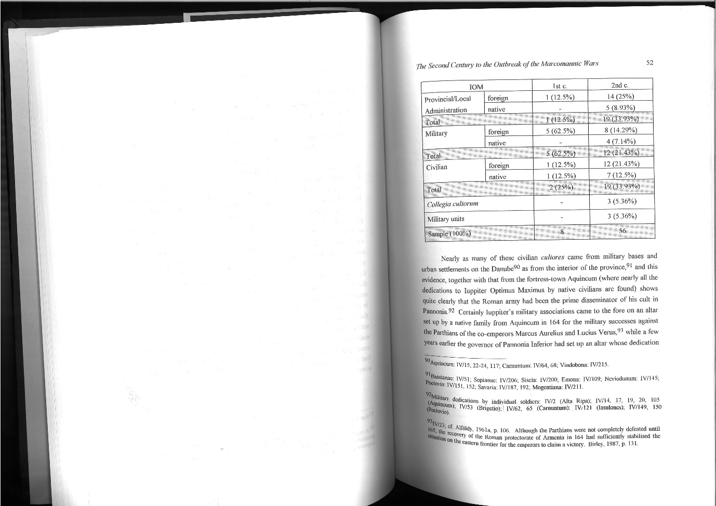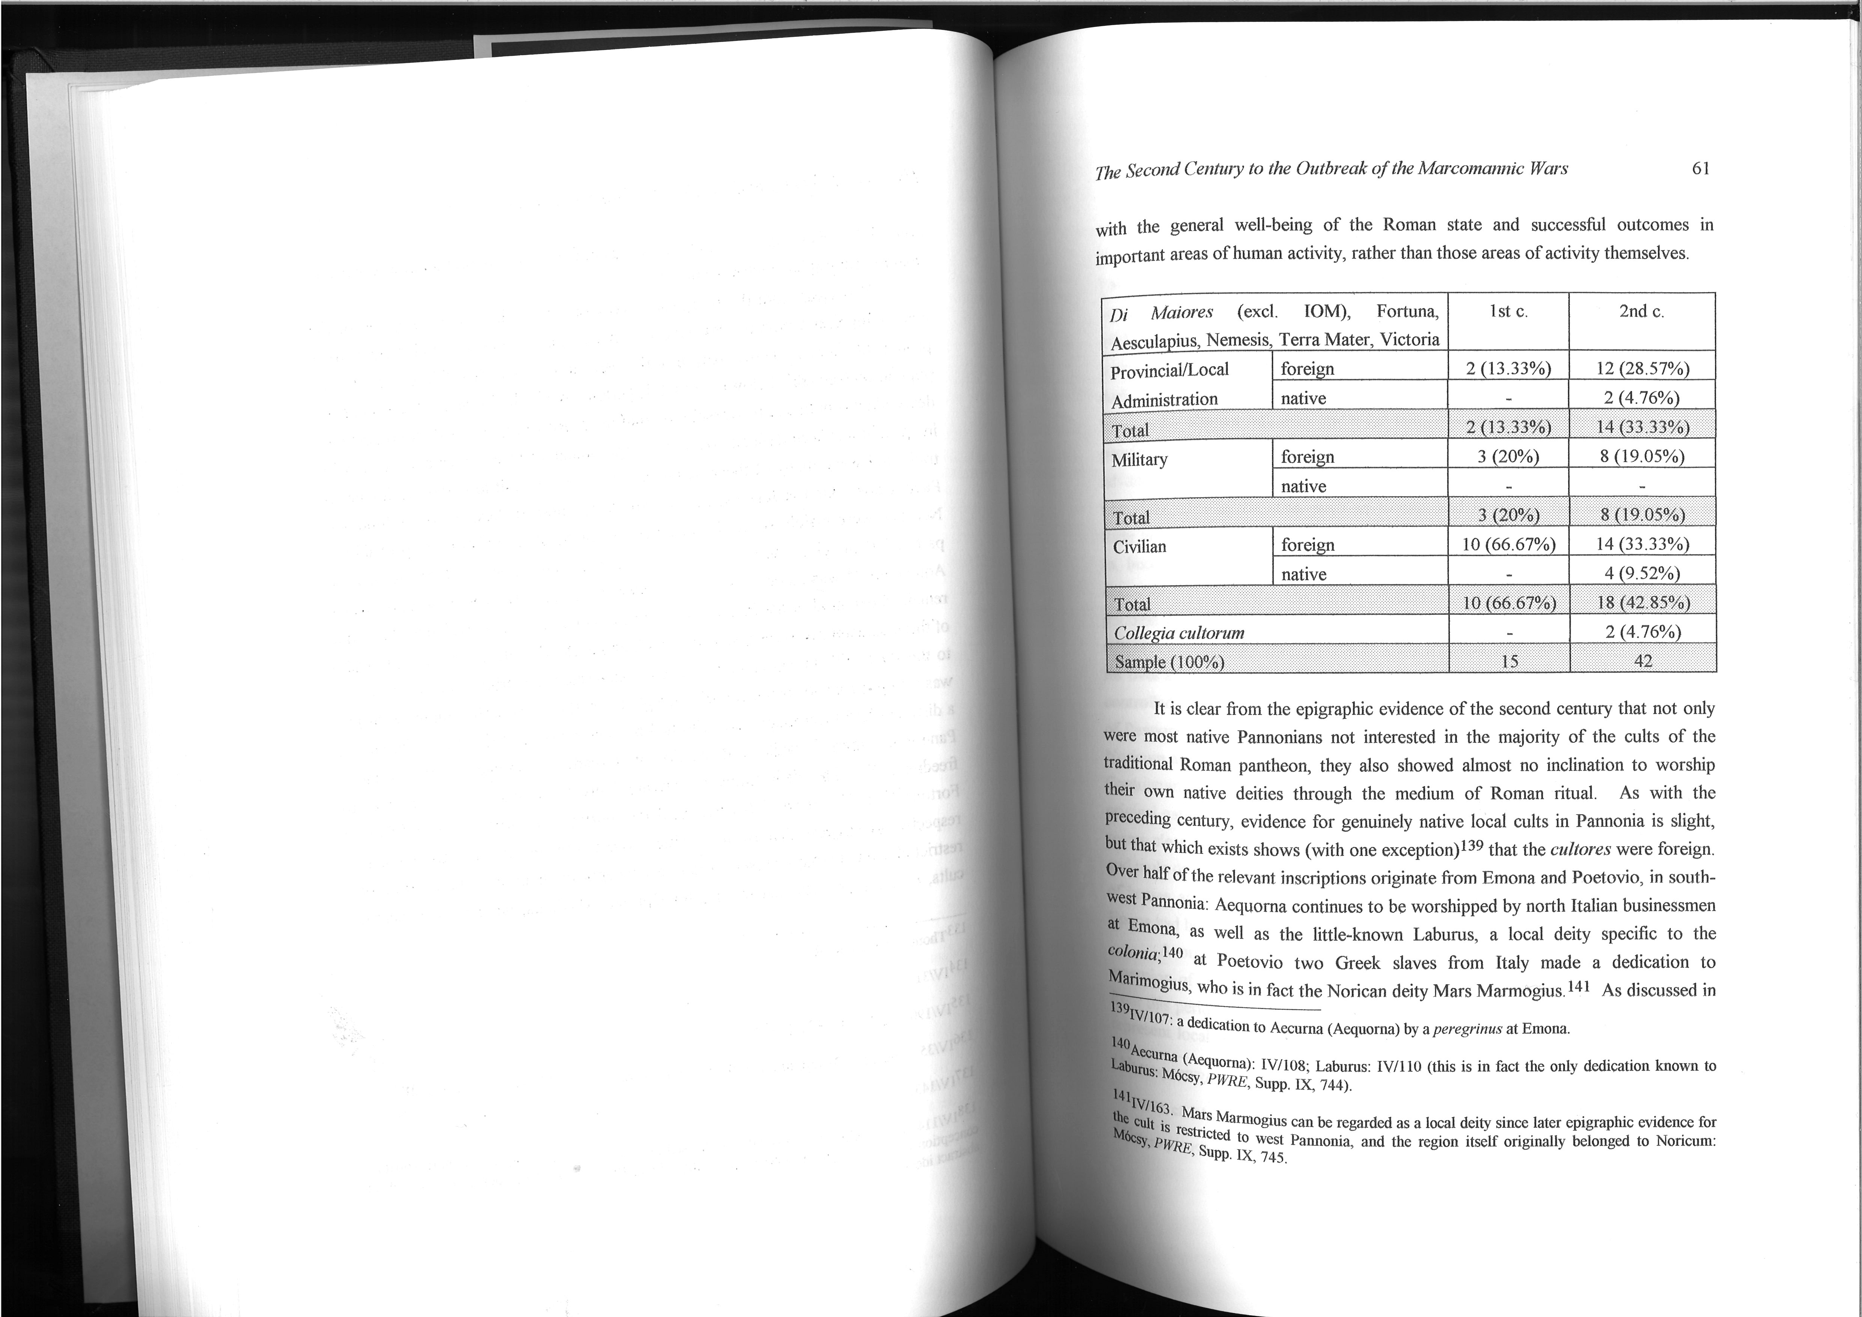

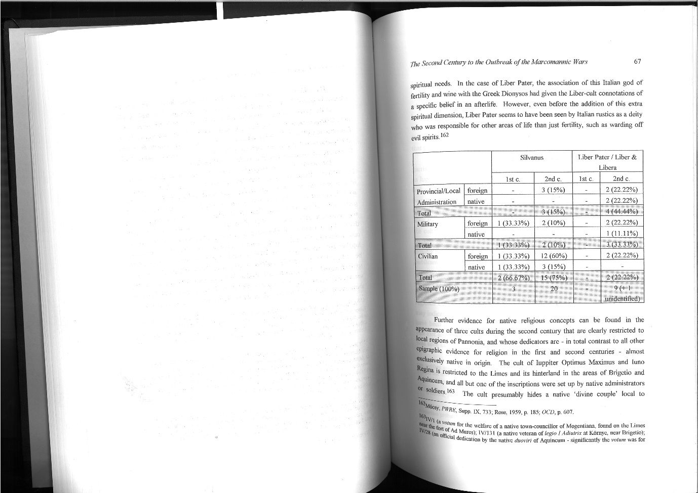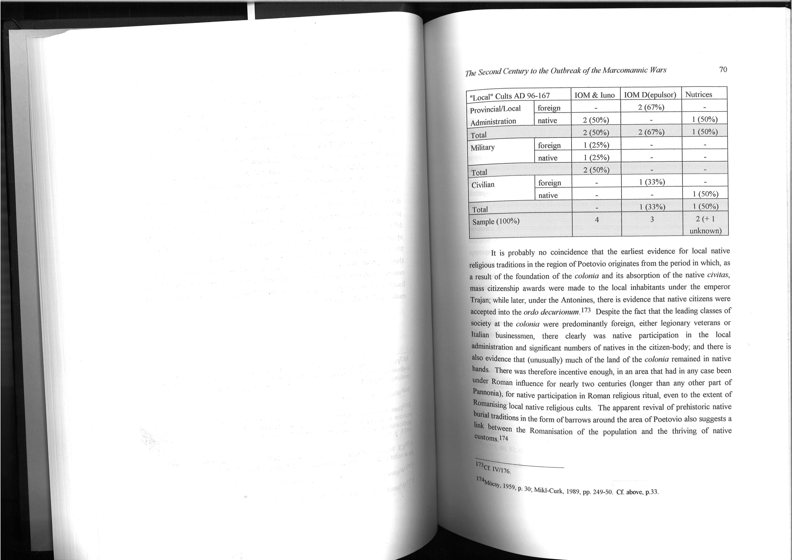

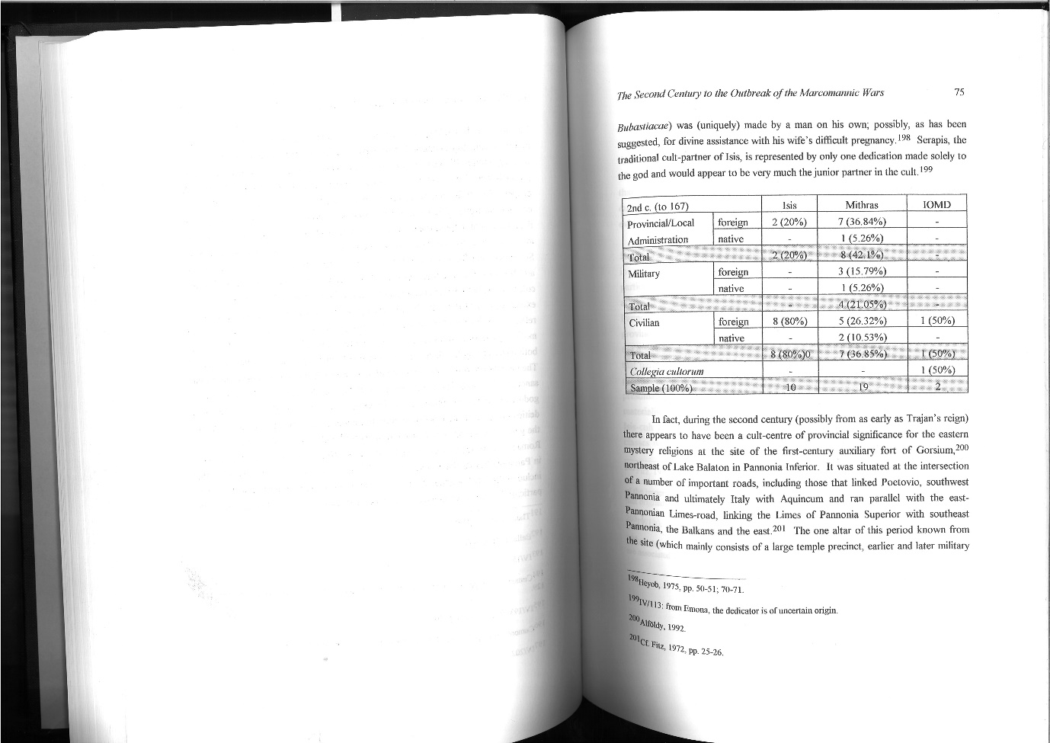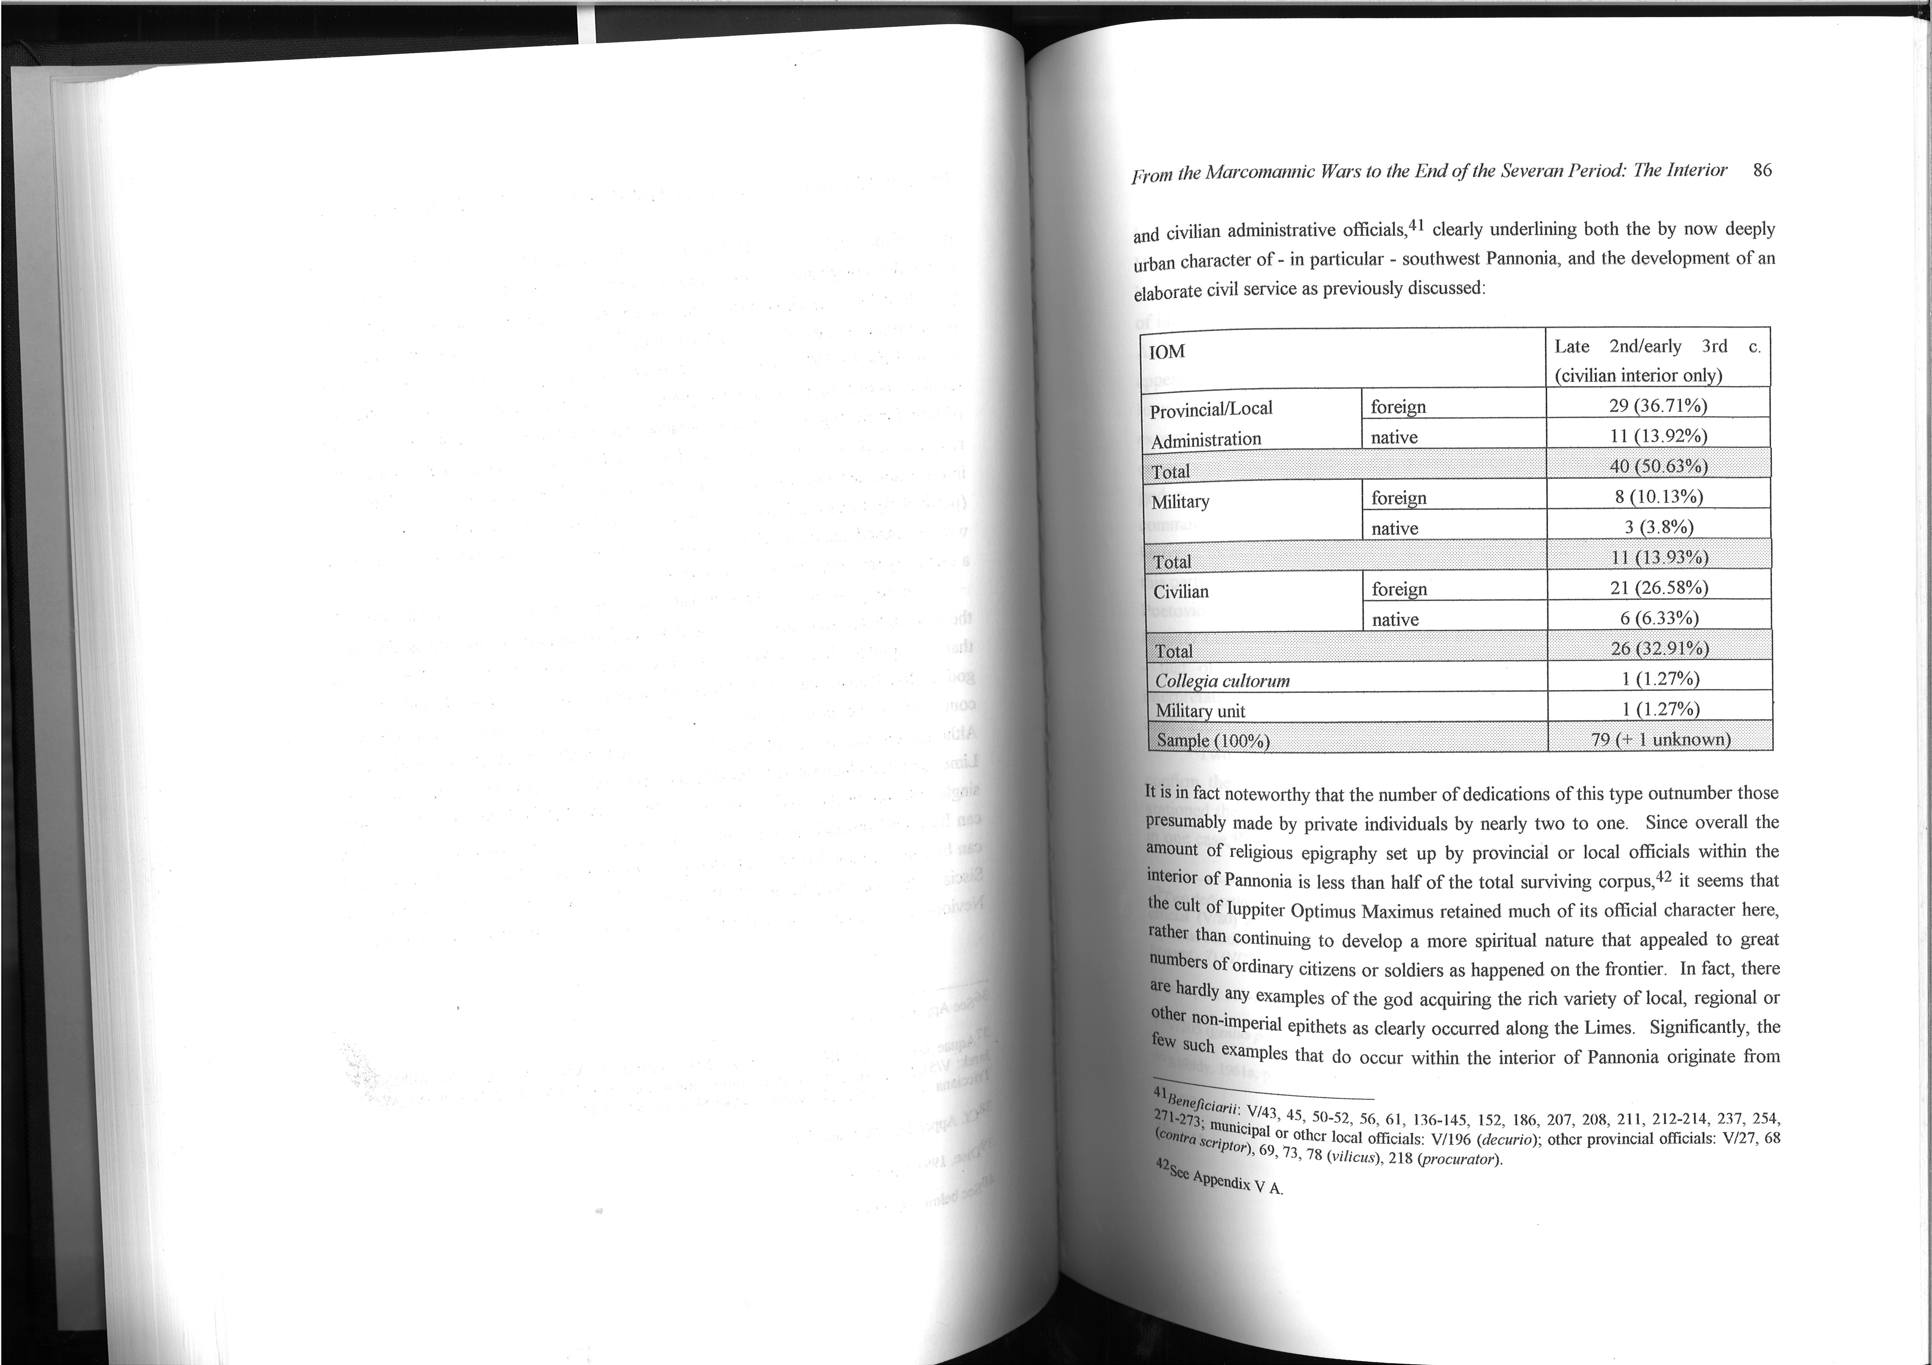

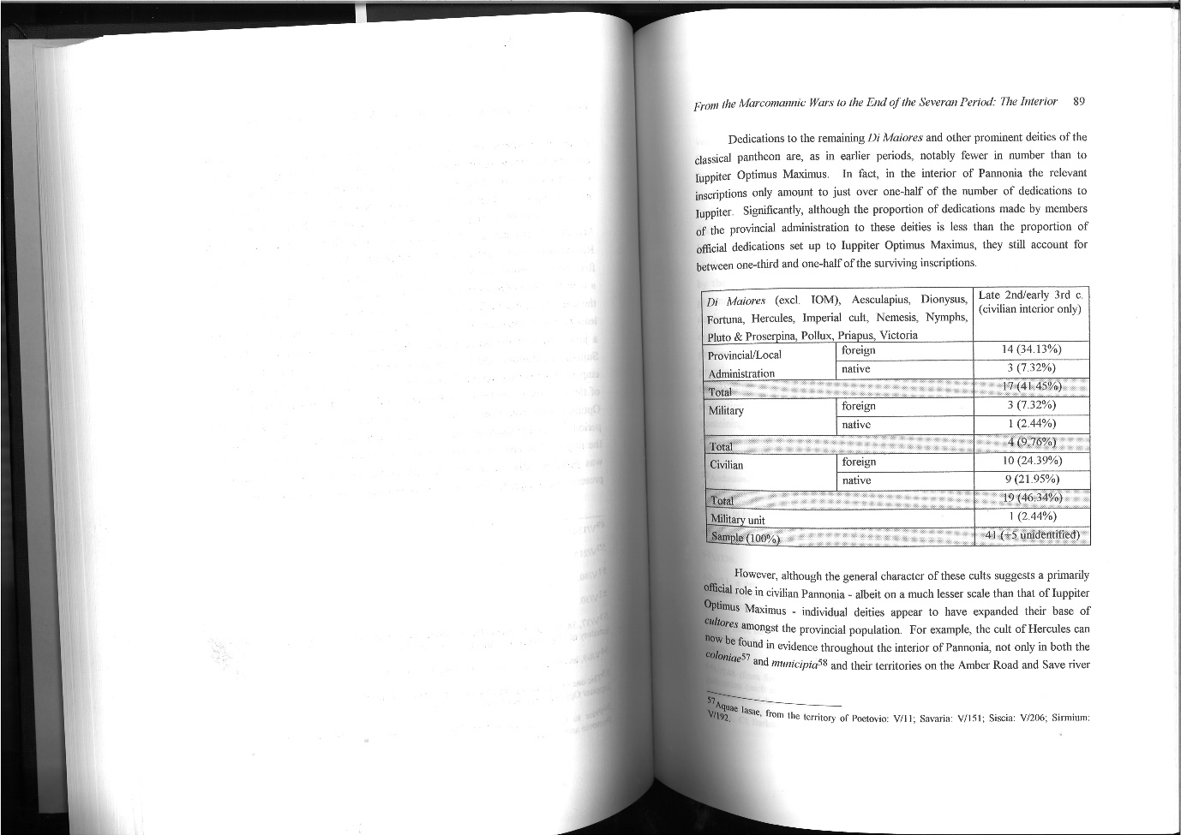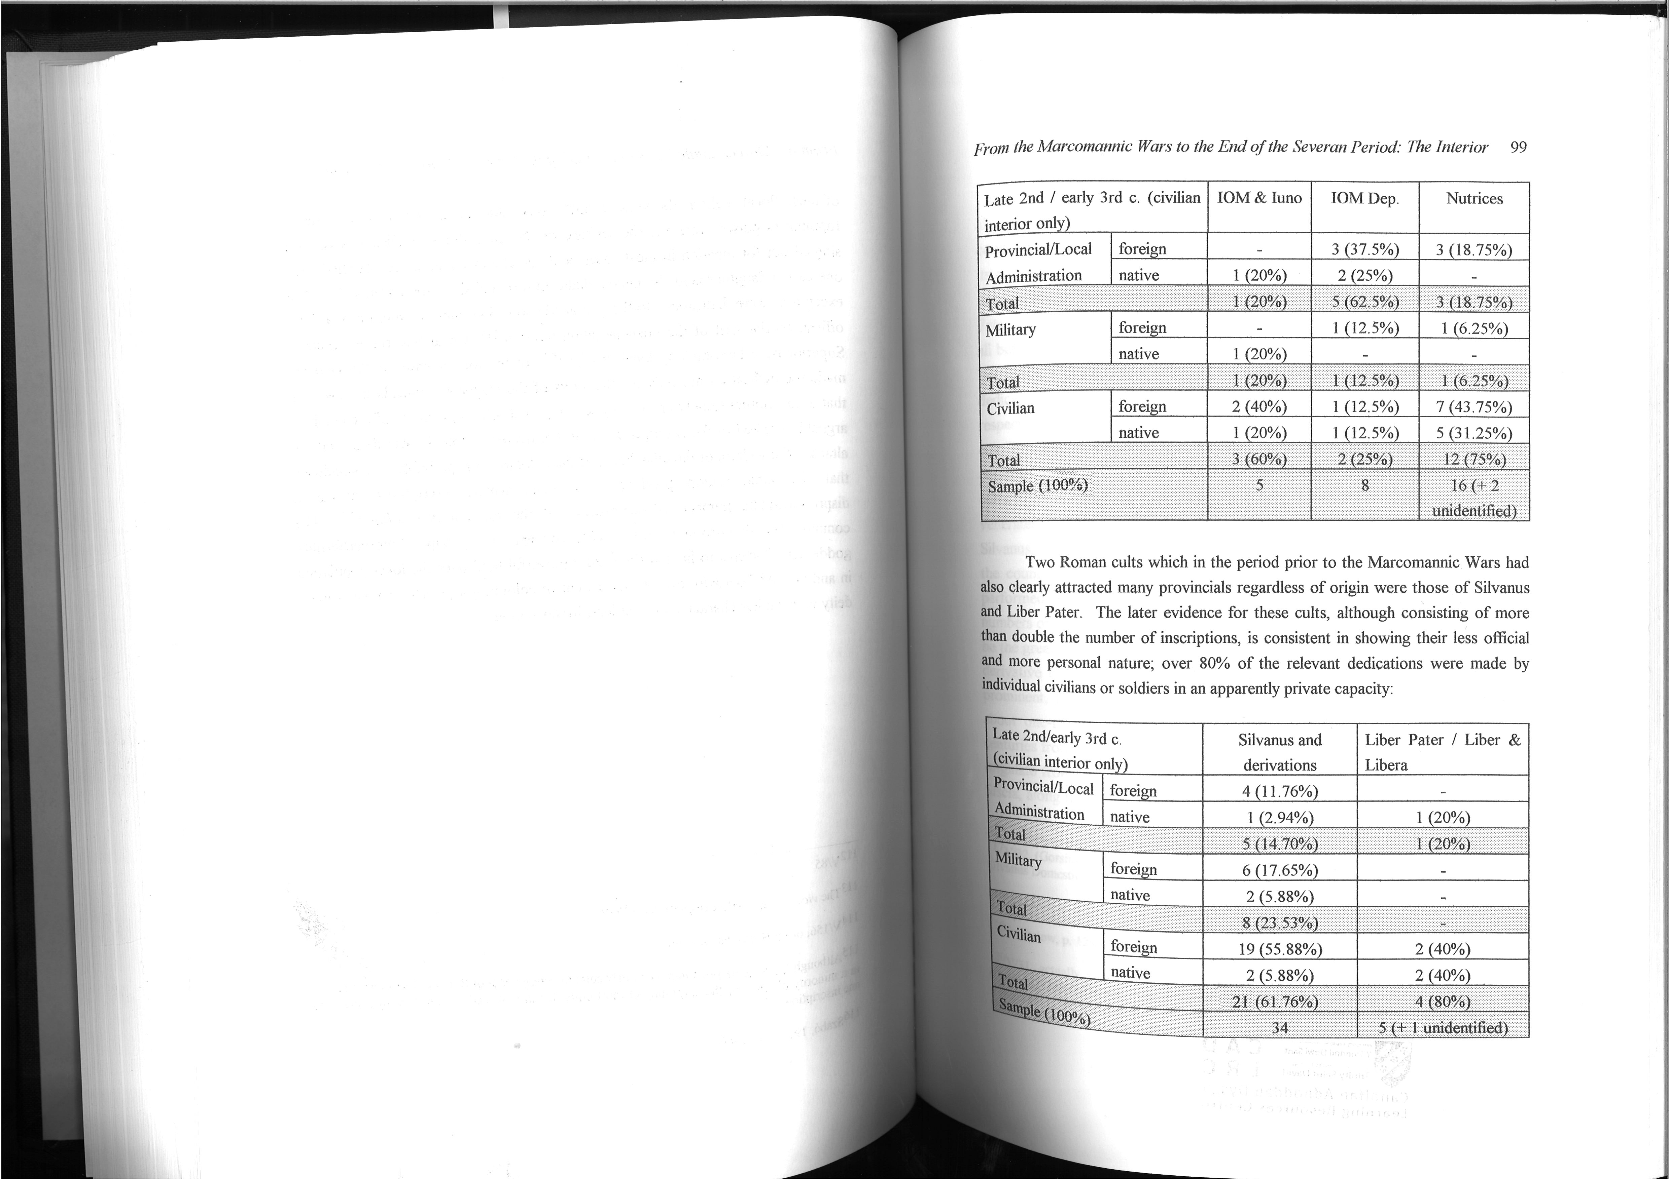

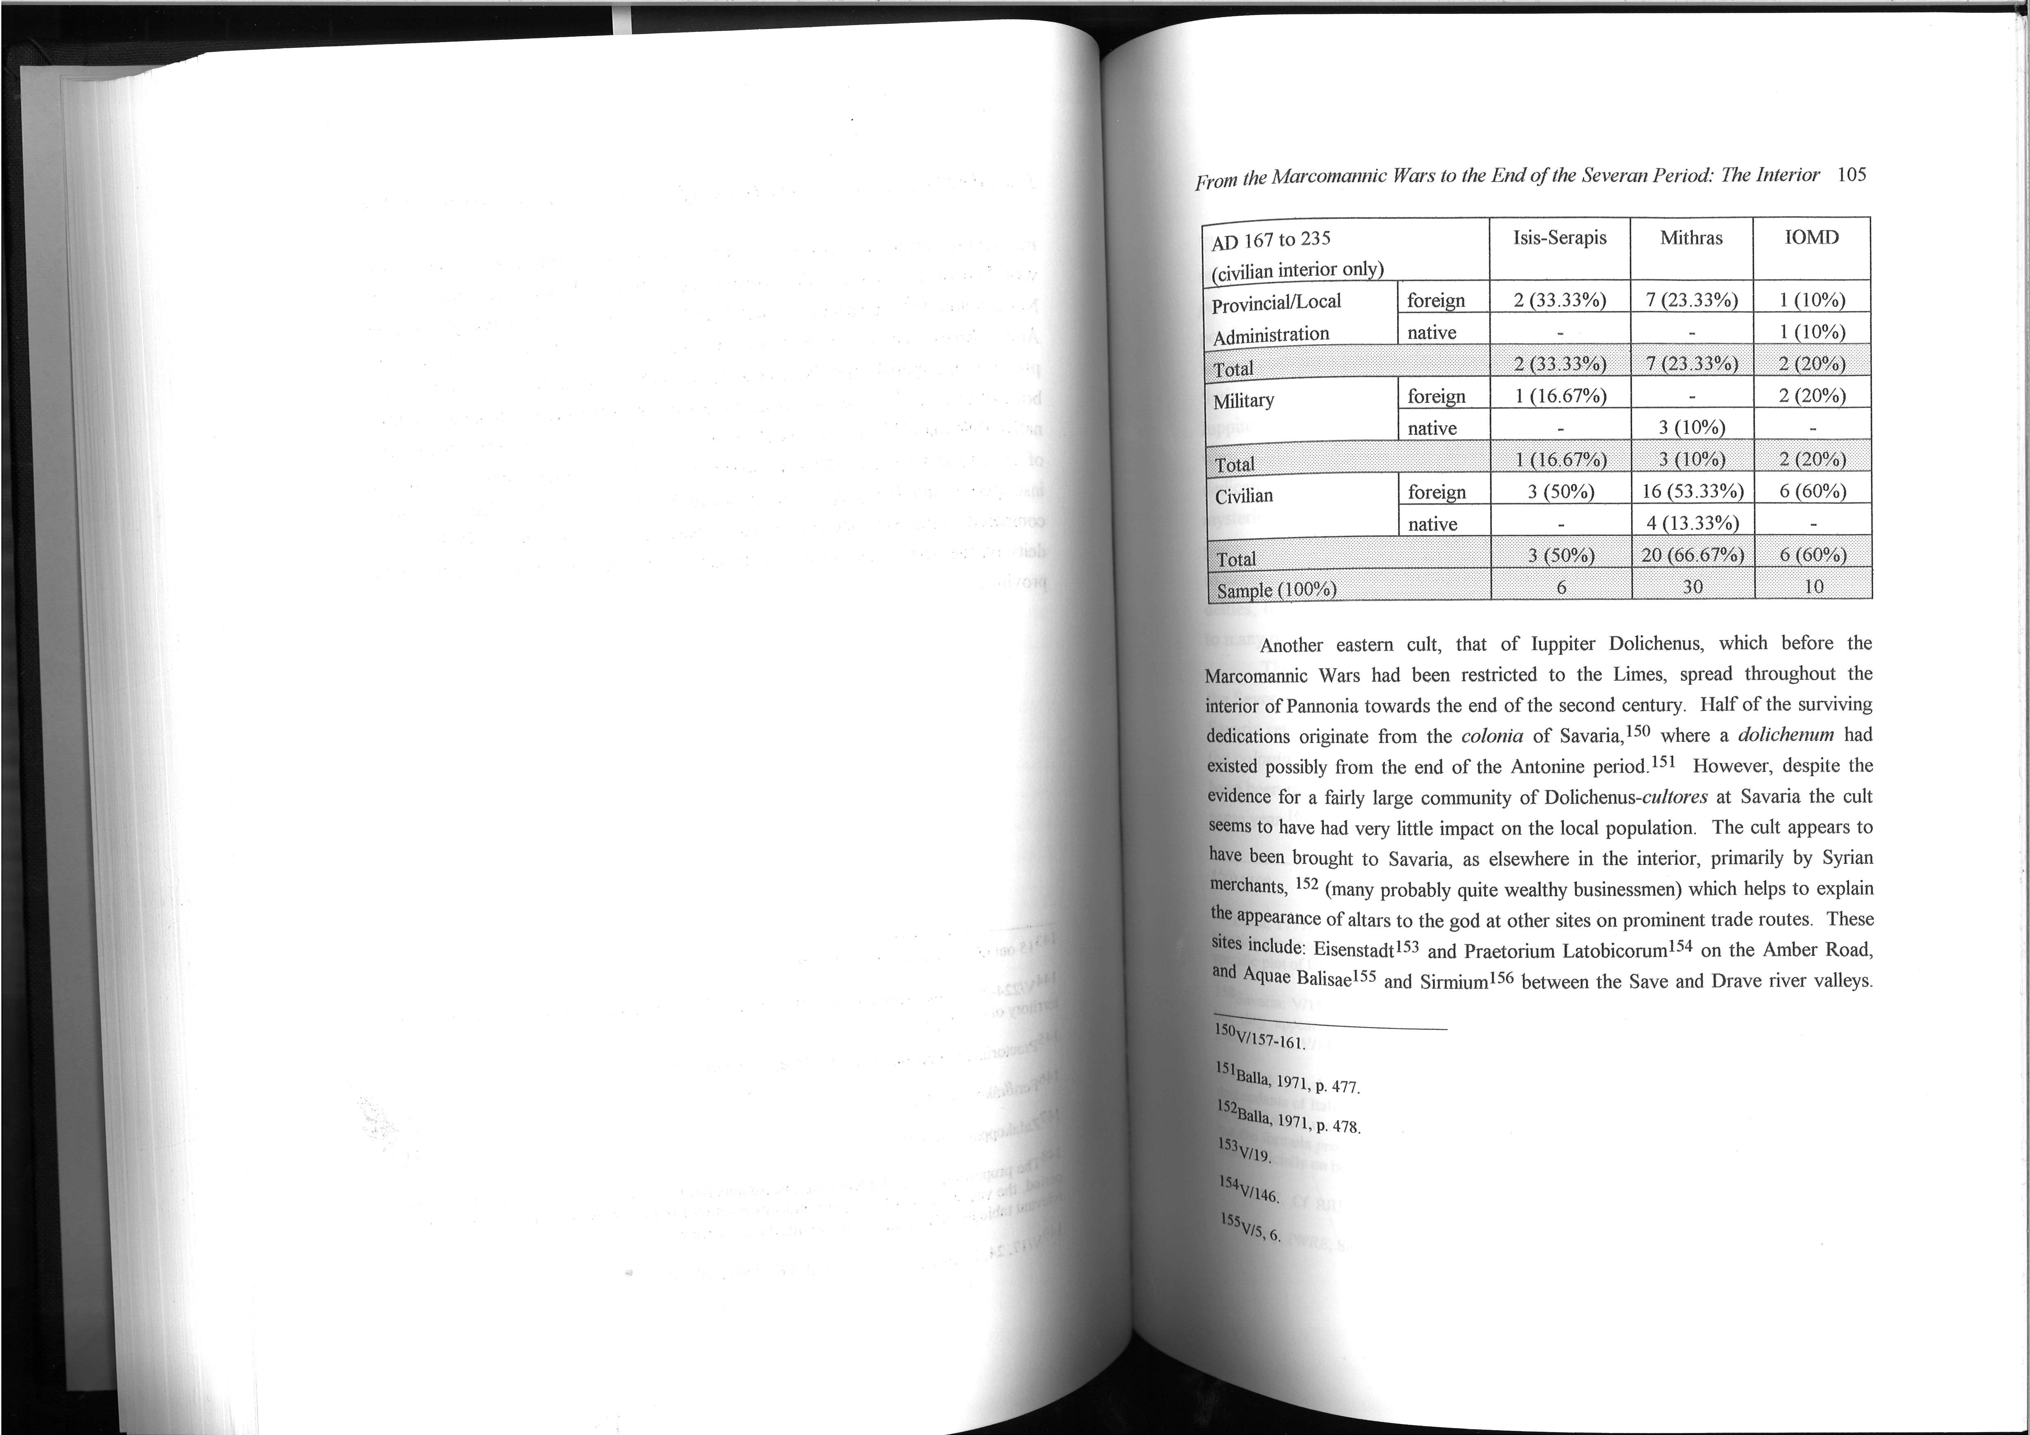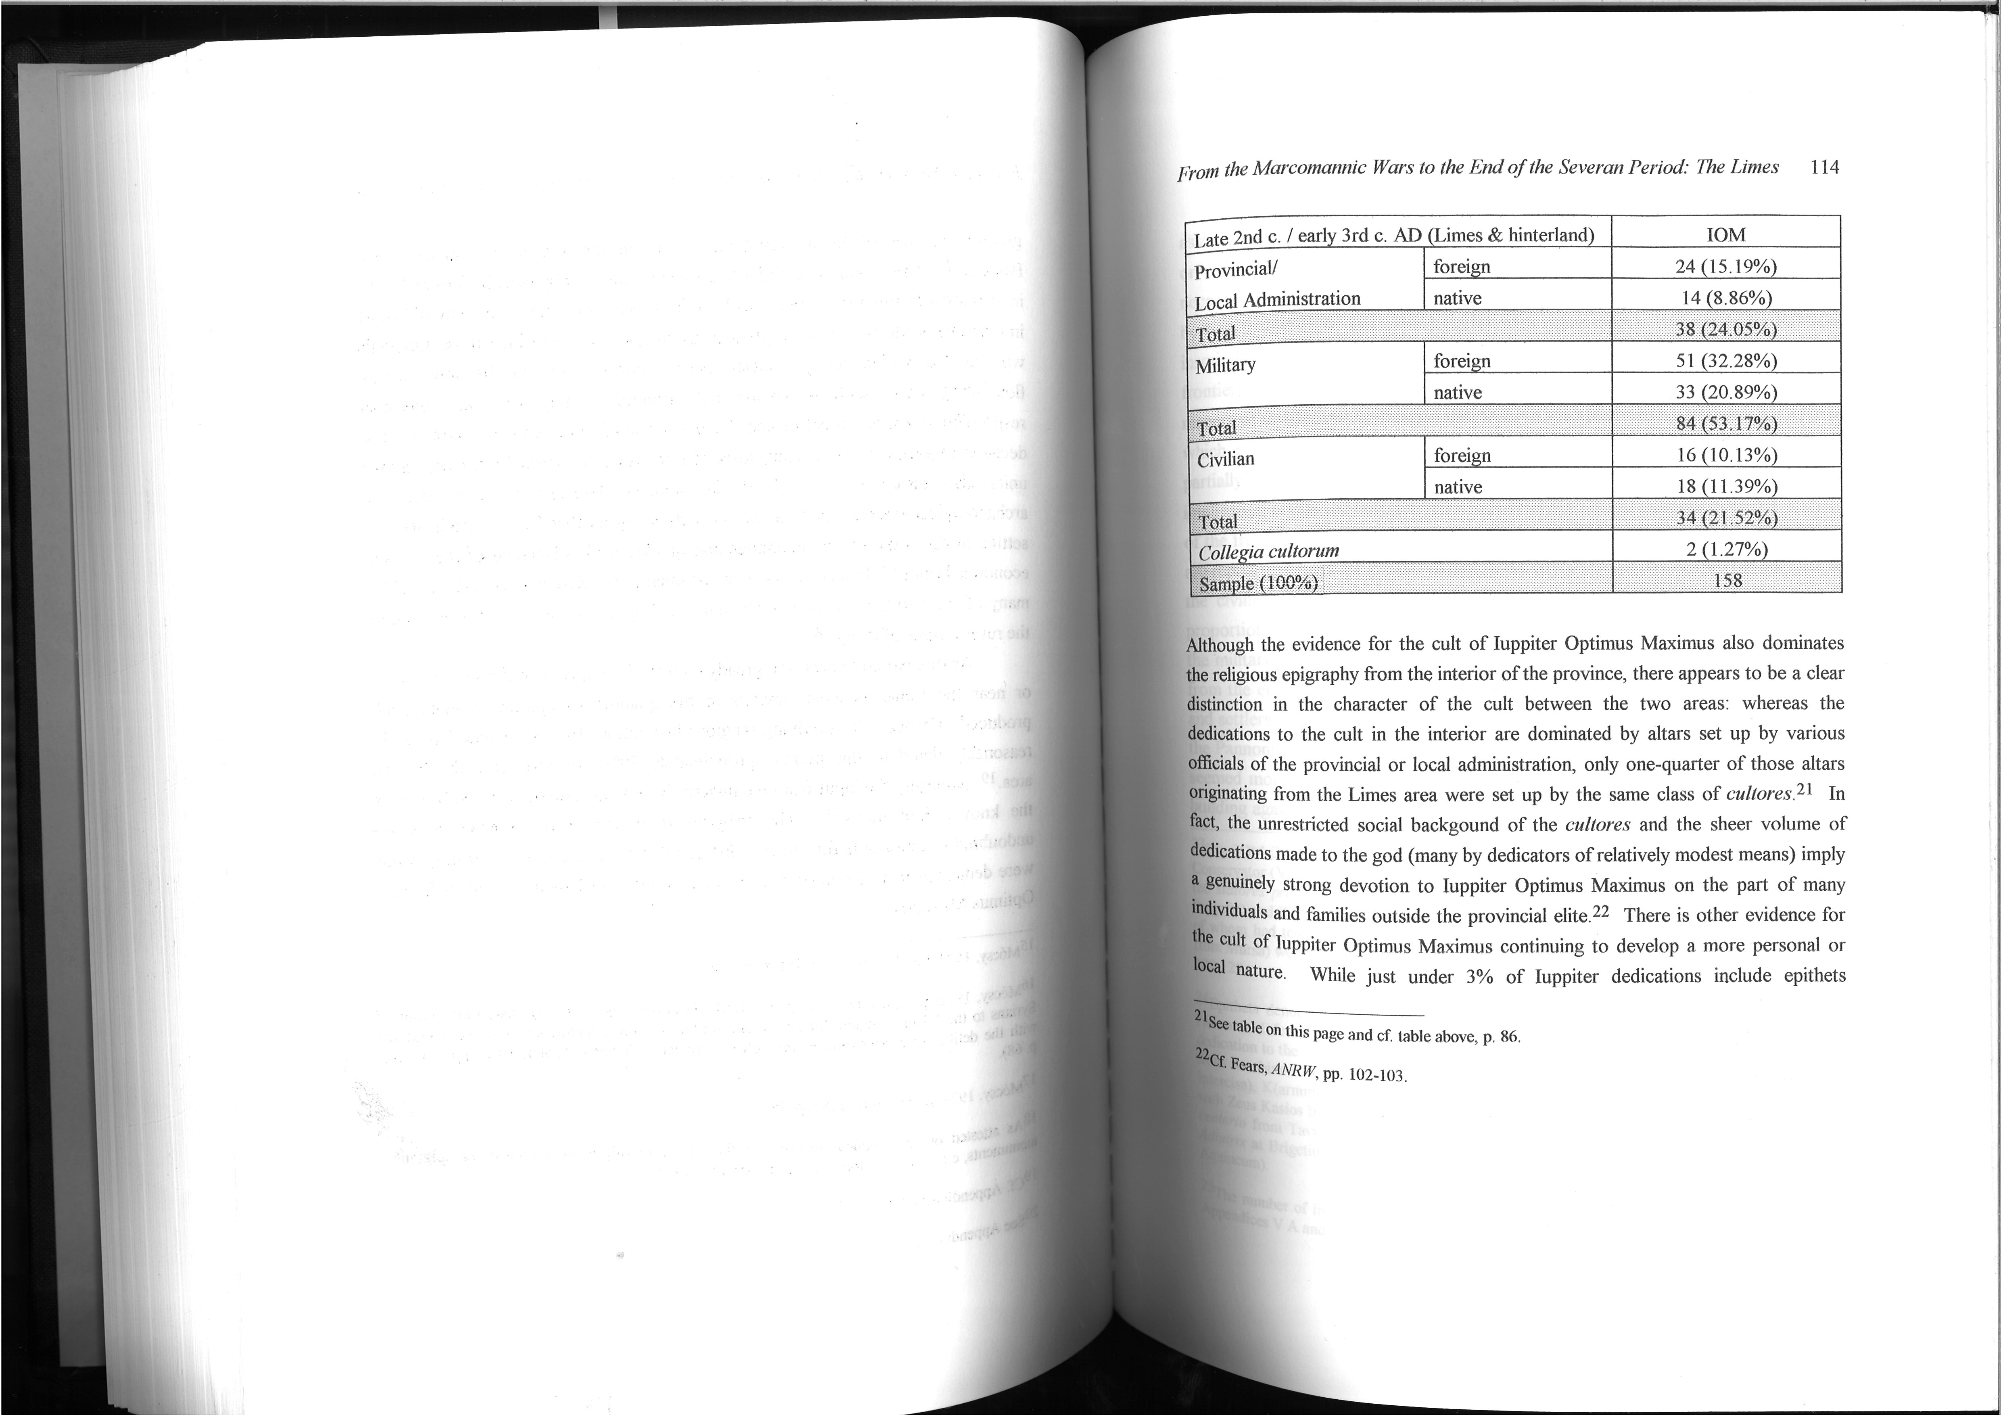

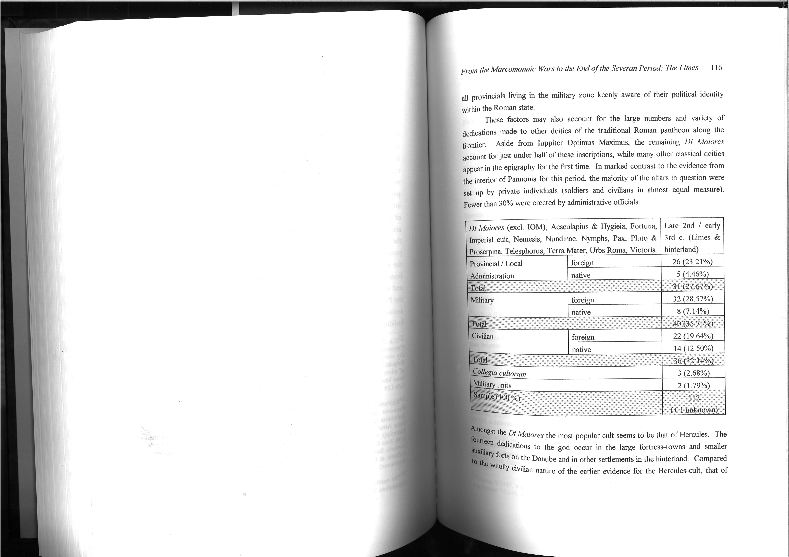

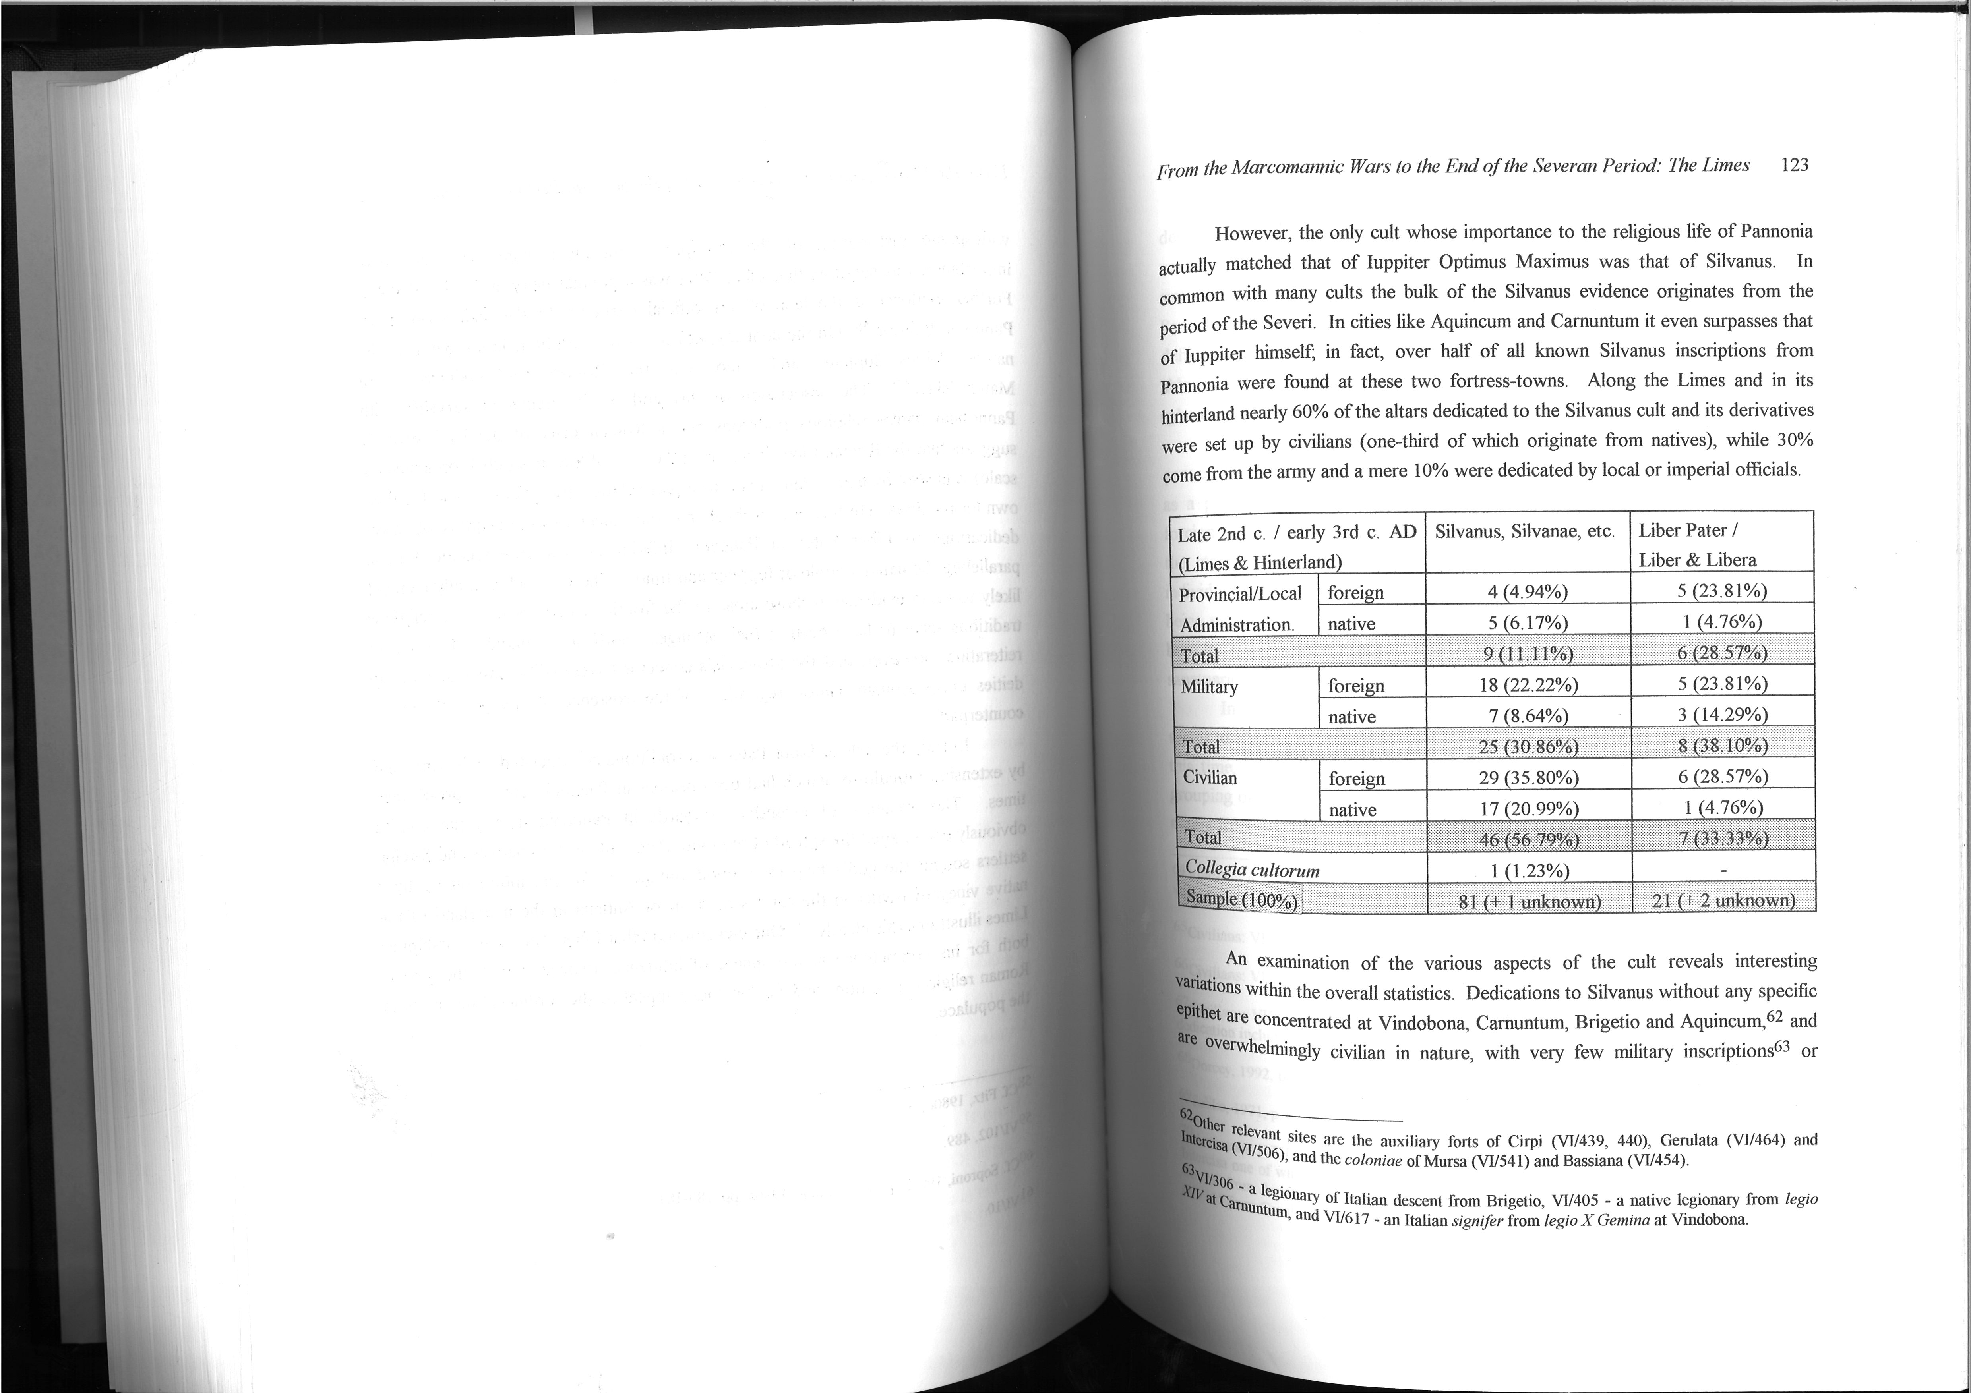

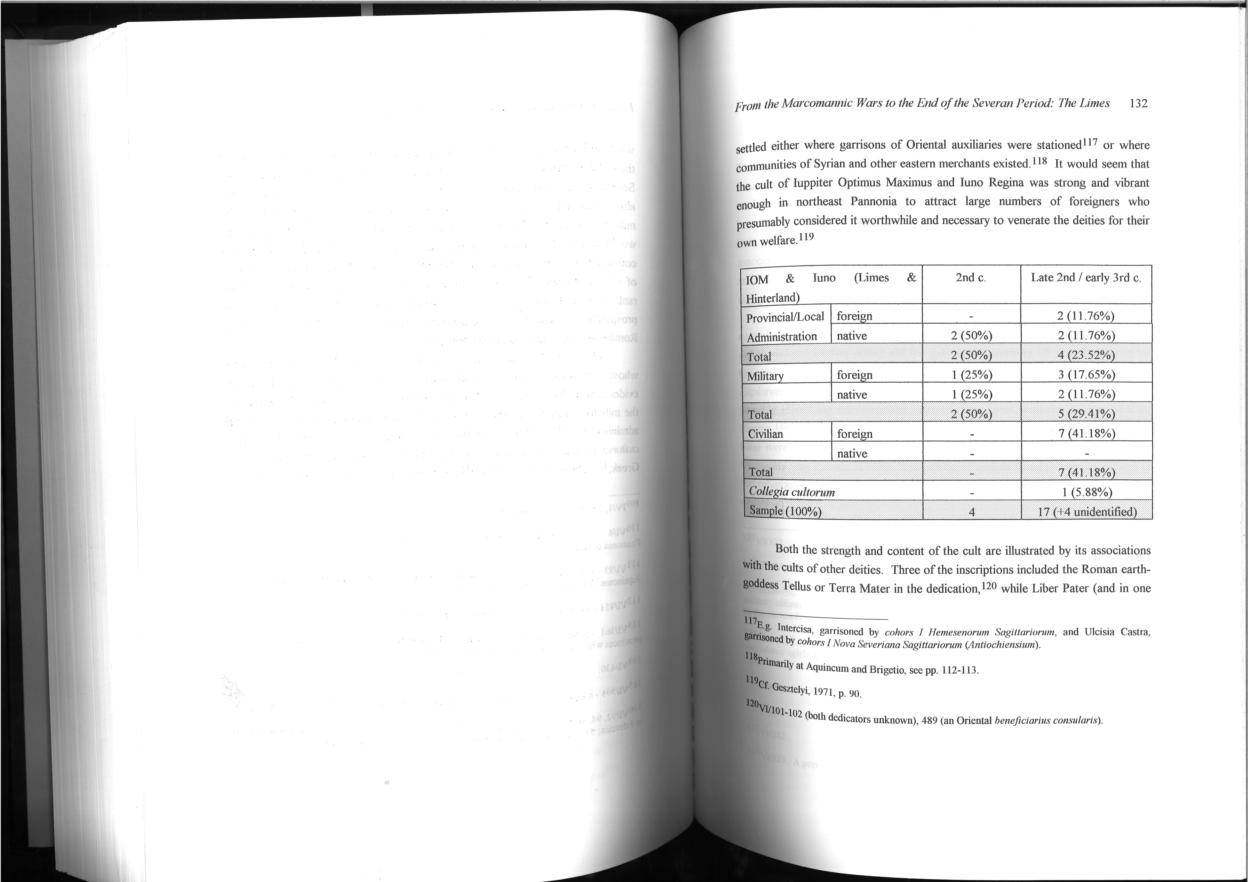

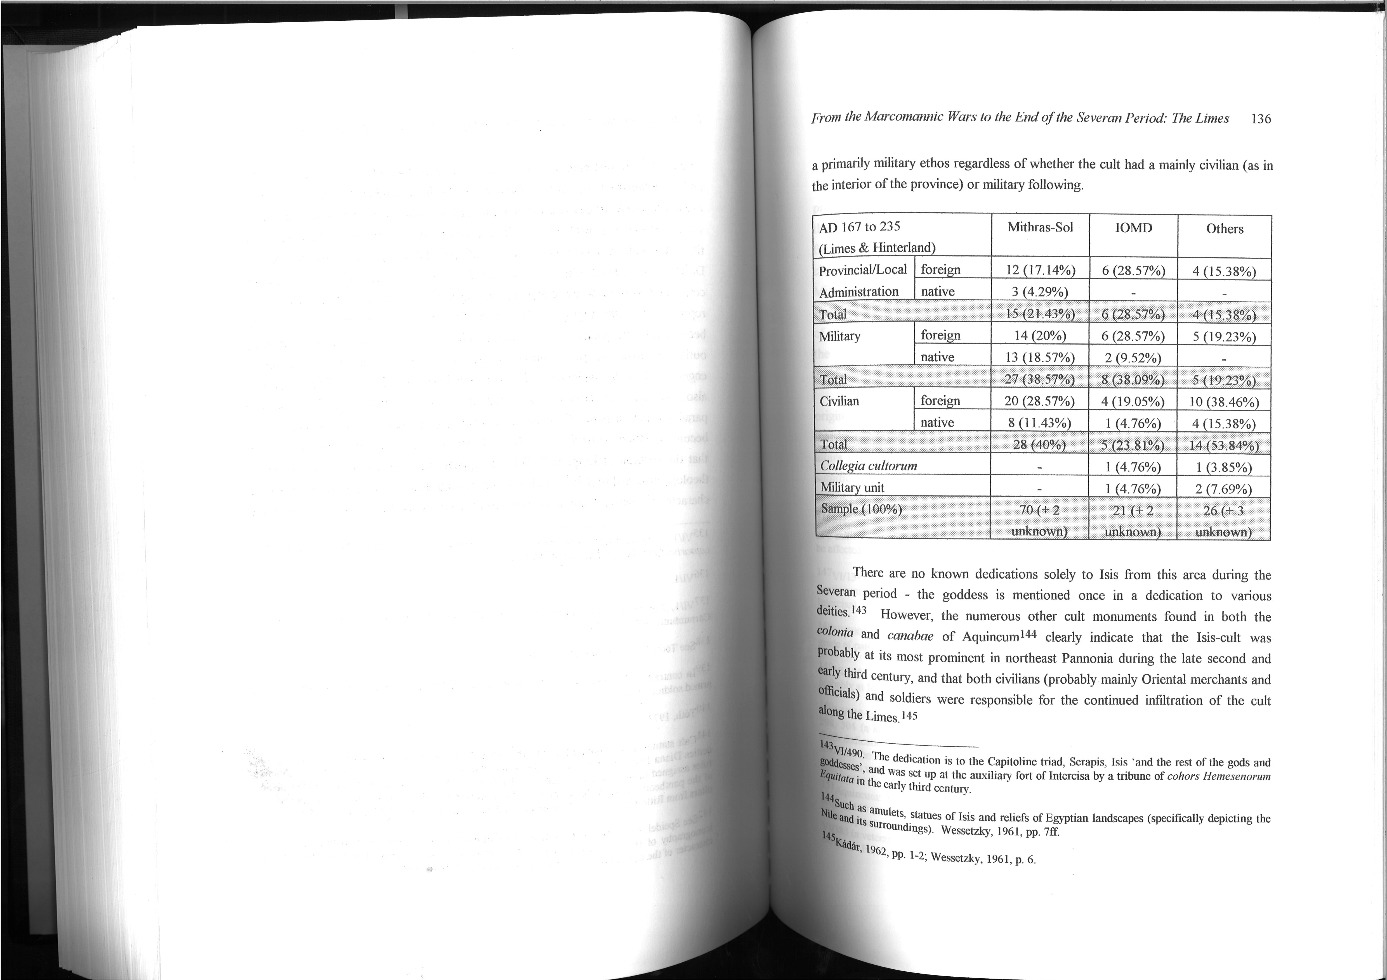

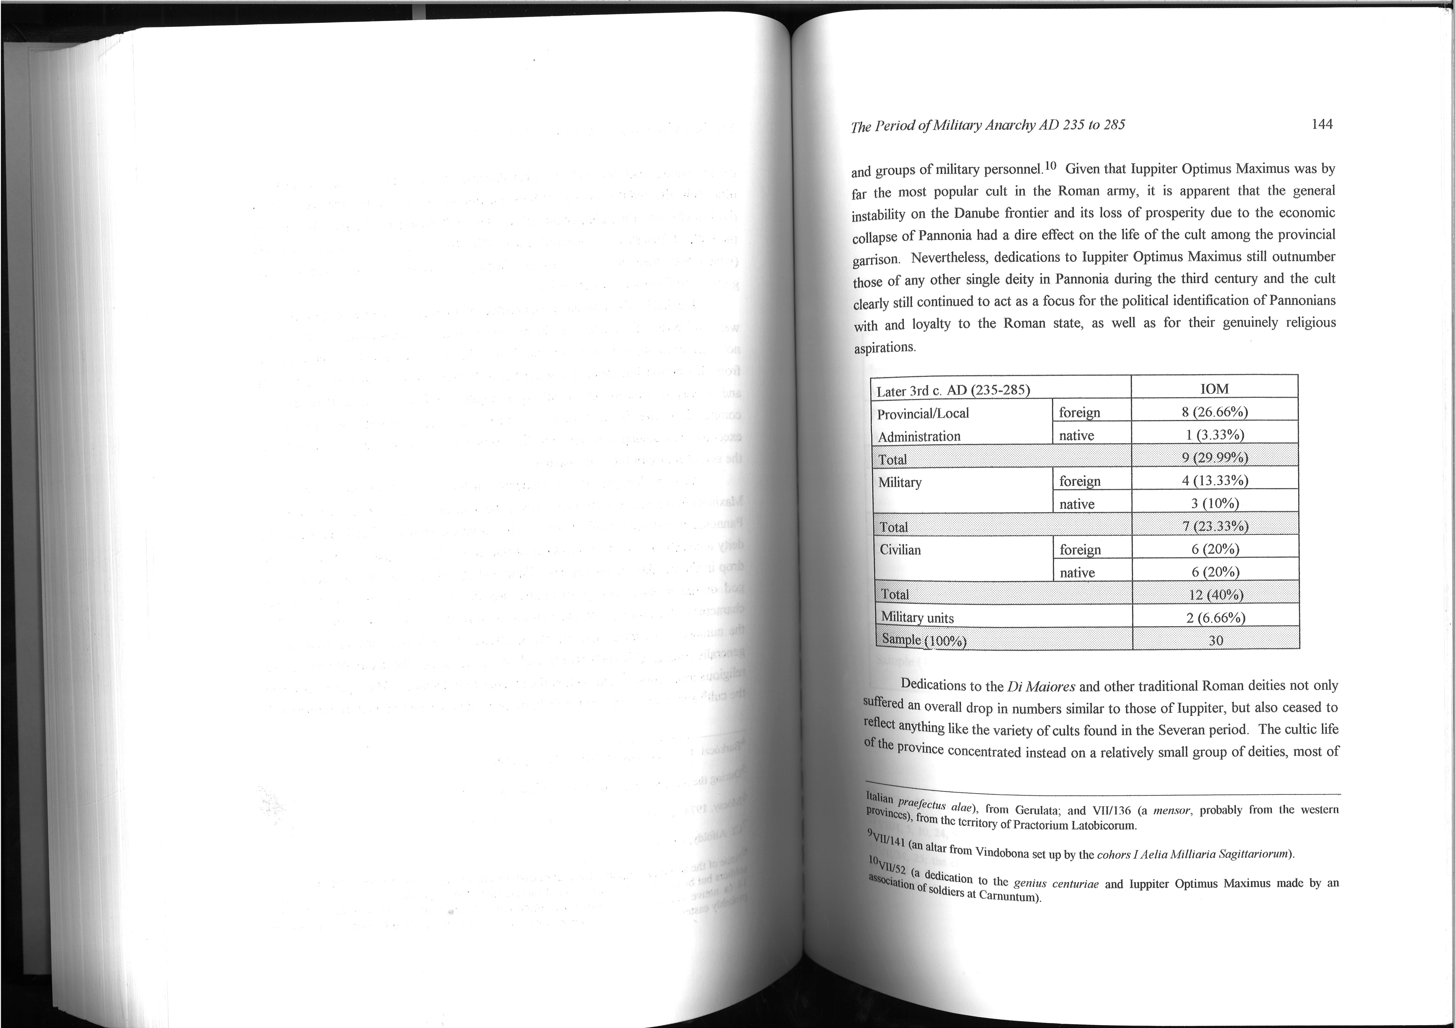

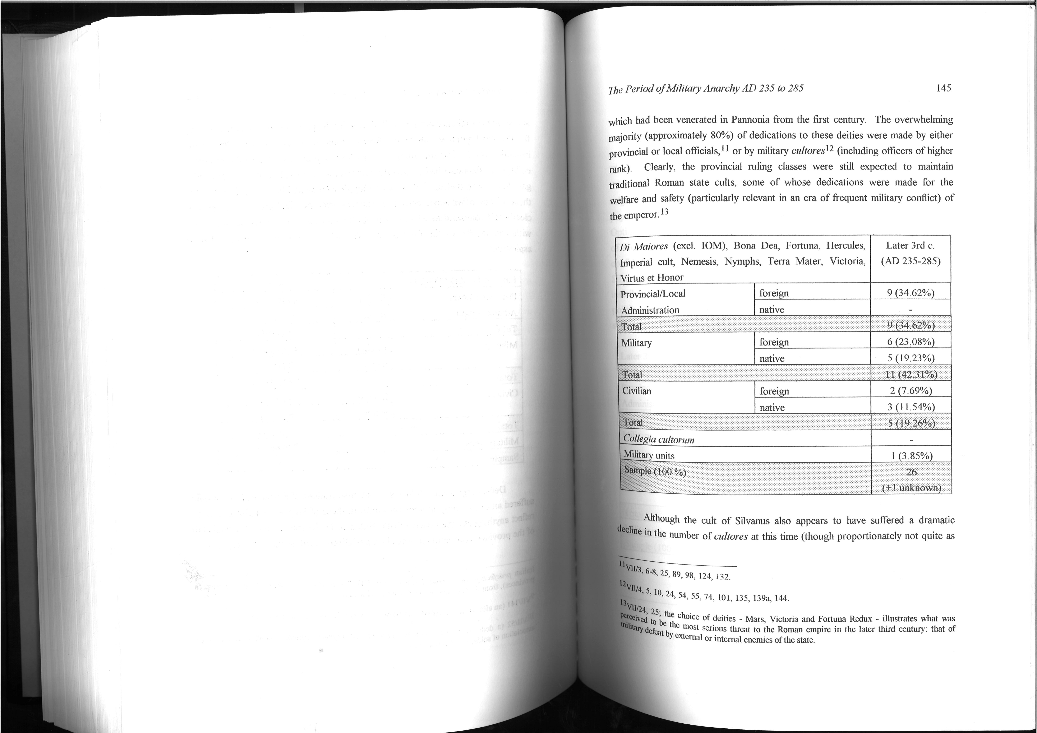

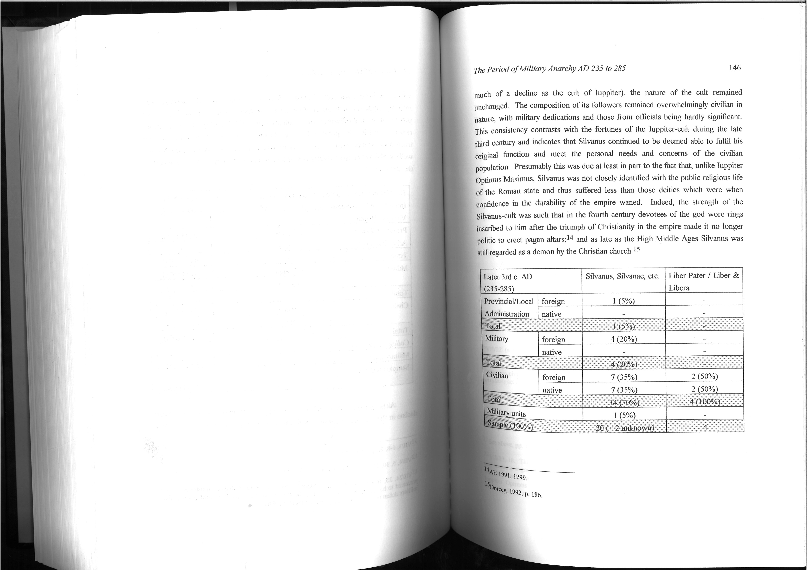

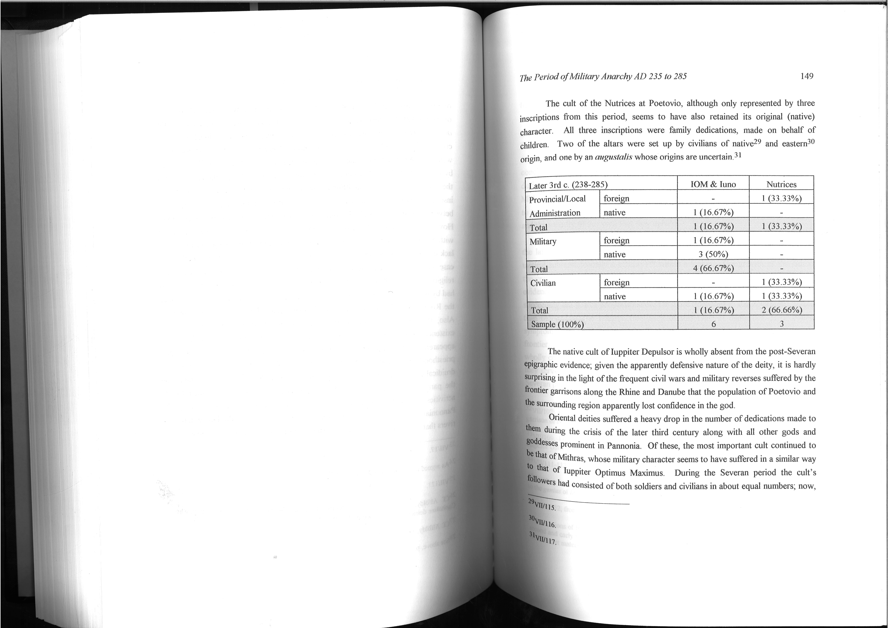

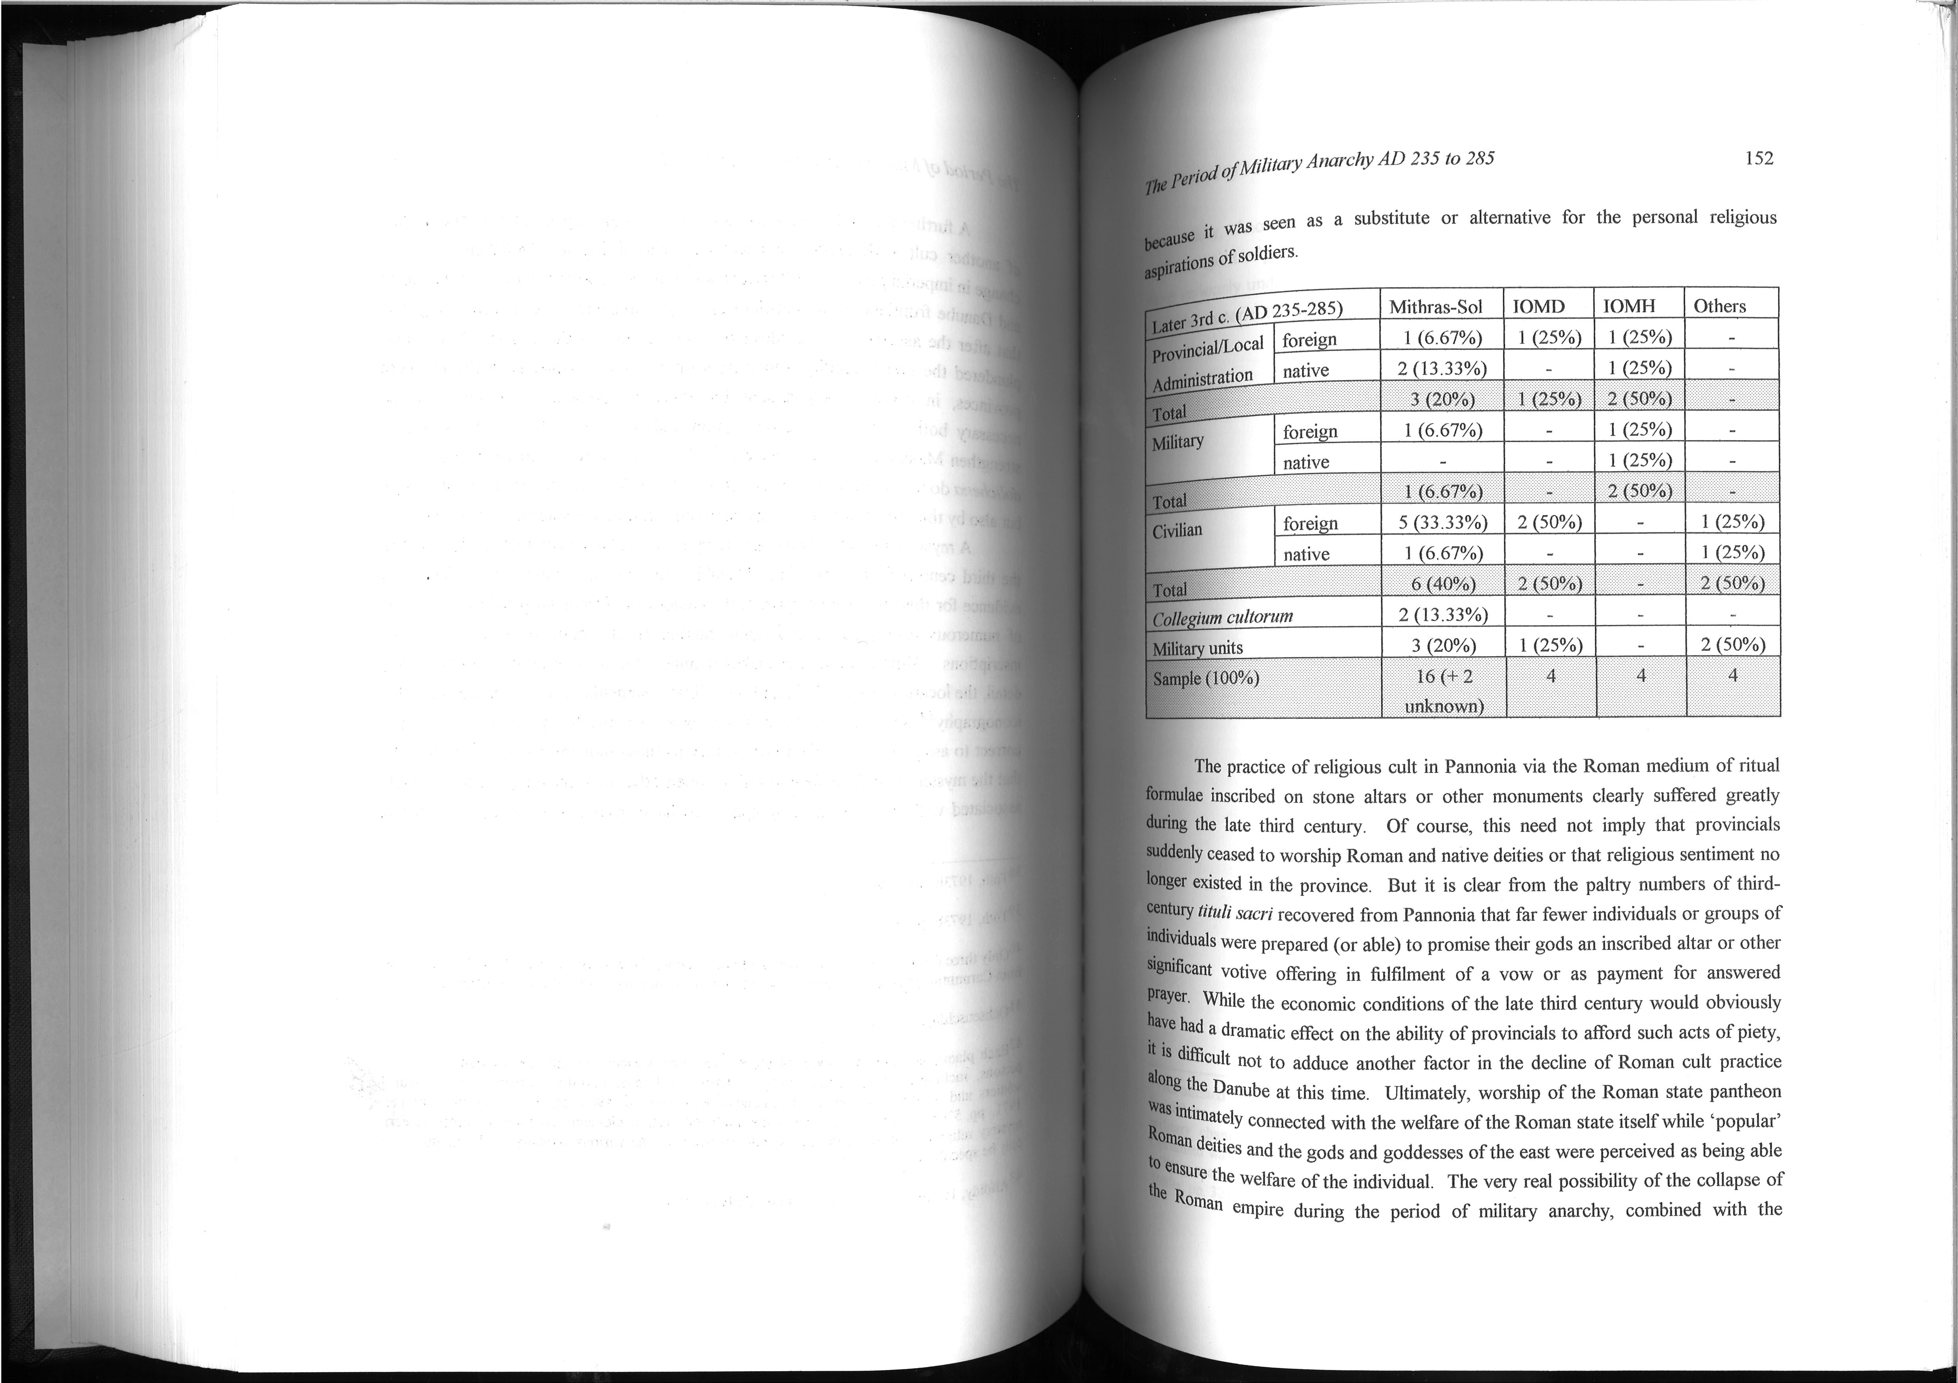

Maps appended from Morton 1995
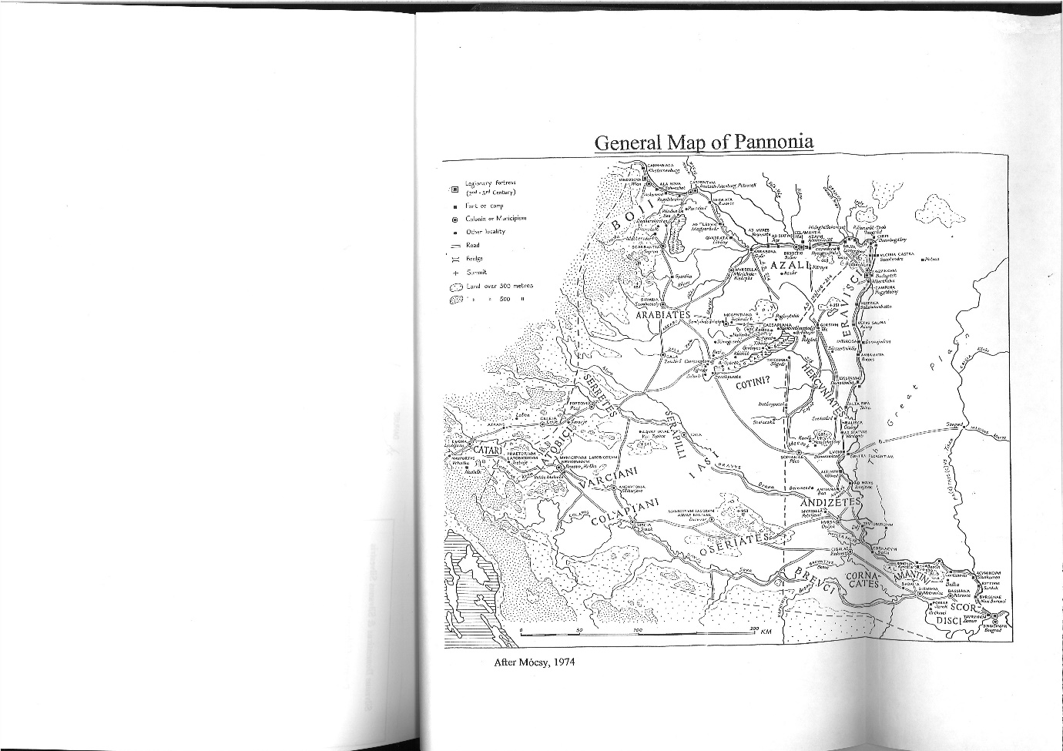

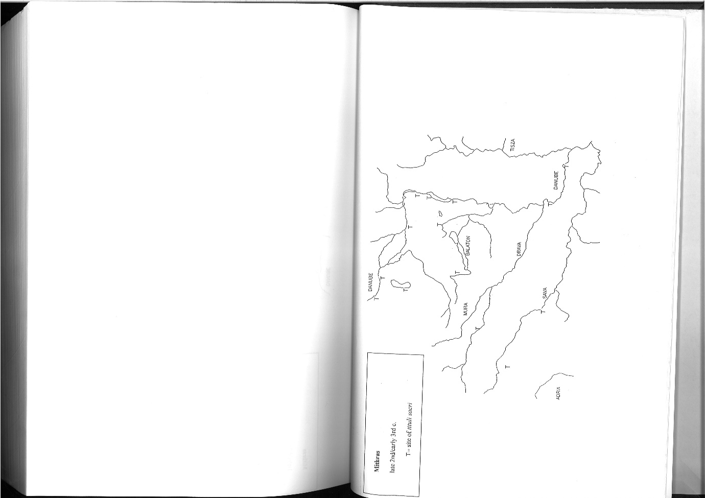

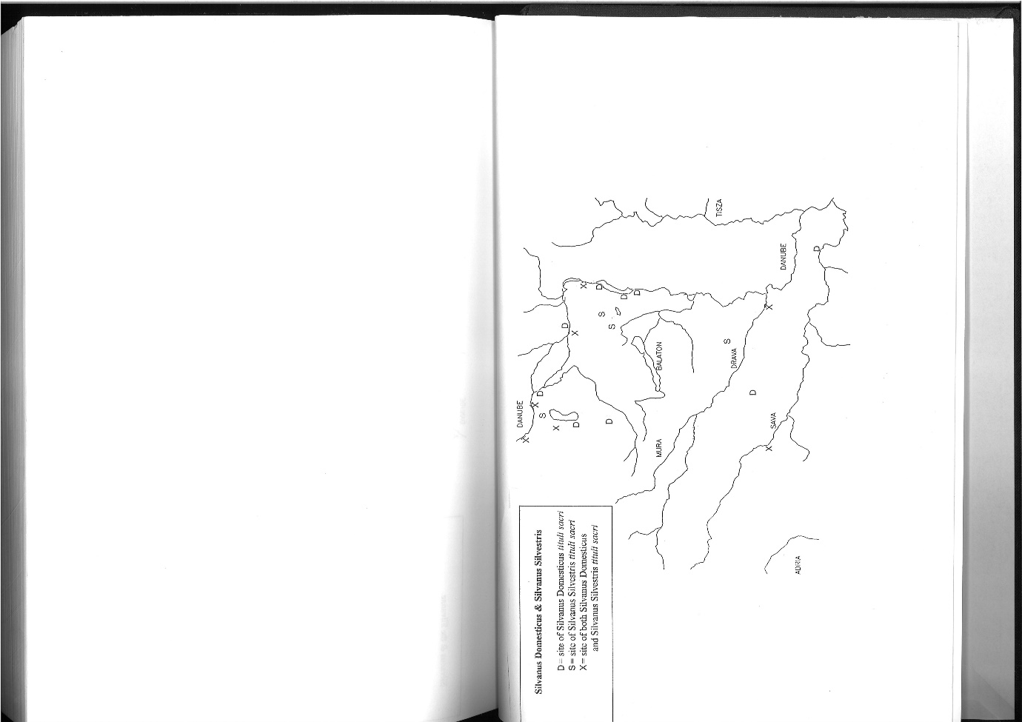

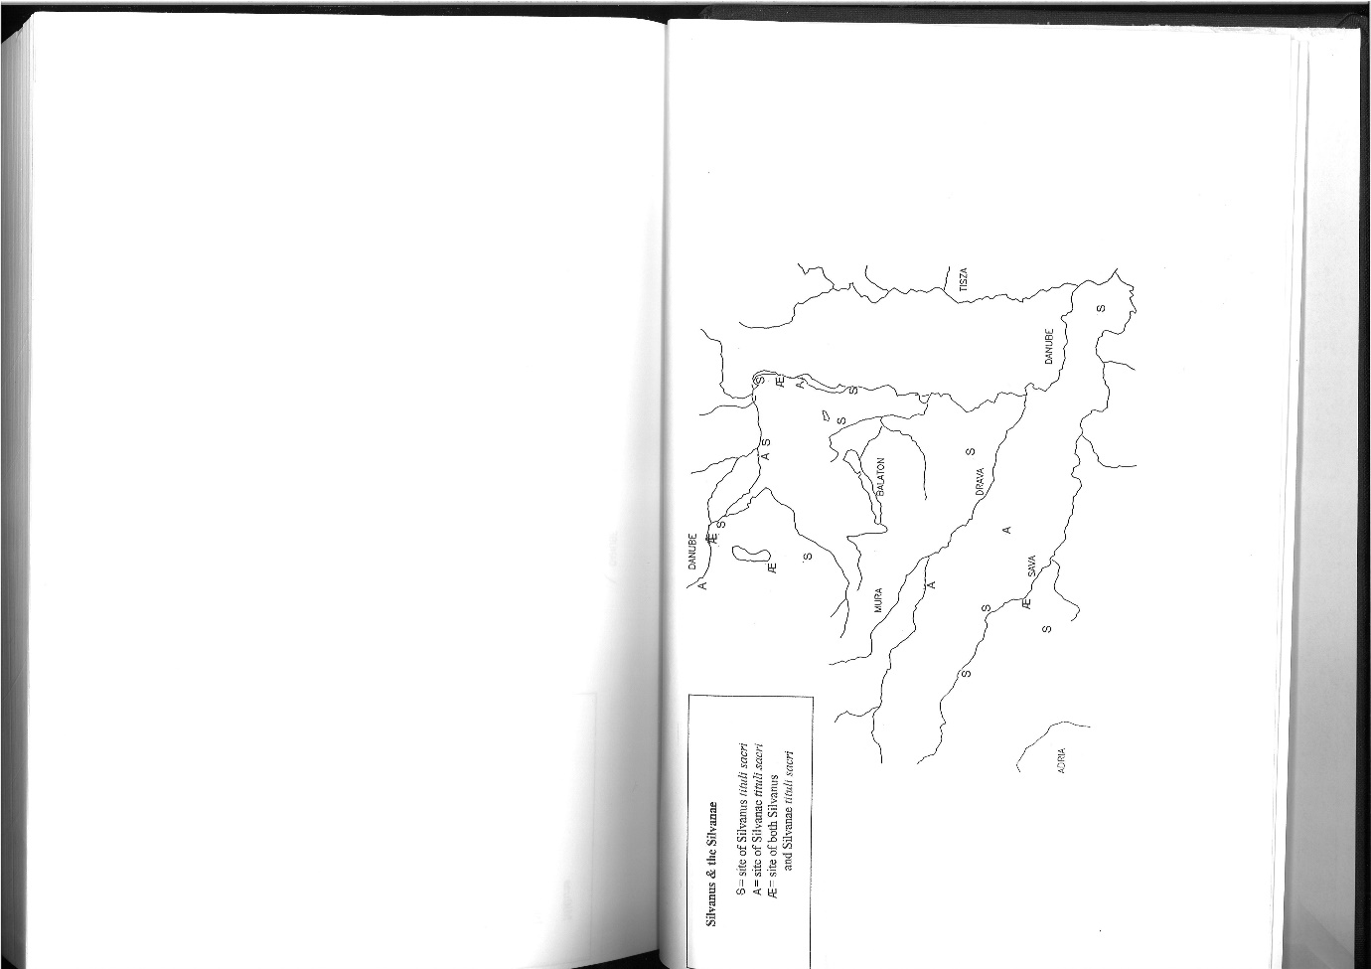

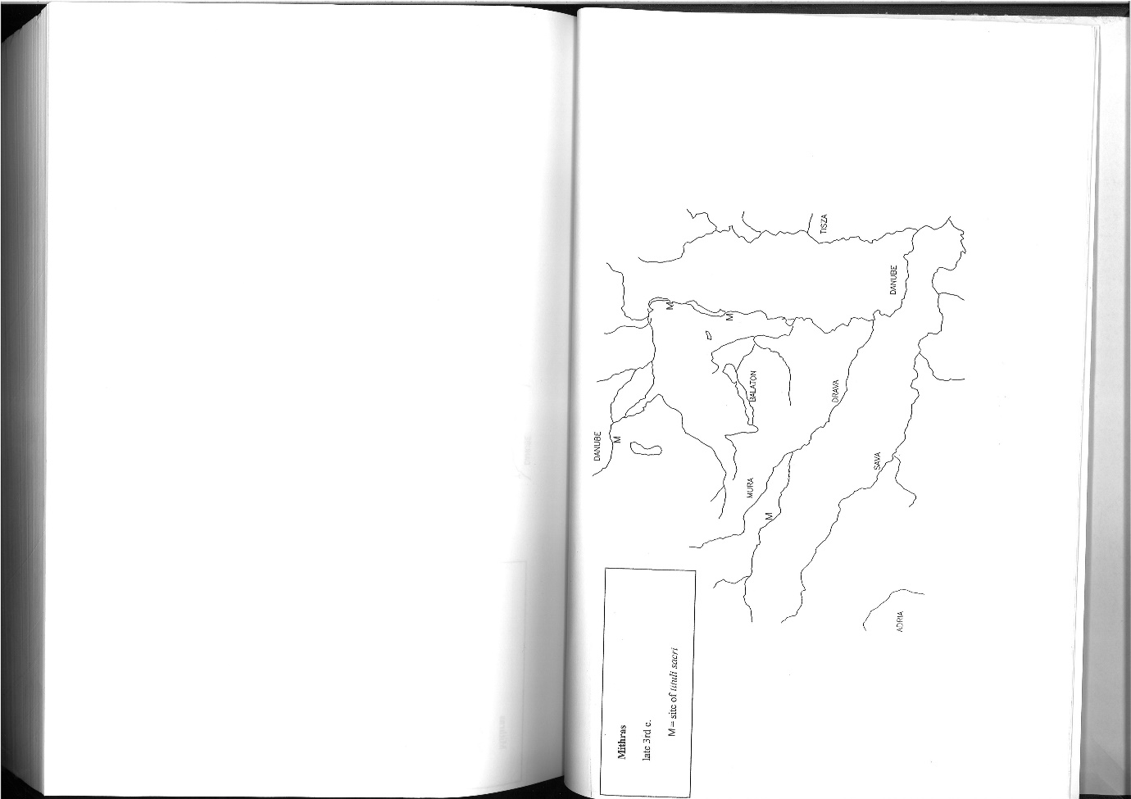

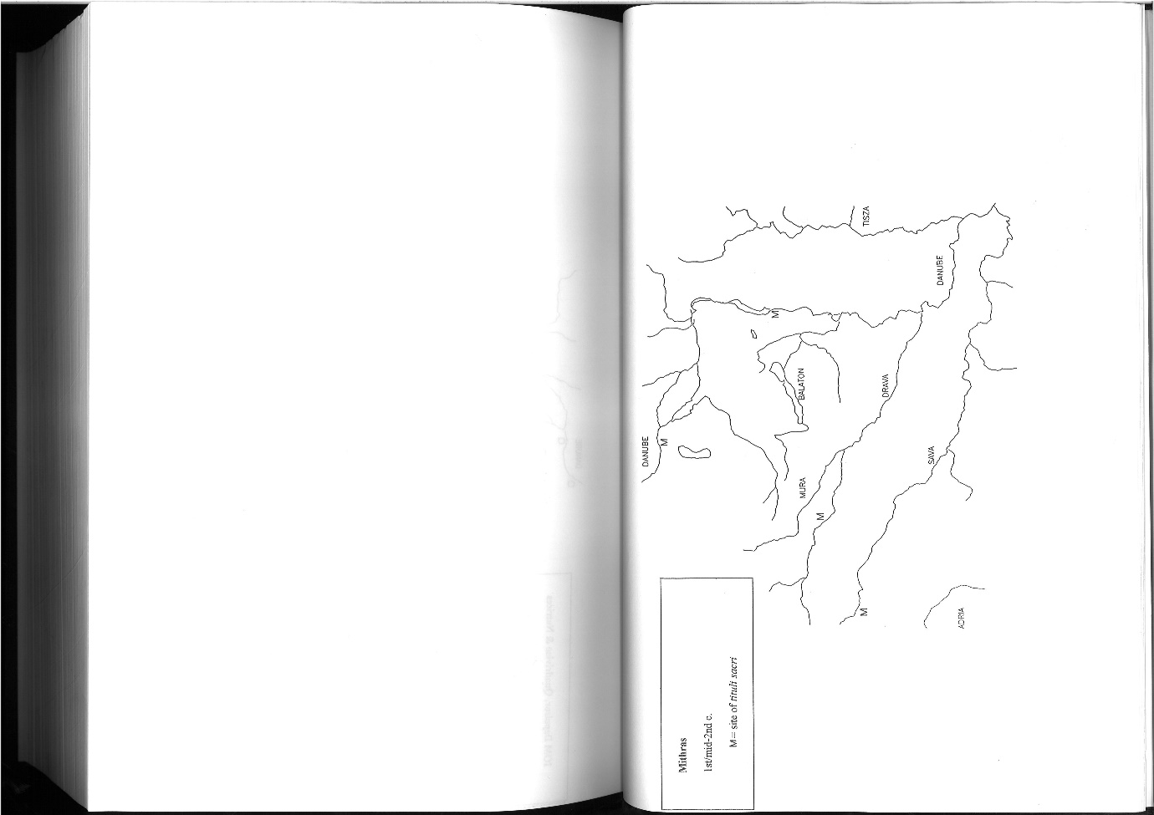

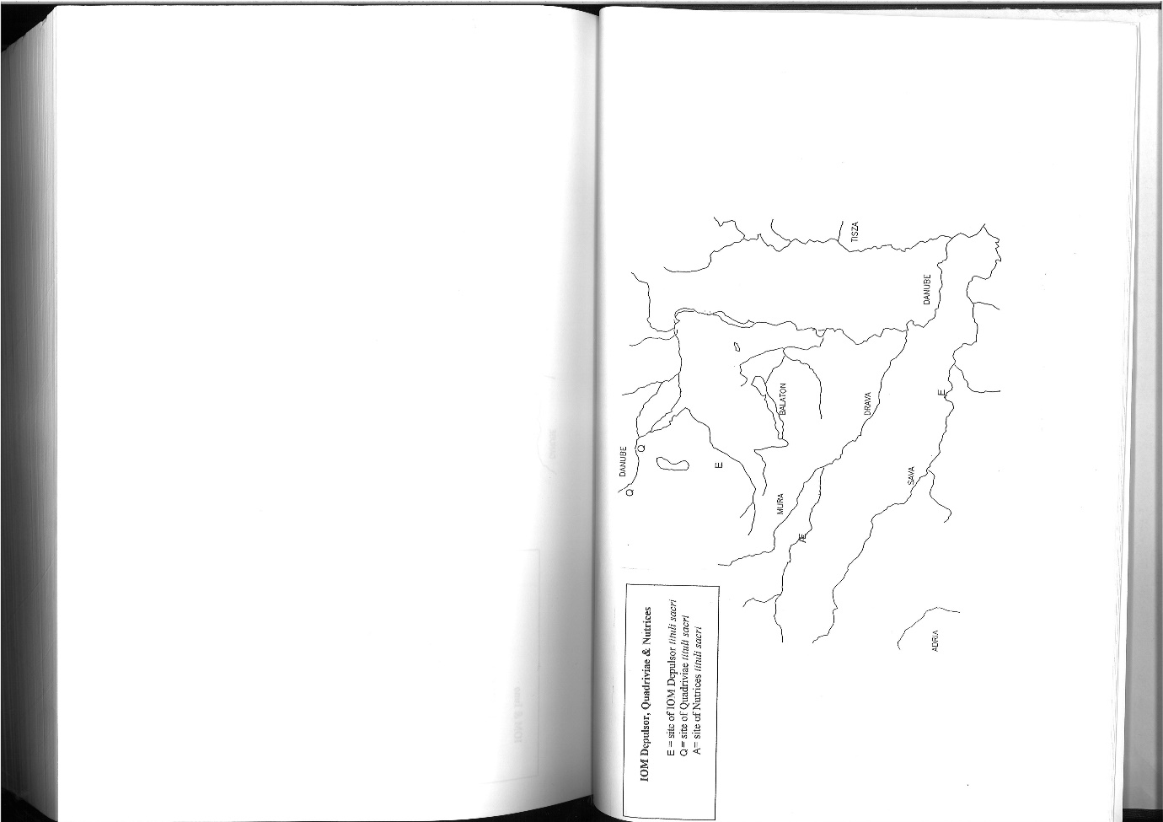

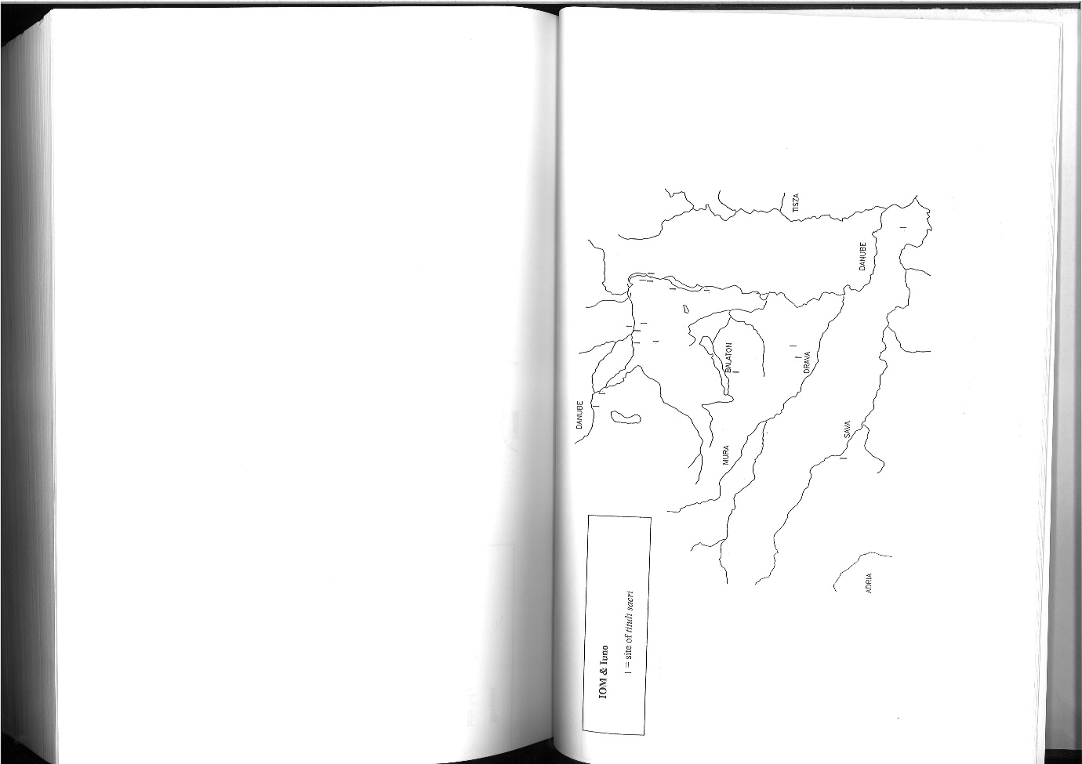

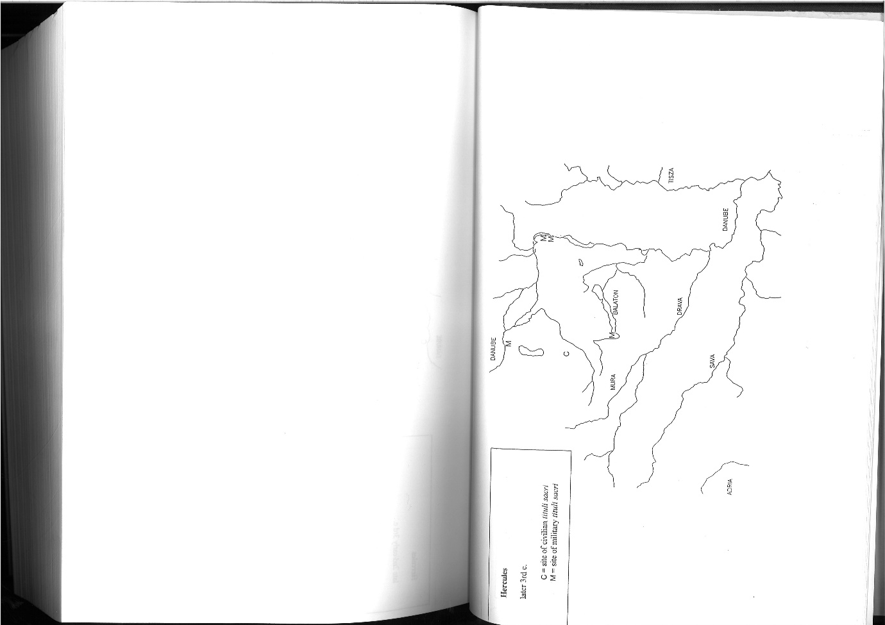

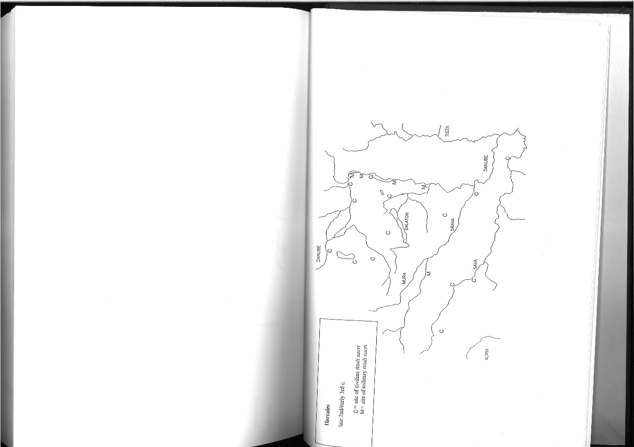

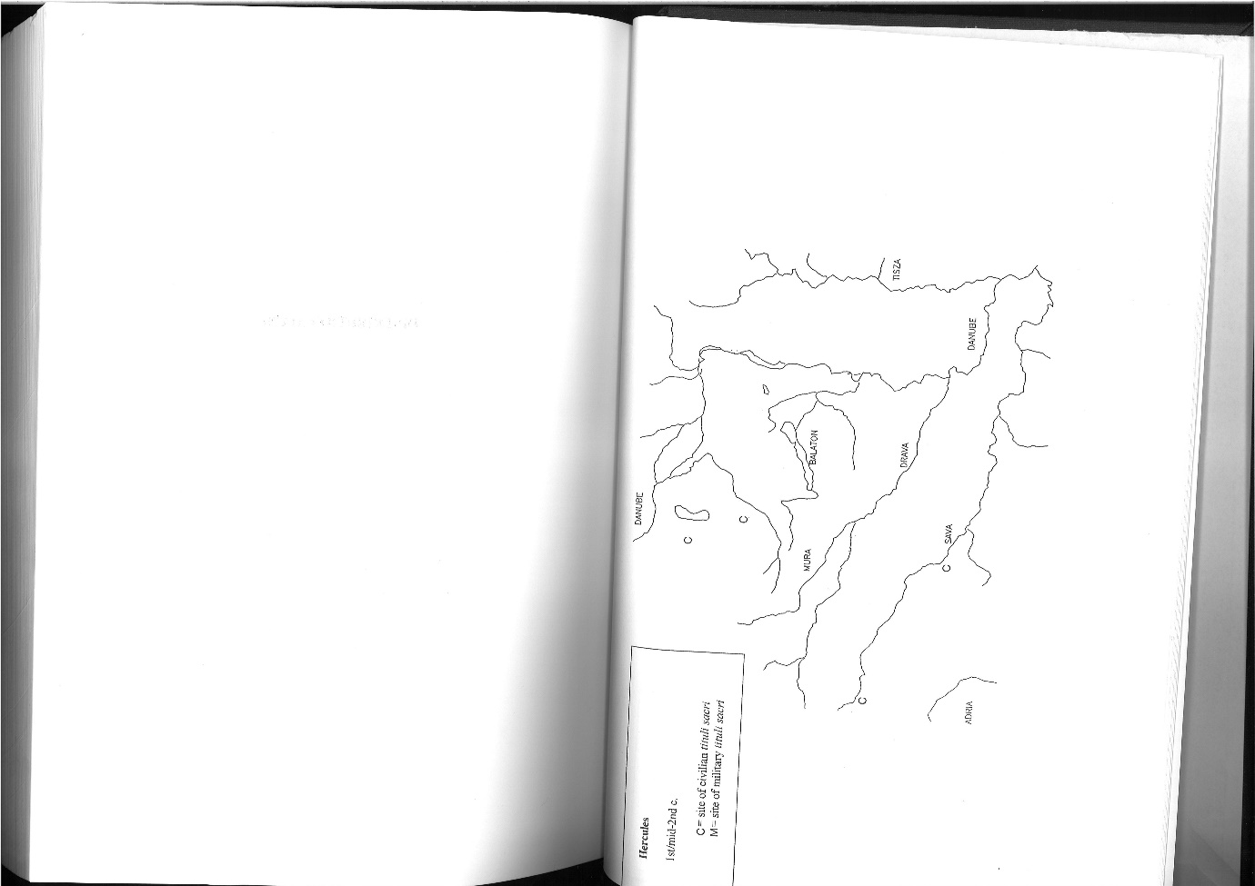

Roux 2004:287ff; Spawforth, Millett and Mitchell 2014; Website 1; Webster 2001:209; Mihajlović 2016:709ff; Hingley 2005:1-13; Misic 2013: 10ff
Website 1; Haussler 2013:20ff,215ff; Woolf 2000:5-7; Misic 2013:23ff
Haussler and King 2017:4-8; Webster 2001:209ff; Haussler 2012:143ff
Tac.Ger.43; Misic 2013:42ff
Haeussler 2012:143ff
Haeussler and King 2017: 2 although Emperors or Governors had influence Mocsy 1974:45; Saller 1982:33; Morton 1995:140
Mocsy 1974:181
Mocsy 1974:181; Morton 1995:105
Mocsy 1974:181,255ff
Mocsy 1974:325-28
Mocsy 1974:181
Morton 1995:i
Morton 1995:iii
Morton 1995:iv
Mocsy 1974:256-7,300-1
Moscy 1974:258
Sourvinou-Inwood 1990:295; Sourvinou-Inwood 2000:259ff; Scheid, J. 2003:21-2; Morton 1995:154
Mocsy 1974:181-2; who is ‘native’ is far from simple Jeno 1998:17; and that ‘native religion’ belies the differences even in a relatively small region Jeno 1998:18; For this paper ‘native’ includes primarily Thracians Illyrians and Celts Mocsy 1974:4; Morton 1995:iii,vi,12-13,140,156; App.Ill.1ff; see appended maps
Mocsy 1974:147ff; Morton 1995:12-13,29-30,63,67-9
Mocsy 1974:82
Morton 1995:i-ii
Morton 1995:iii
Morton 1995:v
Morton 1995:v-vi
Alvar 2008:80; Cumont 1903:1ff; Jeno 1998:29,53; Mocsy 1974:7,10ff,26ff
Morton 1995:115
Morton 1995:29-30,63,94; Póczy 1959:63-69
Jerem 2007:124-8
Mocsy 1974:147ff
Mocsy 1974:149
Mocsy 1974:251; Morton 1995:63-4,299-300
Morton 1974:v,45,29; For example at Aquae Iasae, which was possibly a pre-Roman religious site Misic 2013:52-3
Morton 1995:66-7,122
Jeno 1998:8; Misic 2013:61-2; Jerem 2007:129-30
Morton 1995:63-64; Mocsy 1974:182
Jeno 1998:53; Jerem 2007:129
Morton 1995:95-6
By this it is meant inscriptions, temples and statues etc Morton 1995:63
Morton 1995:140
Mocsy 1974:313,333,335,353; Jeno 1998:44-5
Mocsy 1974:259,322ff
Mocsy 1974:323
Felix.viii
Nolloth 1917:114-5
Morton 1995:i-ii, v
Mocsy 1974:181
Alvar 2008:80; Mocsy 1974:255ff,333-5 although Christian sites may have had significant regional variation
Alvar 2008:80; Morton 1995:13,71-3,94; Cumont 1903:1ff
Mocsy 1974:78
Mocsy 1974:181
Mocsy 1974:181
Mocsy 1974:181; Morton 1995:v
Jeno 1998:10
Cumont 1903:1ff,38
Mocsy 1974:256
Mocsy 1974:258
Cumont 1903:38
Cumont 1903:40
Beck 2006:48-50
Morton 1995:71,77
Mocsy 1974:258
Mocsy 1974:257
Mocsy 1974:257
Speidel 1978:1
Morton 1995:135
Fishwick 2000:328
Morton 1995:151
Jeno 1998:10; Morton 1995:73-5
Morton 1995: 74,183,208-9,212-3,231,235,346; Apul.Met.11.1-3
Morton 1995:107; Apul.Met.11.1-3
Mocsy 1978:244,257
Morton 1995:71-7; table 1
Morton 1995:73-5; table 1
Tomorad 2009:284
Scheid 2007:121-2
Scherrer 2008:217ff
Dorcey 1992:78; Morton 1995:157
Morton 1995:29-30
Morton 1995:ii
Morton 1995:101
Morton 1995:128
Morton 1995:128
Morton 1995:123-4; table 1
Jeno 1998:7
Morton 1995:84
Morton 1995:85
Morton 1995:86-8
Morton 1995:86
Morton 1995:85-8
Morton 1995:143-4
Morton 1995:67-70
Jeno 1998:29-31
Jerem 2007:116ff
Jeno 1998:29
Póczy 1959:63-69; although not the only one Jerem 2007:129-30
Toth 2003:385ff; for issues of ‘Celtic’ cults Haussler and King 2017:13ff; Haussler 2012:143ff
Morton 1995:13,94; Jeno 1998:29,53; Mocsy 1974:7,10ff,26ff; Haussler and King 2017:12-18; Haussler 2012:166,174
Morton 1995:30
Morton 1995:v
Jeno 1998:33ff
Jeno 1998:26
Morton 1995 v
Morton 1995:93
Morton 1995:91
Morton 1995:92
See tables and maps
Beard, North and Price 1998:140-9,169,318,348-63; Weinstock 1971:287ff
Fishwick 2002:267ff
Morton 1995:90
Morton 1995:183,190-1,194,197,200-1,203,207-9,211-4,220-4,226,229,231,233-5,237,241-3,245,247-9,254,260-2,264,274-5,279,283-6,294-6,298-9,303,305-9,315,321,328-9,332,338,340-1,347, 351,353,355
Morton 1995: 6,12,62-3; Tac.Ger.43
Mocsy 1974:182
Jeno 1998:8,53; Morton 1995:29-30,62,67-9,95-6,
Morton 1995:vi
Morton 1995:63; Mocsy 1974:181-2
Morton 1995:37-8,72,141,156
Mocsy 1974:253
Morton 1995:24,79,143; table 1
Morton 1995:38
Mocsy 1974:154
Fishwick 1988:349 assuming the Feriale Duranum is representative.
Mocsy 1974:247
Mocsy 1974:247-8
Morton 1995:79-80
Morton 1995:82
Morton 1995:103,134
Morton 1995:143
Morton 1995:144ff

