Student id: 2106684 Maulik dave
Significance and Properties of Coatings
ACEA7010: Mechanism of Material Failure M.Sc Automotive Engineering

University of Wales Trinity Saint David
[Type the abstract of the document here. The abstract is typically a short summary of the contents of the document. Type the abstract of the document here. The abstract is typically a short summary of the contents of the document.]


Content
1 Introduction………………………………………………………………………………………………4
2 Abstract…………………………………………………………………………………………...........4
- What is Alloy wheel…………………………………………………………………….5

  - Material of wheel Rim………………………………………………………..5
3.1.1.. Aluminum……………………………………………………………………………………….5
3.1.2.. Magnesium alloys…………………………………………………………………………. 6
3.1.3..Titanium Alloys: ……………………………………………………………………………..6
3.1.4 why aluminum use in alloy wheels not steel wheels: ………………………………..6

- Corrosion in alloy wheel…………………………………………………………..7
5 Manufacturing of Wheel……………………………………………………………….8
  - Casting: ………………………………………………………………………………………………8
5.2 Forging : ………………………………………………………………………………........ 8
5.3 Stripping the wheel ………………………………………………………………………………10
5.4 Sand Blasting . . ………………………………………………………………………………………..10
5.5 HLT ……………………………………………………………………………………………10

Coating……………………………………………………………………………….................11
6.1 What is Coating ……………………………………………………………………………………….11
6.2 Powder coating ………………………………………………………………………………….12
6.3 Overview of powder coat process and equipment ………………………………13
6.1.3 Preparation stage …………………………………………………………………………….13
6.3.2 Application stage …………………………………………………………………………………..14
6.3.3 Curing stage ………………………………………………………………………………………………14

6.4 Types of Powder Coating Materials …………………………………………………………………15

6.4.1 Powder Coating Material Considerations………………………………………………15

6.4.1.1 Thermoses powder ……………………………………………………………………16
6.4.1.2 Thermoplastic coating ……………………………………………………………..16

7 Diamond Cutting……………………………………………………………………...17
8 Finishing……………………………………………………………………………17

9 conclusion ……………………………………………………………………………….18
10 References………………………………………………………………………………18

- Introduction
In this assignment illustration about alloy wheel (rim) and explained about manufacturing process of rim and casting, forging process Moreover in this assignment explained about whole coating process and each steps The automotive wheels have evolved[1] in a number of ways in comparison to their original design over the years since the first design of rim designs made of wood to cast or forged aluminium alloy rims of today. The wheel is one of the most important inventions ever made. The first ever wheel made was made from large round ring but now has become an essential part of the modern transportation vehicle. It is an essential physical member of a vehicles suspension system which supports the loads encountered during vehicle operation.The main function of the wheel is facilitating movement of a vehicle while supporting the load on it . Common examples include transport applications. A wheel, along with an axle disables friction, thereby enabling motion in the vehicle by rolling . Safety of the driver and passenger along with low-cost of production are particularly the main factors considered when designing a machine component so that they can be used easily and efficiently. Style, weight, manufacturability and performance are few of the major issues concerned with the design of a new wheel. The wheel used today are generally made of steel, aluminium alloy, magnesium alloy or in cases of superfast cars titanium wheels are also used.

- Abstract
The present invention provides a method for coating an aluminum wheel using a coating composition capable of forming a coating film having a superior cosmetic property as well as an anticorrosive property much enough for preventing corrosion even in the use in an area where the coating film is susceptible to salt damage, and an aluminum wheel obtained by the method. there is one process explain in this and in this file explain about alloy casting process forging powder costing and why aluminum is better marital than steel alloy .

- What is Alloy wheel?

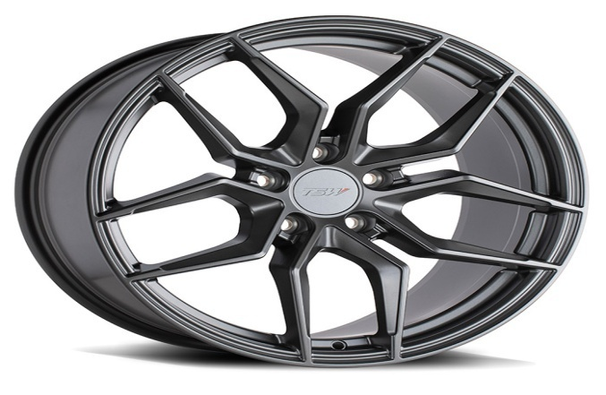
The term ‘alloy wheels’ refers to wheels which are produced from a mixture of aluminium and traces of other metals, a combination which helps to create a wheel that is very strong yet also lightweight. While they are more expensive than steel-plated wheels, they add a fantastic visual enhancement to your vehicle and they can increase a car’s overall value.
Aluminum on its own is rather lightweight, but when it is combined with other metals for the formation of alloy wheels, the entire product becomes substantially reinforced. They are primarily used in high performance vehicles, particularly those for racing purposes, although they have become a common sight on public roads in recent years.
  - Material of wheel Rim
The metals used in the production of light alloy wheels are aluminum and magnesium.
    - Aluminum alloys:
Aluminum is one of the lightest metals (specific weight 2.7 g/cm3). Used as an alloy and hardened and subsequently aged, it maintains its main characteristic, namely, lightness, and improves its mechanical and technological properties, such as tensile strength, dynamic stress resistance and resistance against corrosion.

    - Magnesium alloys:
Magnesium is the lightest among structural metals (specific weight 1.74 g/cm3, thus 35% less than aluminum). Magnesium alloys are characterized by extreme lightness, high resistance to impact and vibration, they do not stretch nor are they damaged superficially by friction: this is another characteristic that makes them particularly appropriate for the production of racing wheels. But they are hard to manufacture. The wheel thickness specifications are mainly in place for strength and safety, as thin layers of magnesium are highly flammable and could be a threat for the driver's safety in case of an accident.
Wheels must be made from an homogeneous metallic material with a minimum density of 1.74g/cm3 at 20°C
    - Titanium Alloys:
A large number of titanium (Ti) alloys have come into production in the past decadethese alloys Can be classified into three main categories alloys. The properties of these Alloys completely depend on factor including, microstructure of alloy, chemical composition of alloy, and thermo-mechanical processes. Due to properties like high specific strength and resistance to Corrosion, titanium alloy is being used in the fields of Aerospatiale, biomedical and automobile.

    - why aluminum use in alloy wheels not steel wheels

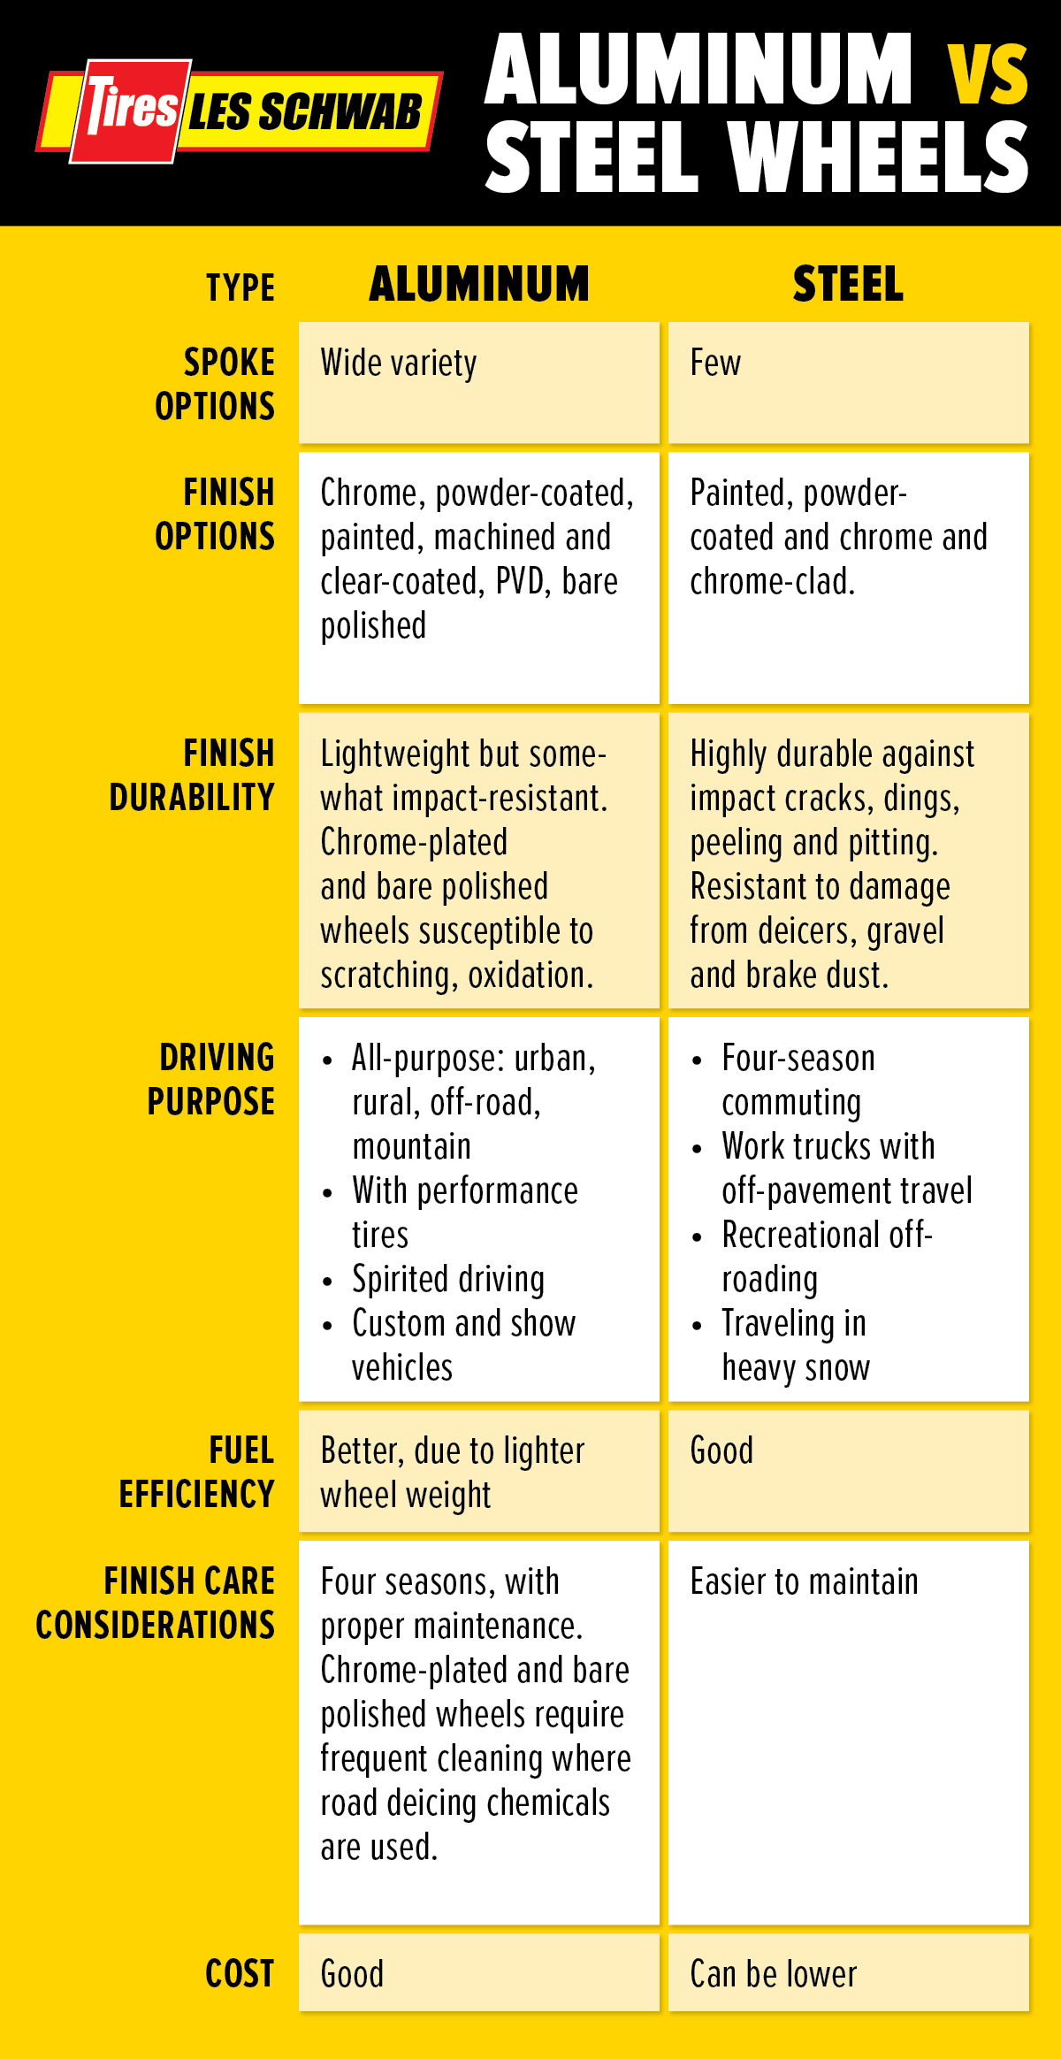

- Corrosion in alloy wheel

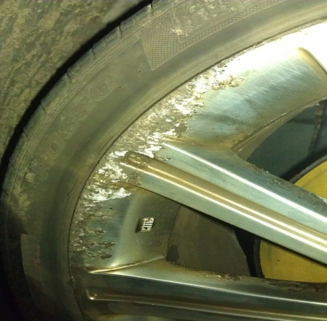
Corrosion rates for aluminum alloys AA1050, AA5183 and AA6016 were monitored in simulated marine and industrial environments and compared to that of coated steel. Polarization resistance measurements on every sample were conducted daily for at least 7 days. Corrosion rates were calculated from the measured Rp values and averaged over the duration of 7 days. The average corrosion rates for the aluminum alloys in 0.6 M NaCl solution is shown in. Aluminum alloy AA5183 showed the lowest corrosion rate of about 1.8 microns per year (μpy) while coated steel showed corrosion rates of 162 microns per year. In fact, corrosion rates for= were tore than 2imes those of worse performing aluminum alloys, AA1050 (7.4 μpy) and AA6016 (8.8 μpy). This clearly shows the significant advantage of aluminum over steel with respect to corrosion in marine environments. The superior performance of 5xxx series aluminum alloys in sea water as compared to commercially pure aluminum alloys has also been reported earlier. It should be noted that the corrosion rates calculated from polarization resistance method are uniform corrosion rates. In chloride containing environments, pitting corrosion also occurs which is much more localized and can lead for failure much faster than that predicted by uniform corrosion rates as reported here.
The average corrosion rates for the aluminum alloys coated steel in an aggressive acidic environment simulated by a 0.1% H2SO4 is shown in. In acidic solutions, AA1050 showed the lowest corrosion rates of 40 μpy while= coated steel showed the highest corrosion rates of 564.9 μpy. Corrosion rates for AA5183 and AA6016 were slightly higher than that of AA1050 at 54.5 and 54 μpy respectively. Thus, in acidic
I_{corr} = βaβc 2.303Rp(βa +βc)
CR = I_{corr} .K.EW dA
environments as well, corrosion rates for aluminum alloys were at least 10 times lower than that of steel. the . Going by corrosion rates alone, 5xxx series alloys are the material of choice in marine environments and 1xxx series alloys are best suited for acidic industrial environments. However, 6xxx series alloys are preferred for several automotive applications because of reasonably good corrosion resistance and more importantly age hardening properties for improved strength.
- Manufacturing of Wheel
  - Casting:
The wheel comes out from the foundry. The aluminum alloy is brought to a temperature of about 700° and is cast in moulds that give to the raw material the desired design when it solidify.
The casting technologies used are:
- Gravity casting: it is also called shell casting, and it basically consists in pouring the cast alloy into a steel mould.
- Low pressure casting: the alloy is heated at about 700°C, cast and then a pressure from the bottom pours it into the mould. OZ mainly uses this second process, which guarantees a better quality of the finished product. Low pressure casting is a relatively young technique and it is used to transform non ferrous materials and alloys into manufactured products presenting a high finishing level.
Aluminium and magnesium alloys are suitable for this metal process, for their pouring features, for the low casting point and a wide solidification interval: these requirements allow a slow filling of the mould cavities, the reproduction of the mould details, also the minimal ones and a correct air outlet, while the pouring connections are still open, through which pressure is transmitted into the piece also during the first solidification phase.
The resulting casting won't present any junctions, porousness and cavities, and the raw manufactured wheel will have a fine a compact grain.
  - Forging :
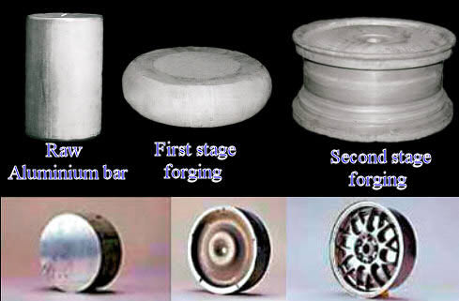
Aluminium or magnesium alloy is poured in a continuous water-based process to get a 6-meter bar with 500 mm diameter. The same bar is extruded, until a diameter of 300 mm.
The extrusion procedure enhances the mechanical and structural characteristics of the metal whose particles are subsequently compacted and in this way they change the non-directional grain structure of starting material to the high integrity multi-directional grain structure of forgings. After that, the extruded forging dies are cuted into disks which are heated at a temperature of 300 degrees and treated with an oil-pressure press, with a gradual pressure of 3000 ton. Another press will print the semi finished product (otherwise called "formaggella, literally translated with "small fresh cheese" because of its shape) with a pressure of 9000 tons which are transmitted in 30 seconds to the cylindrical shape of a wheel. This final piece, which is still raw, has a strong structural tension caused by the extrusion and the forging that have forcedly displaced the material particles. The forging obtained in this way, though still unfinished, is strong in structural tension caused by the extrusion and forging processes. The structural tension is a synonym of fragility, that's the reason why the raw piece is subsequently put through a T4 or T6 thermal treatment which spreads out the internal forces and restores the mechanical characteristics of the alloy, distributing them uniformly in the semifinished product. This forged blank is then placed in a custom built spin-forging machine to spin out and forge the rim section. The resulting radial grain direction places the highest material strength in the same direction as the operating loads. The result is 'premium strength' wheel rim.

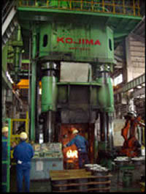

Fig Forging machine
  - Stripping the wheel
The wheels are sent to out chemical room. Here the wheels are dipped in special chemicals where all the previous all extra particles dirt is all removed leaving a bare aluminium. This stage in vital in ensuring a perfect finish.

  - Sand Blasting
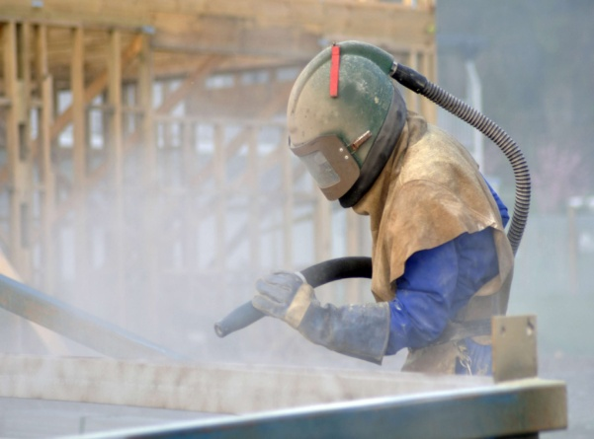
In this stage the wheels are blasted with high speed alminium oxide. Removing any rust and corrosion and also giving the surface a uniform finish for the next stage.

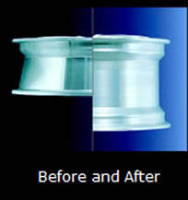
  - HLT
HLT: otherwise called coating or flow forming. This technique uses rollers to move the material along the channel of a low-pressure cast aluminium wheel so as to lengthen it and give it the desired shape. This technology makes the material coated on the channel very compact, enhancing its mechanical characteristics.
The HLT wheels are produced with HLT technology that improves performance reduces consumptions and guarantees the necessary resistance to pass the strictest safety tests. The innovation and the excellence of the HLT production processes (high light technology) are the result of direct experience in racing.
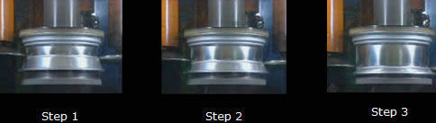
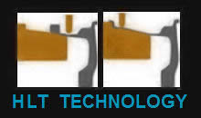
The sensitive channel coating process and the new HLT technologies make it possible to obtain mechanical characteristics that are similar to those of a moulded wheel, increasing drastically resistance, with a consequent reduction of the weight of the wheel.

Coating
  - What is Coating? ^{[1]}
- A coating is a covering that is applied to the surface of an object, usually referred to as the substrate. The purpose of applying the coating may be decorative, functional, or both.^{[1]}
- Paints and lacquers are coatings that mostly have dual uses of protecting the substrate and being decorative, although some artists paints are only for decoration, and the paint on large industrial pipes is for preventing corrosion and identification e.g. blue for process water, red for fire-fighting control etc.
- Functional coatings may be applied to change the surface properties of the substrate, such as adhesion, wettability, corrosion resistance, or wear resistance.^{[2]} In other cases, e.g. semiconductor device fabrication (where the substrate is a wafer), the coating adds a completely new property, such as a magnetic response or electrical conductivity, and forms an essential part of the finished product.
- A major consideration for most coating processes is that the coating is to be applied at a controlled thickness, and a number of different processes are in use to achieve this control, ranging from a simple brush for painting a wall, to some very expensive machinery applying coatings in the electronics industry. A further consideration for 'non-all-over' coatings is that control is needed as to where the coating is to be applied. A number of these non-all-over coating processes are printing processes.

  - Powder coating ^{[2]}

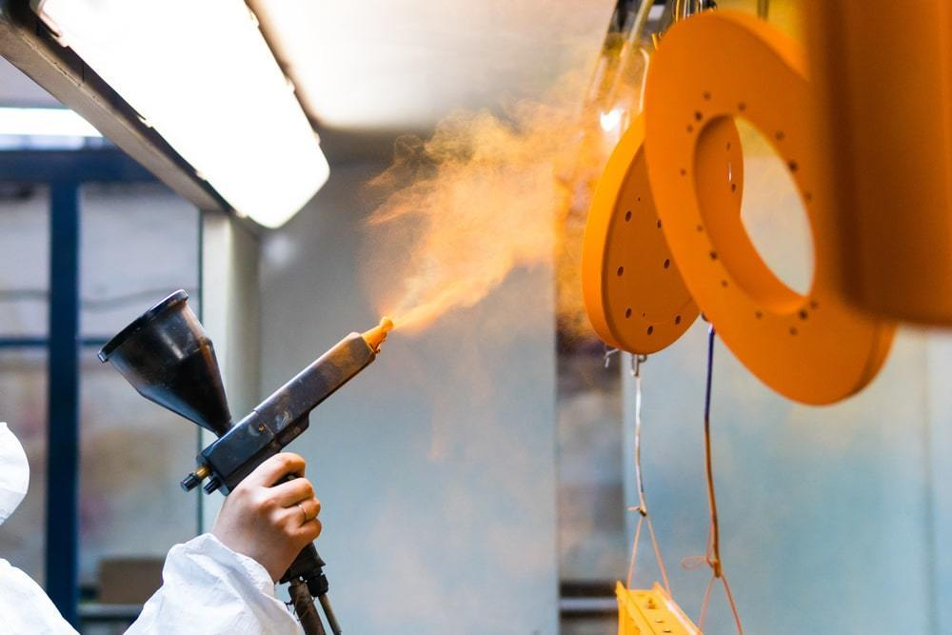
Powder coating is a finishing process in which dry, free-flowing, thermoplastic or thermoset powder material is applied to a surface, melted, and hardened into an even coating. This finishing process is suitable for various materials, including metals, plastics, glass, and medium density fiberboard (MDF), and can provide both functional and decorative surface coatings in a wide range of colors, finishes, and textures that are not readily achievable by conventional liquid coating methods.
There are two main methods of powder coating—electrostatic spray deposition (ESD) and fluidized bed application. Either process can produce an even, hard finish which is generally more durable, cost-effective, and environmentally-friendly than a comparable liquid coating. However, while powder coatings demonstrate some advantages over liquid coatings, especially in thick or high traffic coating applications, they are not suitable for all manufacturing applications, such as for thin film or large part coatings. The requirements and specifications demanded by a particular powder coat—e.g., application environment, substrate materials, sizing, costs, turnaround times, etc.—help determine the type of coating process most suitable for use.
While each coating process has its advantages and disadvantages, this article focuses on powder coating, outlining the basics and the necessary components and mechanics of powder coating technology. Additionally, the article explores the benefits and limitations of the process and provides some of the considerations manufacturers must keep in mind when choosing a coating service provider.

  - Overview of powder coat process and equipment
In contrast to the liquid coating process, which utilizes a liquid coating suspension, powder coating is a dry finishing process which employs powdered coating material. During the process, the powder is applied to a substrate’s pretreated surface, melted, and then dried and hardened into a protective/decorative coating. There are three stages: surface preparation, coating application, an heat curing.
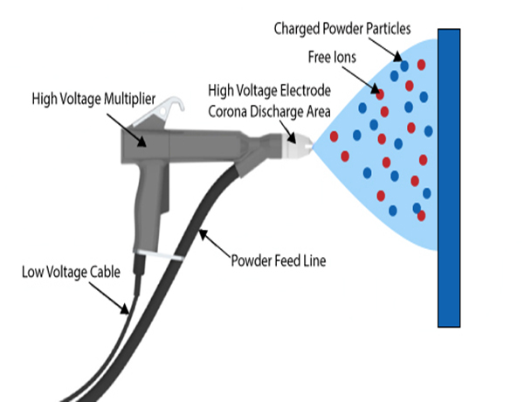
Fig :Coating gun
    - Preparation stage
Before the application of any powder coating material, the surface of the substrate must be cleaned and treated to ensure that the part is free of dust, dirt, and debris. If a surface is not sufficiently prepared, any remaining residues and deposits could affect the adhesion of the powder and the quality of the final finish. A complete preparation treatment is mainly dependent on the material being coated. However, some of the steps that are commonly employed during this stage include cleaning, rinsing, etching, blasting, and drying, and the most widely used equipment include wash stations, blast rooms, and dry-off ovens.
Oil, grease, solvent, and residue can be removed from a part’s surface with weak alkali and neutral detergents in dip tanks or with wash stations. Wash stations are capable of spraying parts with hot water, steam, detergent, and other pretreatment solutions to clean, chemically prepare, and rinse the surface before coating.
If the component design requires certain sections to remain uncoated, masking products (e.g., masking dots) are applied to the substrate prior to the application stage. These aforementioned products are available in a variety of standard and custom shapes and forms. However, generally, they are constructed of paper or plastic film coated with a pressure sensitive adhesive, which allows them to adhere to the substrate and protect the covered area from coming into contact with powder material during powder coating operations.

    - Application stage
As discussed in the next section, there are two types of powder coating materials that can be applied. The type of coating material being used in a coating application, in part, determines the application method. There are two main methods employed by manufacturers and finishing service providers—electrostatic deposition (ESD) and fluidized bed powder coating.
- Electrostatic deposition (ESD): For most metal parts, the coating material is applied via electrostatic spray deposition. This application method employs a powder spray booth, powder feeder, electrostatic spray gun, and, depending on the type of gun used, a power unit.
- The spray booth serves as a work area for applying powder material onto a part, and can also act as an air filter and powder overspray containment and recovery system. Fluidized powder material is distributed from the feeder unit to the powder coat gun, which is used to both impart an electrical charge onto the powder and apply it to the substrate. There are three types of electrostatic guns commonly used—Corona, Tribo, and Bell. The electrically-charged particles can then adhere to the part’s electrically grounded surface and will remain adhered as long as they maintain some of their charge. Any overspray material can be collected by the recovery and retrieval systems and reused in future coating applications.
- Fluidized bed powder coating: Unlike in ESD where the liquid paints materials are electrostatically sprayed and adhered onto a surface, in fluidized bed powder coating, preheated parts are dipped into the powder material within a fluidized bed. There is also an alternative option called electrostatic fluidized bed powder coating, which generates a cloud of electrically charged powder particles above the fluidized bed through which a part is passed to be coated.

    - Curing stage
The particularities and characteristics of the powder coating process’s curing stage are mainly determined by the method in which the dry powder is applied, as well as the type of powder coating material employed.
- Curing ESD coated parts: Parts that are powder coated via ESD must be cured in a powder curing oven. While the cure schedule for a part is mostly dependent on its size, shape, and thickness, generally a curing oven operating between 325 to 450 degrees Fahrenheit will result in cure times that range between ten minutes to over an hour. Accordingly, smaller powder coated parts require less curing time and lower volumes of heated air to cure fully, and larger parts need more. As the ESD coated part reaches the optimum curing temperature within the oven, the powder particles melt and flow together to form a continuous film over the part’s surface.
- Curing fluidized bed coated parts: For parts that are coated within a fluidized bed, the parts are heated before the coating application stage in ovens similar to those used to cure ESD coated parts. As the preheated part is immersed in the coating material, the powder particles melt and flow together upon contact with the part’s heated surface. Parts that are coated via electrostatic fluidized bed powder coating can be either preheated before being passed through the powder coating cloud—in which case the powder coating formed would be to those produced by the regular fluidized bed method—or the part can be heated and cured in a curing oven after it has been coated, like with the ESD coating method.
Once the powder coated part is cool enough to handle, the part can be, if necessary, assembled, packaged, and shipped.

Types of Powder Coating Materials
1. Thermoplastics
- Polyvinyl Chloride (PVC)
- Polyolefin
- Polyester
2. Thermosets
- Epoxy
- Epoxy-Polyester Hybrid
- Acrylic
- Silicon-Based Powders

Powder Coating Material Considerations
As indicated in the previous section and Table 1, below, the powder coating process utilizes two main types of coating materials—thermosets and thermoplastics. Each type can be similarly applied, but undergoes and experiences the curing stage differently, as well as demonstrates distinct physical and mechanical characteristics.
Thermosets | Thermoplastics
Capable of withstanding high temperatures | May soften/melt if subjected to high temperatures
Cannot be remelted, reformed, and recycled | Can be remelted, reformed, and recycled
Higher scratch and mar resistance | Higher impact resistance
Susceptible to brittleness and over-hardening (especially in thick coatings) | More flexible in thick coatings
Requires a cure cycle to harden | Does not require a cure cycle to harden
Undergoes an irreversible chemical reaction | Does not chemically change
Applied only via the ESD method (generally) | Applied via both ESD and fluidized bed method

Table 1: Comparisons between Types of Powder Coating Material ^{[2]}

      - Thermoset powder
When first applied to a substrate, a thermoset powder coating has short polymer molecules. However, during the curing process, the powder undergoes an irreversible chemical cross-linking reaction, which bonds together long chains of polymer molecules. This reaction changes the physical properties and chemistry of the material and allows it to harden into a thin, even, hard finish, if the proper cure schedule is followed.
Thermoplastic powders do not require a cure cycle. Instead, the thermoplastic material only requires the time and temperature necessary to melt, flow out, and create the film-like coating. Unlike with thermoset material, which undergoes a chemical reaction during the curing stage, thermoplastic materials do not change their physical or chemical properties when heat is applied. Therefore, they can be remelted, reformed, and recycled for future coating applications.

      - Thermoplastic coating
Some considerations to keep in mind when choosing between thermoset and thermoplastic coatings are the application method and the intended application for the coating. Generally, thermoset powders are only applied via the ESD method. This limitation exists because dipping preheated parts into thermoset powder can cause any excess powder to cross-link due to built-up and residual heat within the fluid bed. As the cross-linking reaction causes permanent changes to the powder material, such occurrences would lead to excessive coating powder waste. The curing process enables thermosets to attain harder coatings than thermoplastics, thus allowing them to withstand higher temperatures and demonstrate greater scratch and mar resistance. However, the harder finish can also limit the impact resistance of thermoset coatings, and over-hardening can cause the coating to become brittle, particularly in thicker coatings. Thermoplastic powder can be applied via both the ESD and the fluidized bed coating method, and generally can produce thicker, more flexible and impact-resistant coatings than thermoset powder. While the ability to be remelted offers some advantage in regards to material costs, it also makes thermoplastic powder coatings less suitable for high and intense heat applications as the coating material may soften or melt off.

Diamond Cutting
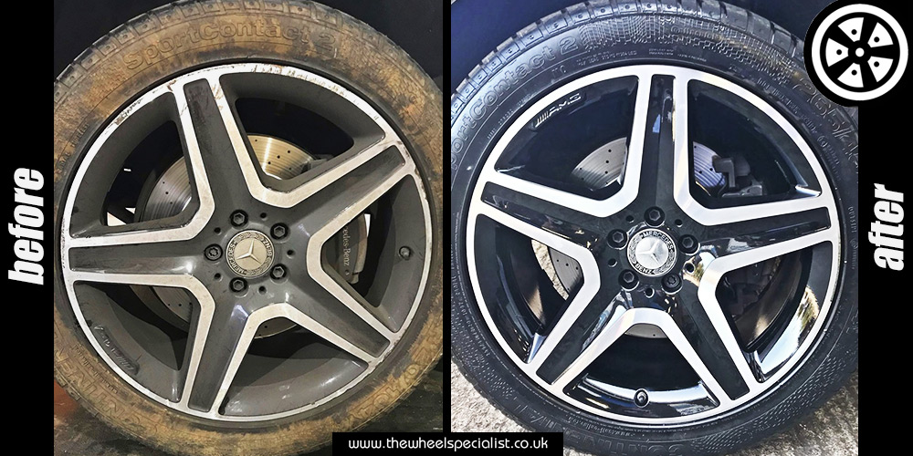
Fig of DIAMOND CUTTINGON ALLOY WHEEL
Although powder coating is The Wheel Specialist’s most popular and most durable alloy wheel refurbishment service, diamond cut finishes are also very desirable. Corroded diamond cut wheels are very common. Applying the lacquer paint to a polished surface will not achieve a long lasting finish. Small stone chips would let water in behind the lacquer and would cause the lacquer to deteriorate and eventually become dull and cloudy looking. The diamond cutting process involves removing a thin layer of alloy from the wheel rim using specialist equipment. Diamond cut wheels have a limit on how many times that they can be refurbished as only a certain amount of alloy can be removed, so it may be worth considering a powder coat finish as a longer and more durable refurbishment. With our specialist equipment, we will be able to provide the highest quality finish possible and also with the quickest turnaround time. Diamond cutting can be applied to the full face and the lip of wheel and combined with an application of base coat paint, this will produce a fantastic finish

- Finishing
The moulded steel and magnesium wheels can be anodized with a special electrochemical treatment which doesn't cause any weight increase, but protects from corrosion and enhances the wheel's design and mechanical workmanship.
Painting, which is traditionally carried out on wheels produced for use on the road, requires the application of four different layers, constituted by heat-applied epoxy powders and liquid metallic paint. Finally, a clear film coating is applied on the wheel, in order to confer greater brilliance and to protect it from abrasions and chemical agents.

conclusion:
After doing the study in this paper on the different types of alloy materials available for the
manufacturing of we would like to conclude by saying that in our opinion the best material for manufacturing of alloy wheels is aluminium as it is easily available moreover, the cost of production of aluminium alloy wheel is also cheaper in comparison to magnesium or titanium. Moreover the use of aluminium gives us the ability to have different design features in the wheel which is not possible in the case of other materials. Aluminium also has more strength, machinability and non-corrosive characteristics as compared any other steel, magnesium or titanium alloys. From studying the analysis we would like to conclude that in comparison to all the other material under fatigue analysis aluminium alloy is long lasting and less susceptible to break under load.
Eventually on aluminum is very effective costing process . Powder coating enables your alloy wheels to match the color of your car, giving the vehicle a smarter appearance. Powder coating will help increase the longevity and performance of your alloy wheels by protecting them from dents and scratches. This is, of course, provided that you get your powder coating done in a reputable outlet by qualified and properly trained technicians. A poor powder coating finish can be as bad for alloy wheels as not getting them refurbished at all.) Powder coating is a great way to refurbish and smarten up alloy wheels which you’ve had for a while. It gives them a new lease of life and makes them appear as good as new. Powder coating takes place in a sealed ‘oven’ and is better for the environment than spray painting. Not only is the powder safely contained during application, but – unlike many paints – powder coatings do not release harmful VOCs (volatile organic compounds) while drying.

- References
  - https://en.wikipedia.org/wiki/Coating
  - https://www.thomasnet.com/articles/custom-manufacturing-fabricating/understanding-powder-coating/
  - https://www.chipsaway.co.uk/blog/powder-coating-alloy-wheels-how-does-it-work/#:~:text=Alloy%20wheel%20powder%20coating%20is,surface%20dry%20rather%20than%20liquid.&text=A
  - https://blog.glwengineering.co.uk/is-it-worth-getting-my-alloy-wheels-powder-coated
  - https://www.google.com/search?q=diamond+cut+alloy&rlz=1C1YTUH_enIN940IN940&sxsrf=AOaemvLnS22cV8ftL--6Dwnj1mquidrE6A:1643180131791&source=lnms&tbm=isch&sa=X&ved=2ahUKEwiymbqA6871AhXQMMAKHaO6B3sQ_AUoAXoECAEQAw&biw=1366&bih=578&dpr=1#imgrc=lfk7sBLo8_hOWM

