Lidl self-checkout tills project plan

Name: Fatjona Ago
Student Number: 1805750
Assignment tittle: Implementing
Lecture name: Joy Boty

Contents
Introduction 3
Lidl 3
Self-checkout tills 3
Objective and the aim of project 4
Activities needed to start the project 4
Project team 5
Project Schedule 6
Work Breakdown structure 6
Cost 8
Time 8
Human resources 9
Risk 9
Communication 10
Conclusion 11
References 12

Introduction

This report will demonstrate and analyse a detailed PMP (project management plan). In order to evaluate the project Lidl UK GmbH has been chosen as the organisation where the project will take place. PRINCE2 model has been used to create a detailed PMP. Installation of 5 new self-checkout tills project is chosen where objectives and aims of the project are set. Moreover, before starting the project, the appointed project manager has identified the activities needed for this project. After the activities are identified and agreed then project schedule was arranged where key project tasks are monitored. Moreover, detailed Work Breakdown Structure has been produced to split the project in small tasks. Furthermore, this report has analysed and evaluated the cost of the project include RIO analysis, the role of human resource in the project and risk assessment analysis are also conducted.

Lidl

Lidl is a German company operating in Europe and the first shop was founded in Germany as a grocery wholesaler in 1930. In 1990s expanded its operation and at present the organisation has become one of leading grocery stores in EU including United Kingdom. The firm classifies itself as a discount company where the store environments are extremely streamlined. Lidl business model is to have 90 percent of products under their own label and stock between 1000-1500 products and store no bigger than 10,000 square feet (Lidl Uk, 2018). This is to keep their overheads low while being able to still cover the basic customer needs.

Self-checkout tills

Lidl, trying to keep the overheads low and being competitive in the market has no investment in technological innovation suck as self-checkout tills. Based in my personal experience, during busy hours the store experiences massive ques due to small number of maned checkouts. This sometimes creates unpleasant situation to customers as if someone has brought just one product it has to wait for 10 minutes in the que for someone who has completed weekly shopping. Self-checkout now has become an essential retail front-end approach by processing $161 billion in 2005, according to a recent study by IHL Consulting group. This has increased to $540 billion in 2008 and looking at this trend now it would be $1.8 trillion. Providing this potential of customer acceptance, if Lidl will implement this approach would lead to higher revenues and return on the investment (ROI) (Franklin, 2006).
Figure 1.1 illustrates the stages of the project using PRINCE2 model and gives an overall idea about each stage which will be analysed and evaluated on this report.

Before the project
Figure 1.1 Project Description Project Plan Stage Planning Work Package Work Package Approval
mandate of approval Performed
a service Project Brief
Lessoning Project Team
IMPUT
Stage Management
Project Initiation
Directing Project Start-Up
Stage Control
Service Delivery Management
Idea
Project Closure
Project Start Up

Schedule

OUTPUT Description Quality Risk Stage Planning Work Package Work Package Service Approval Handover
Project Project brief Analysis Possible update approval Performed
Mandate Project Team Communication on the project Stage
Lessons Report Strategy plan Assessment
Project Plan
Project
Implementation

Source: Own.

Objective and the aim of project

The aim of this project is to demonstrate to the organisation and its customers that self-checkout is a comparable or in some instance better option compared to ordinary cashier lanes. Again, IHL study reports that almost 37% of customers aged between 18-34 consider the privacy and the control of the self-checkout as a valuable/practicable customer service. In addition, this project will have a positive impact on company finances as it will reduce the labour cost. Further, it will increase the revenue as the branch will process more clients. Also, SMART objectives for the project are listed below:
- Increase the volume of sales - by installing 5 new tills the shop will be able to process more customers and sell more products which will convert in revenue.
- To reduce the labour cost – 5 new self-checkout desks will require only one sales assistant to provide help and support for the customers meaning whereas maned desks will require one person for each desk
- To reduce the queue in the shop – by implementing 5 new till the waiting queue will be reduced by 90-100% as the shop will double its processing capacity.
- To improve the store capacity – self-checkout tills are 4 to 5 times smaller compared with other conveyor check-out desks so this would lead in room efficiency for the shop.
- To increase customer satisfaction – by reducing the queeu costumers will be satisfied as their shopping time will be reduced.

Activities needed to start the project

Before the project will commerce, several task must be executed
- To prepare the space in the shop floor where the self-checkout desks will be installed (to be completed within 2 working weeks)
- IT department to install and provide all connecting cables for the new system (to be completed by end of January 2020)
- To demarcate the area where desks will be installed (to be completed by mid-January 2020)
- To prepare safe system of work as per company compliance (to be prepared by Project manager by 1st February 2020
- To induct and train the relevant staff (to be arranged with the supplier and be completed by 25th of February 2020)
- To arrange for a competent staff to deliver the required information to the stakeholders during the transition period and to comfort the customers with new obstructions in the shop and direct them to the right way (to be completed by 10th May 2020).

Project team

Project team consist of project developer, project implementation manager, supplier and installation personnel, IT/ training department and end users and quality assurance department. Each of these individuals/ departments have a specific role in the project implementation process. The training requirements for this project for each individual / department involved on the project are as below:

- Project Developer – no training required
- Project Manager – basic training in the usage of the self-checkout tills, minor maintenance and day to day issues
- Training department – they need detailed training in the usage of the new device i.e. how to start up, log in, resolve issues and maintenance. This department will be responsible for training and completing familiarization process with day to day sales assistants/cashiers as they will be in the front line to deliver and assist the new service to customers
- End users will need day to day assistance and familiarization with new system and this will be ongoing process. 1 employee will be deployed to provide assistance to customers for 5 new self -checkout tills.
- Quality assurance department will require no training.

Project Schedule

Detailed new project schedule is provided below
Task | Estimated date completion | Identified & Agreed | Resources needed | Work force | External Service Required | Status
All project associated tasks are defended / prioritized | 15/01/2020 | Yes | None | Completed | No | Completed
Objectives and aim of the project | 30/01/2020 | Yes | None | Completed | No | Completed
Activities needed to start the project | 10/05/2020 | Yes | Staff Training from Supplier of new self-checkout desks | Completed | Yes | In progress
Identify the project team | 15/02/2020 | Yes | Yes | 1 new staff | no | Completed
Training needed to deliver and implement the project | 30/03/2020 | Yes | None | Completed | Yes | Completed
Work breakdown structure | 15/05/2020 | Yes | Yes | Yes | Yes | Completed
Cost of the project and budgeting include ROI | 20/04/2020 | Yes | No | Completed internally | No | Completed
Estimated time to implement the project | 15/06/2020 | Yes | No | No | No | Completed
Human Resources | 30/04/2020 | Yes | Yes | 1 | No | Completed
Project Risk Assessment analysis | 15/05/2020 | Yes | No | No | No | Completed
Handover of the project | 14/06/2020 | n/a | n/a | n/a | n/a | Delivered

Source: Own.
Note: the above dates are in the future and they are used to illustrate the exercise. They are all assumption that all the above activities are completed on time as the PMP is well organised/detailed and agreed controls to mitigate the risk associated to the project have reduced the downtime.

Work Breakdown structure

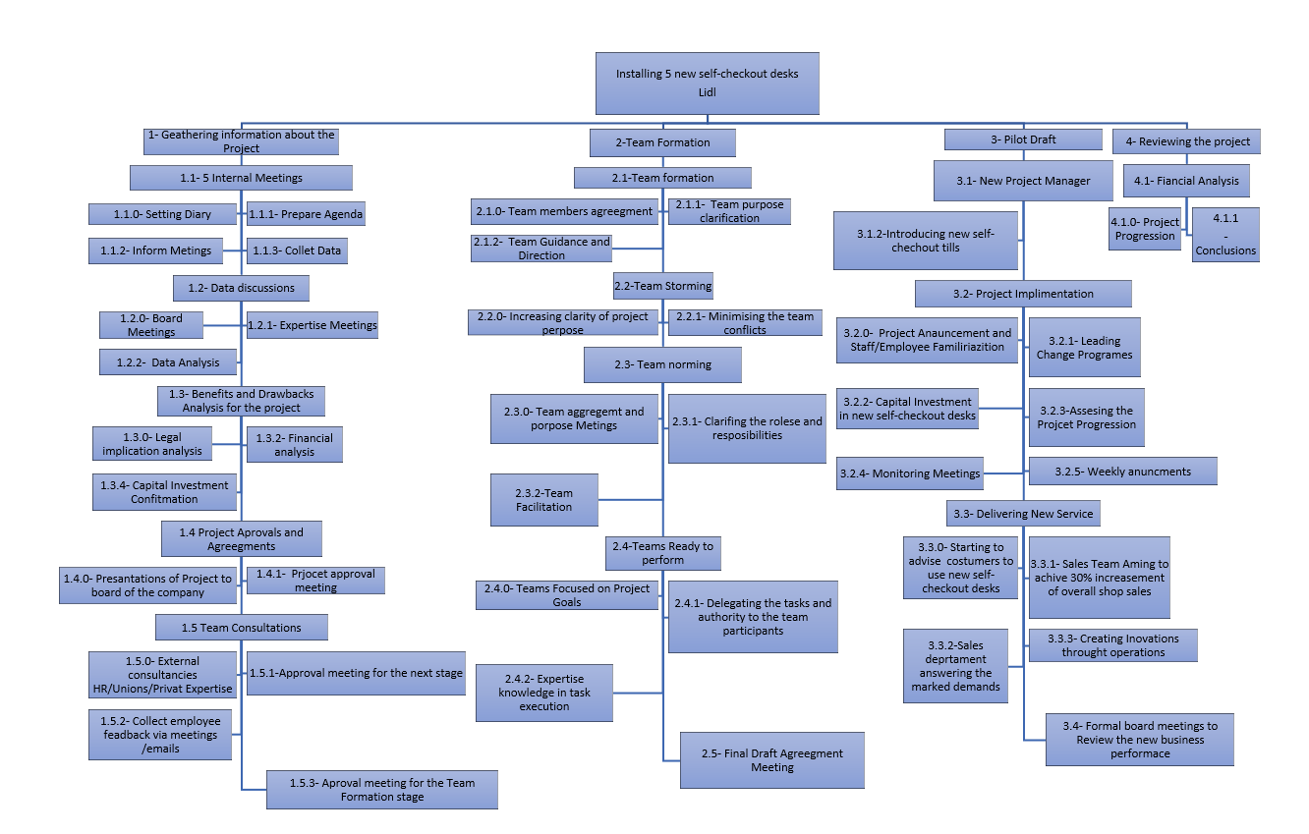
Source: Own. Please note that the charts have been converted in photo format as due to long process cycle the whole document was playing up and create confusion to the reader

Cost

Cost of the project
The cost of the whole project is forecasted to be as below:
5x self-checkout desk @£20000 each = £100,000
Delivery cost = £1250
Installation and Training = £3500
By installing 5 new self-checkout desks Lidl revenue if forecasted to increase by £56000 per year by processing more customers and selling more products.
The investment will be classified as short-term project ( 6 months) and ROI (return on investment) will be as fellow:
ROI =
  Gain from Investment– Cost of Investment
  £224000 -£104750
  Cost of Investment
  £104750

= 90.93%
Investment Gain$95,250.00
ROI90.93%
Annualized ROI13.87%
Investment Length 4.98 years
As it can be seen the outcome of the project and the investment will be returned in 4.98 years.
Note: the above figures are forecasted and might be not accurate – this is only to illustrate the above exercise

Time

The overall project time scale is estimated to be 6 months. 15 days will be required by PM (Project Manager) to identify and prioritize the tasks needed to deliver the project. Another 15 days are required to identify the activities needed to start the project I.e. select the team, identify suppliers and so on. 25 days are needed to select the project and train the team allocated to the project. It will take another 25 days to complete the work breakdown structure and assure that the project is split in small task where the goals for each task are SMART (Specific, Measurable, Achievable, relevant and Timely). This process takes more time compared with other tasks as it must be well detailed, and no mistake are to be made. Costs and budgeting are another important part of the project where 10 days are required to estimate and forecast all related costs to the project include here overtime, downtime and unforeseen events. Human resources will need some time to identify and assess the right employees to be associated to the project. Selective interviews and assessments are to be carried out to find the right candidate for the right task. Moreover, risk assessment is one of the most important factors in delivering successful project. It will take 15 working days to assess and identify risks associated with the project and identify mitigation controls to assure smooth run of the project. Testing, quality assurance, trials and completion of pipework will take 30 working days as this is the final stage where the project will be handover to the store manager ready to deliver its new service.

Human resources
Human resource has used their analysis and expertise to assist the project by providing the right candidate for the right role in the project. Also, HR in cooperation with the self-checkout desk manufacture arranged the training for the individuals that were associated to the project. A work shop war introduced and run by this department and wide range of stakeholders were invited to give their opinions on the project. In post it notes they had the chance to engage with the company by writing down their expectation from the project. £5 voucher was given to the participants to motivate them attending the workshop. The information provided by stakeholders was then analysed by HR and stakeholder expectation were found and applied to the project. In addition, expectation of the stakeholders showed high influence level to the HR department as they recommended the PM to make changes on PMP in order to satisfy their needs. For example, one of the participants raised to the company that elderly people won’t be comfortable with new technology advancements and how Lidl will keep them satisfied. In order to address this, HR recommended that sales assistant personnel will be deployed to assist this category of people if they decide to use self-checkout desks. This will lead to stakeholder power being high and organisation need to respond and satisfy their needs.

Risk
Project risk assessment plays a crucial role in successful project delivery and implementation. The table below will show the risk associated to the project and mitigation controls in place to reduce the likelihood and prevent them from happening.
Table 1.2
1. Identify the Risks |  | 2. Who might be risked and how? | 3. Evaluate the Risk with current Controls in place. | Risk Rating |  |  | 4. Record of Finding and Further Action
 |  | 2. Who might be risked and how? | 3. Evaluate the Risk with current Controls in place. | Likely-hood | Impact | Total | Action to reduce risk | Date Action  to be  completed | Date  Complete
 | Overall Project Failure | Organisation  Employees  Customers | Risk assessment completed, employees and project team trained. Project team selected and filtered by Human resource department | Low | High | High | Project manager to monitor closely for all the duration of the project implementation. Risk register to be reviewed in weekly bases to see for any new findings. Project progression briefings in daily bases to assure the project team is in the loop. | 14/06/2020 | 14/06/2020
 | Equipment failure | Organisation  Employees  Customers | Equipment tested by the hire company. Equipment checked prior to use. Competent operator. Equipment PAT tested for any electrical fault. Installation certificate provided | Low | High | High | Supplier will provide delivery and installation of the system. Test certificates to be issued and quality assurance manager to assure that new system fulfils company compliance and standards. Fixed wiring and RCD test to be carried out a certificate to be provided | 14/06/2020 | 14/06/2020
 | Lack of training knowledge. | Organisation  Employees  Customers | All personnel are to be competent on Safe System of Work and trained in the usage of self-checkout desks. Help support though phone line from the supplier for any unknow error/fault | Low | Low | Low
 | Project exceeding budgeting cost estimations | Organisation | Budget register will be monitored closely by project manager and budget register will be updated in weekly bases. Overtime to be strictly prohibited. Work breakdown structure will be monored closely so each task will be completed on time | Low | Low | Low
 | Customer discarding new technological self-checkout desks | Organisation  Employees  Customers | Customer survey carried out and collected data analysed showing that customers consider the self-checkout tills as added value to the service and que wait time efficient. Dedicated peroneal to assist during transition period. Maned check-out tills available as alternative | Low | Low | Low
 | Accidents / incidents in work place | Suppliers  Employees  Customers  Contractors | All peroneal is competent and possessed competency certificates. Safe system of work documentation provided and signed by employees, contractors and suppliers. Demarcated working area and safety signs displayed. Shop floor inductions and safety briefings carried out to all project related personnel | Low | Low | Low

Communication

Another important factor in delivering a successful project is the communication to the stakeholders. 30 days before the project commencement a project communications plan will be introduced. The plan consists in the strategy to identify the appropriate channels to reach the right audience. In order to achieve this, the project team has prepared a detailed description of the new project and used the following channels to deliver it to stakeholders
- Any information related with stakeholders will be communicated through daily emails and when necessary weekly meetings.
- Weekly newsletters – this was handed to customers and other interested audience from the shop floor and a £5 voucher was included to influence the audience to read and understand the project.
- Social media – pop up advertisements were sponsored to show new service offered by Lidl
- Company website- an article was posted in news section of the official Lidl webpage introducing the new project to the audience
- Videos – in the shop floor tv screens were used to display the project step by step and customer benefits from the new self-checkout desks

Conclusion

Lidl is becoming leader on the food industry as their improved product quality and maintaining low prices. By implementing the above project, the organisation will increase the revenue and improve customer service. The PMP has been prepared using detailed analysis, forecasting and risk assessments to assure that the implementation process will happen as planned. In addition, the above factors as project plan using PRINCE2, time, cost, HR and communication are the key factors to identify-plan-deliver a successful project.
To sum up, PMP is the optimised approach to assure that any organisation plaining to invest, expand, introduce new service/product will achieve expected outcomes i.e. goals, revenue, status in the market and so on. Project monument was found to be very beneficial to expand my understanding and knowledge in the field.

References
Franklin, T. (2006) Consumers on Pace to Spend $475 Billion at Self-Service Kiosks This Year, Says New Report From IHL Consulting Group [Online]. Available at: https://www.businesswire.com/news/home/20060627005079/en/Consumers-Pace-Spend-475-Billion-Self-Service-Kiosks [Accessed 26 December 2019].
Lidl uk (2018). Modern Slavery Statement 2017/18 [Online]. Available at: https://corporate.lidl.co.uk › content › download › fileupload › Lidl_UK_ [Accessed 23 December 2019].

