Student Name: | Mohammedumar Saiyed
Name of University: | University of Wales Trinity Saint David
Programme of Study: | MBA - International business
Research Title: | How Brexit affected supply chain management in the UK automotive industry
Supervisor: | Dennis Pepple

DECLARATATION
I, Mohammedumar Saiyed declare that this dissertation has been composed by myself, that the work contained herein is entirely my own except where explicitly stated otherwise in the text, and that this work has not been submitted for any other degree or qualification, in whole or in part, except as specified.

Signature: Mohammedumar saiyed
Date: 28/08/2024

Acknowledgement
I would like to thank my supervisor Dennis pepple for their consistent support and guidance during the running of this dissertation project. Furthermore I would like to thank our programme manager Mr.Vasilios Tavlaridis for his collaborative effort. I would also like to acknowledge our University of wales Trinity Saint David for their participation and engagement in the study.

HOW BREXIT AFFECTED SUPPLY CHAIN MANAGEMENT IN THE UK AUTOMOTIVE INDUSTRY

Abstract
The study has revealed how the UK regulation post Brexit creates challenges for managing the supply chain of automobile companies. After researching the background information about the UK automotive industry, the study has outlined research objectives, questions and research significance. The study is based on how Brexit has affected the supply chain disruptions in the UK. In addition to that the research on the topic has been provided while identifying the deeper role of Brexit within the supply chain management along with its impact and the challenges which are being quoted within this chapter. Hence the chapter includes the various theories on managing resilience as well as looking into supply chain disruptions. The purpose of this study is to evaluate the consequences of Brexit on British automotive supply chain networks. The study adopts an interpretivist philosophy to establish theories on supply chain disruption. In addition, the deductive research approach is considered to support the chosen philosophy along with the aim of the project. Data is collected by the use of secondary research sources and the themes are analysed through thematic analysis. Thus, this approach guarantees comprehensiveness and contextualisation of Brexit consequences while simultaneously taking into account ethical and methodological issues. From this research study, it has been identified that Brexit is one of the major causes for disrupting the supply chain management of the Automobile industry. On a similar note, due to this, automobile firms face significant issues regarding the availability of the raw materials and manufacturing process which hinder the profitability growth of the business and decline the productivity of the firm as well. However, to mitigate the issue, the management team of the organisation integrated an effective strategic approach which enhanced the performance of the firm as well. This paper aims at discussing diverse effects of Brexit on the UK automobile industry. There is evidence that higher tariffs and customs inspections can entail higher costs and later delivery of imported car parts, affecting just-in-time supply. The pool of human capital in relation to demand has been critically low with probably a 15% shortage of skilled workers that influence both quality of goods produced and pricing. Other consequences are increased cost of imports because of devaluation of currency and increased compliance costs. Brexit has brought about regulatory issues that have affected the operations and caused a lot of time consumption. Also, an altered and strained relationship with suppliers and new supply strategies have also appeared. To these, the automotive manufacturers are resorting to developing local talent, seeking other suppliers and building inventory to counter these hurdles. The results and discussion chapter revealed how employees and labourers faced major setbacks due to a supply chain disruption. The restriction of employee mobility between the UK and EU results in poor supplier relations in UK automotive business and higher tariff rates. From the research study, it has been identified that to manage the supply chain management system in the automobile industry, the leadership group of the companies can create a strong trade relationship with other suppliers which will help to avoid any type of conflicts and manage the entire process in a more efficient manner. On a similar note, organisations can invest a vast amount of money on the supply chain resilience and it will provide the opportunity to the company to avoid any type of disruption and enhance the performance of the business in a more effective manner.

Table of Contents
Chapter 1: Introduction 9
1.1 Research Background 9
1.2 Research Aim 10
1.3 Research Objectives 10
1.4 Research questions 10
1.5 Research Rationale 10
1.6 Research Significance 11
1.7 Structure of the dissertation 12
1.8 Summary 13
Chapter 2: Literature Review 14
2.1 Introduction 14
2.2 Research Areas / Topics 14
2.2.1 “Brexit and its role in supply chain management” 14
2.2.2 “Impact of Brexit on managing supply chain management in the UK automotive sector” 17
2.2.3 “Challenges posed by Brexit that hinder the progress of “supply chain management” of the UK automotive sector” 19
2.2.4 “Strategies that can help mitigate the effects of Brexit on the supply chain management of the UK automotive sector” 23
2.3 Theoretical underpinnings 25
2.3.1 Resilience theory 25
2.4 Conceptual Framework 28
2.5 Conclusion 29
Chapter 3: Research Methodology 30
3.1 Introduction 30
3.2 Research Onion 31
3.3 Research Philosophy 31
3.4 Research approach 32
3.5 Research design 33
3.6 Data collection method 34
3.7 Data analysis 35
3.8 Inclusion and Exclusion 36
3.9 Research Ethics 38
3.10 Research Limitations 38
3.11 Summary 39
Chapter 4: Findings/ Results, Analyses and Discussion 40
4.1 Introduction 40
4.2 Presentation of Findings 40
Table 4.1: Thematic analysis 71
4.3 Analyses of Results 71
4.4 Discussion of results 75
Chapter 5: Conclusion and Recommendation 76
5.1 Conclusion 76
5.2 Linking with Objectives 76
5.3 Recommendation 78
5.4 Limitations of the Research 79
5.5 Future scope of the research 79
References 80

List of tables

Table 3.1: Inclusion and exclusion criteria 38
Table 4.1: Thematic analysis 70

List of figures
Figure 1.1: Structure of the Dissertation 13
Figure 2.1: Supply Chain Preparation of retail business after Brexit 15
Figure 2.2: EU importance on UK car industry 16
Figure 2.3: No-Deal Brexit on UK automotive industry 19
Figure 2.4: Financial Investment Failure post Brexit 21
Figure 2.5: Passenger Car Manufacturing in UK 22
Figure 2.3.1: “Organisational Resilience System.” 26
Figure 3.1: Research Onion 31
Figure 4.1: UK trade in goods with EU and non-EU countries 73
Figure 4.2: Goods and services balances in the UK 73

Chapter 1: Introduction

1.1 Research Background
The initial section of the research provides the background of the study and gives the contexts while surrounding the topic. In addition to that the research background eventually explains to the readers where the journey of the research has been started as well as how one would develop the research questions that would be specified in the later part of this section. Thus the research deals with the effects of the Brexit decision mainly on the automotive sector within the UK. Additionally, the research has also focused on how the “UK supply chains have been affected” by the post-Brexit scenes. Moradlou et al. (2021), have conveyed that the supply chain disruptions could be natural as well as political disputes. The Brexit referendum results in the year 2016 have left uncertainty mainly for the economies around the world over the relationship of the EU-UK. Besides that, the Brexit impact has been reflected in the economies within their supply chains. Hence the disruptions within the supply chain disruptions can emphisely affect the performance of the organisation. In addition to that it has been displayed that 48% of the citizens have voted for remaining in the United Kingdom whereas 52% have voted for leaving the EU (Jucyte et al.,2021). The Brexit-related risks can thereby explain the impact on the performance of the supply chain.
Various supply chain risks based on the context of Brexit include the “stock price depreciation” as the financial risks can cause losses through the debts, rate of exchange as well as loss of the investors. Thus the financial risks can limit the capital resources as well as contract the supply chain activities. Other factors include “Relocation of Investment, Barrier to Immigrate and Barrier to Trade”. In addition to that, there have been changes within the immigration policies after Brexit which might have impacted the validity of the labourers who are quite skilled within the manufacturing sector thus affecting the downstream activities. Serohi, (2020) have also conveyed that the British automotive industry has its advantages along with the economic downfall. It has also been viewed that the production of the cars in the year 2012 was 1.58 million which is an increment while compared to 2011 thus there is the benefit but again 2013 the British cars reached 1.6 million units. Besides that, the Brexit uncertainty has led to the depreciation of the stock prices along with the potential revolution of the investments thus impacting the financial aspects of the supply chain performance along with the investments in quality improvements.

1.2 Research Aim
“This research aims to understand the effects of Brexit on the supply chain management of the UK automotive industry”

1.3 Research Objectives
- “To address the impact of Brexit in managing supply chain management in the UK automotive sector”
- “To elucidate the challenges posed by Brexit that hinder the progress of supply chain management of the UK automotive sector”
- “To highlight strategies that can help mitigate the effects of Brexit on the supply chain management of the UK automotive sector”

1.4 Research questions
- “What is the impact of Brexit on supply chain management in the UK automotive sector?”
- “What are the challenges faced by Brexit that have affected the supply chain management in the UK automotive industry?”
- “What are the strategies that can help mitigate the effects of Brexit on the supply chain management of the UK automotive sector?”

1.5 Research Rationale
This research revolves basically around the impact of Brexit on the UK automotive supply chain. The issues which have been identified are the “delays, red tape, and new supplier challenges post-TCA 2021” (Freeman et al., 2022). Besides that, almost 30% of the revenue has been lost during the past 12 months thus having an average drop of 18%. Also according to the UK supply chain, 31% of the supply chain disruptions have occurred (Kaloyanova, 2023). Hence this has affected the supply chain costs while leading to higher expenses that are related to inventory storage as well as other cross-border operations along with the labour crisis. There has been a negative impact on the transport as well as the warehousing sector with the reduction of the “128,000 EU workers”, a 3% downfall within the retail sector, 4% in the hospitality and food sector along with a 2% downfall in the manufacturing sectors (Kaloyanova, 2023). The issues are the cost of hiring skilled labourers from the European Union has increased as long as the cost of the training has also increased. Thus the freedom of the labourers has led to dreadful changes in the labour market within the UK. In addition to that the companies have also started to increase the inventory within the UK despite having the higher cost of renting warehouse spaces. Hence these costs along with the higher cost of the export can thereby lead to higher production prices.
These companies need to be more competitive in order to survive, thus it would be challenging for the small business as they do not have such huge margins along with a limited number of staff. Additionally, these issues can impact current as can affect operational efficiency, along with that these factors not only can affect the individual business as well as broader the implications for the company while including inflation pressures, economic growth and the confidence of the customers. There are certain actions which can be done in order to overcome the issues. Thus it includes “Government Policy and Support” as the Government could work in order to streamline the customs procedures as well as reduction of the bureaucratic red tape that has risen due to the post-Brexit situation. In addition to that “Labour Market Policies” can help to address the labour shortages that might involve targeted immigration policies in order to attract the workers in the sectors which are facing the shortages. The “Financial Support” can help to stabilise the business operations along with supporting the recovery loss. Also, several other actions like “Supply Chain Resilience”, adoption of innovative technologies, investing in training and developments along with providence of flexible working strategies can help to mitigate the issues.

1.6 Research Significance
The research is quite significant for the future as it would help the raiders to understand the effective strategies in order to help them out if the same scenario occurs in the future. In addition to that they could have a detailed idea regarding the issues that have affected the supply chain of the UK along with the facts in order to learn about effective strategies which would help them to save time before taking the actions. Hudson (2022), has conveyed that the trade deal between the EU as well as the UK is the form of the political-economic context in order to pursue political commitments. Besides that, research would also help to understand the effect of the decisions on the automotive industry in the UK. Additionally, the challenges mentioned along with the elements that would help to reduce or elevate them have been mentioned before. Besides that, these findings can help to inform most of the policymakers about the particular impacts of the Brexit supply chains as well as help to explain the broader economy. Hence this knowledge is quite crucial for refining the policies that are related to the trade immigrants as well as the labour markers along with the industrial strategy thus it highlights the need for the adoption of effective policies which can help to enhance the supply chain reliance as well as mitigate the economic shocks. Tuli and Vadiyala, (2022) have mentioned that the resilience, as well as adaptation strategies which are employed by the stakeholders, can help to mitigate the impact of the issues while promoting effective practices. Thus the business within the automotive sector as well as beyond the challenges posed by Brexit offers critical lessons in the adoption of resilience-building strategies. In addition to that the insights into the strategies that did not work out can help the organisations to prepare for future disruptions while adjusting for the supply chain strategies along with investing within technologies as well as practices that would eventually help to promote operational flexibility and efficiency. Besides that, the research covers the broader economic implications along with that it gives the global interconnectedness of the supply chains thus the research provides a case study on how the regional political decisions can reverberate across the international trade networks.

1.7 Structure of the dissertation

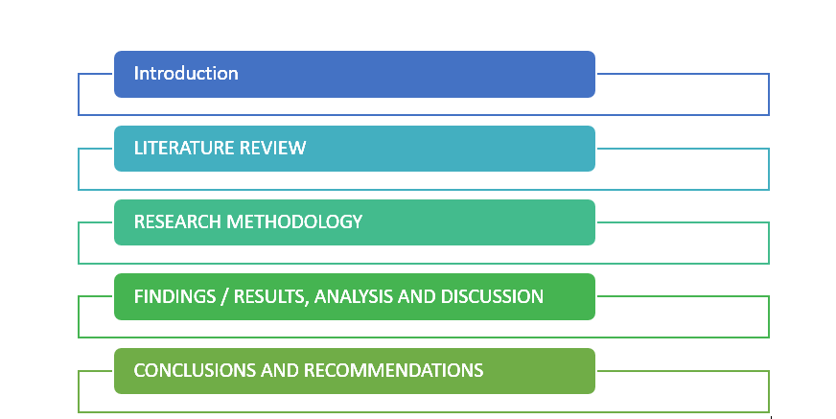

Figure 1.1: Structure of the Dissertation
(Source: Self-created)

1.8 Summary
The Introduction chapter has provided the varied impacts of the supply chains of the UK as well as the challenges faced by them. Hence within the research background, the effects are mentioned along with the significance of the research. Besides that, the chapter has provided the research objectives and the research questions which are based on the impact of the UK supply chains along with the post-Brexit scenarios. Additionally, the Research Rationale has provided the issues as well as the effective strategies that would help to mitigate the issues. Finally, the research significance has mentioned the benefits of the research for the future. The next chapter broadly evaluates the research objectives which have been provided in this chapter.

Chapter 2: Literature Review

2.1 Introduction
Literature review deals with reviewing various scholarly articles and journals within the context of the topic. Hence, the aim of this chapter is to review various articles and journals accessed from relevant sources in order to determine and analyse their underpinnings with the research areas. The research areas here are entirely based on the research objectives which are “Brexit and its role in supply chain management”, “Impact of Brexit on managing supply chain management in the UK automotive sector”, “Challenges posed by Brexit that hinder the progress of “supply chain management” of the UK automotive sector” and “Strategies that can help mitigate the effects of Brexit on the supply chain management of the UK automotive sector”. Apart from reviewing the research areas, this chapter will also review three different theories followed by preparing a conceptual framework.

2.2 Research Areas / Topics

2.2.1 “Brexit and its role in supply chain management”
Brexit refers to the withdrawal of the United Kingdom (UK) from the European Union (EU). The term Brexit is a combination of two words “Britain” and “Exit” (Business Standard, 2024). As per the suggested name, it can be interpreted that this can be referred to as the separation of the UK from the EU. This separation has significantly impacted the UK because, for Britain, Europe is the most important source of foreign investment along with that its membership with the EU has also significantly helped London implant its position as a financial centre across the globe. During the initial stages of Brexit, it was also estimated that this separation would impose a major threat on businesses as it would reduce the country’s economy by 4 - 9% as per the estimates of the government (Business Standard, 2024).
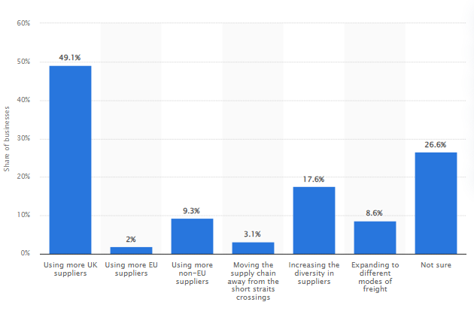

Figure 2.1: Supply Chain Preparation of retail business after Brexit
(Source: Smith, 2022)
The United Kingdom (UK) withdrew its membership from the European Union On the 31st of January 2020. Along with that as per the withdrawal agreement, a transitional period between the UK and the EU continued to the 31st of December 2020 as applied by the EU law (Commission Europa, 2024). As the UK had out of the singles and customs union during the fiscal year 2021 the companies that were associated or had traded with the EU were encountered with new rules, new checks and new paperwork on some of its goods. Hence, this withdrawal had initiated fear over what was going to happen to the “£550 billion” worth of trade between the UK and its nearest trading partner (BBC, 2023). As per the underpinnings of Basu (2023), the supply chain has been significantly impacted due to various geopolitical shifts. The author has also opined that due to Brexit and nationalism, the supply chain has been immensely pressurised resulting in increasing red tape apart from that the economic and business environment have also drastically become more demanding due to these geopolitical shifts. Along with that, it can also be identified that Brexit has mostly disrupted the supply chain of the UK and can be interpreted as the supply chain disruptor. This is because of the primary delays and red tape that were followed by the Trade and Cooperation Agreement (TCA), 2021 which significantly affected most of the businesses to find new suppliers in order to re-establish their supply chain. Hence, it can be determined that these geopolitical shifts then eventually result in creating issues that significantly affect the supply chain across the globe.
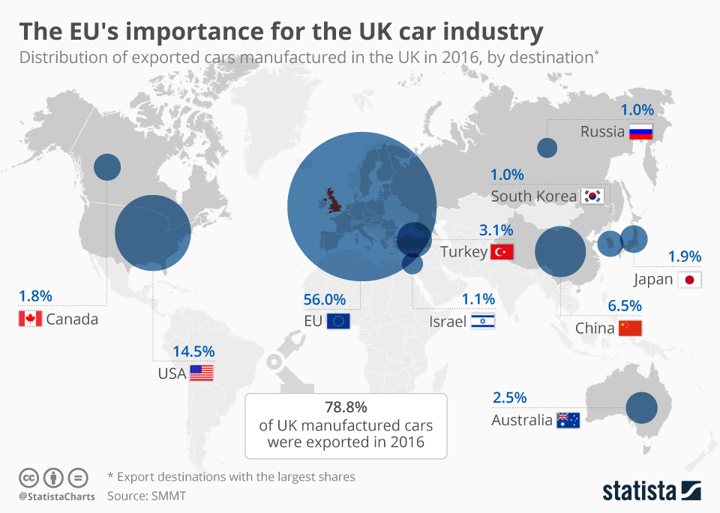

Figure 2.2: EU importance on UK car industry
(Source: Armstrong, 2018)
As per the underpinnings of Jucyte et al. (2021), the impact of Brexit on the economies can be interpreted as a major factor affecting supply chains. This also means that due to this effect, the competitive advantage can also be deteriorated or damaged because of uncertainties and issues in the operational performance of the companies. Hence, this disruption in the networks of supply chain will eventually also impact and affect the performance of the company significantly. Apart from that it also complexes the management of the network among the suppliers and customers in order to ensure a better supply chain. While as per the underpinnings of Moradlou et al. (2022), Brexit has also impacted the supply chain of the manufacturing sector in the UK which resulted in the manufacturing sector being transformed and re-evaluate its global supply chain in order to minimise or mitigate the disruptions caused by Brexit.
As per the underpinnings of Moradlou et al. (2021), the major disruption risk associated with the supply chain can be classified into two categories the first category of risk is the risk that arises due to the issues related to coordinating the demand and supply while on the contrary the other categories of risk are categorised as the risk that rises due to the disruption of normal operations. Hence, it can be stated that as per the underpinnings of the authors, geopolitical disruptions act as a driving force for relocating the distribution and manufacturing facilities which receive limited attention in the context of supply chain and operations. Along with that to support the above underpinnings of the authors related to the impact of geopolitical shifts, Hendry et al. (2019) have also stated that the shifts in geopolitical events in real-time affect each and every aspect of the supply chain that ranges from the positioning the assets of the supply chain, the flows of information and material, accessibility of suppliers and availability of human resources. While on the other hand, according to Roscoe et al. (2020), Brexit has also significantly impacted the pharmaceutical industry of the UK due to uncertainties caused by this geopolitical shift between the EU and the UK within the supply chain of the pharmaceutical industry. Therefore, it can be stated that as power the above underpinnings and various perspectives, it can be determined that Brexit has significantly impacted the supply chain not only within the UK but also affecting the global supply chain.

2.2.2 “Impact of Brexit on managing supply chain management in the UK automotive sector”
Brexit has majorly impacted most of the businesses in the UK within the context of managing its supply chain operations. This is because post-Brexit the UK businesses faced various challenges and difficulties due to the increase of “red tape, bureaucracy and costs” along with causing issues with transportation and shipping. Apart from this Brexit has also impacted the increase of both product shortages along with increasing prices for the public of the UK. According to Bailey et al. (2022), Brexit have always mentioned that businesses in the UK had four years in order to prepare for the separation between the UK and EU in a sense that the basic objective of the minimal FTA (free trade agreement) which only eliminates the tariffs on the trade between the EU and the UK which is an evident factor. Along with various other uncertainties taking place within the UK economy due to Brexit, the automotive industry was also one of those businesses that were impacted or affected by Brexit. This is because the assemblers of the automotive industry had to shut down their productions on various occasions due to different Brexit deadlines due to the concerns of what a “No Deal” scenario would mean for the components of supply and it’s Just in Time systems. Automobile assemblers including Jaguar Land Rover, Toyota and BMW also had to shut down their automobile assembly operations between the time period of April 2019 to October 2019 in order to avoid any disruption during the time of scheduled departure of the UK from the EU. Along with that, the chief executive of Jaguar Land Rover also stated that the company has no choice but to share its production lines in the UK across its four production plants. This is because as per the chief of the company, they required almost 20 million parts each day followed by which they also stated that they require the parts whenever required and within the given time period. Therefore, as per the authors, it can be illustrated that Brexit had majorly affected the Just in Time (JIT) supply chains as it had the potential to delay and disrupt the supply chain. The authors have also opined that the no-deal Brexit by the end of 2021 was also viewed as a potential disruptor by the automotive assemblers toward the JIT systems that were mostly used across the EU and the UK manufacturing. Apart from that, the author has also opined that amidst the uncertainties caused because of Brexit, the investments in the automotive industry in particular had to stroll over the nature of the relationship with the EU in the future from 2016 to the end of 2021. Hence, this had then specifically impacted on widening the shifts within the automotive industry towards electrification which eventually impacted the UK since the country had to moss out various potential investment opportunities related to new technologies during the Brexit uncertainty.
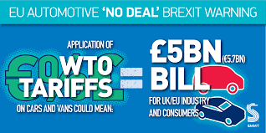

Figure 2.3: No-Deal Brexit on UK automotive industry
(Source:Smmt, 2019)
As per the underpinnings of Li et al. (2019), it can be evaluated that the authors also support the above underpinnings as they mentioned about the uncertainties around the UK related to its future investment endeavours. On the contrary, according to Serohi (2020), the current British automotive industry has various benefits within various economic situations apart from that the author has also opined that the automotive industry across the globe is on the verge of entering a period of revolutionary and comprehensive transformation which will significantly result in boosting the sales in favour of the automotive industry. Along with this, the author has also mentioned the impact of Brexit on rewriting the fate of the British automotive industry as major companies within the automotive industry like Nissan had announced withdrawing their investment plans amidst Brexit while Honda had announced closing its plant in Swindon while BMW mini had also suspended it production for almost 30 days and Jaguar Land Rover, on the other hand, had laid off its staff significantly all during the Brexit.
According to Bailey et al. (2023), Brexit can be referred to as a “disruptive procedure” within the manufacturing operations and the logistics within the automotive industry. This was majorly due to the need of the automotive industry to re-orientate towards electrification in order to provide renewed urgency to reconsider the industrial policy during the spatial terms. Hence., it can be determined that as per the underpinnings of the author Brexit had majorly impacted the West Midlands and East Midlands regions of the UK as it provided an opportunity to explore the issues in detail. According to Alicke and Strigel, (2020), as out of 54 accounting percentage of imports and 49 per cent of exports the EU is one of the most important trade partners for the UK and Brexit significantly impacted international trade flows which significantly impacted the automotive industry of the country increasing its cost and tariffs throughout its supply chain.

2.2.3 “Challenges posed by Brexit that hinder the progress of “supply chain management” of the UK automotive sector”
As opined by Jucyte et al. (2021), the results of the Brexit referendum have left uncertainty for the economies around the world. In addition to that in 2020 both the UK and EU struck a provisional trade agreement which would help to ensure both sides of the trade without facing the traffic. Thus disruptions within the supply chain can thereby affect the performance of the organisations. However, in order to manage the complex networks of the suppliers as well as to ensure a better “supply chain performance” the manager of the organisation plays an important role in order to mitigate those risks. The default risks on the stock market of the UK are identified and have been found to increase the default risks while decreasing the stock market returns. Escaith et al. (2020), have conveyed that the global value chains have been involved in the production where the output of the organisation is used by any other country in order to produce the product. In addition to that UK has continued to attract FDI inflows along with that the decrease in stock prices has thereby impacted the opportunities for future investments.
Besides that, the UK is being dependent on the FDI, thus distinguishing the low corporation taxes as well as the low wages tax along with accounts for 43% of the total FDI from the EU. Thus the policies of Brexit have forced to put pressure on the investment funds thus pushing them to relocate their business out of the country. Furthermore, the negotiations among the UK and EU27 might have led to free trade agreements but as long as there is no compromise within the trade agreement the barrier to trading is the most crucial risk due to the higher uncertainty as well as the simulation of many other risks. Roscoe et al. (2020), have conveyed that firms need to formulate effective strategies in order to manage the uncertainty of the supply chain risks along with the utilisation of the tangible for mitigating the supply chain risks. Besides the connection among the immigration of the labourers who are skilled as well as the investment flows have been associated with the barrier to immigration along with the other risks which include “investment relocation, stock price, depreciation”, as well as a barrier to trade. Thus the immigration policy is one of the reasons for the resulting depreciation within prices. In addition to that the varied political conditions could have led to the fall in the number of immigrants thus identifying the decrement in the workforce. The solid connection between the risks as well as the performance within the supply chain has been identified which has helped to suggest the risks while having the consequences in order to perform at a global scale. Additionally, the leaving of the EU’s market as well as the customs Unions for the manufacturing sectors of the UK has meant no free access to the trade between the EU and the UK, thus resulting in the “Long Custom Procedures”.
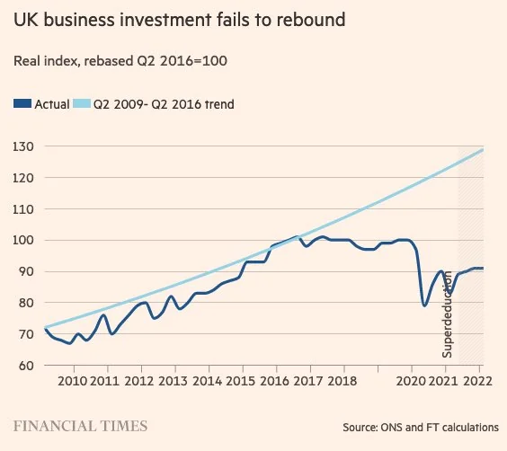

Figure 2.4: Financial Investment Failure post Brexit
(Source: Reddit, 2022)
Roscoe et al. (2022), have conveyed that the managerial supply chain is being constrained by the three environmental conditions which include “the perceived intensity of institutional pressures and the relative mobility of suppliers and supply chain assets”. Additionally, the decision of the UK in order to leave the EU has led to anxiety as well as uncertainty among the UK-based manufacturers. Besides, the automotive industry has been particularly vocal in this regard as the varied automobile companies are giving warnings of the threats in order to continue their viability in the event of Brexit. The UK is the global manufacturer in the automobile industry thus these challenges have significantly impacted the economy of the country. Also, the EU remains the “single largest destination” mainly for the manufacturing of vehicles thus accounting for more than 50% of vehicle exports. Thus within this situation, the UK has served the flexible work environment within the EU while serving as the platform for production thus the prospect of Brexit poses challenges for the industry which is being dominated by techniques like “Just-in-time” ("Lean").
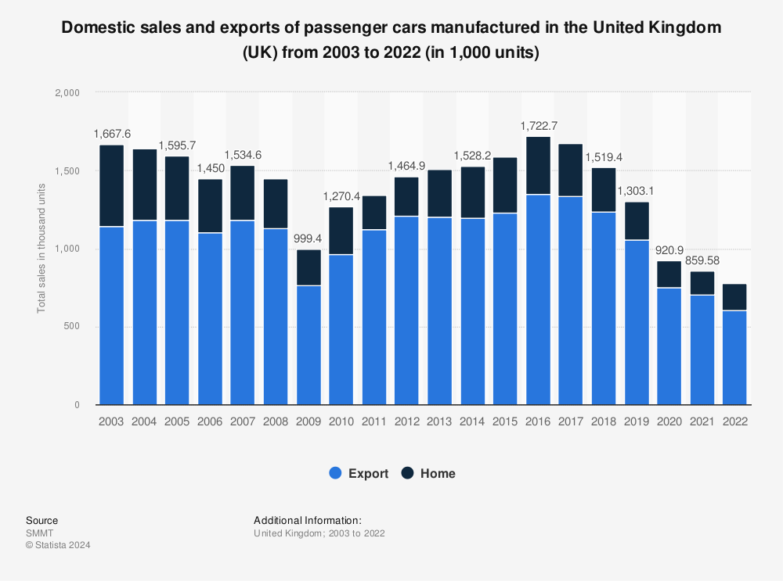

Figure 2.5: Passenger Car Manufacturing in UK
(Source: Carlier, 2023)
Burugu and Owoeye (2024), have also mentioned that supply chain management is being utilised by the market ladders of the automobile industry in order to stand out of the competition while adapting the ability to respond in order to change the market conditions by providing the end-end customer solutions. In addition to that the UK automotive sector competes with the other major automotive producers globally. As it is known that the UK is the 13 largest producer as well as the in Europe thus countries like Germany would have a larger market share as well as revenue. Hence the compound annual growth rate (CARG) of the automotive sector has outperformed France but it has lagged behind Germany thus indicating the need in order to boost competitiveness. Besides that, the sector is highly dominated by the larger players which collectively accounted for two-thirds of the production. Thus this concentration has made the industry quite vulnerable in order to make the decisions which are made by the major manufacturers while including the potential resources or downsizing. In addition to that, there has been an imbalance in trade as well as export reliance as the automotive industry is highly export-dependent with 80% production.

2.2.4 “Strategies that can help mitigate the effects of Brexit on the supply chain management of the UK automotive sector”
To mitigate “the effects of Brexit on the supply chain management of the UK automotive sector” several strategies can be employed in order to address the various challenges which are being highlighted. Johnson and Haug, (2021) have conveyed that several short-term strategies were taken in order to build the inventory from the tariffs as well as long-term proactive techniques like shifting as well as expanding the suppliers along with the manufacturing locations. Thus due to the emergence of several trade disruptors several disruption mitigation strategies can be included. The objective is to reduce the dependency on the EU suppliers as well as to avoid disruptions from the customs procedures or the barriers of trading. Thus the approach needed is to identify as well as to develop relationships with the alternative suppliers both within and outside the EU. This can thereby help to ensure continuity as well as the reduction of the risks that are associated with any of the single source or region. Besides that, the supply chain disruptions entail more than the presence of multiple suppliers along with that it ensures that the suppliers offer more as well as interchangeable products thus maintaining the competitive benefits which are exclusive. In addition to that it would be useful for the UK to include supply chain diversification as it would help to build innovative capabilities in order to adapt to the changing conditions. Thus it would provide the opportunity for the analysis of the metrics in order to arrive at the most sense of the business.
Investment in Supply Chain Resilience can be included in order to enhance the ability to respond to supply chain disruptions as well as uncertainties thus the approach which can be utilised is the building of flexibility into the supply chains by creating buffer stocks as well as developing the contingency theory along with that adopting more robust inventory practices. Hence it can include the movement from the “Just-In-Time” model (JIT) to the “Just-in-case” (JIC) model which would be feasible. Kamalahmadi et al. (2022) have stated some of the key aspects of the investment in supply chain resilience. Besides that, it has been identified that with the implementation of such a model can help to decrease the total cost of the organisation by 5.51% hence it displays the planning as well as the investment within the proactive demand management which could thereby help the organisation to decrease the cost by 7.87%. Strengthening Relationships mainly with Key Partners can help to improve communication as well as coordination with the suppliers and partners is quite essential. Thus the approach which can be adopted is the fostering of close ties with the suppliers can help to share information about the potential risks and work together in order to find the solutions.
Alkaraan et al. (2023), have conveyed that the companies would have enormous opportunities in order to revisit the business model as well as the “strategic business investment decision-making processes” for the enhancement of visibility as well as to make the decisions within the supply chain. Thus leveraging technology and data analytics can be utilised by the UK. Additionally, Rehman et al. (2022), have also mentioned that big data analytics has been revolutionised in order to provide better opportunities within the automobile industry. Also, big data involves the techniques as well as the procedures for the creation, manipulation as well as formulation of the larger data sets while facilitating the offering for its storage. Hence the implementation of real-time technologies like big data, real-time tracking systems as well as artificial intelligence can thereby help to monitor supply chain performance, predict disruptions and optimisation of logistics.
As opined by Marouf (2024), several risk management strategies within global supply chains can help to review the effectiveness and efficiency of the varied approaches. Exploring within the innovative markets can help to reduce the reliance on the EU market as well as open innovative revenue streams. Thus the approach which can be utilised is the investigation along with entering into new markets outside the EU can help to diversify the export destinations and thus it can help to balance the impact of the reduced EU market access. Besides that, the challenges have been addressed related to the skilled labour shortages mainly due to the changes in the in migration policies thus it is essential to invest in varied training and development programs, especially for the existing employees along with alternative labour sources that can be arranged in order to maintain the process of the firms as well as to compensate the potential labour shortages.

2.3 Theoretical underpinnings

2.3.1 Resilience theory
Resilience theory is a procedure of navigating various challenges and difficulties in order to thrive. Hence, it can also be stated that the resilience theory can be interpreted as an idea that surrounds the people who are affected by the challenges or adopt various challenging things such as change, risk, and loss. This theory can be utilised in various fields as it is a strength-based approach that focuses on the inner resources and external supports that eventually contribute towards helping the individuals retrieve from adversity. To support the above statement Kong et al. (2022) have also opined that Resilience is an important frontier theory that contributes towards providing a systemic framework for resolving various issues and enhancing disaster resilience. Hence, the resilience theory can also be interpreted as the ability of a system to adapt, persist and transform itself when the situation requires. However, the theory of resilience might be a concept which has the potential to be both intimidating and appealing because of its necessities within multidisciplinary and coherent explanation. Therefore, during recent times the term resilience has become visible and can be utilised within the context of various fields of knowledge. As per the underpinnings of Negri et al. (2021), sustainability within the supply chain has gained an increased amount of attention over the last few years due to its stringent regulations, consumer pressurisation, and intense competition. Hence, the author has stated that both resilience and sustainability play an important role in the supply chain. This is because within the context of the supply chain resilience can be determined through various aspects as it is the fundamental capability of the firm. Apart from that the authors have also stated that resilience in the supply chain plays an important role as it takes a major part in risk management within the supply chain from various adverse events. As per the underpinnings of Razak et al. (2023), supply chain resilience (SCRs) can be referred as an operational capability which enables the firms to prepare for, respond to and recover from any crisis in order to return to its normal capacity of operations and if possible then to even a better capacity of business operations. followed by this the authors have also opined that there are various benefits which have been identified as the dominant enablers of resilience which are velocity, collaboration, flexibility and visibility. Hence, it can be stated that SCRs is the ability possessed by an organisation of a business entity which allows them to quickly respond and operate within a crisis or disruptions through accessing flexible contingency planning and forecasting. However, according to Wieland and Durach (2021), resilience within an organisation's supply chain management is not only the ability of their organisation to bounce back from any crisis or disruption but is also the ability of the organisation to adapt to the changes and transform itself. Hence, it can be interpreted that as power the underpinnings of the authors SCRes is about both bouncing back and adapting to the changes caused by the disruption and transforming the business operations accordingly. As per the underpinnings of Adobor (2020), resilience within the supply chain plays an important role as a tool that is utilised for the purpose of managing the risks interrelated to the supply chain along with disruptions. The resilience theory also helps in the procedure of survival, recovery and thriving in the face of misfortune. Hence, the companies and businesses within the automotive industry of the UK can utilise the resilience theory in order to mitigate its risk of disruption and border delays by diversifying the supplier base and establishing multiple routes for transportation while maintaining the stocks of crucial components hence it can be stated that supply chain resilience has emerged over the period of time to become a useful tool for managing the supply chain risks.
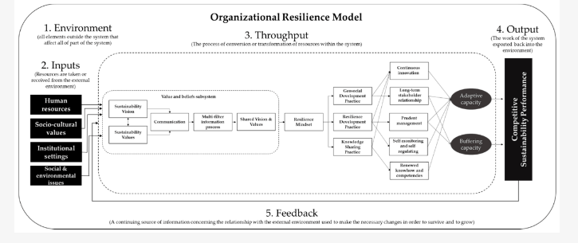

Figure 2.3.1: “Organisational Resilience System.”
(Source: Kantabutra and Ketprapakorn, 2021).
As opined by Shamsuddin (2020), the concept of resilience has helped to capture the imagination which is applied to the cities as well as urban areas. The resilience theory helps to explore the process of the navigation of varied challenges as well as thriving thus it takes the strength-based techniques while emphasising the inner resources along with the external supports that would help the individual to bounce back from the adversity. The author has also discussed that the resilience theory is included across the varied fields of the study, human development along with change management. In addition to that, resilience forces one to pay attention to the positive, individual variables that interpret the trajectories from the issues to the problem behaviours, along with the poor health outcomes. According to Ivanov (2022), supply chain resilience capabilities ensure a firm's capability to withstand and recover from supply chain disruption and maintain business operations in a vulnerable business environment. Resilient supply chain management absorbs negative external disturbances. Resilience theory was built in response to more frequent manmade and natural disasters during the 2000s. The severe supply chain risks such as demand fluctuations, and delayed delivery issues generated a high impact on supply chain performances. The discrete event orientation and review of economic performances within a fixed time horizon is considered as major resilience assessment criteria. Zhao et al. (2023) argued that supply chain resilience capabilities not only build the ability to absorb disruptions but also can quickly respond to better performances after disruption. The concept of SCR is not clear enough because it is linked with appropriate practices and activities. The study has observed how urban lockdowns and changes in the market environment accelerated the process of supply chain disruption during the economic crisis period. A digitally driven supply chain management process mainly works on three arrears such as response capability building, absorptive capability and recovery capability building.
Meerow and Newell, (2021) have conveyed that the policies related to resilience are essential for the implementation of the strategies based on the issues faced. Besides that, the resilience theory focuses on the ability of the systems in order to adapt as well as to discover from the varied disruptions. Thus in response to the Brexit-related disruptions most automotive companies have had to diversify their supply chains while skiing alternatives as well as to increase inventory levels in order to mitigate the risks thus strategic changes are required. Hence organisations need to revaluate the supply chain strategies in order to potentially restore the production or diversify the sources while minimising dependency. Uddin et al. (2022), has measured resilience capabilities of UK firms during demand uncertainties caused by Brexit. The author has observed how demand volatility created major risks for manufacturing firms since the industrial production fell between 3.0% and 4.0% in Europe. The earlier economic shocks caused by the economic crisis increased uncertainties in the UK. Therefore, resilience theory application helps to build better recovery capabilities among UK who were dealing with demand uncertainty issues during Brexit. Qamar et al. (2023) explored how the recent encounter of COVID-19 related economic disruption explored the attention to resilience theory application in automotive supply chain management practices. The High-risk firms including original equipment manufacturers faced disruptive impact due to sufficient lockdown protocols. The destructive impact on the local economy raised concern for economic resilience in UK firms. Before the COVID-19 pandemic, the overall automotive industry in the UK suffered due to Brexit related issues. Therefore, flagships firms adapt the regional economic resilience approach to overcome the suffer economic shocks and supply chain in disruption, the increased costs of products and financial viability impact overall Automotive sectors. Therefore, organisational resilience and strategies build an adaptive capability against economic uncertainties.

2.4 Conceptual Framework
The conceptual framework of this study majorly revolves around the post-Brexit effects of the UK regulations on its automotive industry’s supply chain. The input of this study includes examining the regulatory impact of Brexit, disruptions in the supply chain, shortages of skilled workers, escalation of tariffs and compliance costs and issues related to the availability of raw materials. These inputs of the study collectively shape the research into how Brexit influences supply chain management in the automotive industry. The outputs of this study reveal the consequences on productivity and profitability along with highlighting the need for effective strategic responses and the development of supply chain resilience. However, in order to address these challenges, this study has also proposed relevant strategies which also include the establishment of robust trade relationships with diverse suppliers along with investing in supply chain resilience initiatives and prioritising the development of local talent and an alternative network of suppliers. Apart from these, enhancing inventory management has also been recommended in order to cope with the disruptions. Therefore, this framework has mentioned the impact and strategies required to mitigate the challenges of Brexit in order to provide a comprehensive understanding of how the supply chain with the automotive industry of the UK has been navigated post-Brexit.

2.5 Conclusion
The chapter of the Literature review deals with the varied objectives which are mentioned within the first chapter of the dissertation. Hence within this chapter, the role of Brexit in supply change management, its impact along with the challenges faced and the strategies that should be obtained in order to mitigate the issues have been mentioned. Besides that, the varied theories based on the supply chain disruptions have been included while aligning with the disruption theory as well as the lean manufacturing theory. The next chapter of the dissertation will deal with the methodology chapter.

Chapter 3: Research Methodology

3.1 Introduction
The key focus of Chapter Three is to discuss the methodological background that is used to examine the effects of Brexit on supply chain management in the automotive sector in the UK. This chapter is organised in a manner that will offer the reader a clear appreciation of the methodologies employed, which will enhance the overall credibility and reliability of a study. It starts by presenting the research philosophy whereby epistemological and ontological assumptions are indicated. After this, the research approach is described, determining if it was of a qualitative or quantitative nature or if it used a combination of both. The research design section then expands on how the blueprint of the study was arrived at or why the chosen methodology was appropriate. Collection procedures are elaborated to identify the tools and methods that are used in the collection of data. Lastly, information on the types of methods used for analysing the collected data is also described to show how the collected data was analysed and assessed. These guidelines help to define the limits of the study, thus focusing on the most relevant aspects. Ethical issues are also discussed based on the assuring statement of the ethical consideration during the conduct of the study. Lastly, existing research limitations are also discussed to ensure that the reader is aware of the study’s limitations.

3.2 Research Onion
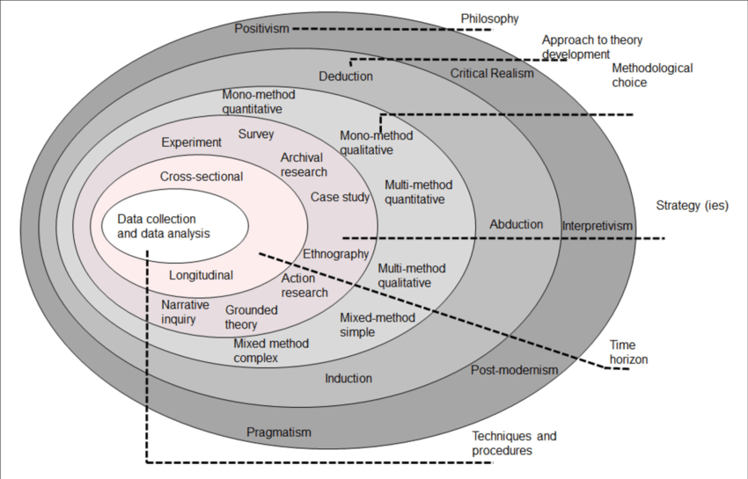

Figure 3.1: Research Onion
(Source: Seuring et al., 2021)

3.3 Research Philosophy
The choice of research philosophy is important as it defines most of the research process, including the selection of methodology, the conduct of data collection instruments, and the conduct of data analysis (Mauthner, 2020). Also, it defines the assumptions that the researcher has regarding reality and knowledge that form the epistemological stance. Therefore, the research study achieves a level of coherence and focus by presenting a clear and concise picture of the research philosophy to fit the specified objectives and research questions in a given study. It also improves the study’s validity and reliability as it offers a strong paradigm for analysing the results.
Subsequently, for this study about the impact of Brexit on supply chain management in the UK automotive industry, the most appropriate research philosophy is Interpretivism. Interpretivism focuses more on the complexity of the social settings, micro and macro factors, and perspectives of people and corporations. This philosophy is suitable for this project as the effects of Brexit on the supply chain are complex since they differ from firm to firm and organisation to organisation in the automotive industry (Ali et al., 2021). Through Interpretivism, these variations can be well explored since the research mainly revolves around the meanings and different interpretations that people give to their experiences. The using of an interpretivist paradigm allows the researcher to employ various research methods, including interviews and case studies, to gather qualitative data (Junjie and Yingxin, 2022). It aids in discovering the complex real impact of Brexit on gross and sub-process activities as well as on the relationships and supply chain strategies from key stakeholders’ points of view. Also, it helps in grasping how behaviour and decision-making at the organisational level are impacted by the external environment of Brexit. Therefore, through the selection of the Interpretivism paradigm, the study will be in a position to offer revealing details of the adaptive approaches together with the challenges that affect the supply chain of the UK automotive industry and contribute to the generation of new knowledge as well as improvement of the supply chain management practices.

3.4 Research approach
The research approach is crucial as it establishes the overall direction of how the research study is conducted, how information is gathered, and how it is analysed or interpreted (Taherdoost, 2022). It gives guidance on how the research questions are going to be solved and how the objective of the study is going to be met. Proper selection of the method of research ensures that the methodology supports the objectives of the research hence making the results valid and reliable (Proudfoot, 2023). This also determines the kind of data needed in the research work and how it will be processed hence has some effect on the richness of data collected.
Thus, when it comes to specifying the chosen research approach for this investigation of the impact of Brexit on supply chain management in the British automotive industry, a deductive approach is quite appropriate. It starts with the assumption of existing theories or principles and evaluates how well they can hold water with the specific cases or circumstances in mind (Hall et al., 2023). This approach is suitable for this project since it enables the author to apply theories in supply chain management from the perspective of Brexit. Hence, the research contributes to the understanding of theoretical frameworks on disruption, resilience, and adaptability beginning with theoretical frameworks relating to supply chain disruption, supply chain resilience, and this new aspect of the UK’s automotive industry that has been affected by Brexit.
In this case, since the research applies a deductive method, hypotheses can be derived from theories, for example, Brexit causes more supply chain breakdowns or requires supply chain adjustments from procurement. After that, the data collection and analysis process will examine these hypotheses to produce empirical verification of the theoretical prediction (Okoli, 2023). This is a structural way of enhancing the relevance of the study whereby the conclusions provided are not only clear but also anchored on the various theoretical frameworks elaborated on the impact of Brexit on the practices of supply chain management within the automotive industry in the UK.

3.5 Research design
The choice of research design is important because it determines the method of data collection and analysis process that is appropriate for tackling the research objectives (Salter, 2023). This factor defines aspects like the approach, the choice of techniques when to take data, and the kind of data to be collected. Conducting research through a well-developed research design gives the direction of how the research problem is going to be solved so that the research produces credible and accurate results.
In the case of this study to discover the impacts of Brexit on supply chain management in the UK automotive industry, the most appropriate research design that can be applied is the descriptive research design. Descriptive research aims to give as much information about the phenomena being researched as possible, to give characteristics and relations without attempting to control the variables (Siedlecki, 2020). This design is suitable for the project as it would enable one to have a view of how different aspects of supply chain management have been affected by Brexit including logistics, procurement and suppliers.
A descriptive research design allows for the accumulation of extensive data by embracing surveys, interviews and case studies that afford an evident picture of the existing impact of Brexit on the industry. This approach assists in capturing and explaining the main issues and modifications that automotive firms encounter, which meets the objective of the study of understanding the overall impact of Brexit on supply chain management.

3.6 Data collection method
Data collection techniques are important since they define how information that is pertinent to the accomplishment of the research intention is obtained (Taherdoost, 2021). These factors affect the types, reliability, and comprehensiveness of the collected data which in turn affect the study results and recommendations. This helps in the selection of appropriate methods of data collection so that the collected information is adequate, pertinent and corresponds to the goals of the research. Therefore, the selection of data collection techniques constitutes a valid and reliable methodological framework for considering the research problem and generating useful conclusions.
Discerning the effects of Brexit on supply chain management within the UK automotive industry requires appropriating a secondary data collection approach. Some form of analysis is needed for secondary data and for this; one may use publications from other industries, academic papers, governmental or non-governmental organisation publications, and records of companies among others. This approach is appropriate for several reasons:
1. Cost-Effectiveness and Time Efficiency: Secondary research on the other hand is cheaper and is undertaken over a shorter period as compared to the primary research procedures (Pederson et al., 2020). It employs secondary data; hence, little primary data collection is needed in the course of the study which comes in handy when examining an extensive phenomenon that was the impact of Brexit on a whole industrial sector.
2. Availability of Relevant Information: The literature review shows that there is a massive availability of secondary data regarding the economic impact, supply chain, and industry studies resulting from Brexit. In relation to the previously mentioned subcategories and trends of the automotive industry, this data generates a general concept of how Brexit affected the supply chain.
3. Historical and Comparative Analysis: Secondary data can be collected for the time before and/or after an event like Brexit so that data collected for a separate time horizon can be compared to another. This analysis can give insights into trends, disruptions and changes in the automotive supply chain, which corresponds with the research objective of establishing the effects.
4. Access to Diverse Perspectives: Previous papers and studies present various related approaches and numerous professionals’ opinions, which contribute to the comprehension of various consequences of Brexit in the automotive supply chain. This method also lays down a wide framework, which may be hard to get if gathering only the primary data.
Due to the secondary data collection approach, the research will be well equipped to accomplish the put-forth aim encompassing the impacts of Brexit towards supply chain management by referencing an extensive database of secondary information towards the formulation of findings and conclusions.

3.7 Data analysis
The methods of data analysis are crucial since they translate collected data into meaningful information used for the study, affecting its outcomes and conclusions. The methods used in the analysis of data depict how well the data will be understood and how closely it will respond to the research aim (Islam, 2020). Appropriate analytical techniques facilitate the identification of regularities, more so trends and interrelations within the data, thus obtaining a definitive answer to the research questions.
In the context of the present research on the impacts of Brexit on supply chain management within the UK automotive business, the use of thematic analysis is particularly suitable. Thematic analysis is a process of analysing qualitative data with the aim of coming up with themes, in a detailed manner explaining the occurrences and experiences (Cernasev and Axon, 2023). This method is well-suited for several reasons:
1. In-depth Understanding: Thematic analysis makes it easier to analyse qualitative data, which in this case will include industry reports, interviews, and case studies (Lochmiller, 2021). It enables the identification of themes concerning Brexit’s implications, for example, disruptions impacting logistics, shifts in procurement tactics and reforms in the supply chain management strategies.
2. Flexibility: This method can therefore be used in all kinds of research involving qualitative data (Ayre and McCaffery, 2022). As it deals with the complexities of Brexit's impacts on the supply chain, it allows consideration of multiple effects from multiple sides in the automobile industry.
3. Pattern Recognition: Another approach that can be used and is fit for identifying different patterns across large amounts of data is thematic analysis; it is especially helpful in the context of the present research topic as the phenomenon of Brexit is complex and affects various aspects of people’s lives. It also assists in integrating contents gathered from various databases as a way of identifying common challenges and patterns.
4. Rich Insights: The advantage of using a thematic approach is that the results reflect a detailed and comprehensive understanding of how Brexit has impacted supply chain management processes. This approach is very effective when the research aim is to develop a profound insight into the effects produced on the UK automotive industry.
Moreover, thematic data analysis entails adequate examination of the qualitative facets of Brexit’s influence on SCM, adequately and proficiently answering the research aim.

3.8 Inclusion and Exclusion
The identification of the subjects or samples involves criteria of inclusion and exclusion to qualify the research as relevant, credible, and accurate. For this project on the effects of Brexit on supply chain management in the UK automotive industry, the following criteria will be applied:
Inclusion Criteria | Exclusion Criteria
1. Relevance: Brexit has to be addressed in the journals and articles searched, and the focus should be made on its effects on supply chain management in the UK automotive industry. | 1. Publication Date: To minimise the use of stale information the articles that were published before the last five years will be excluded.
2. Publication Date: Secondary data sources only those which are published within the last five years will be included to make sure that all data collected is up-to-date to some extent. | 2. Quality of Sources: To achieve this, irrelevant journals with unreadable authors and emblems, irrelevant journals will be eliminated to increase the calibre and relevance of the materials used.
3. Author and Publication Details: Author and publication information should be provided and the authors of articles and sources must be credible. | 3. Bias: Any valued information that is considered biased or not involving objective analysis will be filtered out to avoid compromising the neutrality of the research.
4. Number of Articles: Possible articles that could be included in the review articles would be 23 in number, but the review section of this study will only consist of 12 articles, which were specifically chosen to ensure that the data gathered is more manageable and specific to the research topic at hand.
5. Additional Evidence: Annual reports, industry reports, manufacturers’ data, newspapers, articles, and journals will also be incorporated into the study to develop a deeper context for the research outcomes.

Table 3.1: Inclusion and exclusion criteria
(Source: Created by the learner)
To practise ethical research practices, any information collected will not allow the researchers to be biassed and all the sources used in this research shall be referenced correctly.

3.9 Research Ethics
Ethical consideration for this project is affirmed by compliance with the following principles of research ethics in data collection and analysis. The research materials are duly acknowledged to avoid cases of plagiarism. To eliminate any possibility of bias, the study does not provide an opinion on any material whatsoever, but examines materials and presents evidence for reading and interpretation. Also, there is research integrity where all research is done in a way that results are reported to the public, are free from bias and are truthful. This commitment to ethical practices enhances the research reliability and validity of the outcome.

3.10 Research Limitations
It is necessary to highlight some limitations of applying the research on the impacts of Brexit on supply chain management in the UK automotive industry. Firstly, it has to do with the fact that the research relies on secondary data, which limits the project by the quality and breadth of resources. Although secondary data is cheaper and quicker to gather than primary one, it may be less accurate and detailed than the primary data that is collected from industry insiders. The follow-up conclusion of the study can therefore only draw from literature, reports, and data sources available at the time of the study.
Secondly, sources published five years and below may not include all the related information from historical data. Thus, Brexit’s impacts on supply chain management may be considered dynamic, and earlier investigations’ findings might have helped comprehend long-term changes and trends. Also, the author’s decision to base the findings on only 12 articles and other sources may allow for the inclusion of less variety of viewpoints.
Thirdly, the exclusion criteria that disqualify sources because their authorship cannot be verified or the source seems suspect, can potentially omit good pertinent data which might provide a unique perspective or important information. However, the above selective procedure, as essential for ensuring the quality of studies included in the analysis, might lead to a kind of selection bias.
Finally, irrespective of the efforts to remain impartial and to avoid any ethical violations, the analysis of the secondary data is always to a certain extent subjective. This could lead to bias because the perspective that researchers hold while conducting the study and the theoretical framework applied to the study, may intervene and distort the findings of the study.
Such limitations point towards the fact that the present study’s results should be interpreted with some level of circumspection while also indicating that future research analyzing the consequences of Brexit on the automotive supply chain may optimise their analysis to include primary research data in addition to the secondary sources applied in this study.

3.11 Summary
The current chapter Three gives a detailed understanding of the method used to investigate Brexit's impact on the supply chain in the automobile industry in the United Kingdom. The chapter is on the research philosophy adopted for the study, which is Interpretivism; this approach acknowledges different perceptions within human society and the multiple complexes in the industry. This approach allows for a comprehensive analysis of the effects of Brexit from the perspective of various stakeholders.
The deductive research approach is chosen, and initial hypotheses about supply chain disruption and supply chain resilience are formulated from the existing theoretical knowledge and compared to support the analysis of Brexit's impact. This method is helpful in hypothesis testing and theory validation as explained. The descriptive research design is selected so as to provide an analysis of several ways that involve SCM, logistics and procurement in relation to Brexit. The collection of data depends heavily on secondary data, which is relatively cheaper and takes less time to gather, giving the historical and comparative analysis of the industry’s reaction to Brexit. Thematic analysis is used for extracting qualitative data and understanding the impact of Brexit more broadly. The chapter also describes how to decide on sources and which initial sources are included or excluded based on methodological relevance and quality. However, some study limitations may include the use of secondary data only and possible biases in selected sources, the presented methodology is rather useful for identifying the impact of Brexit on supply chain management.

Chapter 4: Findings/ Results, Analyses and Discussion

4.1 Introduction
This chapter mainly focuses on the data collection on the supply chain management in the UK automobile in the post-Brexit operation. This part of the research has described the impact of Brexit on the supply chain management process of the UK automobile sector with proper evidence-based study. This part has highlighted the influence of taxation and export and import in the supply chain operation. Additionally, the impact of Brexit on the supply and demand of automobile operations in the UK has also been analysed in detail by using evidence-based study. This part provides valuable insight into the research study finding relevant and reliable sources about the ways Brexit gets affected by supply chain management in the UK automobile industry. Based on the literature review section, it can be detected that the research study has undergone global real-time examples of organisations from the automobile industries that faced adverse effects due to Brexit in its supply chain management and integration process.

4.2 Presentation of Findings
Index | Author | Year | Title | Key themes or Keywords
1 | “Fontanelli, F.,.” | 2023 | “The law of UK trade with the EU and the world after Brexit. King's Law Journal, 34(1), pp.3-29.” | Trade and Tariff:  Trade and Tariff is one of the important areas in the international business operation that influence the supply chain operation of the UK automobile sector. Before Brexit, there was a free trade zone between the EU countries which led the companies to the EU countries to trade without any trade barrier and tariff rate. After Brexit, a new trade barrier has been introduced such as a tax barrier and documentation barrier and the tariff rate has increased due to export and import duties in the UK environment. It is seen that a 10% tariff rate has been imposed for sale purchase of automobile parts in the UK from EU countries which significantly increased the costs of the automobile manufacturing process.
2 | “Dhingra, S., Freeman, R. and Huang, H.,.” | 2023 | The impact of non‐tariff barriers on trade and welfare. Economica, 90(357), pp.140-177. | Brexit affects tariffs and trade as leaving the deepest FREE trade association (EU) results in losses that cannot be recovered by individual deep tariff agreements with non-EU partners.
3 | “Giammetti, R.,.” | 2020 | Tariffs, domestic import substitution and trade diversion in input-output production networks: an exercise on Brexit. Economic Systems Research, 32(3), pp.318-350. | Brexit-Induced trade consequences such as chain value for the UK and EU remain at high risk for critical economic loss.
4 | “Ortiz Valverde, G. and Latorre, M.C.,.” | 2020 | A computable general equilibrium analysis of Brexit: Barriers to trade and immigration restrictions. The World Economy, 43(3), pp.705-728. | Brexit’s trade and immigration controls would likely have large negative welfare effects for the UK, while the EU’s welfare would be little affected.
5 | “Du, J., Satoglu, E.B. and Shepotylo, O.,.” | 2023 | “How did Brexit affect UK trade?. Contemporary Social Science, 18(2), pp.266-283.” | Brexit’s terms of consequence agreement led to a decline in UK exports to the EU, leading to questions on continued trade capability and efficiency.
6 | “Graziano, A.G., Handley, K. and Limão, N..” | 2020 | “Brexit uncertainty: Trade externalities beyond Europe. In AEA Papers and Proceedings (Vol. 110, pp. 552-556). 2014 Broadway, Suite 305, Nashville, TN 37203: American Economic Association.” | Brexit had a converse effect on the UK trade with non-EU countries in Preferential Trade Agreements that had to be re-established after Brexit. This uncertainty meant that export values and participation have been decreasing in the same way as the effects observed in the UK-EU trade.
7 | “Novy, D., Sampson, T. and Thomas, C.,.” | 2024 | “Brexit and UK Trade.” | Brexit’s TCA made UK-EU trade less integrated after Brexit despite zero tariffs and quotas by implementing costly non-tariff barriers.
8 | “Gutiérrez, E., Lacuesta, A. and Martín‐Machuca, C.,.” | 2021 | “Brexit: Trade diversion due to trade policy uncertainty. Oxford Bulletin of Economics and Statistics.” | Brexit caused major trade diversion to other European countries including Spain for the Spanish exporting firms, especially the firms with high dependence on the UK; however, the relative trade diversion was moderate for the large firms.
9 | Du, J. and SHEOPOTYLO, O.,. | 2022 | Brexit and UK services trade. | The UK service trade has been influenced with greater assistance such that it could preferably bring over innovative and creative changes in the operational framework.
10 | Stack, M.M. and Bliss, M.,. | 2020 | EU economic integration agreements, Brexit and trade. | EU economic integration agreements have been enlarging with greater efficiency such that it could preferably make the business attentive.
11 | Portes and Springford, | 2023 |  | Labour and Workforce:  The automobile sector of the UK has traditionally relied on skilled labour from the EU nations such as Germany, France and Italy. After Brexit, a restriction has been imposed on the labour movement between the UK and EU countries, which led to a shortage of employees in the business operation. Due to barriers in the labour movement, a significant impact on the total labour force and wage rate has also been seen in the UK automobile sector.
12 | “Taylor, H., Florisson, R. and Wilkes, M.,” | 2020 | “Post-Brexit Labour Supply and Workforce Planning. Work Foundation.” | Brexit has increased labour issues in social care and hospitality through restricting access to European workers, and through making recruitment and domestic workforce integration more complex.
13 | “Portes, J. and Springford, J.,” | 2023 | “The impact of the post-Brexit migration system on the UK labour market. Contemporary Social Science, 18(2), pp.132-149.” | Polices on net migration have decreased the labour supply in the low skill sectors after Brexit; however, permit-led policies in the high skill sectors are still at their pre-Brexit levels.
14 | “Forde, C., Bessa, I., Alberti, G., Dolezalova, M., Ciupijus, Z. and Cutter, J.,.” | 2024 | “Employers' post-Brexit workforce strategies and their use of migrant workers.” | Employers use nonstandard contracts and direct employment, with an emphasis on higher wages, trainees, and flexibility due to the labour deficit after Brexit and COVID-19.
15 | “Blunk, J., Benson Marshall, M. and Cox, A.M.,.” | 2021 | “European Union librarians on the move? An exploration of potential impacts of Brexit on workforce diversity. New Review of Academic Librarianship, 27(4), pp.402-422.” | Brexit shall decrease the diversity of the workforce within the academic libraries in the UK, as doubts make some employees leave or think about it, affecting the sector’s diversity.
16 | “Kumodji, B.D.,.” | 2024 | “Where are the staff?” Where did they go? From Brexit, Covid ‘19 and Cost Hikes to HR Leaders struggling to fill the talent gaps”–Navigating uncertainties in the UK Hospitality Workforce Market.” | Brexit saw the UK cease to be a member of the EU, which profoundly changed its labour and population, and hence interaction with others.
17 | “Javorcik, B.K.S., Kett, B., Stapleton, K. and O'Kane, L.,.” | 2023 | “Unravelling deep integration: Local labour market effects of the brexit vote. Publications Office of the European Union.” | The expectations of trade friction and barriers post Brexit caused a reduction in the number of job advert placements targeting higher skilled professionals especially those in the regions that depended on exported professional services.
18 | “Wilson, R.A., Barnes, S.A., May-Gillings, M., Shyamoli, P. and Bui, H.,.” | 2020 | “Working Futures 2017-2027: long-run labour market and skills projections for the UK: main report. Department for Education.” | Brexit involves uncertainties to labour and workforce in the UK in terms of trade, investment, migration, as well as their skills needed. It also cause changes in employment relations at sectoral level and in the qualifications of human capital in the long run.
19 | “Higgs, L.,.” | 2020 | “Labour Rights, Artificial Intelligence and Automation in the context of the UK, Brexit, and Covid-19 with a comparative study of Singapore (Doctoral dissertation).” | Labour and workforce in the UK is a subject that is not separate from the effects of Brexit, automation, and AI. Brexit sovereignty might be seen as a positive development if it strengthens workers’ rights or as a negative development that will lead to the erosion of their rights and workers’ welfare and social justice and income differences.
20 | Bakker, J.D., Datta, N., De Lyon, J., Opitz, L. and Yang, D.,. | 2022 | Post-Brexit imports, supply chains, and the effect on consumer prices. UK in a Changing Europe. | Economic Impact including demand and supply:  Brexit has an economic and financial impact on the automobile sector of the UK. In the supply chain management process, currency fluctuation has resulted in financial volatility for the automobile business. Due to Brexit, supply and demand of the product have also been hampered as it resulted in increased trade restrictions and cost hikes.
21 | “Dhingra, S. and Sampson, T.,.” | 2022 | “Expecting brexit. Annual Review of Economics, 14(1), pp.495-519.” | Brexit effects are reflected in the increase in import prices, a decline in investment, and a slowdown in GDP, which is manifested in the demand and supply in the UK economy.
22 | “Mustafa, G., Hussain, M. and Aslam, M.A.,.” | 2020 | “Political and Economic Impacts of Brexit on European Union. Liberal Arts and Social Sciences International Journal (LASSIJ), 4(2), pp.11-23.” | Several economical changes have effects exerted by Brexit on UK – EU internal economy, such as changes in supply and demand, potential gaps in national budgets, as well as political conflicts within the EU economy.
23 | “McGrattan, E.R. and Waddle, A.,.” | 2020 | “The impact of Brexit on foreign investment and production. American Economic Journal: Macroeconomics, 12(1), pp.76-103.” | Brexit has implications in terms of FDI effects, trade barriers as well as policy measures regarding technology and investment within the UK and EU affecting supply and demand.
24 | “Latorre, M.C., Olekseyuk, Z. and Yonezawa, H.,.” | 2020 | “Trade and foreign direct investment‐related impacts of Brexit. The World Economy, 43(1), pp.2-32.” | Brexit affects trade and output and results in lower productivity in both regions: the UK and the EU. Technical barriers to trade and regression of access to the EU market lead to severe economic losses in the UK.
25 | “Freeman, R., Manova, K., Prayer, T. and Sampson, T.,.” | 2022 | “The impact of Brexit on UK–EU trade. The Economics of Brexit: What Have We Learned, 2014, p.2015q1.” | Brexit affected the access to EU of the UK financial service and raised the trade barriers and relocate some services and employees to other world financial hubs thereby influencing demand and supply of the UK financial services.
26 | “Allan, G., Comerford, D., Connolly, K., McGregor, P. and Ross, A.G.,.” | 2020 | “The economic and environmental impacts of UK offshore wind development: The importance of local content. Energy, 199, p.117436.” | Brexit effects on the UK’s offshore wind vary in localised content, affecting economic activity and supply chain demand and supply locally, resulting in significant emissions and economic outcomes.
27 | “Berthou, A., Haincourt, S., de la Serve, M.E., Estrada, Á., Roth, M.A. and Kadow, A.,.” | 2020 | “Assessing the macroeconomic impact of Brexit through trade and migration channels. Banco de Espana Ocassional Paper, (1911).” | Most estimates suggest that Brexit will lead to a 6% contraction in the UK’s GDP consistent with disruptions in trade while Europe’s GDP will be hardly affected.
28 | “Freeman, R., Manova, K., Prayer, T. and Sampson, T.,” | 2022 | UK Trade in the Wake of Brexit. | Operational disruption  In the post-Brexit period, operational disruption became one of the major challenging aspects in the Automobile sector. After Brexit, documentation and functionalities have increased in the supply chain process between the EU countries and the UK. Delays in ports and borders have disrupted the smooth flow of the goods supply in the current supply chain operation of the automobile sector. Due to this reason, the economic impact on the supply and demand process has been seen in the UK market which also negatively impacts customer satisfaction.
29 | “Hestermeyer, H. and Ortino”, | 2016 | “Towards a UK trade policy post-Brexit: the beginning of a complex journey. King's Law Journal, 27(3), pp.452-462”. | Supplier Relationship  In the supply chain management process, supplier relationships are important to manage the flow of the supply and enhance the functional development of the business. Due to the new trade barrier after Brexit, supplier relationships have been strained. Many of the UK automobile companies have had to find alternative suppliers outside of the EU nations which creates issues in the re-negotiation aspects and building new supply chain networks. Re-negotiation issues and communication disruption between the EU suppliers and the UK companies have resulted in creating issues in the supplier's relationship with automobile companies.
30 | “Blake, D., ” | 2020 | “How bright are the prospects for UK trade and prosperity postBrexit?. Journal of Self-Governance and Management Economics, 8(1), pp. 7-99. doi: 10.22381/JSME8120201 | Effective strategies are taken by Automobile companies in the post-Brexit:  In order to avoid labour force issues in the UK market, many Automobile companies have incorporated training and skill development training programs in the manufacturing process to improve the training of the local workforce. In order to manage the supply chain disruption, automobile companies take the initiative to contact alternative suppliers outside of the EU nations. In order to minimise the operational disruption, companies are currently investing in additional warehousing and buffer stocks which lead them to lower the delay in supply hence increasing the operational costs.
31 | Chowdhury, S., Rodriguez-Espindola, O., Dey, P. and Budhwar, P., | 2023 | Blockchain technology adoption for managing risks in operations and supply chain management: evidence from the UK | The impact of blockchain implementation on reliability, accuracy, incorruptibility and visibility which reduces the robustness of supply chain efficiency. These are the challenges faced by the UK industry to supply its products to its customers.
32 | Donkor, F., Papadopoulos, T. and Spiegler, V., | 2024 | Supply chain integration and supply chain sustainability relationship | Managers are highly involved in gaining the resilience of the supply chain process and maintaining sustainability. It will provide an opportunity for the UK industry to mitigate the challenges raised due to supply chain disruptions.
33 | Ramjaun, T.I., Rodrigues, V.S. and Kumar, M., | 2024 | Horizontal supply chain collaboration amongst small enterprises | Horizontal helps employees to enhance the supply chain processes such that it can increase its business integrative approach and business availaibility. It will help the UK industry to mitigate all its supply chain efficiency.
34 | Milne-Ives, M., Lam, C., van Velthoven, M. and Meinert, E., | 2020 | The impact of Brexit on the pharmaceutical supply chain of the united kingdom: Scoping review protocol. | In the UK industry, several organisations have been suffering due to Brexit due to an increase in supply chain restrictions. This theme has been intending that the Brexit effect has been adversely affecting the business stabilisation.
35 | Oyegoke, A.S., Fisher, B.W., Ajayi, S., Omotayo, T.S. and Ewuga, D., | 2024 | The disruptive factors and longevity effects of Covid-19 and Brexit on the SMEs construction supply chain in the UK | The disruption in the supply chain results in a challenging situation for an organisation to establish creative support in its business proceedings and strategies.
36 | Bailey, D., De Propris, L., De Ruyter, A., Hearne, D. and Ortega-Argilés, R., | 2023 | Brexit, trade and UK advanced manufacturing sectors: a Midlands’ perspective. | Advanced manufacturing processes and supply chain procedures have been enlarged when the ‘Just In Time’ (JIT) supply chain has been included which preferably supports the supply chain process. It is a mitigation process to enhance the influence of the supply chain.
37 | Casadei, P. and Iammarino, S., | 2021 | Trade policy shocks in the UK textile and apparel value chain: Firm perceptions of Brexit uncertainty | Brexit effects have been increasing the uncertainty in the supply chain process. Trade policy has been induced which preferably makes a higher resolution in intending to serve a greater assistance from supply chain operators.
38 | Coleman, P.C., Dhaif, F. and Oyebode, O., | 2021 | Food shortages, stockpiling and panic buying ahead of Brexit as reported by the British media: A mixed methods content analysis. | Stockpiling is an effective strategy that establishes a collaboration with an increased communication efficiency. It will help the UK industries to understand the changes in customers’ behaviour after facing the effects of Brexit.
39 | Roscoe, S., Aktas, E., Petersen, K.J., Skipworth, H.D., Handfield, R.B. and Habib, F., | 2022 | Redesigning global supply chains during compounding geopolitical disruptions: the role of supply chain logics. | Institutional theory needs to be evolved within this supply chain process and approach that could intend to deliver a quality success. It allows logistics to bring changes in its existing processes for suppliers.
40 | Smith, D., Ahmed, V. and Saboor, S., | 2020 | BREXIT: Assessing the impact on the UK construction industry & mitigating identified risks. | Political ramifications need to be held which preferably allow organisations to ensure creative success and supply chain developments. The UK industries have been termed to bring over evolution in determining the ways it can mitigate supply chain effects.
41 | L. Dey, B., Alwi, S.F.S., Babu, M.M., Roy, S.K. and Muhammad, S.S., | 2023 | Brexit or brand it? The effects of attitude towards Brexit and reshored brands on consumer purchase intention. | The UK industry is required to ensure customers' purchasing by undergoing market research where it could find a preferably supply chain integration dignity.
42 | Bailey, D., Hearne, D. and Charles Budd, L., | 2023 | People, places and policies beyond Brexit. | Reduction in employee collaboartion has caused a challenge as it does not allow to make the supply chain process feasible. It is one of the challenges faced by organisations during Brexit.
43 | Kren, J. and Lawless, M., | 2024 | How has Brexit changed EU–UK trade flows? | An increase in the inefficiency of economic outcomes has negatively inferred effects on organisations. However, it preferably raises a challenging situation in the UK.
44 | Sisson, K., | 2020 | Making Britain the best place in the world to work: how to protect and enhance workers' rights after Brexit… and coronavirus | Increase in provdiing equal rights to workers involved in supply chain operations. It assures to mitigate the challenges raised during the Brexit.
45 | Clarke, S.O.P.H.I.E., Gasiorek, M.I.C.H.A.E.L. and HERNANDEZ, A.S., | 2023 | The challenges facing UK firms: trade and supply chains. | Trade and Cooperation Agreement (TCA) ensures to provision of legal aspects that could allow organisations to make their business attentive and creative.
46 | Syafrian, D., | 2020 | Political strategies of multinational companies in managing uncertainty: Lessons from Brexit. | Collective defence taken by organisations provides an opportunity for them to overcome the challenges raised due to the Brexit effect.
47 | Posen, A.S. and Rengifo-Keller, L., | 2022 | Brexit Britain in a changing global economy. | Financial flows and foreign direct investment have enabled to creation of suitable and effective supply chain processes.
48 | Tiwasing, P., | 2021 | Brexit and skill shortages: An empirical analysis of UK SMEs. | Employees with skill and talent shortages create a challenge that increases the difficulty for the UK industry to influence its business during Brexit.
49 | Makarem, N., Singh, H., Sultana, N. and Henderson, D., | 2023 | Policy uncertainty and real activities manipulation: evidence from Brexit. | Economic and social implications have been gaining the business proceedings which reduces the uncertain factors.
50 | Barry, F., Sun, X. and Hogan, B.F., | 2020 | Brexit damage limitation: Tariff-jumping FDI and the Irish agri-food sector. | The increase in the damage and destruction in tariffs has caused a challenge for the UK industry to influence its business. It has highlighted the challenges that have been faced due to the Brexit effect.

Table 4.1: Thematic analysis
(Source: Created by the learner)

4.3 Analyses of Results
Theme 1: Trade and Tariff
Importing and exporting car parts is now more expensive and takes longer due to tariffs and customs inspections. For example, longer border waiting periods due to increased paperwork requirements have upset the just-in-time supply model that many businesses depend on. According to WTO reports, the average tariff imposed by EU on the cars, trucks and lorries is 16% whereas the average tariff on automobile parts is 10% (Blake, 2020). Due to the impact of Brexit, the tariff rate and tax rate have increased in the UK market for automobile parts which increased the cost of production for the automobile business and resulted in to rise in the car price. On the other hand, trade restriction has increased in the supply chain process for new businesses and old businesses which has resulted in enhanced the total cost and time of the supply chain process in the automobile operation. After Brexit affects, UK businesses have got into multiple deals that have been announced in June 2021. the UK made a business deal with New Zealand where they made a small trading partnership which accounts to be less than 0.2% of the entire UK trade (Edgington, 2024). It can be analysed that the Brexit effect has caused the worst scenario for the automobile market which is mostly based on the rules and regulations of WTO rules. As a result, the UK trade and tariffs have been raised to 10% tariffs on vehicles and a 2.5-4.5% tariff on automobile parts and components (Committees, 2024). As a result, the automobile sector has been making its business at a lower and thinner profit margin and facing larger barriers to make the business expressive. The UK industry believes in a European footprint, foreign direct investment (FDI) and integrated supply chain management. However, it can be analysed that the UK automobile industry has been showing much concern towards making the automobile buisness more secure and effective.
Theme 2: Labour and Workforce
As per data, Brexit has a shortfall of 330,000 in the UK labour force among which a 15% shortfall has been seen in the Automobile industry. Due to the changes in the employment law of the UK, a significant influence in the labour movement has been seen after Brexit which resulted in a shortage of skilled and knowledgeable employees in the Automobile business of the UK. Due to the shortage of skilled labour, a significant impact on the quality of the production and supply chain operation has been seen in the UK automobile sector. Additionally, the cost has also increased in the labour acquisition process in the UK automobile sector. The harmonisation between the UK and EU regulations has been affecting the automobile sector and industry, increasing the uncertainty in business policies. However, the inefficiency in the workforce strength has allowed the authority to develop technologies and innovations that resulted in a reduction or elimination of ultra-low carbon emissions in autonomous vehicles (Committees, 2024). It assures that technologies and innovations can create increased collaboration and incorporation in the automobile industry. It increased the legal clarification which merges with higher association of business developments. On the contrary, the volume of the EU migrant labour force has been reducing whereas the share of non-EU employees has been increasing at an exponential and gradual ratio (Forster-van Aerssen and Apital, 2023). The following are the impacts that depict the exports and imports made by the UK during the Brexit effects. It has been making their automobile business more challenging and complex as they need to take authority and permission from the collaborative authority. There have been some challenging rules and regulations that have been making their business more challenging.
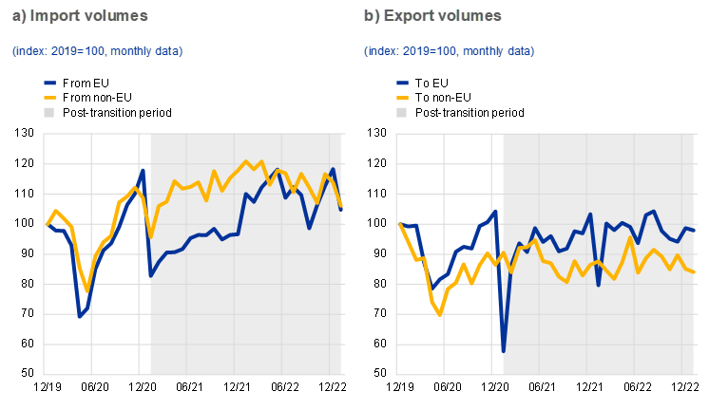
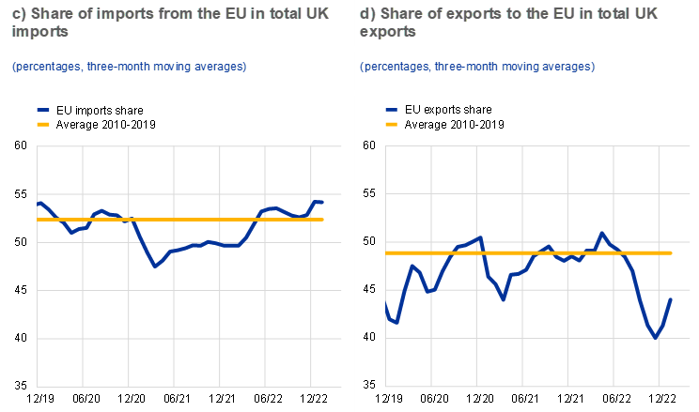

Figure 4.1: UK trade in goods with EU and non-EU countries
(Source: Forster-van Aerssen and Apital, 2023)
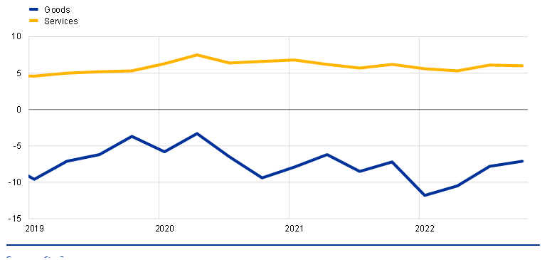

Figure 4.2: Goods and services balances in the UK
(Source: Forster-van Aerssen and Apital, 2023)
Theme 3: Economic Impact including demand and supply
The price structure of the car industry has been impacted by the pound's devaluation, which has increased the cost of imports. Tariffs and more stringent compliance standards have also resulted in higher expenses for businesses. Brexit has also affected supply and demand for the commodity by increasing trade barriers and driving up costs. The economic factors have been affected after the Brexit implications raised a challenging situation in the business industry of the UK. Geopolitical unrest clauses, supply chain pressures and rising inflation have been causing challenges and impacting economic viability which negatively intends to make a challenging situation for the automobile industry to enhance its business efficiently (EY, 2022). In 2021, the car registration was reduced by -24.3% which ensures that buyers have reduced their purchase rate (EY, 2022). In this concern, the leaders of the automobile industry have been showing much initiative and plans that could allow them to receive support from the government. It has been implicating the economic factor of the UK where the demand and supply raised complexities. However, it could be detected that economic stability can be gained where the demand and supply prospects of both the EU and the UK transition.
Theme 4: Operational disruption
Brexit has caused the UK and EU to have different regulatory frameworks, which has an impact on standards for goods and compliance needs. There are now many sets of rules that manufacturers must follow, which adds to the complexity and expense. This discrepancy may cause delays in the introduction of new goods onto the market by influencing the approval procedure for new car models. The seamless flow of goods in the existing supply chain functioning of the car sector has been disturbed by delays in ports and borders. Because of this, the UK market has seen the negative effects of the economy on supply and demand, which also have an adverse effect on consumer satisfaction. During the Brexit challenges the UK car manufacturing sector has been restructuring its supply chain network by shifting from non-European to European car components sellers or suppliers. it has been providing opportunities for the automobile industry to make its business feasible and attentive (Nord France Invest, 2024). It reduces the challenges of facing and getting hit by tariffs at every stage of the car manufacturing process. It is evident that more than 80% of UK vehicles are exported and half of the proportion of cars go to the EU (Nord France Invest, 2024). It serves to bring over evolution and restructuring in the supply chain process when it indicates an increase in the automobile supply.
Theme 5: Supplier Relationship
Relationships with suppliers have been strained as a result of the new trade barrier following Brexit. The need for many UK automakers to locate substitute suppliers outside the EU member states presents challenges for renegotiation and the establishment of new supply chain networks. The connection between suppliers and automakers has been strained as a result of re-negotiation problems and communication breakdowns between EU suppliers and UK firms.
Theme 6: Effective strategies are taken by Automobile companies in Post Brexit
Numerous automakers have integrated skill development and training programs into their production processes to enhance the training of their local workers, hence mitigating labour force concerns in the UK market. Car manufacturers take the initiative to get in touch with suppliers located outside the EU countries in order to prevent an interruption to the supply chain. Companies are increasingly investing in more storage and buffer inventories to reduce operational interruption. This lowers supply delays, but it also raises operating expenses.

4.4 Discussion of results
Trade and Tariffs
An implication of Brexit and change in trade and tariff policies is widely felt in the automobile industry in the United Kingdom. Before Brexit the UK was in a highly integrated trading position with the other countries in the EU; it means that there were no barriers to trade and also no trade tariffs (Mathieu, 2020). This free trade could ensure that the products and parts could be transported easily across borders, helping in cost reduction and efficient handling of supply chains. However, after the Brexit decision, there are new barriers to trade in the form of higher tariffs than before and very complex documentation procedures affecting this sector (Vandenbussche et al., 2022). After analysing all the trading aspects and factors of the UK and EU, it can be indicated that the automobile industry has been suffering due to the relevant changes made in the authority. In order to create change and reliability in the operational process, the UK automobile industry is required to implement changes in their manufacturing and production process so that they can overcome the effects of Brexit. It intervenes that different automobile organisations are required to implement changes within their business such that it could preferably make their business viable and approachable.
Earlier on, Fontanelli (2023), noted that the UK government has put in place a 10% tariff on automobile parts imported from the EU has resulted in increased operation costs for manufacturing firms. This is not some mere accretion over the previous level of cost; it is a weight that slows down and upsets the whole assembly line. The increase in the costs of the imported parts means the finished automobiles will be pricy, a vice that may affect the competitiveness of the automobiles in both the export and local markets. In the same regard, complex processes like documentation and compliance with customs can add more burden and prove to be a negative influence since efforts and funds are pulled away from related developments. As a result, customers have been spending higher costs on purchasing products and car features such as automobiles as the UK organisations have been spending higher costs in their manufacturing and production process. It gains the ability to make the business more viable and effective. It increases the competitive success in the business when the EU and the UK rules and legislations have been relatable in the business process and progression. The domestic automobile in the UK has been facing trouble and challenges in inducing integrated and sustainable supply chain management. It ensures that the company can enlarge its business with better availability and predictions.
The rise of the tariff rates can be seen as responding to the larger aim of eradicating trade imbalances and supporting the domestic industry. However, it might have the potential to eradicate economies of scale that the UK manufacturers used to reap from the EU single market. The overall implication is the possibility of a rise in the cost of production which in turn harms the market share and profit margin that could extend to the prices of its products in the market. The tariff rates have been causing challenges as it does not gain the ability of the automobile business to sell and manufacture products at an affordable price and ensure the quality manufacturing that they used to do before. it has been raising differences within the operational process of cars where it intends to make a higher concern of developments. The UK automobile industry has regulated their business differently and independently and after the emergence of the EU market, it raised a challenge for them to make their business feasible as they need to take over the EU market.
Labour and Workforce
Another crucial aspect of the analysis is also the changes in labour and workforce configuration in the UK automobile sector since Brexit. This sector in particular heavily relied on immigrants especially from the European Union countries including Germany, France and Italy as observed by Portes and Springford (2023). Such reliance was done as part of measures that sought to explore all the potential of the member countries in the EU in a bid to ensure that high standards of production and innovation were achieved. The labourers and employees have been facing trouble in manufacturing products such as automobiles based on customers’ demands and preferences. It has been raising competitive abilities when the automobile industry cannot intend to copy the manufacturing processes of EU car designs. It assures to bring over-development in the market when the EU and the UK automobile market have been merging accordingly. Moreover, the supply chain disruptions have been raising challenges and issues for labour and workforce to intend a secure progression and development. Car production and delivery have been reduced when the Brexit effects have been raising the constraints and complexities by making different rules and regulations. In these regulatory changes, UK manufacturers are required to implement different concepts and changes in their production process so that they can help to take over the EU single market. It aims to create a success when labour and workforce can get to know about the implications they are required to raise and maintain in its automobile market consistently. As a recommended approach, organisations are required to serve with regulatory norms and practices that need to be followed by employees after analysing the effects of Brexit.
The new regulation on freedom of employees’ mobility between the UK and the EU has resulted in the scarcity of qualified workforce. The shortage does not only relate to the workforce population; it has consequences with regard to the quality of outputs and the functioning of firms. The effect is further compounded by the surrounding circumstance that the sector struggles to source and develop new local human capital to substitute the decline in EU worker's import. It has been becoming much more challenging for the UK automobile manufacturer as they have already been making their operations evitable and knowledgeable when the UK employees work with them. Necessarily, the industry requires to implement changes in its manufacturing and operational process so that it can term a crisis evaluation in its business process. It intends to make the operations complex when the labour and workforce have been entirely changed. The quality has changed when employees of EU and the UK have been collaborating among the UK industries. In this concern, there is a high efficiency in providing quality training and production gains when employees of the EU have acquired skills and talents similar to the UK employees. Contradictory, they raise challenges when employees of other countries cannot manipulate the changes within themselves. However, it raises the constraint when the automobile industry lacks in providing quality training to their combined and integrated workplace. It makes the workplace challenging and lacks productivity and development. Making a critical evaluation it could be found that employees from multicultural regions faces trouble to collaborate among themselves.
In addition, the effect of the restrictions is reflected in higher wage pressures due to the limited supply of skilled workers a firm had to offer to attract the best talents. This wage inflation goes a notch higher in operational expenses and lowers competition in the sector. The situation in which firms experience labour scarcity leading to an increase in wages may be counterbalanced by the possible increase in the cost of production which may in turn lead to an increase in prices or reduction of profit margins. The net effect is increased pressure on the sector to retain profitability and adapt to the growing changes in the market.
Economic Impact: Demand and Supply
This paper argues that the effect of Brexit on the economic structure of the UK automobile industry also includes issues of supply and demand. Bakker et al. (2022), also stated that currency fluctuations have created financial uncertainty in the sector where, as a result of the fluctuations, the magnitude of the spiralling has affected the ability of the supply chain management. This fluctuation hampers the costs of importing raw materials and exporting finished products, thus causing economic imbalance.
Brexit has also exerted economic pressures in terms of shedding arguments about key restrictions perturbing supply and demand (Pollitt, 2022). Upstream and downstream operational complexities and costs are greater because trade barriers have risen and global costs are elevated and hence, there has been a shake-up of supply chain operations. These disruptions result in irregular supplies and demands which greatly affect the pricing and the production calendar.
Operational Disruption
Holweg (2019) observed that Daimler has cancelled many of its joint automobile projects with Nissan for Sunderland, Jaguar and Land Rover have been cancelled due to the Brexit Referendum. By leveraging the opportunities of an EU-Japan free trade policy, Nissan has announced that their Next-generation X trail SUV will be produced in Japan. Companies like BMW and Toyota have put out stark warnings that their UK automobile operations are under threat in the no-deal Brexit scenario. Due to the closure of Honda and Nissans decision to not make the X-trail in the UK, the overall project output has been reduced by 8.5%. The non-deal Brexit scenario estimated a 34.6% reduction or car manufacturing over the next ten years. Bailey et al. (2023) outlined the regional impacts of Brexit on manufacturing operations and logistics of the automotive industry. The Brexit-induced economic shocks significantly affect the automotive section of, the West Midlands, and East Midlands of the UK. The UK automotive supply chain can include a wide range of companies from small specialist firms to large multinationals. The study estimated that 3480 businesses were involved in the vehicle manufacturing business in the UK. The UK-tier companies import a large number of metals, plastics, glasses and other relevant subcomponents from outside regions. However, the Brexit economic shock enhances regional inequalities in the UK.
Supplier Relationship
Post Brexit, Car manufacturers in the UK look at the status of the UK’s trading relationship with third countries. Car manufacturers can qualify for the preferential tariffs granted under the Free Trade agreements if they can fix the percentage of the product. The supplier became more conscious of the commercial contracts between automotive companies in the UK. Every supplier demands that contracts need to be updated and manage potential risks arising from Brexit-related restructuring. It is necessary to identify the risk allocation between supplier parties. In-depth information about risks or border delays and tariff costs and changes in the pricing structures in the supplier contracts.
Strategies taken by Automobile companies
Post Brexit, the European Union and Britain take urgent action to postpone the rules for EVs traded between the UK and the bloc, which will trigger 10 tariffs in the car industry of Europe. Malinauskaite et al. (2021) have outlined that many UK automotive companies have changed their waste management policies, which focus on improving environmental performance, safety parameters and capabilities of the car. Due to the growing market of Electric vehicles UK, car manufacturers reduce the use of hazardous substances Therefore, most organisations focus on recycling to eliminate the risk of raw material supply insecurities and price fluctuations. Manufacturers shield themselves from supply chain disruption post-Brexit. They create an additional revenue stream by recycling the EV battery.

Chapter 5: Conclusion and Recommendation

5.1 Conclusion
Based on the above discussion, it can be concluded that Brexit has an immense impact on the supply chain management in the automobile industry of the UK which decreases the profit margin and disrupts the entire business process as well. Therefore, it can be said that due to the Brexit movement, the UK has left the EU which creates issues in the trade practices and leads towards supply chain disruption as well. On a similar note, the supply chain management system has been disrupted due to the several geopolitical tensions which decline the organisational operational activity. Therefore, to mitigate the disruption of the supply chain management system, the owner of the business finds new suppliers and access local suppliers which helps the company to redevelop a new supply chain of the firm. Apart from this, it has been found that there are several uncertainties that have taken place in the economy of the UK which create negative effects on the UK Automobile industry as well. In addition, the automobile organisations in the UK wind up their entire products or manufacturing process which plunges the operational efficiency of the company as well. On a similar note, the Brexit movement is one of the major causes of creating significant pressure on the investment funds which push the owner of the business to relocate their business to another location to access the business opportunities. Furthermore, it has been observed that due to the supply chain disruption, business owners of the Automobile industry face issues in terms of accessing the essential raw materials which is one of the major reasons for the decline in the entire manufacturing process of the company as well. Hence, to improve the supply chain disruption, owners of the automobile business need to invest a wide range of money in supply chain resilience and implement modern technology which helps to enhance the performance of the business and increase productivity as well.

5.2 Linking with Objectives
Objective 1: “To understand the impact of Brexit on supply chain management in the UK before and after 2016”
In terms of this, it has been identified that Brexit has a significant effect on the organisational operational efficiency by disrupting the supply chain management system of the company as well. Hence, it can be stated that post-Brexit the UK experienced several challenges and difficulties due to rising bureaucracy, red tape and high expenses. For instance, automobile firms in the UK such as Jaguar Land Rover, Toyota and BMW also wind up the assembly operation from the period of April 2019 to October 2019 in terms of avoiding any kind of legal vulnerabilities in the UK business market. Based on the entire discussion, it can be stated that it effectively meets the first objective of the research study as well.
Objective 2: “To elucidate the challenges posed by Brexit that hinder the progress of supply chain management of the UK automotive sector”
Brexit has a significant impact on the organisational operational activity which declines the business process along with the revenue growth of the business as well. Therefore, it has been identified that in the fiscal year 2020, the UK and EU struck a trade agreement which has a significant impact on the trade practices of the organisation as well. Apart from this, the owner of the business faces issues in terms of the declining stock market and due to this, organisations face problems in providing a high rate of return to their potential investors as well. On a similar note, due to the Brexit movement, automobile firms in the UK face issues regarding political instability which decline the business practices in a critical way. From the aforementioned discussion, it can be stated that it effectively meets the second objective of the research study as well.
Objective 3: “To highlight strategies that can help mitigate the effects of Brexit on the supply chain management of the UK automotive sector”
In this context, to mitigate the supply chain disruption, owners of automobile companies implement effective strategies that help enhance the performance of their businesses. Therefore, organisation can invest their money in Supply Chain Resilience which helps to improve the capacity of the supply chain management system and bring flexibility that enhances the operational activity of the business in an efficient manner. On a similar note, Automobile organisations can create strong relationships with key partners which aids in reducing threats and increases the productivity of the firm in difficult times as well. Considering the entire context, it can be depicted that it effectively meets the third objective of the research study as well.

5.3 Recommendation
The outcome of Brexit has left an uncertain impact on the economy across the globe. During this separation of the UK from the EU various businesses were affected in the UK which not only impacted the UK economy but also impacted various other businesses from all across the globe. The challenges that have been identified within this study that were caused because of Brexit are higher certainty, pressure on the investment funds, free trade agreements and others. Hence, in order to reduce or prevent the impact of Brexit on the supply chain management of the automotive sector certain recommendations will be highlighted within this section. Hence, in order to mitigate or reduce the impact of trade tariffs or trade disruptions the impacted business can develop trade relationships with other suppliers in order to avoid these trade disruptions from the customs procedures. Apart from building new relationships with suppliers outside of the EU to minimise the impact of Brexit on the supply chain, another strategy that can be used is an investment in supply chain resilience. “Investment in Supply Chain Resilience” can be an effective strategy within this context as proper investment will balance the resilience fitness space which will then eventually contribute to reducing the vulnerabilities of the businesses that erode these businesses' profit maximisation (Al-Banna et al., 2023). Apart from reducing the vulnerabilities, this investment will also enhance the business's ability to address the disruptions within the supply chain. Hence, it can also be determined that investments will also build the business's flexibility within the supply chains through developing “the contingency theory and creating the buffer stocks”. Apart from investing in building a resilient supply chain, the challenges or impacts caused by Brexit can also be enhanced through “Strengthening the relations with key business partners”. Through implementing this strategy the business will be able to enhance the communication and coordination between the partners and suppliers which is very essential for the business in order to work efficiently and smoothly. Apart from improving the efficiency within communication and coordination this strategy will also help the business foster a strong tie with the suppliers which will enable both the businesses and suppliers to mitigate any potential issues or risks through working as a team. Apart from the above-mentioned strategies that are recommended, another strategy that can be used within this context is “leveraging technology and data analytics”. This is because during the current times “big data analytics” is emerging and revolutionising within the context of enhancing the automotive industry. Through implementing the strategy the business can improve its business growth by grasping the better opportunities offered through the utilisation of the “big fat analytics”. Hence, it can be stated that by utilising “big data analytics” or any other real-time technologies such as AI or real-time tracking system the performance metrics within the supply chain of the automotive industry can be significantly enhanced because it will enable the business to monitor the performance in the supply chain along with allowing them to predict and optimise logistics.

5.4 Limitations of the Research
In order to conduct this research the “secondary method of data collection” had been utilised through the utilisation of method data within this dissertations have been accessed through secondary sources such as “scholarly articles, news, journals and other relevant sources”. Hence, one of the limitations of this study is not accessing the “primary data”. This is a limitation because utilising the primary source of data collected would have enhanced the overall quality and intensified the depth of the study as through primary data real perspectives would have been attained which could be further used to contradict the accessed data from the secondary sources. Another limitation of this study is data accuracy and utilisation of limited sources. these are the limitations because in order to prepare a thematic analysis one source has been accessed to analyse the theme within the thematic table which could have been enhanced by using more sources of data. Data accuracy is another limitation because in order to conduct this study some of the accessed data are outdated. This is because Brexit took place in 2020 during the month of February, which means current data within this context was unavailable which could have possibly enhanced the accuracy of the study.

5.5 Future scope of the research
The research has performed secondary data collection methodologies which can be extended through primary research. A case study-based research on a particular UK-based automotive company can improve the research analysis on the actual impact of Brexit on supply chain management practices. The study can further work on supply chain resilience strategies and recent technological advancements in automotive supply chain management practices post-Brexit.

References
Adobor, H., 2020. Supply chain resilience: an adaptive cycle approach. The International Journal of Logistics Management, 31(3), pp.443-463.
Al-Banna, A., Rana, Z.A., Yaqot, M. and Menezes, B., 2023. Interconnectedness between Supply Chain Resilience, Industry 4.0, and Investment. Logistics, 7(3), p.50.
Ali, M., Shah, A.A. and Shah, S.A.A., 2021. Positivism and interpretivism. Qlantic Journal of Social Sciences, 2(1), pp.20-26.
Alicke, K. and Strigel, A., 2020. Supply chain risk management is back. McKinsey & Company, 1(1), pp.1-9.
Alkaraan, F., Floyd, D., Rahman, M. and Nuery, N., 2023. A new era of strategic investment decision-making practices in UK companies: Towards sustainable supply chains and circular economy. Theoretical Economics Letters, 13(3), pp.666-682.
Allan, G., Comerford, D., Connolly, K., McGregor, P. and Ross, A.G., 2020. The economic and environmental impacts of UK offshore wind development: The importance of local content. Energy, 199, p.117436.
Armstrong. M., 2018. The EU's importance for the UK car industry [Online] Available At:https://www.statista.com/chart/13723/the-eus-importance-for-the-uk-car-industry/ [Accessed On: 12th August, 2024]
Ayre, J. and McCaffery, K.J., 2022. Research Note: Thematic analysis in qualitative research. J Physiother.
Bailey, D., De Propris, L., De Ruyter, A., Hearne, D. and Ortega-Argilés, R., 2023. Brexit, trade and UK advanced manufacturing sectors: a Midlands’ perspective. Contemporary Social Science, 18(2), pp.250-265.
Bailey, D., De Ruyter, A., Hearne, D. and Ortega-Argilés, R., 2023. Shocks, resilience and regional industry policy: Brexit and the automotive sector in two Midlands regions. Regional Studies, 57(6), pp.1141-1155.
Bailey, D., Hearne, D. and Charles Budd, L., 2023. People, places and policies beyond Brexit. Contemporary Social Science, 18(2), pp.125-131.
Bakker, J.D., Datta, N., De Lyon, J., Opitz, L. and Yang, D., 2022. Post-Brexit imports, supply chains, and the effect on consumer prices. UK in a Changing Europe.
Barry, F., Sun, X. and Hogan, B.F., 2020. Brexit damage limitation: Tariff-jumping FDI and the Irish agri-food sector. The Irish Journal of Management, 39(1), pp.61-74.
Basu, R., 2023. Managing Global Supply Chains: Contemporary Global Challenges in Supply Chain Management. Routledge.
BBC, 2023. What impact has Brexit had on the UK economy? [online] Available at: https://www.bbc.com/news/business-64450882 [Accessed on 26 July 2024]
Berthou, A., Haincourt, S., de la Serve, M.E., Estrada, Á., Roth, M.A. and Kadow, A., 2020. Assessing the macroeconomic impact of Brexit through trade and migration channels. Banco de Espana Ocassional Paper, (1911).
Blake, D., 2020. How bright are the prospects for UK trade and prosperity postBrexit?. Journal of Self-Governance and Management Economics, 8(1), pp. 7-99. doi: 10.22381/JSME8120201
Blunk, J., Benson Marshall, M. and Cox, A.M., 2021. European Union librarians on the move? An exploration of potential impacts of Brexit on workforce diversity. New Review of Academic Librarianship, 27(4), pp.402-422.
Burugu, C.S.G. and Owoeye, A.B., 2024.An Empirical Investigation of Business Strategy Development, Supply Chain Management, Environmental Analysis and Financial Innovations of Logistic Companies in UK.
Business Standard, 2024. What is Brexit [online] Available at: https://www.business-standard.com/about/what-is-brexit [Accessed on 26 July 2024]
Carlier. M., 2023. Domestic sales and exports of passenger cars manufactured in the United Kingdom (UK) from 2003 to 2022 [Online] Available At: https://www.statista.com/statistics/298834/home-and-export-sales-of-cars-produced-in-the-united-kingdom/ [Accessed On: 12th August, 2024]
Casadei, P. and Iammarino, S., 2021. Trade policy shocks in the UK textile and apparel value chain: Firm perceptions of Brexit uncertainty. Journal of International Business Policy, 4(2), p.262.
Cernasev, A. and Axon, D.R., 2023. Research and scholarly methods: Thematic analysis. Journal of the American College of Clinical Pharmacy, 6(7), pp.751-755.
Chowdhury, S., Rodriguez-Espindola, O., Dey, P. and Budhwar, P., 2023. Blockchain technology adoption for managing risks in operations and supply chain management: evidence from the UK. Annals of operations research, 327(1), pp.539-574.
Clarke, S.O.P.H.I.E., Gasiorek, M.I.C.H.A.E.L. and HERNANDEZ, A.S., 2023. The challenges facing UK firms: trade and supply chains. UK Trade Policy Observatory Briefing Paper, 73.
Coleman, P.C., Dhaif, F. and Oyebode, O., 2022. Food shortages, stockpiling and panic buying ahead of Brexit as reported by the British media: A mixed methods content analysis. BMC Public Health, 22(1), p.206.
Commission Europa, 2024. Brexit [online] Available at: https://commission.europa.eu/law/law-topic/data-protection/international-dimension-data-protection/brexit_en [Accessed on 26 July 2024]
Committees, 2024. Society of Motor Manufacturers and Traders (SMMT) – Written Evidence (FTG0009) [online] Available at: https://committees.parliament.uk/writtenevidence/74738/html/#:~:text=The%20worst%20case%20scenario%20for,%2D4.5%25%20tariff%20on%20parts. [Accessed: 1 August 2024].
Dhingra, S. and Sampson, T., 2022. Expecting brexit. Annual Review of Economics, 14(1), pp.495-519.
Dhingra, S., Freeman, R. and Huang, H., 2023. The impact of non‐tariff barriers on trade and welfare. Economica, 90(357), pp.140-177.
Donkor, F., Papadopoulos, T. and Spiegler, V., 2024. Supply chain integration and supply chain sustainability relationship: A qualitative analysis of the UK and Ghana pharmaceutical industry. Production Planning & Control, 35(6), pp.535-558.
Du, J. and SHEOPOTYLO, O., 2022. Brexit and UK services trade. Jonathan Portes, der., The.
Du, J., Satoglu, E.B. and Shepotylo, O., 2023. How did Brexit affect UK trade?. Contemporary Social Science, 18(2), pp.266-283.
Edgington, T., 2024. Trade deals: What has the UK done since Brexit? [online] Available at: https://www.bbc.com/news/uk-47213842 [Accessed: 1 August 2024].
Escaith, H., Khorana, S. and Kerr, W.A., 2020. The Hidden Cost of Supply Chain Disruptions: Case Study of the UK’s Automotive Sector.
EY, 2022. A ‘70’s style’ crisis brewing for the UK automotive industry [online] Available at: https://www.ey.com/en_uk/news/2022/07/a-70s-style-crisis-brewing-for-the-uk-automotive-industry#:~:text=%E2%80%9CRising%20inflation%2C%20supply%20chain%20pressures,reduction%20over%20pre%2Dpandemic%202019. [Accessed: 1 August 2024].
Fontanelli, F., 2023. The law of UK trade with the EU and the world after Brexit. King's Law Journal, 34(1), pp.3-29.
Forde, C., Bessa, I., Alberti, G., Dolezalova, M., Ciupijus, Z. and Cutter, J., 2024. Employers' post-Brexit workforce strategies and their use of migrant workers.
Forster-van Aerssen, K. and Apital, T., 2023. The impact of Brexit on UK trade and labour markets [online] Available at: https://www.ecb.europa.eu/press/economic-bulletin/articles/2023/html/ecb.ebart202303_01~3af23c5f5a.en.html#:~:text=Following%20the%20Brexit%20referendum%2C%20the,surpassed%2C%20pre%2Dpandemic%20levels. [Accessed: 1 August 2024].
Freeman, R., Manova, K., Prayer, T. and Sampson, T., 2022. The impact of Brexit on UK–EU trade. The Economics of Brexit: What Have We Learned, 2014, p.2015q1.
Freeman, R., Manova, K., Prayer, T. and Sampson, T., 2022. UK Trade in the Wake of Brexit.
Giammetti, R., 2020. Tariffs, domestic import substitution and trade diversion in input-output production networks: an exercise on Brexit. Economic Systems Research, 32(3), pp.318-350.
Graziano, A.G., Handley, K. and Limão, N., 2020, May. Brexit uncertainty: Trade externalities beyond Europe. In AEA Papers and Proceedings (Vol. 110, pp. 552-556). 2014 Broadway, Suite 305, Nashville, TN 37203: American Economic Association.
Gutiérrez, E., Lacuesta, A. and Martín‐Machuca, C., 2021. Brexit: Trade diversion due to trade policy uncertainty. Oxford Bulletin of Economics and Statistics.
Hall, J.R., Savas-Hall, S. and Shaw, E.H., 2023. A deductive approach to a systematic review of entrepreneurship literature. Management Review Quarterly, 73(3), pp.987-1016.
Hendry, L.C., Stevenson, M., MacBryde, J., Ball, P., Sayed, M. and Liu, L., 2019. Local food supply chain resilience to constitutional change: the Brexit effect. International Journal of Operations & Production Management, 39(3), pp.429-453.
Hestermeyer, H. and Ortino, F., 2016. Towards a UK trade policy post-Brexit: the beginning of a complex journey. King's Law Journal, 27(3), pp.452-462.
Higgs, L., 2020. Labour Rights, Artificial Intelligence and Automation in the context of the UK, Brexit, and Covid-19 with a comparative study of Singapore (Doctoral dissertation).
Holweg, M., 2019. Death by a thousand cuts: The strategic outlook for the UK automotive industry beyond Brexit. Said Business School, University of Oxford, available at: www. sbs. ox. ac. uk/sites/default/files/2019-04/Strategic% 20outlook% 20for% 20UK% 20auto% 20sector_white% 20paper_09% 20April, 202019.
Hudson, R., 2022. ‘Levelling up’in post-Brexit United Kingdom: Economic realism or political opportunism?. Local Economy, 37(1-2), pp.50-65.
Islam, M., 2020. Data analysis: types, process, methods, techniques and tools. International Journal on Data Science and Technology, 6(1), pp.10-15.
Ivanov, D., 2022. Lean resilience: AURA (Active Usage of Resilience Assets) framework for post-COVID-19 supply chain management. The International Journal of Logistics Management, 33(4), pp.1196-1217.
Javorcik, B.K.S., Kett, B., Stapleton, K. and O'Kane, L., 2023. Unravelling deep integration: Local labour market effects of the brexit vote. Publications Office of the European Union.
Johnson, J.E. and Haug, P., 2021. Modifications to global supply chain management strategies resulting from recent trade disruptions: an exploratory study. Journal of Global Operations and Strategic Sourcing, 14(4), pp.701-722.
Jucyte, A., Kumar, V. and Ruan, X., 2021. Examining the Impact of Brexit on Supply Chain Risk Management: Evidence From the Uk Manufacturing Sector. International Journal of Organizational Business Excellence, 4(1), pp.41-62.
Junjie, M. and Yingxin, M., 2022. The Discussions of Positivism and Interpretivism. Online Submission, 4(1), pp.10-14.
Kaloyanova, G., 2023. Supply Chain Disruptions in the United Kingdom Caused by Brexit.
Kamalahmadi, M., Shekarian, M. and MellatParast, M., 2022. The impact of flexibility and redundancy on improving supply chain resilience to disruptions. International Journal of Production Research, 60(6), pp.1992-2020.
Kantabutra, S. and Ketprapakorn, N., 2021. Toward an organizational theory of resilience: an interim struggle. Sustainability, 13(23), p.13137.
Kong, L., Mu, X., Hu, G. and Zhang, Z., 2022. The application of resilience theory in urban development: a literature review. Environmental Science and Pollution Research, 29(33), pp.49651-49671.
Kren, J. and Lawless, M., 2024. How has Brexit changed EU–UK trade flows?. European Economic Review, 161, p.104634.
Kumodji, B.D., 2024. “Where are the staff?” Where did they go? From Brexit, Covid ‘19 and Cost Hikes to HR Leaders struggling to fill the talent gaps”–Navigating uncertainties in the UK Hospitality Workforce Market.
L. Dey, B., Alwi, S.F.S., Babu, M.M., Roy, S.K. and Muhammad, S.S., 2023. Brexit or brand it? The effects of attitude towards Brexit and reshored brands on consumer purchase intention. British Journal of Management, 34(3), pp.1215-1237.
Latorre, M.C., Olekseyuk, Z. and Yonezawa, H., 2020. Trade and foreign direct investment‐related impacts of Brexit. The World Economy, 43(1), pp.2-32.
Li, D., Shishank, S., de Ruyter, A., Ali, S., Bailey, D., Hearne, D. and Salh, S., 2019. Brexit and the auto industry: Understanding the issues for supply chain management. In Brexit Negotiations After Article 50: Assessing Process, Progress and Impact (pp. 173-191). Emerald Publishing Limited.
Lochmiller, C.R., 2021. Conducting thematic analysis with qualitative data. The Qualitative Report, 26(6), pp.2029-2044.
Makarem, N., Singh, H., Sultana, N. and Henderson, D., 2023. Policy uncertainty and real activities manipulation: evidence from Brexit. Review of Quantitative Finance and Accounting, 61(4), pp.1415-1440.
Malinauskaite, J., Anguilano, L. and Rivera, X.S., 2021. Circular waste management of electric vehicle batteries: Legal and technical perspectives from the EU and the UK post Brexit. International Journal of Thermofluids, 10, p.100078.
Marouf, A.A., 2024. Risk management strategies in global supply chains: a comparative strategy.
Mathieu, C., 2020. Brexit: What economic impacts does the literature anticipate?. Revue de l'OFCE, 167(3), pp.43-81.
Mauthner, N.S., 2020. Research philosophies and why they matter. In How to Keep your Doctorate on Track (pp. 76-86). Edward Elgar Publishing.
McGrattan, E.R. and Waddle, A., 2020. The impact of Brexit on foreign investment and production. American Economic Journal: Macroeconomics, 12(1), pp.76-103.
Meerow, S. and Newell, J.P., 2021. Urban resilience for whom, what, when, where, and why?. In Geographic Perspectives on Urban Sustainability (pp. 43-63). Routledge.
Milne-Ives, M., Lam, C., van Velthoven, M. and Meinert, E., 2020. The impact of Brexit on the pharmaceutical supply chain of the united kingdom: Scoping review protocol. JMIR Research Protocols, 9(9), p.e17684.
Moradlou, H., Fratocchi, L., Skipworth, H. and Ghadge, A., 2022. Post-Brexit back-shoring strategies: what UK manufacturing companies could learn from the past?. Production Planning & Control, 33(14), pp.1319-1336.
Moradlou, H., Reefke, H., Skipworth, H. and Roscoe, S., 2021. Geopolitical disruptions and the manufacturing location decision in multinational company supply chains: a Delphi study on Brexit. International Journal of Operations & Production Management, 41(2), pp.102-130.
Mustafa, G., Hussain, M. and Aslam, M.A., 2020. Political and Economic Impacts of Brexit on European Union. Liberal Arts and Social Sciences International Journal (LASSIJ), 4(2), pp.11-23.
Negri, M., Cagno, E., Colicchia, C. and Sarkis, J., 2021. Integrating sustainability and resilience in the supply chain: A systematic literature review and a research agenda. Business Strategy and the environment, 30(7), pp.2858-2886.
Nord France Invest, 2024. New challengesfor the UK automotive industry [online] Available at: https://www.nordfranceinvest.com/expert-insights/new-challenges-for-the-uk-automotive-industry/#:~:text=The%20Brexit%20challenge%20to%20the,of%20the%20car%20manufacturing%20process. [Accessed: 1 August 2024].
Novy, D., Sampson, T. and Thomas, C., 2024. Brexit and UK Trade.
Okoli, C., 2023. Inductive, abductive and deductive theorising. International Journal of Management Concepts and Philosophy, 16(3), pp.302-316.
Ortiz Valverde, G. and Latorre, M.C., 2020. A computable general equilibrium analysis of Brexit: Barriers to trade and immigration restrictions. The World Economy, 43(3), pp.705-728.
Oyegoke, A.S., Fisher, B.W., Ajayi, S., Omotayo, T.S. and Ewuga, D., 2024. The disruptive factors and longevity effects of Covid-19 and Brexit on the SMEs construction supply chain in the UK. Journal of Financial Management of Property and Construction, 29(1), pp.115-134.
Pandey, P. and Pandey, M.M., 2021. Research methodology tools and techniques. Bridge Center.
Pederson, L.L., Vingilis, E., Wickens, C.M., Koval, J. and Mann, R.E., 2020. Use of secondary data analyses in research: Pros and Cons. Journal of Addiction Medicine and Therapeutic Science, 6(1), pp.058-060.
Pollitt, M.G., 2022. The further economic consequences of Brexit: energy. Oxford Review of Economic Policy, 38(1), pp.165-178.
Portes, J. and Springford, J., 2023. The impact of the post-Brexit migration system on the UK labour market. Contemporary Social Science, 18(2), pp.132-149.
Posen, A.S. and Rengifo-Keller, L., 2022. Brexit Britain in a changing global economy. The Economics of Brexit: What Have We Learned?.
Proudfoot, K., 2023. Inductive/deductive hybrid thematic analysis in mixed methods research. Journal of mixed methods research, 17(3), pp.308-326.
Qamar, A., Collinson, S. and Green, A., 2023. Covid-19 disruption, resilience and industrial policy: the automotive sector in the West Midlands. Regional Studies, 57(6), pp.1156-1170.
Ramjaun, T.I., Rodrigues, V.S. and Kumar, M., 2024. Horizontal supply chain collaboration amongst small enterprises: insights from UK brewery networks. Production Planning & Control, 35(2), pp.206-224.
Razak, G.M., Hendry, L.C. and Stevenson, M., 2023. Supply chain traceability: A review of the benefits and its relationship with supply chain resilience. Production Planning & Control, 34(11), pp.1114-1134.
Reddit, 2022. UK business investment has failed to rebound since Brexit - Financial Times [Online] Available At: https://www.reddit.com/r/europe/comments/vgvc6t/uk_business_investment_has_failed_to_rebound/ [Accessed On: 12th August, 2024]
Rehman, A., Naz, S. and Razzak, I., 2022. Leveraging big data analytics in healthcare enhancement: trends, challenges and opportunities. Multimedia Systems, 28(4), pp.1339-1371.
Roscoe, S., Aktas, E., Petersen, K.J., Skipworth, H.D., Handfield, R.B. and Habib, F., 2022. Redesigning global supply chains during compounding geopolitical disruptions: the role of supply chain logics. International Journal of Operations & Production Management, 42(9), pp.1407-1434.
Roscoe, S., Skipworth, H., Aktas, E. and Habib, F., 2020. Managing supply chain uncertainty arising from geopolitical disruptions: evidence from the pharmaceutical industry and brexit. International Journal of Operations & Production Management, 40(9), pp.1499-1529.
Salter, M.B., 2023. Research design. In Research Methods in Critical Security Studies (pp. 19-27). Routledge.
Serohi, A., 2020. Sustainable Supply Chain of Automobile Sector: A Literature Review. Int. J. Supply Chain Manag, 9(6), pp.82-87.
Seuring, S., Stella, T. and Stella, M., 2021. Developing and publishing strong empirical research in sustainability management—Addressing the intersection of theory, method, and empirical field. Frontiers in Sustainability, 1, p.617870.
Shamsuddin, S., 2020. Resilience resistance: The challenges and implications of urban resilience implementation. Cities, 103, p.102763.
Siedlecki, S.L., 2020. Understanding descriptive research designs and methods. Clinical Nurse Specialist, 34(1), pp.8-12.
Sisson, K., 2020. Making Britain the best place in the world to work: how to protect and enhance workers' rights after Brexit… and coronavirus (No. 111). Warwick Papers in Industrial Relations.
Smith, D., Ahmed, V. and Saboor, S., 2020. BREXIT: Assessing the impact on the UK construction industry & mitigating identified risks. In Proceedings of the International Conference on Industrial Engineering and Operations Management, Dubai, UAE (pp. 10-12).
Smith. P., 2022. Share of measures businesses in wholesale and retail trade are taking in their supply chains in preparation for Brexit in the United Kingdom (UK) in 2020 https://www.statista.com/statistics/1195342/post-brexit-supply-chain-changes-in-wholesale-and-retail-trade-united-kingdom/ [Online] Available At: https://www.statista.com/statistics/1195342/post-brexit-supply-chain-changes-in-wholesale-and-retail-trade-united-kingdom/ [Accessed On: 12th August, 2024]
Smmt, 2019. EU Automotive leaders unite to say “no” to ‘no deal’ Brexit [Online] Available At: https://www.smmt.co.uk/2019/09/eu-automotive-leaders-unite-to-say-no-to-no-deal-brexit/ [Accessed On: 12th August, 2024]
Stack, M.M. and Bliss, M., 2020. EU economic integration agreements, Brexit and trade. Review of World Economics, 156(3), pp.443-473.
Syafrian, D., 2020. Political strategies of multinational companies in managing uncertainty: Lessons from Brexit. Non-market Strategies in International Business: How MNEs capture value through their political, social and environmental strategies, pp.75-100.
Taherdoost, H., 2021. Data collection methods and tools for research; a step-by-step guide to choose data collection technique for academic and business research projects. International Journal of Academic Research in Management (IJARM), 10(1), pp.10-38.
Taherdoost, H., 2022. What are different research approaches? Comprehensive Review of Qualitative, quantitative, and mixed method research, their applications, types, and limitations. Journal of Management Science & Engineering Research, 5(1), pp.53-63.
Taylor, H., Florisson, R. and Wilkes, M., 2020. Post-Brexit Labour Supply and Workforce Planning. Work Foundation.
Tiwasing, P., 2021. Brexit and skill shortages: An empirical analysis of UK SMEs. Economics and Business Letters, 10(1), pp.9-15.
Tuli, F.A. and Vadiyala, V.R., 2022. Crisis Management in South East Asia's Tourism Industry: Resilience and Adaptation Strategies. Global Disclosure of Economics and Business, 11(2), pp.87-102.
Uddin, M., Chowdhury, A. and Wood, G., 2022. The resilience of the British and European goods industry: Challenge of Brexit. Industrial and Corporate Change, 31(4), pp.934-954.
Vandenbussche, H., Connell, W. and Simons, W., 2022. Global value chains, trade shocks and jobs: An application to Brexit. The World Economy, 45(8), pp.2338-2369.
Wieland, A. and Durach, C.F., 2021. Two perspectives on supply chain resilience. Journal of Business Logistics, 42(3), pp.315-322.
Wilson, R.A., Barnes, S.A., May-Gillings, M., Shyamoli, P. and Bui, H., 2020. Working Futures 2017-2027: long-run labour market and skills projections for the UK: main report. Department for Education.
Zhao, N., Hong, J. and Lau, K.H., 2023. Impact of supply chain digitalization on supply chain resilience and performance: A multi-mediation model. International Journal of Production Economics, 259, p.108817.

